

CONSTRUCTION PHASE
PLAN

For:

New Build

at

146 Leicester Rd Salford, M7 4GA

on behalf of

Yisroel Levenson

Date: 2nd February 2023
C O N T E N T S

Section 1 - Description of project

1a Project description and programme details including any key dates.
1b Details of client, Designer, Principal Contractor and other consultants.
1c Extent and location of existing records and plans that are relevant to health and safety on site, including information about existing structures when appropriate.

Section 2 – Management of the work

2a Management structure and responsibilities.
2b Health & Safety goals for the project and arrangement for monitoring and review of health and safety performance.
2c Arrangements for:
- Regular liaison between parties on site;
- Consultation with the workforce
- The exchange of design information between the client, designers, principal designer and contractors;
- Handling design changes during the project;
- The selection and control of contractors;
- Belverdale Building Contractors Ltd, staff training and competence
- The exchange of health and safety information between contractors;
- Site security;
- Site induction;
- On-site training;
- Welfare facilities and first-aid;
- The reporting and investigation of accidents and incidents including near misses;
- The production and approval of risk assessments and written systems of work;
- Site rules (including drug and alcohol policy);
- Fire and emergency procedures.

Section 3 – Arrangements for controlling significant risks

3a Safety risks including:
- Delivery and removal of materials (inc waste) and work equipment taking into account of any risks to the public, i.e. egress and access to and from site;
- Dealing with services – water, electricity and gas, including overhead power lines and temporary electrical installations;
- Accommodating adjacent land use;
- Stability of structures whilst carrying out construction work, including temporary structures and existing unstable structures;
- Preventing falls;
- Work with or near to fragile materials;
- Control of lifting operations;
- Maintenance of plant and equipment;
- Work on excavations and work where there are poor ground conditions;
- Work on wells, underground earthworks and tunnels;
- Work on or near to water where there is a risk of drowning;
- Work involving diving;
- Work in a caisson or compressed air working;
- Work involving explosives;
- Traffic routes and segregation of vehicles and pedestrians;
- Storage of materials (particularly hazardous materials) and work equipment;
- Any other significant safety risks.

3b Health risks including:
- The removal of asbestos;
- Dealing with contaminated land;
- Manual handling;
- Use of hazardous substances, particularly where there is a need for health monitoring;
- Reducing noise and vibration;
- Work with ionising radiation;
- Exposure to UV radiation (from the sun);
- Any other significant health risks.

Section 4 – The health and safety file

4a Layout and format
4b arrangements for the collection and gathering of information
4c Storage of information

Section 5 – Emergency Information

5a Emergency contact list
5b Hospital route

Section 6 – Appendixes
6a Site Logistic Plan
6b Programme
6c Amendments to the Construction Phase Plan
Section 7 - Pre Construction Information

This 'Construction Phase Health & Safety Plan' has been prepared to comply with the Construction
(Design and Management) Regulations 2015.

Section 1 - Description of project

1a Project description and programme.

The works consist of:
New Build

Address:
146 Leicester Road, Salford M7 4GA

Anticipated duration:
Estimated 52 weeks

Working hours 7:30am to 4:30pm Monday to Friday
Other working hours as agreed with the client

1b Details of Client, Principal Designer, Principal Contractor and other consultants.

Role | Name | Address | Contact | Phone / Mobile / Email
Client: | Yisroel Levenson | 146 Leicester Rd  M7 4GA |  | 07733989313
Architect | Debtal Architecture | 72 Bury New Rd  M25 0JU |  | 0161 773 1630
Structural Engineer | Bell Munro  Consulting ltd | Turing House  5 Archway M15 5RL |  | 0161 209 8032
Building  Control | Ball & Berry |  |  | 01772 702022
Principal Contractor | Belverdale Building Contractors Ltd | 120 Ashton Road, Denton, M34 3JE | Steve Scudder | Tel: 0161 433 8944  Mob: 07973 782139  Email: steve@belverdale.co.uk

1c Extent and location of existing records and plans that are relevant to health and safety on site, including information about existing structures when appropriate.

There is no previous Health and Safety File for this property.

Section 2 – Management of the work

2a Management structure and responsibilities.

Contract Director
Steve Scudder
07973 782139
Tasc
Boo Hole
Bury New Rd
Heywood
Ol10 3JY
03335777123
Specialist Contractors

TBC
Employees & Labour only Sub-Contractors

Material Suppliers
Plant Hire

Site Manager
Andy Sandiford
07702354709
Site First Aiders
Andy Sandiford
07702354709

And other appointed trade operatives

The Contract Director is responsible for ensuring that site activities comply with the Belverdale Building Contractors Ltd Health and Safety Policy - In particular:

Site safety and for ensuring that everyone is aware of their safety responsibilities, are working to safe systems of work and are competent for the work activities undertaken.

Ensuring that necessary method statements are written for site work, and that the degree of supervision, safe systems of work and competencies are available to ensure that all staff maintain a high degree of site health and safety.

Carrying out the necessary preliminary and specific risk and COSHH assessments and ensuring that they are distributed to the project team and all site staff.

Monitoring adherence to the Health & Safety Plan and the Organisation’s Health & Safety Policy.

Ensuring site inductions are carried out in accordance with the Organisation's standards.

Encouraging health and safety communications throughout the duration of the works between him self, the Site Manager, project team and subcontractors.

Ensuring that good site housekeeping discipline is maintained, which shall include correct disposal of all waste material at the end of each working shift.

Ensuring that adequate first aid and firefighting equipment is available at all times.

Investigating promptly, recording and reporting of accidents, incidents and safety defects.

Ensuring that (or undertaking) the necessary Site Safety Inspections and Audits are conducted and that the findings are acted upon.

Ensuring that any work being carried out does not hinder any other contractors by blocking escape routes, fire equipment, pedestrian routes and traffic routes or jeopardise the health and safety of other contractors in any way.

Liaising with the Health & Safety Executive, Environmental Health Department and other external agencies.

The Site Manager is responsible for ensuring that site activities comply with the Belverdale Building Contractors Ltd Limited Health and Safety Policy - In particular:

Ensuring adherence to Method Statements, the Health & Safety Plan and the Organisation’s Health & Safety Policy.

Implementing the health and safety induction, which all site personnel and visitors must attend. A record of this must be retained.

Ensuring that staff are given site briefings covering detail of fire escape routes, fire drills and assembly points on site.

Encouraging health and safety communications throughout the duration of the works between him/herself the project team and subcontractors.

Ensuring that good site housekeeping discipline is maintained, which shall include correct disposal of all waste material at the end of each working shift.

Ensuring that adequate first aid and firefighting equipment is available at all times.

Recording and reporting of accidents, incidents and safety defects and reporting of these to the Contract Manager.

Informing the Contract Director of specific risk management issues such as COSHH, noise, work equipment, method statements etc.
Carrying out, as necessary, Site Safety Inspections and ensuring that the findings are made known to the Contract Director.

Ensuring that all site plant, tools and equipment are of the appropriate type, adequately maintained and operators are competent.

Ensuring that all plant, tools, equipment and materials is/are delivered and handled in a safe manner from delivery to installation.

Ensuring, with respective line managers, that any work being carried out does not hinder any other contractor(s) by blocking escape routes, fire equipment, pedestrian routes and traffic routes or jeopardise the health and safety of other contractors in any way.

Encouraging Employees and Contractors to make suggestions to improve health and safety on site.
Belverdale Building Contractors Ltd is committed to providing a safe environment for all of its employees, visitors to sites and members of the public. As such, our internal Health & Safety objectives ensure that we adhere to industry standards set by the Health & Safety Executive.

Site Operatives/Sub Contractors - In particular:

Responsible for ensuring they carry out their duties/tasks in a manner that ensures, so far that is reasonably practicable, the health, safety and welfare of themselves, other operatives and those affected by the works.

Construction Design and Management

The company will fulfil its duties under the Construction (Design and Management) Regulations 2015 (known as CDM).

All relevant work will be tendered for, negotiated and planned in accordance with the CDM Regulations.

All tenders will include sufficient resources and time allocation to carry out the work safely and to manage the risks to health and safety by applying the general principles of prevention.

When appointing designers or contractors to work on a project we will ensure they have the skills, knowledge and experience to carry out the work in a way that secures health and safety.

We will contribute to the health and safety file with any relevant information relating to the project which is needed to ensure the health and safety of anyone carrying out future construction or maintenance work on the building or structure.

CDM 2015 - The Role of Principal Contractor

When undertaking the role of Principal Contractor, the company will plan, manage, monitor and co-ordinate the construction phase so that health and safety risks are controlled in compliance with The Construction (Design & Management) Regulations 2015 and the HSE Legal (“L”) Series guidance – L153.

The ensure compliance with these regulations the company will observe the following management arrangements to include the following key actions when undertaking the role of principal contractor:

Planning:

We will prepare a construction phase plan that ensures the work is carried out without risk to health or safety.

The plan will be:
- Proportionate to the size and nature of the work, and the risks involved
- Workable and realistic
- Sufficiently developed to allow work to start on site
- Regularly reviewed and added to as new trades start

Managing:

The plan will be implemented to include, facilitating co-operation and co-ordination between contractors.

We will ensure that those managing and supervising the work have the right blend of skills, knowledge, training and experience and that there is an adequate number of supervisors.

Appointed Supervisor to the works will be familiar with the type of work planned.

2b Health & Safety goals for the project and arrangement for monitoring and review of health and safety performance

Preventing injury and ill-health, and maintaining a first class safety and health culture are our key objectives for this project.

The method of work will be planned and carried out in such a way as to reduce to a minimum or eliminate risks of personal injury or property damage.

SAFETY STANDARDS

The works shall be carried out in accordance with the following Health & Safety standards:

- The Construction (Design and Management) Regulations 2015
- The Reporting of Injuries, Diseases and Dangerous Occurrences Regulations 2013
- The Control of Asbestos at Work Regulations 2012
- The Work at Height Regulations 2005
- The Control of Vibration at Work Regulations 2005
- The Control of Noise at Work Regulations 2005
- The Regulatory Reform (Fire Safety) Order 2005
- The Control of Substances Hazardous to Health Regulations 2002 (as amended)
- The Management of Health Safety at Work Regulations 1999
- The Provision and Use of Work Equipment Regulations 1998
- The Lifting Operations and Lifting Equipment Regulations 1998
- The Confined Spaces Regulations 1997
- The Health & Safety (Safety Signs & Signals) 1996
- The Manual Handling Operations Regulations 1992
- The Workplace (Health, Safety and Welfare) Regulations 1992
- The Personal Protective Equipment at Work Regulations 1992 (as emended)
- The New Roads and Street Works Act 1991
- The Electricity at Work Regulations 1989
- The Health & Safety (First-Aid) Regulations 1981
- The Safety Representatives and Safety Committees Regulations 1977
- The Health and Safety at Work, etc. Act 1974
Environmental Standards
- The Waste Electrical Electronic and Equipment Regulations 2013
- The Hazardous Waste (England and Wales) Regulations 2005
- The Environment Protection Act (Duty of Care) Regulations 1991
- The Environmental Protection Act 1990
- Guidance
- GD1 TG20:13 Good Practice Guidance for Tube and Fitting Scaffolding
- GD2 SG4:15 Preventing Falls in Scaffolding Operations
- GN3 HSG47 Avoiding danger from underground services
- GD3 HSG17 Safety in the use of abrasive wheels
- GD4 HSG33 Health and safety in roof work
- GD5 HSG53 Respiratory protective equipment at work
- GD6 HSG85 Electricity at work: Safe working practices
- GD7 HSG150 Health and safety in construction
- GD8 HSG151 Protecting the public: Your next move
- GD9 HSG168 Fire safety in construction
- GD10 Fire Prevention on Construction Sites - JCOP 9th Edition

The above list is used as a guide but in no way constitutes a complete list

Monitoring & review

The safety plan is a living document, which will be developed and reviewed throughout the project.

The company contract manager shall be responsible, in conjunction with the site manager on the project, for ensuring that all information relating to health and safety, welfare and the environment is included in the plan, including continuing risk assessments, method statements, problems incurred during the works, minutes of safety meetings, etc.

To ensure this development the contract manager will review the project plan on a regular basis agreed with the site manager.

In addition, safety review meetings shall take place involving site management, employee representatives, and/or and where appropriate contractor representatives, at which health, safety, welfare and environmental issues related the project shall be discussed and the plan reviewed and developed as necessary.

The site manager or his deputy will undertake a daily visual inspection of site activities, machinery and equipment, welfare arrangements, security, etc. ensuring conformity with the health and safety plan and general health and safety requirements.

The contract manager will make arrangements for monitoring and approving contractors’ health and safety documentation prior to commencement. Once construction works commences, visual inspections of all site activities and documentation will be undertaken on a regular basis.

Internal audits will be undertaken on a regular basis by our appointed consultants Dean Partnership Ltd. The findings will be recorded on the SHE report form, then circulated to all concerned, to be actioned accordingly.

2c Arrangements for:

Liaison between parties on site

Site Operatives are to liaise directly with their Supervisor.

All Contractors representatives are to liaise directly with the Belverdale Building Contractors Ltd Site Management at regular touch-base meetings. Contractors must ensure suitable co-operation and co-ordination with the Belverdale Building Contractors Ltd site management at all times.

The project Contract Director will ensure that any relevant information is communicated to the project team. This will be achieved mainly via correspondence and at site meetings.

The Belverdale Building Contractors Ltd site management will liaise with the project team as necessary regarding:

Co-ordinating and emergency requirements
Site meetings
Formal and informal Inspections
Look ahead programming

Consultation with the workforce

The Company shall ensure that employees and self-employed persons at work on the construction work are able to discuss, and offer advice on matters connected with the project which it can reasonably be foreseen will affect their health or safety.

Arrangements will be available for the co-ordination of the views of employees at work on construction work, or of their representatives.

Belverdale Building Contractors Ltd encourage all site personnel to offer advice and views regarding matters of Health & Safety, site workers are requested to contact their Safety Representative or contact a member of the site project team.

The exchange of design information between the designers, and contractors on site

Where there are significant changes to the design or programme, review meetings shall be held between the Designers, Principal Contractor, CDM Advisor and Sub-Contractors to ascertain and deal with any health and safety issues.

There will be regular progress meetings to ensure the continued coordination on site and to discuss the implications of any documents or drawings.

Handling design changes during the project

The Designer will liaise with the construction team where major changes in design are proposed. The Designer will be responsible to send authorised changes directly to Belverdale Building Contractors Ltd.

Design changes will be notified to the Belverdale Building Contractors Ltd project management team as soon as practicable, the Belverdale Building Contractors Ltd project management team will then take responsibility to ensure that any changes are immediately communicated to other contractors that are affected.

The selection and control of contractors

In order for Belverdale Building Contractors Ltd to assess the competency and resources of contractors, they will regularly issue the Company's contractor’s competency questionnaire to ensure compliance with regulation 9 of the CDM Regulations 2015.

The selection and control of contractors; Contractor and Sub-contractors assessment – The competence of contractors with regards to health and safety awareness shall be assessed at pre-appointment stage. Safety policies and method statements are to be provided in sufficient time to permit comment, approval, etc. prior to commencement of works on site. Contractors will, prior to appointment, be required to show their commitment to health and safety matters.

Belverdale Building Contractors Ltd, staff training and competence

All staff receive training in:
Safe use of leaning ladders and steps
Asbestos awareness
Face fitting
Manual Handling
CSCS / CPCS

Further training is provided as necessary including;
PASMA
Manual handling
Fire Marshal
CPCS Plant Operator Training
Etc

Site Managers are also trained in the use of First Aid and receive SMSTS / SSSTS Health & Safety Awareness training. Belverdale Building Contractors Ltd updates a full training matrix and a copy of this will be filed within the CPP.

The exchange of health and safety information between contractors

Belverdale Building Contractors Ltd will forward relevant sections of the Health & Safety plan and any other relevant health & safety information to contractors concerned.

Contractors are to ensure that all relevant health and safety documentation is passed to Belverdale Building Contractors Ltd for approval, prior to any construction activities commencing on site.

Site security

The existing building work areas will be locked at the end of the work shift to prevent access to unauthorised persons.

New starters and visitors will receive the Belverdale Building Contractors Ltd site induction, followed by the issue of an induction name badge as proof of site induction.

Belverdale Building Contractors Ltd management staff will monitor all persons entering/exiting the work zones for ID compliance, and completion of the site register positioned at the site office.

At the work zones, access / egress will be restricted to authorised routes only (described at induction and via signage). Belverdale Building Contractors Ltd Site Management will monitor all site personnel including visitors, entering and quitting the project via the Belverdale Building Contractors Ltd site register positioned at the site office.

The site shall be protected in the following way:

- Provision of a Heras fencing to prevent access to unauthorised persons as required during the project, with the existing building work areas locked at the end of the work shift to prevent access to unauthorised persons.

- Warning notices shall be placed around site, including notices warning of “no unauthorised entry” and that all visitors must report to the site manager.

- All site personnel shall have their names recorded in the site register and shall be informed that no unauthorised persons shall be permitted onto site. Authorisation can only come from site management – except in the case of an emergency.

- Visitors shall only be permitted access to areas of construction activity when accompanied by the Site Manager or his deputy.

The above shall ensure that everyone except authorised persons are excluded from the workplace. Any person found on site without authorisation shall be removed immediately.

Site induction

Belverdale Building Contractors Ltd Site Induction

The company will ensure a suitable site induction is provided to every site worker. The induction will be site specific and be relevant to the scope of the work. The Site Induction will include the following topics:

- Senior management’s commitment to health and safety
- An outline of the project
- Management of the site, for example who the site manager is
- Site-specific health and safety risks, for example any requirement to work near overhead cables.
- Control measures on site, for example site rules, vehicle and pedestrian segregation, PPE, temporary electrics, and site restrictions such as delivery arrangements.
- First aid arrangements.
- Accident and incident reporting arrangements.
- Training details, for example provision of toolbox talks and task briefings.
- Arrangements for consulting the workforce on health and safety.
- Individual workers’ responsibility for health and safety.

On site training

Contractors will provide copies of competency cards / training certificates to Belverdale Building Contractors Ltd for inclusion into the Health & Safety Plan.

Belverdale Building Contractors Ltd will carry out induction training to all operatives, which will be recorded.

Toolbox talks will be carried out at a frequency to be agreed, dependent upon workforce, activity on site and site conditions.

Welfare facilities and first aid

The welfare facilities will be positioned within the existing building and will consist of the following: washing facilities, drying room, food preparation and seating area a portable toilet compartment will be positioned adjacent to the outside of the property all to conform to the requirements of Schedule 2 of CDM 2015 and the HSE Legal (“L”) Series guidance – L153.

Sanitary conveniences and washing facilities shall be regularly maintained and kept in a clean condition.

An adequate supply of wholesome drinking water shall be provided.

Adequate, suitable and secure space shall be provided to allow employees to store clothing and enable them to change into work clothes.

First Aid

The name of first aiders and location of first aid equipment will be identified on the Emergency Notice for the project as displayed on the project’s health and safety notice board. These persons will also be identified to all employees during their induction. The first aid requirements for this project have been specifically risk assessed for the type of work and numbers of persons employed, as follows:

- First Aid box 1 – 50 person kit and eye wash station is located at the site office.

- The first aid boxes and equipment will be re-filled after each use, visibly checked each week during the weekly inspections and monthly checks carried out and recorded by the person identified on the site responsibility checklist.

- The location of the nearest A&E Department will be shown by way of a map and be displayed on the canteen and site office walls.

The Belverdale Building Contractors Ltd first aid post is to be at the site office; a telephone is available with the appointed person/s.

Belverdale Building Contractors Ltd - FIRST AIDER is:

Andrew Sandiford 07702354709

Other appointed first aiders contact details will be posted on the site notice board.

The reporting and investigation of accidents and incidents including near misses

ACCIDENT / INCIDENT PROCEDURE

All accidents, dangerous occurrences, incidents and near miss incidents occurring on site must be recorded in the appropriate register and reported to the site manager. All injuries shall be entered into the B1510 Accident Book, which will be kept in the site office. Completed forms will be sent to the company office.

It is the duty of all site workers to report all accidents to the site manager who will take the appropriate action. Belverdale Building Contractors Ltd appointed first aiders will form part of the work force to administer prompt first aid in emergency situations. The First Aid post is the Welfare Unit.
Contractors must have sufficient and appropriately trained First Aid personnel (as required under the Health & Safety (First Aid) Regulations 1981) as part of their work force.

All reportable injuries, ill health or dangerous occurrences (as in accordance with RIDDOR The Reporting of Injuries, Diseases and Dangerous Occurrences Regulations 2013) must be notified to the HSE. Belverdale Building Contractors Ltd must be notified immediately of any such notifications communicated to the HSE via sub-contractors.

Notifiable incidents will be reported online on the HSE website:

https://extranet.hse.gov.uk/lfserver/external/F2508IE

The telephone service will be used for reporting fatal and major injuries only to the Incident Contact Centre on 0845 300 9923 (opening hours Monday to Friday 8.30 am to 5 pm).

Details of any accident, incident or near misses occurring on site must be entered onto the site accident report form, situated in the Site Office.

RIDDOR REPORTING

The Site Manager must phone the appropriate Contracts Manager and the Health & Safety Consultant as soon as possible. They will then advise the Site Supervisor if the Sub-contractor needs to make the report, or the Company.

If the Company is reporting a major injury or dangerous occurrence, then the relevant details will be conveyed by phone to the HSE or enforcing authority. Details of RIDDOR reports will be made readily available to the Company’s insurers.

An over-seven-day injury is one, which is not major, but results in the injured person being away from work or unable to do their normal work for more than seven days (including non-workdays). If a person who received injury at one of the Company’s workplaces is away from work for more than seven days, then the Site Supervisor is to advise the appropriate Contracts Manager and the Safety Adviser as soon as possible.

Any accidents resulting in attendance at a hospital must be reported IMMEDIATELY to the Client.

The production and approval of risk assessments and written systems of work

Belverdale Building Contractors Ltd will obtain relevant method statements and risk assessments from all contractors working on site whether they be directly employed by Belverdale Building Contractors Ltd or employed by the Client or the Client’s Direct Contractors. These method statements will be added and included within the Heath and Safety Plan once approved.

Contractors must be in possession of the detailed method statement/s prior to commencement of activities, thereby knowing their responsibilities for successful and safe execution.

Site rules

  - The wearing of hard hats to EN397, safety glasses, gloves and safety footwear with steel toecap and a puncture resistant midsole is required at all times.

  - The wearing of saturn yellow safety vests or jackets is required at all times. Slinger/signallers must wear orange vests or jackets and orange helmets.

  - Other safety equipment must be worn as appropriate and as instructed by management, in accordance with the job specific risk assessments, (prescription spectacles do not constitute eye protection unless they display an EN166 Mark)

  - Do NOT tamper with any scaffold, support or other precautionary measures provided for your safety and welfare. If you see any unsafe condition, please inform your supervisor and Belverdale Building Contractors Ltd IMMEDIATELY.

  - All trades are responsible for clearing their own rubbish away from the site on a daily basis to the agreed collection point. Do NOT let rubbish collect.

  - Fires are NOT permitted on site.

  - No Smoking is allowed anywhere on site. Please restrict eating and drinking to the canteen.

  - All plant and equipment must be fit for purpose, well maintained and operated by trained persons.

  - NO alcohol and NO drugs may be brought on site. Prescription drugs must be notified to your supervisor and Belverdale Building Contractors Ltd.

  - Radios, personal stereos etc are permitted on site. Mobile phone use is restricted to the Site Office & Welfare areas

Fire and emergency procedures

Emergency services contact numbers will be displayed in a prominent position and made known to all operatives.

On hearing the fire alarm:
Leave the work zone immediately by the dedicated fire escape route.
Make your way to the fire assembly point.
Await further instructions - Please do not leave the assembly point area until instructed.

On discovering a fire:
Operate the nearest fire alarm point.
Tackle the fire with fire equipment only if safe to do so.
Leave the work zone by the dedicated fire escape route.

Assembly point: Pavement on Park Ave

Wait for your supervisor to carry out a head count. Please do not leave the assembly point area until instructed.

Hot Work involving the use of blow lamps, welding equipment, abrasive wheels, etc, must obtain the Company Hot Work Permit from the Site Supervisor/s prior to work operations commencing.

Smoking is not allowed anywhere on site

Rubbish is not to be burnt on site.

Fire routes are to be maintained at all times.

A fire point is available at the work zone and includes:
Fire Extinguishers
Means of raising an alarm
Fire Action signage
Fire action plan

Section 3 – Arrangements for controlling significant risks

3a Safety risks, including:

Delivery and removal of materials, waste and work equipment.

All deliveries to and from site of materials and work equipment must be pre-booked with the Belverdale Building Contractors Ltd supervisor, giving at least 3 days’ notice.

Site deliveries will be arranged, planned and managed to avoid peak hours and the impedance of pedestrian and vehicular access to the adjoining properties.

Site materials & equipment required for the works will be delivered direct to the Belverdale Building Contractors Ltd drop zone (see site logistic plan).

Waste from the works will be waste management skip (see site logistic plan).

The Belverdale Building Contractors Ltd appointed Waste Contractor uses only Licensed and registered Landfill sites.

Documentation

Waste documentation will be securely stored at the site where the waste originates. A central record will be kept of the location of waste documentation and the person responsible for ensuring it is kept up to date.

Waste record storage arrangements

Belverdale Building Contractors Ltd will keep records specifying the location, type and contents of all waste containers at each individual operating centre, together with details of their monitoring and disposal frequency.

Dealing with services – water, electricity, including temporary electrical installations

There are no known services affected by the works, however CAT scans using service locators will be undertaken prior to commencing any ground penetration works.

Site power will be provided by a generator as necessary for the works.

Accommodating adjacent land

Site deliveries for materials, plant and equipment will be arranged, planned and managed to avoid peak hours and the impedance of pedestrian and vehicular access to the nearby homes and businesses.

Deliveries of plant and equipment necessary for the works will call off as necessary to avoid long parking periods.

Stability of structures whilst carrying out construction work, including temporary structures and existing unstable structures

The appointed Structural Engineer will be in attendance when the existing structure is opened up to check the adequacy of the loft floor that supports the dormer and provide an adequate design.

Preventing falls

All scaffolding and work at height equipment shall be supplied, inspected, and erected in accordance with the:

• The European Standard BS EN12811-1
• TG20:13
• The Work at Height Regulations 2005
• Construction (Design and Management) Regulations 2015
• The Management of Health & Safety Regulations 1999
• The Provision and Use of Work Equipment Regulations 1998
• NASC SG4:15 Preventing Falls in Scaffolding Operations

Scaftags are to be fitted to all scaffold structures and completed / amended / inspected by a competent person as required by the system.

Scaffolding shall only be erected and dismantled by competent persons with the appropriate and recognised certification i.e. The Construction Industry Scaffolders Record Scheme.

Ladders will be removed to prevent unauthorised access when the scaffold system is not in use.

Statutory Inspection will be undertaken by the appointed scaffolding contractor, copies of the reports will be held in the Belverdale Building Contractors Ltd site file.

Work with or near to fragile materials

N/A

Control of lifting equipment

All plant and equipment brought onto site must be accompanied by all relevant certification and retained for the currency of the work operations. Copies of the weekly inspections are to be made available to Belverdale Building Contractors Ltd as soon as practicable.

Training certification for all equipment operators must also be produced and logged in the site appointed persons register.

Lifting operations involving lifting equipment:
- Must be planned properly
- Use people who are sufficiently competent
- Supervised appropriately
- Carried out in a safe manner

Maintenance of plant and equipment

All maintenance of plant and equipment is to be carried out by a competent person (someone who has the necessary skills, knowledge and experience to carry out the work safely) so it remains safe in accordance with The Provision and Use of Work Equipment Regulations 1998 (PUWER).

All Plant and Equipment used on site is to be:

- well maintained
- fit for use
- appropriate for the work operation/s being undertaken
- CE marked and supplied with a Declaration of Conformity and instructions in English
- Used in accordance with the manufacturer’s instructions

Work on excavations and work where there are poor ground conditions

N/A

Work on wells, underground earthworks and tunnels

N/A

Work on or near to water where there is a risk of drowning

N/A

Work involving diving

N/A

Work in a caisson or compressed air working

N/A

Work involving explosives

N/A

Traffic routes and segregation of vehicles and pedestrians

Site traffic will service the project via the existing roadways, banksmen will be available and in attendance to assist in the safe manoeuvring of vehicular site deliveries and collections.

Site materials & equipment required for the works will be delivered direct to the Belverdale Building Contractors Ltd drop zone, avoiding peak hours.

Storage of materials (particularly hazardous materials) and work equipment

Materials and work equipment for the works are to be stored within the project demise.

Contractors must liaise closely with Belverdale Building Contractors Ltd prior to and during the contract work to establish:

- their storage requirements
- a programmed schedule of deliveries
- all safety signs displayed in storage areas must conform to the current statutory provisions
- any safety requirements for the storage of hazardous substances or materials
- all storage areas must be maintained in a clean and tidy condition
- all plant and work equipment to be made suitably safe and secure at the end of each shift

Any other significant safety risks

The Architect has noted two areas of potential risk:

- Roof works adjacent to the adjoining property

- Existing sewer passing beneath the site, further details are noted in the United Utilities & engineers service drawings.

3b Health risks including:

Manual handling

Materials and equipment are to be moved via mechanical means as far as possible, assessments will be made of handling tasks. The assessment will evaluate the task, the individuals chosen, the load to be manoeuvered and the environment it is to be moved in.

Reducing Noise and Vibration

Belverdale Building Contractors Ltd will continually assess the level of noise and vibration that operations are creating and implement measures that keep levels within acceptable limits, not only for workers on site but for others who may be affected by the works.

Belverdale Building Contractors Ltd will limit the amount of noise that workers are exposed to, either by providing better, quieter equipment or by providing hearing protectors such as muffs or foam plugs.

Work with ionising radiation

N/A

Exposure to UV radiation (from the sun)

The site rules ‘Long trousers and shirt to be worn at all times’ will be enforced for the duration of the project.

Workers will be advised of the dangers and health risks from working in the sun at induction and via Tool Box Talks.

Contractors affected by sunscreen exposure to UV radiation (from the sun) will advised to provide creams / lotions to their workforce with a sun protection factor (SPF) rating of 15 or more.

Any other significant health risks

N/A

Section 4 – The health and safety file

Much of the material for the Health and Safety File will arise from the information provided by the Designers, Principal Contractors and Contractors as required under the CDM Regulations, and from the suppliers.

Relevant information to be included in the Health and Safety File is:

• As built drawings, plans and design criteria;

• General details of construction methods and materials used;

• Drawings of location and nature of utilities and services including emergency and fire-
fighting systems (as applicable);

• Test, inspection and commissioning certificates;

• Operation and maintenance information for plant and equipment.

EMERGENCY INFORMATION

PROJECT  New Build |  | ADDRESS  146 Leicester Rd M7 4GA
EMERGENCY SERVICES |  | Police, Fire, Ambulance |  | 999
LOCAL POLICE |  | Greater Manchester Police |  | Tel: 0161 856 9484
LOCAL FIRE STATION |  | Broughton fire station |  | Tel: 0161 907 0702
HOSPITAL ACCIDENT & EMERGENCY |  | North Manchester  General Hospital  M8 5RB |  | Tel: 0161 795 4567
HEALTH & SAFETY EXECUTIVE |  | Reece Scudder |  | Tel: 0161 337 9403
FIRST AIDER |  | Andy Sandiford |  | Tel: 07702354709

ESSENTIAL PERSONS
AVAILABLE OUTSIDE OFFICE HOURS
CONTRACT MANAGER | Name  Steve Scudder |  | Tel: 07973 782139
SITE MANAGER | Name  Andy Sandford |  | Tel: 07702354709
H & S ADVISORS | Name  Tasc |  | Tel: 03335777123

5b Hospital Route 1.8miles – 7 Mins

North Manchester General Hospital M8 5RB

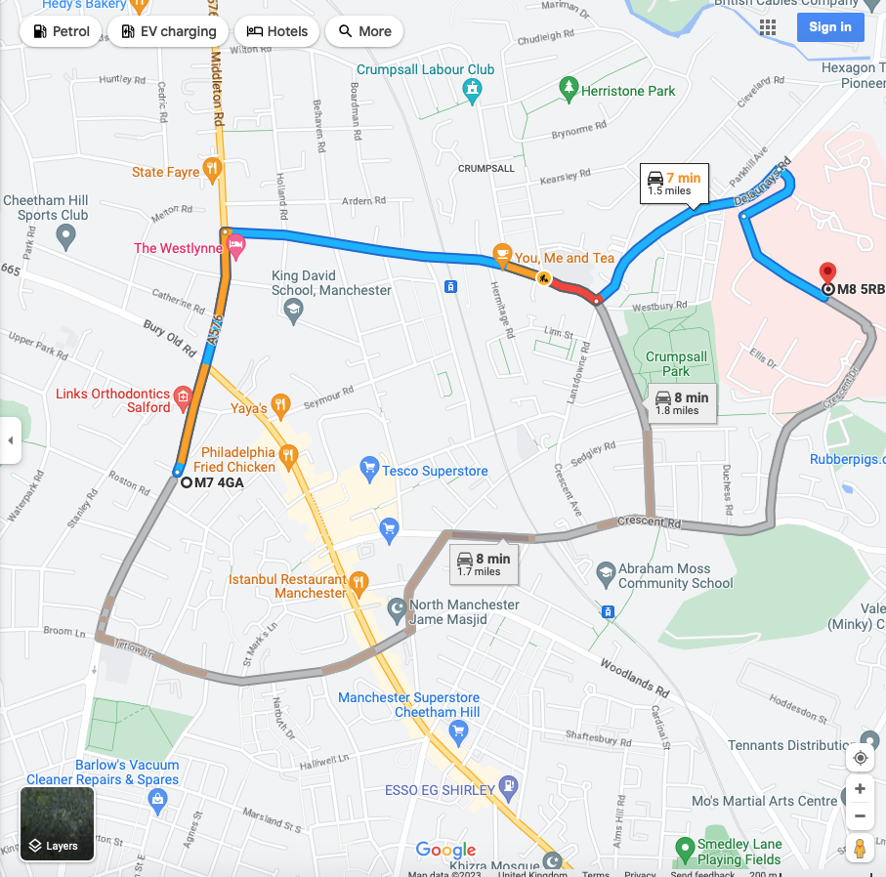

6a Site Logistic Plan

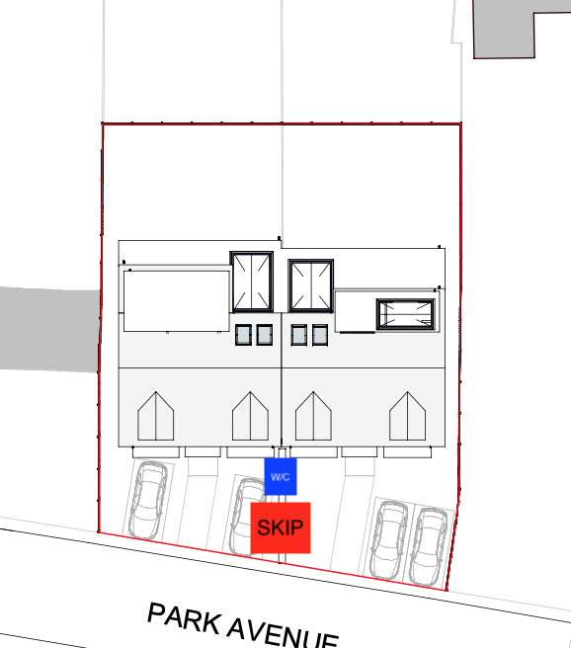

Status: | Brief Summary of Amendments:

6b Amendments to the Construction Phase Plan

16th May 2023

- Working hours 8am to 6pm Monday to Friday with quieter activities taking place outside of these hours

- Average of 3 operatives working on site at any one time.

- Workforce to park so as not to obstruct or park in such a manner as to restrict the operation of the local highway network, local residents and businesses.

- Heras fencing to be erected along the entire boundary. The footway adjacent to the site will be kept clear of materials during the construction period.

- In order to keep the site and the public highway clean, the site will be swept along with the highways and damped down to lessen the dust.

- When we have confirmed a start date, we will advise all neighbours and will also enclose our complaints procedure.

