DELEGATED DECISION RECORD REF: 23/81163/FUL

Address: Co-Op Academy , Sefton Road, Swinton, Salford, M27 6JU
Proposal: Replacement mesh fencing with concrete posts (maximum height 3m)

Reason for delay beyond stat deadline and EoT: N/A

Have all pre-commencement conditions been agreed with the applicant? N/A

Description of Site and Surrounding Area
This application refers to the field to the north of the Co-op Academy Swinton. Along the eastern boundary of the site is a public right of way (Swinton & Pendlebury Footpath 52).

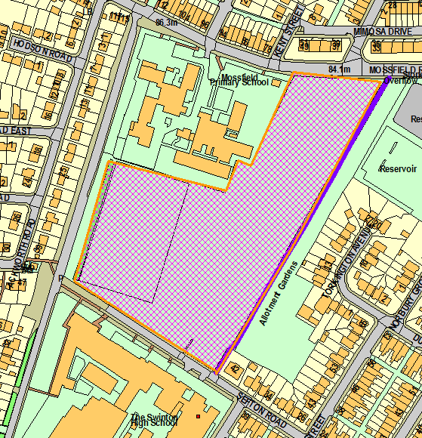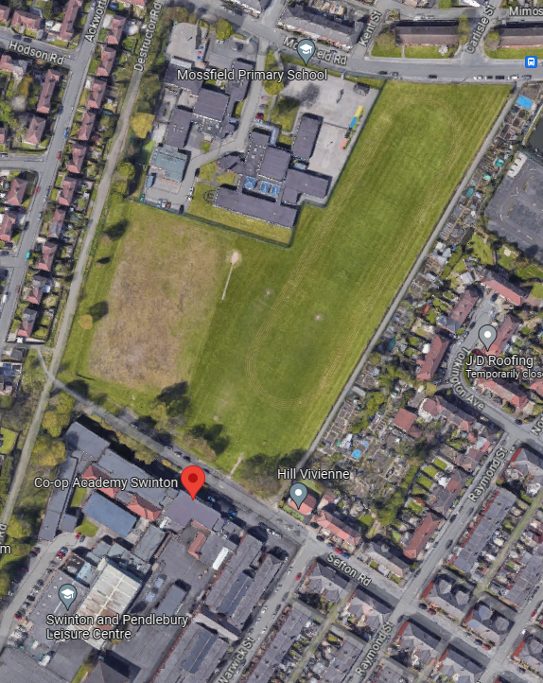
Location Plan edge in orange and public right of way in purple Aerial showing the site to the north of the school

Description of Proposal

- Installation of 3m high mesh fencing around the perimeter of the site.
- Replace existing 1m high fencing
- Proposed plan and elevations:
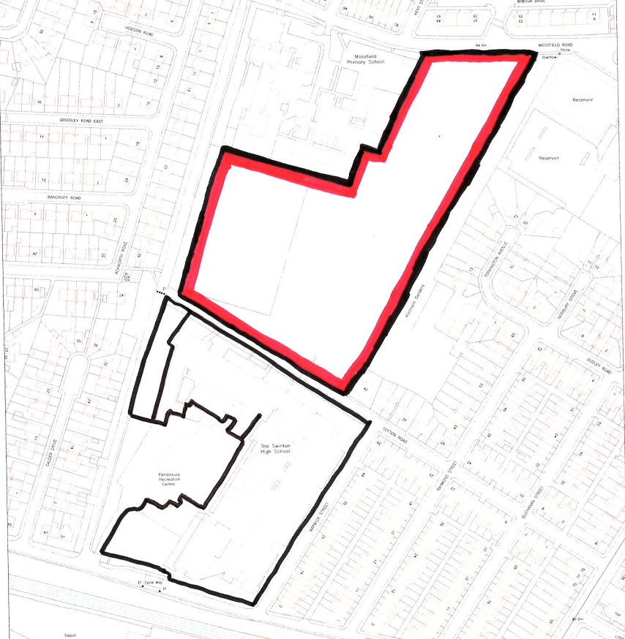

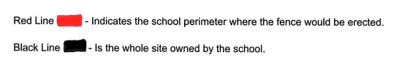

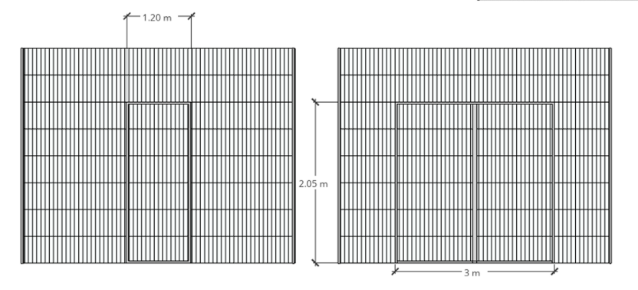

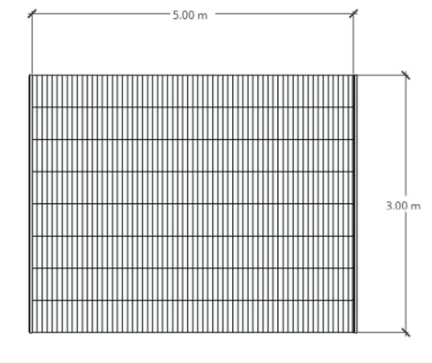

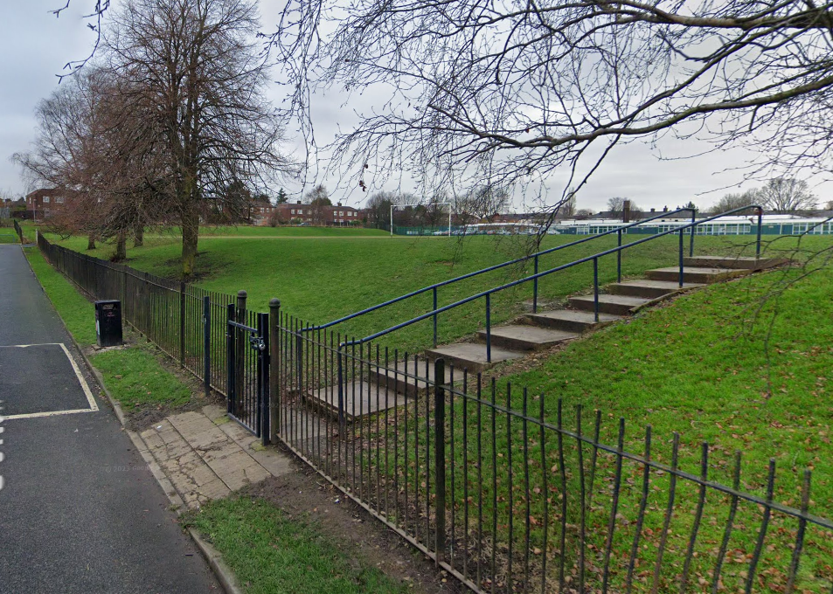
Existing boundary fencing

Publicity
Earliest Decision Date: 15 June 2023
Revised Expiry Date: No extension agreed

Site Notice: Non HH Affecting public right of way Date Displayed: 24 May 2023
Reason: Article 13 affect public right of way

Press Advert: Manchester Weekly News Salford Edition Date Published: 4 May 2023
Reason: Article 15 Affect Public right of Way

Relevant Site History

No relevant site history.

Neighbour Notification

35 neighbouring occupiers have been notified of the application.

Representations

No letters of representation have been received in response to then application publicity.

Consultations

Gmpa The Greater Manchester Pedestrian Assoc. -
No comments received to date

The Open Spaces Society -
No comments received to date

Ramblers Association (Manchester Area) -
Ramblers do not object to this proposal subject to there being a firm undertaking that S & P 52 will not be closed or narrowed either during fence removal / replacement or subsequently.

Peak and Northern Footpaths Society -
If the Council were minded to approve the planning application, please ensure that the applicant is made aware that:
- the grant of planning permission does not entitle developers to obstruct a public right of way crossing or adjoining the proposed development site;
- the use of an existing public right of way as a vehicular access to the site would be an offence unless the applicant has a private vehicular right.
- the line of the proposed replacement fencing must not encroach on the existing right of way.

Rights Of Way -
No comments received to date

Highways -
No objection subject to guidance discussed in the appraisal section of the report.
Senior Drainage Engineer -
No objection

Planning Policy

National Planning Policy
National Planning Policy Framework

Local Planning Policy

Salford Local Plan

D1 - Design principles
D2 - Local character and distinctiveness
D3 - Layout and access
D4 - Spaces
D5 - Amenity
A6 - Highway network

Emerging Planning Policy

The National Planning Policy Framework (NPPF) paragraph 48 establishes that local planning authorities may give weight to relevant policies in emerging plans according to:
- The stage of preparation of the emerging plan (the more advanced its preparation, the greater the weight that may be given);
- The extent to which there are unresolved objections to relevant policies (the less significant the unresolved objections, the greater the weight that may be given); and
- The degree of consistency of the relevant policies in the emerging plan to the NPPF (the closer the policies in the emerging plan to the policies in the NPPF, the greater the weight that may be given).

The Places for Everyone Publication Plan, a joint Development Plan Document for nine districts in Greater Manchester, was published for consultation under Regulation 19 of the Town and Country Planning (Local Planning) (England) Regulations 2012 on 9 August 2021. Representations were invited until 3 October 2021; the plan was submitted to the Secretary of State for examination on 14 February 2022 and examination hearings commenced in November 2022 and are due to run until March 2023. The emerging policies which are relevant to this application are discussed where applicable in this report with appropriate weight being afforded in accordance with NPPF paragraph 48.

Appraisal

Impact on surrounding area:

- The proposed fencing and gated entrance replaces the existing railings along the site boundary but a higher level of 3 metres.
- The proposed fencing would remain permeable and therefore maintain an open appearance from the street scene.
- The proposal would include a matching finish to the existing fencing in the school which is shown below. The finish and design of the fencing is appropriate within an educational setting/school site.

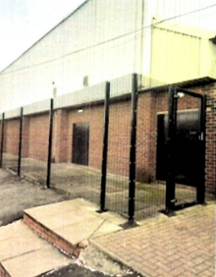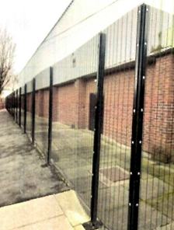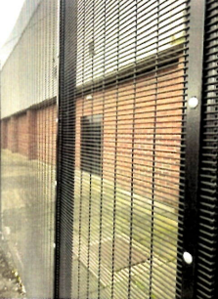

Impact on amenity:

- The proposed new fencing is in the same location as the existing railing, which is maintains a separation distance to nearby residential dwellings. On the east side of the site, the public right of way separates the proposed fencing and residential curtilages. And along the west side, Destructor Road creates a separation distance to the rear gardens of Ackworth Road.
- The location, scale and permeable nature of the new fencing is not considered to have a significant impact on residential amenity.

Impact on highway network:

- Although the development increases the height of the fence line adjacent to the highway, the fencing maintains its permeability. This way the development would not have any detrimental impact on the visibility of drivers when travelling in both directions along the streets of Sefton Road and Mossfield Road.
- The Councils highways department have no objection to the development. However, they have advised that on Mossfield Road there is a road street name plate attached to the existing fence line. This will need to be removed and reattached to new fence in the same location at a similar height to the current position. It is also noted that the sign is aged and worn and requires replacement. The applicant should speak to the LHA about the replacement of the existing sign with a new sign.

Impact on Public Right of Way:

- There is a Public Right of Way that runs between Mossfield Road and Sefton Road to the east side of the site.
- The proposal would be located adjacent to the Public Right of Way and would have no impact. However, the applicant should not block access along this footpath during construction works. If the applicant needs to temporarily obstruct the footway for construction works, they must apply for a temporary footpath diversion order.
Recommendation

Approve

1. The development must be begun not later than three years beginning with the date of this permission.

Reason: Required to be imposed by Section 91 of the Town and Country Planning Act 1990 (as amended).

2. The development hereby permitted shall be carried out in accordance with the following approved plans:

- Location Plan: Received 20/04/2023
- Elevations: Reference 23/81163/FUL – Received 15/06/2023

Reason: For the avoidance of doubt and in the interest of proper planning.

Statement of conformity with Article 35 of The Town and Country Planning (Development Management Procedure) (England) Order 2015

The proposal complies with the development plan and would improve the economic, social and environmental conditions of the area. It therefore comprises sustainable development and the Local Planning Authority worked proactively and positively to issue the decision without delay. The Local Planning Authority has therefore implemented the requirement in Paragraph 38 of the NPPF.

Notes to Applicant

- Informative Note:
The grant of planning permission does not entitle developers to obstruct a public right of way crossing or adjoining the proposed development site;
  - the use of an existing public right of way as a vehicular access to the site would be an offence unless the applicant has a private vehicular right.
  - the line of the proposed replacement fencing must not encroach on the existing right of way.

- Highway Information:
Requests for general Information regarding the adopted highway network shall be directed to the Local Highway Authority – John Horrocks/Pam Docksey - 0161 603 4046 / 4006- Mobile: 07974157474 / 07925638521 Email: John.horrocks@salford.gov.uk Pam.docksey@salford.gov.uk
For any matters concerning the Public Rights of Way within Salford the applicant should contact the Public Rights of Way officer Email: Public.Rightsofway@salford.gov.uk

Officer | James Bridgman | DC |  | LPA | AS
Date | 28/06/2023 | Date |  | Date | 29.6.23

