HOUSE EXTENSION REPORT

REF: 21/77246/HH

Address: 16 Kempnough Hall Road, Worsley, M28 2GN

Proposal: Enclosure of existing carport to a garage

Appropriate consultation undertaken Yes
Earliest Decision date: 25 May 2021
Reason for delay beyond stat deadline and EoT: n/a

Description of Site and Surrounding Area

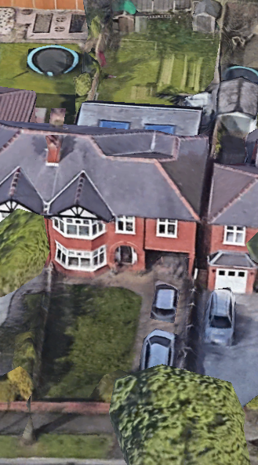
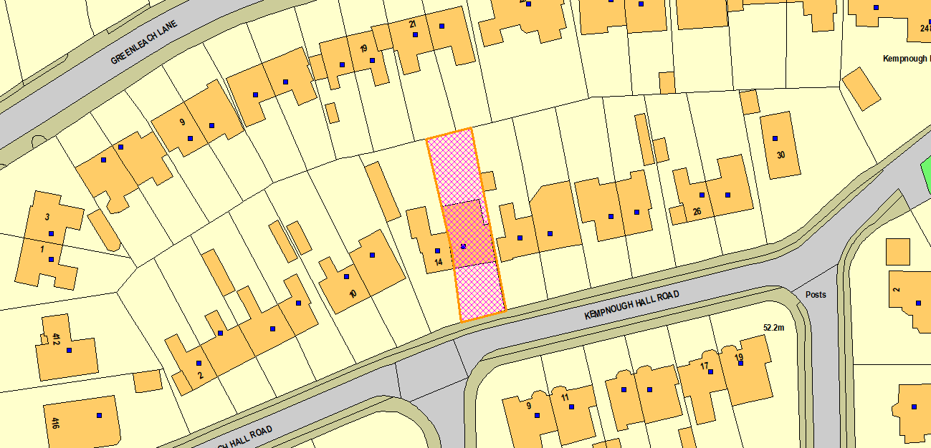
The application dwelling is a semi-detached property located in a residential area. The frontage of the dwelling is set back from the public highway by a generous driveway and front garden. The dwelling has an existing car port as part of the ground floor of a previously approved two storey side extension.
Figure 1 - Aerial
Figure 2 - Location Plan

Description of Proposal

Carport to garage conversion:

- Projects 0.75m beyond the principal elevation of the original dwelling.
- Pitched roof structure.
- Maintains existing side building line.
- New brickwork to side elevations with obscure glass and windows above.

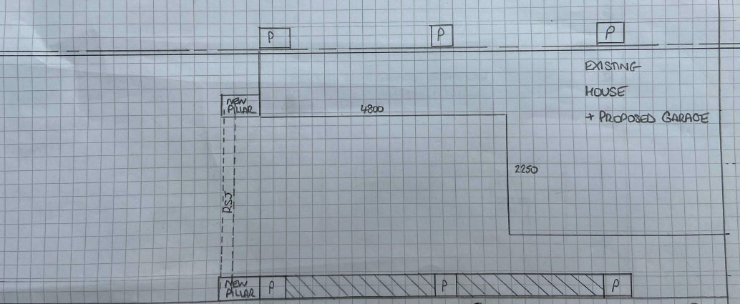
Figure 3 - Proposed GF Plan

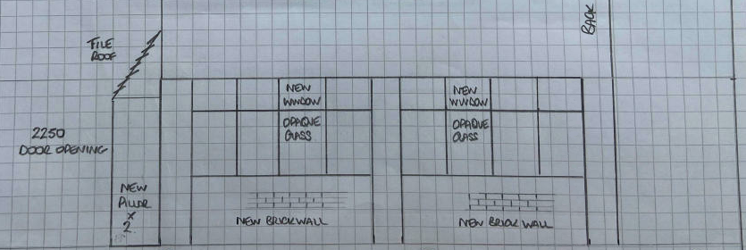
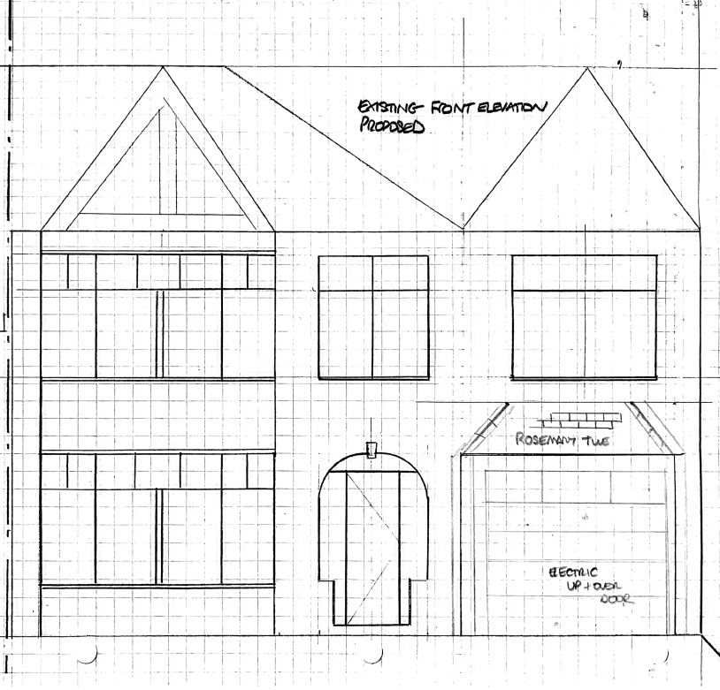
Figure 5 - Proposed Side Elevation
Figure 4 - Proposed Front Elevation

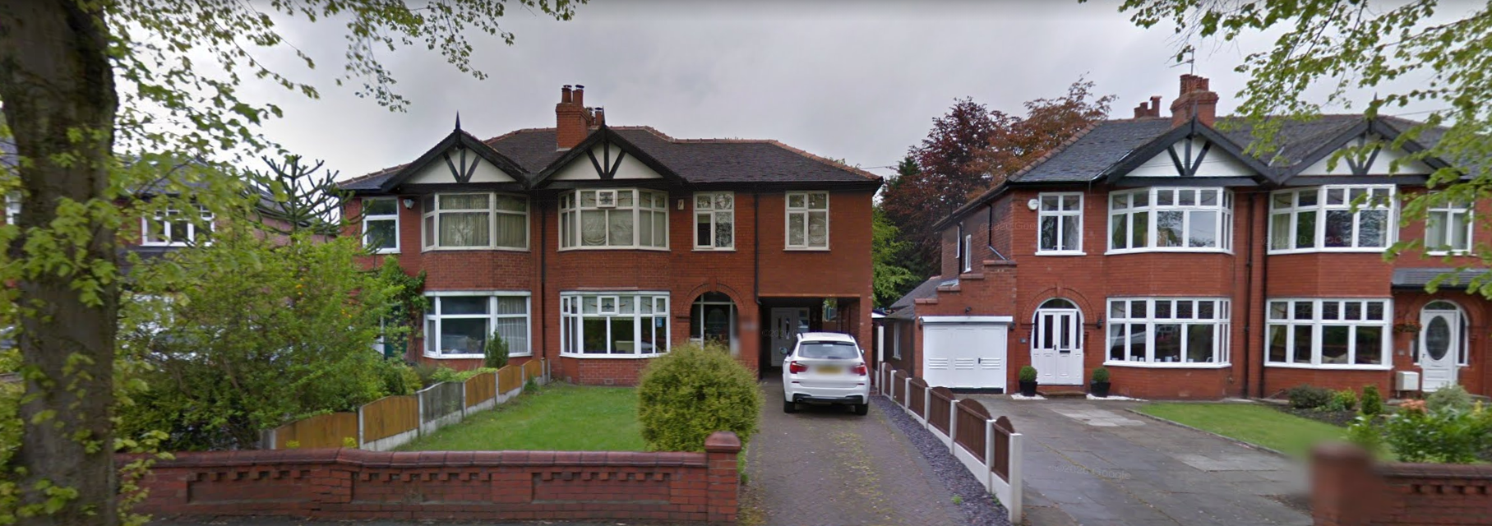
Picture 1 - Google Street View

Relevant Site History

00/40639/HH - Erection of two storey side extension to extend existing carport and provide en-suite above with demolition of rear outbuilding and erection of single storey rear kitchen extension – PER

15/66556/HH - Demolition of existing rear extensions and erection of a single storey rear sunroom – REF

16/67905/PDE - Erection of a rear conservatory - NOOBJ

Consultations

Not applicable.

Publicity
Earliest Decision Date: 25 May 2021
Revised Expiry Date: 24 June 2021

Site Notice: n/a
Reason: n/a

Press Advert: n/a
Reason: n/a

Representations

None received.

Planning Policy

Development Plan Policy

Unitary Development Plan DES1 - Respecting Context
This policy states that development will be required to respond to its physical context and respect the positive character of the local area in which it is situated and contribute towards a local identity and distinctiveness.

Unitary Development Plan DES7 - Amenity of Users and Neighbours
This policy states that all new development, alterations and extensions to existing buildings will be required to provide potential users with a satisfactory level of amenity in terms of space, sunlight, daylight, privacy, aspect and layout. Development will not be permitted where it would have an unacceptable impact on the amenity of occupiers or users of other development.

Unitary Development Plan DES8 - Alterations and Extensions
This policy states that planning permission will only be granted for alterations or extensions to existing buildings that respect the general scale, character, rhythm, proportions, details and materials of the original structure and complement the general character of the surrounding area.

Other Material Planning Considerations

National Planning Policy Framework
National Planning Policy Guidance

Local Planning Policy

Supplementary Planning Document - House Extension
This document contains a number of policies and standards to ensure that extensions within the curtilage of dwellings have a limited and acceptable impact on neighbouring residents; future residents of the application dwelling and that development makes a positive contribution to the local environment in terms of design.

The Revised Draft Greater Manchester Spatial Framework (‘GMSF’) was subject to public consultation at the start of 2019. In accordance with paragraph 48 of the National Planning Policy Framework it is considered that very limited weight can be given to the policies in the GMSF.

The Publication Salford Local Plan: Development Management Policies and Designations (‘Local Plan’) was published on 27 January 2020 and comments were invited until 20 March 2020. This is the version of the document that the city council would like to adopt and has been subject to a significant amount of public consultation in previous stages of its production. However, in accordance with paragraph 48 of the National Planning Policy Framework the weight that can be given to the Local Plan overall is currently limited. The city council is in the process of considering the comments made to determine the extent to which there are unresolved objections to the policies in the Plan. Those policies with less significant (or no) objections will be capable of carrying more weight than those with significant unresolved objections.

In addition, following the publication of the National Planning Policy Framework (NPPF) it is necessary to consider the weight which can be afforded to the policies of the Council's adopted Unitary Development Plan (paragraph 213 NPPF February 2019).

In terms of this application it is considered that the relevant policies of the UDP can be afforded due weight for the purposes of decision making as the relevant criteria within the UDP policies applicable to the proposed development are consistent with the policies contained in the NPPF.

It is not considered that there are any local finance considerations that are material to the application

Appraisal of the Proposed Development

Impact on the character of the area

- The development would be visible from the street scene when travelling in both directions, although projects and is set back a substantial distance from the street. The majority of dwellings in the street scene have side garages and therefore the development would not be out of place or considered an incongruous feature.
- The development uses matching materials in order to aid harmonisation with the existing dwelling and surrounding area.

Impact on the amenity of neighbours

- The projection of the garage to the front of the principal elevation would be of a distance that would not impact neighbouring occupiers and conform to existing building lines visible on the street.

For the reasons above the development is considered to conform with the listed UDP policies as well as policy HE2 of the Salford House Extensions SPD.

Other issues

Does the proposal require any work to trees? No

Is there a significant change in levels across the site or between the site and the neighbouring land? No

Has the applicant/agent indicated any personal circumstances? No

Approve

1. The development must be begun not later than three years beginning with the date of this permission.

Reason: Required to be imposed by Section 91 of the Town and Country Planning Act 1990 (as amended).

2. The development hereby permitted shall be carried out in accordance with the following approved plans:

- Existing Front Elevation
- Floor Layouts
- Location Plan (22 May 2021)
- Existing Front Elevation: Proposed
- Proposed Side Elevation
- Site Plan (22 May 2021)

Reason: For the avoidance of doubt and in the interest of proper planning.

3. The external materials used shall match those of the existing building so far as practicable.

Reason: In order to ensure a satisfactory appearance in the interests of visual amenity in accordance with Policies DES1 and DES8 of the City of Salford Unitary Development Plan and the requirements of the National Planning Policy Framework.

Notes to Applicant

1. STANDING ADVICE - DEVELOPMENT LOW RISK AREA

The proposed development lies within a coal mining area which may contain unrecorded coal mining related hazards. If any coal mining feature is encountered during development, this should be reported immediately to the Coal Authority on 0345 762 6848.

Further information is also available on the Coal Authority website at:
www.gov.uk/government/organisations/the-coal-authority

Standing Advice valid from 1st January 2021 until 31st December 2022

Officer | Jonathan Mumby | DC |  | LPA | AS
Date | 22/06/21 | Date |  | Date | 23.6.21

