HOUSE EXTENSION REPORT

REF: 21/78014/HH

Address: 253 Beesley Green, Worsley, M28 2QW

Proposal: Erection of first floor rear extension

Appropriate consultation undertaken Yes
Earliest Decision date: 16 September 2021
Reason for delay beyond stat deadline and EoT: n/a

Description of Site and Surrounding Area

The application dwelling is a terrace property located in the Roe Green / Beesley Green conservation area. The area is mostly residential, however there is a Community Centre adjoined to part of the property and an associated cricket ground to the east of the site. The site is in an ‘s’ shape with the dwelling extending towards the east but with the entrance to the dwelling facing south. The dwelling has a front garden space which is located to the front of no. 253a. The rear of the dwelling backs onto the cricket ground with a public pathway in between.
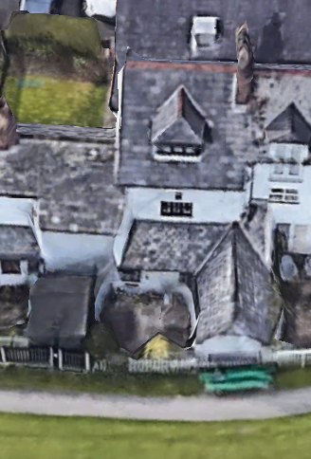
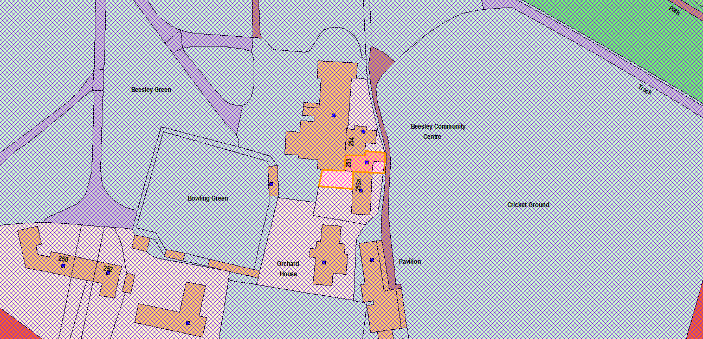
Figure 1 - Aerial
Figure 2 - Location

Description of Proposal

- First floor extension above existing ground floor rear section.
- Follows first floor building line of neighbouring dwelling.
- Set 0.9m away from north first floor site boundary line.
- Projects 1.8m to rear of dwelling from first floor elevation.
- Continuation of neighbouring roof slope into gable roof above first floor extension.
- Width of 3.7m with height of roof located just above eaves height of main roof.
- First floor rear facing Juliet balcony with full length doors.
- Ground floor rear facing full length doors.

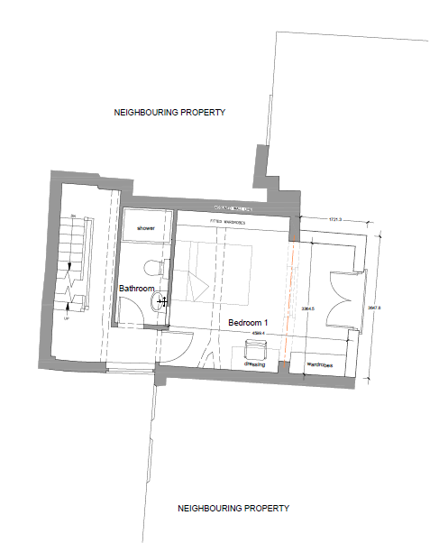
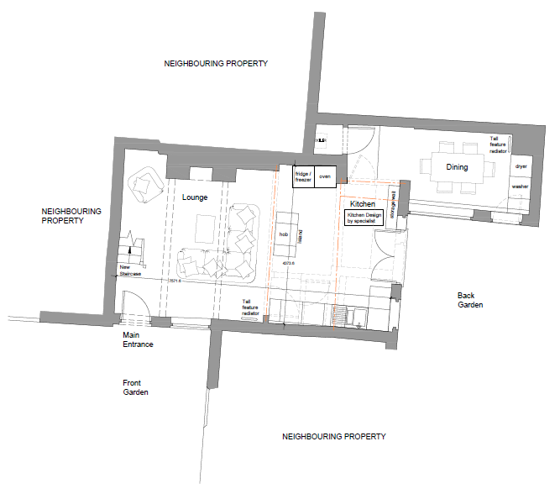
Figure 3 - Proposed FF Plan
Figure 4 - Proposed GF Plan

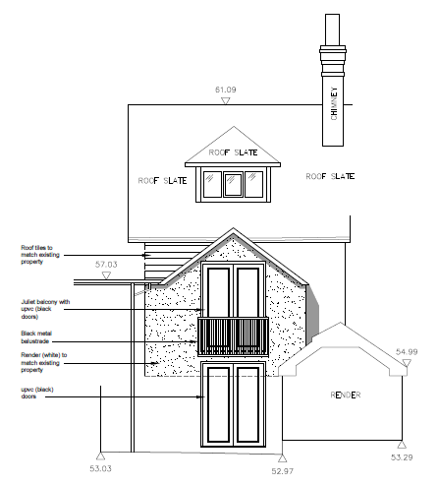
Figure 5 - Proposed Rear Elevation

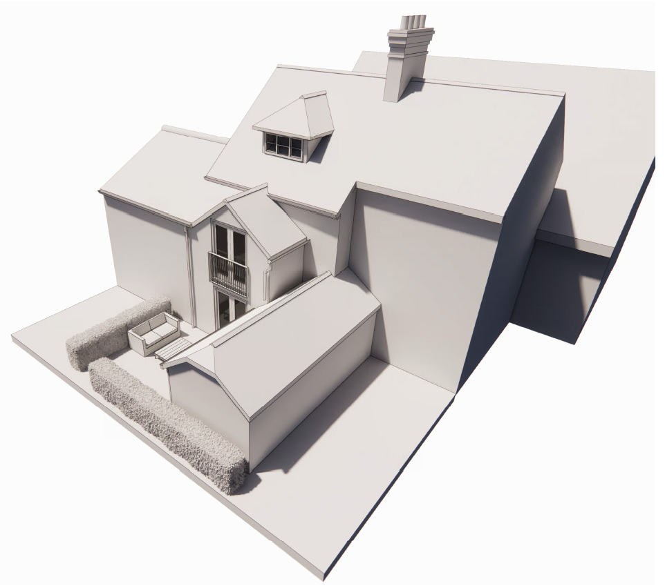
Figure 6 - Proposed 3D Visual

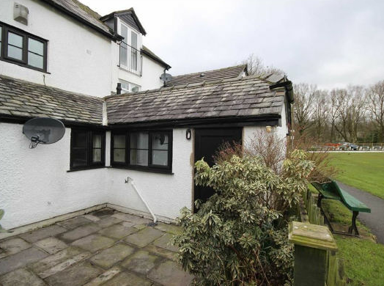
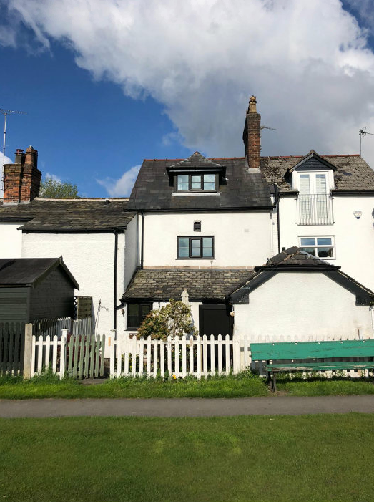
Picture 2 - Rear Details
Picture 1 - Rear Elevation

Relevant Site History

95/33412/HH - Erection of new kitchen and porch - PER

Consultations

Not applicable.

Publicity
Earliest Decision Date: 16 September 2021
Revised Expiry Date: No extension agreed

Site Notice: Household within Conservation Area Date Displayed: 25 August 2021
Reason: Planning App in Conservation Area

Press Advert: Manchester Weekly News Salford Edition Date Published: 12 August 2021
Reason: Planning App in Conservation Area

Representations

None received.

Planning Policy

Development Plan Policy

Unitary Development Plan DES1 - Respecting Context
Unitary Development Plan DES7 - Amenity of Users and Neighbours
Unitary Development Plan DES8 - Alterations and Extensions
Unitary Development Plan CH3 - Works Within Conservation Areas

Other Material Planning Considerations

National Planning Policy Framework
National Planning Policy Guidance

Local Planning Policy

Supplementary Planning Document - House Extension

The National Planning Policy Framework (NPPF) paragraph 48 establishes that local planning authorities may give weight to relevant policies in emerging plans according to:
- The stage of preparation of the emerging plan (the more advanced its preparation, the greater the weight that may be given);
- The extent to which there are unresolved objections to relevant policies (the less significant the unresolved objections, the greater the weight that may be given); and
- The degree of consistency of the relevant policies in the emerging plan to the NPPF (the closer the policies in the emerging plan to the policies in the NPPF, the greater the weight that may be given).
There are currently two emerging plans to consider.
First, Places for Everyone Publication Plan 2021, the joint Development Plan Document for nine districts in Greater Manchester, which was published for consultation under Regulation 19 of the Town and Country Planning (Local Planning) (England) Regulations 2012 on 9 August 2021. Representations are currently being invited until 3 October 2021. The emerging policies which are relevant to this application are discussed where applicable in this report with appropriate weight being afforded in accordance with NPPF paragraph 48.

Second, the Publication Salford Local Plan: Development Management Policies and Designations (SLP:DMP), which was published on 27 January 2020 and comments were invited until 20 March 2020. An Addendum was published on 5 February 2021 and comments were invited on this until 19 March 2021. The Publication SMP:DMP and the Addendum were submitted to the Secretary of State for examination on 30 June 2021 and the examination hearings are expected to take place in November 2021. The Publication SLP:DMP policies as modified through the Addendum is the version of the plan that the city council would like to adopt. The plan has been subject to a significant amount of public consultation in previous stages of its production and the city council has considered the comments made to determine the extent to which there are unresolved objections to its policies. Those policies (i.e. the Publication SLP:DMP policies as modified through the Addendum) which are relevant to this application are discussed where appropriate in this report with appropriate weight being afforded in accordance with NPPF paragraph 48.

In addition, NPPF paragraph 219 establishes that existing policies (such as Salford’s UDP) are not out-of-date simply because they were adopted or made prior to the publication of NPPF. Due weight should be given to them, according to their degree of consistency with the NPPF, and the closer the policies in the UDP to the policies in the NPPF, the greater the weight that may be given. In terms of this application it is considered that the relevant policies of the UDP can be afforded due weight for the purposes of decision making as the relevant criteria within the UDP policies applicable to the proposed development are consistent with the policies contained in the NPPF.

Appraisal of the Proposed Development

Impact on the character of the area

- The development is solely to the rear of the dwelling and therefore not visible from the front with dwelling on either side, including the community centre.
- The development would be visible from the rear of the dwelling from the path running towards the pavilion, however the scale and design of the development is not one of an offensive appearance and would not be considered to have a detrimental impact on the character of the surrounding area.
- The proposal uses matching materials in order to aid harmonisation with the original dwelling and those in the surrounding environment which are of a similar design.

Impact on the amenity of neighbours

- There are no facing habitable windows of neighbouring dwellings to the rear of the site, as the site faces a cricket ground to the rear.
- Neither window on ground or first floor, as part of the development, would be considered to overlook neighbouring outdoor amenity spaces.
- The first floor extension does not break the first floor building line of the neighbouring dwelling to the south.
- The first floor extension is set in from the north side boundary line by 2.1m with the projection of the extension being 1.8m. In the absence of a single storey rear extension next door along the shared boundary, this level of projection is considered acceptable.

Impact on Conservation Area

- The development is considered to be a small scale development to the original dwelling. The development does not increase the footprint of the existing dwelling and is design in a way as to complement the existing features of the dwelling with the roof pitch of the proposal matching the scale and design or the existing second floor rear dormer.
- The development uses white rendering, along with slate tiles and black uvpc windows, all of which match the current appearance of the dwelling and therefore harmonise with the existing dwelling and its character.
- The first floor extension is considered to be proportionate with the existing dwelling and not having a detrimental impact on the character of the dwelling when viewed from the foopath behind the dwelling.
- In conclusion the development is not considered to have a significant impact on the conservation area and is considered to retain the character and heritage of the original dwelling.

Other issues

Does the proposal require any work to trees? No

Is there a significant change in levels across the site or between the site and the neighbouring land? No

Has the applicant/agent indicated any personal circumstances? No

Approve

1. The development must be begun not later than three years beginning with the date of this permission.

Reason: Required to be imposed by Section 91 of the Town and Country Planning Act 1990 (as amended).

2. The development hereby permitted shall be carried out in accordance with the following approved plans:

- Existing Plans (DP2106)
- Proposed Plans (DP2106-04 (Opt 2))
- Existing Elevations (DP2106-03)
- Proposed Elevations (DP2106-05 (Opt 2))
- Block Plan & Location Plan (DP2106-01)

Reason: For the avoidance of doubt and in the interest of proper planning.

3. The external materials used shall match those of the existing building so far as practicable.

Reason: In order to ensure a satisfactory appearance in the interests of visual amenity in accordance with Policies DES1 and DES8 of the City of Salford Unitary Development Plan and the requirements of the National Planning Policy Framework.

Statement of conformity with Article 35 of The Town and Country Planning (Development Management Procedure) (England) Order 2015

The proposal complies with the development plan and would improve the economic, social and environmental conditions of the area. It therefore comprises sustainable development and the Local Planning Authority worked proactively and positively to issue the decision without delay. The Local Planning Authority has therefore implemented the requirement in Paragraph 38 of the NPPF.

Notes to Applicant

1. STANDING ADVICE - DEVELOPMENT LOW RISK AREA

The proposed development lies within a coal mining area which may contain unrecorded coal mining related hazards. If any coal mining feature is encountered during development, this should be reported immediately to the Coal Authority on 0345 762 6848.

Further information is also available on the Coal Authority website at:
www.gov.uk/government/organisations/the-coal-authority

Standing Advice valid from 1st January 2021 until 31st December 2022

Officer | Jonathan Mumby | DC |  | LPA | AS
Date | 08/09/21 | Date |  | Date | 8.9.21

