DELEGATED DECISION RECORD REF: 21/78121/FUL

Address: Holy Cross And All Saints Roman Catholic Primary School, Trafford Road, Eccles, M30 0JA
Proposal: The erection of a single classroom modular mobile building

Reason for delay beyond stat deadline and EoT: N/A

Have all pre-commencement conditions been agreed with the applicant? N/A

Description of Site and Surrounding Area

This application relates to the Holy Cross and All Saints Roman Catholic Primary School which is located on Trafford Road in Eccles. The school is locally listed because of its aesthetic and its social or communal value. It is an attractive building, the main frontage of which dates from the late 19th century and is built from red pressed brick with a Welsh slate roof and has large gable features with a central pair of gablets. There are a number of 20th century flat roofed extensions to the rear.

Vehicular access to the school site is from Trafford Road, with on-site parking being available for 15 cars, with one space being suitable for use by disabled people.

The school is located within a mixed use area being bounded by a variety of uses including a nursing home, apartments and dwelling houses, commercial units with flats above and a public house. The image below shows the site and its surroundings -
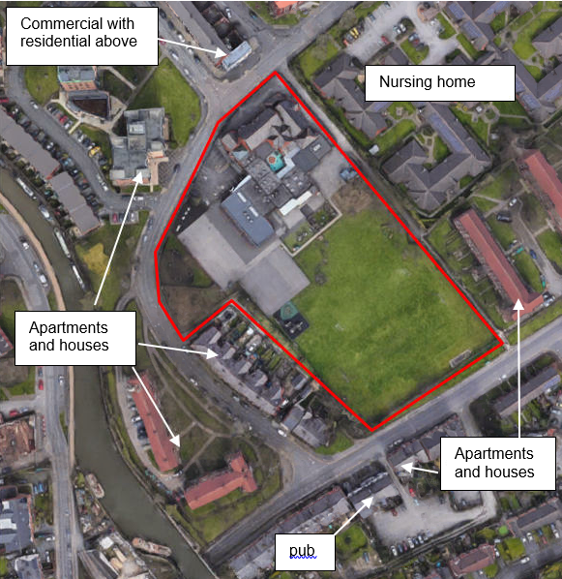
Proposal

Planning permission is sought to install a modular building on the tarmacked play area as per the images below-

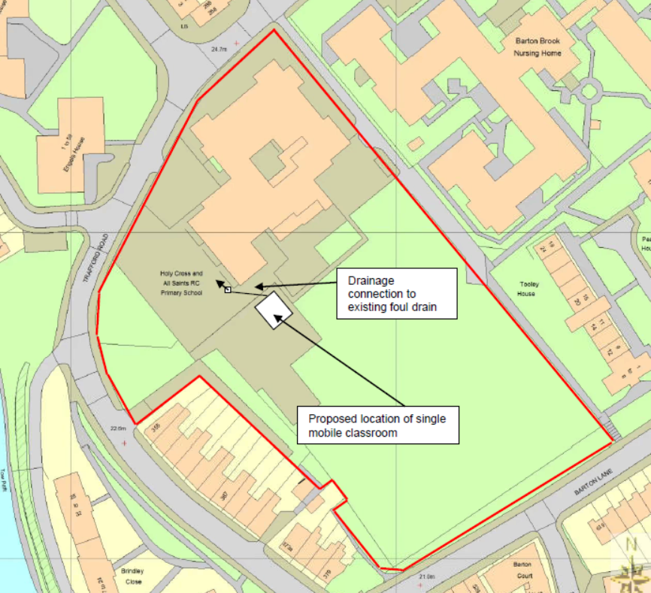
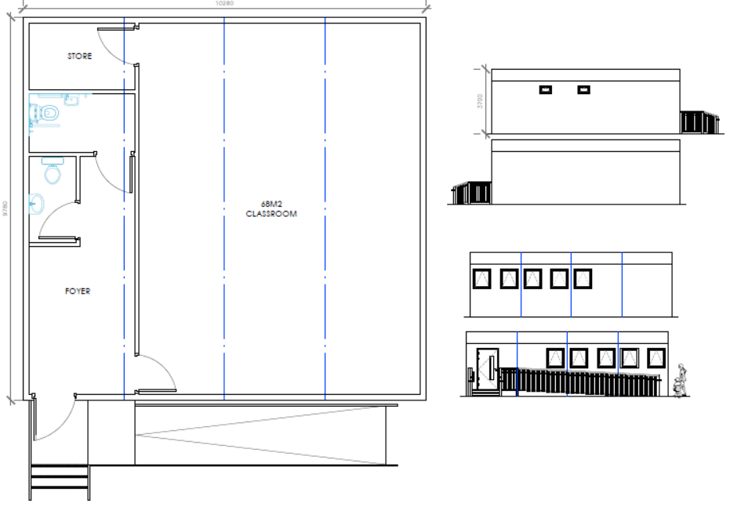
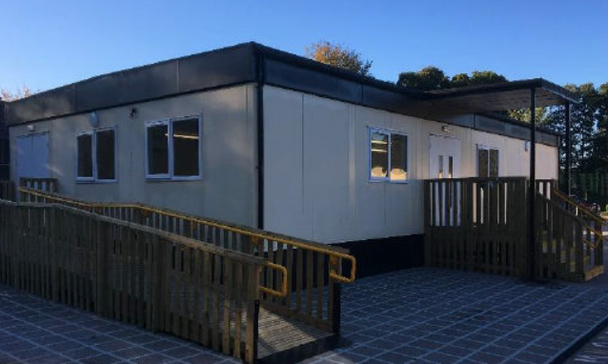

Relevant Site History

17/69693/FUL – Single storey extension to provide 3no. additional classrooms, together with relocation of hard play surface, and additional windows to existing two classrooms – Approved 10.07.2017

16/67868/FUL - Creation of new main entrance to North elevation of the existing school together with construction of a canopy and alterations to elevations – Approved 25.05.2016

13/63921/FUL - Erection of a single storey classroom extension – Approved 06.12.2013

04/49159/FUL - Erection of 2.4m high boundary fencing and single storey brick store and canopy (re-submission of planning application 04/48574/FUL) – Approved 22.11.2004

04/48574/FUL - Erection of 2.4m high boundary fencing and single storey brick store and canopy – Refused 28.07.2004

03/47020/FUL - Erection of single storey extension – Approved 20.11.2003

01/42403/DEEM3 – Erection of 2.4m high security fencing – Approved 21.06.2001

01/42377/FUL – Erection of storeroom extension – Approved 12.06.2001

01/41833/DEEM3 – Erection of 2.4m high security palisade fencing – Approved 01.03.2001

00/41327/DEEM3 - Erection of 2.4m high security fencing – Approved 06.11.2000

Publicity
Earliest Decision Date: 26 August 2021
Revised Expiry Date: No extension agreed

Site Notice: Non HH Within Conservation Area Date Displayed: 4 August 2021
Reason: Planning App in Conservation Area

Press Advert: Manchester Weekly News Salford Edition Date Published: 5 August 2021
Reason: Planning App in Conservation Area

Neighbour Notification

60 neighbouring properties have been notified of this application by letter.

Representations

No letters of representation have been received in response to the application publicity.

Consultations

Highways -
Note that the school has 15 on site car parking spaces for staff, with these including 1 space that is suitable for use by disabled people, with this area being unaffected by the proposal.

State that the number of pupils attending the school will increase as a consequence of the proposal with the number of pupils rising from 210 to 240 by September 2022. State that this increase in pupil numbers will likely result in an associated increase in trips to the school, especially around pick up and drop off times, however they advise that the increase in trips will be minor and consequently they do not consider that the proposal will have any significant impact on the highway network. Conclude that they therefore have no objections to the proposal.

Suggest that the school updates their Travel Plan and considers ways to increase walking and cycling to the school, such as the provision of on-site cycle parking for pupils.

Senior Drainage Engineer -
Advise that they have no objections to the application, stating that all drainage works must be completed in accordance with Building Regulations Approved Document H.

Air Quality, Noise, Contaminated Land -
Advise that there are no objections to the application on the grounds of air quality.

State that there are no significant noise issues with the proposal, advising that a condition should be attached that restricts noise generative construction works to between 8am and 6pm Monday to Friday and 9am and 2pm on Saturdays given the residential nature of the surrounding area.

Advise that as there is a limited amount of development, a condition for a watching brief is required to ensure any unanticipated ground contamination is appropriately dealt with.

Planning Policy

Development Plan Policy

Unitary Development Plan - Policy EHC1 Provision and Improvement of Schools and Colleges
Unitary Development Plan - Policy DES1 Respecting Context
Unitary Development Plan - Policy CH8 Local List of Buildings, Structures and Features of Architectural, Archaeological or Historic Interest
Unitary Development Plan - Policy DES7 Amenity of Users and Neighbours
Unitary Development Plan - Policy EN17 Pollution Control
Unitary Development Plan - Policy A2 Cyclists, Pedestrians and the Disabled
Unitary Development Plan - Policy A8 Impact of Development on Highway Network
Unitary Development Plan - Policy A10 Provision of Car, Cycle and Motorcycle Parking in New Developments
Unitary Development Plan - Policy EN19 Flood Risk and Surface Water

Other Material Planning Considerations

National Planning Policy

National Planning Policy Framework

Local Planning Policy
It is not considered that there are any local finance considerations that are material to the application.

The National Planning Policy Framework (NPPF) paragraph 48 establishes that local planning authorities may give weight to relevant policies in emerging plans according to:
- The stage of preparation of the emerging plan (the more advanced its preparation, the greater the weight that may be given);
- The extent to which there are unresolved objections to relevant policies (the less significant the unresolved objections, the greater the weight that may be given); and
- The degree of consistency of the relevant policies in the emerging plan to the NPPF (the closer the policies in the emerging plan to the policies in the NPPF, the greater the weight that may be given).
There are currently two emerging plans to consider.
First, Places for Everyone Publication Plan 2021, the joint Development Plan Document for nine districts in Greater Manchester, which is due to be published for consultation under Regulation 19 of the Town and Country Planning (Local Planning) (England) Regulations 2012 in August 2021. The emerging policies which are relevant to this application are discussed where applicable in this report with appropriate weight being afforded in accordance with NPPF paragraph 48.

Second, the Publication Salford Local Plan: Development Management Policies and Designations (SLP:DMP), which was published on 27 January 2020 and comments were invited until 20 March 2020. An Addendum was published on 5 February 2021 and comments were invited on this until 19 March 2021. The Publication SMP:DMP and the Addendum were submitted to the Secretary of State for examination on 30 June 2021 and the examination hearings are expected to take place in November 2021. The Publication SLP:DMP policies as modified through the Addendum is the version of the plan that the city council would like to adopt. The plan has been subject to a significant amount of public consultation in previous stages of its production and the city council has considered the comments made to determine the extent to which there are unresolved objections to its policies. Those policies (i.e. the Publication SLP:DMP policies as modified through the Addendum) which are relevant to this application are discussed where appropriate in this report with appropriate weight being afforded in accordance with NPPF paragraph 48.

In addition, NPPF paragraph 219 establishes that existing policies (such as Salford’s UDP) are not out-of-date simply because they were adopted or made prior to the publication of NPPF. Due weight should be given to them, according to their degree of consistency with the NPPF, and the closer the policies in the UDP to the policies in the NPPF, the greater the weight that may be given. In terms of this application, it is considered that the relevant policies of the UDP can be afforded due weight for the purposes of decision making as the relevant criteria within the UDP policies applicable to the proposed development are consistent with the policies contained in the NPPF.

Appraisal

Visual amenity, impact upon the character and appearance of the Barton Upon Irwell Conservation Area and the locally listed school building

The proposed modular building is a simple, functional structure, the design of which is a product of its function. The scale and massing of the unit would be comparable to that of the existing school building, with the materials that would be used in its construction being deemed to be of an appropriate quality, with the unit being located in a position where it has limited visibility from public vantage points due to its set back from the site’s boundaries, many of which have vegetation running along them. It is not therefore considered that the unit would form an incongruous addition to the site.

In respect of the proposals impact upon the nearby heritage assets the submission has been reviewed by the Council’s heritage advisor with them having confirmed that given the building would be sited at the rear of the main building, which has previously been extended with more modern additions with flat roofs, they do not consider that the introduction of the proposed mobile unit would have a detrimental impact upon the setting and significance of the locally listed school. Similarly given the siting of the unit and the fact that the main body of the conservation area is separated from the school site by intervening housing at 355 – 373 Trafford Road and the properties of Brindley Close they do not consider that the introduction of the unit would have a significant detrimental impact upon the character and appearance of the Barton Upon Irwell conservation area.

For these reasons, subject to the attachment of a condition to secure the use of the materials and finishes detailed in the application, the proposal would not have an unacceptable adverse impact upon the visual amenities of the area, the setting of the locally listed school or the character and appearance of the Barton Upon Irwell Conservation Area. The proposal is therefore considered to be in accordance with saved UDP policies DES1, DES8 and CH8 and the design and heritage policies in the NPPF.

Residential Amenity

The proposed modular classroom building would be set well within the site, over 25m from the rear boundary of the closest residential properties on Trafford Road. Consequently, it is not considered that the proposal would result in neighbouring land users experiencing a loss of amenity by virtue of a loss of light, privacy and/or overbearing impact.

In respect of noise and disturbance the introduction of the modular building will allow in an additional 30 pupils to attend the school, with this being likely to result in an associated increase in staffing levels. It is not considered that the increase in staff and pupils numbers will result in the use of the site being intensified to the extent that it would have a significant adverse impact upon the level of residential amenity neighbouring residents enjoy by virtue of them being exposed to an increase in the levels of noise and disturbance they are exposed to. The Council’s environment team have not raised any objections to the proposal subject to the attachment of a condition to control the hours of construction.

The proposal is therefore considered to be in accordance with policies DES7 and EN17 of the City of Salford UDP and the amenity policies in the NPPF.

Parking and highway safety

The introduction of the proposed extension would not alter the existing parking and access arrangements for the school; however, it would result in an additional 30 pupils attending, with this being likely to result in an associated increase in staffing levels.

It is not considered that the minor increase in pupil and staff levels that would occur will result in a significant increase in traffic flow to and from the site or additional demand for parking with many of those attending the school being likely to live in the surrounding area which means they will be able to arrive at the site on foot or via public transport.

Having regard to this and given that the Council’s highway officer has raised no objections to the proposal, it is not considered that the proposal raises any issues from a highways perspective, with the development therefore being considered to be in accordance with policies A8 and A10 of the City of Salford UDP.

A suitably worded informative will be added to make the applicant aware of the highway officer’s advice re updating their travel plan and giving consideration to ways to increase walking and cycling to the school, such as the provision of on-site cycle parking for pupils.

Recommendation

Approve subject to the following conditions

- The development must be begun not later than three years beginning with the date of this permission.

Reason: Required to be imposed by Section 91 of the Town and Country Planning Act 1990 (as amended).

- The development hereby permitted shall be carried out in accordance with the following approved plans:
Streetwise site location plan and proposed site plan dated 15/07/2021
Proposed floorplans and elevations – drawing 3170

Reason: For the avoidance of doubt and in the interest of proper planning.

- The development hereby permitted shall be constructed using the materials and finishes set out in the section 7 of the application form and the Appearance section of the Design and Access Statement, document reference 2021/11/DAS

Reason: In order to ensure a satisfactory appearance in the interests of visual amenity in accordance with Policies DES1 and DES8 of the City of Salford Unitary Development Plan and the requirements of the National Planning Policy Framework.

- All noise generative construction works including deliveries to the site shall be restricted to the following hours;
Monday to Friday: 08:00 – 18:00
Saturdays: 09:00 -14:00
Sundays and public holidays: No noise generative works

Reason: In the interest of the amenity of residents in accordance with policy EN 17 of the City of Salford Unitary Development Plan and the National Planning Policy Framework

- During the period of construction, should contamination be found on site that has not been previously identified, no further works shall be undertaken in the affected area. Prior to further works being carried out in the affected area, the contamination shall be reported to the Local Planning Authority within a maximum of 5 days from the discovery; a contaminated land assessment shall be carried out; appropriate mitigation identified and agreed in writing by the Local Planning Authority. The development shall be undertaken in accordance with the agreed mitigation scheme.
Reason: To prevent pollution of the water environment and to ensure the safe development of the site in the interests of the amenity of future occupiers in accordance with Policy EN17 of the City of Salford Unitary Development Plan and the National Planning Policy Framework.

Notes to Applicant

- The proposed development lies within a coal mining area which may contain unrecorded coal mining related hazards. If any coal mining feature is encountered during development, this should be reported immediately to the Coal Authority on 0345 762 6848.

Further information is also available on the Coal Authority website at:
www.gov.uk/government/organisations/the-coal-authority

Standing Advice valid from 1st January 2021 until 31st December 2022

- All drainage works shall be undertaken in accordance with Building Regulations Approved Document H.

- The developer and contractor should ensure they are observant during groundwork for any visual or olfactory sources of ground contamination. This may take the form of (for example); locally discoloured soils, an oily sheen on water standing in puddles / trenches / footings, petroleum, hydrocarbon or chemical type odours. Should such evidence be detected the Local Authority Contaminated Land Officer should be contacted for specialist advice

- The Council’s highway officer has recommended that the school updates their Travel Plan and considers ways to increase walking and cycling to the school, such as the provision of on-site cycle parking for pupils.

Officer | NT | DC | James Ketley
Date | 21.9.21 | Date | 21.09.2021

