HOUSE EXTENSION REPORT

REF: 21/77922/HH

Address: 4 Beaufort Avenue, Swinton, M27 0HW,

Proposal: Demolition of existing garage and single storey rear extension. Proposed two storey side extension and single storey rear extension.

Appropriate consultation undertaken Yes
Earliest Decision date: 21 July 2021
Reason for delay beyond stat deadline and EoT: N/a

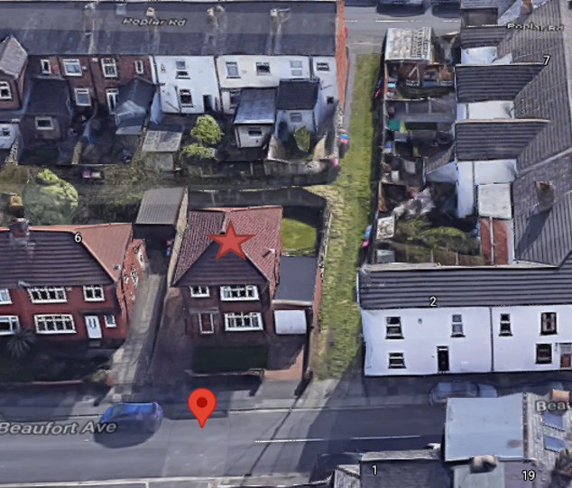
Description of Site and Surrounding Area

The application property is a detached dwelling within an area largely dominated with semi detached and terraced properties.

To the side and rear is an alleyway which runs to the rear of properties along Arthur Street, Beaufort Avenue and Poplar Road.

The property has an existing single storey attached garage to the side which would be demolished in order to accommodate the proposed extension.

Description of Proposal

The proposed side extension would sit flush with the main front elevation of the existing dwelling. It would project 2.67m to the side before extending back the full depth of the existing dwelling. The side extension would have a hipped roof and would be the same height as the existing dwelling.

The proposed single storey rear extension would extend the full width of the existing dwelling and the proposed two storey side extension and would be 1.837m in depth. It would have a flat roof with lantern style roof lights.

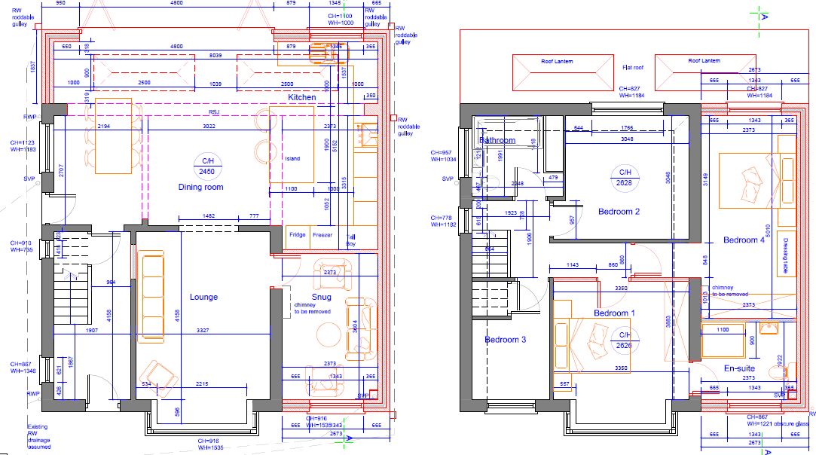

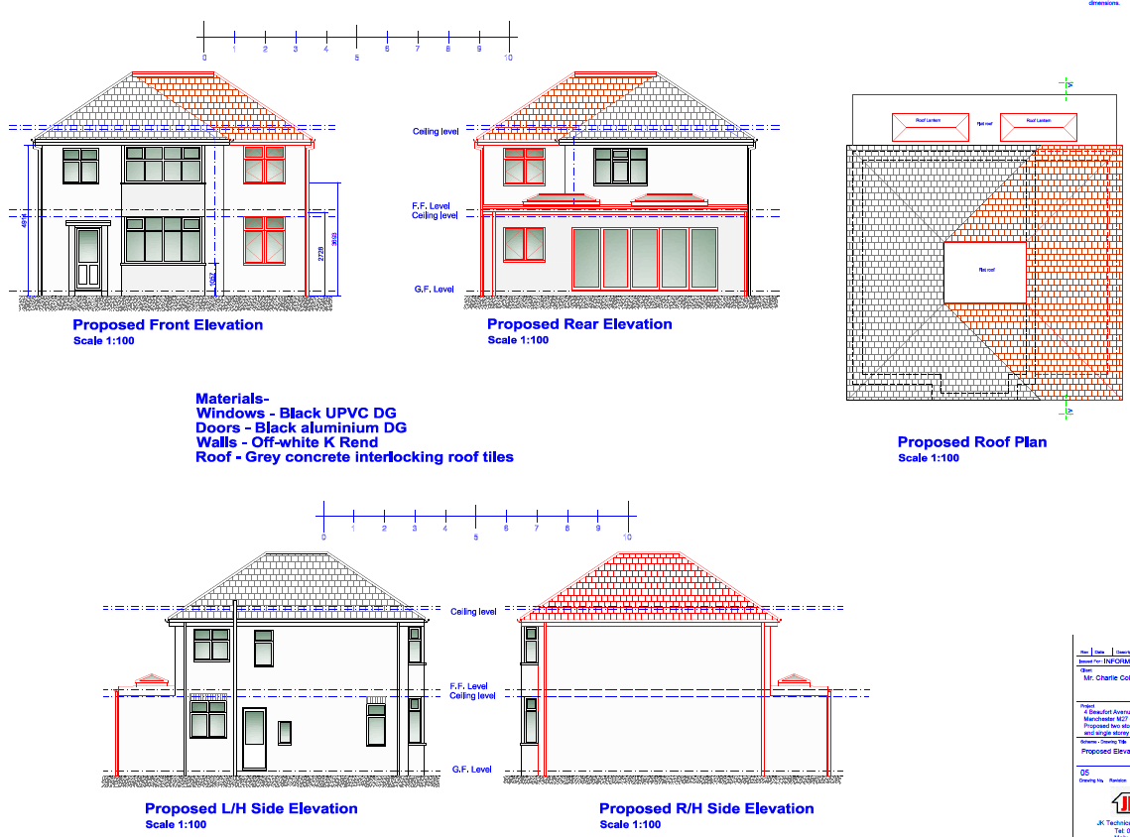

Relevant Site History

No relevant site history

Consultations

Not applicable.

Publicity
Earliest Decision Date: 21 July 2021
Revised Expiry Date: 10 September 2021

Representations

None received to date.

Planning Policy

Development Plan Policy

Unitary Development Plan DES1 - Respecting Context
Unitary Development Plan DES7 - Amenity of Users and Neighbours
Unitary Development Plan DES8 - Alterations and Extensions

Other Material Planning Considerations

National Planning Policy Framework
National Planning Policy Guidance

Local Planning Policy

Supplementary Planning Document - House Extension

The National Planning Policy Framework (NPPF) paragraph 48 establishes that local planning authorities may give weight to relevant policies in emerging plans according to:
(a) The stage of preparation of the emerging plan (the more advanced its preparation, the greater the weight that may be given);
(b) The extent to which there are unresolved objections to relevant policies (the less significant the unresolved objections, the greater the weight that may be given); and
(c) The degree of consistency of the relevant policies in the emerging plan to the NPPF (the closer the policies in the emerging plan to the policies in the NPPF, the greater the weight that may be given).
There are currently two emerging plans to consider.
First, Places for Everyone Publication Plan 2021, the joint Development Plan Document for nine districts in Greater Manchester, which was published for consultation under Regulation 19 of the Town and Country Planning (Local Planning) (England) Regulations 2012 on 9 August 2021. Representations are currently being invited until 3 October 2021. The emerging policies which are relevant to this application are discussed where applicable in this report with appropriate weight being afforded in accordance with NPPF paragraph 48.

Second, the Publication Salford Local Plan: Development Management Policies and Designations (SLP:DMP), which was published on 27 January 2020 and comments were invited until 20 March 2020. An Addendum was published on 5 February 2021 and comments were invited on this until 19 March 2021. The Publication SMP:DMP and the Addendum were submitted to the Secretary of State for examination on 30 June 2021 and the examination hearings are expected to take place in November 2021. The Publication SLP:DMP policies as modified through the Addendum is the version of the plan that the city council would like to adopt. The plan has been subject to a significant amount of public consultation in previous stages of its production and the city council has considered the comments made to determine the extent to which there are unresolved objections to its policies. Those policies (i.e. the Publication SLP:DMP policies as modified through the Addendum) which are relevant to this application are discussed where appropriate in this report with appropriate weight being afforded in accordance with NPPF paragraph 48.

In addition, NPPF paragraph 219 establishes that existing policies (such as Salford’s UDP) are not out-of-date simply because they were adopted or made prior to the publication of NPPF. Due weight should be given to them, according to their degree of consistency with the NPPF, and the closer the policies in the UDP to the policies in the NPPF, the greater the weight that may be given. In terms of this application it is considered that the relevant policies of the UDP can be afforded due weight for the purposes of decision making as the relevant criteria within the UDP policies applicable to the proposed development are consistent with the policies contained in the NPPF.

Appraisal of the Proposed Development

Impact on the character of the area

The existing single storey rear extension to be demolished is of no particular architectural merit and as such its demolition is considered acceptable.

The proposed side and rear extensions would be visible within the street scene and from the alleyway to the side and rear of the property.

The side extension would be the same height as the existing dwelling and whilst it wouldn’t be set back or in from the boundary the presence of the alleyway to the side and the set in of the property from the common boundary with the adjacent property at 6 Beaufort Avenue means that it would not have the potential to create a terracing effect in accordance with policy HE8.

The property is currently brick but is proposed to be rendered as is the proposed extension. Whilst the properties along Beaufort Avenue are predominantly brick there are rendered properties within the vicinity including directly adjacent to the application site at the junction of Beaufort Avenue and Arthur Street. It is not considered that the rendering of the property would result in an unacceptable impact on the street scene or the character of the area in this instance and is therefore considered acceptable.

The proposed extensions are considered to be of appropriate scale and design. Materials used would match those of the existing dwelling which is proposed to be rendered and a condition would be attached to ensure this.

The development is therefore considered acceptable and in accordance with the house extensions SPD and UDP Policies DES1 and DES8.

Impact on the amenity of neighbours

The proposed side extension would not directly face any properties to the front but would face the rear garden of 19 Arthur Street, which sits side on to Beaufort Avenue, at a distance of approximately 15m.

To the rear, ground floor windows in the proposed single storey rear extension would retain a distance of approximately 4.5m to the rear boundary with the rear alleyway beyond and the single storey rear outriggers of the properties along Poplar Road approximately 13m away at its closest point. Existing boundary treatments and the presence of the alleyway will ensure no direct overlooking at ground floor level.

The proposed side extension would introduce a bedroom window at first floor level which would retain a distance of approximately 7m to the rear boundary, 15m to the closest rear outrigger to the rear and 20m to the main rear elevation of the properties to the rear. This new bedroom window would not be any closer to the properties to the rear than the existing first floor bedroom window in the rear elevation and the relationship of other properties along Beaufort Avenue and Arthur Street. Having regard to the above it is not considered that the introduction of one additional bedroom window would result in an unacceptable loss of privacy to occupiers of properties to the rear.

The proposed single storey rear extension would not project beyond a 45 degree line taken from a point 3m along the common boundary from the rear extension of the adjacent property at 6 Beaufort Avenue in accordance with policy HE5. The two storey side extension would not be visible from within 6 Beaufort Avenue as it would be screened by the existing dwelling at the application site.

The proposed extension would introduce no windows in its side elevations. To the side of the application property, beyond the alleyway are the rear elevations of the properties along Arthur Street. Numbers 15 and 17 Arthur Street contain kitchen/dining room windows at ground floor level with number 15 including an office room at first floor level. Whilst the occupier confirmed this room is currently used as an office it was previously a bedroom and as such the application has been assessed on that basis. The proposed two storey side extension and the side elevation of the proposed rear extension would retain a distance of approximately 13m from the rear elevations of 15 and 17 in accordance with policies HE3 and HE4.

The property at 13 Arthur Street has an existing two storey rear extension with double doors at ground floor level serving a kitchen with dining area beyond and an office window at first floor level which as with number 15 is understood was used as a bedroom until more recently. The rear elevation of number 13 would partially face the proposed two storey side extension at a distance of approximately 10.5m with the side of the proposed rear extension sitting more directly behind its rear elevation again at a distance of approximately 10.5m. The separation retained to the single storey extension would therefore accord with policy HE4. Whilst the separation to the two storey extension would be less than the 13m required by policy HE3 it is acknowledged that there are similar relationships in the area including at the opposite end of Arthur Street where properties face the side gable of 1 Poplar Road. In addition it is noted that the alleyway between the rear of Arthur Street and the side of the application site give a perspective of separation between the dwellings. The property at 13 currently has quite dense shrubbery to the rear and as set out above would only partially face the proposed two storey side extension with some light and outlook being provided to the south over the rear garden of the application property and the alleyway.

Number 2 Beaufort Avenue is a narrow property that adjoins and turns the corner with 17 Arthur Street. The whole of the existing property and the proposed extensions would sit to the rear of 2 Beaufort Avenue but would be offset and separated by the alleyway. Number 2 Beaufort Avenue does have a ground floor habitable room window in its rear elevation however the room is also served by a further window within the front elevation with the rear window looking directly out onto a garden/yard area which is shared with 17 Arthur Street.

The development would therefore not have an unacceptable impact on the amenity of occupiers of surrounding residential dwellings and would provide its occupiers with an acceptable level of amenity in accordance with UDP Policy DES7 and the House Extensions SPD.

Impact on the highway network

The property has two existing in curtilage hardstanding areas to the front of the property. From the plans submitted these areas appear to be slightly smaller in length than the 4.8m required by policy HE11 however they are existing parking areas and the proposed side extension would not project beyond the main front elevation of the existing dwelling and would therefore not impact on the existing use of these areas. In addition, on street parking is available within the vicinity.

Other issues

Does the proposal require any work to trees? No

Is there a significant change in levels across the site or between the site and the neighbouring land? No

Has the applicant/agent indicated any personal circumstances? No

Recommendation
Approve

1. The development must be begun not later than three years beginning with the date of this permission.

Reason: Required to be imposed by Section 91 of the Town and Country Planning Act 1990 (as amended).

2. The external materials used shall match those of the existing building so far as practicable.

Reason: In order to ensure a satisfactory appearance in the interests of visual amenity in accordance with Policies DES1 and DES8 of the City of Salford Unitary Development Plan and the requirements of the National Planning Policy Framework.

3. The development hereby permitted shall be carried out in accordance with the following approved plans:

- Drawing no 05 - OS map
- Drawing no 05 - Proposed elevations and roof plan
- Drawing no 04 - Proposed section
- Drawing no 03 - Proposed ground floor and first floor plan

Reason: For the avoidance of doubt and in the interest of proper planning.

Notes to Applicant

- STANDING ADVICE - DEVELOPMENT LOW RISK AREA

The proposed development lies within a coal mining area which may contain unrecorded coal mining related hazards. If any coal mining feature is encountered during development, this should be reported immediately to the Coal Authority on 0345 762 6848.

Further information is also available on the Coal Authority website at:
www.gov.uk/government/organisations/the-coal-authority

Standing Advice valid from 1st January 2021 until 31st December 2022

Officer | A.Stewart | DC |  | LPA | M Hodgson
Date | 8/9/21 | Date |  | Date | 09.09.21

