DELEGATED DECISION RECORD REF: 22/80316/ADV

Address: Gable 128 And 132, Moorside Road, Swinton,
Proposal: Replacement of existing poster advertisement display with internally illuminated D-Poster

Reason for delay beyond stat deadline and EoT: N/A

Have all pre-commencement conditions been agreed with the applicant? N/A

Description of Site and Surrounding Area

- The site is located in Swinton and refers to the gable end of no.128 Moorside Road.
- The surrounding area consists of a mix of residential and commercial/industrial properties including Wardley Business Park.
- There is an existing 48-sheet poster and paste billboard which has been there for at least 13 years.
- Adjacent is a grass verge and entrance to footbridge over the East Lancashire Road/A580.

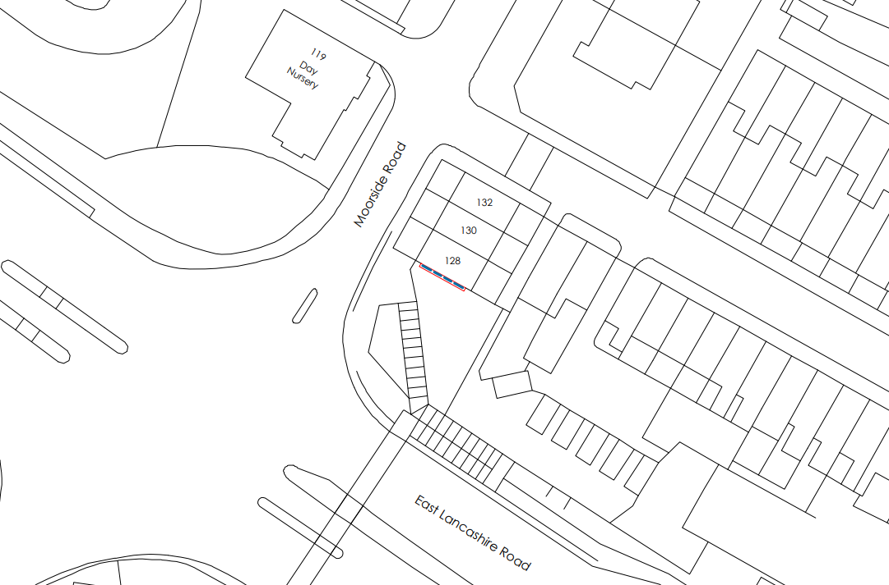
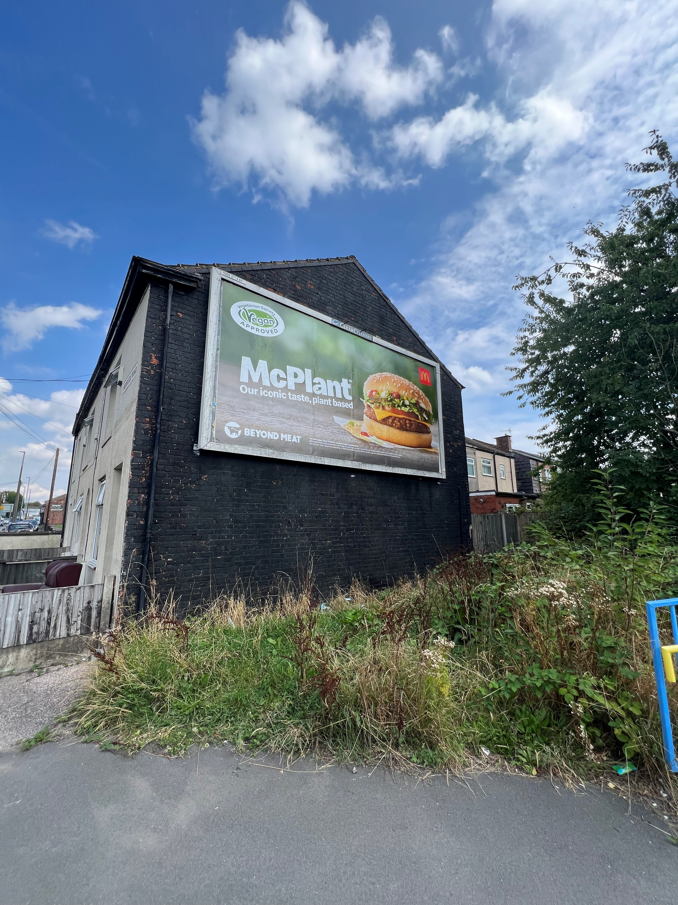
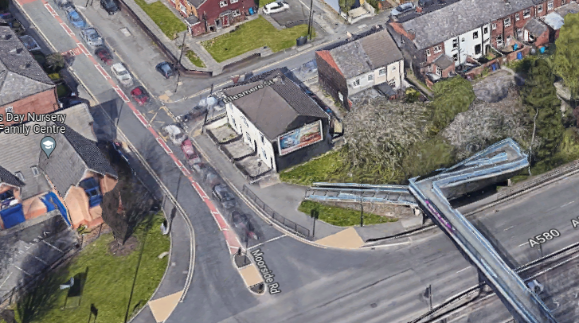
Figure 1 – Location Plan
Figure 2 – Photo of site
Figure 3 – Aerial of site

Description of Proposal

- Consent in sought for the replacement of the existing billboard with an internally illuminated digital display (D-Poster)
- The proposed advertisement would be 6m by 3m with a 0.2m frame.
- The proposal is the same size and location on the gable end of no.128 as the existing advertisement.
- Maximum luminance of 300cd/m²
- Details and drawings are shown below:
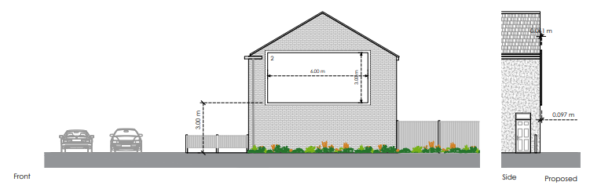
Figure 4 – Elevations

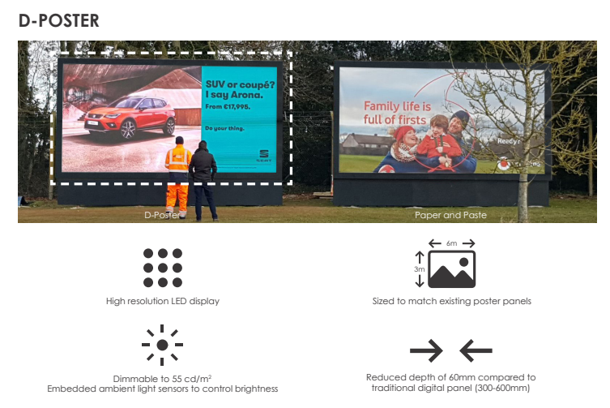
Figure 5 – Details and comparison with existing paper and paste

Publicity
Earliest Decision Date: 17 September 2022
Revised Expiry Date: 5th October

Site Notice: General Site Notice date: 1st October
Reason: Wider Publicity

Neighbour Notification and Representations

2 neighbouring occupiers have been notified of the application and a general site notice was displayed at the site. No letters of representation have been received in response to the application publicity.

Consultations

Highways - No objection

Planning Policy

Development Plan Policy

Unitary Development Plan - Policy DEV2 Advertisements
Unitary Development Plan - Policy A8 Impact of Development on Highway Network

Other Material Planning Considerations

National Planning Policy

Local Planning Policy
It is not considered that there are any local finance considerations that are material to the application.

The National Planning Policy Framework (NPPF) paragraph 48 establishes that local planning authorities may give weight to relevant policies in emerging plans according to:
- The stage of preparation of the emerging plan (the more advanced its preparation, the greater the weight that may be given);
- The extent to which there are unresolved objections to relevant policies (the less significant the unresolved objections, the greater the weight that may be given); and
- The degree of consistency of the relevant policies in the emerging plan to the NPPF (the closer the policies in the emerging plan to the policies in the NPPF, the greater the weight that may be given).
There are currently two emerging plans to consider.
First, Places for Everyone Publication Plan, the joint Development Plan Document for nine districts in Greater Manchester, which was published for consultation under Regulation 19 of the Town and Country Planning (Local Planning) (England) Regulations 2012 on 9 August 2021. Representations were invited until 3 October 2021; the plan was submitted to the Secretary of State for examination on 14 February 2022 and examination hearings are due to commence in Summer 2022. The emerging policies which are relevant to this application are discussed where applicable in this report with appropriate weight being afforded in accordance with NPPF paragraph 48.

Second, the Publication Salford Local Plan: Development Management Policies and Designations (SLP:DMP), which was published on 27 January 2020 and comments were invited until 20 March 2020. An Addendum was published on 5 February 2021 and comments were invited on this until 19 March 2021. The Publication SMP:DMP and the Addendum were submitted to the Secretary of State for examination on 30 June 2021 and the examination hearings took place over 7 days in December 2021. The plan has been subject to a significant amount of public consultation in previous stages of its production and the city council has considered the comments made to determine the extent to which there are unresolved objections to its policies. Those policies (i.e. the Publication SLP:DMP policies as modified through the Addendum) which are relevant to this application are discussed where appropriate in this report with appropriate weight being afforded in accordance with NPPF paragraph 48. It is expected that the SLP:DMP will be adopted in Autumn 2022.

In addition, NPPF paragraph 219 establishes that existing policies (such as Salford’s UDP) are not out-of-date simply because they were adopted or made prior to the publication of NPPF. Due weight should be given to them, according to their degree of consistency with the NPPF, and the closer the policies in the UDP to the policies in the NPPF, the greater the weight that may be given. In terms of this application it is considered that the relevant policies of the UDP can be afforded due weight for the purposes of decision making as the relevant criteria within the UDP policies applicable to the proposed development are consistent with the policies contained in the NPPF.

Appraisal

The main issues for consideration with this application are the impact of the proposed advertisement on amenity and public safety. The main policies of relevance are Policy DEV 2 and A 8 of the City of Salford adopted Unitary Development Plan (UDP) and paragraph 136 of the NPPF revised on 20th July 2021.

Amenity

- The advertisement would be seen when travelling along Moorside Road and along East Lancashire Road, given its location on a gable end of no.128.
- Although the proposed advertisement will be illuminated, it would be the same size and location as the existing paper billboard. As such, the proposal accords with parts (i) and (iii) of Policy DEV2 as it is not considered to appear significantly dominating in comparison to the existing advert.
- The proposed signage is a replacement and therefore would not result in any additional clutter to the street scene, in accordance with Policy DEV2 (iii).
- The illuminated display would be static and accords with Policy DEV2 (iv). Given it will display multiple adverts on rotation, a condition will be added to control the changing frequency of no more than 10 seconds.
- There are residential dwellings to the north, west and south of the application site, however the proposed digital display nearest facing residential window would be over 82m away due to its position. Therefore, the illumination of the proposed digital hoarding would not have a significant impact on the amenity of the nearby residential properties.
- Due to the composition of the locality, coupled with the size and siting of the proposal, it is therefore considered that the proposed advertising screen would not significantly harm the amenity of the neighbouring area in accordance with Policy DEV 2.

Public Safety

- The proposed sign is fixed to the gable wall of no.128 Moorside Road and would be internally illuminated with a static display. Highways have been consulted and have no objections, provided that the illuminance level is controlled under a condition.
- The advertisement would not cause any pedestrian obstruction. It would be highly visible from pedestrians using the footbridge over East Lancashire Road towards Moorside Road, however it is considered to have a similar impact as the existing situation.
- It is therefore considered that the signage does not have an adverse impact on highway safety, in accordance with Policy A8 of the Salford UDP.

Recommendation

Approval, subject to the following conditions:

- The development hereby permitted shall be carried out in accordance with the following approved plans:

- Site Plan: 011-0206-5714/PA/02
- Location Plan: 011-0206-5714/PA/03
- Existing and Proposed Elevations: 011-0206-5714/PA/04
Reason: For the avoidance of doubt and in the interest of proper planning.

- (a) Any advertisements, displayed, and any land used for the display of advertisements, shall be maintained in a clean and tidy condition to the reasonable satisfaction of the Local Planning Authority.

(b) Any structure or hoarding erected or used principally for the purpose of displaying advertisements shall be maintained in a safe condition.

(c) Where an advertisement is required under these Regulations to be removed, the removal shall be carried out to the reasonable satisfaction of the Local Planning Authority.

(d) No advertisement is to be displayed without the permission of the owner of the site or any other person with an interest in the site entitled to grant permission.

(e) No advertisement shall be sited or displayed so as to obscure, or hinder the ready interpretation of, any road traffic sign, railway signal or aid to navigation by water, or air, or so as otherwise to render hazardous the use of any highway, waterway (including any coastal waters) or aerodrome (civil or military).

The source of any illumination shall not be visible to users of the public highway.

Reason: Required to be imposed by Regulation 2(1) of the Town and Country Planning (Control of Advertisements) (England) Regulations 2007.

- The maximum level of luminance of the sign(s) hereby permitted shall not exceed the relevant thresholds contained within the Institute of Lighting Professionals (ILP) guidance document "PLG05 - The Brightness of Illuminated Advertisements" or any guidance updating or replacing it and shall never exceed the following values:

Illuminated Area Luminance cd/m2

More than 10sq.m 300 (sunset to sunrise); 3000 (sunrise to sunset)
Less than 10sq.m 600 (sunset to sunrise); 3000 (sunrise to sunset)

The illumination shall consist of static lighting and static images only. Changes between adverts shall be instant only with no sequencing, fading, swiping or merging of images. Adverts shall not change more frequently than once every ten seconds.

Reason: To protect the amenity of neighbouring occupiers and the character of the area in accordance with policy DEV2 of the City of Salford Unitary Development Plan.

Officer | James Bridgman | DC |  | LPA | AS
Date | 04/10/2022 | Date |  | Date | 4.10.22

