HOUSE EXTENSION REPORT

REF: 22/80472/HH

Address: 4 Ashton Field Drive, Worsley, Salford, M28 3TH

Proposal: Proposed single storey side extension and single storey rear extension

Appropriate consultation undertaken Yes
Earliest Decision date: 4 October 2022
Reason for delay beyond stat deadline and EoT: n/a

Description of Site and Surrounding Area

The application dwelling is a semi-detached dwelling located in a residential area. The dwelling is set back from the street scene with the rear of the neighbouring dwelling to the south east facing towards the side of the rear garden of the application dwelling at an angle. Neither the application nor adjoining dwelling has any existing extension to the rear.
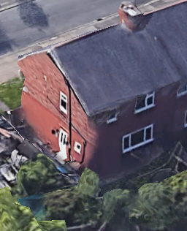
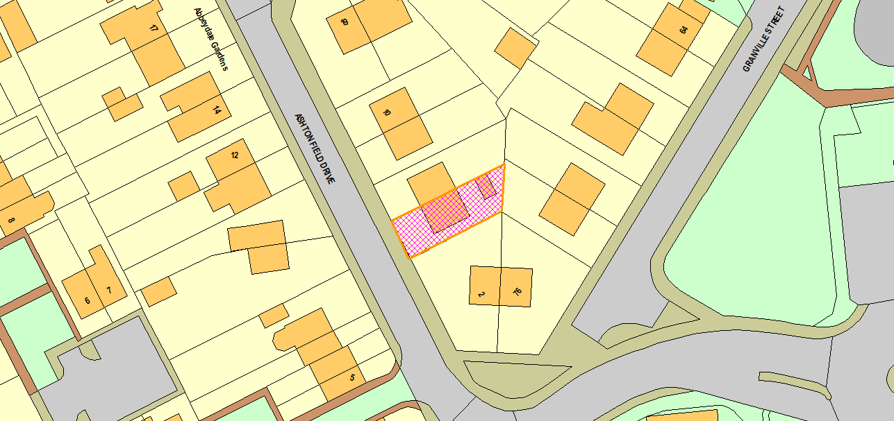
Figure 1 - Aerial (Rear)
Figure 2 - Location

Description of Proposal

- Single storey side and rear extension.
- Projects 1.7m to the side of the original dwelling and 3.6m to the rear.
- Set 3.9m back from the principal elevation of the dwelling and 1.3m from the common boundary at the rear.
- The area between the front elevation of the extension driveway is occupied by ramped access leading to access to the extension via a platform and front door.
- The development uses a pitched roof structure.

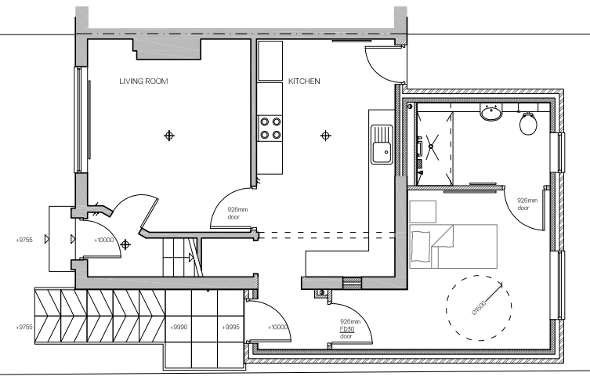
Figure 3 - Proposed GF Plan

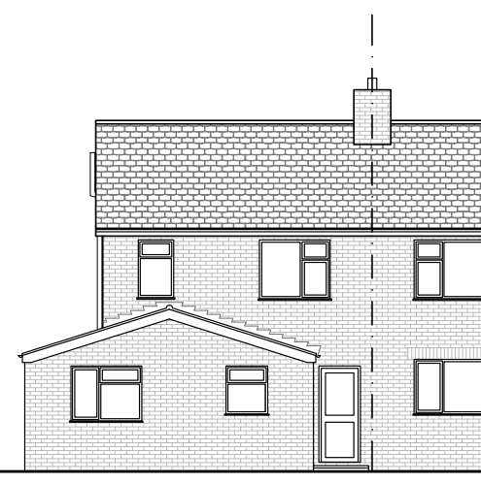
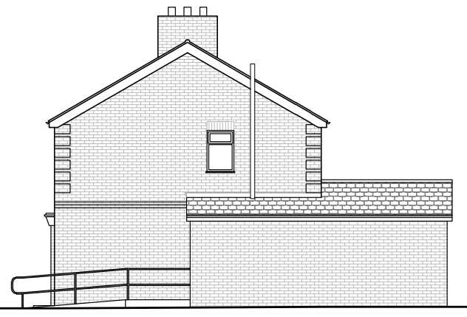
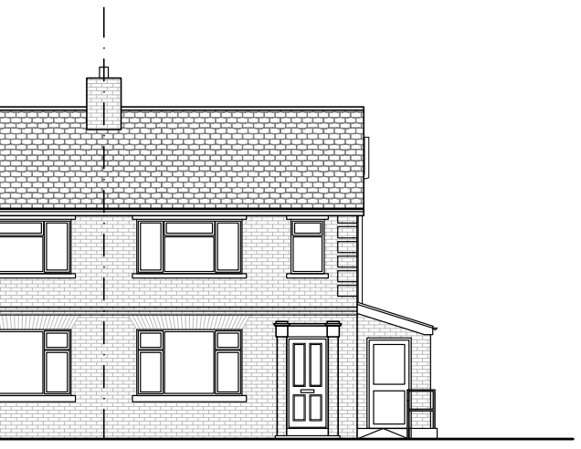
Figure 6 - Proposed Rear Elevation
Figure 4 - Proposed Side Elevation
Figure 5 - Proposed Front Elevation

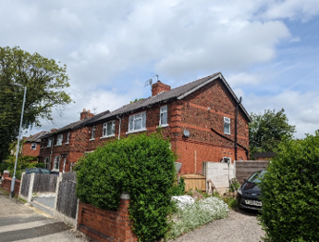
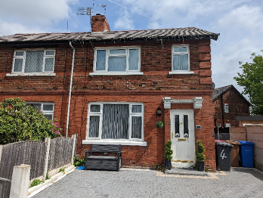
Picture 1 - Front / Side Elevation
Picture 2 - Front Elevation

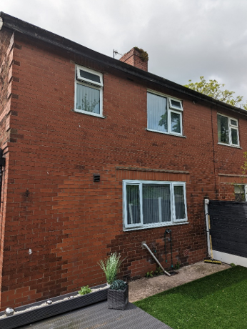
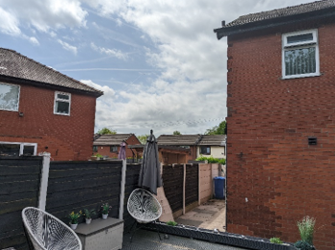
Picture 3 - Rear Elevation
Picture 4 - Rear Elevation / No. 2

Relevant Site History

No relevant site history.

Consultations

Not applicable.

Publicity
Earliest Decision Date: 4 October 2022
Revised Expiry Date: No extension agreed

Site Notice: n/a
Reason: n/a

Press Advert: n/a
Reason: n/a

Representations

None received.

Planning Policy

Development Plan Policy

Unitary Development Plan DES1 - Respecting Context
Unitary Development Plan DES7 - Amenity of Users and Neighbours
Unitary Development Plan DES8 - Alterations and Extensions

Other Material Planning Considerations

National Planning Policy Framework
National Planning Policy Guidance

Local Planning Policy

Supplementary Planning Document - House Extension

The National Planning Policy Framework (NPPF) paragraph 48 establishes that local planning authorities may give weight to relevant policies in emerging plans according to:
- The stage of preparation of the emerging plan (the more advanced its preparation, the greater the weight that may be given);
- The extent to which there are unresolved objections to relevant policies (the less significant the unresolved objections, the greater the weight that may be given); and
- The degree of consistency of the relevant policies in the emerging plan to the NPPF (the closer the policies in the emerging plan to the policies in the NPPF, the greater the weight that may be given).
There are currently two emerging plans to consider.
First, Places for Everyone Publication Plan, the joint Development Plan Document for nine districts in Greater Manchester, which was published for consultation under Regulation 19 of the Town and Country Planning (Local Planning) (England) Regulations 2012 on 9 August 2021. Representations were invited until 3 October 2021; the plan was submitted to the Secretary of State for examination on 14 February 2022 and examination hearings are due to commence in Summer 2022. The emerging policies which are relevant to this application are discussed where applicable in this report with appropriate weight being afforded in accordance with NPPF paragraph 48.

Second, the Publication Salford Local Plan: Development Management Policies and Designations (SLP:DMP), which was published on 27 January 2020 and comments were invited until 20 March 2020. An Addendum was published on 5 February 2021 and comments were invited on this until 19 March 2021. The Publication SMP:DMP and the Addendum were submitted to the Secretary of State for examination on 30 June 2021 and the examination hearings took place over 7 days in December 2021. The plan has been subject to a significant amount of public consultation in previous stages of its production and the city council has considered the comments made to determine the extent to which there are unresolved objections to its policies. Those policies (i.e. the Publication SLP:DMP policies as modified through the Addendum) which are relevant to this application are discussed where appropriate in this report with appropriate weight being afforded in accordance with NPPF paragraph 48. It is expected that the SLP:DMP will be adopted in Autumn 2022.

In addition, NPPF paragraph 219 establishes that existing policies (such as Salford’s UDP) are not out-of-date simply because they were adopted or made prior to the publication of NPPF. Due weight should be given to them, according to their degree of consistency with the NPPF, and the closer the policies in the UDP to the policies in the NPPF, the greater the weight that may be given. In terms of this application it is considered that the relevant policies of the UDP can be afforded due weight for the purposes of decision making as the relevant criteria within the UDP policies applicable to the proposed development are consistent with the policies contained in the NPPF.

Appraisal of the Proposed Development

Impact on the character of the area

- The development would be visible when travelling in both directions along Ashton Field Drive, however more visible when travelling north.
- Although the development would be visible the proposal is considerably set back from the principal elevation of the dwelling and at a height of a single storey and therefore would not be considered to have a detrimental impact on the street scene or surrounding area.
- The rear of the development would not be easily visible from the street scene or any other public vantage points to the rear of the site.
- The proposal makes use of matching materials in order to harmonise with the original dwelling and the brick built dwellings of the surrounding area.

Impact on the amenity of neighbours

- The development includes a habitable room window to the rear elevation which would be located 3.7m from the rear boundary line of the site and 19m from the rear elevation of the dwellings to the rear on a direct sight line, however these properties are angled roughly at 40 degrees in relation to the rear of the application site. Given the angle of the properties to the rear, the window would not be considered to provide an opportunity for overlooking of the properties to the rear and the boundary treatment along the rear of the site would provide suitable shielding to views of the garden area of the dwelling at no.74.
- The non-habitable room window to the rear of the development would be set outside of a 5m distance from the rear of the site and would not be considered to overlook the neighbouring outdoor amenity area to the rear of the site due to the boundary treatment to the rear of the site acting as a shield to views.
- The north facing elevation of the development facing the common boundary would be set 1.3m from the common boundary and there at a projection of 3.6m, avoid intersecting the 45 degree line from 3m along the common boundary starting at the rear elevation of the neighbouring dwelling.
- The proposed development projects to and extends along the south side boundary of the application site. The side elevation would face the rear of the neighbouring dwelling at no. 2. The ground floor window of the neighbouring dwelling is non-habitable in the form of a kitchen space which would not be afforded statutory protection regarding the impact of the development on amenity through this window.
- The first floor habitable room window of the neighbouring dwelling would partially face the corner of the proposed development at a distance of 9.8m which would be outside of the interface distance of 9m referenced in policy HE4. Although the development has a closer relationship with the neighbouring dwelling further to the west due to the angle of the site boundary, this section would not be considered to impact on the habitable room window due to its location further to the east of the rear elevation of the neighbouring dwelling.

For the reasons above the development is considered to comply with UDP policies as well as policies HE1, HE2, HE4 and HE5 of the Salford House Extensions SPD.

Other issues

Does the proposal require any work to trees? No

Is there a significant change in levels across the site or between the site and the neighbouring land? No

Has the applicant/agent indicated any personal circumstances? Yes

Approve

1. The development must be begun not later than three years beginning with the date of this permission.

Reason: Required to be imposed by Section 91 of the Town and Country Planning Act 1990 (as amended).

2. The development hereby permitted shall be carried out in accordance with the following approved plans:

- Location Plan (SAL.2022.04.OS)
- Site Plan as Existing (SAL.2022.04.P1)
- Ground Floor Plan as Existing (SAL.2022.04.P2)
- Elevations as Existing (SAL.2022.04.P3)
- Site Plan as Proposed (SAL.2022.04.P4)
- Ground Floor Plan as Proposed (SAL.2022.04.P5)
- Elevations as Proposed (SAL.2022.04.P6)

Reason: For the avoidance of doubt and in the interest of proper planning.

3. The external materials used shall match those of the existing building so far as practicable.

Reason: In order to ensure a satisfactory appearance in the interests of visual amenity in accordance with Policies DES1 and DES8 of the City of Salford Unitary Development Plan and the requirements of the National Planning Policy Framework.

Statement of conformity with Article 35 of The Town and Country Planning (Development Management Procedure) (England) Order 2015

The proposal complies with the development plan and would improve the economic, social and environmental conditions of the area. It therefore comprises sustainable development and the Local Planning Authority worked proactively and positively to issue the decision without delay. The Local Planning Authority has therefore implemented the requirement in Paragraph 38 of the NPPF.

Notes to Applicant

1. INFORMATIVE NOTE

The proposed development lies within an area that has been defined by the Coal Authority as containing potential hazards arising from former coal mining activity at the surface or shallow depth. These hazards can include: mine entries (shafts and adits); shallow coal workings; geological features (fissures and break lines); mine gas and former surface mining sites. Although such hazards are seldom readily visible, they can often be present and problems can occur in the future, particularly as a result of new development taking place.

It is recommended that information outlining how former mining activities may affect the proposed development, along with any mitigation measures required (for example the need for gas protection measures within the foundations), is submitted alongside any subsequent application for Building Regulations approval (if relevant).

Any form of development over or within the influencing distance of a mine entry can be dangerous and raises significant land stability and public safety risks. As a general precautionary principle, the Coal Authority considers that the building over or within the influencing distance of a mine entry should be avoided. In exceptional circumstance where this is unavoidable, expert advice must be sought to ensure that a suitable engineering design which takes into account all the relevant safety and environmental risk factors, including mine gas and mine-water. Your attention is drawn to the Coal Authority Policy in relation to new development and mine entries available at:
www.gov.uk/government/publications/building-on-or-within-the-influencing-distance-of-mine-entries

Any intrusive activities which disturb or enter any coal seams, coal mine workings or coal mine entries (shafts and adits) requires a Coal Authority Permit. Such activities could include site investigation boreholes, excavations for foundations, piling activities, other ground works and any subsequent treatment of coal mine workings and coal mine entries for ground stability purposes. Failure to obtain a Coal Authority Permit for such activities is trespass, with the potential for court action.

If any coal mining features are unexpectedly encountered during development, this should be reported immediately to the Coal Authority on 0345 762 6848. Further information is available on the Coal Authority website at:
www.gov.uk/government/organisations/the-coal-authority

Informative Note valid from 1st January 2021 until 31st December 2022

Officer | Jonathan Mumby | DC |  | LPA | M Hodgson
Date | 05/10/22 | Date |  | Date | 07.10.22

