HOUSE EXTENSION REPORT

REF: 22/80424/HH

Address: 57 Cypress Road, Eccles, Salford, M30 8JX

Proposal: Part two storey, part single storey side and rear extension to existing dwelling.

Appropriate consultation undertaken Yes
Earliest Decision date: 28 September 2022
Reason for delay beyond stat deadline and EoT: n/a

Description of Site and Surrounding Area

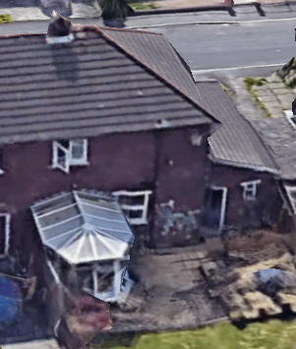
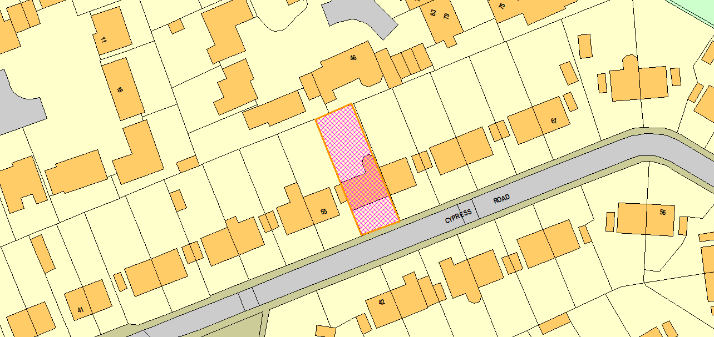
The application dwelling is a semi-detached property located in a residential area. The dwelling is set back from the street by an area of hard standing. The existing dwelling has an attached single storey side garage and a rear conservatory along the common boundary. To the rear of the is a 1 – 1 ½ storey dwelling.
Figure 1 - Aerial (Rear)
Figure 2 - Location

Description of Proposal

- Part two storey, part single storey wrap around extension.
- Projection to the side of 2.9m with first floor set back by 2.1m.
- Two storey extending past rear elevation by 2.9m and set in from common boundary by 3.6m.
- Gap between two storey section and common boundary filled in by single storey extension with same projection from rear elevation.
- Front canopy over garage and front entrance.

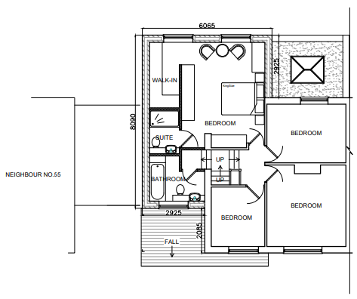
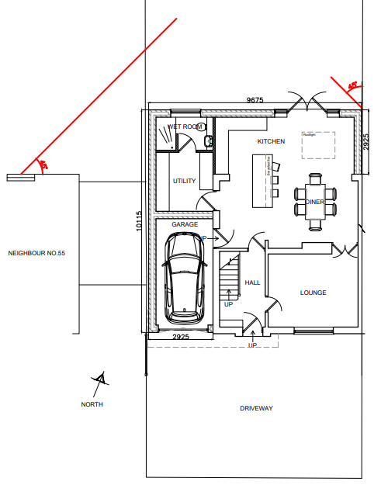

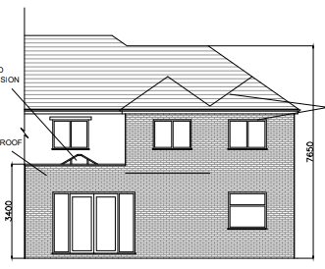
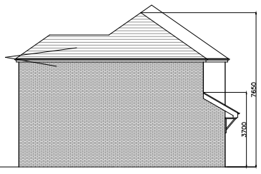
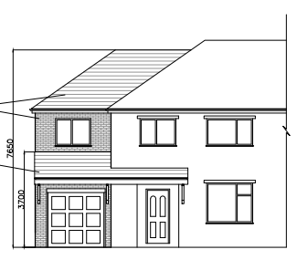
Figure 3 - Proposed Rear Elevation
Figure 4 - Proposed Side Elevation
Figure 5 - Front Elevation
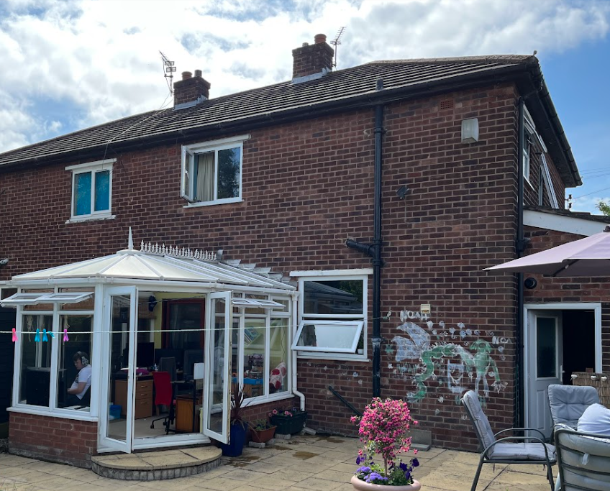
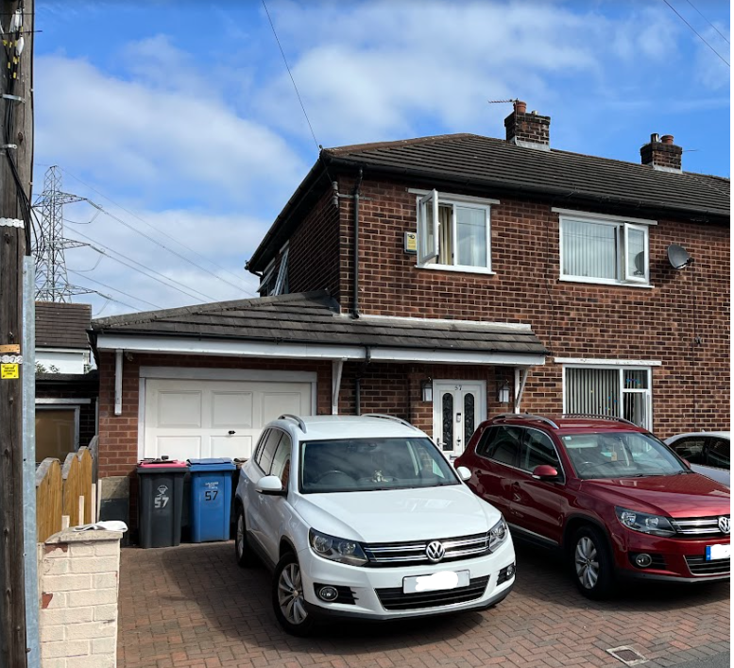
Picture 2 - Rear Elevation
Picture 1 - Front Elevation

Relevant Site History

03/47290/HH - Demolition of existing brick outhouse and erection of attached garage and front canopy - PER

Consultations

Not applicable.

Publicity
Earliest Decision Date: 28 September 2022
Revised Expiry Date: No extension agreed

Site Notice: n/a
Reason: n/a

Press Advert: n/a
Reason: n/a

Representations

7 neighbours consulted on the application, 1 representations made.

 | C – comment received R – officer response
C | - Impact of development on privacy of outdoor area of dwelling to rear.  - Request of obscure glazing to first floor rear facing windows.

Planning Policy

Development Plan Policy

Unitary Development Plan DES1 - Respecting Context
Unitary Development Plan DES7 - Amenity of Users and Neighbours
Unitary Development Plan DES8 - Alterations and Extensions

Other Material Planning Considerations

National Planning Policy Framework
National Planning Policy Guidance

Local Planning Policy

Supplementary Planning Document - House Extension

The National Planning Policy Framework (NPPF) paragraph 48 establishes that local planning authorities may give weight to relevant policies in emerging plans according to:
- The stage of preparation of the emerging plan (the more advanced its preparation, the greater the weight that may be given);
- The extent to which there are unresolved objections to relevant policies (the less significant the unresolved objections, the greater the weight that may be given); and
- The degree of consistency of the relevant policies in the emerging plan to the NPPF (the closer the policies in the emerging plan to the policies in the NPPF, the greater the weight that may be given).
There are currently two emerging plans to consider.
First, Places for Everyone Publication Plan, the joint Development Plan Document for nine districts in Greater Manchester, which was published for consultation under Regulation 19 of the Town and Country Planning (Local Planning) (England) Regulations 2012 on 9 August 2021. Representations were invited until 3 October 2021; the plan was submitted to the Secretary of State for examination on 14 February 2022 and examination hearings are due to commence in Summer 2022. The emerging policies which are relevant to this application are discussed where applicable in this report with appropriate weight being afforded in accordance with NPPF paragraph 48.

Second, the Publication Salford Local Plan: Development Management Policies and Designations (SLP:DMP), which was published on 27 January 2020 and comments were invited until 20 March 2020. An Addendum was published on 5 February 2021 and comments were invited on this until 19 March 2021. The Publication SMP:DMP and the Addendum were submitted to the Secretary of State for examination on 30 June 2021 and the examination hearings took place over 7 days in December 2021. The plan has been subject to a significant amount of public consultation in previous stages of its production and the city council has considered the comments made to determine the extent to which there are unresolved objections to its policies. Those policies (i.e. the Publication SLP:DMP policies as modified through the Addendum) which are relevant to this application are discussed where appropriate in this report with appropriate weight being afforded in accordance with NPPF paragraph 48. It is expected that the SLP:DMP will be adopted in Autumn 2022.

In addition, NPPF paragraph 219 establishes that existing policies (such as Salford’s UDP) are not out-of-date simply because they were adopted or made prior to the publication of NPPF. Due weight should be given to them, according to their degree of consistency with the NPPF, and the closer the policies in the UDP to the policies in the NPPF, the greater the weight that may be given. In terms of this application it is considered that the relevant policies of the UDP can be afforded due weight for the purposes of decision making as the relevant criteria within the UDP policies applicable to the proposed development are consistent with the policies contained in the NPPF.

Appraisal of the Proposed Development

Impact on the character of the area

- The development would be visible when travelling in both directions along Cypress Road, however the visible side extension would appear visually subservient through a set back at first floor level and a lowered ridge height in comparison to the original dwelling and therefore not be considered to have a detrimental impact on the street scene.
- The remainder of the development would not be visible from the street scene or easily from public vantage points to the rear of the site and therefore not have a detrimental impact on the wider character of the area.
- The set back of 2m at first floor level prevents a terracing impact in the street scene and complies with policy HE8.
- The proposal makes use of matching materials to aid harmonisation with the existing dwelling and its construction.

Impact on the amenity of neighbours

- The proposal includes 2no. first floor rear facing habitable room windows which face the dwelling to the rear which has no first floor rear facing windows but a rear facing window at ground floor level. The interface distance between the windows of the development and window to the rear of the ground floor would be inside of 21m at 18.1m. This interface distance would fall short of that referenced in policy HE1, however given that a 15.5m gap would remain between the development and the rear of the site and there would be adequate shielding to the rear of the site at a distance of 3m from the neighbouring window, it is considered that the existing boundary treatment would prevent significant overlooking from the windows of the development to the rear of the neighbouring property and outdoor amenity area.
- The ground floor would also include rear facing habitable room patio doors which would be located the same distance from the rear of the boundary and for the same reasons not have any impact on the privacy of the occupants to the rear of the site.
- There is a rear facing first floor window of the dwelling to the north west of the site (no. 44), however this would not be considered to be in direct sight line of the development due to the orientation / relationship between the two properties, therefore although the interface distance is less than 21m, it would not have a detrimental impact on the occupants of the neighbouring dwelling. This is shown below:
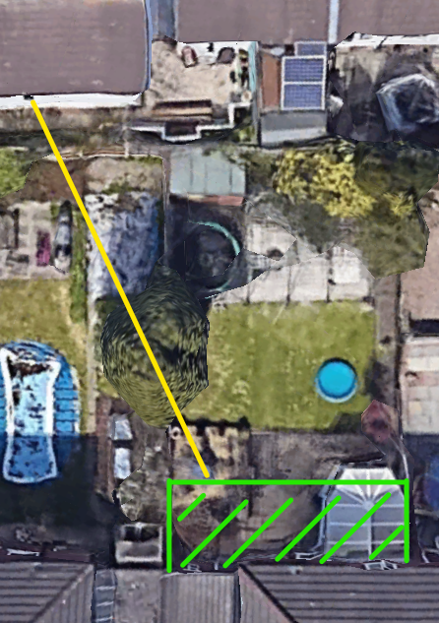
Figure 6 - Sight line from most west rear facing first floor habitable window of proposal

- None of the windows of the development would be considered to directly overlook any neighbouring outdoor amenity spaces laterally.
- The projection of the single storey rear extension is 2.9m which avoid intersecting the 45 degree line from 3m along the common boundary from the rear building line of the adjoining dwelling.
- In the absence of a rear extension to the adjoining dwelling the two storey projection to the rear is less than the gap between the east facing elevation of the extension and the common boundary and therefore complies with policy HE7.
- The development projects closer to the common boundary with the neighbouring dwelling at no. 55. As the two first floor windows to the side of the neighbouring dwelling are non-habitable the proposal is considered to have no detrimental impact on the amenity of the occupants when using rooms associated with these windows.
- The projection of the two storey extension past the existing rear building line would avoid intersecting the 45 degree line from the nearest habitable room windows of the neighbouring dwelling at no. 55. The development would not be considered to block a considerable amount of the daylight or sunlight to the rear garden and would avoid its projection would avoid creating an overbearing appearance when stood in the neighbouring garden.
For the reasons above the development is considered to comply with UDP policies as well as policies HE1, HE2, HE4, HE5, HE7 and HE8 of the Salford House Extensions SPD.

Other issues

Does the proposal require any work to trees? No

Is there a significant change in levels across the site or between the site and the neighbouring land? No

Has the applicant/agent indicated any personal circumstances? No

Approve

1. The development must be begun not later than three years beginning with the date of this permission.

Reason: Required to be imposed by Section 91 of the Town and Country Planning Act 1990 (as amended).

2. The development hereby permitted shall be carried out in accordance with the following approved plans:

- Site Location Plan (SP)
- Block Plan (BP)
- Existing Layouts & Elevations (01)
- Proposed Layouts & Elevations (02)

Reason: For the avoidance of doubt and in the interest of proper planning.

3. The external materials used shall match those of the existing building so far as practicable.

Reason: In order to ensure a satisfactory appearance in the interests of visual amenity in accordance with Policies DES1 and DES8 of the City of Salford Unitary Development Plan and the requirements of the National Planning Policy Framework.

Statement of conformity with Article 35 of The Town and Country Planning (Development Management Procedure) (England) Order 2015

The Local Planning Authority worked positively and proactively with the applicant to identify various solutions during the application process to ensure that the proposal comprised sustainable development and would improve the economic, social and environmental conditions of the area and would accord with the development plan. These were incorporated into the scheme and/or have been secured by planning condition. The Local Planning Authority has therefore implemented the requirement in Paragraph 38 of the NPPF.

Notes to Applicant

1. STANDING ADVICE - DEVELOPMENT LOW RISK AREA

The proposed development lies within a coal mining area which may contain unrecorded coal mining related hazards. If any coal mining feature is encountered during development, this should be reported immediately to the Coal Authority on 0345 762 6848.

Further information is also available on the Coal Authority website at:
www.gov.uk/government/organisations/the-coal-authority

Standing Advice valid from 1st January 2021 until 31st December 2022

Officer | Jonathan Mumby | DC |  | LPA | AS
Date | 05/10/22 | Date |  | Date | 7.10.22

