HOUSE EXTENSION REPORT

REF: 21/77054/HH

Address: 6 New Hall Road, Salford, M7 4EL

Proposal: Retention of part two storey/ part single storey side extension and single storey rear extension

Appropriate consultation undertaken Yes
Earliest Decision date: 12 April 2022
Reason for delay beyond stat deadline and EoT: 8 August 2022

Description of Site and Surrounding Area

- This application relates to a two-storey detached dwelling located on the eastern side of New Hall Road.
- The surrounding area is predominantly residential, with a mixture of detached and semi-detached dwellings that have been extended/altered in the forms of side and/or rear extensions.
- An unauthorised part single, part two-storey side and rear extension has been erected at the property and is currently the subject of enforcement investigation ref: 20/00254/WPP2.
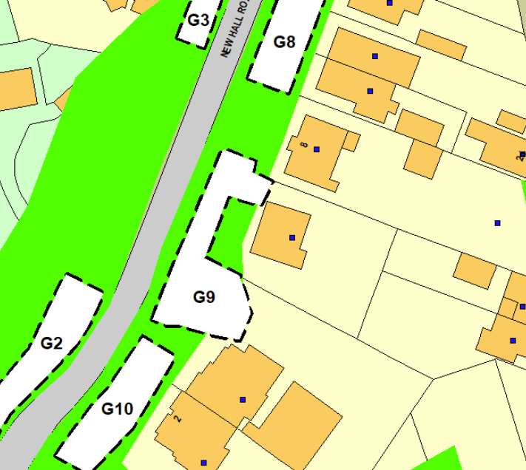
Figure 1 – the subject site under consideration

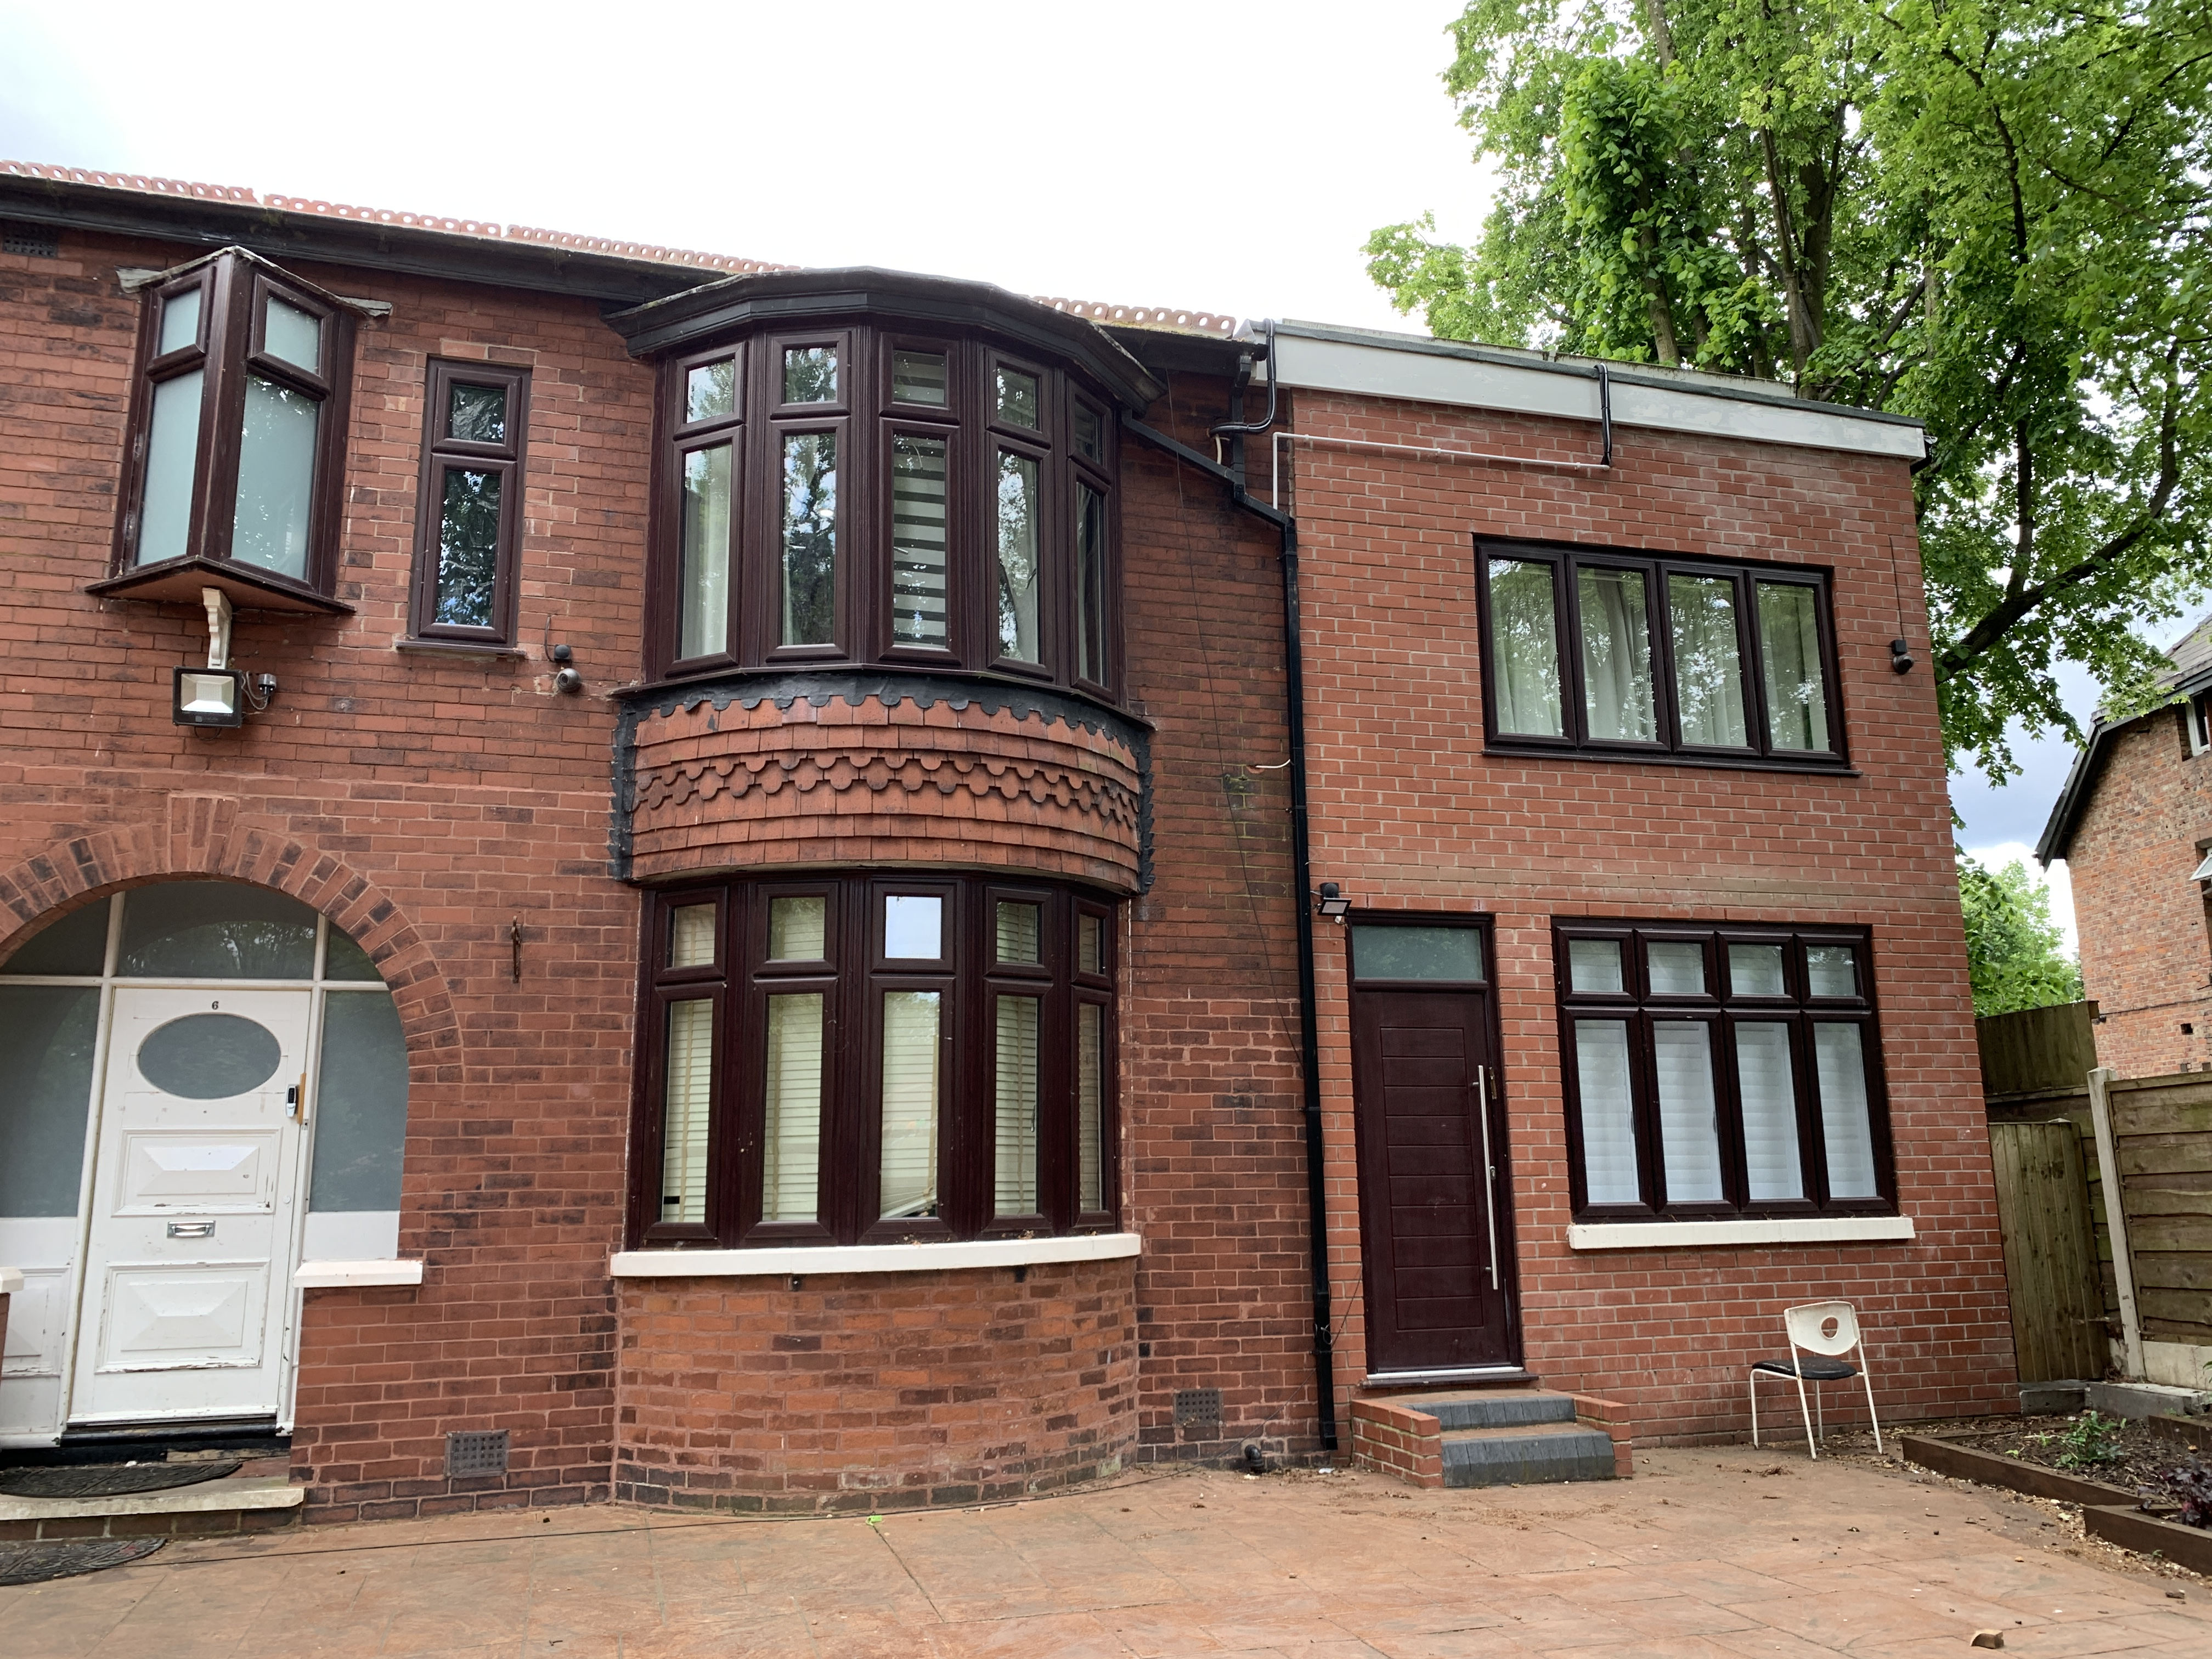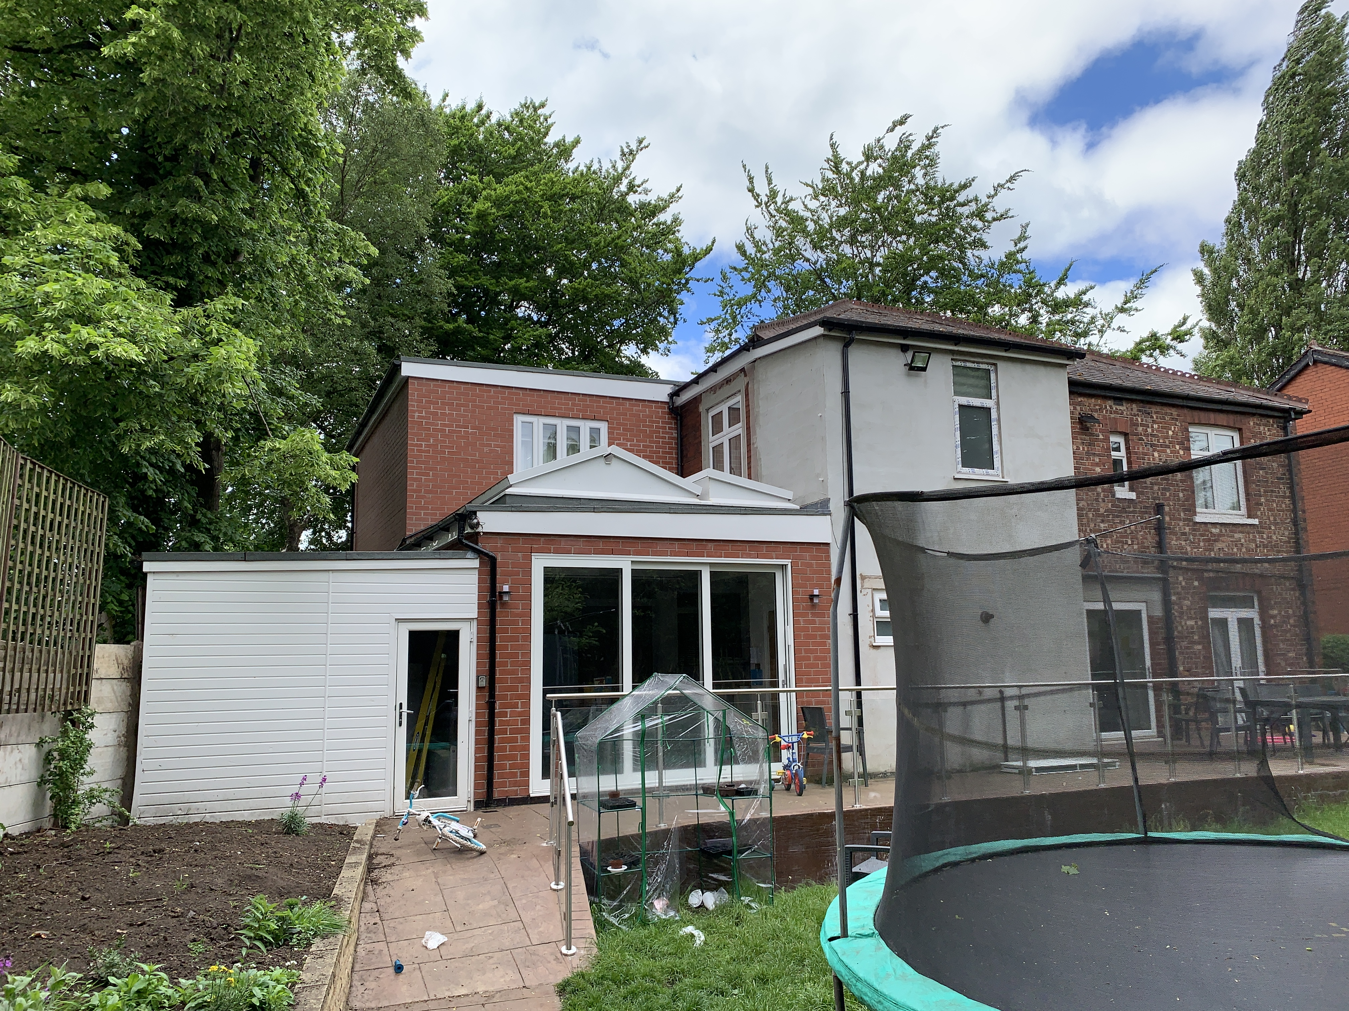
Figure 2 – the subject dwelling with the existing side extension Figure 3 – the rear elevation of the subject dwelling

Description of Proposal

This is a retrospective application for the retention of the existing flat-roofed part single storey / part two-storey side and rear extension (shown in the images above and Figure 5 and 6 below).

Part two/part single storey side extension:
- Projects 4.4m from the south side elevation.
- Ground floor element: at full length of the original dwelling. Inserted with front and side windows and bi-fold patio doors to the rear. Part of this element has a sukkah rooflight. A store has been added to the side.
- First floor element: 6.8m in length, with windows to the front and rear. It has a flat roof with a sukkah rooflight.
Plans and drawings are shown below, with the proposal highlighted in red:

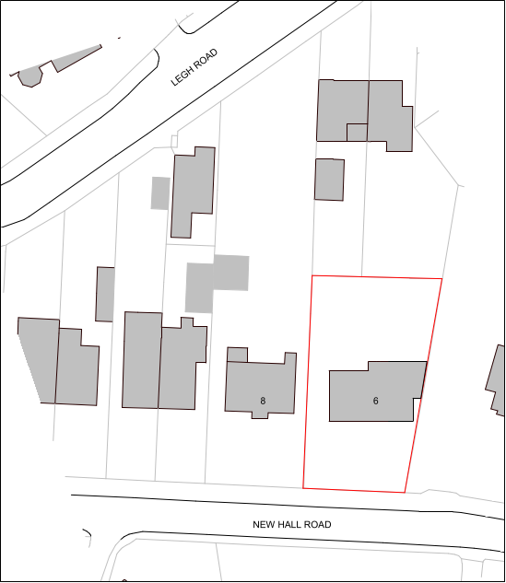
Figure 4 – the proposed site plan

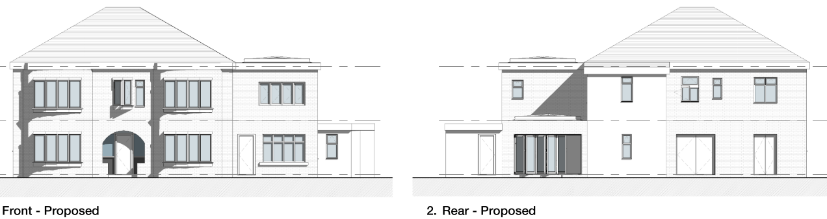

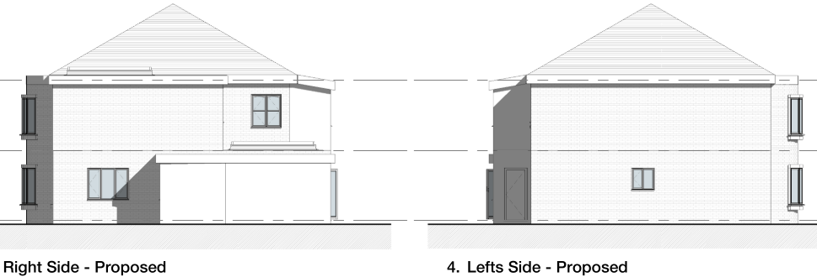
Figure 5 – the proposed elevations

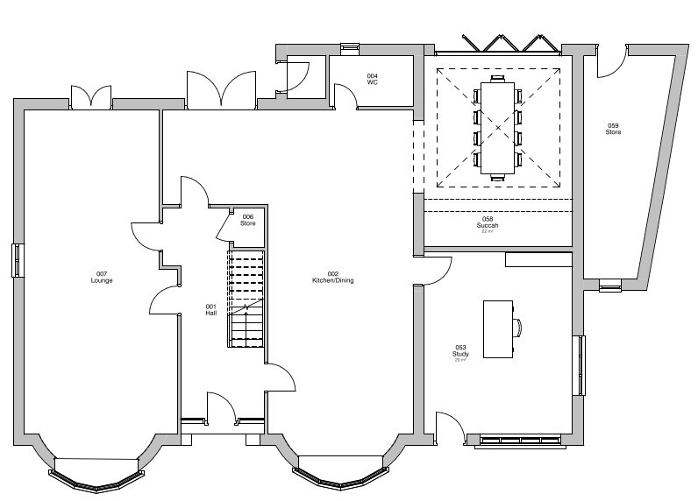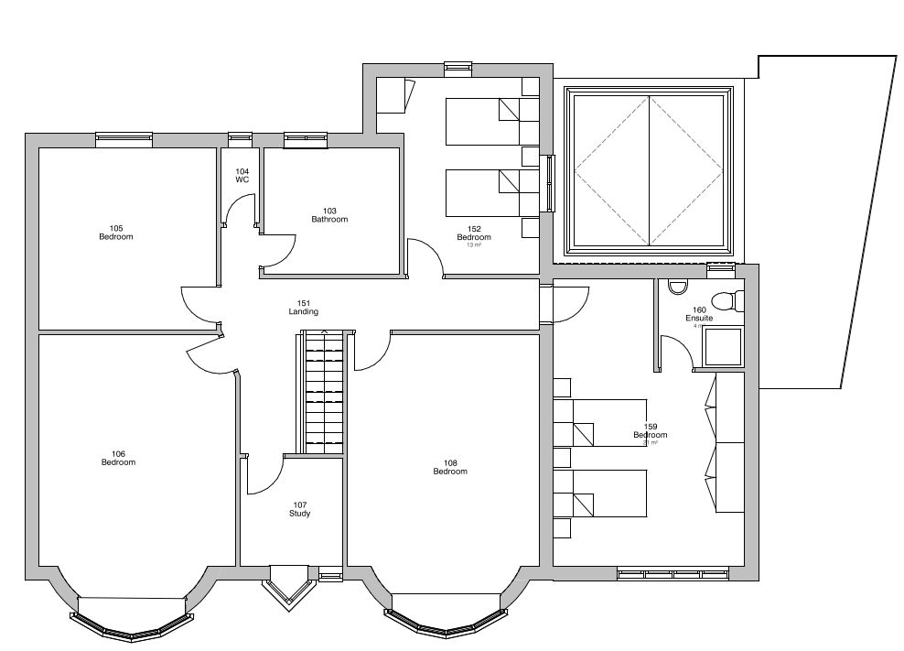
Figure 6 – the proposed ground (left) and first (right) floor plans

Relevant Site History

Enforcement Case Ref: 20/00254/WPP2 - Received: 17.09.2020

02/44439/TPO - 1/3 crown thin one beech (T3), crown lift to 18ft over highway and 1/3 crown thin one beech (T6), Crown lift to 18ft over highway, 1/3 crown thin and prune away from lampost one lime (T5) – Approved (19.08.2002)

Consultations

Arborist: no objection subject to condition. See ‘Impact on Trees’ section of this report.

Publicity
Earliest Decision Date: 12 April 2022
Revised Expiry Date: 18 July 2022

Site Notice: N/A
Reason:

Press Advert: N/A
Reason:

Representations

None received.

Planning Policy

Development Plan Policy

Currently adopted plan (City of Salford Unitary Development Plan) -
Unitary Development Plan DES1 - Respecting Context
Unitary Development Plan DES7 - Amenity of Users and Neighbours
Unitary Development Plan DES8 - Alterations and Extensions

Emerging plan (SLP:DMP) -
Policy D1 - Design principles
Policy D2 - Local character and distinctiveness
Policy D5 - Amenity
Policy D8 - Alterations and extensions

Other Material Planning Considerations

National Planning Policy Framework
National Planning Policy Guidance

Local Planning Policy

Supplementary Planning Document - House Extension

The National Planning Policy Framework (NPPF) paragraph 48 establishes that local planning authorities may give weight to relevant policies in emerging plans according to:
- The stage of preparation of the emerging plan (the more advanced its preparation, the greater the weight that may be given);
- The extent to which there are unresolved objections to relevant policies (the less significant the unresolved objections, the greater the weight that may be given); and
- The degree of consistency of the relevant policies in the emerging plan to the NPPF (the closer the policies in the emerging plan to the policies in the NPPF, the greater the weight that may be given).
There are currently two emerging plans to consider.
First, Places for Everyone Publication Plan, the joint Development Plan Document for nine districts in Greater Manchester, which was published for consultation under Regulation 19 of the Town and Country Planning (Local Planning) (England) Regulations 2012 on 9 August 2021. Representations were invited until 3 October 2021; the plan was submitted to the Secretary of State for examination on 14 February 2022 and examination hearings are due to commence in Summer 2022. The emerging policies which are relevant to this application are discussed where applicable in this report with appropriate weight being afforded in accordance with NPPF paragraph 48.

Second, the Publication Salford Local Plan: Development Management Policies and Designations (SLP:DMP), which was published on 27 January 2020 and comments were invited until 20 March 2020. An Addendum was published on 5 February 2021 and comments were invited on this until 19 March 2021. The Publication SMP:DMP and the Addendum were submitted to the Secretary of State for examination on 30 June 2021 and the examination hearings took place over 7 days in December 2021. The plan has been subject to a significant amount of public consultation in previous stages of its production and the city council has considered the comments made to determine the extent to which there are unresolved objections to its policies. Those policies (i.e. the Publication SLP:DMP policies as modified through the Addendum) which are relevant to this application are discussed where appropriate in this report with appropriate weight being afforded in accordance with NPPF paragraph 48. It is expected that the SLP:DMP will be adopted in Autumn 2022.

In addition, NPPF paragraph 219 establishes that existing policies (such as Salford’s UDP) are not out-of-date simply because they were adopted or made prior to the publication of NPPF. Due weight should be given to them, according to their degree of consistency with the NPPF, and the closer the policies in the UDP to the policies in the NPPF, the greater the weight that may be given. In terms of this application it is considered that the relevant policies of the UDP can be afforded due weight for the purposes of decision making as the relevant criteria within the UDP policies applicable to the proposed development are consistent with the policies contained in the NPPF.

Appraisal of the Proposed Development

Impact on the character of the area

- The development is positioned to the side and rear of the subject dwelling. It would be visible from the street scene.
- The two-storey side extension does not create a terracing effect to the property despite it extending close to the southern side boundary of the site. Houses in the area generally retain a good amount of space around them, however in this instance it is considered that the close proximity of the extension to the boundary would not unduly harm the spacious character of the area as the adjacent synagogue is set well away from No. 6 in its own large plot. Notwithstanding this, the flat roof design, together with the slight projection forward of the front elevation, and the mismatch of brickwork used to the extension, has means that the structure reads as an incongruous and ill-considered addition to the house that bears little resemblance to the form and alignment of the original building. The windows to the extension do not respect the proportions and details of the original house: the first-floor front window in the extension has a stretched frame that it does not line through horizontally with the existing bay windows of the parent dwelling, or even vertically with the ground-floor window below. It is noted that the relationship between the first-floor front-facing window in the extension and the first-floor bay window, is differs in reality to that shown on the submitted plans (i.e. the bay extends to the underside of the eaves) – see Figure 7 below.

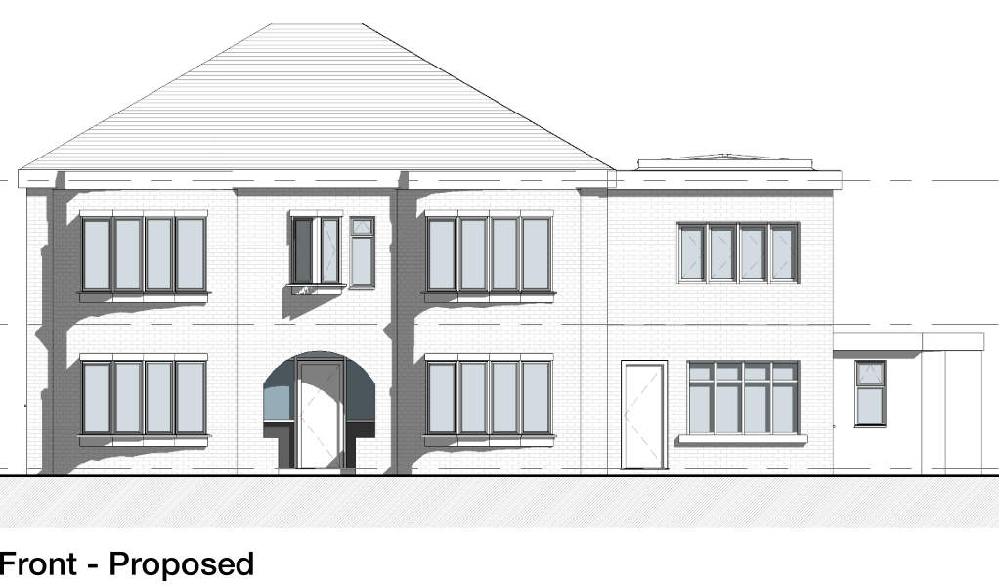
Figure 7 – comparison of the front windows as built on site and that shown on the submitted drawings

- In addition to the above, the introduction of a new front door is considered inappropriate in that it competes with the front main entrance to the house. It is also noted that the barge boards of the extension are of different thickness, colour and material to those used on the original house. Taken altogether, the two storey side extension is of a poor design that does not relate to the parent dwelling positively. It results in the creation of an incongruous addition to the side of the property that is at odds with the character of the subject property and the streetscene.
- The single storey element is finished in white cladding; whilst this does not match with the material palette used to construct the existing house, it is not readily seen from the street scene due to it being tucked in and screened by the trees to the front.
- Given the above discussion, overall the development results in significant harm to the character of the dwelling and its surrounding area, contrary to policies DES1 and DES8 of the currently adopted UDP, and policy D1, D2 and D8 of the SLP:DMP which can now be afforded some weight in the determination of planning applications.

Impact on the amenity of neighbours

- The front windows at both the ground and first floor levels do not protrude further than the existing curved front bay windows of the house.
- The ground floor side window serving the study room is screened out by the fence along the southern boundary.
- The ground floor rear patio doors look onto the rear garden. The boundary fence would block out views.
- The first-floor rear window is set well back from its existing counterparts. Overall, the winodows of the extensions in subject are not considered to generate overlooking to the neighbouring occupiers.
- The extensions bring the subject dwelling closer to the adjacent property no. 6. Nonetheless, it is established that there are no habitable room windows in no. 6 that face onto the extensions (20/75985/FUL) and that no. 6 maintains a separation distance of over 10m at its nearest from the subject dwelling. Therefore, it is not considered to be affected by the development in terms of dominance and/or loss of light.
- The other neighbour no. 8 is also not considered to be adversely impacted by the development as the extension does not result in the subject dwelling coming any closer to no. 8.
- Overall, Policy DES 7 of the adopted UDP has been satisfied.

Impact on Trees

- As assessed by the Council’s arborist, The Lime tree (T1) to the side of the extension has been significantly affected by the development, both from the unsympathetic crown pruning and the major root damage. It is likely to have a significantly shortened life expectancy and therefore, if the development were to be approved, it would need to be replaced in accordance with a condition that secures a tree replacement scheme.

Other issues

Does the proposal require any work to trees? Yes – see section above.

Is there a significant change in levels across the site or between the site and the neighbouring land? No.

Has the applicant/agent indicated any personal circumstances? No.

Recommendation

Refuse for the following reason(s):

- The two storey side extension, by reason of its siting, form and design, does not respect the design, proportions, character, detailing and appearance of the existing dwelling and therefore results in an incongruous form of development that is at odds with the existing house and has an unacceptable detrimental impact on the streetscene, contrary to policies DES1 and DES8 of the Salford UDP and the National Planning Policy Framework.

Statement of conformity with Article 35 of The Town and Country Planning (Development Management Procedure) (England) Order 2015

The proposal would not improve the economic, social and environmental conditions of the area nor does it comply with the development plan and therefore does not comprise sustainable development. There were no amendments to the scheme, or conditions which could reasonably have been imposed, which could have made the development acceptable and it was therefore not possible to approve the application. The Local Planning Authority has therefore implemented the requirement in Paragraph 38 of the NPPF.

Notes to Applicant

Officer | Mandy Pang | DC |  | LPA | James Ketley
Date | 09.08.2022 | Date |  | Date | 18.10.2022

