DELEGATED DECISION RECORD REF: 22/80271/LBC

Address: RHS Garden Bridgewater , Leigh Road, Worsley, Salford, M28 2LJ
Proposal: Listed building consent application for works to existing Garden Cottage to refurbish and convert first floor and part of ground floor to form office and associated accommodation, mechanical and electrical system upgrade/installations, fire protection works, subdivision of existing garage to form shower room and corridor, subdivision of existing first floor bathroom to form WC and cleaners cupboard, Isolated deteriorated window replacements, External elevation works including new/extended drainage pipework and installation of new extract fan grilles.

Reason for delay beyond stat deadline and EoT:

Have all pre-commencement conditions been agreed with the applicant? Yes / No

Description of Site and Surrounding Area

This application relates to the Gardener’s Cottage, which is a Grade II listed building that sits within the wider RHS Bridgewater Site. The ground floor of the Gardener’s Cottage is currently being used as an office and storage of equipment for the gardeners. However, the property was previously used for residential purposes, and planning permission has been granted for its change of use to a use ancillary to the operation of RHS Garden Bridgewater including, but not limited to, retail, catering, amenity, education, library, gallery, exhibition, events, and staff offices (Ref: 19/74033/COU).

The listing for Gardeners Cottage describes the building as “House, originally for Worsley Hall head gardener. 1834. Rock-faced stone with slate roof and brick additions. L- shaped 2-storey plan with an octagonal tower at the external angle. Gothic style. Quoins. A picturesque elevation with 3 bays as well as the octagonal tower which has a conical swept roof. Bay 1 is gabled and has a finial, copings and kneelers. The gabled porch projects in bay 2 but the Tudor- arched doorway with hoodmould has been made into a window. Various 1 and 2-light windows with chamfered stone mullions (one of which has been removed) many with hoodmoulds. The tower rises to a third storey and has quoins and bracketed eaves. Cross-shaped diagonally-set ashlar chimney stacks. Brick addition to right. Similar but less elaborate rear.”

There are three other Grade II Listed buildings/structures within the wider site – The Bothy, Worsley Hall Ice House and the entrance gates to the former Worsley New Hall. The Worsley Park site is also included in the City Council’s Local List of Heritage Assets due to its architectural, historical and local interest, its aesthetic and social/communal value and the collective value of the landscape (group value).

Description of Proposal

The application concerns listed building consent application for works to refurbish and convert the first floor and part of ground floor to form office and associated accommodation (note Image 1). In addition, the works would include mechanical and electrical system upgrade/installations, fire protection works, subdivision of existing garage to form shower room and corridor, subdivision of existing first floor bathroom to form WC and cleaner’s cupboard, isolated deteriorated window replacements, external elevation works including new/extended drainage pipework and installation of new extract fan grilles.

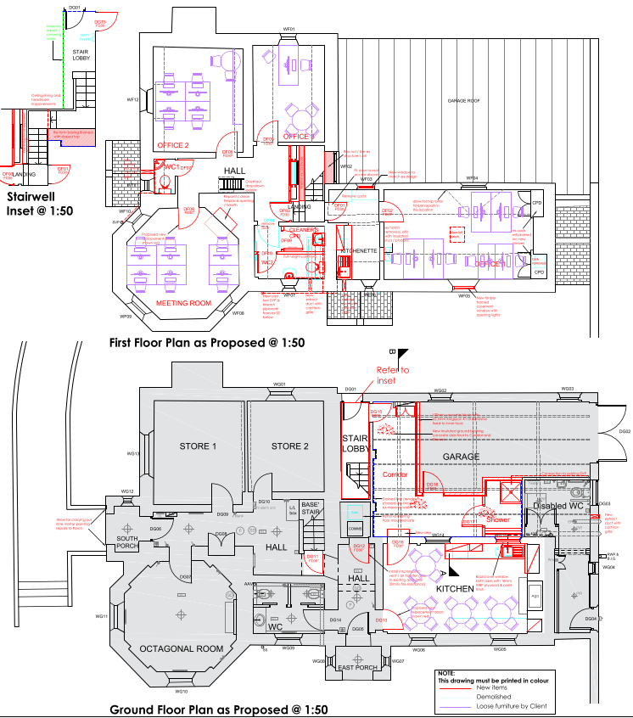
Image 1: Proposed Works

Publicity

Earliest Decision Date: 30 September 2022
Revised Expiry Date: 21 October 2022

Site Notice: All Listed Building Consent Date Displayed: 8 September 2022
Reason: Listed Building Consent

Press Advert: Manchester Weekly News Salford Edition Date Published: 1 September 2022
Reason: Listed Building Consent

Relevant Site History

22/80478/FUL
Erection of a Chinese-style pavilion, footpath, landscaping, and steppingstone crossing. Pending Consideration.

22/79540/NMA
Application for a non-material amendment following the grant of planning permission 16/69281/HYB to amend the proposed floor, elevation, roof, and section plans relating to the stable block and cited in condition 2. Permitted 21.04.2022

21/78269/LBC
Listed Building consent for the repairs to RHS Garden Bridgewater, Bothy Chimney. Removal of vegetation, take down and rebuild top 1.5m to secure loose stonework, re-pointing and replacement of existing lightening protection with new. Permitted 06.10.2021

20/75187/FUL
Construction of external access ramp and steps. Permitted 01.12.2020

20/74882/LBC
Listed Building consent for the Internal works and formation of external access ramp and steps. Permitted 01.12.2020

19/74033/COU
Change of use of Gardeners Cottage to a use ancillary to the operation of RHS Garden Bridgewater including but not limited to retail, catering, amenity, education, library, gallery, exhibition, events, staff offices. Permitted 11/10/2019

18/71635/LBC
Listed Building Consent for the change of use of the Bothy building on the new RHS Bridgewater site, relating to approved planning application number 16/69281/HYB. Conversion of the current vacant residential building to office (B1) and ancillary support for RHS Horticultural staff creation of office, mess, changing and locker space, drying room and alterations to toilet layouts with no alterations to internal wall layouts or external façade. Permitted June 2018

18/71652/FUL
Change of use of the Bothy building on the new RHS Bridgewater site, relating to approved planning application number 16/69281/HYB. Conversion of the current vacant residential building to office (B1) and ancillary support for RHS Horticultural staff Creation of office, mess, changing and locker space, drying room and alterations to toilet layouts with no alterations to internal wall layouts or external façade. Permitted June 2018

18/71802/NMA
Application for non-material amendment to planning permission 16/69281/HYB for amendments to approved plans. Permitted 08.06.2018

17/71166/FUL
Development of a Horticultural Services Yard with associated access, landscaping and boundary treatment in connection with RHS Garden Bridgewater. Permitted

16/67680/SCI
Request for screening opinion for RHS Bridgewater, Worsley. Closed

16/69281/HYB
A part detailed and part outline planning application to establish a new RHS Garden proposing the following:
- Full planning permission for the use of land and buildings in and around the existing walled garden as a garden centre and ancillary activities, including retail sales of plants and goods, plant displays, horticultural sales and advice, show gardens offering sale of garden and landscape concepts, holding of horticultural events, and facilities for visitors, groups and children, including learning and teaching gardens; renovation works to former potting sheds; conversion of former stable blocks to cafe and office use; creation of demonstration and teaching allotments; development of a car park, coach parking, cycle parking and associated infrastructure; horticultural service yard; compost site and pond and associated access track; development of Welcome Building to include RHS Garden ticket sales and entry, gift shop, indoor and outdoor plant sales, greenhouse, cafe, kitchen, classroom and associated external areas; visitor gardens; formation of new lake; site perimeter boundary treatment; works to the existing Leigh Road western access, including the widening of Leigh Road, formation of a signal controlled junction and new pedestrian footway; the widening and re-alignment of the site access road and associated works; electricity sub-station and gas kiosk; SUDS; hard and soft landscaping; and site infrastructure.
- Outline planning permission for the creation of an RHS garden including a range of gardens, landscapes, woodland and meadow walks; formation of new watercourses and drainage infrastructure; internal access roads; learning centre; events building; lakeside cafe; renovation of terraces; glass house; use of existing eastern Leigh Road access for servicing; renovation of former civil defence bunker and its use as an exhibition space; and development of school of horticulture.
Permitted 12/5/2017

09/57847/HRR Remove the existing hedgerow and replace with a new hedgerow (as indicated on the plan). No objections

Neighbour Notification

Due to the nature of the site neighbouring occupiers have not been notified of the application.

Consultations

Historic England -
No formal comments offered as the building is not Grade I or II* listed nor in the setting of a Grade I or II* listed property/structure.

Planning Policy

Development Plan Policy

Policy CH1 Works to, and Demolition of, Listed Buildings

Emerging Local Plan

Policy HE1 Heritage Protection

National Planning Policy

National Planning Policy Framework 2021
National Planning Policy Guidance

Local Planning Policy
It is not considered that there are any local finance considerations that are material to the application.

First, Places for Everyone Publication Plan, the joint Development Plan Document for nine districts in Greater Manchester, which was published for consultation under Regulation 19 of the Town and Country Planning (Local Planning) (England) Regulations 2012 on 9 August 2021. Representations were invited until 3 October 2021; the plan was submitted to the Secretary of State for examination on 14 February 2022 and examination hearings are due to commence in Summer 2022. The emerging policies which are relevant to this application are discussed where applicable in this report with appropriate weight being afforded in accordance with NPPF paragraph 48.

Second, the Publication Salford Local Plan: Development Management Policies and Designations (SLP:DMP), which was published on 27 January 2020 and comments were invited until 20 March 2020. An Addendum was published on 5 February 2021 and comments were invited on this until 19 March 2021. The Publication SMP:DMP and the Addendum were submitted to the Secretary of State for examination on 30 June 2021 and the examination hearings took place over 7 days in December 2021. The plan has been subject to a significant amount of public consultation in previous stages of its production and the city council has considered the comments made to determine the extent to which there are unresolved objections to its policies. Those policies (i.e. the Publication SLP:DMP policies as modified through the Addendum) which are relevant to this application are discussed where appropriate in this report with appropriate weight being afforded in accordance with NPPF paragraph 48. It is expected that the SLP:DMP will be adopted in Autumn 2022.

In addition, NPPF paragraph 219 establishes that existing policies (such as Salford’s UDP) are not out-of-date simply because they were adopted or made prior to the publication of NPPF. Due weight should be given to them, according to their degree of consistency with the NPPF, and the closer the policies in the UDP to the policies in the NPPF, the greater the weight that may be given. In terms of this application it is considered that the relevant policies of the UDP can be afforded due weight for the purposes of decision making as the relevant criteria within the UDP policies applicable to the proposed development are consistent with the policies contained in the NPPF.

Appraisal

In the case of Listed Building Consents, there is no statutory requirement to have regard to the provisions of the Development Plan, although UDP policy CH1 and emerging Local Plan policy HE1 deals with works to, and demolition of listed buildings. In consideration of applications for listed building consent the local planning authority must therefore consider Section 16 of the Planning (Listed Buildings and Conservation Areas) Act 1990, the National Planning Policy Framework, UDP policy CH1 and emerging policy HE1.

Section 66 of the Planning (Listed Buildings and Conservation Areas) Act 1990 states that when considering whether to grant planning permission for development which affects a listed building or its setting “special regard” will be given to the “desirability of preserving the building or its setting or any features of special architectural or historic interest which it possesses”.

Paragraph 195 of the National Planning Policy Framework states: “…the particular significance of any heritage asset that may be affected by a proposal (including by development affecting the setting of a heritage asset) taking account of the available evidence… [should be identified and assessed]. They should take this into account when considering the impact of a proposal on a heritage asset, to avoid or minimise any conflict between the heritage asset’s conservation and any aspect of the proposal.”.

The significance of a heritage asset relates to the value of the asset because of its heritage interest which may be archaeological, architectural, artistic or historic. However, significance derives not only from an asset’s physical presence but also from its setting. In the annex to the NPPF the setting of a heritage asset is described as “the surroundings in which a heritage asset is experienced. Its extent is not fixed and may change as the asset and its surroundings evolve. Elements of a setting may make a positive or negative contribution to the significance of an asset, may affect the ability to appreciate that significance or may be neutral”.

The NPPF outlines that “…great weight should be given to the asset’s conservation.”, which is irrespective of whether or not the development would cause harm (NPPF, 199). The change of use of the Gardener’s Cottage has previously been approved and this application would facilitate an element of that work (to form office and associated accommodation).

Major aesthetic changes are not proposed to the external envelope; the only items of external works are isolated window replacements, repointing to a small area of the South Porch, extract grills and drainage works related to the new first floor WCs / Kitchenette. With regards to the internal of the building, the works relate to the following:

- First Floor Office and Meeting Room works include installation of new toilet and kitchen facilities, generally maintaining the existing building layout.
- Installation of new Shower Room (to assist with the RHS’s cycle to work sustainability initiative) and access Corridor to the existing Garage area to facilitate the offices and circulation within the building.
- New ground floor Kitchen cupboards / worktop installations.
- Essential fire risk assessment action works to the Basement including lining the existing Basement ceiling.
- New Basement windows.
- Isolated First Floor window replacements.

Essentially the proposal would consist of refurbishment of the property, and sub-division of an existing garage (later addition) and WC with stud walls that can be easily removed in the future if necessary. Having regard to this, it is considered that the proposed development would lead to less than substantial harm to the heritage asset. Paragraph 202 of the NPPF states that “where a development proposal will lead to less than substantial harm to the significance of a designated heritage asset, this harm should be weighed against the public benefits of the proposal including, where appropriate, securing its optimum viable use.”

The proposal would assist with bringing the property back into an active use, which attracts great weight in accordance with paragraph 199 of the NPPF (referred to above). Furthermore, the proposed alterations are relatively minor, could be reversed if necessary, and the details can be controlled via condition. Considering these factors, the development would help secure the building’s “optimal use” so any potential harm is weighed against the public benefit. Therefore, the relatively minor harm that would be imposed by the modern additions to the significance of the heritage asset is considered acceptable when weighed against bringing more of the property back into active/optimal use (i.e. the public benefit). With regards to the setting of neighbouring listed property, the distances, intervisibility and minor nature of the alterations are such that there would be a neutral impact.

Special regard has been given to the desirability of preserving the building. The less than significant harm incurred through the introduction of modern additions (described above) when weighed against the public benefit of brining the building back into an active use, is considered acceptable. Therefore, the development concurs with the aforementioned policy.

Recommendation

Approve subject to conditions

- The works must be begun not later than the expiration of three years beginning with the date of this consent.
Reason: To comply with the requirements of section 18 of the Planning (Listed Building and Conservation Areas) Act 1990 as amended by the Planning and Compulsory Purchase Act 2004.

- The development hereby permitted shall be carried out in accordance with the following approved plans:

3190-PL-000 Location Plan
3190-PL-201 A Proposed Floor Plans - Listed Planning
3190-PL-202 A Proposed Elevations - Listed Planning
3190-T-204 Existing and Proposed Sections

Reason: For the avoidance of doubt and in the interest of proper planning.

- Notwithstanding any description within the application, full details of the materials to be used for the following shall be submitted to and approved in writing by the Local Planning Authority prior to installation:

- Windows
- Extract Grills
- Rainwater goods
- Fire Doors

Only the materials so approved shall be used, in accordance with any terms of such approval.

Reason: In order to ensure a satisfactory appearance in the interests of visual amenity and to preserve the character and features of the listed building in accordance with Policy CH1 of the City of Salford Unitary Development Plan and the requirements of the National Planning Policy Framework.

- Prior to any works being undertaken to the fireplace on the first floor, full details of the repair works and finish shall be submitted to and approved in writing by the Local Planning Authority. The fireplace shall be repaired in accordance with the approved details and be retained as such thereafter.

Reason: In order to preserve the character and features of the listed building in accordance with Policy CH1 of the City of Salford Unitary Development Plan and the requirements of the National Planning Policy Framework.

- Any necessary repointing shall be carried out using lime mortar to match exactly the existing mortar in terms of colour, texture and profile.

Reason: To preserve the character of the building in the interests of visual amenity, in accordance with Policy CH1 of the City of Salford Unitary Development Plan and the requirements of the National Planning Policy Framework.

Notes to Applicant

Officer | JC | DC |  | LPA | James Ketley
Date | 21/10/22 | Date |  | Date | 21/10/2022

