DELEGATED DECISION RECORD REF: 22/79953/FUL

Address: Land At Kara Street And Liverpool Street, Salford, M6 5GG,
Proposal: Variation of condition 2 (approved plans) attached to planning permission 20/74751/FUL (residential development comprising 157 dwellings (Use Class C3) (of 111 houses and 46 apartments) across two adjacent sites, including new and realigned public highway, landscaping, open space and all other associated works) for changes to 8no house type D dwellings including the adjacent landscapes and highways relating to Site B.

Reason for delay beyond stat deadline and EoT: N/a

Have all pre-commencement conditions been agreed with the applicant? N/a

Description of Site and Surrounding Area

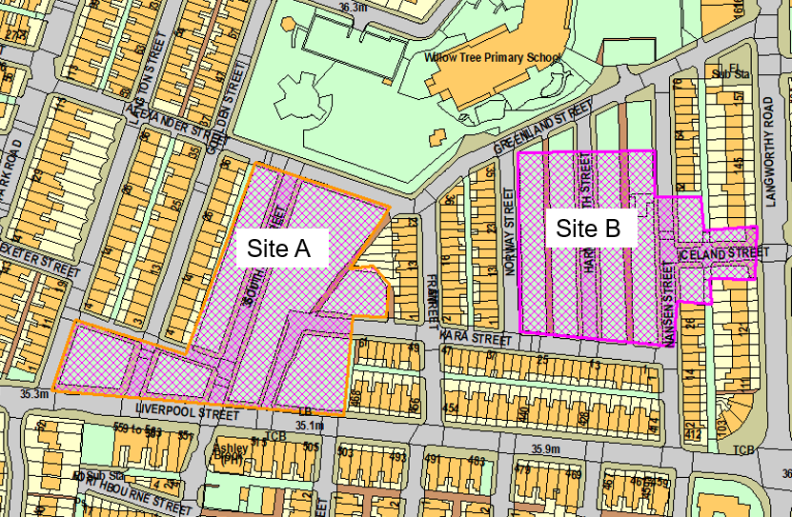
This application relates to site B of the wider Kara Street site which covers the two parcels identified on the adjacent plan. The immediate surrounding area is predominantly residential in nature with traditional rows of terraced dwellings. Further to the northeast of the site is the Langworthy Road Neighbourhood Centre. The application plots themselves previously accommodated terraced housing which has since been demolished and cleared (between 2008-2012) with the sites remaining vacant and laid to grass, bounded with a knee rail until the commencement of their re-development as permitted under application 20/74751/FUL.

Background

Application 20/74751/FUL was approved in March 2021 and permitted the “residential development comprising 157 dwellings (Use Class C3) (of 111 houses and 46 apartments) across two adjacent sites, including new and realigned public highway, landscaping, open space and all other associated works.”

Development on site has commenced under 20/74751/FUL as amended by 21/78109/NMA relating to site B.

Description of Proposal

This application relates to the eight, house type D units within site B which front Kara Street.

The following changes are proposed to the house type D units:
- Removal of tandem parking (16 spaces);
- Removal of raised garden deck to rear and stepped access in between pairs of semi’s;
- Addition of tandem parking spaces to Norway St, Harmsworth St and Nansen St (8 spaces);
- Removal of first floor amenity terrace area to rear elevation;
- Inclusion of private gardens to rear at ground floor level instead of parking bays;
- Revision of house type arrangement including roof gardens changed from front to rear and inclusion of privacy screens;
- Metal canopy replaced with glass canopy to front of properties;
- Recessed aluminium rain screen panel replaced with grey brick recessed panel;
- Building height reduced to accommodate amendments to proposed floor to floor levels and reduction of proposed window heights.

The type D units are coloured light green on the plan snippets below which show a comparison between approved and proposed:

Ground floor level:
Approved under 20/74751/FUL Proposed under this application
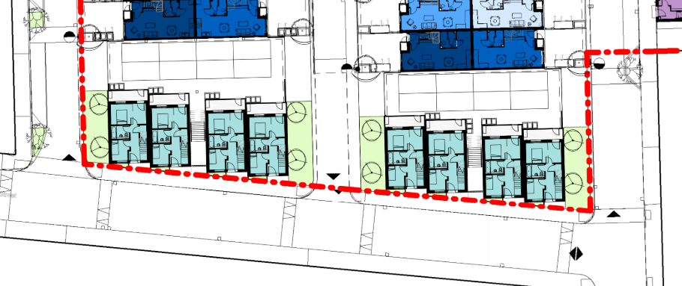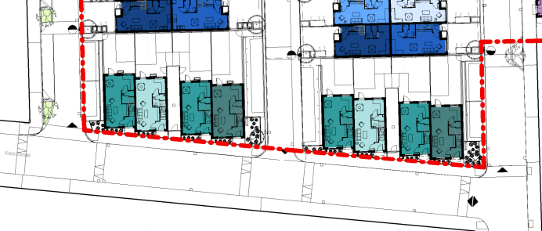

Second floor level:
Approved under 20/74751/FUL Proposed under this application
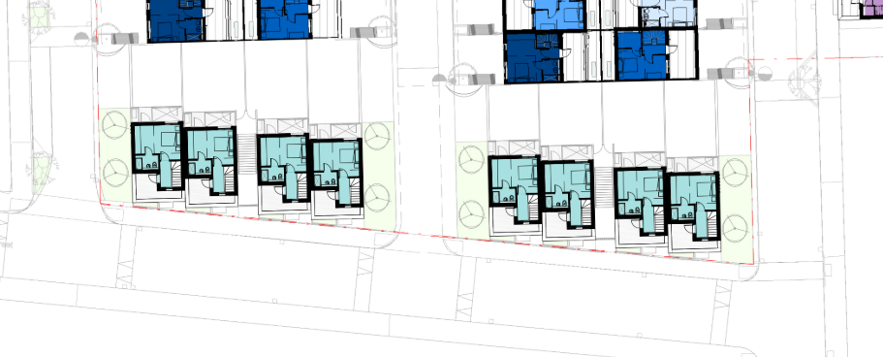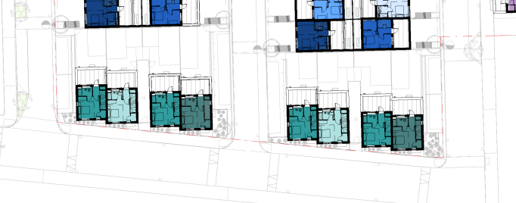

Elevations
Approved under 20/74751/FUL
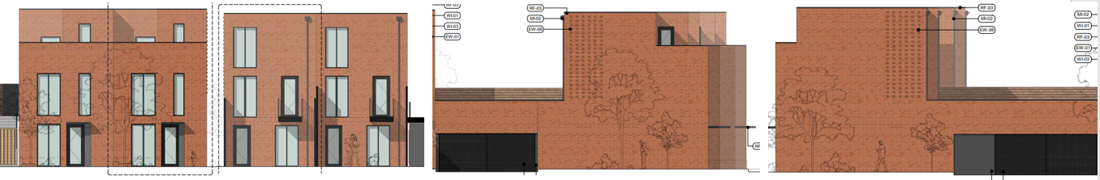
Front Rear Side Side

Elevations now proposed under this application
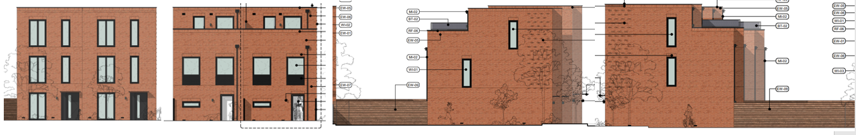
Front Rear Side Side

Publicity
Earliest Decision Date: 7 July 2022
Revised Expiry Date: No extension agreed

Site Notice: Non HH Article 15 Date Displayed: 26 May 2022
Reason: Article 13

Press Advert: Manchester Weekly News Salford Edition Date Published: 16 June 2022
Reason: Article 15 Standard Press Notice

Relevant Site History

Whole site:
20/74751/FUL - Proposed residential development comprising 157 dwellings (Use Class C3) (of 111 houses and 46 apartments) across two adjacent sites, including new and realigned public highway, landscaping, open space and all other associated works. Permitted 14/5/20

Site A:
21/77345/DISCON - Application for approval of details reserved by condition 4 ( Construction Method Statement) attached to planning permission 20/74751/FUL (relating to Site A - Salix). Request determined.

21/77897/DISCON - Request for confirmation of partial compliance of condition 9 (contaminated land remediation strategy) attached to planning permission 20/74751/FUL (relating to Site A - Salix). Request determined.

21/78572/DISCON - Request for confirmation of partial compliance of conditions 3 (Materials), 4 (Construction Method Statement), 5 (Landscaping and Ecology), 12 (Tree Replacement), 13 (EV Charging), 17 (Substation details), 20 (Highway layout design and widths) and 25 (Disabled bays for apartments) attached to planning permission 20/74751/FUL (relating to site A). Request determined.

21/78767/NMA - Application for a non-material amendment following grant of planning permission 20/74751/FUL for amendments to condition 2 (approved plans) to accommodate general layout improvements, affordability, coordination with structure and M&E systems, survey results from site investigations and to improve buildability (relating to Site A). Pending consideration.

Site B:
22/80069/DISCON - Request for confirmation of partial compliance of conditions 13 (electric vehicle charging), 15 (waste management strategy), 17 (substation), 21 (highway works) and 24 (secure cycle parking) attached to planning permission 20/74751/FUL (For Site B). Request determined.

21/77962/FUL - Substation enclosure with masonry external walls, flat roof and louvred openings. The substation is to serve the residential development approved in application 20/74751/FUL. Permitted 21/6/22

21/78109/NMA - Application for a non-material amendment following the grant of planning permission 20/74751/FUL for design updates (relating to site B.) Permitted 14/6/22

21/78268/DISCON - Request for confirmation of partial compliance of conditions 3 (materials), 12 (tree replacement scheme), 14 (1:20 scaled drawings), 20 (highway layout design and widths) and 25 (disabled bays for apartments) attached to planning permission 20/74751/FUL (relating to site B). Request determined.

21/77769/DISCON - Request for confirmation of partial compliance of conditions 4 (Construction Method Statement) and 9 (Contaminated Land Remediation Strategy) attached to planning permission 20/74751/FUL (relating to Site B). Request determined.

Neighbour Notification

97 neighbouring occupiers have been notified of the application.

Representations

None received to date.

Consultations

Highways - No objection. Recommend a condition in relation to the provision of bollards to the southern end of the parking bays. Please refer to the highways section of the report for further discussion.

Planning Policy

Development Plan Policy

Unitary Development Plan ST1 - Sustainable Urban Neighbourhoods
Unitary Development Plan ST12 - Development Density
Unitary Development Plan DES1 - Respecting Context
Unitary Development Plan DES2 - Circulation and Movement
Unitary Development Plan DES3 - Design of Public Space
Unitary Development Plan DES7 - Amenity of Users and Neighbours
Unitary Development Plan DES9 - Landscaping
Unitary Development Plan DES10 - Design and Crime
Unitary Development Plan H1 - Provision of New Housing Development
Unitary Development Plan H4 - Affordable Housing
Unitary Development Plan H8 - Open Space Provision with New Housing
Unitary Development Plan A2 - Cyclists, Pedestrians and the Disabled
Unitary Development Plan A8 - Impact of Development on Highway Network
Unitary Development Plan A10 - Provision of Car, Cycle, Motorcycle Park
Unitary Development Plan EN17 - Pollution Control
Unitary Development Plan EN19 - Flood Risk and Surface Water
Unitary Development Plan DEV5 - Planning Conditions and Obligations

Draft Local plan policy F3 - Inclusive places

Draft Local plan policy A1 - Supporting sustainable transport
Draft Local plan policy A2 - Transport hierarchy and sustainable streets

Draft Local plan policy DG1 - Digital infrastructure
Draft Local plan policy DG2 - Protecting digital infrastructure

Draft Local plan policy WA4 - Development and flood risk

Draft Local plan policy D1 - Design principles
Draft Local plan policy D2 - Local character and distinctiveness
Draft Local plan policy D3 - Layout and access
Draft Local plan policy D4 - Spaces
Draft Local plan policy D5 - Amenity
Draft Local plan policy D6 - Design and crime

Local plan policy GI6 - Trees, woodland and hedgerows

Local plan policy WM1 - Waste and development

Other Material Planning Considerations

National Planning Policy

National Planning Policy Framework

National Planning Policy Guidance

Local Planning Policy

Supplementary Planning Document - Sustainable Design and Construction
Supplementary Planning Document - Design
Supplementary Planning Document - Design and Crime
Supplementary Planning Document - Trees and Development
Supplementary Planning Document - Planning Obligations
Planning Guidance - Flood Risk and Development
Planning Guidance - Housing

It is not considered that there are any local finance considerations that are material to the application.

The National Planning Policy Framework (NPPF) paragraph 48 establishes that local planning authorities may give weight to relevant policies in emerging plans according to:
- The stage of preparation of the emerging plan (the more advanced its preparation, the greater the weight that may be given);
- The extent to which there are unresolved objections to relevant policies (the less significant the unresolved objections, the greater the weight that may be given); and
- The degree of consistency of the relevant policies in the emerging plan to the NPPF (the closer the policies in the emerging plan to the policies in the NPPF, the greater the weight that may be given).
There are currently two emerging plans to consider.
First, Places for Everyone Publication Plan, the joint Development Plan Document for nine districts in Greater Manchester, which was published for consultation under Regulation 19 of the Town and Country Planning (Local Planning) (England) Regulations 2012 on 9 August 2021. Representations were invited until 3 October 2021; the plan was submitted to the Secretary of State for examination on 14 February 2022 and examination hearings are due to commence in Summer 2022. The emerging policies which are relevant to this application are discussed where applicable in this report with appropriate weight being afforded in accordance with NPPF paragraph 48.

Second, the Publication Salford Local Plan: Development Management Policies and Designations (SLP:DMP), which was published on 27 January 2020 and comments were invited until 20 March 2020. An Addendum was published on 5 February 2021 and comments were invited on this until 19 March 2021. The Publication SMP:DMP and the Addendum were submitted to the Secretary of State for examination on 30 June 2021 and the examination hearings took place over 7 days in December 2021. The plan has been subject to a significant amount of public consultation in previous stages of its production and the city council has considered the comments made to determine the extent to which there are unresolved objections to its policies. Those policies (i.e. the Publication SLP:DMP policies as modified through the Addendum) which are relevant to this application are discussed where appropriate in this report with appropriate weight being afforded in accordance with NPPF paragraph 48. It is expected that the SLP:DMP will be adopted in Summer 2022.

In addition, NPPF paragraph 219 establishes that existing policies (such as Salford’s UDP) are not out-of-date simply because they were adopted or made prior to the publication of NPPF. Due weight should be given to them, according to their degree of consistency with the NPPF, and the closer the policies in the UDP to the policies in the NPPF, the greater the weight that may be given. In terms of this application it is considered that the relevant policies of the UDP can be afforded due weight for the purposes of decision making as the relevant criteria within the UDP policies applicable to the proposed development are consistent with the policies contained in the NPPF.

Appraisal

Principle of Development

The principle of the proposed development was established during the consideration of application
20/74751/FUL and was considered to be acceptable.

The changes proposed under this application relate to design changes and a change to the parking spaces to serve the type D houses.

Issues around housing mix, flood risk, air quality, noise, contaminated land, highway safety and impact, ecology, landscaping, trees, affordable housing and planning obligations were also assessed and considered acceptable under the previous application and there have been no significant changes in planning policy or on site that would change the acceptability of the principle of the development now proposed.

Having regard to the above, the remainder of this appraisal will consider issues around the proposed changes only.

Design and layout

The internal arrangements of the type D houses are proposed to be changed to a more traditional dwelling. As a result the parking bays to the rear at ground floor level are proposed to be relocated to parallel parking bays adjacent to the side gables resulting in a reduction in 8 spaces. The area to the rear of the properties is now proposed as traditional ground level garden areas. The small first floor terrace area to the rear has been removed and the roof terrace is proposed to be relocated from the front of the properties to the rear.

The property would therefore be 3 storey at the front and two storey with roof terrace at the rear. The resulting property would still be in keeping with the design, appearance and scale of other properties within the development, a number of which are 3 storey with rear roof terraces. The overall appearance would also remain as per the original permission but with windows amended to reflect the change to the elevations/roof terrace etc. materials used would match those already approved under the discharge of condition 3 attached to 20/74751FUL.

Amenity

In relation to amenity of future occupiers the proposed changes to house type D would still ensure future occupiers are provided with an adequate level of amenity with sufficient light and outlook to all habitable rooms.

To the rear of the type D houses are the blank side gables of other properties within the wider development. These properties also have roof terrace areas to the front or rear (dependant on the property type). Habitable room windows are contained within the rear elevation of the proposed revised house type at ground and first floor level which is consistent with the approved house type D and this arrangement remains acceptable.

At second floor level the bedroom and roof terrace have swapped meaning that the bedroom is now proposed at the front of the property with the roof terrace to the rear.it is not considered that this change would result in an unacceptable impact on the amenity of future occupiers of the type D houses or future occupiers of the properties to the rear that form part of the wider development having regard to other approved separation distances and relationships between roof terraces and properties across the development.

Privacy screens are proposed to the roof terraces of end properties which directly face the front elevations of existing dwellings outside the side at a distance of between approximately 12m and 12.5m. Having regard to the extant permission and that the separation distances approved have remained the same but with the terrace moved from front to rear it is not considered that this would result in an increase impact on the amenity of current or future occupiers of adjacent properties on Norway Street and Nansen Street which face the side gables of the type D houses.

To the front, on the opposite side of Kara Street are existing terraced properties that directly face the type D houses. The front elevation of the type D houses would remain in its extant position between approximately 11m to 11.5m from the front elevation of the facing properties. The type D houses approved under 20/74751/FUL included their roof terraces to the front of the properties and are now proposed to be replaced with internal living accommodation with the roof terrace moved to the rear.

The section and floor plans below demonstrate the extant and proposed relationship between the type D houses and the facing properties. The second floor front elevation was previously staggered and is now proposed to become flush with the ground and first floor front elevation. The overall height of the property is also proposed to be reduced by 0.2m.

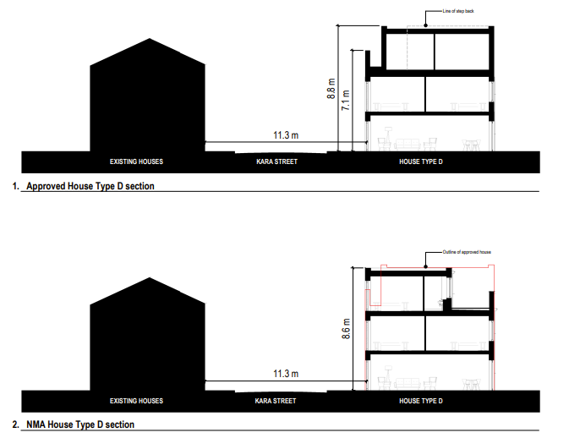

It is not considered that the change from a roof terrace to bedroom window would result in an increased impact in terms of privacy particularly as these windows would also be no closer than existing habitable room windows in the front elevations and are likely to be less intensely used than residents sitting out on a roof terrace for longer periods of time, particularly in the summer months.

In terms of built development, the proposed changes are consistent with that of other relationships across the development. As with the extant consent it is recognised that separation distances are tight however the previous assessment considered that the layout of the development has been developed having regard to the constraints of the site and also having regard to the grid pattern of streets and the terraced character of the area.

In addition, the type D houses consist of four pairs of semi detached properties rather than one long terraced row which will provide some relief through gaps between and at either ends of the properties.

Taking all of the above, and the efficient use of land as a result, into account it is considered that the scale, massing and separation distances proposed are acceptable in this instance and would not result in an unacceptable impact on the amenity of occupiers of existing residential dwellings.

Highways

The changes to the 8no house type D dwellings also includes changes to the private parking arrangements for these properties. The 16 spaces previously proposed to the rear of the properties would be replaced with traditional ground floor gardens and 8 parallel parking spaces would instead be provided, two at the end of each of the gable elevations along Norway St, Harmsworth St and Nansen St.

This represents a loss of 50% parking provision for the type D dwellings but nevertheless still complies with the council’s maximum 1.5 parking space per dwelling parking policy.

Each of the parallel parking bays is proposed to accommodate 2 vehicles with each parking space having approximate dimensions of 6.5m long x 2.6m wide but without entry and exit spays on either ends of the parallel parking bays. A standard parking bay of this type is normally 6m in length however in this instance the bays are proposed at 6.5m in an attempt to overcome the parking issues that may arise in the absence of an entry or exit taper.
The submitted swept path plans indicate that this 6.5m long bay would work for smaller vehicles. A further swept path plan indicates that there are instances where larger vehicles will overrun and require the adjoining parking space to be clear of any parked vehicle to enable a large vehicle to enter the parking spaces. The applicant states that in reality this would be avoided by vehicle users using multiple movements to complete the manoeuvre, which is typical for any kind of parallel parking arrangement and would not cause any issues.
The Local Highway Authority have not raised objections to this but recommend bollards are introduced at the southern end of each parallel parking bay to prevent vehicles overrunning of the soft landscaping and footway and that this should be secured by condition. The submitted plans currently indicate a wall in this location which would also be acceptable (subject to its maximum height being no higher than 0.6m to retain visibility splays) but final details have not yet been secured and are to be agreed via the attached landscaping and boundary treatment conditions (conditions 4 and 17). Having regard to this a separate condition requiring the provision of bollards is not considered necessary. An informative is recommended to advise the developer of the requirements for this area when they seek to discharge the landscape condition.
Conditions and legal agreement

The conditions attached to the extant permission have been carried forward and amended where necessary to take account those where information has been submitted and discharged. The applicants are also entering in new S106 agreement to ensure the planning obligations agreed under the original planning permission are secured.

Recommendation

That planning permission be granted subject to the following planning conditions and that:

- The City Solicitor be authorised to enter into a legal obligation under Section 106 of the Town and Country Planning Act 1990 to secure the following heads of terms:
  - £824,339 open space contribution for works to Langworthy Park and/or Buile Hill and/or Clarendon Park;
  - A public realm contribution for local public realm street greening project, focussing on the streets surrounding the proposed development, namely Nansen Street, Fram Street, Kara Street, Goulden Street, Langton Street, Iceland Street and Seedly Park Road and extending to include tree planting on Langworthy Road;
  - £249,587.05 education contribution for Pupil Planning Area 9: Weaste and Langworthy; and
  - £5000 monitoring fee.

- That the applicant be informed that the Council is minded to grant planning permission, subject to the conditions stated below, on completion of such legal obligation;

- That authority be given for the decision notice relating to the application be issued, (subject to the conditions and reasons stated below) on completion of the above-mentioned legal obligation.

Conditions

- The development hereby permitted shall be carried out in accordance with the following approved plans:
- Location plan - 0112-BDP-XXX-ZZ-DR-A-(0-)-206
- Proposed site plan key - 0112-BDP-XXX-ZZ-DR-A-(2-)-250 Revision P03
- Site Areas plan - 0112-BDP-XXX-ZZ-DR-A-(0-)-207

- Level 00 Masterplan - 0112-BDP-XXX-ZZ-DR-A-(2-)-200 Revision P14
- Level 01 Masterplan - 0112-BDP-XXX-ZZ-DR-A-(2-)-201 Revision P13
- Level 02 Masterplan - 0112-BDP-XXX-ZZ-DR-A-(2-)-202 Revision P13
- Level 03 Masterplan - 0112-BDP-XXX-ZZ-DR-A-(2-)-203 Revision P13
- Level 04 Masterplan - 0112-BDP-XXX-ZZ-DR-A-(2-)-204 Revision P11

- Bin store typical - 0112-BDP-XXX-ZZ-DR-A-(2-)-001 (Site A only)
- Blocks BH1 and BH2 – external bin store – 1320-BDP-BHX-00-DR-A-(86)-200 Revision P02 (site B only)
- Street cross sections - 0112BDP-XXX-ZZ-DR-A-(2-)-310 Revision P01
- Street scene elevations - 0112-BDP-XXX-ZZ-DR-A-(2-)-410 Revision P02

- House Type A1 Typical bay elevation - 0112-BDP-XA1-ZZ-DR-A-(2-)-300 Revision P03 (site A only)
- House Type A1 Typical bay elevation - 1320-BDP-XA1-ZZ-DR-A-(2-)-300 Revision P04 (site B only)

- House Type A4 Typical bay elevation - 0112-BDP-XA4-ZZ-DR-A-(2-)-300 Revision P03 (site A only)
- House Type A4 Typical bay elevation - 1320-BDP-XA4-ZZ-DR-A-(2-)-300 Revision P04 (site B only)

- House Type B1 Typical bay elevation - 0112-BDP-XB1-ZZ-DR-A-(2-)-300 Revision P03 (site A only)
- House Type B1 Typical bay elevation – 1320-BDP-XB1-ZZ-DR-A-(2-)-300 Revision P06 (site B only)

- House Type B3 Typical bay elevation - 0112-BDP-XB3-ZZ-DR-A-(2-)-300 Revision P03

- House Type B4 Typical bay elevation - 0112-BDP-XB4-ZZ-DR-A-(2-)-300 Revision P03(site A only)
- House Type B4 Typical bay elevation - 1320-BDP-XB4-ZZ-DR-A-(2-)-300 Revision P06 (site B only)

- House Type B7 Typical bay elevation - 1320-BDP-XB7-ZZ-DR-A-(2-)-300 Revision P05

- House Type B8 Proposed GA elevation - 0112-BDP-XB8-ZZ-DR-A-(2-)-300 Revision P03

- House Type C1 Typical bay elevation - 0112-BDP-XC1-ZZ-DR-A-(2-)-300 Revision P02

- House Type D1 Typical bay elevation - 0112-BDP-XD1-ZZ-DR-A-(2-)-300 Revision P02 (site A only)
- House Type D1 Typical bay elevation - 1320-BDP-XD1-ZZ-DR-A-(2-)-300 Revision P04 (site B only)

- Proposed GA plans - Type A1 3 bed back terrace - 0112-BDP-XA1-ZZ-DR-A-(2-)-200 Revision P04 (site A only)
- Proposed GA plans - Type A1 3 bed back terrace – 1320-BDP-XA1-ZZ-DR-A-(2-)-200 Revision P10 (site B only)

- Proposed GA plans - Type A4 3 bed front terrace - 0112-BDP-XA4-ZZ-DR-A-(2-)-200 Revision P04 (site A only)
- Proposed GA plans - Type A4 3 bed front terrace - 1320-BDP-XA4-ZZ-DR-A-(2-)-200 Revision P10 (site B only)

- Proposed GA plans - Type B1 3 bed front terrace - 0112-BDP-XB1-ZZ-DR-A-(2-)-200 Revision P04 (site A only)
- Proposed GA plans - Type B1 3 bed front terrace – 1320-BDP-XB1-ZZ-DR-A-(2-)-200 Revision P07 (site B only)

- Proposed GA plans - Type B3 (2 storey) 3 bed terrace - 0112-BDP-XB3-ZZ-DR-A-(2-)-200 Revision P02

- Proposed GA plans - Type B4 3 bed back terrace - 0112-BDP-XB4-ZZ-DR-A-(2-)-200 Revision P04 (site A only)
- Proposed GA plans - Type B4 3 bed back terrace - 1320-BDP-XB4-ZZ-DR-A-(2-)-200 Revision P08 (site B only)

- Proposed GA plans - Type B7 infill house - Langworthy Road - 1320-BDP-XB7-ZZ-DR-A-(2-)-200 Revision P06

- Proposed GA plans - Type B8 4 bed terrace - 0112-BDP-XB8-ZZ-DR-A-(2-)-200 Revision P02

- Proposed GA plans - Type C1 3 bed - 0112-BDP-XC1-ZZ-DR-A-(2-)-200 Revision P03

- Proposed GA plans - Type D1 - 0112-BDP-XD1-ZZ-DR-A-(2-)-200 Revision P03 (Site A only)
- Proposed GA plans - Type D1 – 1320-BDP-XD1-ZZ-DR-A-(2-)-200 Revision P07 (Site B only)

- Block AH1 Proposed elevations - 0112-BDP-AH1-ZZ-DR-A-(2-)-400 Revision P02
- Block AH2 Proposed elevations - 0112-BDP-AH2-ZZ-DR-A-(2-)-401 Revision P01
- Block AH3 Proposed elevations - 0112-BDP-AH3-ZZ-DR-A-(2-)-402 Revision P02

- Block BH1 Proposed elevations – 1320-BDP-BH1-ZZ-DR-A-(2-)-450 Revision P07
- Block BH2 Proposed elevations - 1320-BDP-BH2-ZZ-DR-A-(2-)-451 Revision P07
- Block BH3 Proposed elevations - 1320-BDP-BH3-ZZ-DR-A-(2-)-452 Revision P04

- Apartment building A1 proposed GA plan ground floor - 0112-BDP-AA1-00-DR-A-(2-)-200 Revision P03
- Apartment building A1 proposed GA plan first floor - 0112-BDP-AA1-01-DR-A-(2-)-201 Revision P03
- Apartment building A1 proposed GA plan second floor - 0112-BDP-AA1-02-DR-A-(2-)-202 Revision P03
- Apartment building A1 proposed GA plan third floor - 0112-BDP-AA1-03-DR-A-(2-)-203 Revision P03
- Apartment building A1 proposed GA elevation south elevation - 0112-BDP-AA1-ZZ-DR-A-(2-)-400 Revision P02
- Apartment building A1 proposed GA elevation north elevation - 0112-BDP-AA1-ZZ-DR-A-(2-)-401 Revision P02
- Apartment building A1 proposed GA elevation east elevation - 0112-BDP-AA1-ZZ-DR-A-(2-)-402 Revision P02
- Apartment building A1 proposed GA elevation west elevation - 0112-BDP-AA1-ZZ-DR-A-(2-)-403 Revision P02
- Apartment building A1 proposed GA section Section AA - 0112-BDP-AA1-ZZ-DR-A-(2-)-300
- Apartment building A1 proposed GA plan roof - 0112-BDP-AA1-04-DR-A-(2-)-204 Revision P03

- Apartment building A2 proposed GA plan ground floor - 0112-BDP-AA2-00-DR-A-(2-)-200 Revision P03
- Apartment building A2 proposed GA plan first floor - 0112-BDP-AA2-01-DR-A-(2-)-201 Revision P03
- Apartment building A2 proposed GA plan second floor - 0112-BDP-AA2-02-DR-A-(2-)-202 Revision P03
- Apartment building A2 proposed GA plan third floor - 0112-BDP-AA2-03-DR-A-(2-)-203 Revision P03
- Apartment building A2 proposed GA elevation south elevation - 0112-BDP-AA2-ZZ-DR-A-(2-)-400 Revision P02
- Apartment building A2 proposed GA elevation north elevation - 0112-BDP-AA2-ZZ-DR-A-(2-)-401 Revision P02
- Apartment building A2 proposed GA elevation east elevation - 0112-BDP-AA2-ZZ-DR-A-(2-)-402 Revision P02
- Apartment building A2 proposed GA elevation west elevation - 0112-BDP-AA2-ZZ-DR-A-(2-)-403 Revision P02
- Apartment building A2 proposed GA section Section AA - 0112-BDP-AA2-ZZ-DR-A-(2-)-300
- Apartment building A2 proposed GA plan roof - 0112-BDP-AA2-04-DR-A-(2-)-204 Revision P03

- Apartment building A3 proposed GA plan ground floor - 0112-BDP-AA3-00-DR-A-(2-)-200 Revision P03
- Apartment building A3 proposed GA plan first floor - 0112-BDP-AA3-01-DR-A-(2-)-201 Revision P03
- Apartment building A3 proposed GA plan second floor - 0112-BDP-AA3-02-DR-A-(2-)-202 Revision P03
- Apartment building A3 proposed GA plan third floor - 0112-BDP-AA3-03-DR-A-(2-)-203 Revision P03
- Apartment building A3 proposed GA elevation south elevation - 0112-BDP-AA3-ZZ-DR-A-(2-)-400 Revision P02
- Apartment building A3 proposed GA elevation north elevation - 0112-BDP-AA3-ZZ-DR-A-(2-)-401 Revision P02
- Apartment building A3 proposed GA elevation east elevation - 0112-BDP-AA3-ZZ-DR-A-(2-)-402 Revision P02
- Apartment building A3 proposed GA elevation west elevation - 0112-BDP-AA3-ZZ-DR-A-(2-)-403 Revision P02

- Apartment building A3 proposed GA section Section AA - 0112-BDP-AA3-ZZ-DR-A-(2-)-300
- Apartment building A3 proposed GA plan roof - 0112-BDP-AA3-04-DR-A-(2-)-204 Revision P03

Reason: For the avoidance of doubt and in the interest of proper planning.

- The development hereby approved shall be carried out in accordance with the material samples and details submitted and approved under applications 21/78572/DISCON (site A) and 21/78268/DISCON (site B).
Reason: In order to ensure a satisfactory appearance in the interests of visual amenity in accordance with Policy DES1 of the City of Salford Unitary Development Plan, policy D2 of the Draft Salford Local Plan and the requirements of the National Planning Policy Framework.

- The development hereby permitted shall be implemented in strict accordance with the Construction Environmental Management Plan submitted and approved under applications 21/77345/DISCON (site A) and 21/77769/DISCON (site B).
Reason: In the interests of the amenity of neighbours in accordance with policies DES7 and EN17 of the Salford Unitary Development Plan, policy D5 of the Draft Salford Local Plan and the National Planning Policy Framework.

4. a) Notwithstanding the details shown on the approved plans, the development hereby permitted within Area A or B shall not be occupied until full details of both hard and soft landscaping works for that particular area have been submitted to and approved in writing by the Local Planning Authority. The details shall include the formation of any banks, terraces or other earthworks, hard surfaced areas and materials, external lighting, planting plans, specifications and schedules (including planting size, species and numbers/densities), existing plants / trees to be retained and a scheme for the timing / phasing of implementation works. The landscaping scheme shall also incorporate all mitigation and enhancement as identified in Section 5 of the submitted Ecological Assessment.

(b) The landscaping works shall be carried out in accordance with the approved scheme for timing / phasing of implementation or within 18 months of first occupation of the development hereby permitted, whichever is the later.

(c) Any trees or shrubs planted or retained in accordance with this condition which are removed, uprooted, destroyed, die or become severely damaged or become seriously diseased within 5 years of planting shall be replaced within the next planting season by trees or shrubs of similar size and species to those originally required to be planted.

Reason: To ensure that the site is satisfactorily landscaped having regard to its location, to secure opportunities for the enhancement of the nature conservation value of the site and to support protected species in accordance with Policies DES1 and DES9 of the City of Salford Unitary Development Plan, policy D4 of the Draft Local Plan, the Nature Conservation and Biodiversity Supplementary Planning Document and the National Planning Policy Framework.

5. The development hereby permitted shall be carried out in accordance with the approved Ecological Assessment (Urban Green, Revision 02, original report dated 27.11.19) submitted under 20/74751/FUL. All mitigation and enhancement measures as identified in Section 5 of the report shall be implemented in full including the provision of the lighting scheme and the landscape details which shall also be incorporated into the scheme required to be submitted under condition 4.

Reason: To secure opportunities for the enhancement of the nature conservation value of the site and to support protected species in accordance with the Nature Conservation and Biodiversity Supplementary Planning Document and the National Planning Policy Framework.

6. The development shall be undertaken in strict accordance with the noise mitigation measures, including garden boundary treatment, specified in the submitted and agreed Noise Assessment Report (under application 20/74751/FUL), January 2020, Ref: RSA306/2019, RSA Acoustic Engineering shall be installed.

Reason: To safeguard the amenity of future occupants of the development hereby approved in accordance with policy EN17 of the City of Salford Unitary Development Plan and the National Planning Policy Framework.

7. Prior to occupation of the residential units hereby approved a site completion report confirming that all necessary noise attenuation measures as identified in condition 6 above have been installed shall be submitted to and approved in writing by the local planning authority. The noise attenuation measures shall be retained thereafter.

Reason: To safeguard the amenity of future occupants of the development hereby approved in accordance with policy EN17 of the City of Salford Unitary Development Plan and the National Planning Policy Framework.

8. The development hereby permitted shall be implemented in strict accordance with the contaminated land remediation strategy submitted and approved under applications 21/77897/DISCON (site A) and 21/77769/DISCON (site B).

Reason: To prevent pollution of the water environment and to ensure the safe development of the site in the interests of the amenity of future occupiers in accordance with Policy EN17 of the City of Salford Unitary Development Plan and the National Planning Policy Framework.

9. Pursuant to condition 8 and prior to first use or occupation a verification report, which validates that all remedial works undertaken on site were completed in accordance with those agreed with the Local Planning Authority, shall be submitted to and approved in writing by the Local Planning Authority.

Reason: To prevent pollution of the water environment and to ensure the safe development of the site in the interests of the amenity of future occupiers in accordance with Policy EN17 of the City of Salford Unitary Development Plan and the National Planning Policy Framework

10. The development hereby approved shall be carried out in accordance with the Arboricultural Impact Assessment (AIA), document ref: URBAN GREEN AIA, Kara Street, Seedley, Salford M6 5GG, Document No: UG379 submitted under 20/74751/FUL.

Reason: To safeguard existing trees and to ensure that adequate provision is made for their protection whilst the development is carried out in accordance with Policy EN12 of the City of Salford Unitary Development Plan, policy GI6 of the Draft Salford Local Plan and the National Planning Policy Framework.

11. The felled trees shall be replaced in accordance with a tree replacement scheme which shall be submitted to and approved in writing by the Local Planning Authority. The scheme shall be submitted prior to the commencement of above ground development and shall include details of: quantity; tree species; tree sizes (including the minimum height and circumference of stem at 1m from the ground level); plan indicating the location of the replacement trees; a timetable for tree planting and details of aftercare.

Reason: To ensure that the site is satisfactorily landscaped having regard to its location and the nature of the proposed development and in accordance with Policies DES1 and DES9 of the City of Salford Unitary Development Plan and the National Planning Policy Framework.

12. The development hereby permitted, shall be carried out in accordance with the schemes for the provision of electric vehicle charging infrastructure submitted and agreed under applications 21/78572/DISCON (site A) and 22/80069/DISCON (site B) which shall provide a minimum of 7kv charging capacity and shall be implemented prior to first occupation of units within the relevant phase and retained as such thereafter.

Reason: In accordance with paragraph 105, 110, 170 and 181 of the NPPF, to encourage the uptake of ultra-low emission vehicles and ensure the development is sustainable. To safeguard residential amenity, public health and quality of life.

13. Notwithstanding the details shown on the plans hereby approved, no above ground construction works within Area A or B shall be undertaken until 1:20 scaled drawings of the window details, textured and recessed brick areas including fenestration for that particular area have been submitted to and approved in writing by the Local Planning Authority. The development shall be constructed in accordance with the details so approved.

Reason: In order to ensure a satisfactory appearance in the interests of visual amenity in accordance with Policy DES1 of the City of Salford Unitary Development Plan, policy D2 of the Draft Salford Local Plan and the requirements of the National Planning Policy Framework.

14. The development hereby permitted, in so far as it relates to site B shall be carried out in accordance with the waste management strategy approved under 22/80069/DISCON which shall be implemented prior to first occupation of units within site B and retained as such thereafter. A verification report to demonstrate that waste management arrangements have been implemented in accordance with the approved strategy shall be submitted to and approved in writing by the Local Planning Authority within 6 months of first occupation.

Prior to first occupation of units within site A of the development hereby approved a waste management strategy for that particular area shall be submitted to and approved in writing by the Local Planning Authority. The strategy shall include details of storage provision; how bins are moved to and from the collection point, recycling facilities and, bulky waste storage. A verification report to demonstrate that waste management arrangements have been implemented in accordance with the approved strategy shall be submitted to and approved in writing by the Local Planning Authority within 6 months of first occupation.

Reason: To ensure that the development is adequately serviced and in the interests of pedestrian and highway safety in accordance with policies DES1, A2 and A8 of the Salford Unitary Development Plan, policy WM1 of the Draft Salford Local Plan and the National Planning Policy Framework.

15. Foul and surface water shall be drained on separate systems.

Reason: To secure proper drainage and to manage the risk of flooding and pollution.

16. Notwithstanding the details shown on the approved plans, prior to installation of the substation within site A, full details including floor plans, elevations and material details shall be submitted and approved in writing by the Local Planning Authority. The substation shall be erected in accordance with the approved details.

Reason: In order to ensure a satisfactory appearance in the interests of visual amenity and to safeguard the amenity of existing, neighbouring and/or future occupants of the development hereby approved in accordance with policies DES1 and DES7 of the City of Salford Unitary Development Plan, policies D2 and D5 of the Draft Salford Local Plan and the National Planning Policy Framework.

17. Notwithstanding the details shown on the approved plans, prior to installation of any boundary treatments full details including a boundary treatment site plan, scaled elevations and material details shall be submitted and approved in writing by the Local Planning Authority. The boundary treatments shall be erected in accordance with the approved details.

Reason: In order to ensure a satisfactory appearance in the interests of visual amenity and to safeguard the amenity of existing, neighbouring and/or future occupants of the development hereby approved in accordance with policies DES1 and DES7 of the City of Salford Unitary Development Plan, policies D2 and D5 of the Draft Salford Local Plan and the National Planning Policy Framework.

18. The development hereby permitted shall be carried out in full accordance with the Drainage Strategy by BWB, submitted under 20/74751/FUL, dated March 2020, document number: SXH-BWB-ZZ-XX-RP-YE-0001_DS, BWB reference: MCS-2412_DS. For the avoidance of doubt, surface water must drain at the restricted rate of 5l/s on each site, resulting in a restricted flow of 10l/s across the whole development.

Reason: To ensure a satisfactory method of surface water disposal to reduce the risk of flooding elsewhere in accordance with policy EN19 of the City of Salford Unitary Development Plan and seeks to provide betterment in terms of water quality and surface water discharge rates and meets requirements set out in the following documents;
o NPPF,
o Water Framework Directive and the NW River Basin Management Plan
o The national Planning Practice Guidance and the Non-Statutory Technical Standards for Sustainable Drainage Systems (March 2015)
o Manchester, Salford, Trafford Strategic Flood Risk Assessment (SFRA) (2011) and associated technical guidance
o Environment Agency Pollution Prevention Guidelines (now withdrawn)
o Flood Risk Assessment/SuDS Requirements for new developments (Salford's SuDS Checklist)

19. Notwithstanding the details shown on the approved plans, no above ground construction works shall commence until final details of the layout design and highway widths (carriageway and footway) has been submitted to and approved in writing by the Local Planning Authority. The development shall be carried out in accordance with the approved details prior to first occupation of the development and shall be retained thereafter.

Reason: In the interests of the safe and efficient operation of the highway network and to minimise potential conflicts between pedestrians, cyclists and other road users in accordance with policies DES2, A2 and A8 of the City of Salford Unitary Development Plan and the National Planning Policy Framework.

20. Prior to first occupation a scheme shall be to submitted and agreed in writing by the Local Planning Authority to detail highway works. Those works shall include:
i) Full construction details of the carriageways and footways;
ii) Details of tree pits;
iii) Details of pedestrian infrastructure;
iv) Details of traffic calming features any physical works required in order to facilitate them;
v) Redundant access points reinstated as continuous footway with correct kerb heights, and to provide dropped crossings on pedestrian routes in the vicinity of the site.

The scheme shall be implemented in accordance with the approved details prior to first occupation of the development and shall be retained thereafter.

Reason: In the interests of the safe and efficient operation of the highway network and to minimise potential conflicts between pedestrians, cyclists and other road users in accordance with policies DES2, A2 and A8 of the City of Salford Unitary Development Plan and the National Planning Policy Framework.

21. Prior to first occupation of units within Area A or Area B of the development hereby permitted an updated Travel Plan for that particular Area including travel pack shall be submitted to and approved in writing by the Local Planning Authority. The plan shall focus on sustainable transport options (including walking, cycling, public transport incentives, car share options, electric and ultra-low vehicle incentives and include full details of the travel plan coordinator and information in relation to the budget set aside for implementation and monitoring).

Within 6 months of first occupation (or alternative timeframe which has been agreed in writing with the Local Planning Authority), a further updated Travel Plan shall be submitted to and agreed in writing with the Local Planning Authority. The agreed Travel Plan shall be implemented and reviewed in accordance with the timetable embodied therein.

Reason: To ensure that the travel arrangements to the development are appropriate and to limit the effects of the increase in travel movements in accordance with policies ST14 and A8 of the City of Salford Unitary Development Plan, policy A1 of the Draft Salford Local Plan and the National Planning Policy Framework.

22. The vehicle parking arrangements as shown on the approved plans, to serve the houses hereby permitted, shall be made available for use prior to the development being brought into use and shall be retained thereafter for their intended purpose.

Reason: In the interest of highway safety and the free flow of traffic in accordance with policies A2, A8 and A10 of the City of Salford Unitary Development Plan and the National Planning Policy Framework.

23. Notwithstanding the details shown on the drawings hereby approved, full details of secure cycle parking for both the apartments and the houses, including consideration of the use of on street secure parking, shall be submitted to and approved in writing by the Local Planning Authority. The approved cycle parking shall be implemented and made available for its intended use prior to the occupation of the development hereby approved and shall be retained thereafter.

Reason: To encourage more sustainable modes of travel in accordance with policies ST14, A2 and A10 of the City of Salford Unitary Development Plan, policy A1 of the Draft Salford Local Plan and the National Planning Policy Framework.

24. Notwithstanding the details shown on the approved plans, prior to first use of the apartment buildings hereby permitted a revised car parking layout for each building which incorporates the provision of 1 disabled parking bay per apartment block shall be submitted to and approved in writing by the Local Planning Authority. The approved car parking layout shall be implemented and made available for its intended use prior to the first occupation of the apartment blocks and shall be retained thereafter.

Reason: In the interest of highway safety and the free flow of traffic in accordance with policies A2, A8 and A10 of the City of Salford Unitary Development Plan and the National Planning Policy Framework.

25. Where privacy screens are indicated on the approved plans they shall be erected prior to the first occupation of that dwelling and shall be retained as such thereafter.

Reason: In the interest of the amenity of residents in accordance with policy DES7 of the City of Salford Unitary Development Plan, policy D5 of the Draft Salford Local Plan and the National Planning Policy Framework.

Notes to Applicant

- STANDING ADVICE - DEVELOPMENT LOW RISK AREA
The proposed development lies within a coal mining area which may contain unrecorded coal mining related hazards. If any coal mining feature is encountered during development, this should be reported immediately to the Coal Authority on 0345 762 6848.

Further information is also available on the Coal Authority website at:
www.gov.uk/government/organisations/the-coal-authority

Standing Advice valid from 1st January 2021 until 31st December 2022

- The applicant is advised that they have a duty to adhere to the regulations of Part 2A of the Environmental Protection Act 1990, the National Planning Policy Framework 2021 and the current Building Control Regulations with regards to contaminated land. The responsibility to ensure the safe development of land affected by contamination rests primarily with the developer.

- The applicant's attention is drawn to the comments from design for security set out in the Crime Impact Statement submitted under application 20/74751/FUL and in particular the recommendations set out in sections 3.3 and 4 of the statement.

- In relation to condition 4 (Landscaping) and 17 (boundary treatments), the developers are advised that the scheme should provide suitable cover and shelter features for hedgehogs and should also incorporate the mitigation and enhancement measures set out in section 5 of the submitted ecological report. The developers are also advised that solid boundary treatment (max 0.6m high) or bollards must be provided to the southern end of the parallel parking bays on Norway St, Harmsworth St and Nansen St adjacent to the house type D gables.

- In relation to condition 12 (Electric Vehicle charging) the applicant’s attention is drawn to paragraph 5.10 of the 'Land-Use Planning & Development Control: Planning for Air Quality' document, bullet point 1 under the heading 'Operational Phase' which states ' The provision of at least 1 Electric Vehicle (EV) "rapid charge" point per 10 residential dwellings and/or 1000m2 of commercial floor space. Where on-site parking is provided for residential dwellings, EV charging points for each parking space should be made.'
For the avoidance of doubt the reference to '1 point per 10 residential dwellings' is in relation to apartment type development and the reference to 'where on-site parking is provided for residential dwellings, EV charging points for each parking space should be made' is in relation to dwelling houses.

- The applicant's attention is drawn to the comments from United Utilities dated 1st May 2020 submitted in relation to application 20/74751/FUL.

- The applicants are advised of the following comments from the Local Highway Authority:
- Regarding adopted carriageway and footways, any amendments to the carriageway need to be re-instated using similar materials or a material that is recommended by Salford City Council engineers;
- The developer must ensure existing utilities (ie BT floor box and adopted street lighting) are protected and have permission from various utility providers to undertake any work within the vicinity of the utility and within the footway and protection to the construction of the existing carriageway;
- Prior to ANY works commencing on site the developer shall contact the Local Highway Authority to arrange a full dilapidation/Condition Survey of all adopted highways surrounding the site. For the full duration of the construction, the developer will be responsible for 'Wear & Tear' / accelerated deterioration' of all existing highways, either adjacent to the site or highways used as access and egress to the site. Any necessary remedial works will be carried out under licence and at the developer's expense;
- The developer will be required to enter into a S278 / S38 agreement to facilitate associated highway works for the following:
a) Prior to the S278 agreement being signed, the works on the adopted highway will be delivered by an S171 agreement and Greater Manchester Roads Activities Permit Scheme (GMRAPS).
b) Drainage, street lighting, street name signage, traffic regulatory signage and utilities floor box that is affected by the development should be diverted or protected.
c) For the creation of a new vehicular / pedestrian access points, street lighting, pedestrian infrastructure and tree pits that is approved by the Local Highways Authority.
d) Any redundant access points associated to the formal development to be appropriately reinstated as continuous footway and the renewal of footway surrounding the development.
e) To deliver a suitable traffic management scheme in form of double yellow line on either side of old and new junctions to ensure the visibility splay is not compromised by on-street parking.
f) To enhance the safety of the development, traffic calming should be incorporated as part of the proposed highway arrangement. ie 20mph Zone or 20mph Speed Limit, road humps and etc.
Additional Note to Developer
- Dilapidation Survey: Prior to ANY works commencing on site the developer shall contact John Horrocks/Pam Docksey to arrange a full dilapidation/Condition Survey of all adopted highways surrounding the site. Tel: 0161 603 4046/4006;
- Highway Permits/Licensing: Applications for all forms of highway permits/licenses shall be made in advanced of any works being undertaken on the adopted highway Note: NO boundary fencing shall be erected or positioned on any part of the adopted highway with first seeking the relevant permits/licenses from the Local Highway Authority Tel: 0161 603 4046/4006;
- S278 Works - The Developer shall contact Neil Ashmall to arrange for the S278 element of the development. Neil Ashmall 0161 779 4883;
- Traffic Regulation Order and Traffic Management - The Developer shall contact Rob Owen to arrange for the TRO element of the development. Rob Owen 0161 779 4848;
- The Developer shall contact Rob Smith to arrange for the Temporary TRO and On-site Traffic Management element of the development. Rob Smith 0161 779 6165.

Officer | A.Stewart | DC |  | LPA | AS
Date | 9/8/22 | Date |  | Date | 10.8.22

