HOUSE EXTENSION REPORT

REF: 22/80479/HH

Address: 5 The Boundary, Swinton, Salford, M27 6WA

Proposal: Demolition of existing conservatory and rear extension, new single storey rear extension, raising of roof ridge height to create second floor, construction of rear dormers,

Appropriate consultation undertaken Yes
Earliest Decision date: 11 October 2022
Reason for delay beyond stat deadline and EoT: n/a

Description of Site and Surrounding Area

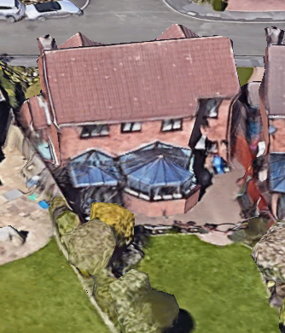
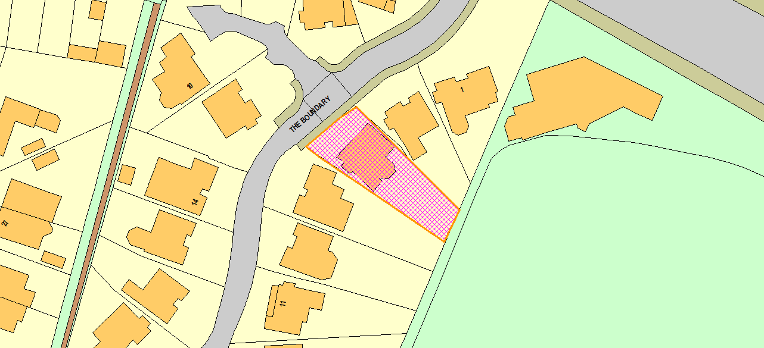
The application dwelling is a detached property located in a residential area. The topography of the land rises from the junction to the north of the site and then levels out further towards the end of the cul-de-sac. The rear gardens of the neighbouring dwellings are therefore stepped up to the SW of the site and down to the east of the site. There are no facing dwellings to the rear of the site. This area is occupied by a cricket ground. The application dwelling has 2no existing conservatories on ground floor with the neighbouring dwelling to the east at no.3 having a single storey conservatory along the common boundary.
Figure 1 - Aerial (Rear)
Figure 2 - Location

Description of Proposal

- Demolition of existing single storey rear developments (conservatories).
- Proposed single storey rear extension projecting 3.5m to the rear of the original dwelling with width of 6.7m and lean to roof structure.
- The development raises the roof of the property by 0.9m at above the existing ridge level.
- Dormer extension to the rear roof slope of the dwelling encompassing the majority of the rear roof slope projecting out to in line with the existing rear elevation of the property.

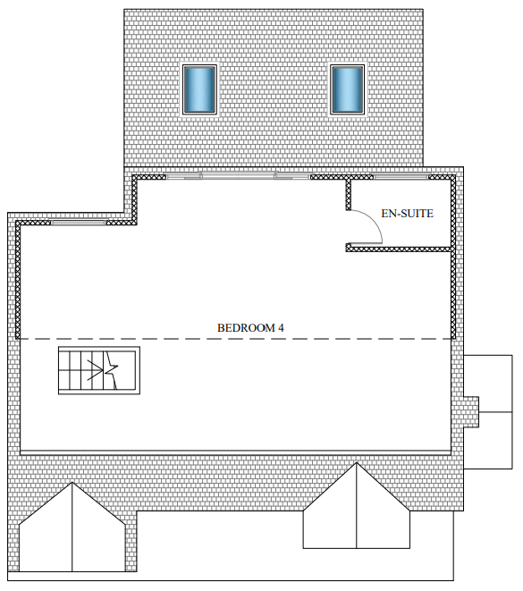
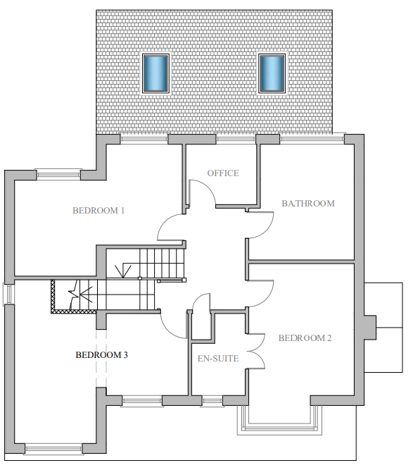
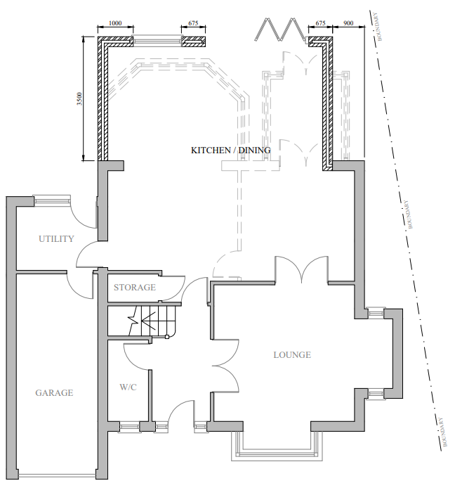
Figure 3 - Proposed SF Plan
Figure 4 - Proposed FF Plan
Figure 5 - Proposed GF Plan

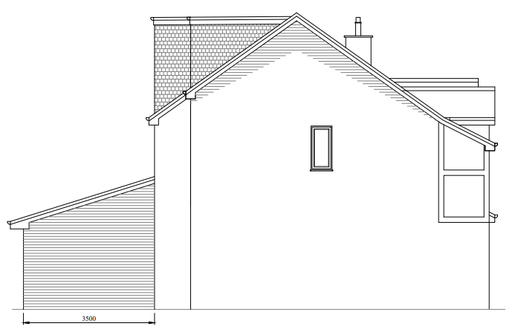
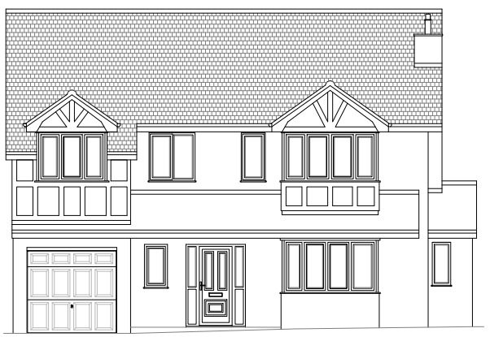
Figure 6 - Proposed Side Elevation
Figure 7 - Proposed Front Elevation

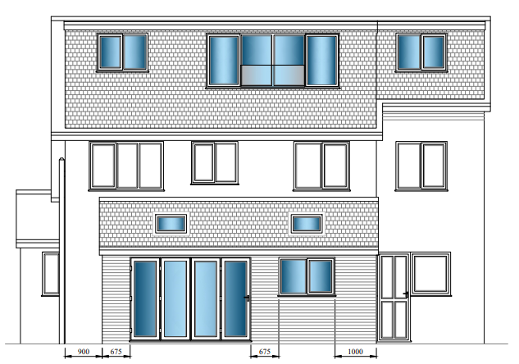
Figure 8 - Proposed Rear Elevation

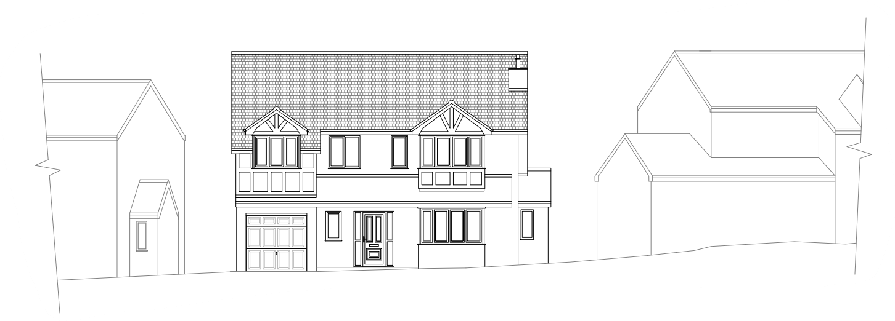
Figure 9 - Proposed Street Scene

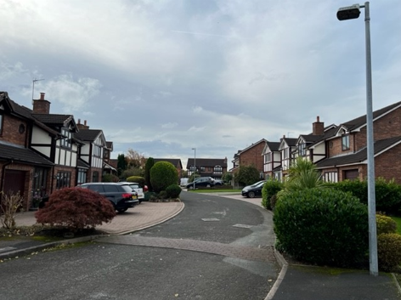
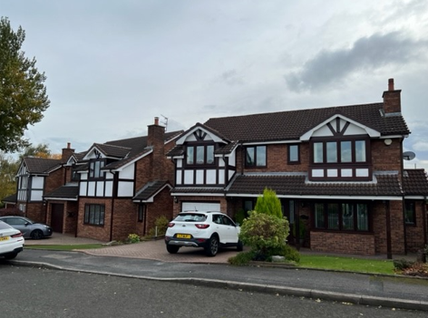
Picture 1 - Street Scene
Picture 2 - Front Elevation / No.3

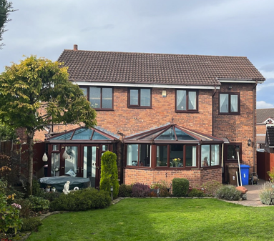
Picture 3 - Rear Elevation

Relevant Site History

No relevant site history.

Consultations

Not applicable.

Publicity
Earliest Decision Date: 11 October 2022
Revised Expiry Date: No extension agreed

Site Notice: n/a
Reason: n/a

Press Advert: n/a
Reason: n/a

Representations

5 neighbours have been consulted on the application. 1 representation has been made.

 | C – comment received R – officer response
C | - Overlooking from proposed dormer extension to neighbouring ground floor orangery accentuated by proximity of orangery to application site.  - Dominance and prominence of scale of dormer extension as well as out of keeping with original and surrounding dwellings.  - Increase of height of ridge considered to dominate skyline and poorly related to roof form of original dwelling and those surrounding.  - Dormer extension cause loss of light and overshadowing to orangery, side window and rear of the neighbouring property inc. garden area.  - Materials are out of character with original property.

Planning Policy

Development Plan Policy

Unitary Development Plan DES1 - Respecting Context
Unitary Development Plan DES7 - Amenity of Users and Neighbours
Unitary Development Plan DES8 - Alterations and Extensions

Other Material Planning Considerations

National Planning Policy Framework
National Planning Policy Guidance

Local Planning Policy

Supplementary Planning Document - House Extension

The National Planning Policy Framework (NPPF) paragraph 48 establishes that local planning authorities may give weight to relevant policies in emerging plans according to:
- The stage of preparation of the emerging plan (the more advanced its preparation, the greater the weight that may be given);
- The extent to which there are unresolved objections to relevant policies (the less significant the unresolved objections, the greater the weight that may be given); and
- The degree of consistency of the relevant policies in the emerging plan to the NPPF (the closer the policies in the emerging plan to the policies in the NPPF, the greater the weight that may be given).
There are currently two emerging plans to consider.
First, Places for Everyone Publication Plan, the joint Development Plan Document for nine districts in Greater Manchester, which was published for consultation under Regulation 19 of the Town and Country Planning (Local Planning) (England) Regulations 2012 on 9 August 2021. Representations were invited until 3 October 2021; the plan was submitted to the Secretary of State for examination on 14 February 2022 and examination hearings are due to commence in Summer 2022. The emerging policies which are relevant to this application are discussed where applicable in this report with appropriate weight being afforded in accordance with NPPF paragraph 48.

Second, the Publication Salford Local Plan: Development Management Policies and Designations (SLP:DMP), which was published on 27 January 2020 and comments were invited until 20 March 2020. An Addendum was published on 5 February 2021 and comments were invited on this until 19 March 2021. The Publication SMP:DMP and the Addendum were submitted to the Secretary of State for examination on 30 June 2021 and the examination hearings took place over 7 days in December 2021. The plan has been subject to a significant amount of public consultation in previous stages of its production and the city council has considered the comments made to determine the extent to which there are unresolved objections to its policies. Those policies (i.e. the Publication SLP:DMP policies as modified through the Addendum) which are relevant to this application are discussed where appropriate in this report with appropriate weight being afforded in accordance with NPPF paragraph 48. It is expected that the SLP:DMP will be adopted in Autumn 2022.

In addition, NPPF paragraph 219 establishes that existing policies (such as Salford’s UDP) are not out-of-date simply because they were adopted or made prior to the publication of NPPF. Due weight should be given to them, according to their degree of consistency with the NPPF, and the closer the policies in the UDP to the policies in the NPPF, the greater the weight that may be given. In terms of this application it is considered that the relevant policies of the UDP can be afforded due weight for the purposes of decision making as the relevant criteria within the UDP policies applicable to the proposed development are consistent with the policies contained in the NPPF.

Appraisal of the Proposed Development

Impact on the character of the area

- The application dwelling is located at a section of the road where the road begins to level out and therefore the neighbouring dwelling at no. 3 and no. 7 are at differing heights comparatively. The only change which would be visible from the street scene would be the increased height of the dwelling. Given the location of the dwelling, it is not considered that the increase in ridge height of the dwelling would be overly noticeable in the street scene or have a detrimental impact on it. There is not considered to be a clearly uniformity of the heights of dwellings in the street regardless of level changes and this is highlighted by the dwellings at the end of the cul-de-sac being on the same ground level but of differing ridge heights, albeit marginal:
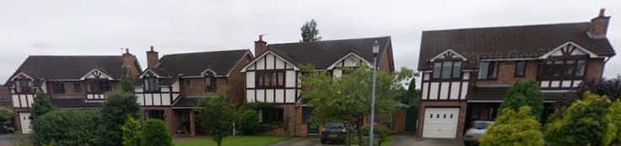
Picture 4 - Ridge Heights
- The mock tudor character of the application dwelling includes low set gable features to the front of the property. It is not considered that the increase in ridge height would have a detrimental impact on the character of the original dwelling as the frontage of the property would mostly remain the same besides a slight change to the angle and height of the roof which would not be of a sufficient enough change to have a drastic impact on the overriding character of the property or surrounding area.
- The remainder of the development, ie. the dormer extension and single storey rear extension would not be easily visible from the street and therefore have very limited impact upon it. Although there may be a slight view of the dormer in between properties, the dormer would not present enough of a view to cause a detrimental visual impact.
- The development, as a whole, uses matching materials to aid its harmonisation with the original dwelling.

Impact on the amenity of neighbours

- There are no facing dwellings to the rear of the site and therefore the habitable windows to the rear of the single storey extension and dormer extension would not be considered to directly face neighbouring dwellings to the rear.
- It is not considered that any of the windows would directly face laterally towards the associated gardens of neighbouring dwelling. However the nearest window of the dormer extension to no.3, is considered to be in close proximity to the boundary line and slightly angle in and set above a neighbouring garden which is set lower and therefore this window is to be conditioned as obscurely glazed to protect the privacy of the neighbouring occupants when using their outdoor space.
- The single storey rear extension projects 3.5m to the rear and given the presence of a conservatory to the neighbouring dwelling at no.3 would avoid intersecting the 45 degree line from the nearest rear facing habitable room window. The single storey extension would also avoid intersecting the 45 degree line from the nearest rear facing window of no.7, which is to the rear of the existing single storey extension.
- The dormer extension to the rear would be sited lower than the new ridge height of the dwelling, set in line with the eaves of the original dwelling and not built off any external walls. Therefore the development is not considered to be cause visual offense or have a detrimental impact to the wider surrounding area.
- Although it is appreciated that the neighbouring dwelling at no.3 is located on lower ground and stepped down in comparison to the application dwelling, the dormer extension would not be considered to present an overbearing appearance or loss of light to the neighbouring occupants when using the rear of the dwelling for the following reasons:
  - The location of the dormer extension would not be set in front of the existing rear building line of the neighbouring property at no.3, therefore the appearance of the dormer would not be overly visible when using the rear of the property or garden space. It is not considered that the appearance of the dormer to the rear of the property would cause an overbearing appearance, enough to have a detrimental impact on the amenity of the neighbouring occupants.
  - Given the lack of dwellings to the rear of the neighbouring dwelling at no. 3 the neighbouring property would still receive an adequate level of sunlight throughout the day regardless of the increase in height of the application dwelling and dormer extension due to the rear of the dwelling being east facing.
- The neighbouring dwelling to the south (no. 7) is stepped back at the rear in relation to the application dwelling. There are no windows to the rear of the single storey side garage and therefore the dormer extension would have no impact in terms of amenity to this section of the neighbouring dwelling. The dormer extension would not project past the rear elevation of the existing dwelling and therefore would not intersect the 45 degree line from the centre of the nearest first floor rear facing window of the no. 7. This is shown below. Although the dormer would be visible from this window, it would not be considered to be in direct site line and therefore not have a detrimental impact in terms of outlook or cause a significant reduction in daylight entering the habitable room window of the neighbouring dwelling.
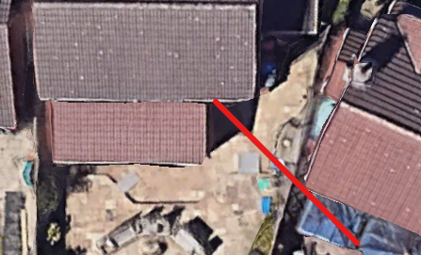
Picture 5 - 45 degree line from nearest rear facing window of no. 7

For the reasons above the development is considered to comply with relevant UDP policies as well as policies HE1, HE2, HE5 and HE10 of the Salford House Extensions SPD.

Other issues

Does the proposal require any work to trees? No

Is there a significant change in levels across the site or between the site and the neighbouring land? No

Has the applicant/agent indicated any personal circumstances? No

Approve

1. The development must be begun not later than three years beginning with the date of this permission.

Reason: Required to be imposed by Section 91 of the Town and Country Planning Act 1990 (as amended).

2. The development hereby permitted shall be carried out in accordance with the following approved plans:

- Location Plan, Existing Plans and Proposed Site Plan (001 A)
- Existing Elevations (002 A)
- Proposed Floor Plans (003 A)
- Proposed Elevations (004 A)
- Proposed Front Street Scene and Proposed Site Plan (005 A)

Reason: For the avoidance of doubt and in the interest of proper planning.

3. The external materials used shall match those of the existing building so far as practicable.

Reason: In order to ensure a satisfactory appearance in the interests of visual amenity in accordance with Policies DES1 and DES8 of the City of Salford Unitary Development Plan and the requirements of the National Planning Policy Framework.

4. The most northerly window of bedroom 4, set back from the main elevation plane of the rear dormer as shown in plan ‘003 A’ shall be fitted with, and permanently glazed, in textured glass whose obscuration level is at least 3 on the Pilkington scale of 1-5 (where 1 is clear and 5 is completely obscure).

Reason: In the interest of the amenity of residents in accordance with policy DES7 of the City of Salford Unitary Development Plan and the National Planning Policy Framework.

Statement of conformity with Article 35 of The Town and Country Planning (Development Management Procedure) (England) Order 2015

The proposal complies with the development plan and would improve the economic, social and environmental conditions of the area. It therefore comprises sustainable development and the Local Planning Authority worked proactively and positively to issue the decision without delay. The Local Planning Authority has therefore implemented the requirement in Paragraph 38 of the NPPF.

Notes to Applicant

1. STANDING ADVICE - DEVELOPMENT LOW RISK AREA

The proposed development lies within a coal mining area which may contain unrecorded coal mining related hazards. If any coal mining feature is encountered during development, this should be reported immediately to the Coal Authority on 0345 762 6848.

Further information is also available on the Coal Authority website at:
www.gov.uk/government/organisations/the-coal-authority

Standing Advice valid from 1st January 2021 until 31st December 2022

Officer | Jonathan Mumby | DC |  | LPA | M Hodgson
Date | 25/10/22 | Date |  | Date | 25.10.22

