APPLICATION No: | 22/79468/HH
APPLICANT: | Mr Naseer Ahmad
LOCATION: | 4 Finstock Close, Eccles, M30 7NP
PROPOSAL: | Retention of a two storey side/rear extension
WARD: | Barton And Winton

REASON FOR PANEL DECISION: Planning application deferred at Panel held on 16th June 2022

Description of Site and Surrounding Area

This application relates to a two-storey detached property on Finstock Close, Eccles with a mix of semi-detached and detached properties within the vicinity of the site.

Planning permission has previously been granted for a two storey side and rear extension under planning references 21/77774/HH and 21/78504/HH respectively. This application is for a two storey side and rear extension that has been recently constructed. It is an application to retain what has been built. The principle of erecting a two storey side and rear extension has been established.

Location Plan

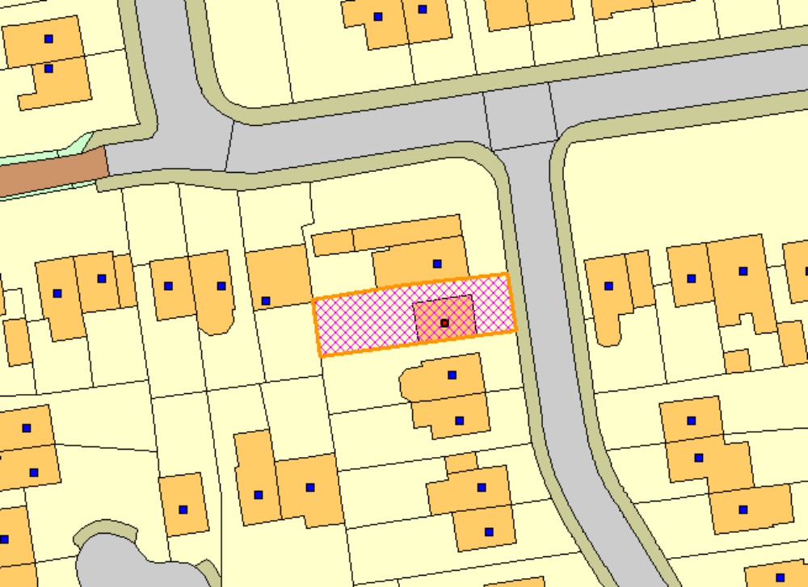

Description of Development

The two storey side/rear extension projects 2.2m from the main side elevation, the ground and first floor is set back by 1m from the main front elevation and projects 2.1m from the main rear elevation of the dwellinghouse. The extension is set off the shared common boundary by 0.3m and 0.28m respectively with the adjacent property No.2 Finstock Close.
The two storey element has a pitched roof structure. The eaves height are set marginally higher than the existing and the ridge is set lower than the main roof ridge.

Alterations from the previous approved development 21/78504/HH include:

- Raising the eaves to the front elevation by 0.40m as well as 0.45m and 0.75m respectively to the rear elevation of the two storey side extension;
- Replacement of a garage door with patio window doors in the front elevation and replacement of a window to a door in the side elevation facing No.6 Finstock Close; and
- Minor amendments to window sizes;

The external materials used included ‘Woodland Mixture’ brick and grey roof tiles, white uPVC framed openings with brick headers.

The application was deferred at Panel on 16th June 2022 in order to allow the applicant to consider ways in which:

- The appearance of the extension may be improved which could include measures to balance the asymmetrical eaves line of the rear extension and re-positioning its rear window and associated lintel and sill, and
- The materials can be matched more closely to those of the parent dwelling.

Subsequently the following details have been received dated 23/09/2022 & 29/09/2022 addressing the above:

- Increase width of the first floor window in the rear elevation of the side/rear extension to match the ground floor window including solider course brickwork to suit new window width;
- Solider course to existing brickwork above ground floor window in the rear elevation of the rear/side extension to match window width;
- Installation of concealed gutter on both sides of the roof of the rear/side extension;
- New 250mmm wide hoppers installed to serve new concealed gutter detail to extension roof to run into downpipe;
- Brickwork of the extension to be tinted to match colour profile of existing facing brick.

Floor & Elevations Plans (under the current application revised drawings received dated 29/09/2022)

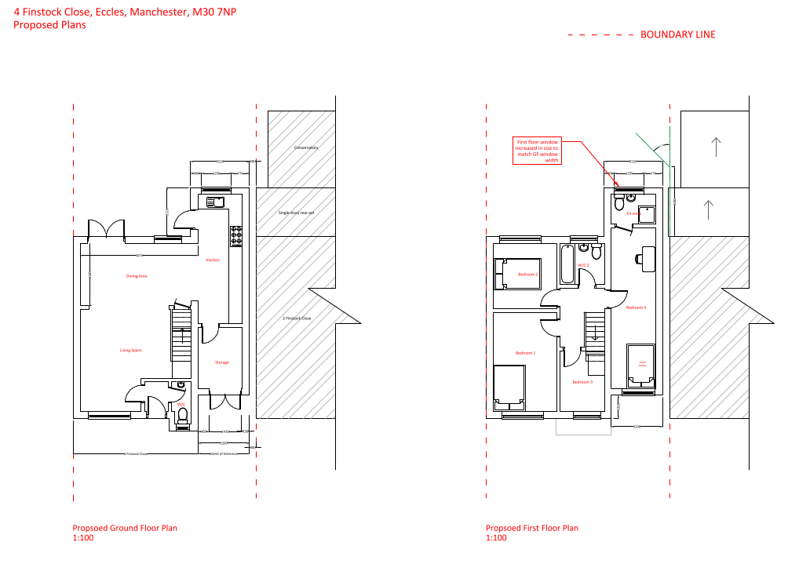

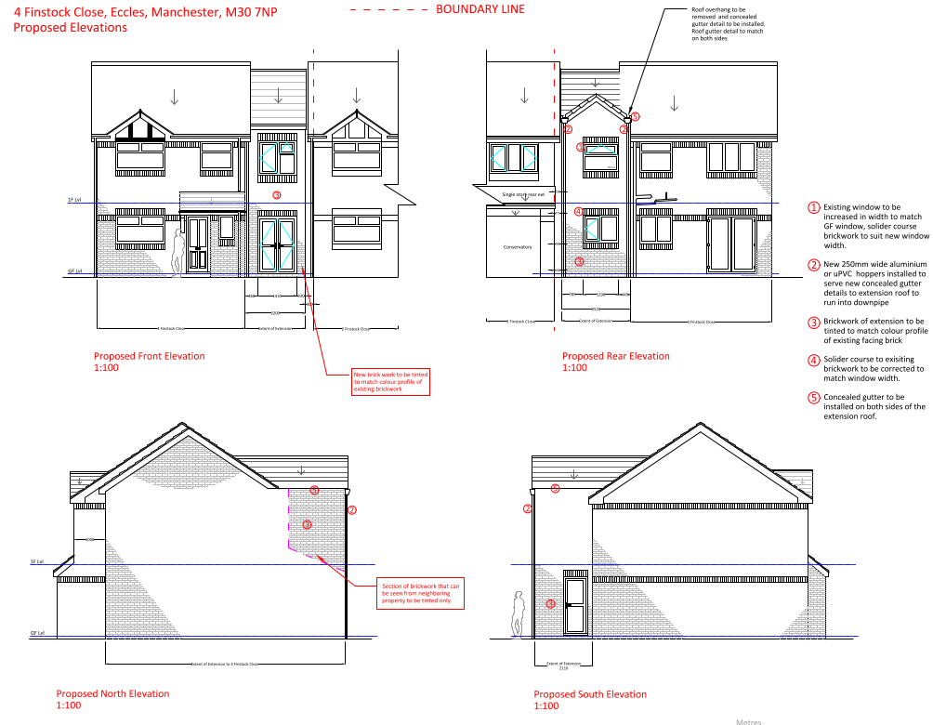

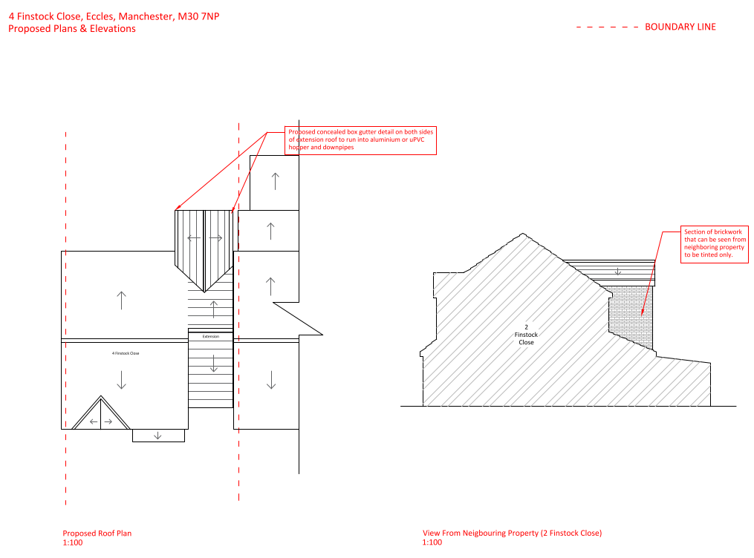

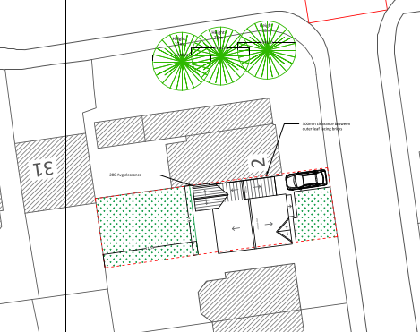

Publicity

22 representations (two from the same neighbour following a 2nd round of publicity) have been received. The following comments were made:

8 representations have been received from neighbours and 3 representations have been received from Councillor Boshell, Councillor Lancaster and Councillor Mullen, (a total of 11) a further 8 representations received, and 3 representations have been received following a 2nd round of publicity (a total of 11) whereby the following comments were made:

 | C – comment received R – officer response
C | Neighbours:  1st round of publicity/notification:  The eaves height are higher than existing dwellinghouse;  Materials of development do not match brickwork or roof tiles of the dwellinghouse;  Discrepancy between approved plans and development recently constructed;  Guttering overhang/encroachment on No.2 Finstock Close;  Poor workmanship/execution of works/leaning & safety of the two storey flank wall.  2nd round of publicity/notification:  Not enough time provided to respond to consultation, unfair and favouring the applicant;  Concerns over building quality which has been signed off by Building Control;  Object to every single action outlined and comments made by the applicant/agent;  Zero effort made to comply with regulations, nor real effort to consider the harm this has done to the neighbourhood and neighbours;  No valid resolutions have been put forward/neither a balanced approach or practical solution suggested to rectify the breaches of the NPPF, Salford UDP and permitted development policies;  This approach has been put forward to aid the homeowner and the builders and is practical only to them and does not address the major breaches of planning policies and planning approval decision;  Comments made in relation to stress on the homeowner of the host dwelling is down to cost saving measures and cowboy builders;  Brick work tinting is not an easy and straightforward methodology for correction with a low probability of success;  The brick type including texture, colour and low quality of brick used should a colour match be possible there would be differing textures which would cause the bricks to weather differently and further highlight the disparity;  Miss-match of roof tiles;  Windows are not aligned to the rear contributing to the asymmetry of the building causing it to appear unbalanced to look at – windows should be central;  Policy DES1 and DES8 has been ignored;  No consideration given to this build at any stage and blatant disregard to planning conditions further exacerbated by the dismal performance of Align Building Control and a significant lack of interest by the planning department;  The height of roof/eaves is sheer incompetence and disregard for regulations. Possible solution to hide the gutters is pointless and does not fix wider issues, building is too high and zero effort to rectify this;  Insurance should cover costs to rectify embarrassing build;  No comment regarding the illegal movement of gas supply pipe;  No.2 Finstock Close did not sign a party wall agreement or approve extension was built upon their raft;  The build sets a precedent for all and sundry to build what you want/not fair on people who abide with the regulations;  If financial burden is being considered in this case, then greater consideration needs to be given to the impact that this had on neighbours in terms of devaluation/unsellable home;  Detrimental impact on mental health during and after construction;  Only solution is that for this build to be taken down and rebuilt as it should have been in the first instance.  Councillors:  1st round of publicity/notification:  Disregard of previous planning requirements and design - not meeting agreed requirement including agreed height /size of extension;  Not matching and poor quality brick, and not meeting agreed distance from the neighbour’s wall;  Shameful standard of work including attaching the roof to No.2 Finstock Close and in doing so causing damage to the detached property;  Wall seen to lean causing concern re safety;  Residents of No.2 put house on the market due to the above concerns;  Work and damage caused will prove difficult and stress to sell property;  Negative effects on amenity including overbearing and out of character in terms of appearance and materials which do not meet original application;  Evidence - previously provided to LPA through photographs, the photos show the infringement on No.2 Finstock Close’s roof, the leaning wall and the breach of approved height and materials.  2nd round of publicity/notification:  No intention to test the brick tinting - the applicant only added a link to a company on google;  Odd that the proposal only suggested tinting part of the rear wall (one corner);  There has been no suggestion of altering the height apparently due to the inner ceiling height, error by builders and cost hardship this is not acceptable reason - had the builder made a mistake it is for them to put right;  The proximity to the neighbours house has not been rectified, the elderly neighbours have removed off the market and been advised they have a loss of £40k value on their property due to the extension at No.4;  The leaning wall has not been addressed and was previously, specifically commented on by panel members;  Generally, unless prompted by officers there has appeared to be reluctance to make any changes to rectify mistakes or to consider neighboring properties and the local neighborhood. Therefore also have difficulty in being reassured that any future work would be of any required or acceptable standard.
R | 1st Round of Publicity/Notification  Issues such as the alleged damage to No.2 Finstock Close and poor workmanship is a civil issue. Quality of work is covered under the Building Regulations 2010 with regards to materials and workmanship. However the focus is on using and installing correct products for the conditions they are being used for and not on the aesthetic quality/appearance of the finished work which is always individually subjective i.e. it may not look good but it does the job. Safety on building-leaning wall is a matter that is considered either under other legislation (such as building regulations) or as a private matter. Selling property and stress caused by development is not a planning material consideration. Drawing No.P4 REV G does not show encroachment on to the adjacent property No.2 Finstock Close. During this live application the breathable felt, which lapped into the existing gutter, has been removed, and therefore no longer cuts into No.2 Finstock Close’s roof. All other matters are discussed in the appraisal section below. In all other respects the proposal is similar as that approved under application 21/77774/HH and 21/78504/HH.  2nd Round of Publicity/Notification  Given the nature of the details provided by the applicant/agent a 10 day letter to respond to the householder application is considered to be appropriate length of time, the time limit can be extended if required. No requests were made by neighbours to the planning officer to extend the time to respond to the planning application.  The relocation of gas pipe, safety on building/leaning wall is a matter that is considered either under other legislation such as building regulations, gas network or as a private matter. Selling property/de-value of property and stress including detrimental impact on mental health caused by development is not a material planning consideration.  Drawing No.P4 Rev H – Proposed Elevations (Received dated 29/09//2022) and No.P6 Rev B – Proposed Plans & Elevations (Received dated 29/09//2022) show all elevations of the two storey side/rear extension are proposed to be brick tinted apart from the section of the side wall hidden by No.2’s Finstock Close’s flank wall. The highlighted/shaded corner elements shown on Drawing No.P4 Rev H is the agent’s drawing technique to create the illusion of depth and make the property appear three-dimensional.  As stated in the applicant’s planning statement the web page link to brick tinting specialist is a one way of a solution for the bricks used for the development to match with the existing facing house brick and whether the LPA would consider brick tinting acceptable here as a possible solution. The applicant/agent has arranged for an on-site provision of a test patch for inspection at the property and for the LPA to inspect shortly after.  The application is assessed on its own merits in accordance with planning policies. Planning material considerations are discussed in the appraisal section below. In all other respects the proposal is similar as that approved under application 21/77774/HH and 21/78504/HH.

Relevant Site History

Enforcement Case Ref: 22/00039/BRCD3 - Received: 22.02.2022 – Pending Decision

21/77774/HH - Erection of a two storey side/rear extension – Permitted

21/78504/HH - Erection of a two storey side/rear extension (resubmission of 21/77774/HH) - Permitted

The applicant re-submitted the scheme under planning application 21/78504/HH due to changes made to the side/rear extension and proposed a 1m set back from the main front elevation at ground and first floor as opposed to the approved 2m set back from the main front elevation at first floor under planning reference 21/77774/HH.

Planning Policy

Development Plan Policy

Saved policies of the City of Salford Unitary Development Plan

Unitary Development Plan DES1 - Respecting Context
Unitary Development Plan DES7 - Amenity of Users and Neighbours
Unitary Development Plan DES8 - Alterations and Extensions
Unitary Development Plan A8 - Impact of Development on Highway Network

Emerging Policies of the City of Salford Local Plan

Policy D2 - Local character and distinctiveness
Policy D5 - Amenity
Policy D8 - Alterations and extensions

Other Material Planning Considerations

National Planning Policy

National Planning Policy Framework
National Planning Policy Guidance

Local Planning Policy

Supplementary Planning Document - House Extensions

It is not considered that there are any local finance considerations that are material to the application.

The National Planning Policy Framework (NPPF) paragraph 48 establishes that local planning authorities may give weight to relevant policies in emerging plans according to:
- The stage of preparation of the emerging plan (the more advanced its preparation, the greater the weight that may be given);
- The extent to which there are unresolved objections to relevant policies (the less significant the unresolved objections, the greater the weight that may be given); and
- The degree of consistency of the relevant policies in the emerging plan to the NPPF (the closer the policies in the emerging plan to the policies in the NPPF, the greater the weight that may be given).
There are currently two emerging plans to consider.
First, Places for Everyone Publication Plan, the joint Development Plan Document for nine districts in Greater Manchester, which was published for consultation under Regulation 19 of the Town and Country Planning (Local Planning) (England) Regulations 2012 on 9 August 2021. Representations were invited until 3 October 2021; the plan was submitted to the Secretary of State for examination on 14 February 2022 and examination hearings are due to commence in Summer 2022. The emerging policies which are relevant to this application are discussed where applicable in this report with appropriate weight being afforded in accordance with NPPF paragraph 48.

Second, the Publication Salford Local Plan: Development Management Policies and Designations (SLP:DMP), which was published on 27 January 2020 and comments were invited until 20 March 2020. An Addendum was published on 5 February 2021 and comments were invited on this until 19 March 2021. The Publication SMP:DMP and the Addendum were submitted to the Secretary of State for examination on 30 June 2021 and the examination hearings took place over 7 days in December 2021. The plan has been subject to a significant amount of public consultation in previous stages of its production and the city council has considered the comments made to determine the extent to which there are unresolved objections to its policies. Those policies (i.e. the Publication SLP:DMP policies as modified through the Addendum) which are relevant to this application are discussed where appropriate in this report with appropriate weight being afforded in accordance with NPPF paragraph 48. It is expected that the SLP:DMP will be adopted in Summer 2022.

In addition, NPPF paragraph 219 establishes that existing policies (such as Salford’s UDP) are not out-of-date simply because they were adopted or made prior to the publication of NPPF. Due weight should be given to them, according to their degree of consistency with the NPPF, and the closer the policies in the UDP to the policies in the NPPF, the greater the weight that may be given. In terms of this application it is considered that the relevant policies of the UDP can be afforded due weight for the purposes of decision making as the relevant criteria within the UDP policies applicable to the proposed development are consistent with the policies contained in the NPPF.

Appraisal

Impact on the character of the area

The development of a two storey side and rear extension has been already established as being acceptable under planning applications 21/77774/HH & 21/78504/HH and has recently been constructed but in a modified form. In particular the extension is set back 1m from the line of the main principal/elevation to prevent an actual or perceived terracing effect. Policy HE8,( which applies to semi-detached or detached dwellings) of the council’s adopted Householder SPD is therefore met.

The extension is visible from the street scene. The scale, massing, roof form and fenestration detailing including concealed gutter boxes is appropriate. Although the eaves height of the extension has been built above that of the main dwellinghouse the extension still appears as a subordinate addition against the host dwelling.

Photographs of extension as built:

Front elevation Rear Elevation l

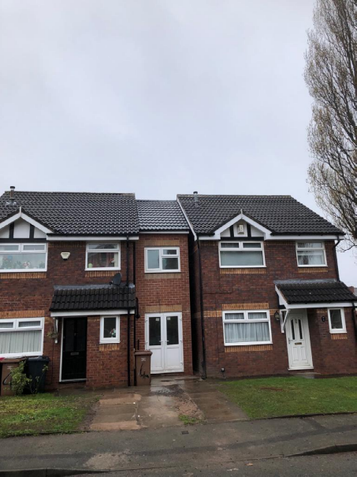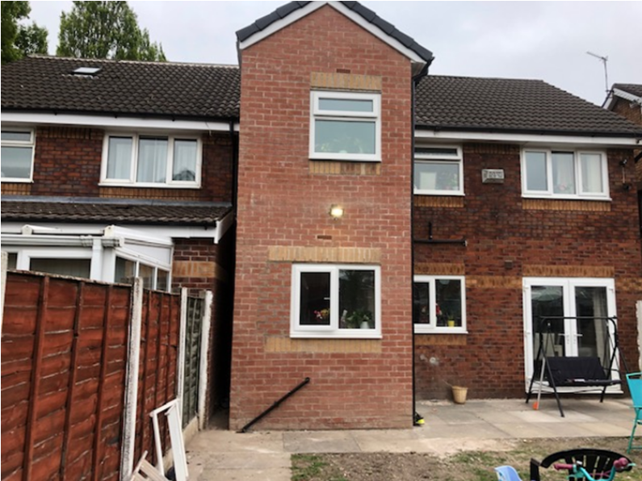

The applicant has provided a Planning Statement (received dated 23rd September 2022) referencing details of brick tinting as part of their submission in order to better match the brick used for the extension with the existing facing brick of the dwellinghouse. The brick tinting as annotated on Drawing No. P4 Rev H received dated 29/09/2022 would be applied to all elevations of the development apart from a section of the side wall of the extension hidden by No.2 Finstock Close’s flank wall.

Given the level of information/details submitted by the agent and brick tinting specialist it is considered a satisfactory brick tint can be achieved on the facing brick used to build the extension which will result in a better match with the original brickwork. As part of this process a test patch for inspection at the property has been arranged for the LPA to inspect and determine if suitable. A condition has been added to ensure this will take affect within a certain time period.

The other combination of works outlined above ,which are mainly to the rear of the dwelling, would serve to better harmonise the integration of the extension with the original dwelling and remove some unfortunate building mistakes. Policy DES8 of the adopted development plan and its replacement (D8) is concerned with ensuring alterations or extensions respect the general scale, character, rhythm, proportions, details and materials of the original structure and complement the general character of the surrounding area. The design of alterations and extensions must ensure the resultant building appears as an attractive and coherent whole…

It is clear that the extension is of a subordinate scale and its design and appearance (with the modifications now proposed) represents a cohesive whole with that of the original dwelling. The use of brick tinting will only serve to add to that cohesiveness. It is on the other hand clear that the raised eaves heights (more pronounced at the rear) are perhaps somewhat at odds with the desire to integrate the extensions both to its host and the surrounding area. However, as a matter of planning judgement this slight discordant feature is not harmful to the appearance of the house in the street scene or with its neighbours.

On this basis, it is considered that the development is considered acceptable in relation to its impact on the character of the area in accordance with UDP Policies DES1, DES8, emerging SLP Policies D2 and D8 and Policy HE8 cited within the House Extensions SPD.

Impact on the amenity of neighbours

The proposed two storey side/rear extension have been already established as acceptable in the reports 21/77774/HH & 21/78504/HH.

An opening is created in front elevation of the extension at ground and first floor. It is considered that the development does not cause harm to any nearby occupiers as it does not project beyond the parent dwelling at the front therefore it does not introduce any significant additional overlooking to the property opposite.

No openings are positioned in the side elevation of the extension.No.2 Finstock Close has one opening in their gable elevation at the apex of the roof serving a roof space and with principal windows serving habitable rooms in the front and rear elevations of their dwellinghouse. In this instance it is considered the development does not result in an unacceptable loss of daylight and/or sunlight, be overbearing or create undue overshadowing, overlooking or loss of privacy to neighbours.

No.31 Guilford Road lies beyond the applicant’s rear site boundary set perpendicular to the host dwelling. A distance of circa.11m is maintained between the development and the rear site boundary with No.31’s garden beyond. The development proposes an opening at ground floor serving a kitchen given the location of the 1.8m high fencing interrupting views, the ground floor of the development does not introduce any significant additional overlooking to the garden opposite.

The insertion/alteration of an obscure window at first floor in the rear elevation of the extension serving an en-suite (non-habitable room) does not result in a significant loss of privacy to the neighbouring residents nor does it have an unacceptable loss of light and/or be overbearing for neighbouring residents beyond the rear shared site boundary.

In the absence of an extension along the common boundary to the adjacent dwelling No.6 Finstock Close the projection of the rear/side extension is set off the shared boundary by more than it exceeds. Given the distance of 5m maintained to the shared common boundary it is considered that the development does not result in an unacceptable loss of daylight, privacy and/or sunlight, or pose a detrimental overbearing impact or create undue overshadowing to neighbouring occupiers at No.6 complying with Policy HE7 and HE2 of the House Extensions SPD.

To the other side, the adjacent property No.2 Finstock Close has a single storey rear extension sited along the common boundary with the host dwelling. The first floor of the side/rear extension does not project beyond the neighbour’s ground floor extension and does not project beyond a point 3m along the common boundary from the rear elevation of No.2. It is considered that the development does not result in an unacceptable loss of daylight and/or sunlight or pose a detrimental overbearing impact or create undue overshadowing to neighbouring occupiers at No.2 complying with Policy HE6 of the House Extensions SPD.

Given this, it is considered the impact on the amenities of neighbouring occupants remain as previously judged, as there are no significant material changes made to that part of the development. The development does not therefore cause any substantial harm to the amenity or privacy of the neighbouring occupiers and is in line with saved UDP Policy DES7, emerging SLP Policy D5, SPD and the NPPF.

Impact on the highway network

The development introduces an additional bedroom from 3 to 4 bed. It is considered that there is sufficient hard standing to the front to accommodate 1 vehicle within the curtilage and areas of unrestricted parking on the road. The development would not create a severe impact on the highway network.

Recommendation

Approve

- The following plans have been considered in the assessment of this application:

- Drawing No.P1 Rev B – Location & Block Plan (Received dated 29/09//2022)
- Drawing No.P2 Rev B – Existing Plans (Received dated 29/09//2022)
- Drawing No.P3 Rev H – Proposed Floor Plans (Received dated 29/09//2022)
- Drawing No.P4 Rev H – Proposed Elevations (Received dated 29/09//2022)
- Drawing No.P5 Rev D – Proposed Site Plan (Received dated 29/09//2022)
- Drawing No.P6 Rev B – Proposed Plans & Elevations (Received dated 29/09//2022)

Reason: For the avoidance of doubt and in the interest of proper planning.

- Within 3 months from the issue date of this permission, the following works the details of which are shown on the plans in condition 1 shall be commenced and shall be completed within 6 months of the date of issue of this permission.

- Increase width of the first floor window in the rear elevation of the side/rear extension to match the ground floor window including solider course brickwork to suit new window width;
- Solider course to existing brickwork above ground floor window in the rear elevation of the rear/side extension to match window width;
- Installation of concealed gutter on both sides of the roof of the rear/side extension;
- New 250mmm wide hoppers installed to serve new concealed gutter detail to extension roof to run into downpipe.

Reason: In order to ensure a satisfactory appearance in the interests of visual amenity in accordance
with Policies DES1 and DES8 of the City of Salford Unitary Development Plan and the requirements of
the National Planning Policy Framework.

- The first floor window in the rear elevation facing the common boundary with No.31 Guilford Road, shall be fitted with, and permanently glazed, in textured glass whose obscuration level is at least 3 on the Pilkington scale of 1-5 (where 1 is clear and 5 is completely obscure).

Reason: In the interest of the amenity of residents in accordance with policy DES7 of the City of Salford Unitary Development Plan and the National Planning Policy Framework.

- Within 1 month from the issue date of this decision, details of the proposed brick tinting shall be submitted to and approved in writing by the Local Planning Authority. Such details shall include the on-site provision of a test patch for inspection and approval by the local planning authority within that same 1 month period. The brick tinting as may be approved shall be applied to all the brick finishes of the extension the subject of this permission (save for the gable wall that faces the main gable end of No.2 Finstock) within 6 months of the written approval being given by the local planning authority and shall be maintained in such a colour tint thereafter.

Reason: In order to ensure a satisfactory appearance in the interests of visual amenity in accordance
with Policies DES1 and DES8 of the City of Salford Unitary Development Plan and the requirements of
the National Planning Policy Framework.

Statement of conformity with Article 35 of The Town and Country Planning (Development Management Procedure) (England) Order 2015

The proposal complies with the development plan and would improve the economic, social and
environmental conditions of the area. It therefore comprises sustainable development and the Local
Planning Authority worked proactively and positively to issue the decision without delay. The Local
Planning Authority has therefore implemented the requirement in Paragraph 38 of the NPPF.

