HOUSE EXTENSION REPORT

REF: 21/78497/HH

Address: 5 Hope Street, Kersal, Salford, M7 2ES

Proposal: Demolition of existing rear conservatory. Erection of single storey rear extension with first floor terrace with privacy screens

Appropriate consultation undertaken Yes
Earliest Decision date: 28 October 2021
Reason for delay beyond stat deadline and EoT: 21 October 2022

Description of Site and Surrounding Area

- This application relates to a large semi-detached dwelling located on the northern side of the road. The subject dwelling features bay windows to the front on the ground and first floor level, with a pitched roof gabled dormer to the front that attaches to that of the adjoining neighbour no. 7.This provides further accommodation in the roof space.
- To the rear of the dwelling, it has a roof canopy lying across the full width of the house, then followed with a conservatory lying along the common boundary with the adjacent neighbour no. 3. Such design is replicated within the adjoining neighbour.
- The application site sits within the conservation area of The Cliff. To the northeast (rear), it is the Star Inn which is on the local list of buildings, structures and features of architectural, archaeological or historic interest.
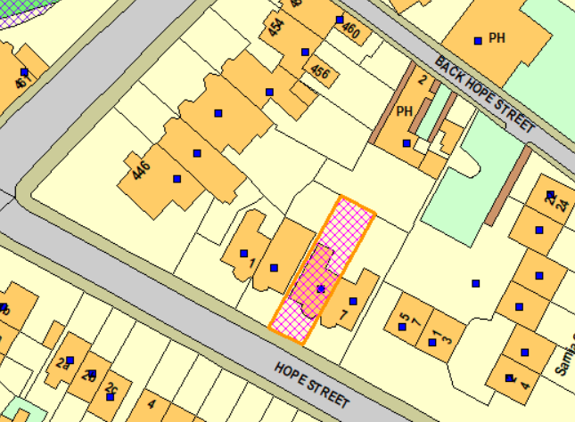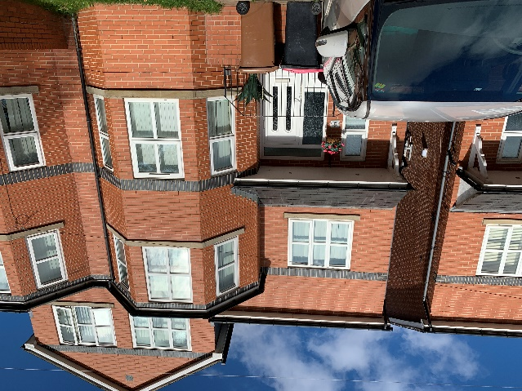
Figure 1 – the subject site under consideration Figure 2 – the subject dwelling

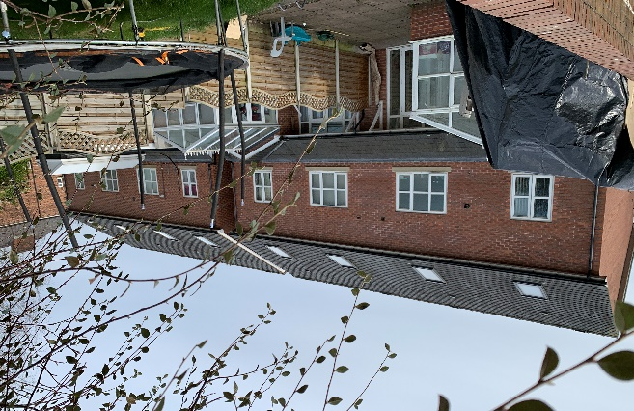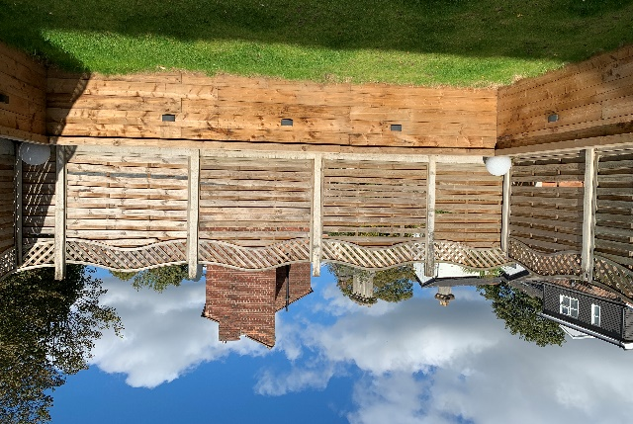
Figure 3 – the rear elevations of the subject dwelling and the Figure 4 – the rear garden of the subject dwelling
adjoining neighbour no. 7

Description of Proposal

Demolish the existing rear conservatory to make way for the following:

- Single storey rear extension
  - Project 4.4m - 5.2m from the rear elevation of the subject dwelling and across the full width of the house.
  - There would be 2no. pairs of patio doors inserted to the rear, leaving blank gable walls on both sides.
  - It would have a flat roof at a height of 2.9m, with a sukkah rooflight on top.

- First floor terrace with privacy screen
  - On top of the proposed rear extension, a terrace is proposed at the same depth of the extension and just over half the width of the extension (3.6m).
  - It would be bounded by 1.1m tall brick walls with 0.8m tall privacy screening on top of the walls on both sides. There would be 1.1m tall balustrading to the front of the terrace.
Plans and drawings are shown below:

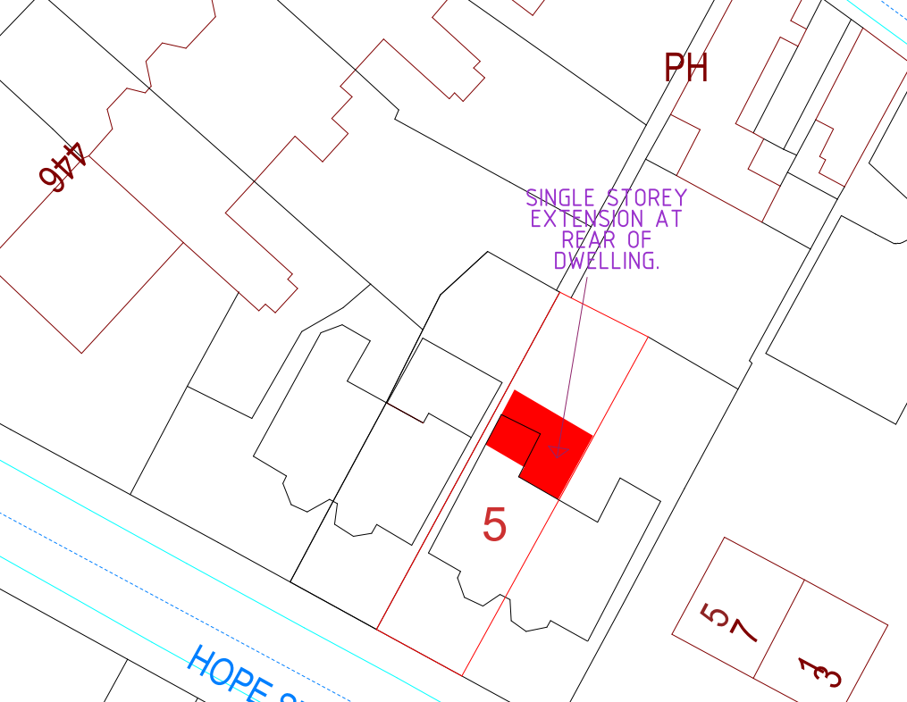
Figure 5 – the proposed site plan

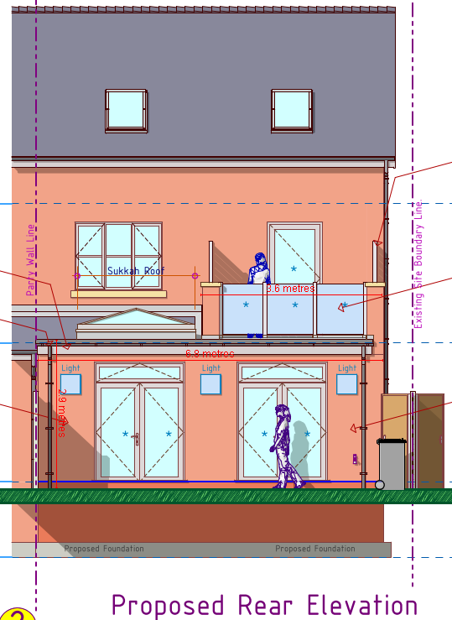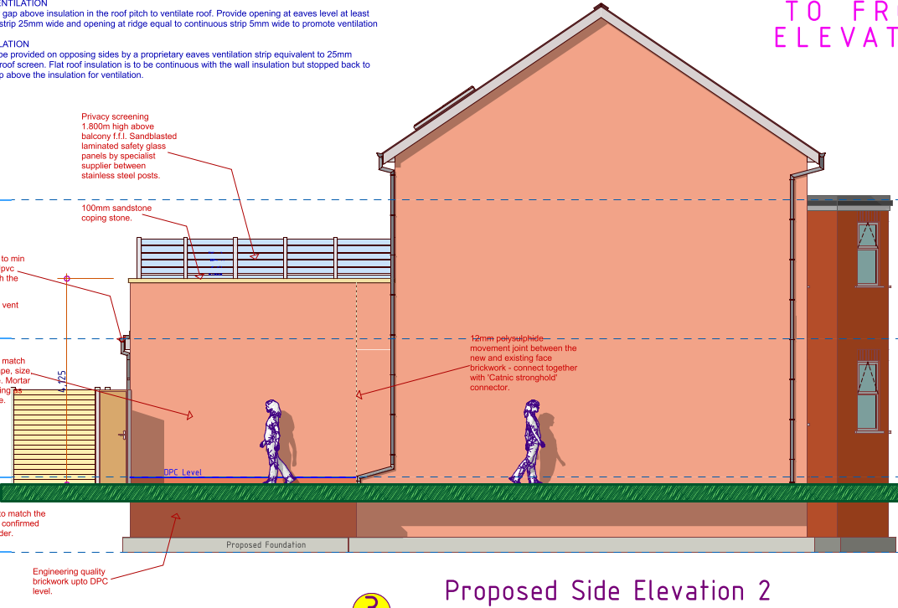

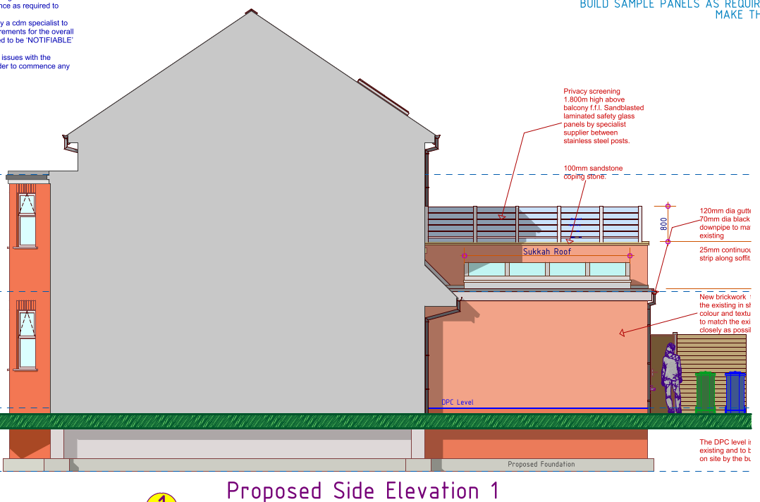
Figure 6 – the proposed elevations

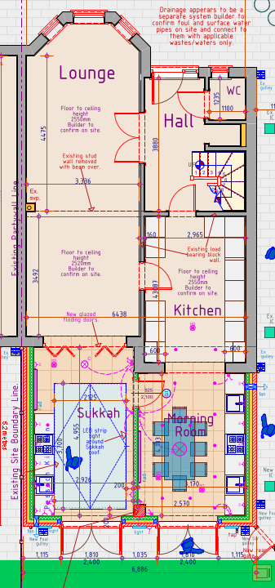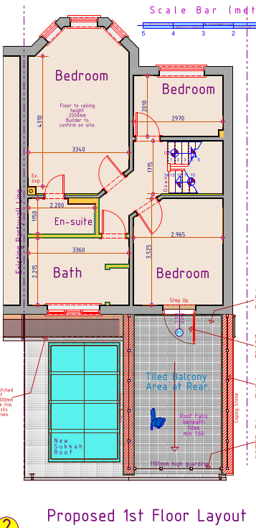
Figure 7 – the proposed ground (left) and first (right) floor plan

Relevant Site History

The block of dwellings along this side of Hope Street:
04/49437/FUL - Erection of two pairs of semi -detached houses together with associated car parking and creation of new vehicular and pedestrian access (amendment to planning approval 03/47037/FUL) – Approved (16.12.2004)

03/47037/FUL - Erection of four - three storey town houses together with associated car parking and creation of new vehicular access – Approved (18.12.2003)

Consultations

Heritage officer: no objection

Publicity
Earliest Decision Date: 28 October 2021
Revised Expiry Date: 21 October 2022

Site Notice: Household within Conservation Area Date Displayed: 6 October 2021
Reason: Planning App in Conservation Area

Press Advert: Manchester Weekly News Salford Edition Date Published: 7 October 2021
Reason: Planning App in Conservation Area

Representations

The occupiers of No 3 and No 7 Hope Street have made representations supporting the planning application stating that the applicant had consulted them both prior to the submission of the application and to allow any thoughts on the proposals to be considered. Both neighbours have stated that they find the proposals would have inconsequential impacts on the enjoyment of their properties and have given their full and unconditional support to the proposals.

Cllr Walters supports the proposed development.

Planning Policy

Development Plan Policy

Currently adopted plan (City of Salford Unitary Development Plan) -
Unitary Development Plan CH3 – Works within conservation areas
Unitary Development Plan DES1 - Respecting Context
Unitary Development Plan DES7 - Amenity of Users and Neighbours
Unitary Development Plan DES8 - Alterations and Extensions

Emerging plan (SLP:DMP) -
Policy D1 - Design principles
Policy D2 - Local character and distinctiveness
Policy D5 - Amenity
Policy D8 - Alterations and extensions

Other Material Planning Considerations

National Planning Policy Framework
National Planning Policy Guidance

Local Planning Policy

Supplementary Planning Document - House Extension

The National Planning Policy Framework (NPPF) paragraph 48 establishes that local planning authorities may give weight to relevant policies in emerging plans according to:
- The stage of preparation of the emerging plan (the more advanced its preparation, the greater the weight that may be given);
- The extent to which there are unresolved objections to relevant policies (the less significant the unresolved objections, the greater the weight that may be given); and
- The degree of consistency of the relevant policies in the emerging plan to the NPPF (the closer the policies in the emerging plan to the policies in the NPPF, the greater the weight that may be given).
There are currently two emerging plans to consider.
First, Places for Everyone Publication Plan, the joint Development Plan Document for nine districts in Greater Manchester, which was published for consultation under Regulation 19 of the Town and Country Planning (Local Planning) (England) Regulations 2012 on 9 August 2021. Representations were invited until 3 October 2021; the plan was submitted to the Secretary of State for examination on 14 February 2022 and examination hearings are due to commence in Summer 2022. The emerging policies which are relevant to this application are discussed where applicable in this report with appropriate weight being afforded in accordance with NPPF paragraph 48.

Second, the Publication Salford Local Plan: Development Management Policies and Designations (SLP:DMP), which was published on 27 January 2020 and comments were invited until 20 March 2020. An Addendum was published on 5 February 2021 and comments were invited on this until 19 March 2021. The Publication SMP:DMP and the Addendum were submitted to the Secretary of State for examination on 30 June 2021 and the examination hearings took place over 7 days in December 2021. The plan has been subject to a significant amount of public consultation in previous stages of its production and the city council has considered the comments made to determine the extent to which there are unresolved objections to its policies. Those policies (i.e. the Publication SLP:DMP policies as modified through the Addendum) which are relevant to this application are discussed where appropriate in this report with appropriate weight being afforded in accordance with NPPF paragraph 48. It is expected that the SLP:DMP will be adopted in Autumn 2022.

In addition, NPPF paragraph 219 establishes that existing policies (such as Salford’s UDP) are not out-of-date simply because they were adopted or made prior to the publication of NPPF. Due weight should be given to them, according to their degree of consistency with the NPPF, and the closer the policies in the UDP to the policies in the NPPF, the greater the weight that may be given. In terms of this application it is considered that the relevant policies of the UDP can be afforded due weight for the purposes of decision making as the relevant criteria within the UDP policies applicable to the proposed development are consistent with the policies contained in the NPPF.

Appraisal of the Proposed Development

Impact on the character of the area

- Policy CH13 aims to only permit development in conservation areas where it would preserve or enhance the character or appearance of the Conservation Area. This is supported by SPD paragraph 13.3 that extensions to properties within Conservation Areas are likely to be particularly sensitive, and the design standards applied may be stricter than those outlined for non-designated areas.
- The application property and its neighbouring properties have been identified within the conservation area appraisal as positive contributors to The Cliff – they are good examples of Regency style houses with a simple amount of decoration in the form of terracotta plaques and mouldings to the bay windows. Notwithstanding this, it is considered that the vast majority of the architectural detailing were focused on the front elevations of the properties.
- The proposed development would be positioned to the rear of the subject dwelling and hence not be visible from the street scene. As such, it would not impact upon features that contribute to the character and appearance of the area and therefore not to impact upon views into and out of the conservation area.
- The Council’s heritage officer has raised no objection to the proposal, subject to the materials used to match the existing main dwelling. A condition is attached to ensure this.
- Overall, the proposal is therefore considered to be in accordance with the provisions of the NPPF, policy CH8 of the development plan and policy HE1 of the SLP:DMP which can now be afforded some weight in the determination of planning applications.

Impact on the amenity of neighbours

- The proposed ground rear patio doors would face onto the rear boundary that screens out the views and thus not to have any interplay with neighbouring windows/openings.
- The proposed terrace/balcony on top of the ground floor extension would be bounded by brick walls to both sides with obscurely glazed privacy screens on top. There would be 1.1m tall balustrading to the front of the terrace. Given such, it would have some views onto the amenity space of the rear neighbour the Star Inn (which is not a residential space to be protected) and not to overlook onto that of the adjacent neighbours no. 3 and 7. The enclosure of the terrace/balcony area whilst using the same brick would have a lighter top with the screening panels and thus not to add significant bulk to the proposed development and so is considered acceptable. Taken altogether, the proposal would not generate any undue overlooking to the neighbouring residents.

- The proposed ground floor extension would project 4.4m along the northwestern boundary shared with no. 3. As such, it would be in line with the existing single storey rear extension at no. 3 and not to project beyond a 45 degree line drawn from the mid-point of any ground floor principal habitable room window in no. 3 in accordance with Policy HE 5. In addition the increase in the height of the extension wall to form the enclosure to the terrace would be separated by the gap between no. 5 and no. 3 and is of a height and design that would not unacceptably impinge on the outlook from the nearest habitable room windows at no. 3 or be overbearing or result in overshadowing.
- With regards to the adjoining neighbour no. 7, it has a patio door to the rear serving its dining room next to the shared boundary. It is established that there are inter-connecting doors in between the living room (which is to the front of the dining room and served by the bay windows and is south facing) and the dining room and so arguably this combination of rooms would enable light to be borrowed from the front aspect. No. 7 also has a conservatory extension set away from the boundary and given this offset the continued enjoyment of it as an amenity is unlikely to be unacceptably affected by the proposed development. No. 7 also has a reasonable size (width and depth) rear garden and with the proposal in place the occupants would still enjoy the sense of openness and not being hemmed in by overbearing built development. With the lightweight structure of the conservatory at no. 7, the tunnelling effect of the proposed extension on the patio window is less pronounced (compared to a more solid structure). So the harm to the enjoyment of the outside space and conservatory is not significant.
- The rear patio window of no. 7 faces north and sits under a simple projecting canopy. It is likely that the introduction of the extension as proposed (even taking into account its length and height) would not unacceptably impinge on the receipt of daylight or sunlight or result in unacceptable over shadowing.
- What remains to be considered is whether the extension is judged to be overbearing and as such harmful to the amenities of the those who occupy no7 or who would do so in the future. Policy DES7 seeks to strike a balance between those who wish to extend and to protect the amenity of those occupants who are neighbours. It does on the one hand seek to provide users with a satisfactory level of amenity (space, sunlight, daylight, privacy, aspect and layout). On the other where the development that would unacceptably impact on the amenity of the occupiers of neighbouring development will not be permitted. Policy HE5 of the adopted HH SPD seeks to balance the above by suggesting that a specified “rule” (in this case a 45 degree rule) should not normally be broken if permission is to be granted. In this case the 45 degree rule would be broken-see diagram/picture below. The guidance allows the situation where it would the longest extension so the red line.

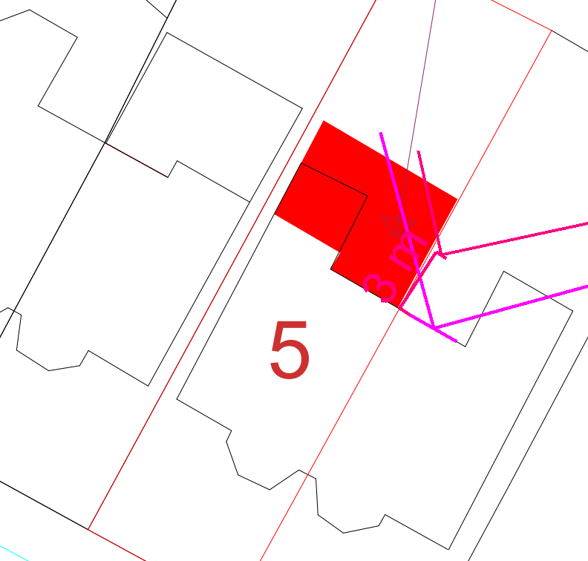
Figure 8 – the 45 degree test on the rear window of the adjoining neighbour no. 7

- It has already been demonstrated that the impact is likely to be limited to that of whether the proposed extension would be overbearing. It is considered that the feeling of being overbearing is concentrated on the impact to the outlook from the rear patio windows next door. The applicant has submitted a written statement explaining why the extra space/room to the ground floor is needed. This statement talks about the particular needs of the family to exercise their religious and family beliefs and freedoms. It states that there are supply and demand issues regarding the availability of appropriate housing given the constrained geography/area that the Orthodox Jewish community have settled in, such that large houses are very scarce. To remain in the community extensions are therefore needed. There is clarity on the needs around cooking and kitchen preparation (need for separate areas); the sukkah and the desire to have more generous space for family life and enjoying family gatherings. The proposal would allow what are overcrowded conditions on the ground floor to be resolved and improve family life including space for their large and growing family for gatherings homework and religious festivals. The letters of support from the immediate neighbours would give weight to the statements that have been made. Weight can be attributed to the neighbours representations and to a degree to the statement made by the applicant although the latter should not be determinative in its own right.
- In light of the above, it is on balance considered there is likely to be some harm to the outlook from the patio windows at no. 7 but that harm is limited despite the proposal extending beyond the red line depicted above. Weight has been attached to the supportive representations of the neighbours and to a lesser degree to the statement made by the applicant.

Other issues

Does the proposal require any work to trees? No.

Is there a significant change in levels across the site or between the site and the neighbouring land? No.

Has the applicant/agent indicated any personal circumstances? Yes – see the appraisal section above.

Recommendation:

Approve, subject to the following conditions:

1. The development must be begun not later than three years beginning with the date of this permission.

Reason: Required to be imposed by Section 91 of the Town and Country Planning Act 1990 (as amended).

2. The development hereby permitted shall be carried out in accordance with the following approved plans:

Site Plan (Received: 27.09.2021)
Proposed Elevations (Received: 27.09.2021)
Existing and Proposed Ground Floor Layout (Received: 27.09.2021)
Existing and Proposed First Floor Layout (Received: 27.09.2021)

Reason: For the avoidance of doubt and in the interest of proper planning.

- The external materials used shall match those of the existing building so far as practicable.

Reason: In order to ensure a satisfactory appearance in the interests of visual amenity in accordance with Policies DES1 and DES8 of the City of Salford Unitary Development Plan and the requirements of the National Planning Policy Framework.

- The proposed privacy screening shall be built on both sides of the first floor balcony, as specified within the approved plans referenced in Condition 2 of this permission, prior to its first use and shall be retained and maintained in its approved form thereafter. The privacy screening shall be fitted with, and permanently glazed, in textured glass whose obscuration level is at least 3 on the Pilkington scale of 1-5 (where 1 is clear and 5 is completely obscure).
Reason: In the interest of the amenity of residents to ensure privacy is retained in accordance with policy DES7 of the City of Salford Unitary Development Plan and the National Planning Policy Framework.

Statement of conformity with Article 35 of The Town and Country Planning (Development Management Procedure) (England) Order 2015

The proposal complies with the development plan and would improve the economic, social and environmental conditions of the area. It therefore comprises sustainable development and the Local Planning Authority worked proactively and positively to issue the decision without delay. The Local Planning Authority has therefore implemented the requirement in Paragraph 38 of the NPPF.

Notes to Applicant

- STANDING ADVICE - DEVELOPMENT LOW RISK AREA

The proposed development lies within a coal mining area which may contain unrecorded coal mining related hazards. If any coal mining feature is encountered during development, this should be reported immediately to the Coal Authority on 0345 762 6848.

Further information is also available on the Coal Authority website at:
www.gov.uk/government/organisations/the-coal-authority

Standing Advice valid from 1st January 2021 until 31st December 2022

Officer | Mandy Pang | DC |  | LPA | M Hodgson
Date | 20.10.2022 | Date |  | Date | 20.10.22

