HOUSE EXTENSION REPORT

REF: 22/80296/HH

Address: 7 Cliff Crescent, Salford, M7 2FQ,

Proposal: Erection of lightwell to front, single storey side extension and single storey rear extension

Appropriate consultation undertaken Yes
Earliest Decision date: 16 September 2022
Reason for delay beyond stat deadline and EoT: N/A

Description of Site and Surrounding Area

- This application relates to a two-storey large-sized semi-detached house on the northern side of Cliff Crescent.
- The subject dwelling has an existing single storey rear extension of 3.3m deep, accommodating the kitchen. It has also an existing rear dormer on the second floor level.
- The applicant site is bounded by dwarf brick walls to the front with hedges above It sits west to the neighbour properties 2 and 3 Cliff Grange which feature a single storey flat-roofed extension and an outbuilding respectively to their rear.
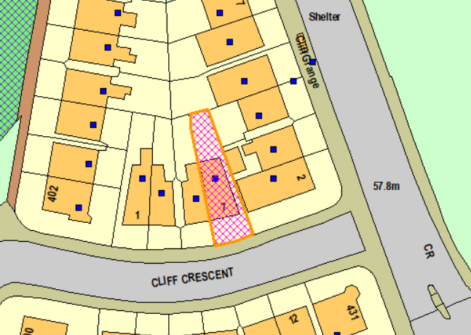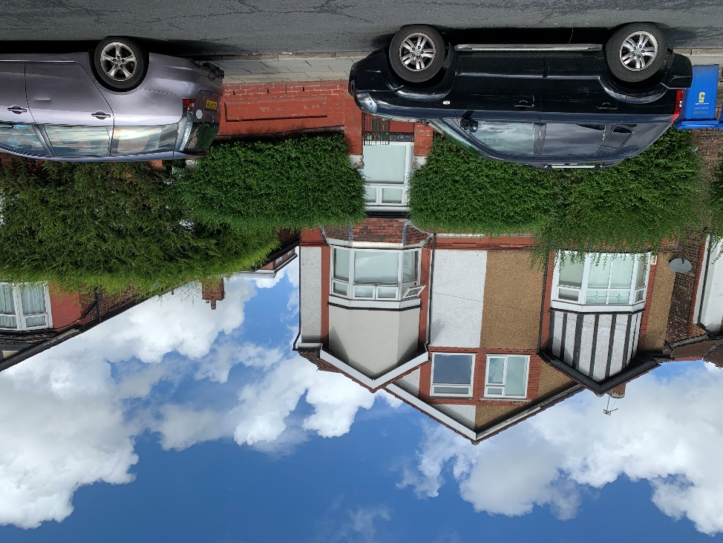
Figure 1 – the subject site under consideration Figure 2 – the subject dwelling

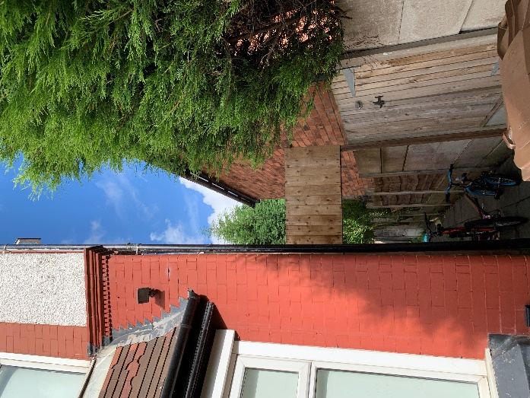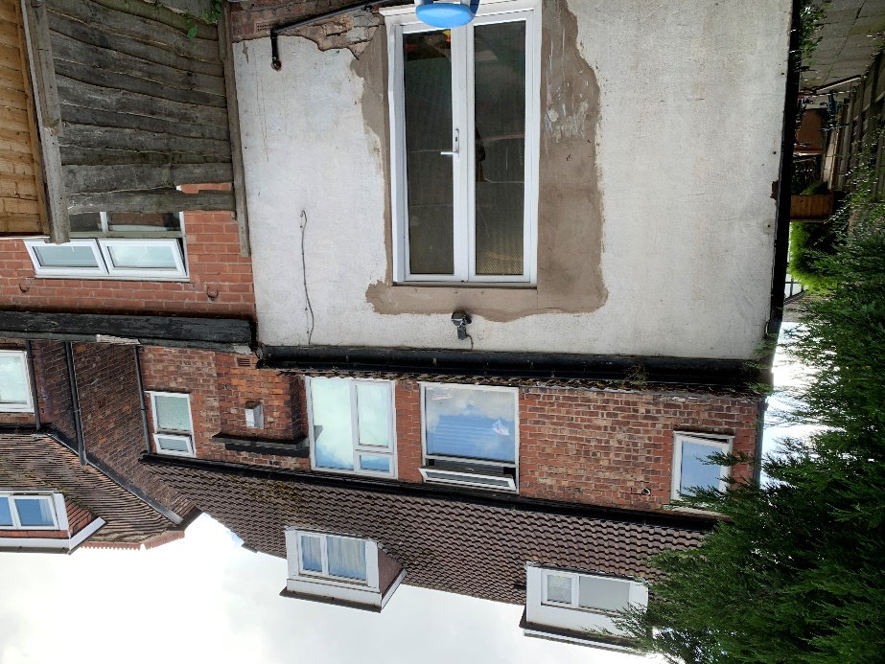
Figure 3 – the eastern side of the subject dwelling Figure 4 – the rear elevation of the subject dwelling
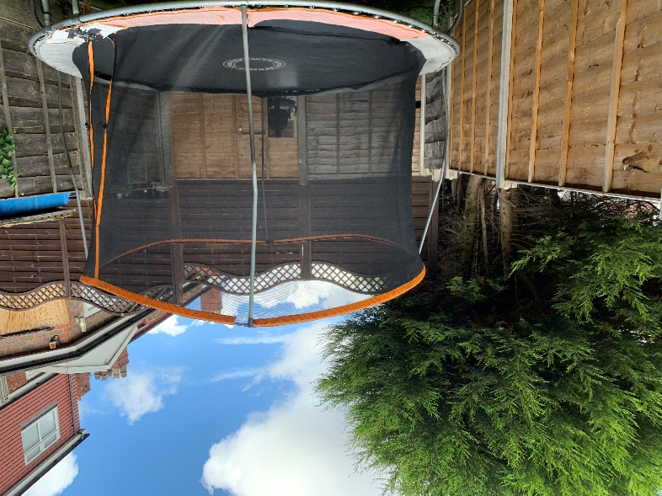
Figure 5 – the rear garden of the site

Description of Proposal

- Lightwell to the front
  - To provide light into the playroom at the basement level

- Single storey side extension
  - Front section: to expand the kitchen area and create a WC by projecting 0.5 – 1m from the east elevation of the dwelling. It would have a flat roof at a height of 3.4m.

- Single storey rear extension
  - The rear section of the proposed side extension together with the proposed rear extension, they would create a larger dining/lounge area by projecting 1m from the east side and 2.8m from the rear.
  - It would have a flat roof, featuring a sukkah roof light, at the same height as the proposed side extension.
  - Patio doors inserted to the rear.
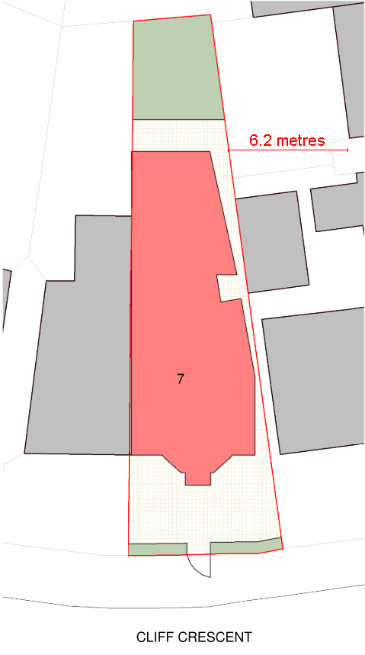
Figure 6 – the proposed site plan
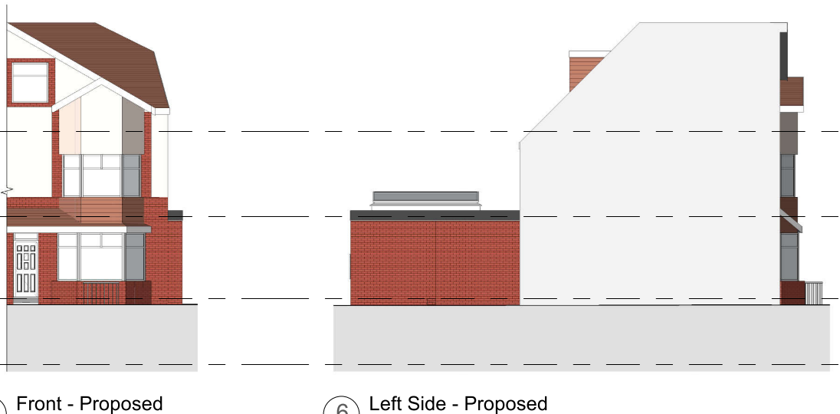
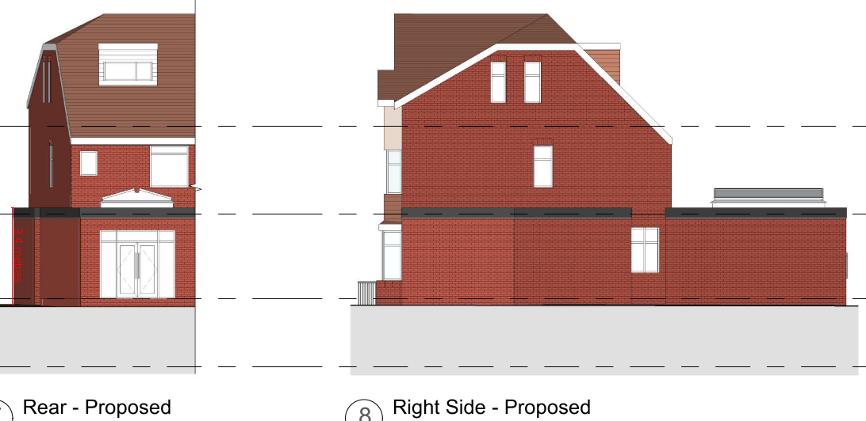
Figure 7 – the proposed elevations

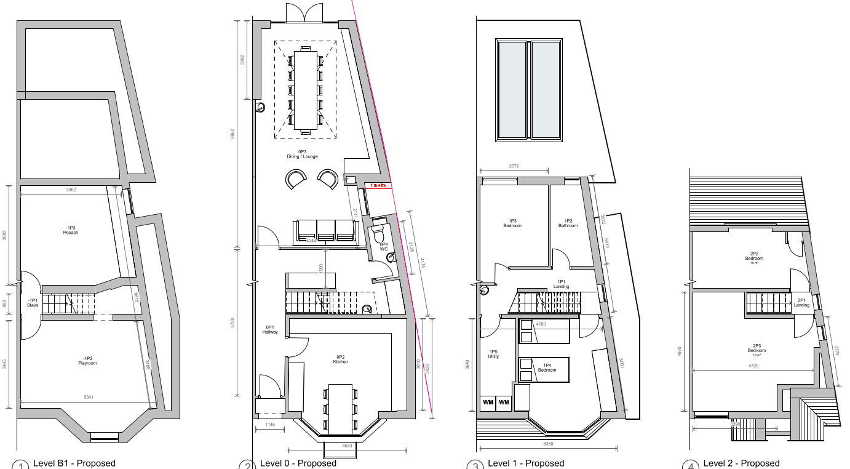
Figure 8 – the proposed floor plans

Relevant Site History

No relevant site history to the subject site.

Relevant Site history to the neighbouring property 2 Cliff Grange:

22/79854/HH - Loft conversion with flat rear dormer and pitched front dormer – Approved (06.07.2022)

06/52512/HH - Demolition of existing garage and erection of a single storey rear extension with staircase (re-submission of planning application 05/51281/HH) – Approved (22.05.2006)

05/51281/HH - Demolition of existing garage and erection of single storey rear extension – Refused (23.11.2005)

Consultations

Not applicable.

Publicity
Earliest Decision Date: 16 September 2022
Revised Expiry Date: No extension agreed

Site Notice: N/A
Reason:

Press Advert: N/A
Reason:

Representations

None received.

Planning Policy

Development Plan Policy

Currently adopted plan (City of Salford Unitary Development Plan) -
Unitary Development Plan DES1 - Respecting Context
Unitary Development Plan DES7 - Amenity of Users and Neighbours
Unitary Development Plan DES8 - Alterations and Extensions

Emerging plan (SLP:DMP) -
Policy D1 - Design principles
Policy D2 - Local character and distinctiveness
Policy D5 - Amenity
Policy D8 - Alterations and extensions

Other Material Planning Considerations

National Planning Policy Framework
National Planning Policy Guidance

Local Planning Policy

Supplementary Planning Document - House Extension

The National Planning Policy Framework (NPPF) paragraph 48 establishes that local planning authorities may give weight to relevant policies in emerging plans according to:
- The stage of preparation of the emerging plan (the more advanced its preparation, the greater the weight that may be given);
- The extent to which there are unresolved objections to relevant policies (the less significant the unresolved objections, the greater the weight that may be given); and
- The degree of consistency of the relevant policies in the emerging plan to the NPPF (the closer the policies in the emerging plan to the policies in the NPPF, the greater the weight that may be given).
There are currently two emerging plans to consider.
First, Places for Everyone Publication Plan, the joint Development Plan Document for nine districts in Greater Manchester, which was published for consultation under Regulation 19 of the Town and Country Planning (Local Planning) (England) Regulations 2012 on 9 August 2021. Representations were invited until 3 October 2021; the plan was submitted to the Secretary of State for examination on 14 February 2022 and examination hearings are due to commence in Summer 2022. The emerging policies which are relevant to this application are discussed where applicable in this report with appropriate weight being afforded in accordance with NPPF paragraph 48.

Second, the Publication Salford Local Plan: Development Management Policies and Designations (SLP:DMP), which was published on 27 January 2020 and comments were invited until 20 March 2020. An Addendum was published on 5 February 2021 and comments were invited on this until 19 March 2021. The Publication SMP:DMP and the Addendum were submitted to the Secretary of State for examination on 30 June 2021 and the examination hearings took place over 7 days in December 2021. The plan has been subject to a significant amount of public consultation in previous stages of its production and the city council has considered the comments made to determine the extent to which there are unresolved objections to its policies. Those policies (i.e. the Publication SLP:DMP policies as modified through the Addendum) which are relevant to this application are discussed where appropriate in this report with appropriate weight being afforded in accordance with NPPF paragraph 48. It is expected that the SLP:DMP will be adopted in Autumn 2022.

In addition, NPPF paragraph 219 establishes that existing policies (such as Salford’s UDP) are not out-of-date simply because they were adopted or made prior to the publication of NPPF. Due weight should be given to them, according to their degree of consistency with the NPPF, and the closer the policies in the UDP to the policies in the NPPF, the greater the weight that may be given. In terms of this application it is considered that the relevant policies of the UDP can be afforded due weight for the purposes of decision making as the relevant criteria within the UDP policies applicable to the proposed development are consistent with the policies contained in the NPPF.

Appraisal of the Proposed Development

Impact on the character of the area

- The proposed development involves additions/alterations to the front, side and rear. The rear extension would not be visible from the street scene and so is not considered to pose an impact upon the character of the subject dwelling.
- The light well would be by definition ‘sub terranean’ and moreover it would be screened out by the front brick wall and mid-sized hedge. Therefore, it would have only a limited impact upon the street scene if the hedge were to be removed in future.
- Whilst the side extension would be flush to the existing front wall of the house, it is single storey in nature, which makes it subservient to the subject dwelling. It is also considered that the maximum projection of 1m is minor.
- A condition is attached to ensure that the materials would match that of the existing house.
- The proposal is therefore in accordance with Policy DES1 and 8 of the adopted UDP.

Impact on the amenity of neighbours

- The proposed light well is deemed acceptable in terms of width, depth and height. It would ensure that appropriate light and outlook would be provided to the basement rooms, given their intended use. Due to its nature, it would not pose an impact upon the amenity of the neighbouring residents in terms of overlooking, dominance and/or loss of light.
- The rear window serving the WC would face onto the wall of the proposed side extension. Although it would not provide much a view for the occupants of No.7, the window is not serving a habitable room and so it is not of concern. More importantly, it would not lead to any overlooking to the neighbours.
- The side window serving the open plan area of the dining/lounge is secondary to that space. Also, it would look onto the blank wall of the outbuilding at no. 3 Cliff Grange. And so, it is considered to be acceptable in planning terms.
- The patio doors to the rear would look onto the boundary fence which screens out the views and therefore not to cause overlooking.

- The proposed side extension would bring the subject property closer to the neighbouring dwellings no. 2, 3 and 4 Cliff Grange. As nos. 2 and 3 have existing structures to the rear with their blank walls facing towards the proposed extension, it is not considered that the proposal would result in an impact upon the amenity of no. 2 and 3 in regard to overbearing and/or loss of light. As for no. 4, there is a section of the proposal that would maintain a separation distance of circa 6.2m with the rear windows at no. 4. Nonetheless, it is noted that the property of no. 4 offsets from the proposal and so there is no direct relationship between the proposed extension and no. 4 (see Figure 6). Moreover, the nearest ground floor rear window at no. 4 is a high-level window which would not be greatly affected in any event. The existing 1.8m tall fence would screen out much of the extension. Overall, the proposal would not pose a detrimental impact on the general amenity of the neighbouring properties at no. 2, 3 and 4 Cliff Grange.
- The proposed rear extension would project 2.8m further from the existing extension at the adjoining neighbour no. 5. This relationship complies with Policy HE5 of the House Extensions SPD and it is established that the ground floor rear window at no. 5 serves the kitchen which is not a habitable room in concern. As such, the proposed rear extension is considered to be acceptable that it would not lead to a significant impact upon the amenity of no. 5 in respect of light and dominance.
- Overall, the proposal complies with Policy DES 7 of the adopted UDP.

Other issues

Does the proposal require any work to trees? No.

Is there a significant change in levels across the site or between the site and the neighbouring land? No.

Has the applicant/agent indicated any personal circumstances? No.

Recommendation:

Approve, subject to the following conditions:

1. The development must be begun not later than three years beginning with the date of this permission.

Reason: Required to be imposed by Section 91 of the Town and Country Planning Act 1990 (as amended).

2. The development hereby permitted shall be carried out in accordance with the following approved plans:

Site Plan Existing and Proposed – Dwg no: GSS22016.1 004 (Received: 23.08.2022)
Proposed Plans and Elevations – Dwg no: GSS22016.1 003 Rev: 2 (Received: 23.08.2022)

Reason: For the avoidance of doubt and in the interest of proper planning.

3. The external materials used shall match those of the existing building so far as practicable.

Reason: In order to ensure a satisfactory appearance in the interests of visual amenity in accordance with Policies DES1 and DES8 of the City of Salford Unitary Development Plan and the requirements of the National Planning Policy Framework.

Statement of conformity with Article 35 of The Town and Country Planning (Development Management Procedure) (England) Order 2015

The proposal complies with the development plan and would improve the economic, social and environmental conditions of the area. It therefore comprises sustainable development and the Local Planning Authority worked proactively and positively to issue the decision without delay. The Local Planning Authority has therefore implemented the requirement in Paragraph 38 of the NPPF.

Notes to Applicant

- STANDING ADVICE - DEVELOPMENT LOW RISK AREA

The proposed development lies within a coal mining area which may contain unrecorded coal mining related hazards. If any coal mining feature is encountered during development, this should be reported immediately to the Coal Authority on 0345 762 6848.

Further information is also available on the Coal Authority website at:
www.gov.uk/government/organisations/the-coal-authority

Standing Advice valid from 1st January 2021 until 31st December 2022

Officer | Mandy Pang | DC |  | LPA | M Hodgson
Date | 11.10.22 | Date |  | Date | 12.10.22

