HOUSE EXTENSION REPORT

REF: 22/79767/HH

Address: 112 Leicester Road, Salford, Salford, M7 4GF

Proposal: Two storey side extension, single storey rear extension and a new front porch

Appropriate consultation undertaken Yes
Earliest Decision date: 26 May 2022
Reason for delay beyond stat deadline and EoT: 28 Oct 2022

Description of Site and Surrounding Area

- This application relates to a two-storey semi-detached property located on the corner plot at the junction between Leicester Road and Westwood Avenue.
- The subject dwelling is set back from the highway with an area of landscaping to the front bound by a brick wall and vegetation along the front boundary. It has a temporary succah structure constructed to a similar size of the existing single storey rear extension, and also a detached garage lying along the rear boundary. The adjoining neighbour no. 110 has also a single storey rear extension that sits along most of the common boundary. The application property looks onto the gable end of 2 Westwood Avenue.
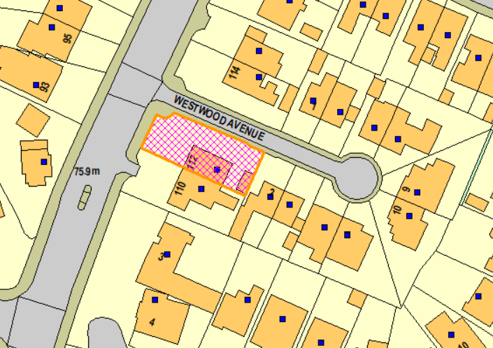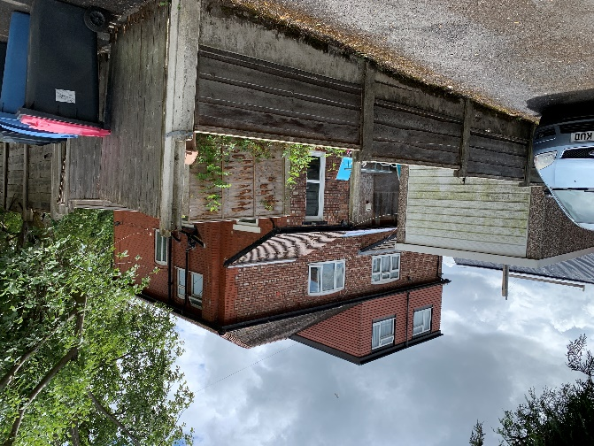
Figure 1 – the subject site under consideration Figure 2 – the rear of the subject dwelling and that of its neighbour

Description of Proposal

Amendments have been made to the original proposal during the determination of this application. The final proposal submitted on 5th August 2022 comprises the following:

- Two storey side extension
  - Projecting 3.2m from the northeast elevation and run flush with the original extended single storey house to the rear.
  - The first floor element would be set back from the front main wall by 0.5m.
  - Hipped roof to match with a lower roof ridge.
  - Windows added to the front, side and rear on both floor levels.

- Single storey rear extension
  - Projecting 1.9m from the rearmost wall of the original house and 4.5m from the recessed rear wall.
  - Finish with a flat roof at a height of 3m. A sukkah rooflight is inserted.
  - Patio doors are added to the northeast side and rear elevation.
  - A decking of 0.2m tall, 12.9m 6.4m wide and 3.4m deep (max.) would be constructed to the rear of the proposed extension.

- New front porch
  - 0.8m projection from the front wall and 2.1m wide.
  - Pitched roof with a height of 3.3m to the ridge and 2.6m to the eaves.
Plans and drawings are shown below:

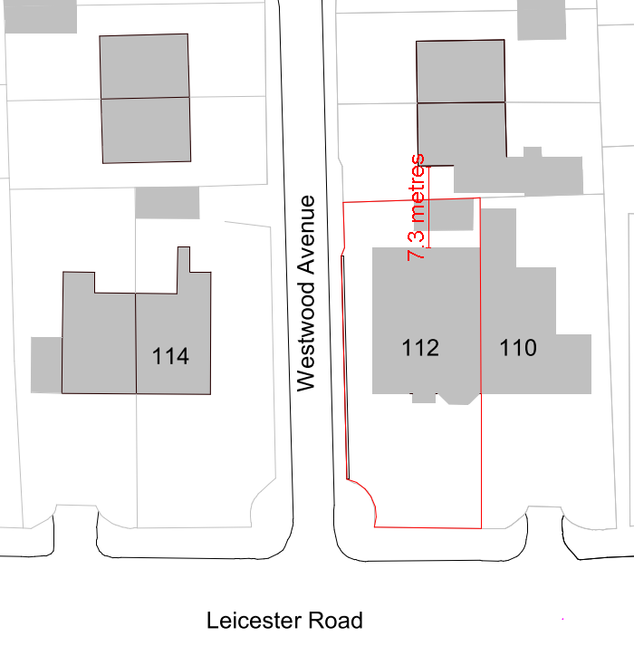
Figure 3 – the proposed site plan

Relevant Site History

No relevant site history to the application property.

110 Leicester Road:
16/68379/HH - Demolition of single storey rear extension/side chimney, erection of a two storey side/rear extension and a single storey rear extension to include alterations to the existing roof – Approved (12.10.2016)

Consultations

Arborist – no objection.

Publicity
Earliest Decision Date: 26 May 2022
Revised Expiry Date: 28 October 2022

Site Notice: N/A
Reason:

Press Advert: N/A
Reason:

Representations

None received.

Planning Policy

Development Plan Policy

Currently adopted plan (City of Salford Unitary Development Plan) -
Unitary Development Plan DES1 - Respecting Context
Unitary Development Plan DES7 - Amenity of Users and Neighbours
Unitary Development Plan DES8 - Alterations and Extensions

Emerging plan (SLP:DMP) -
Policy D1 - Design principles
Policy D2 - Local character and distinctiveness
Policy D5 - Amenity
Policy D8 - Alterations and extensions

Other Material Planning Considerations

National Planning Policy Framework
National Planning Policy Guidance

Local Planning Policy

Supplementary Planning Document - House Extension

The National Planning Policy Framework (NPPF) paragraph 48 establishes that local planning authorities may give weight to relevant policies in emerging plans according to:
- The stage of preparation of the emerging plan (the more advanced its preparation, the greater the weight that may be given);
- The extent to which there are unresolved objections to relevant policies (the less significant the unresolved objections, the greater the weight that may be given); and
- The degree of consistency of the relevant policies in the emerging plan to the NPPF (the closer the policies in the emerging plan to the policies in the NPPF, the greater the weight that may be given).
There are currently two emerging plans to consider.
First, Places for Everyone Publication Plan, the joint Development Plan Document for nine districts in Greater Manchester, which was published for consultation under Regulation 19 of the Town and Country Planning (Local Planning) (England) Regulations 2012 on 9 August 2021. Representations were invited until 3 October 2021; the plan was submitted to the Secretary of State for examination on 14 February 2022 and examination hearings are due to commence in Summer 2022. The emerging policies which are relevant to this application are discussed where applicable in this report with appropriate weight being afforded in accordance with NPPF paragraph 48.

Second, the Publication Salford Local Plan: Development Management Policies and Designations (SLP:DMP), which was published on 27 January 2020 and comments were invited until 20 March 2020. An Addendum was published on 5 February 2021 and comments were invited on this until 19 March 2021. The Publication SMP:DMP and the Addendum were submitted to the Secretary of State for examination on 30 June 2021 and the examination hearings took place over 7 days in December 2021. The plan has been subject to a significant amount of public consultation in previous stages of its production and the city council has considered the comments made to determine the extent to which there are unresolved objections to its policies. Those policies (i.e. the Publication SLP:DMP policies as modified through the Addendum) which are relevant to this application are discussed where appropriate in this report with appropriate weight being afforded in accordance with NPPF paragraph 48. It is expected that the SLP:DMP will be adopted in Autumn 2022.

In addition, NPPF paragraph 219 establishes that existing policies (such as Salford’s UDP) are not out-of-date simply because they were adopted or made prior to the publication of NPPF. Due weight should be given to them, according to their degree of consistency with the NPPF, and the closer the policies in the UDP to the policies in the NPPF, the greater the weight that may be given. In terms of this application it is considered that the relevant policies of the UDP can be afforded due weight for the purposes of decision making as the relevant criteria within the UDP policies applicable to the proposed development are consistent with the policies contained in the NPPF.

Appraisal of the Proposed Development

Impact on the character of the area

- Due to its corner plot location, the proposed development would be visible from the Leicester Road and/or Westwood Avenue.
- The proposed front porch is considered to be a minor addition to the front which is well-designed to ensure that the subject dwelling appears as an attractive and coherent whole. It also appears to be subservient to the main building.
- The proposed two-storey side extension would project from the northeast elevation and maintain circa 2.6m away from the boundary of the site at its closest point, in accordance with Policy HE 9. Whilst it is accepted that it would project beyond the building line along Westwood Avenue and hence creates some degree of enclosure to the street, it is however considered that Westwood Avenue is relatively tightly packed and the front/side garden of the site is spacious enough that allow an acceptable separation with the opposite dwelling no. 114. Also, the tall boundary treatment along the side boundary would screen out part of the proposed side extension and so to alleviate any visual impact to the street. In combination of these factors, it is considered that the proposed side extension would not create any terracing or “over prominence” effect and not have a detrimental impact upon the character of the area.
- The proposed rear extension would be single storey in nature and thus appear subservient to the main dwelling. Any views to the extension would be of a brick built structure that complements the existing property. Such features are commonplace within a residential environment.
- The development has been proposed in materials to match the existing house. A condition is attached to ensure this.
- Given the above, the proposal is in compliance with Policy DES 1 and 8 of the adopted UDP.
Impact on the amenity of neighbours

- The proposed front windows in the side extension would not protrude further than the existing.
- The ground floor rear windows would be screened out by the boundary fence.
- The first floor rear window would maintain around 7.3m from the rear boundary and would have some degree of overlooking onto the driveway and front yard of the rear neighbour no. 2 Westwood Avenue. However, it is considered that the neighbour has no windows in its side elevation that have direct interplay with the proposed rear window, and it has the rear garden as its primary amenity space. Therefore, it is considered not to have overlooking issues with the neighbour. Overall, the proposed fenestrations would not generate overlooking to the neighbouring occupiers.

- The proposed side extension would bring the subject dwelling sidewards by 3.2m. Nonetheless, it would not have an impact on the adjacent neighbour no. 114 because of the separation distance (circa 14.7m) in between them. The adjoining neighbour no. 110 would not be affected by the side extension due to its position in relation to the side extension.
- The single storey rear extension would project 4.5m along the common boundary with no. 110. However, the neighbour has an outbuilding next to the boundary with no windows to be impacted. And so, the single storey rear extension is not considered to pose an impact on the amenity of the neighbour no. 110.
- No. 114 is not considered to be adversely affected by the rear extension given the ample distance between the properties.
- The rear extension would bring the subject dwelling closer to the rear neighbour no. 2 Westwood Avenue. Nonetheless, no. 2 has no side windows on the ground floor that would be impacted by the extension. Taken altogether, the proposal is not considered to result in a detrimental impact upon the general amenity of the neighbours in terms of dominance and/or loss of light in accordance with policy DES 7 of the adopted UDP.

Other issues

Does the proposal require any work to trees? The submitted tree survey states that no trees require removal to facilitate the development. There would be protective fences to the tree in the front to avoid it being impacted by the development.

Is there a significant change in levels across the site or between the site and the neighbouring land? No.

Has the applicant/agent indicated any personal circumstances? No.

Recommendation:

Approve, subject to the following conditions:

1. The development must be begun not later than three years beginning with the date of this permission.

Reason: Required to be imposed by Section 91 of the Town and Country Planning Act 1990 (as amended).

2. The development hereby permitted shall be carried out in accordance with the following approved plans:

Proposed GA Plans and Elevations – Dwg no: DA22027.003 Rev: 3 (Received: 05.08.2022)

Reason: For the avoidance of doubt and in the interest of proper planning.

- The external materials used shall match those of the existing building so far as practicable.

Reason: In order to ensure a satisfactory appearance in the interests of visual amenity in accordance with Policies DES1 and DES8 of the City of Salford Unitary Development Plan and the requirements of the National Planning Policy Framework.

- The development hereby approved shall be carried out in accordance with the submitted Arboricultural Method Statement [section 5 of the Rowbottom's Tree Services Report, Ref: RTS/08082022 Rev:001, dated 8th of August 2022].

Reason: To ensure the protection and preservation of trees, hedges, bushes and other natural features during construction works, in accordance with policies EN12 and EN13 of the City of Salford Unitary Development Plan and the National Planning Policy Framework.

- No development shall be started until all the retained trees as shown on the Tree Protection Plan (TPP) contained within the appendices of the Rowbottom's Tree Services Report, Ref: RTS/08082022 Rev:001, dated 8th of August 2022 within (or overhanging) the site, have been protected using temporary protective fencing. Such fencing shall be installed in accordance with the description contained within section 5 of the Rowbottom's Tree Services Report, Ref: RTS/08082022 Rev:001, dated 8th of August 2022 in the positions as shown on the TPP; and shall remain until all development is completed and no work, including any form of drainage or storage of materials, earth or topsoil shall take place within the perimeter of such protection.

Reason: To safeguard important trees on the site and to ensure that adequate provision is made for their protection whilst the development is carried out in accordance with policy EN13 of the adopted City of Salford Unitary Development Plan.

Reason for pre commencement: It is important to ensure the proper safeguarding of protected trees on the site prior to any works being undertaken that could jeopardise their continued health and vigour in accordance with policy EN13 of the adopted City of Salford Unitary Development Plan.

Statement of conformity with Article 35 of The Town and Country Planning (Development Management Procedure) (England) Order 2015

The Local Planning Authority worked positively and proactively with the applicant to identify various solutions during the application process to ensure that the proposal comprised sustainable development and would improve the economic, social and environmental conditions of the area and would accord with the development plan. These were incorporated into the scheme and/or have been secured by planning condition. The Local Planning Authority has therefore implemented the requirement in Paragraph 38 of the NPPF.

Notes to Applicant

- STANDING ADVICE - DEVELOPMENT LOW RISK AREA

The proposed development lies within a coal mining area which may contain unrecorded coal mining related hazards. If any coal mining feature is encountered during development, this should be reported immediately to the Coal Authority on 0345 762 6848.

Further information is also available on the Coal Authority website at:
www.gov.uk/government/organisations/the-coal-authority

Standing Advice valid from 1st January 2021 until 31st December 2022

Officer | Mandy Pang | DC |  | LPA | M Hodgson
Date | 25.10.2022 | Date |  | Date | 26.10.22

