HOUSE EXTENSION REPORT

REF: 22/80470/HH

Address: 14 Chadwick Road, Eccles, Salford, M30 0NZ

Proposal: Proposed external step lift installation and associated building works

Appropriate consultation undertaken Yes
Earliest Decision date: 4 October 2022
Reason for delay beyond stat deadline and EoT: N/A

Description of Site and Surrounding Area
This application refers to a two storey end-terrace dwelling within a residential area. The surrounding properties are of a similar size and design, generally terraced constructed in brick with two storey outriggers to the rear with small front and rear gardens.

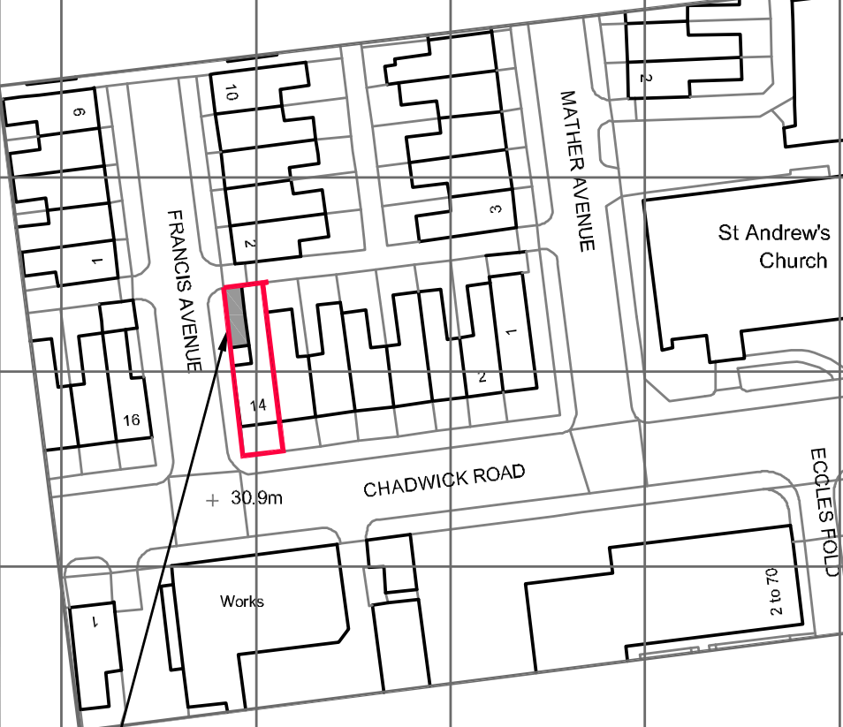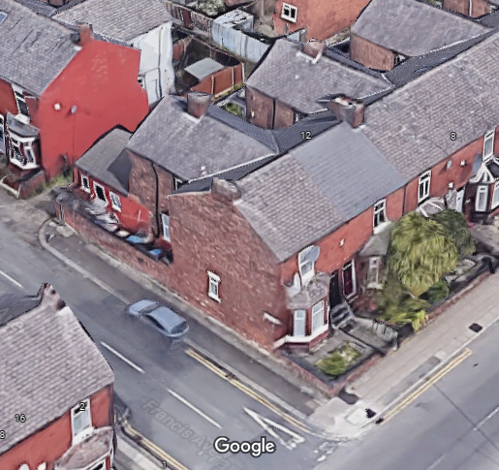
Figure 2 – Aerial
Figure 1 – Location Plan

Description of Proposal
- Permission is sought for an external step lift installation to the rear of the dwelling.
- The step lift will have galvanised steel balustrade railings on all exposed sides.
- The external alterations include:
- New back door/frame
- Excavation and relaying of the concrete in the yard
- Replacement timber gate and fencing
- Opening in the side facing existing boundary wall to create an entrance.

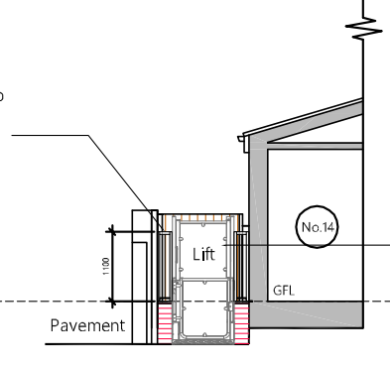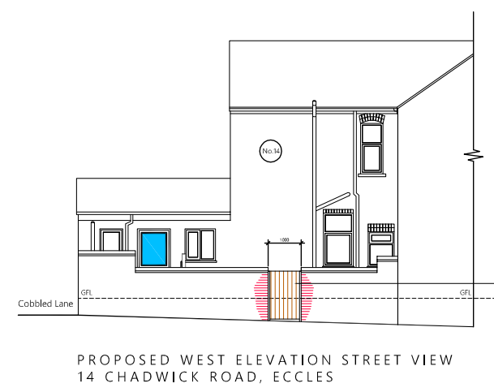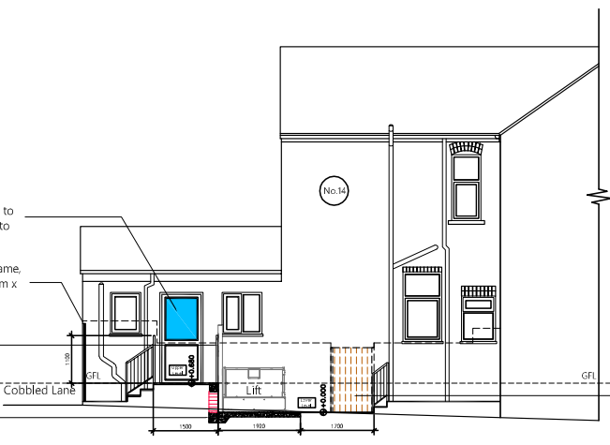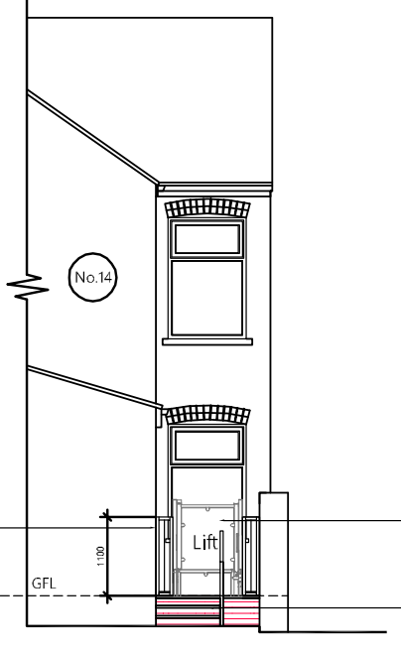
Figure 3 – Proposed West Elevation Street View
Figure 4 – Proposed Section
Figure 5 – Proposed West Elevation
Figure 6 – Proposed North Elevation

Site Photographs
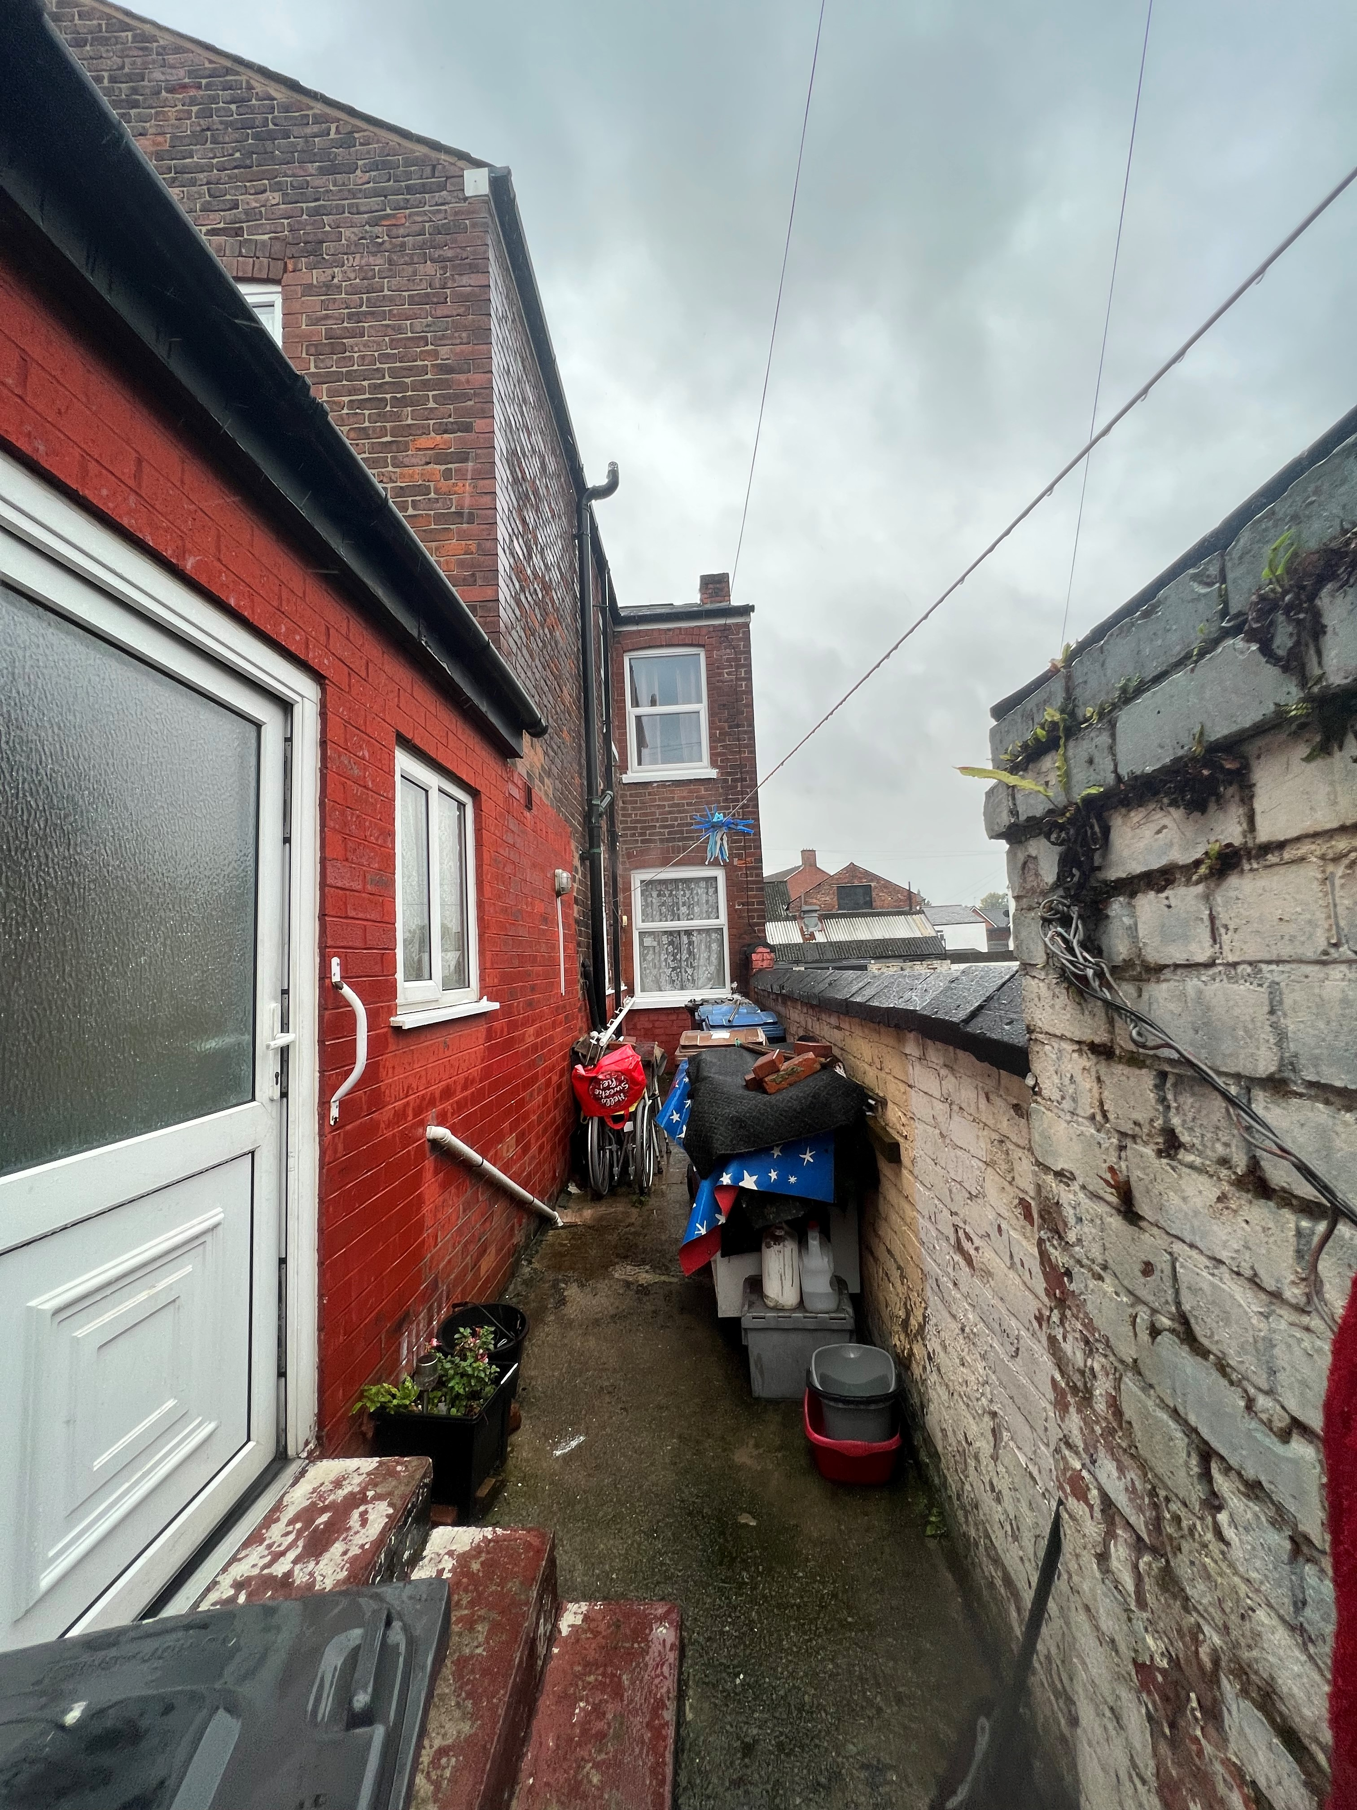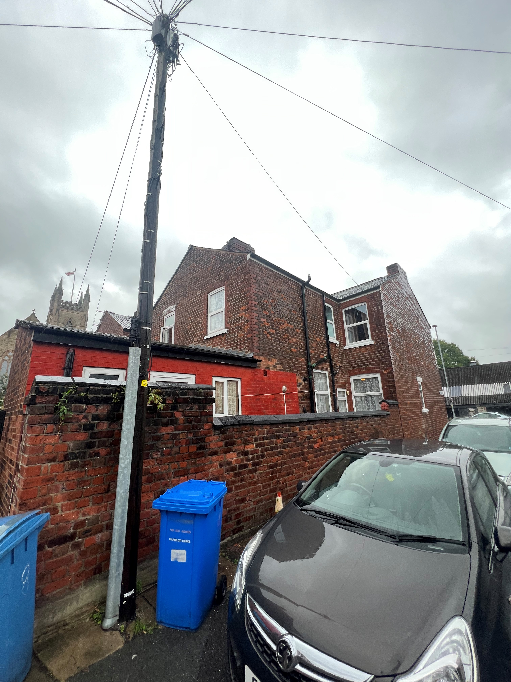
Relevant Site History

No relevant site history.

Neighbour Notification

Five neighbouring occupiers have been notified of the application.

Representations

One neutral letter of representation has been received in response to the application publicity.

 | C – comment received R – officer response
C | Where on the property will the proposed installation be?
R | The stair lift will be in the rear courtyard/garden of no.14 Chadwick Road and the entrance via Francis Street on the side facing boundary.
C | Will there still be room on the property for their bins?
R | There would still be sufficient space within the rear garden to store bins.
C | When will the proposed work take place?
R | This will be at the discretion of the applicant. However, if approved, a condition will be added to ensure the development begins within three years.
C | Builder’s vehicles will want to park and this will cause issues. Will it have an impact on utility supplies? How much noise would there be?
R | These are not material planning considerations to the assessment of the application.
C | Why is an external lift required rather than a internal stair lift?
R | To provide access to the property.

Consultations

Highways
The application is for the installation of a new external step lift for disabled access along with associated works.
The proposed changes to the building are minor in nature and are unlikely to have any effect on the local highway network.
The Local Highways Authority have no objection to the proposal.

Publicity
Earliest Decision Date: 4 October 2022
Revised Expiry Date: No extension agreed

Site Notice: N/A
Reason:

Press Advert: N/A
Reason:

Planning Policy

Development Plan Policy

Unitary Development Plan DES1 - Respecting Context
Unitary Development Plan DES7 - Amenity of Users and Neighbours
Unitary Development Plan DES8 - Alterations and Extensions

Other Material Planning Considerations

National Planning Policy Framework
National Planning Policy Guidance

Local Planning Policy

Supplementary Planning Document - House Extension

The National Planning Policy Framework (NPPF) paragraph 48 establishes that local planning authorities may give weight to relevant policies in emerging plans according to:
- The stage of preparation of the emerging plan (the more advanced its preparation, the greater the weight that may be given);
- The extent to which there are unresolved objections to relevant policies (the less significant the unresolved objections, the greater the weight that may be given); and
- The degree of consistency of the relevant policies in the emerging plan to the NPPF (the closer the policies in the emerging plan to the policies in the NPPF, the greater the weight that may be given).
There are currently two emerging plans to consider.
First, Places for Everyone Publication Plan, the joint Development Plan Document for nine districts in Greater Manchester, which was published for consultation under Regulation 19 of the Town and Country Planning (Local Planning) (England) Regulations 2012 on 9 August 2021. Representations were invited until 3 October 2021; the plan was submitted to the Secretary of State for examination on 14 February 2022 and examination hearings are due to commence in Summer 2022. The emerging policies which are relevant to this application are discussed where applicable in this report with appropriate weight being afforded in accordance with NPPF paragraph 48.

Second, the Publication Salford Local Plan: Development Management Policies and Designations (SLP:DMP), which was published on 27 January 2020 and comments were invited until 20 March 2020. An Addendum was published on 5 February 2021 and comments were invited on this until 19 March 2021. The Publication SMP:DMP and the Addendum were submitted to the Secretary of State for examination on 30 June 2021 and the examination hearings took place over 7 days in December 2021. The plan has been subject to a significant amount of public consultation in previous stages of its production and the city council has considered the comments made to determine the extent to which there are unresolved objections to its policies. Those policies (i.e. the Publication SLP:DMP policies as modified through the Addendum) which are relevant to this application are discussed where appropriate in this report with appropriate weight being afforded in accordance with NPPF paragraph 48. It is expected that the SLP:DMP will be adopted in Autumn 2022.

In addition, NPPF paragraph 219 establishes that existing policies (such as Salford’s UDP) are not out-of-date simply because they were adopted or made prior to the publication of NPPF. Due weight should be given to them, according to their degree of consistency with the NPPF, and the closer the policies in the UDP to the policies in the NPPF, the greater the weight that may be given. In terms of this application it is considered that the relevant policies of the UDP can be afforded due weight for the purposes of decision making as the relevant criteria within the UDP policies applicable to the proposed development are consistent with the policies contained in the NPPF.

Appraisal of the Proposed Development

Impact on the character of the area

- The stair lift is located within the rear garden of No.14 so would not be visible from the street scene.
- The external alterations including the new boundary fencing and side entrance are appropriately designed and would not appear out of character with the area.

Impact on the amenity of neighbours

- Given the property is an end-terrace and the development would be screened by the existing single storey extension, the proposal would not have any impact on any surrounding neighbours.

Other issues

Does the proposal require any work to trees? No

Is there a significant change in levels across the site or between the site and the neighbouring land? No

Has the applicant/agent indicated any personal circumstances? Yes, the applicant has indicated a disability. The applicant needs long term adaptions to provide access to the dwelling.

Approve

- The development must be begun not later than three years beginning with the date of this permission.

Reason: Required to be imposed by Section 91 of the Town and Country Planning Act 1990 (as amended).

- The development hereby permitted shall be carried out in accordance with the following approved plans:

Drawing No.01 – Existing & Proposed Layouts and elevations including Site Location Plan
Reason: For the avoidance of doubt and in the interest of proper planning

- The development hereby approved shall be constructed in the materials specified on the approved plans.

Reason: In order to ensure a satisfactory appearance in the interests of visual amenity in accordance with Policies DES1 and DES8 of the City of Salford Unitary Development Plan and the requirements of the National Planning Policy Framework.

Statement of conformity with Article 35 of The Town and Country Planning (Development Management Procedure) (England) Order 2015

The proposal complies with the development plan and would improve the economic, social and environmental conditions of the area. It therefore comprises sustainable development and the Local Planning Authority worked proactively and positively to issue the decision without delay. The Local Planning Authority has therefore implemented the requirement in Paragraph 38 of the NPPF.

Notes to Applicant

STANDING ADVICE - DEVELOPMENT LOW RISK AREA

The proposed development lies within a coal mining area which may contain unrecorded coal mining related hazards. If any coal mining feature is encountered during development, this should be reported immediately to the Coal Authority on 0345 762 6848.

Further information is also available on the Coal Authority website at:
www.gov.uk/government/organisations/the-coal-authority

Standing Advice valid from 1st January 2021 until 31st December 2022

Officer | James Bridgman | DC |  | LPA | James Ketley
Date | 27.10.2022 | Date |  | Date | 27.10.2022

