HOUSE EXTENSION REPORT

REF: 22/79762/HH

Address: 9 Carnarvon Street, Salford, Salford, M7 4QH

Proposal: Single storey front porch extension, two storey side extension, single storey rear extension and loft conversion with front and rear dormers

Appropriate consultation undertaken Yes
Earliest Decision date: 26 May 2022
Reason for delay beyond stat deadline and EoT: 28 October 2022

Description of Site and Surrounding Area

- This application relates to a two-storey semi-detached property located at the end of a private drive of Carnarvon Street.
- The subject site has its side boundary set at an angle to the neighbouring dwellings to the east and hence consists of a side/rear garden.
- The property sits within a housing estate constructed in 2012 with the surrounding built form predominantly arranged over two storeys with extensions and alterations to the rear elevations.
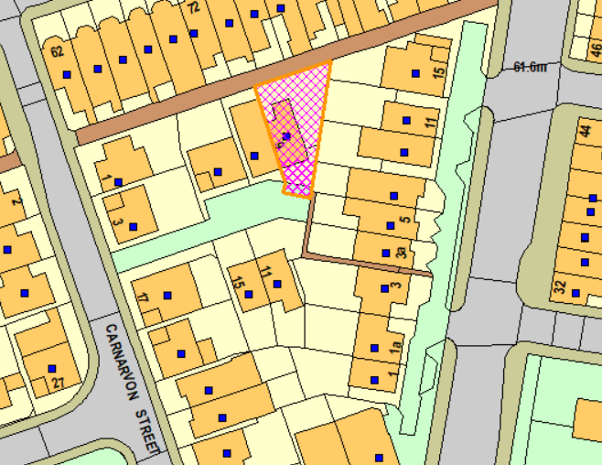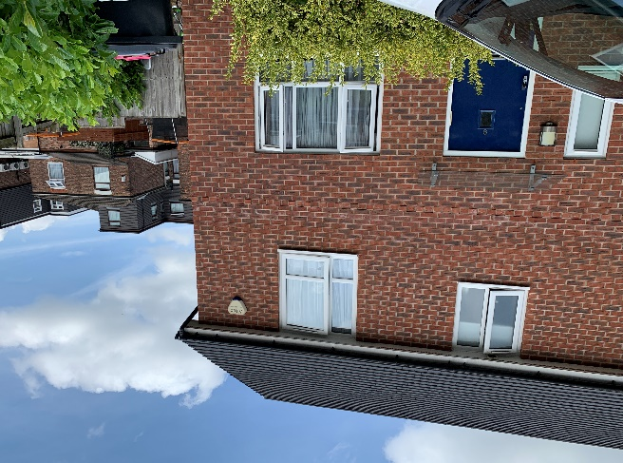
Figure 1 – the subject site under consideration Figure 2 – the subject dwelling

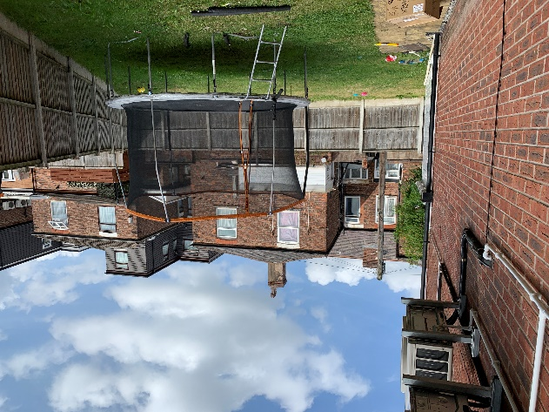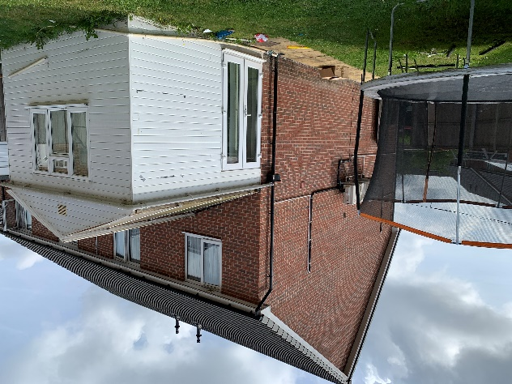
Figure 3 – the side/rear garden of the subject site Figure 4 – the side/rear elevation of the subject house as existing

Description of Proposal

Amendments have been made to the original proposal during the determination of this application. The final proposal submitted on 1st September 2022 comprises the following:

- front porch extension
  - 1.2m projection from the front, 2.9m wide
  - Pitched roof with a height of 3.5m to the ridge and 2.7m to the eaves.
  - Positioned to the west of the front main wall.

- two storey side extension
  - Due to the angled nature of the side boundary, the side extension would have a stepped projection from 1.8m to 3.7m from the east elevation of the original house.
  - Pitched roof with the same roof ridge as the original house but stepped eaves height.
  - There would be a ground floor window and patio doors inserted to the east elevation.

- single storey rear extension
  - Projecting 4.5m from the rear wall of the subject house, with a total length of 12.8m.
  - It would have a curved surface to the eastern end, with 3no. floor-to-ceiling height windows inserted to the east.
  - There would be patio doors and sliding doors added to the rear.

- loft conversion with front and rear dormers
  - 2no. front dormers: a base to ridge height of 2.4m and a width of 1.7m, set back around 1.1m from the eaves and set 1.7m down the ridge.
  - Rear box dormer: located within the existing rear roof space, spans the majority of the width of the original rear roof slope, be set 1.4m below the ridge and 0.5m back from the eaves of the dwelling. Includes 3no. rear facing windows and a sukkah roof light on top.
Plans and drawings are shown below:

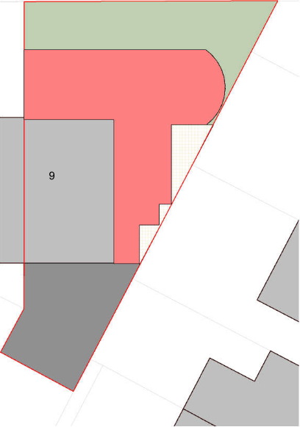
Figure 5 – the proposed site plan

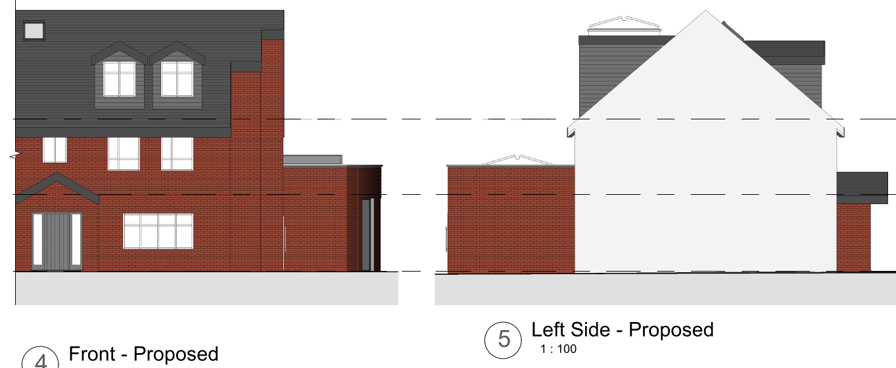

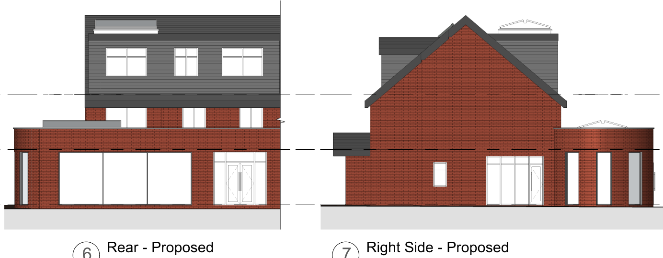
Figure 6 – the proposed elevations

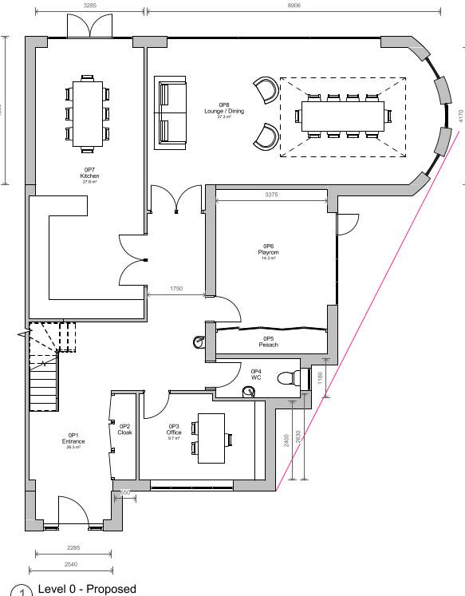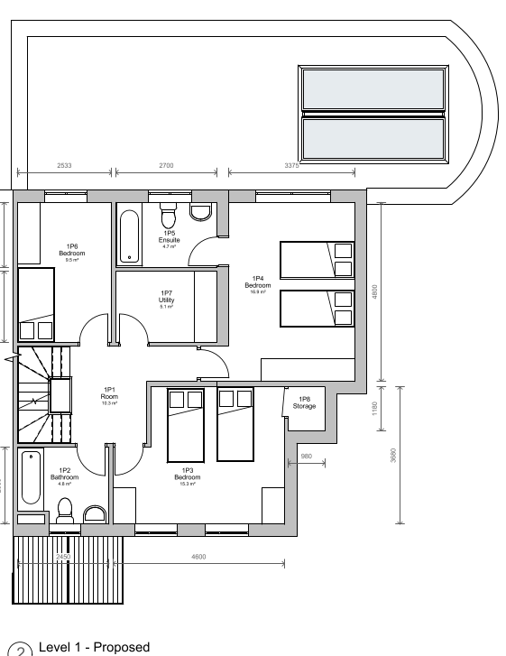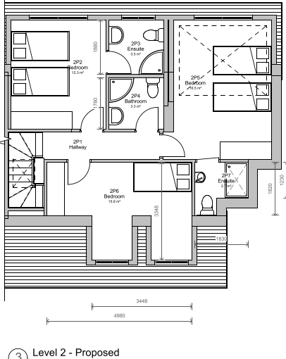
Figure 7 – the proposed floor plans

Relevant Site History

No relevant site history.

Consultations

Not applicable.

Publicity
Earliest Decision Date: 26 May 2022
Revised Expiry Date: 28 October 2022

Site Notice: N/A
Reason:

Press Advert: N/A
Reason:

Representations

None received.

Planning Policy

Development Plan Policy

Currently adopted plan (City of Salford Unitary Development Plan) -
Unitary Development Plan DES1 - Respecting Context
Unitary Development Plan DES7 - Amenity of Users and Neighbours
Unitary Development Plan DES8 - Alterations and Extensions

Emerging plan (SLP:DMP) -
Policy D1 - Design principles
Policy D2 - Local character and distinctiveness
Policy D5 - Amenity
Policy D8 - Alterations and extensions

Other Material Planning Considerations

National Planning Policy Framework
National Planning Policy Guidance

Local Planning Policy

Supplementary Planning Document - House Extension

The National Planning Policy Framework (NPPF) paragraph 48 establishes that local planning authorities may give weight to relevant policies in emerging plans according to:
- The stage of preparation of the emerging plan (the more advanced its preparation, the greater the weight that may be given);
- The extent to which there are unresolved objections to relevant policies (the less significant the unresolved objections, the greater the weight that may be given); and
- The degree of consistency of the relevant policies in the emerging plan to the NPPF (the closer the policies in the emerging plan to the policies in the NPPF, the greater the weight that may be given).
There are currently two emerging plans to consider.
First, Places for Everyone Publication Plan, the joint Development Plan Document for nine districts in Greater Manchester, which was published for consultation under Regulation 19 of the Town and Country Planning (Local Planning) (England) Regulations 2012 on 9 August 2021. Representations were invited until 3 October 2021; the plan was submitted to the Secretary of State for examination on 14 February 2022 and examination hearings are due to commence in Summer 2022. The emerging policies which are relevant to this application are discussed where applicable in this report with appropriate weight being afforded in accordance with NPPF paragraph 48.

Second, the Publication Salford Local Plan: Development Management Policies and Designations (SLP:DMP), which was published on 27 January 2020 and comments were invited until 20 March 2020. An Addendum was published on 5 February 2021 and comments were invited on this until 19 March 2021. The Publication SMP:DMP and the Addendum were submitted to the Secretary of State for examination on 30 June 2021 and the examination hearings took place over 7 days in December 2021. The plan has been subject to a significant amount of public consultation in previous stages of its production and the city council has considered the comments made to determine the extent to which there are unresolved objections to its policies. Those policies (i.e. the Publication SLP:DMP policies as modified through the Addendum) which are relevant to this application are discussed where appropriate in this report with appropriate weight being afforded in accordance with NPPF paragraph 48. It is expected that the SLP:DMP will be adopted in Autumn 2022.

In addition, NPPF paragraph 219 establishes that existing policies (such as Salford’s UDP) are not out-of-date simply because they were adopted or made prior to the publication of NPPF. Due weight should be given to them, according to their degree of consistency with the NPPF, and the closer the policies in the UDP to the policies in the NPPF, the greater the weight that may be given. In terms of this application it is considered that the relevant policies of the UDP can be afforded due weight for the purposes of decision making as the relevant criteria within the UDP policies applicable to the proposed development are consistent with the policies contained in the NPPF.

Appraisal of the Proposed Development

Impact on the character of the area

- The proposed development would be positioned to the front, side and rear of the subject dwelling. The proposed front dormers, porch and side extension would be visible from the street scene, while the rear extension would only be seen from the alleyway. The alleyway is not regarded as a public vantage point that provides views to the important features of the dwelling. And so any proposals to the rear are not considered to create undue harm to the character of the dwelling and its surrounding area.
- While front porches are not common in the immediate surrounding area, the proposed porch is considered to be a minor addition that would appear subservient to the subject dwelling.
- The front dormers are found in neighbouring properties within King Square, such as no. 27 King Street which is on a prominent corner plot location. The proposed front dormers are generally in line with Policy HE 10: sited below the ridge line, set back from the eaves line and not to build off any external walls. They are therefore considered acceptable in design terms.
- Whilst it is not ideal that the proposed side extension would have a stepping elevation which would appear at odds on the street scene, it would be tucked behind the main house due to its end of private drive location and thus not to be overly prominent in the street scene.
- The development has been proposed in materials to match the existing house. A condition could be attached to any grant of permission to ensure this.
- On this basis, the proposal complies with the requirements of Policies DES1 and DES8 of the adopted UDP.

Impact on the amenity of neighbours

- The proposed front porch is not a habitable space and so the associated openings are not considered to cause an overlooking to the neighbours.
- The proposed rear patio doors and windows and the side windows on the ground floor level would be screened out by the boundary fence and not to look into any neighbouring windows.
- The proposed first floor rear window serving the new bedroom would not protrude further than the existing rear windows on the same level.
- The front dormer window would be set back from the existing front windows of the dwelling.
- The rear dormer window would face towards the rear neighbour no. 76 and 78 Wellington Street East. Those neighbours have not been extended on the second floor and thus no direct interplay with the proposed dormer windows. Also, the dormer is not considered to lead to additional overlooking to the amenity space of No.76 and No.78 Wellington Street which have been extended to the rear and therefore reducing any loss of amenity into their respective private amenity areas. Overall, the proposal is not considered to generate any undue overlooking to the neighbouring occupiers.

- The proposed front dormers are not considered to result in any overbearing and/or loss of light the neighbours as they are set well back from the external walls of the subject house.
- Although there are no specific policies that relate to front extensions/porches, we can apply policy HE5 of the House Extension SPD that relates to a similar set up but at the front of the house. It is measured that the nearest ground floor habitable room window in the adjoining neighbour no. 7 is set 3m away from the subject dwelling. As such, the front porch would not project beyond a 45 degree line drawn from the mid-point of that window in no. 7, in accordance with Policy HE 5.
- The ground floor rear extension would project 4.5m from the rear wall of the original house and would be in line with the rear extension of no. 7. Therefore, it would not project beyond a 45 degree line drawn from the mid-point of any principal habitable room window in no. 7, in accordance with Policy HE 5.
- With regards to the east neighbour no. 11 Leicester Road, it would maintain circa 10.3 – 11.4m from the shared boundary. The rear extension has a curved surface on that side which would not have the same effect as that of a normal blank wall. The boundary fence would further alleviate any dominance impact of the rear extension to no. 11 Leicester Road.
- It is measured that the ground floor rear opening in the neighbour no. 9 Leicester Road maintains a direct distance of circa 7.8m with the shared boundary and 10.7m with the existing gable end of the application property. The proposed two storey side extension would bring the gable end wall closer to no. 9 and therefore reduces the distance to 7.8m to the ground floor window/opening in no. 9 at its nearest point. This falls short of the distance as required in Policy HE 3 where the blank gable end wall should be 13m away from the facing ground floor habitable room window of neighbouring dwellings. It is accepted that there would be some impact to no. 9 due to the close relationship. Nonetheless, the side extension would have a staggered wall facing towards no. 9, which would have less expanse of brick wall and so not to have the same effect as a normal solid wall. The proposed rear dormer is not considered to add bulk/increase brick wall and height to the extension given that it is of a normal scale that it sets slightly in from the gable end and not to project beyond the rear wall of the original house. The subject dwelling is to the west of no. 9 and thus there is already some overshadowing effect on the rear garden space of no. 9. A shadow study has been submitted which shows that the shadowing impact would occur at periods of time but not continuously. By weighing up all the factors, it is on balance considered that the proposed extension would not result in a detrimental harm to the amenity of no. 9.
- As for the neighbour no. 11 Leicester Road, its ground floor rear openings are 11.4m away from the common boundary and currently does not have any direct interplay with the side gable of the subject dwelling. Due to the angled nature, the distance between the proposed side extension and the rear windows/openings in no. 11 increases gradually. It would have oblique views but not direct sights to the new gable end. It is also noted that the neighbours no. 9, 11 and 15 have put through their support to the application, although this does not carry a significant weight in the consideration of this application.
- Taken altogether, the proposed side extension is not considered to pose an unacceptable impact upon the amenity of the neighbours in terms of dominance, loss of light and overshadowing, that it warrants a refusal.

Other issues

Does the proposal require any work to trees? No.

Is there a significant change in levels across the site or between the site and the neighbouring land? No.

Has the applicant/agent indicated any personal circumstances? No.

Recommendation:

Approve, subject to the following conditions:

1. The development must be begun not later than three years beginning with the date of this permission.

Reason: Required to be imposed by Section 91 of the Town and Country Planning Act 1990 (as amended).

2. The development hereby permitted shall be carried out in accordance with the following approved plans:

Proposed Plans and Elevations – Dwg no: GSS22009. 003 Rev: 4 (Received: 1.9.2022)

Reason: For the avoidance of doubt and in the interest of proper planning.

3. The external materials used shall match those of the existing building so far as practicable.

Reason: In order to ensure a satisfactory appearance in the interests of visual amenity in accordance with Policies DES1 and DES8 of the City of Salford Unitary Development Plan and the requirements of the National Planning Policy Framework.

Statement of conformity with Article 35 of The Town and Country Planning (Development Management Procedure) (England) Order 2015

The Local Planning Authority worked positively and proactively with the applicant to identify various solutions during the application process to ensure that the proposal comprised sustainable development and would improve the economic, social and environmental conditions of the area and would accord with the development plan. These were incorporated into the scheme and/or have been secured by planning condition. The Local Planning Authority has therefore implemented the requirement in Paragraph 38 of the NPPF.

Notes to Applicant

- STANDING ADVICE - DEVELOPMENT LOW RISK AREA

The proposed development lies within a coal mining area which may contain unrecorded coal mining related hazards. If any coal mining feature is encountered during development, this should be reported immediately to the Coal Authority on 0345 762 6848.

Further information is also available on the Coal Authority website at:
www.gov.uk/government/organisations/the-coal-authority

Standing Advice valid from 1st January 2021 until 31st December 2022

Officer | Mandy Pang | DC |  | LPA | AS
Date | 27.10.2022 | Date |  | Date | 28.10.22

