HOUSE EXTENSION REPORT

REF: 22/79958/HH

Address: 8 Stanley Road, Salford, M7 4EG,

Proposal: Garage conversion into habitable living space, single storey front porch extension, first floor side extension and first floor rear extension with minor external alterations

Appropriate consultation undertaken Yes
Earliest Decision date: 30 June 2022
Reason for delay beyond stat deadline and EoT: 20 October 2022

Description of Site and Surrounding Area

- This application relates to a two storey semi-detached dwelling located on the eastern side of Stanley Road.
- The subject dwelling has been extended to the side, with an existing integral garage. It has also a single storey rear extension, accommodating a bedroom and bathroom. There is a rear box dormer that provides extra accommodation in the roof space.
- The surrounding area is predominantly residential and characterised by semi-detached properties. The frontages of the neighbouring properties are different, with some of them featuring bay windows while others have front canopies.
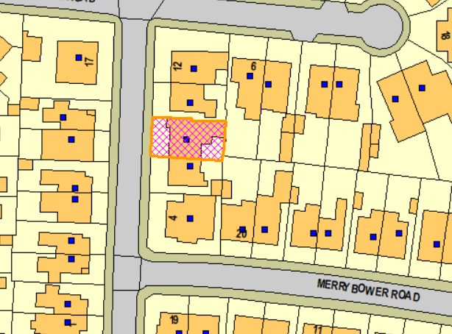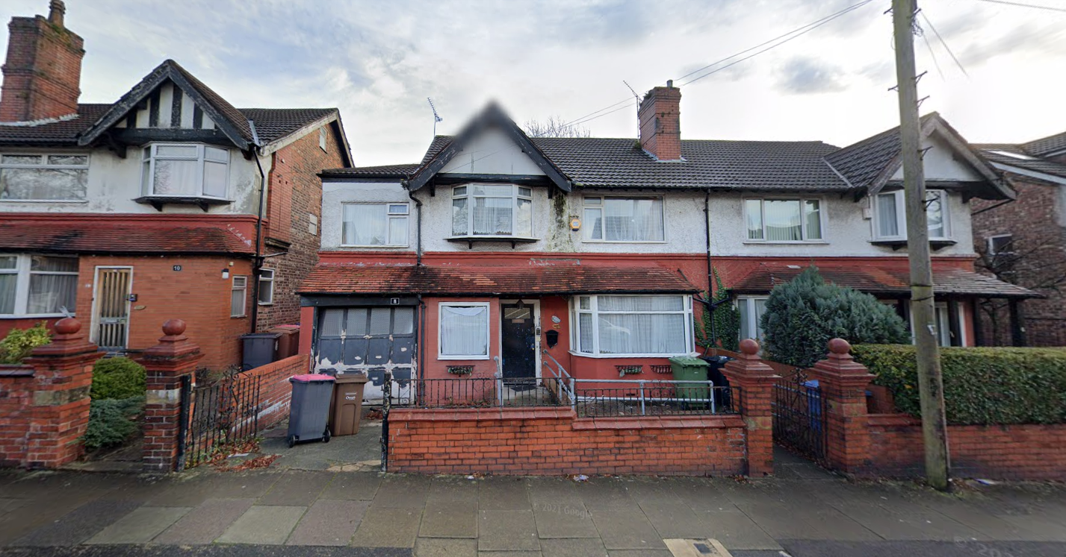
Figure 1 – the subject site under consideration Figure 2 – the subject dwelling and its neighbouring properties

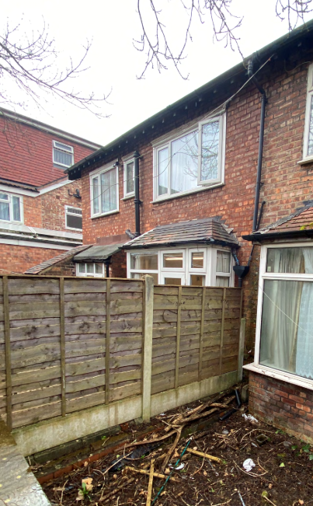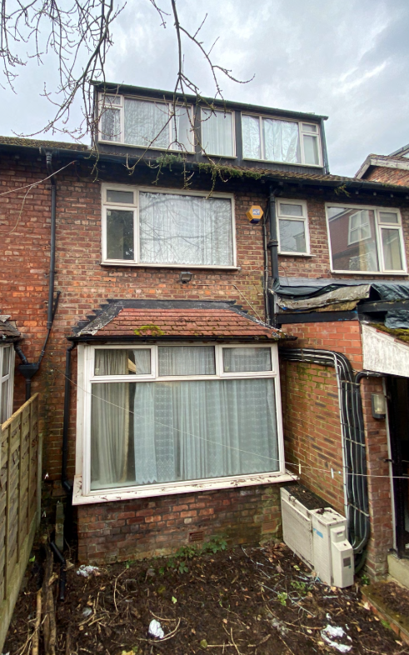
Figure 3 and 4 – the rear elevation of the neighbour no. 6 and the subject dwelling

Description of Proposal

- Garage conversion into habitable living space
  - Convert the garage into an office space.
  - Removal of garage door and replace it with a large front window.

- Front porch extension
  - Increase the width of the existing porch by 1.1m.
  - There would be a new front door with sidelights to replace the existing main entrance and window.

- First floor side/rear extension
  - To make space for a utility room and en-suite for an existing bedroom.
  - It would be 6.5m wide and be set 3.7m in from the southern boundary. It would project 1.6m at its shortest and 4.2m at its longest from the rear wall of the original house.
  - There would be 2no. obscurely glazed windows inserted to the rear and one to the southern side.
  - It would have a hipped roof at a height of 5.1m to the eaves and 6.2m to the ridge.

- Minor external alterations
  - Removal of existing chimney.
Plans and drawings are shown below:

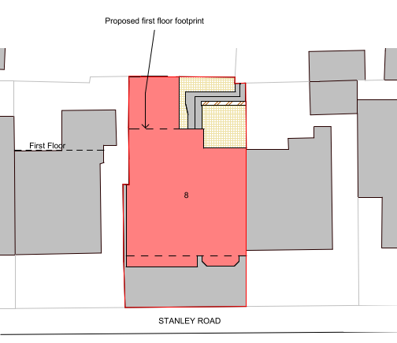
Figure 5 – the proposed site plan

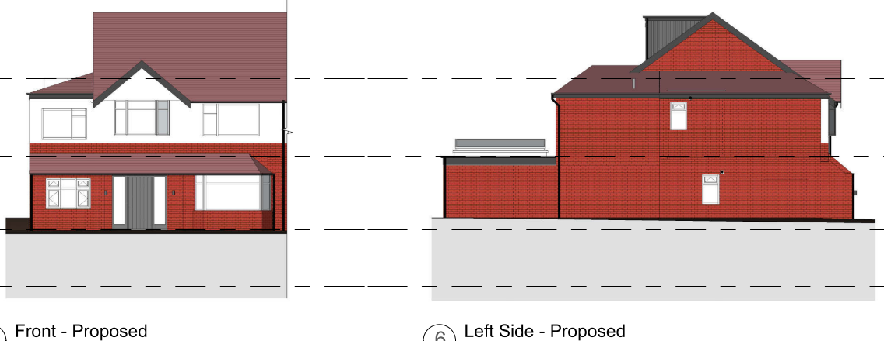
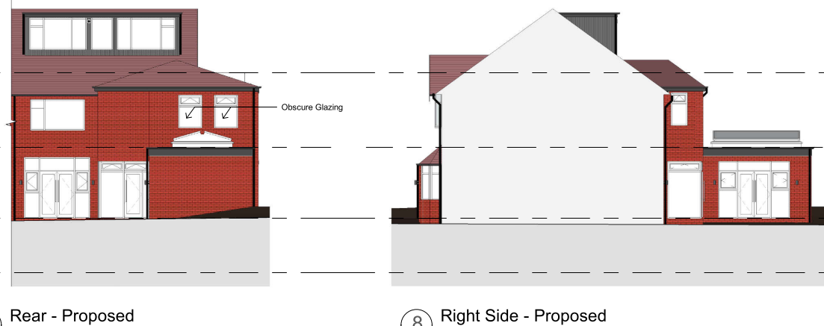
Figure 6 – the proposed elevations

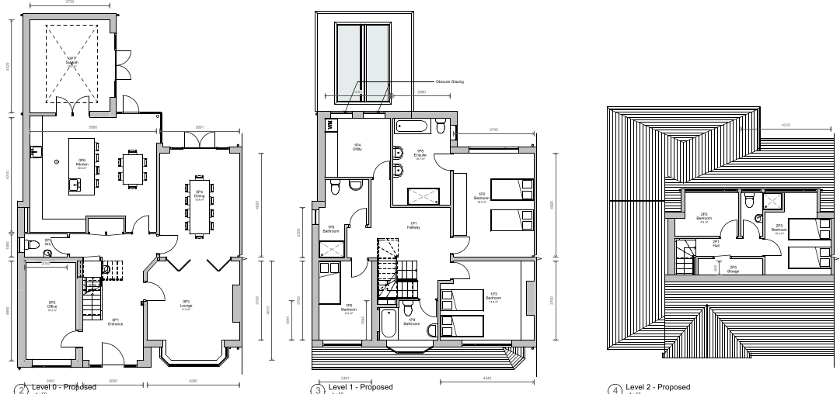

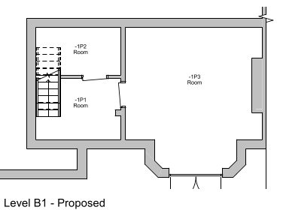
Figure 7 – the proposed floor plans

Relevant Site History

No relevant site history.

Consultations

Not applicable.

Publicity
Earliest Decision Date: 30 June 2022
Revised Expiry Date: No extension agreed

Site Notice: N/A
Reason:

Press Advert: N/A
Reason:

Representations

None received.

Planning Policy

Development Plan Policy

Currently adopted plan (City of Salford Unitary Development Plan) -
Unitary Development Plan DES1 - Respecting Context
Unitary Development Plan DES7 - Amenity of Users and Neighbours
Unitary Development Plan DES8 - Alterations and Extensions

Emerging plan (SLP:DMP) -
Policy D1 - Design principles
Policy D2 - Local character and distinctiveness
Policy D5 - Amenity
Policy D8 - Alterations and extensions

Other Material Planning Considerations

National Planning Policy Framework
National Planning Policy Guidance

Local Planning Policy

Supplementary Planning Document - House Extension

The National Planning Policy Framework (NPPF) paragraph 48 establishes that local planning authorities may give weight to relevant policies in emerging plans according to:
- The stage of preparation of the emerging plan (the more advanced its preparation, the greater the weight that may be given);
- The extent to which there are unresolved objections to relevant policies (the less significant the unresolved objections, the greater the weight that may be given); and
- The degree of consistency of the relevant policies in the emerging plan to the NPPF (the closer the policies in the emerging plan to the policies in the NPPF, the greater the weight that may be given).
There are currently two emerging plans to consider.
First, Places for Everyone Publication Plan, the joint Development Plan Document for nine districts in Greater Manchester, which was published for consultation under Regulation 19 of the Town and Country Planning (Local Planning) (England) Regulations 2012 on 9 August 2021. Representations were invited until 3 October 2021; the plan was submitted to the Secretary of State for examination on 14 February 2022 and examination hearings are due to commence in Summer 2022. The emerging policies which are relevant to this application are discussed where applicable in this report with appropriate weight being afforded in accordance with NPPF paragraph 48.

Second, the Publication Salford Local Plan: Development Management Policies and Designations (SLP:DMP), which was published on 27 January 2020 and comments were invited until 20 March 2020. An Addendum was published on 5 February 2021 and comments were invited on this until 19 March 2021. The Publication SMP:DMP and the Addendum were submitted to the Secretary of State for examination on 30 June 2021 and the examination hearings took place over 7 days in December 2021. The plan has been subject to a significant amount of public consultation in previous stages of its production and the city council has considered the comments made to determine the extent to which there are unresolved objections to its policies. Those policies (i.e. the Publication SLP:DMP policies as modified through the Addendum) which are relevant to this application are discussed where appropriate in this report with appropriate weight being afforded in accordance with NPPF paragraph 48. It is expected that the SLP:DMP will be adopted in Autumn 2022.

In addition, NPPF paragraph 219 establishes that existing policies (such as Salford’s UDP) are not out-of-date simply because they were adopted or made prior to the publication of NPPF. Due weight should be given to them, according to their degree of consistency with the NPPF, and the closer the policies in the UDP to the policies in the NPPF, the greater the weight that may be given. In terms of this application it is considered that the relevant policies of the UDP can be afforded due weight for the purposes of decision making as the relevant criteria within the UDP policies applicable to the proposed development are consistent with the policies contained in the NPPF.

Appraisal of the Proposed Development

Impact on the character of the area

- The proposed development would be positioned to the front, side and rear of the subject dwelling. The additions and alterations to the front and side would be visible from the street scene while that to the rear would not. The first floor side/rear extension would not have an impact upon the character of the area.
- The front window replacing the existing garage door is considered to be of a proportionate size and is well-positioned. Such an alteration is considered to be minor, and it would not have a significant impact upon the appearance of the house.
- The extension to the front porch would sit nicely in between the garage (now an office space) and the bay window. It would maintain the same roof height and style. It is therefore not considered to pose a negative impact on the external appearance but to ensure a coherent frontage to the house.
- The removal of chimney is considered to be a minor alteration to the house.
- The development has been proposed in materials to match that of the existing house. A condition is attached to ensure this.
- Given the above, the proposed works would not significantly change the character of the dwelling as well as the surrounding area, in accordance with UDP policies DES 1 and DES 8.

Impact on the amenity of neighbours

- The proposed ground floor front window replacing the garage door would not protrude further than the existing front bay window.
- The proposed first floor rear windows would maintain a distance of circa 4.5m from the rear boundary which is considered too close according to Policy HE 2. However, they would serve the utility room which is not a habitable room. They have been proposed in obscure-glazing and so do not give rise to any amenity issues. A condition is attached to ensure this.
- The first floor window on the southern side elevation would serve an en-suite, which is not a habitable room. A condition is attached to request it to be obscurely glazed due to its proximity to the neighbour’s boundary (less than 5m).
- The garage conversion and front porch would not result in the subject dwelling coming any closer to the neighbouring residential properties than it does currently and therefore it is not considered that they would result in neighbouring residents experiencing a loss of amenity.
- The proposed first floor side/rear extension would project 1.5m from the rear wall of the subject dwelling and be set 3.6m in from the shared boundary with the adjoining neighbour no. 6, in accordance with Policy HE 7.
- With regards to no. 10, it has openings in their side elevation at first floor and with principal windows serving habitable rooms in the front and rear elevation of its dwellinghouse. the proposed first floor element would not project beyond the ground floor extension at no. 10. It would project 1.7m beyond the rear wall of no. 10, however it would be set 2.1m in from the house of no. 10. Given such a relationship, the proposed first floor extension is not considered to pose an unacceptable impact upon the amenity of the rear windows at no. 10 in terms of loss of light and/or overbearing.

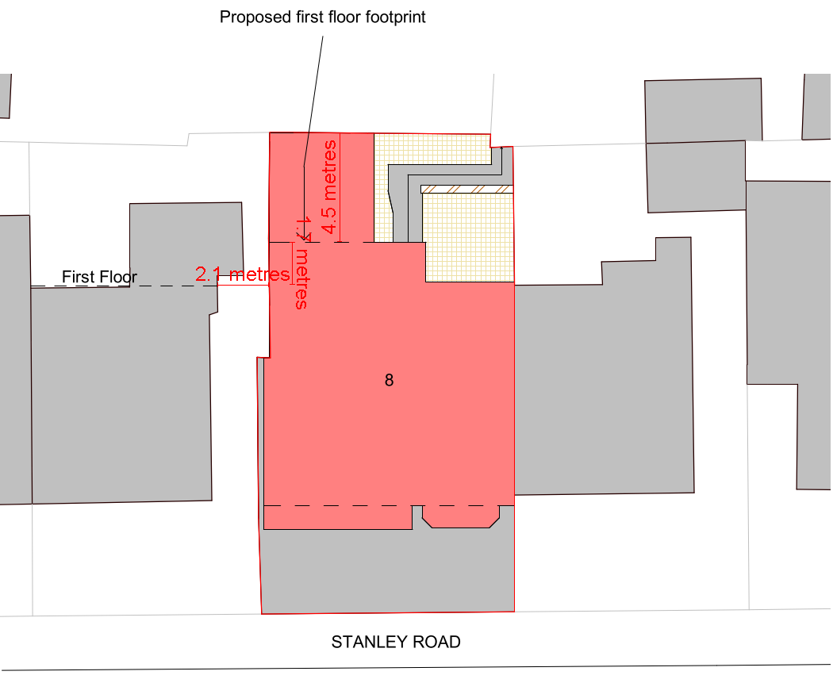
10
Figure 8 – the relationship between the proposed first floor extension and its neighbouring properties

Impact on the highway network

- The proposal would result in the loss of the garage. Nonetheless, there are multiple streets with unrestricted parking nearby. Also, the property and occupiers are within walking distance to public transport links.
- The proposal is therefore not considered to have a negative impact on highway network.

Other issues

Does the proposal require any work to trees? No.

Is there a significant change in levels across the site or between the site and the neighbouring land? No.

Has the applicant/agent indicated any personal circumstances? No.

Recommendation:

Approve, subject to the following conditions:

1. The development must be begun not later than three years beginning with the date of this permission.

Reason: Required to be imposed by Section 91 of the Town and Country Planning Act 1990 (as amended).

2. The development hereby permitted shall be carried out in accordance with the following approved plans:

Proposed Plans – Dwg no: GSS22028.1 003 (Received: 12.09.2022)
Existing & Proposed Elevations – Dwg no: GSS22028.1 004 (Received: 12.09.2022)

Reason: For the avoidance of doubt and in the interest of proper planning.

- The external materials used shall match those of the existing building so far as practicable.

Reason: In order to ensure a satisfactory appearance in the interests of visual amenity in accordance with Policies DES1 and DES8 of the City of Salford Unitary Development Plan and the requirements of the National Planning Policy Framework.

- The proposed first floor windows that serve the utility and the en-suite in the rear and side elevations respectively of the development hereby approved, shall be fitted with, and permanently glazed, in textured glass whose obscuration level is at least 3 on the Pilkington scale of 1-5 (where 1 is clear and 5 is completely obscure).
Reason: In the interest of the amenity of residents to ensure privacy is retained in accordance with policy DES7 of the City of Salford Unitary Development Plan and the National Planning Policy Framework.

Statement of conformity with Article 35 of The Town and Country Planning (Development Management Procedure) (England) Order 2015

The Local Planning Authority worked positively and proactively with the applicant to identify various solutions during the application process to ensure that the proposal comprised sustainable development and would improve the economic, social and environmental conditions of the area and would accord with the development plan. These were incorporated into the scheme and/or have been secured by planning condition. The Local Planning Authority has therefore implemented the requirement in Paragraph 38 of the NPPF.

Notes to Applicant

- STANDING ADVICE - DEVELOPMENT LOW RISK AREA

The proposed development lies within a coal mining area which may contain unrecorded coal mining related hazards. If any coal mining feature is encountered during development, this should be reported immediately to the Coal Authority on 0345 762 6848.

Further information is also available on the Coal Authority website at:
www.gov.uk/government/organisations/the-coal-authority

Standing Advice valid from 1st January 2021 until 31st December 2022

Officer | Mandy Pang | DC |  | LPA | James Ketley
Date | 07.10.2022 | Date |  | Date | 18.10.2022

