Jemma Brabrook
Deloitte LLP
The Hanover Building
Corporation Street
Manchester
M4 4AH
Salford City Council
Planning and Building Control
Place
Civic Centre, Chorley Road,
Swinton, Salford, M27 5AW

Phone 0161 604 7793
Email david.allen@salford.gov.uk
Web www.salford.gov.uk

Ref. 22/80369/SCO

BY EMAIL ONLY – jbrabrook@deloitte.co.uk

14 October 2022

Dear Ms. Brabrook,

Location: Land bound by Collier Street, Queen Street, Northgate Avenue and Bankside Boulevard, Greengate (Plot FG)
Proposal: Request for Scoping Opinion relating to a proposed Reserved Matters application for residential-led development comprising up to 518 dwellings and up to 1,850 sq. m GIA commercial floorspace within a circa 42-storey building (max. 158.9m AOD), at Plot FG (Phase 3) of the Greengate Masterplan (Hybrid planning permission ref. 21/78473/HYBEIA)

I am writing in response to your request of 9 August 2022 for a formal scoping opinion under Regulation 15 of The Town and Country Planning (Environmental Impact Assessment) Regulations 2017 (‘the EIA regs’).
The information submitted to the Local Planning Authority (LPA) comprises:
- A Scoping Report titled ‘Greengate – Phase 3 (Plot FG) Reserved Matters Environmental Impact Assessment (EIA) Scoping Report’, prepared by Deloitte dated August 2022; and
- Ten appendices to the above report.
The request relates to the proposed submission of an application for approval of reserved matters (Access, Appearance, Landscaping, Layout and Scale) pursuant to a hybrid planning permission. The submission will therefore comprise the second stage of a ‘multi-stage consent’ and will comprise a “subsequent application” for the purposes of the EIA regs.
The Council has not received a request for a screening opinion under Regulation 6(3) of the EIA regs; Section 1.8 to 1.13 of the submitted Scoping Report make clear, however, the applicant’s position regarding the need for EIA and the Council concurs with this opinion.
Although likely significant effects of the project on the environment were appropriately identified and assessed, insofar as they could be identified/quantified, at the time of making the ‘principal decision’ on the hybrid planning permission, there are likely significant effects which require further consideration at this subsequent consent stage, given the inherent extent of additional information to be presented for approval.
The submitted Scoping Report identifies those matters which you consider should be ‘scoped-out’ of the Environmental Impact Assessment, as you conclude that additional significant effects are unlikely to occur with respect to these environmental topics, and then identifies those matters which you consider should be ‘scoped-in’. In addition, the Scoping Report outlines your proposed methodology for the assessment of cumulative effects, and provides a summary of the development sites which you consider relevant to consideration of cumulative effects.
The Council has engaged with statutory and non-statutory consultees to assist in determining its position. The responses of these consultees have been incorporated into the following advice. For clarity, this advice follows the general structure and format of your Scoping Report and confirms whether each identified topic area should be included in the Environmental Impact Assessment.

Site Description and Context Overview
This request relates to proposals for the development of land located to the east of Collier Street, north of Queen Street, west of Northgate Avenue and south of Bankside Boulevard in Greengate. The site comprises the third phase, known as Plot FG, of the developer’s (Renaker) Masterplan, for which hybrid planning permission was granted in March 2020 (ref. 19/74465/HYBEIA) – this granted full planning permission for Phase 1 and outline permission for Phases 2 and 3. The approved Masterplan included for the clearance and phased redevelopment of approximately 2ha of land with a residential-led scheme comprising a total of 1,407-1,521 dwellings along with 2,725 sq. m – 3,975 sq. m of commercial floorspace (Use Classes A1-A4, B1, D1 and D2) across three tall buildings.
Planning permission for a revised Masterplan was granted by the Council in March 2022 (ref. 21/78473/HYBEIA). The construction of Phase 1 (Plot HJ) is well underway, with the building ‘topped-out’ in July 2022, and ground works for Phase 2 (Plot C) – which benefits from reserved matters approval granted in March 2022 (ref. 21/78474REM) – are also currently being undertaken on site.
The Masterplan includes for the closure and amalgamation of Caygill Street and Boond Street, narrow service roads, to create more efficient development plots. In accordance with the Council’s Greengate Regeneration Strategy (GRS), a new east-west ‘Boulevard’ is created across the site, to stitch the development plots together and provide a strategic route across Greengate. Bankside Boulevard runs from the junction of Gravel Lane/Greengate and leads westwards to a proposed new public square (‘Collier Square’) adjacent to the Collier Street Baths. A new highway, Northgate Avenue, maintains vehicular and pedestrian movements north-south and separates Phases 1 and 3 of the development.
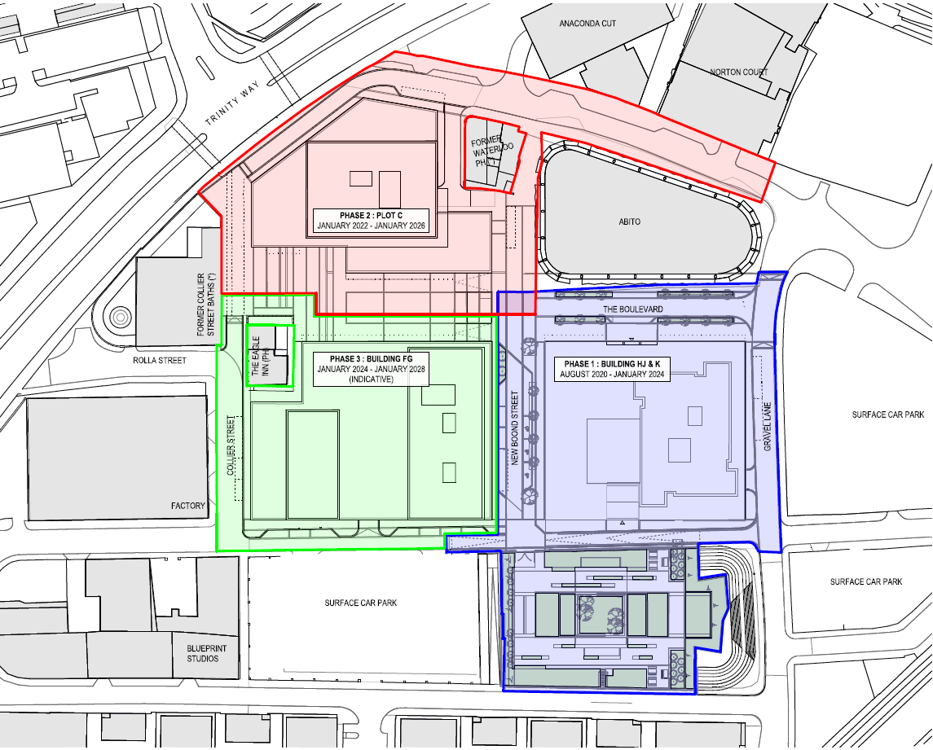
Figure 1 – Site Location and Phasing Plan (Plot FG coloured green)

The site is located within a Mixed-Use Area (UDP Policy MX1/1) and comprises part of the wider 13ha area of the City subject of the adopted Greengate Regeneration Strategy, which sets out a broad framework to guide and influence the comprehensive delivery of development within Greengate.
There are two listed buildings which sit immediately adjacent to the site – the Grade II listed Eagle Inn and attached dwelling at 17 Collier Street, and the Grade II* listed former Collier Street Baths. North-east of Plot FG is the locally listed former Waterloo Public House at 93 Greengate, and south of the site, on the opposite side of Queen Street, is the locally listed Blueprint Studios (listed as The Institute, 39 Queen Street).
There is a further cluster of listed and locally listed buildings further to the south and south-west of the site, centred on Blackfriars Road, and the site is within relatively close proximity of both the Flat Iron Conservation Area (containing the Grade II* listed Church of The Sacred Trinity) and the Cathedral Conservation Area, which extends into the boundary of the City of Manchester. The Cathedral CA is host to a number of listed buildings, including the Grade I listed Chethams Hospital & attached wall and the Cathedral Church of St. Mary.
The entirety of the site, and all access routes into Greengate, lie within the Greater Manchester Combined Authority Air Quality Management Area.
The site lies within a Site of Special Scientific Interest (SSSI) risk zone associated with the designated sites to the north-east and east of the site (Rochdale Canal - also designated as a Special Area of Conservation (SAC) – Hollinwood Branch Canal and the Huddersfield Narrow Canal), but the development proposed falls outside of the identified development type to pose a likely risk to the features of interest. Approximately 1km to the west of the site is the River Irwell Site of Biological Importance.
Plot FG is located within Flood Zone 1. The site is not located within a Source Protection Zone, nor within a Drinking Water Protected Area/Safeguard Zone.
The site is not located within the Development High Risk Area, as designated by The Coal Authority.

The Proposed Development
The Scoping Report sets out that approval of reserved matters (Access, Appearance, Landscaping, Layout and Scale) is to be sought for Phase 3 of the Greengate Masterplan (ref. 21/78473/HYBEIA).
The key approved parameters for development of Phase 3 are set out below:
 | Phase 3 (Plots F&G)
Height | Eastern Tower  39 – 41 storeys*  (153.2m - 158.9m AOD)  Western Tower  3 - 8 storeys*  (47.55m - 61.8m AOD)  Podium  2 – 3 storeys*  * Storey figures are indicative and AOD figures take precedence
No. of Dwellings | 428 – 518 dwellings
Commercial Floorspace  (Use Classes A1-A4, B1, D1 and D2) | 1,100 – 1,850 sq. m GIA
Car Parking Provision | 20% - 40%
Table 1 – Phase 3 Approved Parameters

Sections 2.14 to 2.16 of the Scoping Report provide a summary of the proposals, as follows:
- Demolition of the existing buildings on site and re-development of the site with a residential led tall building, in accordance with the parameters approved at outline stage
- Construction of a building comprising a 3-4 storey podium (with 1-2 storey element) with a tower set on top – podium to reach a maximum height of 45.85m AOD and the tower to reach a height of 156.4m AOD, with a lift over-run reaching 157.9m AOD
- 915 sq. m. (GIA) of commercial floorspace
- 428 to 518 Class C3 dwellings
- Car parking provision at a quantum falling between 20% and 40%.
The applicant is proposing to submit a ‘non-material amendment’ (S96a) application to regularise changes to the approved parameters to facilitate the detailed design for Plot FG.

Previous Environmental Impact Assessment
The first ‘hybrid’ planning application (19/74465/HYBEIA) for the Masterplan was accompanied by an Environmental Statement, within which the following topics were considered:
- Construction Management and Phasing;
- Townscape and Visual Impact Assessment;
- Historic Built Environment;
- Noise and Vibration;
- Air Quality;
- Sunlight, Daylight and Overshadowing;
- Wind Microclimate;
- Transport and Highways.
The S73 application (ref. 21/78473/HYBEIA) and the application for approval of reserved matters relating to Phase 2, Plot C (ref. 21/78474/REM) were accompanied by an Environmental Statement Addendum and associated Technical Notes, which contained an assessment of the potential significant effects of the revised scheme and the detailed proposals for Plot C (in respect of the matters of Construction Management and Phasing, Townscape and Visual Impact, Historic Built Environment, Wind Microclimate, Noise and Vibration, Air Quality and Transport and Highway) within the context of the assessment undertaken at outline stage.

Agricultural Circumstances [Scoped-Out]
The Scoping Report (§3.11) sets out that the site is entirely previously developed land, and so there would be no likely significant effects with respect to agriculture. The Council concurs with this view and raises no objection to the matter being scoped-out of the forthcoming assessment.

Archaeology [Scoped-Out]
The Scoping Report includes a detailed section on archaeology (§3.12 – 3.36) that sets out the baseline conditions and assesses the archaeological potential of the application site; an even more detailed consideration of the site’s archaeological potential is presented in a desk-based assessment that is included as Appendix 3 to the Scoping Report. The Report concludes that archaeology should be scoped out of the EIA as delivery of the proposed development will not give rise to likely significant effects, but notes that the applications site merits further archaeological investigation in in accordance with a Written Scheme of Investigation (WSI) that was prepared by Salford Archaeology in consultation with the GMAAS in July 2022, and commits to undertaking this investigation in advance of any development works.
Consultation has been undertaken with GMAAS, who concur with the conclusions of the Scoping Report and consider that the below-ground archaeology has the potential to be of local to regional significance, and therefore that archaeology can be scoped-out of the EIA providing that investigation works in accordance with the WSI are secured.
Accordingly, the Council raises no objection to the topic being scoped-out of the forthcoming assessment.

Aviation [Scoped-Out]
The Scoping Report notes that tall buildings and structures have the potential to impact aviation and radar infrastructure in their vicinity, and that given its proximity to Manchester Airport, the development may, in principle, represent a collision risk or reduce the capabilities of radar located at/near to the airport.
The Scoping Report (§3.39 – 3.41) details the previous engagement with Manchester Airport Group (MAG) Safeguarding and NATS (formerly National Air Traffic Services) in relation to the hybrid planning permission and sets out that implementation of mitigation has been previously secured by way of conditions on the existing permission, which require the implementation of a radar mitigation scheme. Accordingly, it is proposed that the topic is scoped-out of the assessment.
The Council has undertaken consultation with MAG and NATS, neither of whom have raised any objection to the proposed approach. NATS note that they do not consider that the development will result in any impact to features of relevance, and MAG have referred to their Aerodrome Safeguarding Pre-app Consultation Response provided in November 2019, which sets out the need for appropriate mitigation.
In light of the above, the Council raises no objection to the topic being scoped-out of the forthcoming assessment.

Climate Change [Scoped-Out]
The Scoping Report (§3.42 – 3.44) notes that the development will have an impact on climate change through the emission of greenhouse gasses, but that these impacts are considered unlikely to be significant. It is reported that sustainability measures have informed the design process from the outset, including climate change mitigation and energy usage. A new Energy Strategy and Sustainability Checklist will be submitted alongside the reserved matters application, outlining this process in greater detail, including an assessment of the energy efficiency of the building and the utilisation of low carbon technologies.
Any impacts of climate change on the wind microclimate are proposed to be considered as part of the Wind Microclimate assessment, and the previously completed Flood Risk Assessment has considered the impact of climate change on flood risk.
The Council raises no objection to the topic being scoped-out of the forthcoming assessment.

Ecology [Scoped-Out]
The Scoping Report (§3.45) sets out that a desktop study and relevant ecological surveys (Phase 1 Habitat Survey, invasive plant species survey, and bat surveys) have been previously undertaken, culminating in the submission of an Ecological Survey and Assessment with the original hybrid planning application. The proposed development site comprises existing buildings, hard standing and colonising vegetation, and the previous assessment work has concluded that there are no significant ecological constraints relating to implementation of the masterplan, and that there would be no adverse effect on designated sites, protected species and ecologically valuable habitats.
The site lies within a SSSI Impact Risk Zone, however the development does not fall within the categories which require consultation with Natural England due to potential risks to features of interest.
On the basis of the findings and conclusions of previous survey and assessment work, the Council raises no objection to Ecology / Biodiversity being scoped out of the assessment.
Your attention is drawn to the supplementary advice provided by Natural England within their consultation response, a copy of which is enclosed with this letter.

Ground Conditions [Scoped-Out]
The Scoping Report (§3.54 – 3.59) details the investigation work which has been previously undertaken across the Masterplan area with respect to ground conditions and land contamination (both at outline planning stage and to satisfy conditions relating to Phases 1 and 2), and the Phase I Preliminary Risk Assessment, Phase II Site Investigation and Controlled Waters Detailed Quantitative Risk Assessment (the latter two reports relating to Phase 2, Plot C) have been submitted as appendices.
The site location is located upon the Sherwood Sandstone Group Principal aquifer and 150m from the River Irwell, making this location sensitive in terms of risk to controlled waters.
The development site has historically been used for industrial purposes and as such there is the potential for land contamination to exist within it. The proposed end use mix includes residential and commercial properties, which are classed as a ‘sensitive end use’ with respect to land contamination risk. The Scoping Report recognises that contamination may exist within Plot FG, and that further Phase II investigation works will be carried out in order to determine an appropriate remediation strategy, as is required by conditions attached to the hybrid planning permission.
Neither the Council’s Environmental Consultant nor the Environment Agency have raised any objection to the proposal to ‘scope-out’ the topic of Ground Conditions, and accordingly the Council raises no objection to the proposed approach, subject to the undertaking of the further site investigation work as required by the hybrid planning permission.
Your attention is drawn to the supplementary advice provided by the Environment Agency within their consultation response, a copy of which is enclosed with this letter.

Water Resources, Flood Risk and Drainage [Scoped-Out]
The site is located within Flood Zone 1. The matter of flood risk to and arising from the development was considered as part of the hybrid planning application, with an appropriate Flood Risk Assessment being submitted to the Council, a detailed drainage strategy for Phase 1 and an outline drainage strategy for the Masterplan area also submitted. Conditions on the hybrid planning permission require the future approval of a detailed scheme for drainage within Phase 3, Plot FG - it is accepted that this provides sufficient and appropriate control over the matter.
The Scoping Report proposes that this topic is scoped-out of the EIA; in light of the above, no objection is raised by the Council to this approach.

Electronic Interference [Scoped-Out]
The Scoping Report considers the potential for the development to result in interference to terrestrial television services (§3.71 – 3.75) and to analogue and digital radio services (§3.76 – 3.81), in particular with respect to transmissions from Winter Hill transmitting station on Rivington Moor.
A Television and Radio Impact Assessment was previously undertaken to support the hybrid planning application, and a condition on the permission provides a mechanism to secure a scheme of mitigation measures in the event that an adverse impact on TV or radio services attributable to the development arises.
In light of the presence of the baseline assessment information provided within the historic assessment, and the mechanism for control provided by the condition, it is not considered that further assessment is necessary. The proposal to scope-out Electronic Interference from the EIA is therefore agreed.

Human Health [Scoped-Out]
The Scoping Report recognises (§3.83) that the development proposals result in the potential for some short-term impacts to human health during the construction phase, with the potential for accidental spillages, dust and noise and vibration. It recognises that mitigation for these risks will be provided through a Construction Management Plan; a condition on the hybrid planning permission requires the approval of a CMP prior to commencement of development in any phase. In respect of the operational phase, the development may result in impacts arising from traffic movements, air quality impacts, noise, and daylight/sunlight impacts.
The Council agrees that the identified potential impacts have already been addressed at outline stage, or can be suitably addressed within other chapters of the Environmental Impact Assessment or within other supporting reports. Accordingly, no objection is raised to this topic being scoped-out of the forthcoming assessment.

Socio-economics [Scoped-Out]
Sections 3.85 – 3.85 of the Scoping Report recognise that the socio-economic impacts of the development are likely to be local in nature and therefore unlikely to result in significant effects on the environment. No objection is raised to this matter being scoped-out of the assessment.

Solar Glare [Scoped-Out]
The Scoping Report identifies that Solar Glare was not assessed as part of the original Environmental Impact Assessment undertaken in association with the hybrid planning application. It is recognised that the façade treatment for the proposed development of Plot FG, emerging as part of the preparation work for the reserved matters submission, is likely to comprise large areas of glazing and/or reflective cladding (§3.88). It is therefore considered appropriate for a technical assessment of the potential impacts arising from solar glare to be undertaken (as it was for the reserved matters stage relating to Phase 2, Plot C. The Council concurs with the view expressed within the Scoping Report that it is unlikely that solar glare from the development would have a significant impact on the environment, and therefore it is agreed that the matter may be scoped-out of the assessment, subject to submission of a standalone technical report.

Historic Built Environment [Scoped-In (EIA Chapter Addendum)]
The Scoping Report (§3.93) sets out the assessment of the impact of the development on the Historic Built Environment will be addressed by way of an Environmental Statement addendum, accompanied by one technical appendix – a Heritage Statement.
The proposed assessment methodology is set out at §3.93 - 3.101 of the Scoping Report; this is considered by the Council to be broadly acceptable, with the exception of the following matters:
- Paragraph 3.95 refers to a list of listed buildings within close proximity to the site. In addition to those identified, the Church of the Sacred Trinity (Grade II*) on Chapel Street, which is also within the Flat Iron Conservation Area, should be included and therefore addressed within any subsequent related work (this asset lies approximately 215m from the southern site boundary).
- Paragraph 3.96 refers to the method of assessment and identifies documents that would be taken into consideration as part of the addendum process. This refers to the Salford Revised Draft Local Plan (2019) and also the Publication Salford Local Plan: Development Management Policies and Designations (SLP:DMP). The examination hearings into the SLP:DMP were held in December 2021 and the subsequent modifications were out for public consultation during May/June 2022. The Council is therefore now awaiting the Inspector’s final report and is anticipating adoption of the local plan in Autumn (likely November 2022). Depending on the timing of the reserved matters submission, this will influence the most relevant version of the Salford Local Plan that should be used and taken into consideration for the ES update.
- In addition to the EIA update, a Heritage Statement/Assessment will be required and expected as part of the reserved matters submission, in accordance with paragraph 194 of the NPPF.

Townscape and Visual Impact [Scoped-In (EIA Chapter Addendum)]
Sections 3.102 to 3.108 of the Scoping Report set out the proposed approach towards the TVIA, which is proposed to be scoped-in for further assessment at this stage – in brief, it is understood that the same methodology and approach taken for the original ES submitted with the hybrid planning application is proposed, but that this would be updated to include compliance with the Landscape Institute Technical Guidance Note 06/19 ‘Visual Representation of Development Proposals’.
In addition, the assessment is also to be updated to take account of material changes in baseline conditions which have occurred since 2019 – this largely relates to short and middle range views. The baseline conditions will be updated in the addendum chapter with any changes to the assessment noted (§3.102 & 3.103). It is considered that this is a reasonable and appropriate approach.
The Scoping Report sets out that the viewpoints used for the baseline assessment will be the same as those used for the TVIA undertaken in relation to the reserved matters submission for Phase 2, Plot C (ref. 21/78474/REM). The Council has no objection to the viewpoints as proposed but, given that the updated TVIA will focus more closely on the impacts of development of Plot FG, request that additional viewpoints are included – these additional viewpoint positions are indicated with a blue “X” on the extract from the viewpoint plan contained below (Figure 2).
Section 3.105 of the Scoping Report sets out which views are to be provided as rendered and wireline visualisations. There are no objections to the majority of these, but the Council requests that proposed Viewpoint 4 is provided as a rendered image rather than a wireline. The suggested additional viewpoints identified within Figure 2 should also be provided as rendered images.
In respect of the cumulative effects as outlined in §3.107, it is recognised that the number of cumulative schemes coming forward has changed and therefore it is proposed that any buildings that could materially affect the cumulative assessment will be modelled and included within the addendum chapter and appendices - this is considered appropriate.
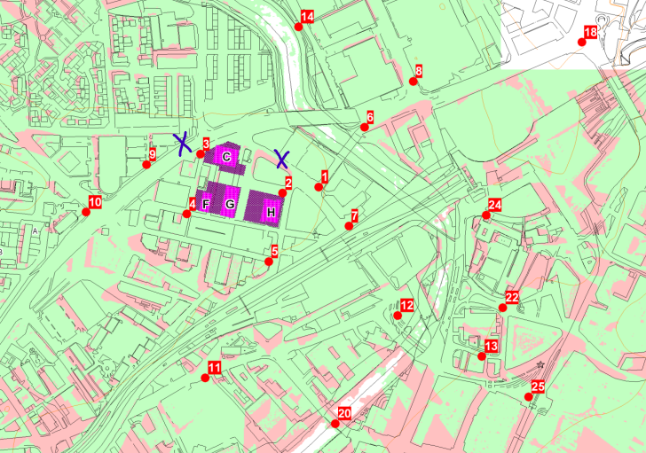
Figure 2 – Council’s requested additional TVIA viewpoint locations

Noise and Vibration [Scoped-Out (EIA Technical Note)]
The Scoping Report sets out that proposed final siting and design of Plot FG would not affect the conclusions of the Noise and Vibration chapter of the Environmental Statement provided at hybrid application stage (and as updated to reflect the revised construction phasing subsequently approved under the S73 application). Section 3.111 of the Scoping Report sets out that the mitigation measures advised at outline stage will still be appropriate for the reserved matters and the residual impacts would be unchanged.
This section of the Scoping Report has been reviewed by the City Council’s Environmental Consultant, and the Council concurs that it is appropriate for the topic of Noise and Vibration to be scoped out, given the presence of existing conditions on the hybrid planning permission which secure appropriate mitigation – this is subject to the submission, as proposed (§3.114), of an acoustics Technical Note with the reserved matters submission, to detail and confirm the suggested compliance.

Air Quality [Scoped-Out (EIA Technical Note)]
The application site is located within the Greater Manchester Combined Authority Air Quality Management Area (AQMA), declared as a result of an exceedance of the UK limit value for Nitrogen Dioxide (NO₂). NO₂ and particulate matter resulting from emissions from road transport are known to adversely affect human health.
The matter of Air Quality was scoped-in to the Environmental Impact Assessment undertaken at hybrid application stage, with the chapter including detailed operational phase dispersion modelling, a construction phase dust risk assessment and a damage cost mitigation strategy in accordance with Defra guidance. The assessment undertaken at that stage considered impacts with respect to all phases of the Masterplan development. The Scoping Report considers (§3.119) that the conclusions and recommendations of that previous work remain valid, and note that there has been no deterioration in baseline air quality since the original assessment work was undertaken (§3.121).
This section of the Scoping Report has been reviewed by the City Council’s Environmental Consultant, and the Council concurs that it is appropriate to scope-out the matter of Air Quality, given the extent of previous assessment and given that mitigation is secured by way of a condition attached to hybrid planning permission – this is contingent on the submission, as proposed (§3.119 and 3.122-3.127) of an appropriate Technical Note with the reserved matters submission, to detail and evidence the conclusions drawn within the Scoping Report.

Wind Microclimate [Scoped-In (EIA Chapter Addendum)]
The Scoping Report (§3.128 – 3.155) outlines that this topic is proposed to be scoped-in to the assessment - the Council agrees with this proposal. The proposed methodology, which accords with that utilised for previous assessment work within the Masterplan area, is considered acceptable.

Sunlight, Daylight and Overshadowing [Scoped-In (EIA Chapter Addendum)]
Section 3.156 of the Scoping Report sets out that a Sunlight, Daylight and Overshadowing EIA Chapter Addendum will be prepared and submitted, including an assessment of the potential effects of the proposals on neighbouring buildings. The Council considers this approach to be appropriate.
It is noted that there is a drafting error within the Scoping Report, with §3.161 – 3.163 referring to documents published by Manchester City Council. For the avoidance of doubt, the current Development Plan of relevance in this case is the City of Salford Unitary Development Plan (2004-2016). In accordance with advice provided previously within this letter, it should be noted that the Council is currently anticipating that the Salford Local Plan: Development Management Policies and Designations will be adopted in Autumn 2022.
The Scoping Report (§3.164 – 3.166) refers to the BRE Guidelines 2011 – the BRE Daylight and Sunlight Guidelines (Site Layout Planning for Daylight and Sunlight: a guide to good practice) were recently (June 2022) updated, and the forthcoming assessment should take into account the updated guidance.
The proposed methodology, including scenarios to be assessed and the list of neighbouring buildings to be included within the assessment (§3.170 – 3.172) is considered otherwise to be acceptable, with the exception that the development which benefits from a resolution to grant planning permission at the corner of Greengate and New Bridge Street (known as One Heritage Tower, SCC ref. 19/74205/FULEIA) should be included within the assessment, as per the assessment undertaken in relation to the development of Phase 2, Plot C.

Transport and Highways [Scoped-Out (EIA Technical Note)]
The Scoping Report (§3.208) sets out that the Transport Chapter within the EIA submitted at hybrid application stage considered the traffic and highways impact for a ‘worst-case’ scenario, occurring when all three phases of the development would be operational (with the maximum possible quantum of development implemented) and background traffic growth would be at its highest.
The Local Highway Authority has reviewed the matter, and confirmed that they do not expect that the conclusions of the previous submissions will change as a result of the detailed design for Phase 3; however, they note that the production of a Technical Note will ensure that consideration has been afforded to the impact, relative to that previously assessed and accepted. No objection is therefore raised to the proposed approach to this topic, subject to the submission of the Technical Note as proposed with the reserved matters application.

Waste and Materials [Scoped-Out]
No consideration is given within the submitted Scoping Report to the potential effects arising in relation to production of waste and consumption of materials. Given the nature of the site and the character of the proposed development it is not considered significant environmental effects would be likely to occur, and therefore it is not considered that assessment within the EIA would be required.

Vulnerability to Major Accidents or Disasters [Scoped-Out]
No consideration is given within the submitted Scoping Report to the potential effects arising from vulnerability to major accidents or disasters. However, given the nature of the site and the character of the proposed development, it is not considered that there are any specific risks (not already set to be covered by the EIA) that require detailed consideration as part of a standalone chapter within the Environmental Statement.

Other Developments and Cumulative Effects
The Local Planning Authority is satisfied with the proposed list of cumulative schemes provided at Appendix 2 of the Scoping Report, however the following is noted:
- ID 1 – Embankment Exchange – The Council recently (September 2022) granted permission for amended development proposals on this site (ref. 17/69573/FUL).
- ID 25 – Ralli Quays – This application (21/78277/FUL) has not yet been approved.
- ID 37 – Springfield Lane – A planning application was recently submitted to the Council and is awaiting validation. The application reference is 22/80643/FULEIA.

If you have any queries regarding the Local Planning Authority’s adopted Screening Opinion, as set out above, please do not hesitate to contact me.
Yours sincerely,

David Allen
Principal Planning Officer

Encl.
- Environment Agency response dated 10 October 2022
- Natural England response dated 20 September 2022

