HOUSE EXTENSION REPORT

REF: 22/80280/HH

Address: 25 Brentwood Road, Swinton, Salford, M27 0EE

Proposal: Proposed single storey rear extension

Appropriate consultation undertaken Yes
Earliest Decision date: 13 September 2022
Reason for delay beyond stat deadline and EoT: n/a

Description of Site and Surrounding Area

The application dwelling is a tow storey detached property located in a residential area. The property is the last of a row of properties to the south side of the street. The west facing elevation of the property faces the rear elevations of the properties along Stott Road. The dwelling has had no previous extensions to the rear at ground floor level with the neighbouring dwelling to the east having a flat roof single storey extension across the width of the dwelling.
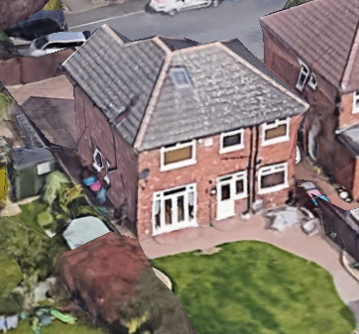
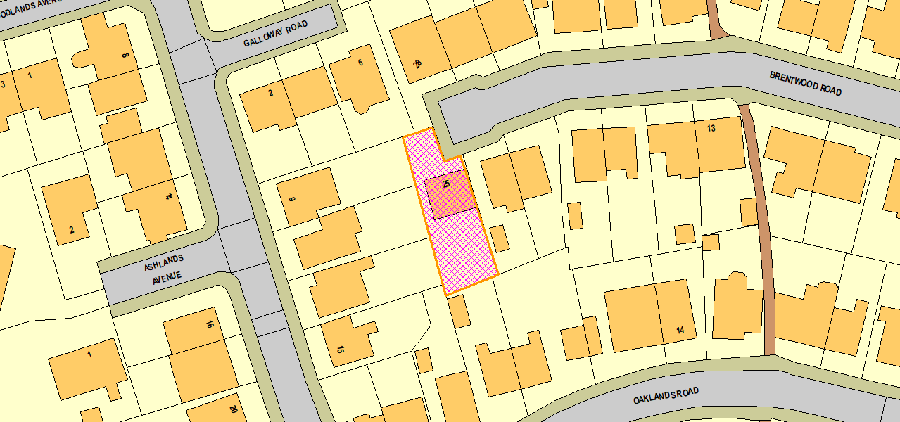
Figure 1 - Aerial (Rear)
Figure 2 - Location

Description of Proposal

- Single storey rear extension projecting 3m to the rear of the original dwelling.
- Spanning full width of existing dwelling.
- Lean to roof structure.

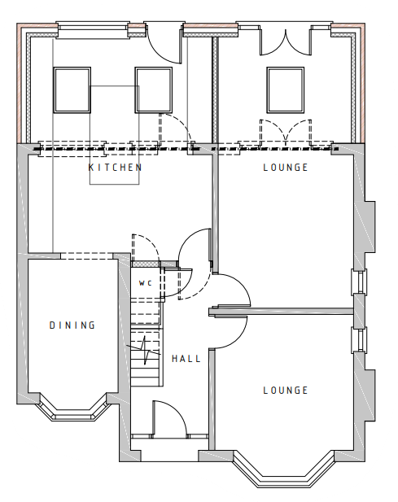
Figure 3 - Proposed GF Plan

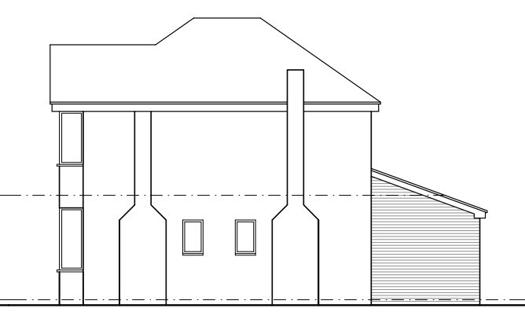
Figure 4 - Proposed Side Elevation (West)
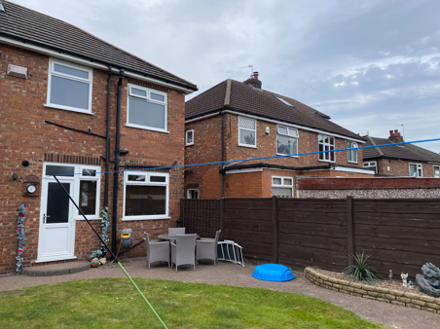
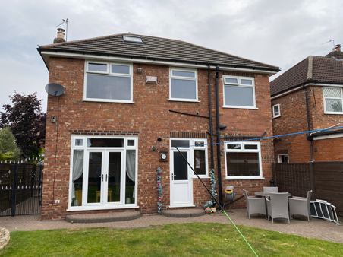
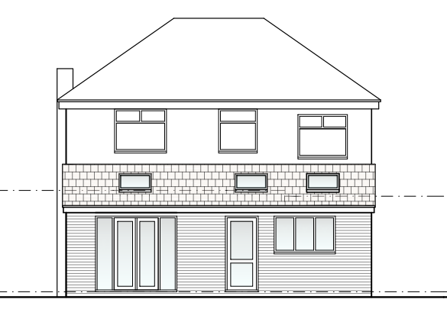
Picture 2 - Rear Elevation / Neighbour
Picture 1 - Rear Elevation
Figure 5 - Proposed Rear Elevation

Relevant Site History

07/55341/HH - Erection of a two storey side extension and construction of hipped roof over existing two storey side extension (re-submission of planning application 07/55104/HH) - PER

Consultations

Not applicable.

Publicity
Earliest Decision Date: 13 September 2022
Revised Expiry Date: 24 October 2022

Site Notice: n/a
Reason: n/a

Press Advert: n/a
Reason: n/a

Representations

11 neighbours consulted on the application, 1 representation received.

 | C – comment received R – officer response
C | - Concerns regarding whether development will overhang neighbouring dwelling and built solely on applicant’s land.
R | - Certificate A has been completed as part of the application stating that nobody except the application is the owner of the land relating to the development.

Planning Policy

Development Plan Policy

Unitary Development Plan DES1 - Respecting Context
Unitary Development Plan DES7 - Amenity of Users and Neighbours
Unitary Development Plan DES8 - Alterations and Extensions

Other Material Planning Considerations

National Planning Policy Framework
National Planning Policy Guidance

Local Planning Policy

Supplementary Planning Document - House Extension

The National Planning Policy Framework (NPPF) paragraph 48 establishes that local planning authorities may give weight to relevant policies in emerging plans according to:
- The stage of preparation of the emerging plan (the more advanced its preparation, the greater the weight that may be given);
- The extent to which there are unresolved objections to relevant policies (the less significant the unresolved objections, the greater the weight that may be given); and
- The degree of consistency of the relevant policies in the emerging plan to the NPPF (the closer the policies in the emerging plan to the policies in the NPPF, the greater the weight that may be given).
There are currently two emerging plans to consider.
First, Places for Everyone Publication Plan, the joint Development Plan Document for nine districts in Greater Manchester, which was published for consultation under Regulation 19 of the Town and Country Planning (Local Planning) (England) Regulations 2012 on 9 August 2021. Representations were invited until 3 October 2021; the plan was submitted to the Secretary of State for examination on 14 February 2022 and examination hearings are due to commence in Summer 2022. The emerging policies which are relevant to this application are discussed where applicable in this report with appropriate weight being afforded in accordance with NPPF paragraph 48.

Second, the Publication Salford Local Plan: Development Management Policies and Designations (SLP:DMP), which was published on 27 January 2020 and comments were invited until 20 March 2020. An Addendum was published on 5 February 2021 and comments were invited on this until 19 March 2021. The Publication SMP:DMP and the Addendum were submitted to the Secretary of State for examination on 30 June 2021 and the examination hearings took place over 7 days in December 2021. The plan has been subject to a significant amount of public consultation in previous stages of its production and the city council has considered the comments made to determine the extent to which there are unresolved objections to its policies. Those policies (i.e. the Publication SLP:DMP policies as modified through the Addendum) which are relevant to this application are discussed where appropriate in this report with appropriate weight being afforded in accordance with NPPF paragraph 48. It is expected that the SLP:DMP will be adopted in Autumn 2022.

In addition, NPPF paragraph 219 establishes that existing policies (such as Salford’s UDP) are not out-of-date simply because they were adopted or made prior to the publication of NPPF. Due weight should be given to them, according to their degree of consistency with the NPPF, and the closer the policies in the UDP to the policies in the NPPF, the greater the weight that may be given. In terms of this application it is considered that the relevant policies of the UDP can be afforded due weight for the purposes of decision making as the relevant criteria within the UDP policies applicable to the proposed development are consistent with the policies contained in the NPPF.

Appraisal of the Proposed Development

Impact on the character of the area

- The single storey rear extension would not be visible from the street scene or easily visible from any public vantage points due to the scale of the development and location of the site.
- The development uses matching materials and is therefore considered to harmonise with the existing dwelling.

Impact on the amenity of neighbours

- The development includes rear facing habitable room windows at ground floor level. These would be located in excess of 21m from facing habitable room windows of the dwelling to the rear.
- There are no windows to the side elevations and therefore no risk of overlooking laterally to neighbouring garden spaces.
- The projection of the single storey rear extension (3m) would avoid intersecting the 45 degree line from 3m along the common boundary from the neighbouring dwelling’s rear elevation to the east of the site.
- The development would follow the existing building line of the west facing elevation of the existing property and therefore maintain existing interface distances to the rear of the neighbouring dwelling to the west on Stott Road.

For the reasons above the development is considered to comply with UDP policies as well as policies HE1, HE2, HE4 and HE5 of the Salford House Extensions SPD.

Other issues

Does the proposal require any work to trees? No

Is there a significant change in levels across the site or between the site and the neighbouring land? No

Has the applicant/agent indicated any personal circumstances? No

Approve

1. The development must be begun not later than three years beginning with the date of this permission.

Reason: Required to be imposed by Section 91 of the Town and Country Planning Act 1990 (as amended).

2. The development hereby permitted shall be carried out in accordance with the following approved plans:

- H. M. Land Registry - Location Plan (LA114849)
- Existing Plans & Elevations (01 A)
- Proposed Plans & Elevations (02 B)

Reason: For the avoidance of doubt and in the interest of proper planning.

3. The external materials used shall match those of the existing building so far as practicable.

Reason: In order to ensure a satisfactory appearance in the interests of visual amenity in accordance with Policies DES1 and DES8 of the City of Salford Unitary Development Plan and the requirements of the National Planning Policy Framework.

Statement of conformity with Article 35 of The Town and Country Planning (Development Management Procedure) (England) Order 2015

The proposal complies with the development plan and would improve the economic, social and environmental conditions of the area. It therefore comprises sustainable development and the Local Planning Authority worked proactively and positively to issue the decision without delay. The Local Planning Authority has therefore implemented the requirement in Paragraph 38 of the NPPF.

Notes to Applicant

1. STANDING ADVICE - DEVELOPMENT LOW RISK AREA

The proposed development lies within a coal mining area which may contain unrecorded coal mining related hazards. If any coal mining feature is encountered during development, this should be reported immediately to the Coal Authority on 0345 762 6848.

Further information is also available on the Coal Authority website at:
www.gov.uk/government/organisations/the-coal-authority

Standing Advice valid from 1st January 2021 until 31st December 2022

2. This decision does not imply consent to carry out any work which may encroach over a common boundary. Such work may include excavation, positioning of walls, fences or other construction such as roofs or gutters which overhang the boundary line. The applicant is therefore advised to obtain the consent of any landowner prior to the commencement of such work. The applicant's attention is also drawn to the provision of the Party Wall Act 1996 (as amended), which sets out the rights and responsibilities of adjoining landowners in respect of the construction or alterations of any party walls, excavations and other construction works adjacent to the boundary line. Before proceeding with the development professional advice on the provision of the Act should be sought.

Officer | J Mumby | DC |  | LPA | M Hodgson
Date | 20.10.22 | Date |  | Date | 20.10.22

