goHOUSE EXTENSION REPORT

REF: 17/70556/HH

Address: 4 Leyland Avenue, Irlam, M44 6HG

Proposal: Erection of a single storey side/rear extension

Appropriate consultation undertaken Yes
Earliest Decision date: 19 September 2017

Description of Site and Surrounding Area

This application relates to a semi-detached property with a hipped roof. The property currently has a part built front porch; the applicant has advised that this is being built under permitted development.
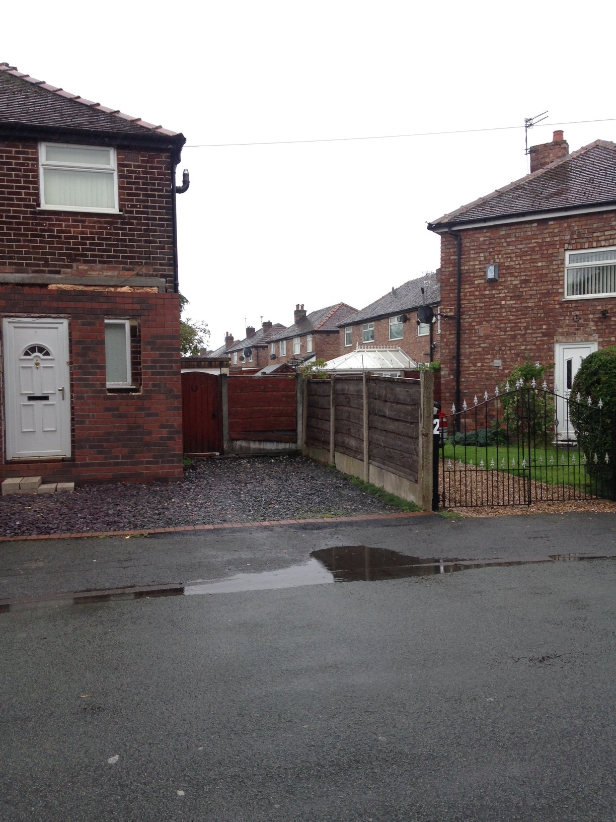
Front elevation and neighbouring property, no.2 Leyland Avenue

Description of Proposal

This application seeks permission for a ‘wrap around’ single storey side and rear extension. This would project beyond the side elevation of the property by approximately 2.4m and would project beyond the rear elevation by approximately 2.5m. It would have a hipped lean-to roof.

One new window would be introduced into the front elevation of the property; this would serve a habitable room (a bedroom). A new window and a new set of French doors serving an open plan kitchen/dining area would be introduced into the rear elevation of the property and another set of French doors serving the living room would also be introduced into the rear elevation of the property. In addition, two roof lights would be installed at the rear of the property. No new windows or open aspects would be introduced into the side elevation of the property.

All external materials would match existing.

Relevant Site History

No relevant site history.

Consultations

Not applicable.

Publicity
Earliest Decision Date: 19 September 2017
Revised Expiry Date: No extension agreed

Representations

1 representation received – a neighbour advised that they have no objections to the proposed development.

Planning Policy

Development Plan Policy

Unitary Development Plan DES1 - Respecting Context
This policy states that development will be required to respond to its physical context and respect the positive character of the local area in which it is situated and contribute towards a local identity and distinctiveness.

Unitary Development Plan DES7 - Amenity of Users and Neighbours
This policy states that all new development, alterations and extensions to existing buildings will be required to provide potential users with a satisfactory level of amenity in terms of space, sunlight, daylight, privacy, aspect and layout. Development will not be permitted where it would have an unacceptable impact on the amenity of occupiers or users of other development.

Unitary Development Plan DES8 - Alterations and Extensions
This policy states that planning permission will only be granted for alterations or extensions to existing buildings that respect the general scale, character, rhythm, proportions, details and materials of the original structure and complement the general character of the surrounding area.

Other Material Planning Considerations

National Planning Policy Framework
National Planning Policy Guidance

Local Planning Policy

Supplementary Planning Document - House Extension
This document contains a number of policies and standards to ensure that extensions within the curtilage of dwellings have a limited and acceptable impact on neighbouring residents; future residents of the application dwelling and that development makes a positive contribution to the local environment in terms of design.

It is not considered that there are any local finance considerations that are material to the application

Appraisal of the Proposed Development

Impact on the character of the area

The proposed extension would appear subordinate to the main dwelling and would respect its current appearance as the same external materials would be used and its roof would be hipped like the main roof of the house. Its design and impact on the character of the area are therefore considered to be acceptable.

Impact on the amenity of neighbours

There would be no facing habitable room windows of neighbouring properties within 21m of the habitable room windows proposed for the rear elevation of this property. The proposed development would therefore be in accordance with Policy HE 1.
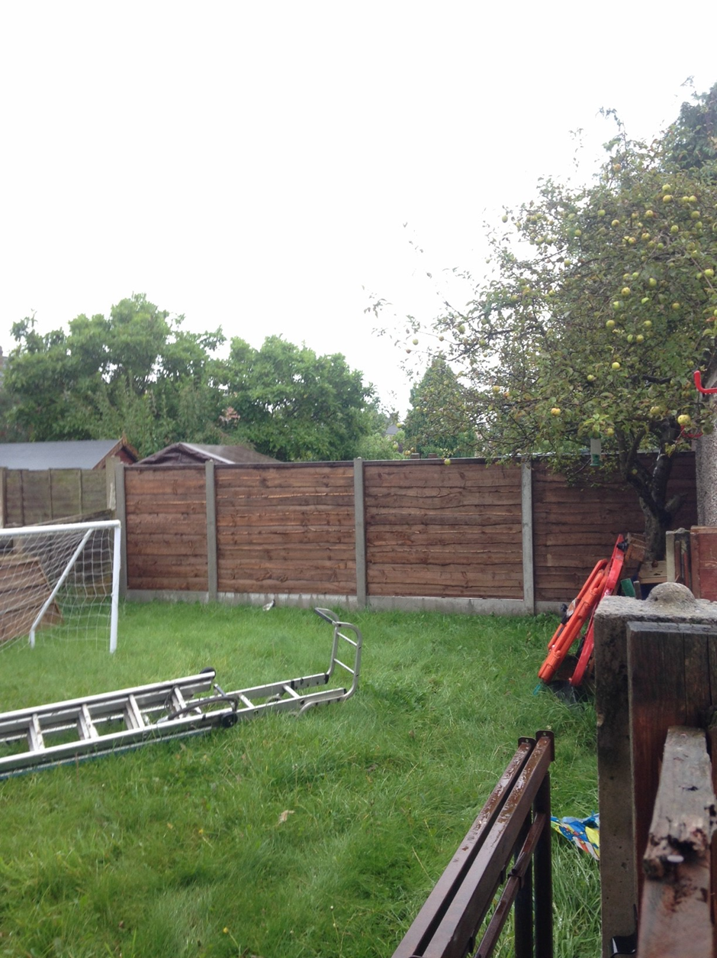

No ground floor windows in no.6 Leyland Avenue would face the blank gable end wall of the proposed extension. Patio doors in the rear elevation of no.2 Leyland Avenue serve a habitable room; because of the way this neighbouring property is angled, these doors face into the garden of no.4. However they do not directly face the space where the extension is proposed, and the proposed development would therefore not lead to an unacceptable loss of light for this property, in accordance with Policy HE 4.

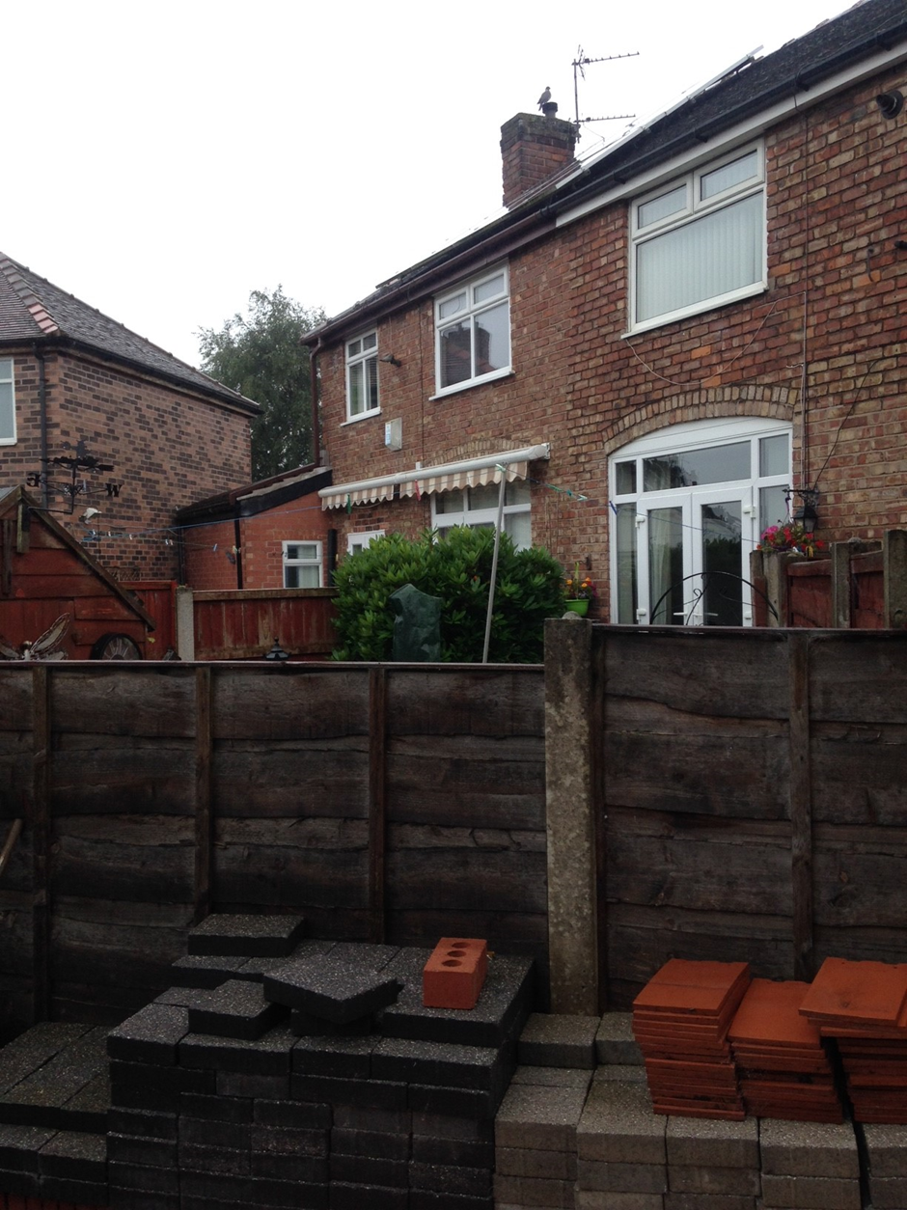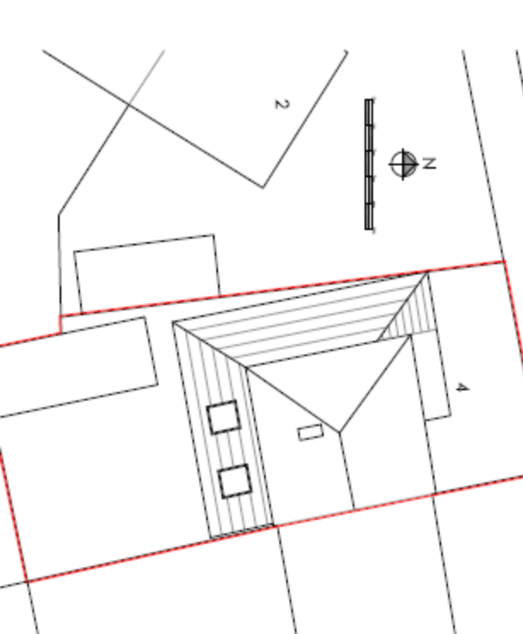

The proposed extension would not project beyond a 45 degree line drawn from a point 3m along the common boundary with the adjoining property, no.6. A 45 degree line drawn from the mid-point of the doors in the rear elevation of 2 Leyland Avenue would intersect with the proposed extension. However, given that these doors already directly face a detached garage located to the rear of no.4, and given that the proposed extension would be of similar size to this and with a hipped roof, it is considered unlikely that the proposed development would have an unacceptably overbearing impact on no.2 Leyland Avenue.

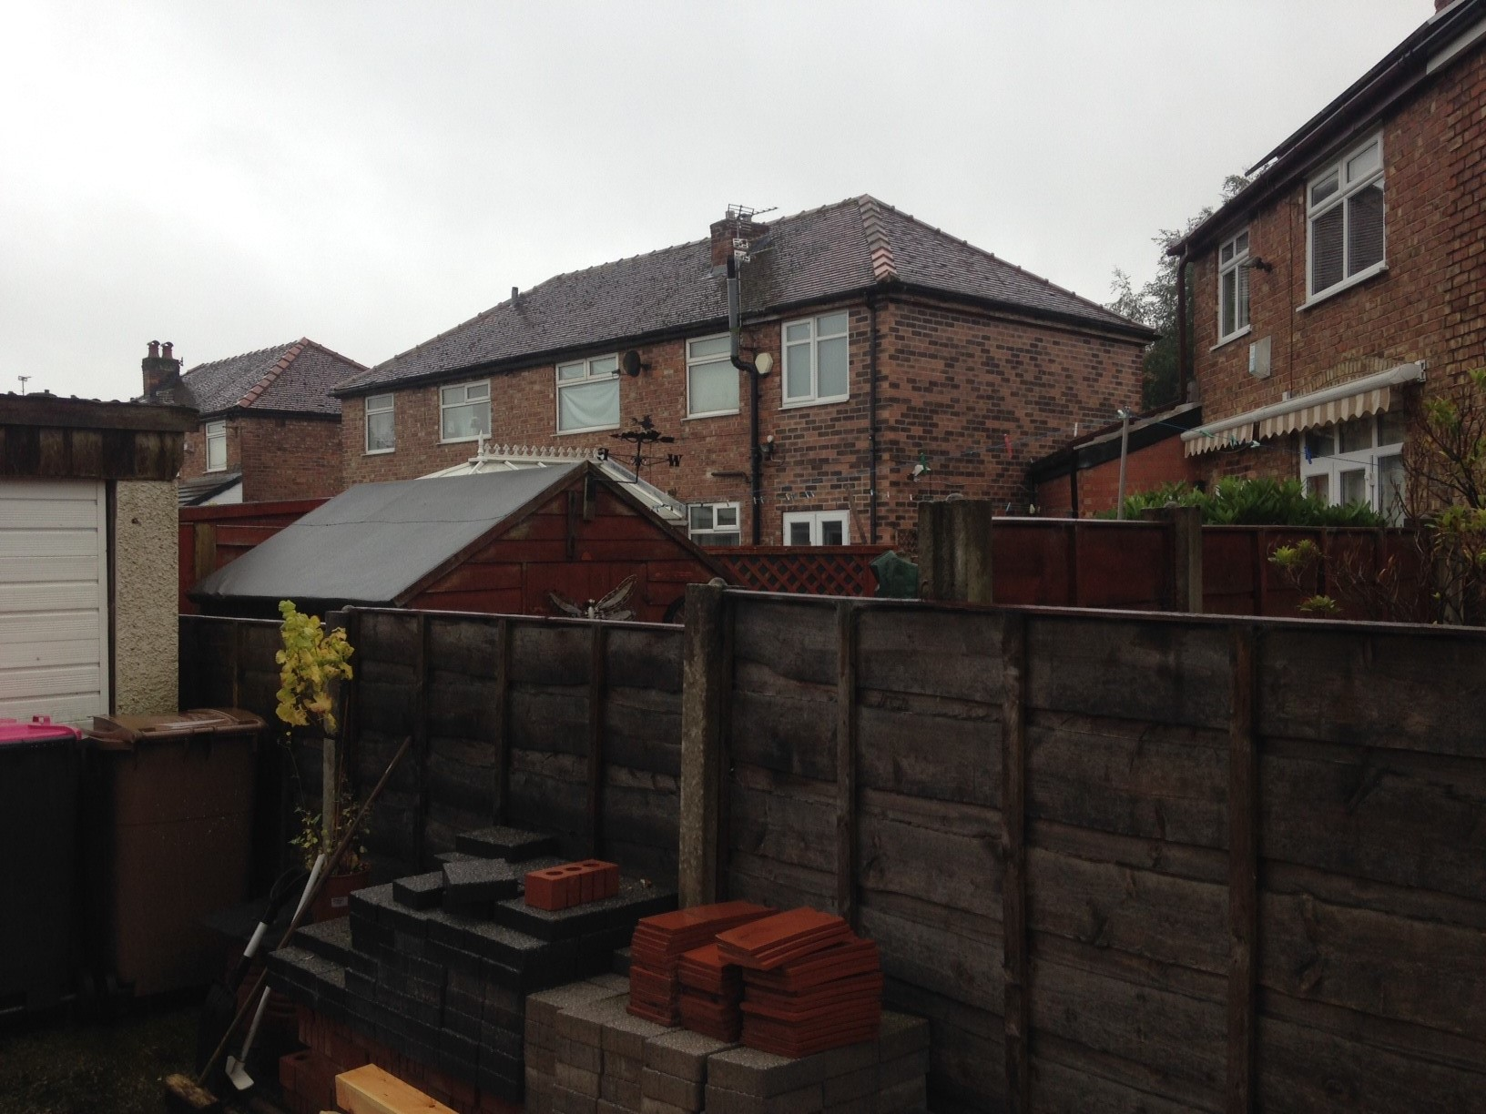

Impact on the highway network

A hardstanding of at least 4.8m in length and 2.4m in width would not be maintained, meaning that the proposed development would not comply with Policy HE11. However, the loss of one off-street parking space is unlikely to have an unacceptable impact on parking amenity given the fact that most of the properties on this street have front driveways.

Other issues

Does the proposal require any work to trees? No

Is there a significant change in levels across the site or between the site and the neighbouring land? No

Has the applicant/agent indicated any personal circumstances? No

Recommendation:

Approve

1. The development must be begun not later than three years beginning with the date of this permission.

Reason: Required to be imposed by Section 91 of the Town and Country Planning Act 1990 (as amended).

2. The development hereby permitted shall be carried out in accordance with the following approved plans:

Proposed site plan - drawing no. 105
Proposed ground plan - drawing no. 106
Proposed section B - drawing no. 107
Proposed elevations - drawing no. 108
Proposed first floor plan - drawing no. 109

Reason: For the avoidance of doubt and in the interest of proper planning.

3. The external materials used shall match those of the existing building so far as practicable.

Reason: In order to ensure a satisfactory appearance in the interests of visual amenity in accordance with Policies DES1 and DES8 of the City of Salford Unitary Development Plan and the requirements of the National Planning Policy Framework.

Officer | Chloe Tomlinson | DC | Faye Tomlinson | LPA | Jimmy McManus
Date | 26.09.17 | Date | 03.10.2017 | Date | 04.10.2017

