APPLICATION No: | 17/70897/HH
APPLICANT: | Mr Daniel Stribling
LOCATION: | 72 Ringlow Park Road, Swinton, M27 0HB
PROPOSAL: | Erection of a single storey side and rear extensions.
WARD: | Worsley

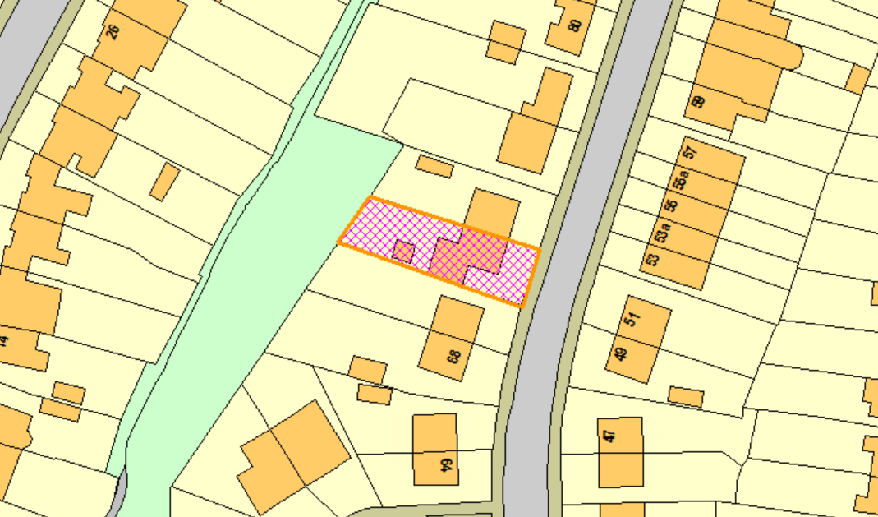

Description of Site and Surrounding Area
The application relates to a semi-detached dwelling on Ringlow Park Road, Swinton. The property as existing has hard standing to the front and a detached garage and enclosed garden to the rear. The property has already been subject to a part single/ part two storey side/rear extension. The surrounding area is residential in nature with a mix of semi-detached and terraced dwellings. Boundary treatment to the rear of the site consists of a 1.8m high concrete fence, beyond this is an area of open space and the brook - the brook is approximately 30m away from the proposed development and as such it is not necessary to consult the Environment Agency.

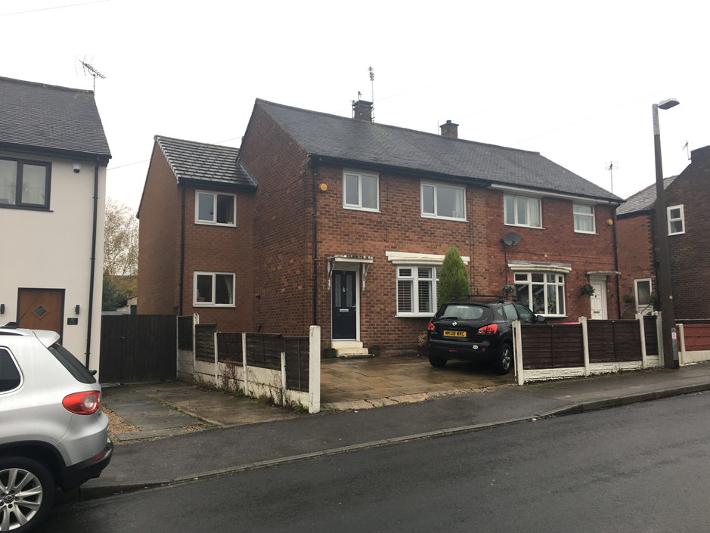  The application property | 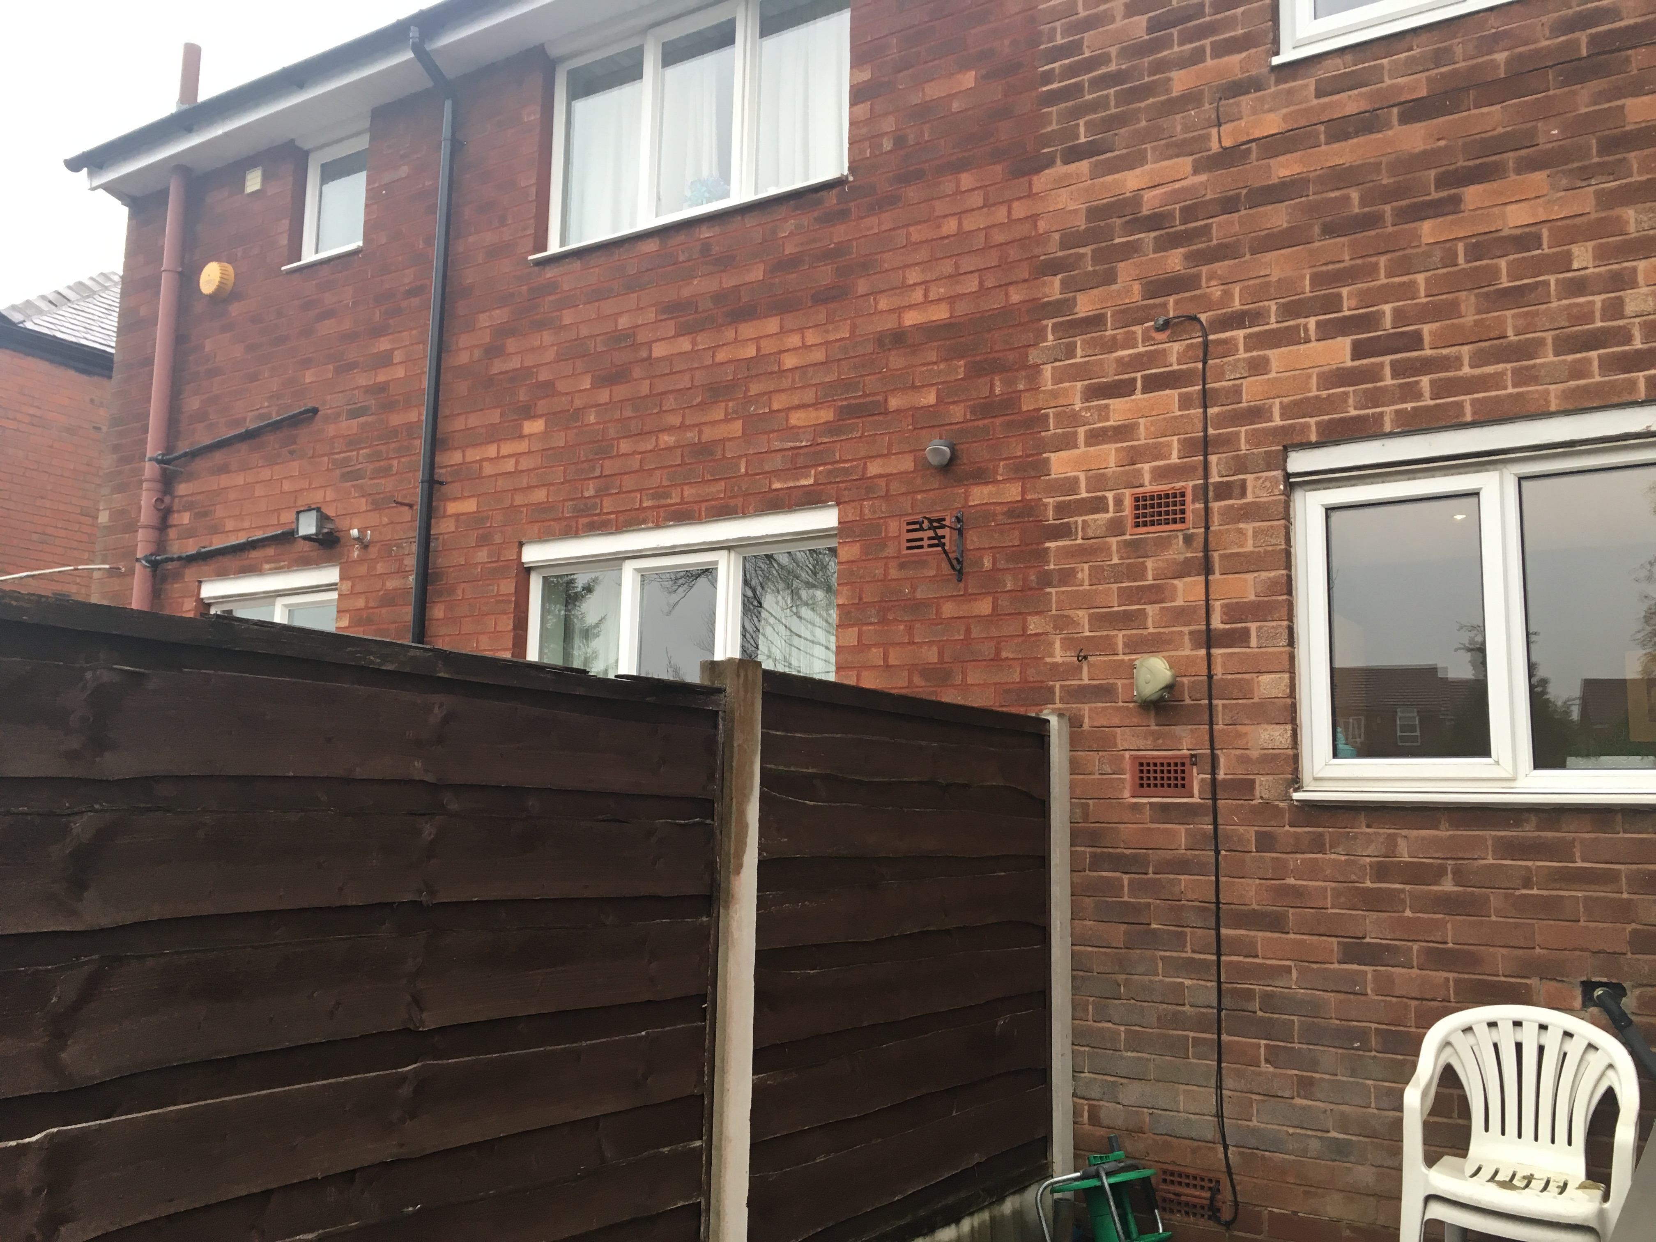  The rear of the property and no.74

Description of Proposal
The applicant seeks to erect a single storey side extension and a single storey rear extension. The proposed side extension will project 2.5m from the existing side elevation of the property. It will sit flush with the front elevation of the property and would join onto the existing two storey side extension. It would serve as a utility, W.C. and extended hallway. A window is proposed to the front elevation.

The rear extension would project 3m from the main rear elevation of the property. It would extend from the existing rear extension to create a snug. The roof would be pitched in design and would be 3.5m in height and would extend in part over the existing single storey rear extension element. A set of bi-folding patio doors would be introduced to the rear elevation and a velux window to the roof.

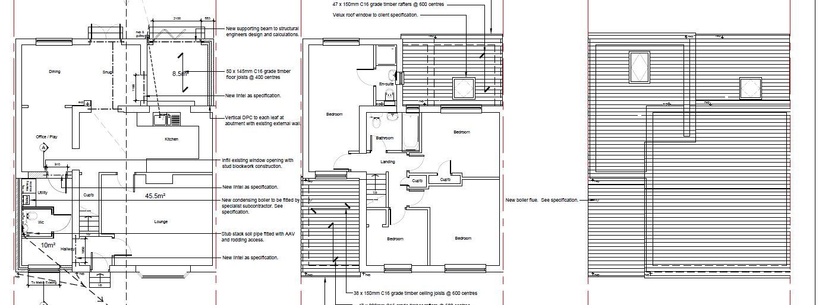
Proposed floor plans
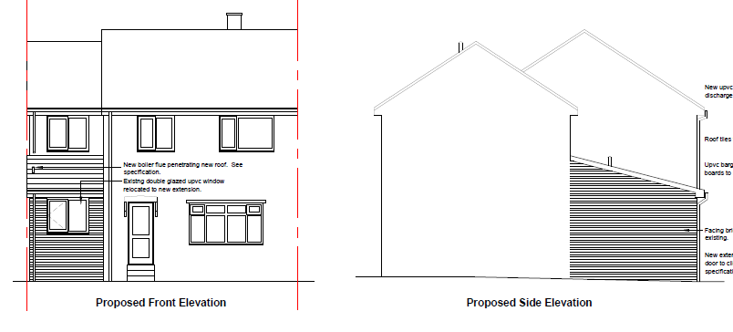

Proposed elevations
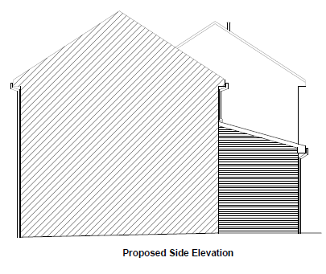
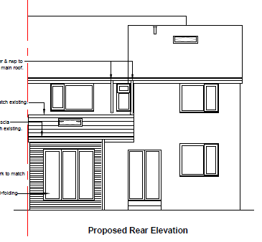

Publicity

Site Notice: N/A
Reason: N/A

Press Advert: N/A
Reason: N/A

Relevant Site History

09/58266/HH- Erection of part single/part two storey side/rear extension. Approved 21st December 2009.

Consultations
Neighbours notification:

49 Ringlow Park Road, Swinton, Manchester, M27 0HA
53 Ringlow Park Road, Swinton, Manchester, M27 0HA
22 Douglas Road, Worsley, Manchester, M28 2SG
24 Douglas Road, Worsley, Manchester, M28 2SG
70 Ringlow Park Road, Swinton, Manchester, M27 0HB
51 Ringlow Park Road, Swinton, Manchester, M27 0HA
74 Ringlow Park Road, Swinton, Manchester, M27 0HB

Representations

One objection has been received. The key issue raised involves the loss of light and sun for the neighbouring property and their garden amenity space. This will be assessed within the appraisal section of the report.

Other issues raised involve concerns about damage to the rear patio of the neighbouring garden during construction; this is not a material planning consideration and therefore cannot be taken into account in the assessment of this planning application.

Planning Policy

Development Plan Policy

Unitary Development Plan DES1 - Respecting Context
This policy states that development will be required to respond to its physical context and respect the positive character of the local area in which it is situated and contribute towards a local identity and distinctiveness.

Unitary Development Plan DES7 - Amenity of Users and Neighbours
This policy states that all new development, alterations and extensions to existing buildings will be required to provide potential users with a satisfactory level of amenity in terms of space, sunlight, daylight, privacy, aspect and layout. Development will not be permitted where it would have an unacceptable impact on the amenity of occupiers or users of other development.

Unitary Development Plan DES8 - Alterations and Extensions
This policy states that planning permission will only be granted for alterations or extensions to existing buildings that respect the general scale, character, rhythm, proportions, details and materials of the original structure and complement the general character of the surrounding area.

Other Material Planning Considerations

National Planning Policy Framework
National Planning Policy Guidance

Local Planning Policy

Supplementary Planning Document - House Extension
This document contains a number of policies and standards to ensure that extensions within the curtilage of dwellings have a limited and acceptable impact on neighbouring residents; future residents of the application dwelling and that development makes a positive contribution to the local environment in terms of design.

It is not considered that there are any local finance considerations that are material to the application.

Appraisal of the Proposed Development

Impact on the character of the area
The single storey side element of this extension would be visible from the street. The scale and massing of the extension is considered to be appropriately designed to complement the existing structure. The side extension would adjoin the existing two storey side extension which is set back by 4m; this is in accordance with policy HE8 of the house extensions SPD and alleviates any potential for terracing to occur between the property and the adjacent property at no. 70 Ringlow Park Road.

The rear extension would not be visible from the street and is considered to be appropriately designed. Materials have been set to match the existing in order to respect the context of the original dwelling and character of the area. Due to these factors it is subsequently considered that the design of the development will be in keeping with the existing property and will not look out of place or have a significant effect on the character of the area, nor will it be an incongruous feature in the residential setting in accordance with policies DES1 and DES8.

Impact on the amenity of neighbours

In relation to the single storey side extension, there are no habitable room windows featured on the side elevation of no. 70 Ringlow Park Road that would be affected by the proposed development.

The rear extension would not project past a 45 degree line drawn from a point 3m along the common boundary from the rear elevation of no. 74 Ringlow Park Road. This is in accordance with policy HE5 of the House Extensions SPD and therefore it is considered that the extension would not result in an unacceptable impact on the adjoining property at no. 74 Ringlow Park Road in terms of loss of light or overbearing impact. Furthermore, there are no properties to the rear that would be affected by the development.

Due to the factors assessed it is therefore considered that the proposed extensions would not result in an unacceptable impact upon the amenity of neighbours, in accordance with UDP policy DES7 and the policies within the House Extensions SPD.

Impact on the highway network

The proposed extensions would not affect parking arrangements at the site, with an area of hardstanding existing to the front of the property to accommodate off-street parking.

Recommendation
Approve

Conditions

1. The development must be begun not later than three years beginning with the date of this permission.

Reason: Required to be imposed by Section 91 of the Town and Country Planning Act 1990 (as amended).

2. The external materials used shall match those of the existing building so far as practicable.

Reason: In order to ensure a satisfactory appearance in the interests of visual amenity in accordance with Policies DES1 and DES8 of the City of Salford Unitary Development Plan and the requirements of the National Planning Policy Framework.

3. The development hereby permitted shall be carried out in accordance with the following approved plans:

Location plan, drawing no. 1
Proposed plans, drawing no.4
Proposed elevations and section, drawing no. 5
(All received 7/11/2017)

Reason: For the avoidance of doubt and in the interest of proper planning.

Notes for Applicant

1. STANDING ADVICE - DEVELOPMENT LOW RISK AREA

The proposed development lies within a coal mining area which may contain unrecorded coal mining related hazards. If any coal mining feature is encountered during development, this should be reported immediately to the Coal Authority on 0345 762 6848.

Further information is also available on the Coal Authority website at:
www.gov.uk/government/organisations/the-coal-authority

This Standing Advice is valid from 1st January 2017 until 31st December 2018

2. The applicant is advised that their site lies within 250m of a former landfill site. In the event that landfill gas is migrating, suitable precautions need to be undertaken to avoid the ingress of landfill gas into the new extension or existing house. It is strongly advised that the detailed design specification incorporates suitable measures to mitigate against the ingress of landfill gas. Any measures would be expected to conform to the standards contained in the 1990 Building research Establishment Report "Construction of new buildings on gas-contaminated land"

