HOUSE EXTENSION REPORT

REF: 18/71537/HH

Address: 464 Walkden Road, Worsley, M28 2NF

Proposal: Demolition of existing single storey porch and erection of single/two storey side extension, infill of existing door and replacement with new window to the front.

Appropriate consultation undertaken Yes
Earliest Decision date: 4 May 2018

Description of Site and Surrounding Area

The application relates to a detached property on Walkden Road in the Worsley area of Greater Manchester. It is a residential area made up of a variety of different styles of detached houses.

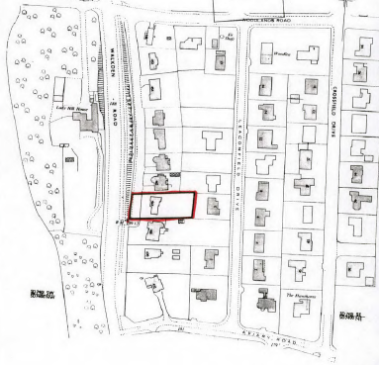
Location Plan of 484 Walkden Road

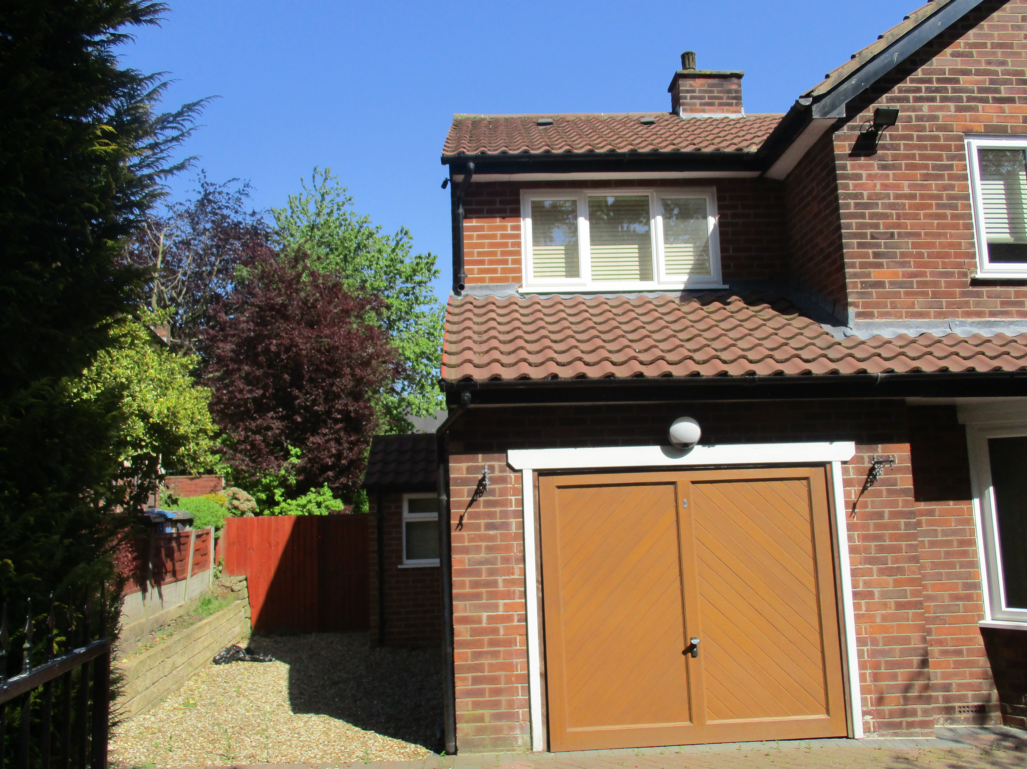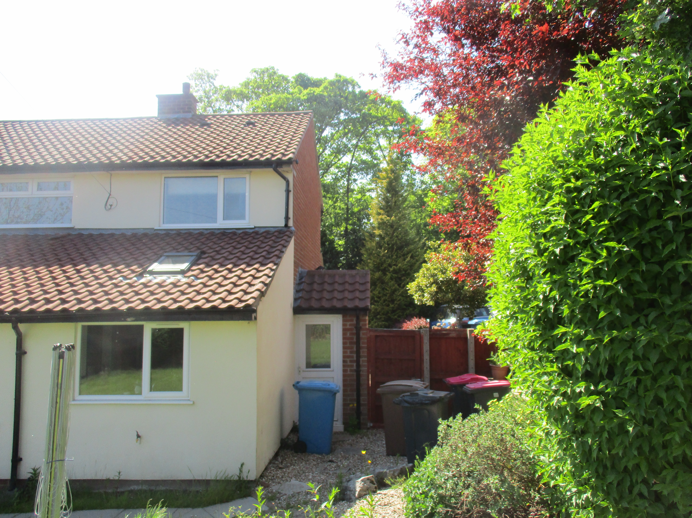
Front of 484 Walkden Road Rear of 484 Walkden Road

Description of Proposal

The proposed application is for the demolition of the existing single storey porch to the side of the property and the erection of single/two storey side extension as well as the infill of existing garage door and its replacement with a new window to the front. The proposed single/two storey side extension will measure (to maximum dimensions) 2.53m wide, 11.16m deep and 7.4m high with a pitched rood to match the existing side extension. Materials to be used will match those used on the existing house and consist of facing bricks and smooth render for the walls, concrete roof tiles for the roof and white uPVC windows and doors.

Relevant Site History

- 92/30599/HH – Construction of pitched roofs over existing garage, part of house and over single storey bay window – Approved 12.01.1993
- 00/40566/HH – Construction of first floor side extension above existing garage to provide bedroom – Approved 19.04.2000
- 00/41297/HH – Erection of rear sunroom extension and erection of side porch and replace roof on existing rear extension to pitched roof – Approved 12.10.2000
- 03/46480/HH – Erection of a single storey rear extension – Approved 13.08.2003
- 04/49072/HH – Erection of single storey rear extension and porch extension to front – Approved 11.10.2004
- 10/59160/HH – Demolition of existing porch and erection of a part single/part two-storey side/rear extension and single storey rear extension – Refused 08.09.2010
- 10/59392/HH – Demolition of existing porch on side elevation and erection of two storey side extension and single storey rear extension – Approved 15.11.2010

Consultations

Not applicable.

Publicity

Earliest Decision Date: 4 May 2018
Revised Expiry Date:

Site Notice: N/A
Reason: N/A

Press Advert: N/A
Reason: N/A

Representations

One letter of representation received – Neighbour is concerned with the removal of the existing garage and the addition of a two storey side extension stating that the house has already undergone many extensions and this extension will now deprive a large detached house of its only single garage. The neighbour feels it is excessive to develop a two storey side extension.

Planning Policy

Development Plan Policy

Unitary Development Plan DES1 - Respecting Context
This policy states that development will be required to respond to its physical context and respect the positive character of the local area in which it is situated and contribute towards a local identity and distinctiveness.

Unitary Development Plan DES7 - Amenity of Users and Neighbours
This policy states that all new development, alterations and extensions to existing buildings will be required to provide potential users with a satisfactory level of amenity in terms of space, sunlight, daylight, privacy, aspect and layout. Development will not be permitted where it would have an unacceptable impact on the amenity of occupiers or users of other development.

Unitary Development Plan DES8 - Alterations and Extensions
This policy states that planning permission will only be granted for alterations or extensions to existing buildings that respect the general scale, character, rhythm, proportions, details and materials of the original structure and complement the general character of the surrounding area.

Other Material Planning Considerations

National Planning Policy Framework
National Planning Policy Guidance

Local Planning Policy

Supplementary Planning Document - House Extension
This document contains a number of policies and standards to ensure that extensions within the curtilage of dwellings have a limited and acceptable impact on neighbouring residents; future residents of the application dwelling and that development makes a positive contribution to the local environment in terms of design.

It is not considered that there are any local finance considerations that are material to the application

Appraisal of the Proposed Development

Impact on the character of the area

- The proposed single/two storey side extension would be set back from the main house at first floor level by approximately 1.5m to reduce the appearance of terracing. While it is not set back the required 2m as outlined in the Policy HE8 of the SPD on House Extensions, it would be in line with the existing side extension and to set the new extension 2m back would create a stepped appearance that would be visually incongruous. Therefore, it is considered that the single/two storey side extension would not have a negative impact on the character of the area.
- The existing garage is to be converted to a bedroom. This will see the replacement of an existing garage door with a new window. The proposal would not have a detrimental impact on the character of the area and would not detract visually from the house.

Impact on the amenity of neighbours

- The proposed single/two storey side extension would not protrude any further to the rear of the property than the existing rear single storey projection and as a result, there would be a distance of approximately 28.9m between the rear of the property and any rear facing properties on Leaconfield Drive. There are no properties facing the front of the application property. Therefore, the proposed development would comply with Policy HE1 of the SPD.
- There would be a distance of approximately 1.5m (minimum distance) between the side elevation of the proposed new extension and the common boundary with the neighbouring property at 462 Walkden Road. The proposed windows on the side elevation would serve an en-suite bathroom on the ground floor while the window on the first floor would serve a bedroom but would not be the principal window. It is the applicant’s intention to obscure glaze the two windows and the door on the side elevation to afford privacy to residents of both properties Therefore, the side extension would comply with Policy HE2 of the SPD.
- In addition, the extension would not project past the rear elevation of the neighbouring property No 462 Walkden Road and therefore would not have an impact on the windows within the rear elevation of this neighbouring property.

Impact on the highway network

- While the application proposes the change of the existing garage into a store area, it would not have an impact on the highway network as there would be sufficient parking in the driveway for at least two vehicles.

Other issues

Does the proposal require any work to trees? NO

Is there a significant change in levels across the site or between the site and the neighbouring land? NO

Has the applicant/agent indicated any personal circumstances? NO

Recommendation:
Approve

1. The development must be begun not later than three years beginning with the date of this permission.

Reason: Required to be imposed by Section 91 of the Town and Country Planning Act 1990 (as amended).

2. The external materials used shall match those of the existing building so far as practicable.

Reason: In order to ensure a satisfactory appearance in the interests of visual amenity in accordance with Policies DES1 and DES8 of the City of Salford Unitary Development Plan and the requirements of the National Planning Policy Framework.

3. The development hereby permitted shall be carried out in accordance with the following approved plans:

Location Plan Drg. No. GM557262
Proposed Floor Plans Drg. No. 4A
Proposed Elevations Drg. No. 5A
Proposed Elevations Drg. No. 6A

Reason: For the avoidance of doubt and in the interest of proper planning.

4. The ground floor and first floor windows in the northern elevation facing the common boundary with 462 Walkden Road shall be fitted with, and permanently glazed, in textured glass whose obscuration level is at least 3 on the Pilkington scale of 1-5 (where 1 is clear and 5 is completely obscure).

Reason: In the interest of the amenity of residents in accordance with policy DES7 of the City of Salford Unitary Development Plan and the National Planning Policy Framework.

Statement of conformity with Article 35 of The Town and Country Planning (Development Management Procedure) (England) Order 2015.

The proposal complies with the development plan and would improve the economic, social and environmental conditions of the area. It therefore comprises sustainable development and the Local Planning Authority worked proactively and positively to issue the decision without delay. The Local Planning Authority has therefore implemented the requirement in Paragraphs 186-187 of the NPPF.

Notes for Applicant:

Officer | James Griffin | DC | Faye Tomlinson | LPA | Claire Thorn
Date | 21/06/2018 | Date | 26.06.2018 | Date | 27.06.18

