HOUSE EXTENSION REPORT

REF: 18/71606/HH

Address: 3 Woodlands Road, Worsley, M28 2QG

Proposal: Erection of a part ground and first floor, two storey extension and first floor extensions, installation of balcony at first floor level and construction of front dormer together with alterations to elevations

Appropriate consultation undertaken Yes
Earliest Decision date: 14 May 2018

Description of Site and Surrounding Area

The application relates to a detached bungalow on the corner of Woodlands Road and Crossfield Drive.

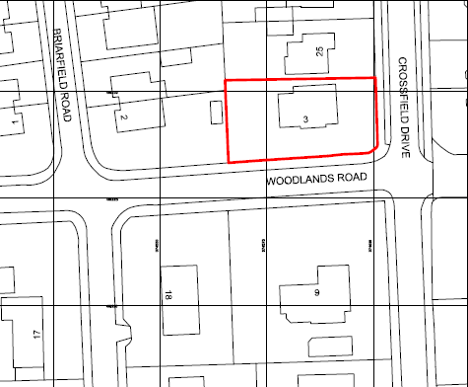
Site Location Plan

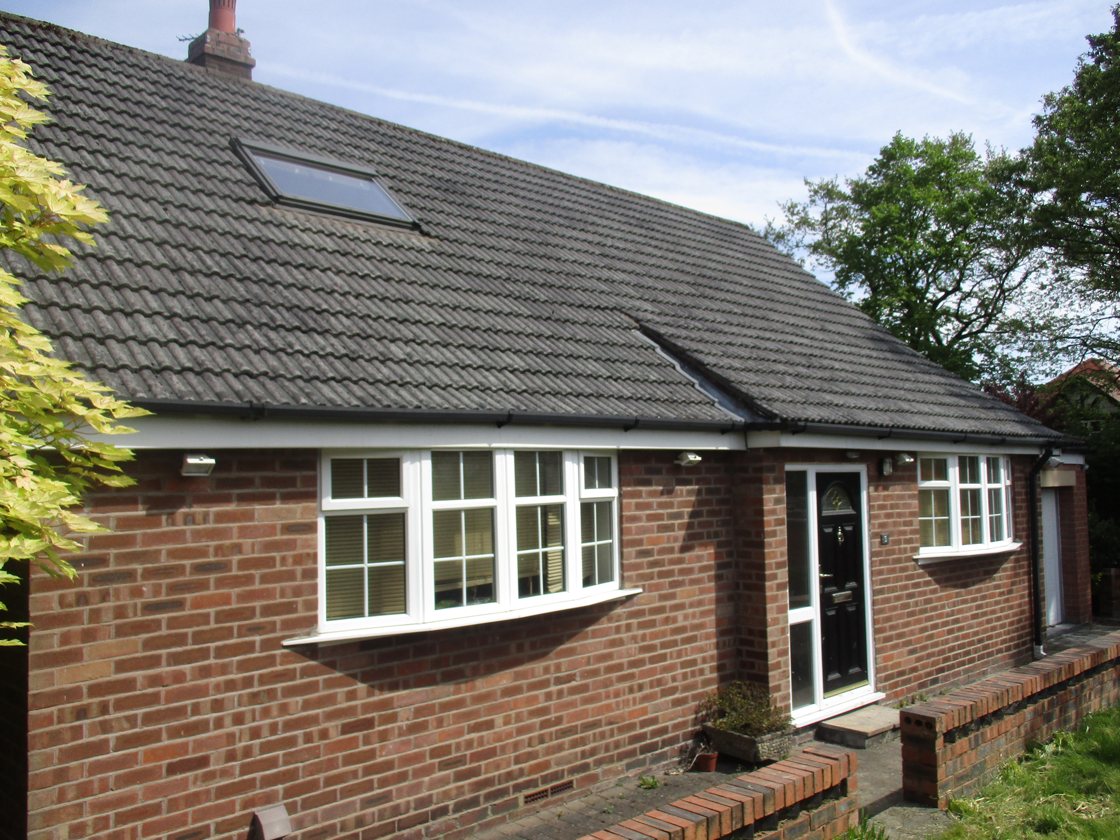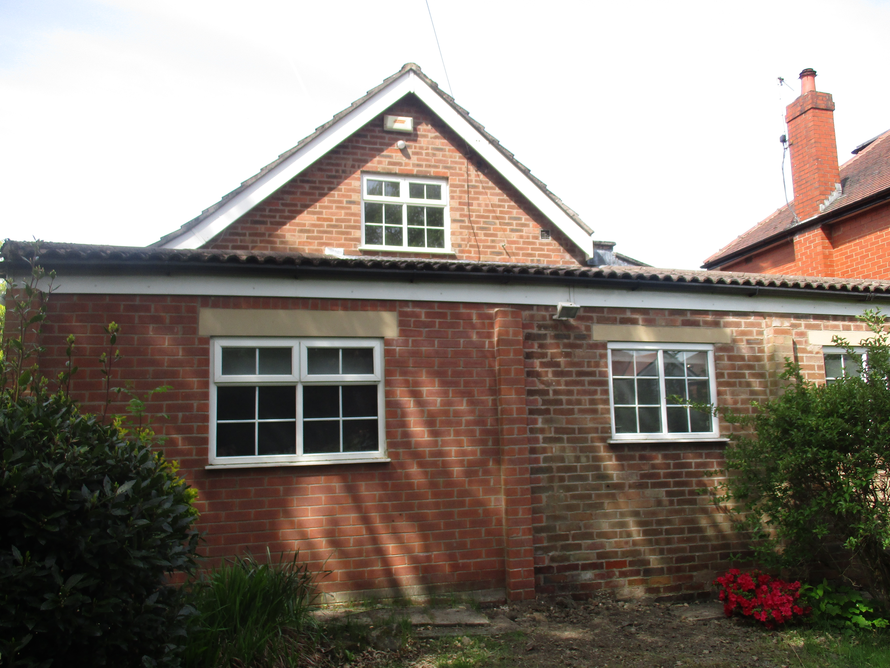
Front of application property West elevation of application property

Description of Proposal

The application is for the erection of a part ground and first floor two storey extension and first floor extensions, as well as the installation of balcony at first floor level and the construction of front dormer together with alterations to elevations. The proposed ground floor extensions would measure 3.97m wide, 1.57m deep and 2.9m high and would be located to the rear (north-east) of the property and will be flush with the side and rear elevations. The proposed new first floor would measure 14.3m wide, 9.64m deep and maximum 5.25 high (2.15m to eaves). This would add an additional 2.9m to the ridge height of the property and 2.05m to the eaves. Proposed materials would consist of roof tiles which would match the existing and a mix of brickwork, render and cladding for the external walls.

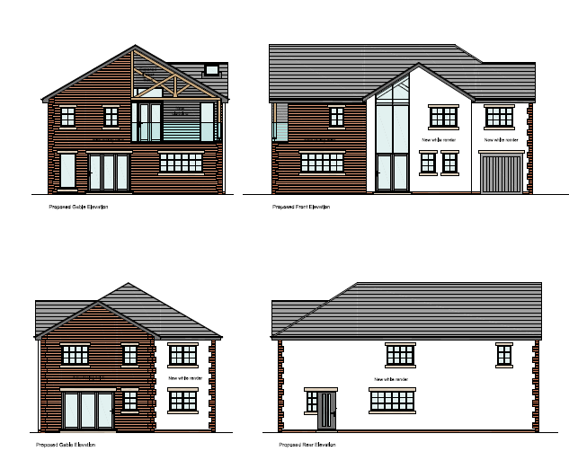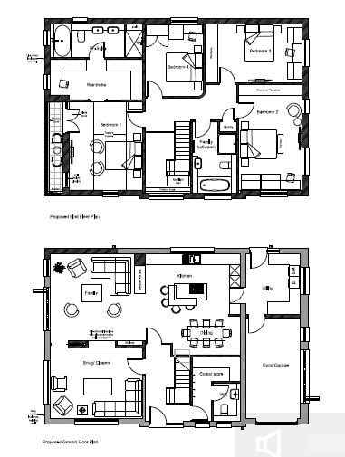

Relevant Site History

02/45311/HH – Erection of single storey side extension and construction of pitched roof over existing garage – Approved 11.02.2003

Consultations

Not applicable.

Publicity
Earliest Decision Date: 14 May 2018
Revised Expiry Date: 21 June 2018

Site Notice: N/A
Reason: N/A

Press Advert: N/A
Reason: N/A

Representations

Two individual representations received:

- Neighbours raised issues with holes dug in the garden of the property and had concerns that work had already commenced. – Small holes were dug at the property to check the quality of the ground. No construction work was carried out.
- There are also concerns with the scale and size of the property on a road which they maintain is characterized by single storey bungalows. – Addressed in report below.
- Concerns that the proposed development will block light.– Addressed in report below.
- Concerns that the proposed development will block satellite television signal. – Unlikely that household extension would block TV signals.
- Questions regarding consultations and public site notices.–Neighbour letters sent on the 23rd April and appropriate consultation carried out as per statutory requirements.
- Concerns of the balcony reducing privacy in the side elevation – Addressed in report below
- Concerns over the permissions over the original kitchen extension – Not related to this current proposal and therefore does not need to be considered.
- Issues over the design of the property when being viewed by neighbours – Addressed in report below

Planning Policy

Development Plan Policy

Unitary Development Plan DES1 - Respecting Context
This policy states that development will be required to respond to its physical context and respect the positive character of the local area in which it is situated and contribute towards a local identity and distinctiveness.

Unitary Development Plan DES7 - Amenity of Users and Neighbours
This policy states that all new development, alterations and extensions to existing buildings will be required to provide potential users with a satisfactory level of amenity in terms of space, sunlight, daylight, privacy, aspect and layout. Development will not be permitted where it would have an unacceptable impact on the amenity of occupiers or users of other development.

Unitary Development Plan DES8 - Alterations and Extensions
This policy states that planning permission will only be granted for alterations or extensions to existing buildings that respect the general scale, character, rhythm, proportions, details and materials of the original structure and complement the general character of the surrounding area.

Other Material Planning Considerations

National Planning Policy Framework
National Planning Policy Guidance

Local Planning Policy

Supplementary Planning Document - House Extensions
This document contains a number of policies and standards to ensure that extensions within the curtilage of dwellings have a limited and acceptable impact on neighbouring residents; future residents of the application dwelling and that development makes a positive contribution to the local environment in terms of design.

It is not considered that there are any local finance considerations that are material to the application

Appraisal of the Proposed Development

Impact on the character of the area

- The proposed first floor addition to the existing property would not be out of character with the area. A neighbour representation raises concerns that the extensions would not be in keeping with other properties in the area. However, the property’s location on the corner of Woodlands Road and Crossfield Drive means that it is sited adjacent to other two storey properties. As most of the property is viewable from Crossfield Drive, rather than Woodlands Road, it would be more in keeping as a two storey property. No.3 is viewed in the context of the two-storey property’s on Crossfield Drive rather than the predominantly single storey properties on Woodlands Road. Therefore increasing the height of No 3 would be in character with neighbouring properties and the streetscene.
- The choice of a mix of render, cladding and brickwork would mean it would match the materials used in the area.
- The proposed first floor extension would not appear overbearing or dominant on its plot of land. The ridge and eaves height would be 8.1m and 5m respectively, an increase of 2.9m and 2.09m. This height is similar to the properties on Crossfield Drive and it is felt it would not have a detrimental impact on the character of the area.

Impact on the amenity of neighbours

- There would be at least 21m between front facing windows of the application property and any front facing windows of the neighbouring property at 9 Woodlands Road. The rear facing windows of the application property would face the side of the neighbouring property at 25 Crossfield Drive.
- As mentioned, the rear of the property faces onto the side elevation of the neighbouring property at 25 Crossfield Drive. Two new first floor windows which would serve Bedroom 4 and a bathroom are proposed and would look onto the side elevation of 25 Crossfield Drive. While there would only be a distance of 2.73m between the properties, there are no windows on the side elevation of Crossfield Drive that would be overlooked by the proposed new windows. Therefore, while it would not strictly comply with Policy HE2, the proposed new window would not have a negative impact on the amenity of either property.
- No. 25 Crossfield Drive raised an objection on the grounds of loss of light. No.3 Woodlands Road is south of their boundary and extends 1.8m further west. The proposed extension would not extend beyond a 45 degree line drawn from the midpoint of the rear habitable windows of no.25 adhering to Policy HE 6.
- The application property is a detached property located on a corner plot and therefore, Policy HE8 would not apply in this case.
- The extensions would not project further forward than the existing building line on Woodlands Road and Crossfield Drive and therefore Policy HE9 is not applicable.
- Included in the plans is a proposed balcony on the western elevation. There would be a distance of at least 28m between the balcony and any habitable rooms of the neighbouring property at 2 Briarfield Road, therefore, it would be unlikely to have a detrimental impact on the amenity of this property.
- Objections were raised on the loss of privacy due to the balcony of the property; this balcony will be flush with the building line and therefore will not cause any loss of amenity to no.25 and the elevation of no.2 Brierfield will be over 21m in distance, therefore complying with HE2.

Impact on the highway network

- The proposed development would not have a negative impact on the highway network.

Impact on trees

- An arboricultural method statement and a tree protection plan have been submitted to show how on-site trees will be protected prior to and during any work on the property.
- The City’s Arboricultural consultant has reviewed the application and has advised that the AMS and TPP as acceptable with conditions detailed below (5 and 6)

Other issues

Does the proposal require any work to trees? NO

Is there a significant change in levels across the site or between the site and the neighbouring land? NO

Has the applicant/agent indicated any personal circumstances? NO

Recommendation:
Approve

1. The development must be begun not later than three years beginning with the date of this permission.

Reason: Required to be imposed by Section 91 of the Town and Country Planning Act 1990 (as amended).

2. The external materials used shall match those of the existing building so far as practicable.

Reason: In order to ensure a satisfactory appearance in the interests of visual amenity in accordance with Policies DES1 and DES8 of the City of Salford Unitary Development Plan and the requirements of the National Planning Policy Framework.

3. The development hereby permitted shall be carried out in accordance with the following approved plans:

Existing and Proposed Block Plan and Site Location Plan Drg. No. 1229/201
Proposed Floor and Roof Plans Drg. No. 1229/101 Rev A
Proposed Elevations Drg. No. 1229/201 Rev A

Reason: For the avoidance of doubt and in the interest of proper planning.

4. No development shall be started until all the retained trees within (or overhanging) the site as shown on [Tree Protection Scheme, Drawing No: 1229/202], have been surrounded by substantial fences. Such fences shall be erected in accordance with the fence specification shown at [Tree Protection Scheme, Drawing No: 1229/202] in the positions as shown on [Tree Protection Scheme, Drawing No: 1229/202] and shall remain until all development is completed and no work, including any form of drainage or storage of materials, earth or topsoil shall take place within the perimeter of such fencing.

Reason: To safeguard protected trees on the site and to ensure that adequate provision is made for their protection whilst the development is carried out and to protect trees which are the subject of a Tree Preservation Order in accordance with policy EN13 of the City of Salford Unitary Development Plan

5. The development hereby approved shall be carried out in accordance with the submitted Arboricultural Method Statement [Document reference: 1229/203].

Reason: To ensure the work is carried out in accordance with good Arboricultural practice and to safeguard the amenity of the area.

Statement of conformity with Article 35 of The Town and Country Planning (Development Management Procedure) (England) Order 2015.

The proposal complies with the development plan and would improve the economic, social and environmental conditions of the area. It therefore comprises sustainable development and the Local Planning Authority worked proactively and positively to issue the decision without delay. The Local Planning Authority has therefore implemented the requirement in Paragraphs 186-187 of the NPPF.

Notes for Applicant:

Officer | Blythe Smith | DC | Faye Tomlinson | LPA | Matthew Doherty
Date | 19.07.2018 | Date | 23.07.2018 | Date | 23.07.2018

