HOUSE EXTENSION REPORT

REF: 17/70744/HH

Address: 35 Broom Lane, Salford, M7 4FF,

Proposal: Erection of part two storey/part first floor side extension and alteration from hipped to gable roof.

Appropriate consultation undertaken Yes
Earliest Decision date: 24 October 2017

Description of Site and Surrounding Area
- The application property is located within a predominantly residential area.
- It is sited close to the junction with Cheltenham Crescent and is set at an angle to the adjacent property 37 Broom Lane.
- The property has an existing single storey side extension that is recessed from the front elevation of the dwelling by 4.21m and runs along the angled side boundary of the application site. The subject property also has an existing single storey rear extension.
- Adas Yeshurun Synagogue is located to the South of the site.
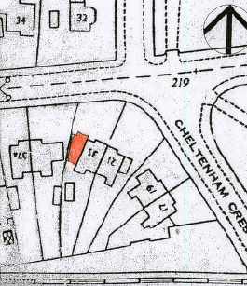
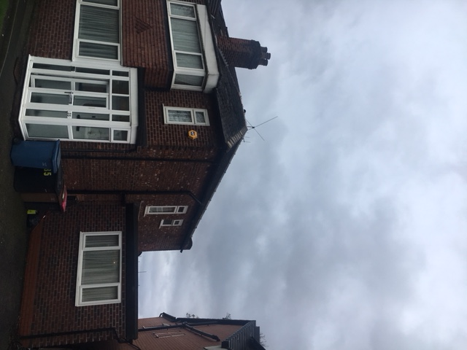

Description of Proposal

Part two storey side extension
- The two storey side extension would have a gable roof with an eaves height of 4.91m and a ridge height of 7.45m.
- The two storey side extension would also be 4.21m in depth and would run flush with the front elevation of the property and would maintain a maximum distance of 1.11m to the side boundary.
- It would have matching bay windows to serve a guest bedroom at first floor and a guest living room at ground floor.
- Within the first floor element of the extension a small window would be positioned in the side elevation and would serve a W/C.

Part first floor side extension
- The first floor side extension would be built off the foundations of the existing single storey side extension.
- It would have an eaves height of 4.91m and a ridge height of 7.45m.
- The first floor extension would be 4.05m in depth and would serve a bedroom.
- The first floor extension would extend up to the side boundary.
Details of the plans are shown below:
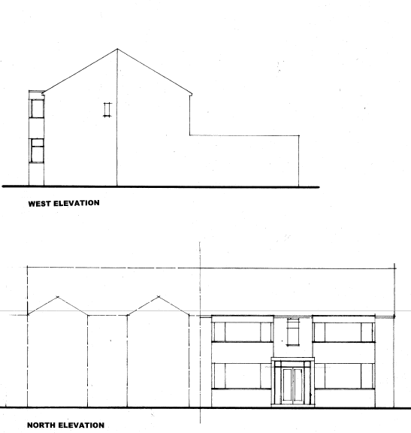
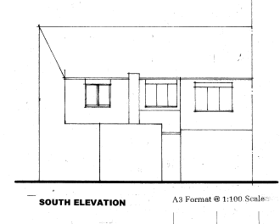
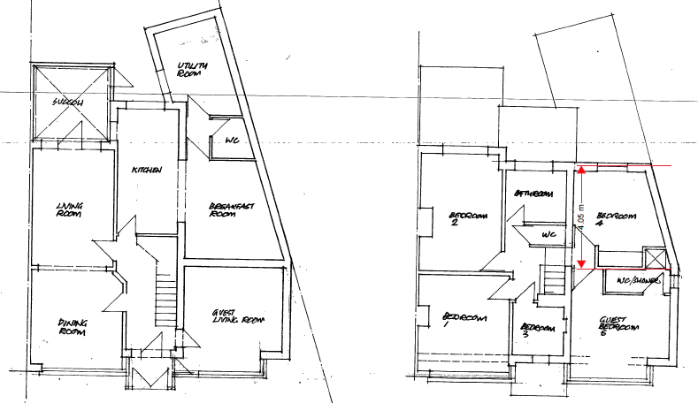

Relevant Site History
11/61184/HH (Re-sub of 11/60084/HH) Erection of a single storey side extension. Approved: 03.02.2012
11/60084/HH Erection of a single storey side/rear extension. Refused 08.12.12

Consultations
Not applicable.

Publicity
Earliest Decision Date: 24 October 2017
Revised Expiry Date: No extension agreed

Site Notice: N/A
Reason:

Press Advert: N/A
Reason:

Representations
None received.

Planning Policy

Development Plan Policy

Unitary Development Plan DES1 - Respecting Context
This policy states that development will be required to respond to its physical context and respect the positive character of the local area in which it is situated and contribute towards a local identity and distinctiveness.

Unitary Development Plan DES7 - Amenity of Users and Neighbours
This policy states that all new development, alterations and extensions to existing buildings will be required to provide potential users with a satisfactory level of amenity in terms of space, sunlight, daylight, privacy, aspect and layout. Development will not be permitted where it would have an unacceptable impact on the amenity of occupiers or users of other development.

Unitary Development Plan DES8 - Alterations and Extensions
This policy states that planning permission will only be granted for alterations or extensions to existing buildings that respect the general scale, character, rhythm, proportions, details and materials of the original structure and complement the general character of the surrounding area.

Other Material Planning Considerations

National Planning Policy Framework
National Planning Policy Guidance

Local Planning Policy

Supplementary Planning Document - House Extension
This document contains a number of policies and standards to ensure that extensions within the curtilage of dwellings have a limited and acceptable impact on neighbouring residents; future residents of the application dwelling and that development makes a positive contribution to the local environment in terms of design.

It is not considered that there are any local finance considerations that are material to the application.

Appraisal of the Proposed Development

Impact on the character of the area
- Due to the angled boundary the two storey extension would not maintain 1m along the full length of its extent along the common side boundary with no.37. However the front of the two storey extension would maintain a distance of 1.11m to this boundary in accordance with HE8 and therefore would not cause a terracing affect when viewed from the street.
- The adjoining property has a gable ended roof therefore the gable roof of the proposed two storey side extension would assist in balancing the pair of semi-detached dwellings.
- The part single/part two storey side extension would also use materials and bay windows that would match the existing frontage of the property.
- Dwellings within the vicinity have differing materials and facades and there is no uniformity in the types of roofs and roof heights within the area.
- Dwellings within the area have been extended both to the side and rear, including the neighbouring attached property of 21 Cheltenham Crescent which has a two storey side extension.
- The proposed extension would therefore have no unacceptable impact on the host dwelling or character of the street.

Impact on the amenity of neighbours
Part two storey side extension
- There are no habitable room windows in the side elevation of no.37 Broom Lane that would be affected by the proposed part singe/part two storey side extension.
- However the window serving the W/C in the side elevation of the two storey side extension would be located on the boundary line and would maintain a distance of 1.39m to the side elevation of no.37, therefore an obscure glazing condition will be attached to this decision to prevent any overlooking.
- The proposed two storey extension would not extend beyond the front elevation on no.37 Broom Lane.
- The habitable room windows serving the guest bedroom and living room within the front elevation of the two storey extension would maintain a distance of 29.1m to the habitable room windows within the property located opposite the application site in accordance with Policy HE1.

Part first floor side extension
- The first floor extension would not extend beyond the rear elevation of the host dwelling.
- Due to the angled boundary the extension would partly extend beyond the rear of the two storey extension of no.37 Broom Lane. However it would not extend beyond a 45 degree line taken from the first floor habitable room window of the neighbouring extension and therefore would not appear as overbearing or unacceptably impact on the amenity of no.37.
- The principal habitable room window to the rear of the first floor extension serving bedroom 4 would maintain a distance of 26.16m to the rear boundary in accordance with HE2 and would not result in any overlooking or loss of privacy onto the grounds of the Adas Yeshurun Synagogue.

Impact on the highway network
The proposed extension would reduce the hardstanding however it would still be able to accommodate space for one car in accordance with HE11.

Other issues

Does the proposal require any work to trees? No

Is there a significant change in levels across the site or between the site and the neighbouring land? No

Has the applicant/agent indicated any personal circumstances? No

Recommendation:

Approve

- The development must be begun not later than three years beginning with the date of this permission.

Reason: Required to be imposed by Section 91 of the Town and Country Planning Act 1990 (as amended).

- The external materials used shall match those of the existing building so far as practicable.

Reason: In order to ensure a satisfactory appearance in the interests of visual amenity in accordance with Policies DES1 and DES8 of the City of Salford Unitary Development Plan and the requirements of the National Planning Policy Framework.

- The development hereby permitted shall be carried out in accordance with the following approved plans:

Location Plan
Site Plan
Proposed Floor Plans Drawing no. M2281 10
Proposed Elevations Drawing no. M2281 11 Revision A

Reason: For the avoidance of doubt and in the interest of proper planning.

- The first floor W/C window in the side elevation of the two storey side extension facing the common boundary with no.37 Broom Lane; shall be fitted with, and permanently glazed, in textured glass whose obscuration level is at least 3 on the Pilkington scale of 1-5 (where 1 is clear and 5 is completely obscure).

Reason: In the interest of the amenity of residents in accordance with policy DES7 of the City of Salford Unitary Development Plan and the National Planning Policy Framework.

Notes for Applicant:

1. STANDING ADVICE - DEVELOPMENT LOW RISK AREA

The proposed development lies within a coal mining area which may contain unrecorded coal mining related hazards. If any coal mining feature is encountered during development, this should be reported immediately to the Coal Authority on 0345 762 6848.

Further information is also available on the Coal Authority website at:
www.gov.uk/government/organisations/the-coal-authority

This Standing Advice is valid from 1st January 2017 until 31st December 2018

Officer | Beth Bradburn | DC | Gareth Clegg | LPA | Jimmy McManus
Date | 21.11.2017 | Date | 22/11/2017 | Date | 22/11/2017

