HOUSE EXTENSION REPORT

Application reference: 18/71734/HH
Address: 15 Houghton Lane, Swinton M27 0DX
Proposal: Retention of existing single storey rear addition

Appropriate consultation undertaken: Yes
Earliest Decision date: 21 May 2018

***

Description of site and surrounding area

The subject site is located on the eastern side of Houghton Lane, Swinton. The site accommodates a large two-storey dwelling generally representative of the built form character of the surrounding area. This detached dwelling occupies the centre of the site. A large outbuilding occupies the rear part of the site and may be accessed via the laneway extending across the rear property boundary.

The adjacent semi-detached dwellings to both the north and south are also substantial and built generally in line with the subject dwelling.

Description of proposal

This application seeks retrospective permission to construct a single storey addition at the rear of the existing dwelling.

This addition in part replaces an existing single storey structure currently used as a kitchen. The now built addition comprises a larger kitchen and adjacent dining space.

The addition stands to a maximum height of 4.1 metres and is 6.4 metres wide. The addition features glazed French doors opening out onto a patio and is generally finished to match the host dwelling.

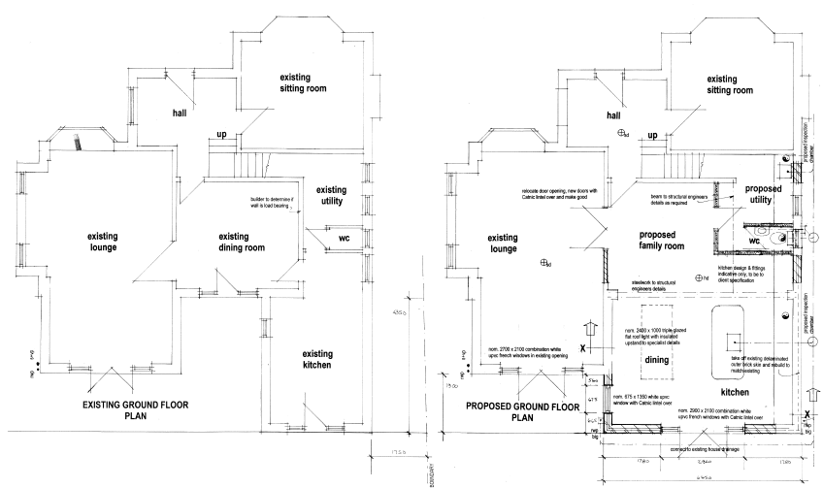

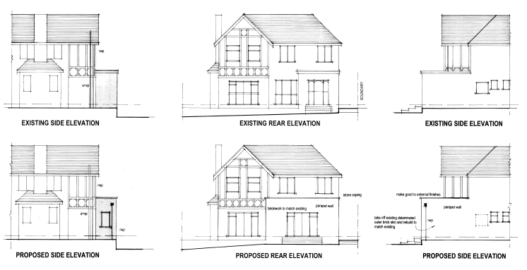

Site history

One prior approval has previously been issued for this site. This approval (refer 17/70841/PDE issued 24 November 2017) allowed the construction of a similar addition to that now constructed. The overall height of the addition has however now increased from 3.8 metres to 4.15 metres. The addition also now incorporates the existing kitchen at the rear of the dwelling and as such is approximately two metres wider than that permitted by 17/70841/PDE.

Consultations

Given the nature and scale of the addition, it was not considered necessary to consult other Council departments or external authorities.

Publicity

Earliest decision date: 21 May 2018
Revised expiry date: No extension agreed

Site notice: Not required
Reason: Notice of the application was sent to affected neighbours. Given the nature and scale of the addition it was not considered necessary to place a public notice on site.

Press advert: Not required
Reason: Notice of the application was sent to affected neighbours. Given the nature and scale of the addition it was not considered necessary to further advertise the application.

Representations

No representations received

Planning policy

Development Plan Policy

Unitary Development Plan DES1 - Respecting Context
This policy states that development will be required to respond to its physical context and respect the positive character of the local area in which it is situated and contribute towards a local identity and distinctiveness.

Unitary Development Plan DES7 - Amenity of Users and Neighbours
This policy states that all new development, alterations and extensions to existing buildings will be required to provide potential users with a satisfactory level of amenity in terms of space, sunlight, daylight, privacy, aspect and layout. Development will not be permitted where it would have an unacceptable impact on the amenity of occupiers or users of other development.

Unitary Development Plan DES8 - Alterations and Extensions
This policy states that planning permission will only be granted for alterations or extensions to existing buildings that respect the general scale, character, rhythm, proportions, details and materials of the original structure and complement the general character of the surrounding area.

Other material planning considerations

National Planning Policy Framework
National Planning Policy Guidance

Local Planning Policy

Supplementary Planning Document (SPD) - House Extensions
This document contains a number of policies and standards to ensure that extensions within the curtilage of dwellings have a limited and acceptable impact on neighbouring residents; future residents of the application dwelling and that development makes a positive contribution to the local environment in terms of design.

It is considered that there are no local finance considerations that are material to this application.

Appraisal

Impact on the character of the area

The addition is located at the rear of the dwelling and as such is not visible from the street. A large outbuilding at the rear of the dwelling also inhibits views of the addition from the laneway extending across the rear property boundary.

Elements of the addition may be visible from neighbouring dwellings to both the north and south though these views are also largely restricted by other existing elements of the dwelling. Importantly, the addition is finished to match the host dwelling

On this basis, it is considered that the addition accords with the provisions of Retained Policies DES1 and DES8 of the Salford UDP. To this end, it is considered that the addition is respectful of the built form character of the dwelling and surrounding area.

Impact on the amenity of neighbours

The addition does not impact upon the general amenity of surrounding residents. For the most part the addition is concealed from view from neighbouring properties. The addition does however include an increased height side northern wall. This wall is setback 1.7 metres from the common boundary and projects no further from the rear of the dwelling than the wall it replaced. Whilst this wall is now, at its highest point, 350mm higher than that previously approved by 17/70841/PDE, it is not constructed within a 45 degree line drawn from the centre of the habitable room windows of the adjacent dwelling to the north in accordance with Policy HE1 of the Council’s House Extensions SPD. Importantly, the adjacent dwelling to the north is itself also setback from the common boundary and this provides for added visual relief. Again, the wall projects no further than the wall it replaced.

The addition is also not constructed within 21 metres of any facing habitable room windows to the rear. Regardless of this, a large outbuilding stands between the addition and rear property boundary and this prevents views to or from the addition.

It is considered that the addition does not impact upon the general amenity of neighbouring residents in accordance with the provisions of Retained Policy DES7 of the Salford UDP.

Impact on the highway network

The addition is located at the rear of the dwelling and separate to the rear outbuilding which appears to also comprise a garage. As such, the addition does not impact upon existing on site car parking arrangements.

Other issues

Does the proposal require any work to trees? No

Is there a significant change in levels across the site or between the site and the neighbouring land? Whilst the land slopes downward from north to south, this has no bearing on the appropriateness of the addition. The addition is largely concealed from view behind existing structures on site and only elements of it are visible from neighbouring sites.

Has the applicant/agent indicated any personal circumstances? No

Recommendation:

Approve, subject to the following condition:

1. The development hereby permitted shall be completed in accordance with the following plans:

- Dwg. No. DM/01/17, Revision B entitled ‘Proposed single storey rear extension, 15 Houghton Lane, Swinton M27 0DX’ and dated October 2017; and
- Dwg. No. DM/02/17B, Revision B entitled ‘Proposed single storey rear extension, 15 Houghton Lane, Swinton M27 0DX’ and received by the Local Planning Authority on 30 April 2018.

Reason: For the avoidance of doubt and in the interests of proper planning.

Statement of conformity with Article 35 of The Town and Country Planning (Development Management Procedure) (England) Order 2015.

The proposal complies with the development plan and would improve the economic, social and environmental conditions of the area. It therefore comprises sustainable development and the Local Planning Authority worked proactively and positively to issue the decision without delay. The Local Planning Authority has therefore implemented the requirement in Paragraphs 186-187 of the NPPF as required.

Officer | Connor Perrott | DC | Faye Tomlinson | LPA | Amelia Lucas
Date | 21 May 2018 | Date | 22.06.2018 | Date | 22.06.2018

