DELEGATED DECISION RECORD REF: 18/71611/LBC

Address: 144 The Green, Worsley, M28 2PA
Proposal: Listed Building Consent for the installation of electric car charging port

Reason for Delay: N/A

Description of Site and Surrounding Area

The application site forms part of a row of Grade II listed residential terraced dwellings constructed in a revived Tudor style during the Edwardian period in brick with timber frame revival panelling under a mixture of gable ended pitched roofs. The properties face onto The Green and are located within the Worsley Village Conservation Area, therefore forming part of attractive views across The Green.

The English Heritage Listing for the property states:

‘WORSLEY THE GREEN SD 70 SW (south side) 2/53 Nos. 140 to 145 - (consecutive) G.V. II
Row of 6 houses. c.1907. Brick, applied timber-framing and clay tile roof. A near-symmetrical plan with a total of 13 bays and 2 storeys. Picturesque timber-framed revival. Elevation dominated by 4 gabled projections, the outer ones projecting further than the others and having plain 1 and 2- light windows. The inner ones are jettied at first floor level and have decorative square panelling, 4-light ovolo- moulded mullion and transom ground floor windows and 3- light ovolo-moulded mullion first floor windows. Decorative bargeboards and finials. The intermediate bays which are brick on the ground floor have doors (mostly replacements) with tiled canopies and small 2-light ground floor windows, and on the first floor, 3-light windows as above. All windows have leaded lights. Central gabled dormer window and prominent brick ridge chimney stacks. The right and left returns have recessed porches with Tudor-arched openings. The group is an interesting example of the garden suburb movement and came about as a result of early de-industrialisation.
Listing NGR: SD7502800298’

Site Plan
Applicant Property

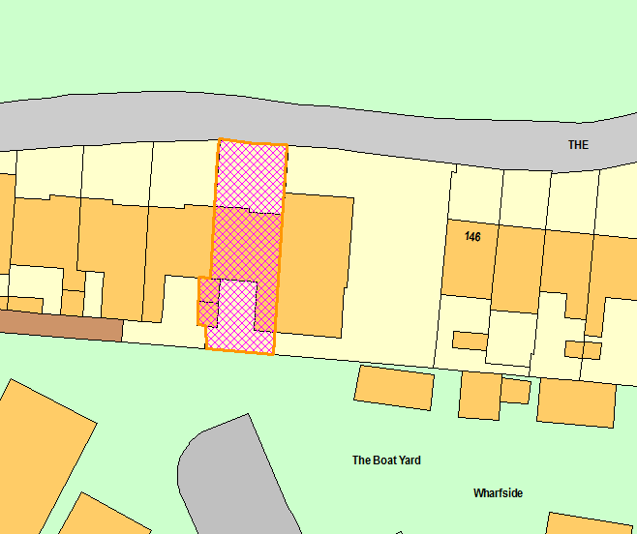
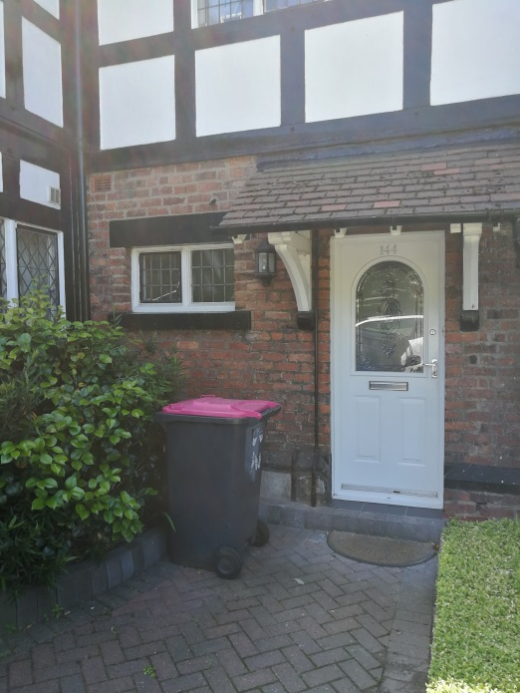

Publicity
Earliest Decision Date: 19 July 2018
Revised Expiry Date: No extension agreed

Site Notice: HH setting listed building: 24 June 2018
Reason: Listed Building Consent

Press Advert: Manchester Weekly News Salford Edition Date Published: 28 June 2018
Reason: Listed Building Consent

Description of Proposal

The proposed development is the installation of an electric car charger, located on the front wall of the property adjacent to the front door and below the left hand side window on the front of the property.

The charger will be the Universal Pod Point Solo and located approximately 1m off the ground.

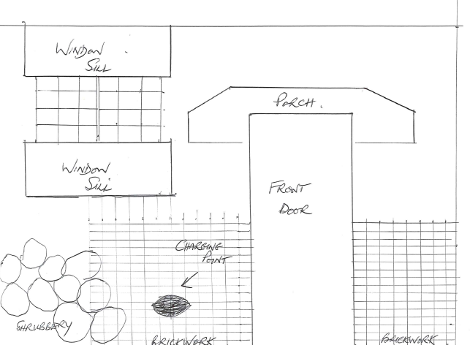

Relevant Site History

No relevant site history.

Consultations

Historic England

Did not need to be consulted

Officer advising about heritage matters

“The recently published NPPF (July 2018) identifies that heritage assets are an irreplaceable resource and should be conserved in a manner appropriate to their significance so that they can be safeguarded and enjoyed for future generations. Historic England also recognise the threats of climate change to the historic and natural environments and therefore welcomes the Government’s commitment to reduce the emissions which contribute to global warming. They also believe that high quality design can play a key role in minimising any adverse effects of projects.

Taking the above into consideration and having looked at other electric chargers currently available on the market, I am now satisfied that the proposed Universal POD charger would be acceptable with minimum impact upon the character and significance of the listed building in accordance with the NPPF, the approach of Historic England and also the purpose of policy CH1 of the UDP. Therefore I support the proposal in principle.“

Planning Policy

Section 16 of the Planning (Listed Buildings and Conservation Areas) Act 1990

Other Material Planning Considerations

National Planning Policy

National Planning Policy Framework

Local Planning Policy

It is not considered that there are any local finance considerations that are material to the application

Appraisal

In the case of Listed Building Consents, there is no statutory requirement to have regard to the provisions of the Development Plan. In consideration of applications for Listed Building Consent the Local Planning Authority must therefore consider Section 16 of the Planning (Listed Buildings and Conservation Areas) Act 1990 and the National Planning Policy Framework.

Section 16(2) of the Planning (Listed Buildings and Conservation Areas) Act 1990 states that 'in considering whether to grant listed building consent for any works, the Local Planning Authority shall have special regard to the desirability of preserving the building or its setting or any features of special architectural or historic interest which it possesses'.

Section 72 confirms that special attention is to be paid to the desirability of preserving or enhancing the character and appearance of a conservation area. The meaning of “preservation” is taken to be the avoidance of harm.

One of the core planning principles of the NPPF which was published in July 2018, is to “conserve heritage assets in a manner appropriate to their significance”.

Paragraph 193 states that when considering the impact of a proposed development on the significance of a designated heritage asset, great weight should be given to the asset’s conservation. It then continues to say, in paragraph 194, that significance can be harmed or lost through alteration or destruction of the heritage asset or development within its setting and that as heritage assets are irreplaceable any harm or loss “should require clear and convincing justification”.

Paragraph 195 of the NPPF states: “Where a proposed development will lead to substantial harm to or total loss of significance of a designated heritage asset, local planning authorities should refuse consent, unless it can be demonstrated that the substantial harm or loss is necessary to achieve substantial public benefits that outweigh that harm or loss”.

The applicant wishes to erect a POD Point Solo Universal charger on the front elevation of the property, to the left hand side of the front door when looking towards the front of the property. It would be erected approximately 1m above ground level. Whilst charging points are not a characteristic of the front of properties in this area or of the listed building, it is considered that the charging point, due to its size, location and design, would have a minimal impact upon the character and significance of the listed building and is therefore acceptable and in accordance with the NPPF.

It is noted that the precise location of the charger on the wall is not known yet because this will be determined by the exact location and availability of the electricity supply when the charger is installed. At the time of the assessment of this application the location as shown on the submitted drawing can be described as a maximum of 1.2m above ground level and a maximum of 2.2m to the east of the front door. This approximate location is considered to be acceptable, however, in order to ensure that the final location of the charger does not differ significantly from this, given that the submitted drawing is not precise, it is recommended that a condition be attached to ensure that the final location of the charger does not differ significantly from that current proposed.

It is therefore considered that the proposals would preserve the heritage value of the building and as such would be in accordance with Section 16 of the Planning (Listed Buildings and Conservation Areas) Act 1990.

Recommendation:

Approve subject conditions:

1. The development shall be begun not later than the expiration of three years beginning with the date of this permission.

Reason: Required to be imposed by virtue of Section 18 of the Planning (Listed Buildings and Conservation Areas) Act 1990.

2. The development hereby permitted shall be carried out in accordance with the following approved plans:

Front Elevation Drawing received 13.06.2018
Pod Point Solo Single Phase Datasheet by Pod Point dated June 2017, ref: PP-D-130042-10

Reason: For the avoidance of doubt and in the interest of proper planning

3. The electric car charging port hereby approval shall be installed on the front wall of the property at a maximum height of 1.20m above ground level and a maximum of 2.2m to the east of the front door as illustrated on the submitted front elevation drawing received 13.06.2018.

Reason: For the avoidance of doubt and in the interest of proper planning

Statement of conformity

The Local Planning Authority worked positively and proactively with the applicant to identify various solutions during the application process to ensure that the proposal comprised sustainable development and would improve the economic, social and environmental conditions of the area and would accord with the development plan. These were incorporated into the scheme and/or have been secured by planning condition. The Local Planning Authority has therefore implemented the requirement in Paragraphs 186-187 of the NPPF.

Officer | Blythe Smith | DC | Faye Tomlinson | LPA | Amelia Lucas
Date | 10.08.2018 | Date | 13.08.2018 | Date | 13.08.2018

