HOUSE EXTENSION REPORT

REF: 18/72351/HH

Address: 3 Eskrigge Close, Salford, M7 4QL

Proposal: Retention of single storey wooden sukkah room extension

Appropriate consultation undertaken Yes
Earliest Decision date: 26 September 2018
Reason for delay beyond stat deadline and EoT: N/A

Description of Site and Surrounding Area

- The application relates to a semi-detached dwelling at no.3 Eskrigge Close, Salford. The subject site is situated within a residential area close to the A576 (Leicester Road) and Bury Old Rd.
- The dwelling is set back from the road and features a rear yard, which has pedestrian access to Park Avenue.
- There is on street parking in the surrounding area, including Park Avenue and George St Street.
- The road is occupied by dwellings of a similar scale and size. The materials used are brickwork walls, roof tiles and UPVC windows and doors.

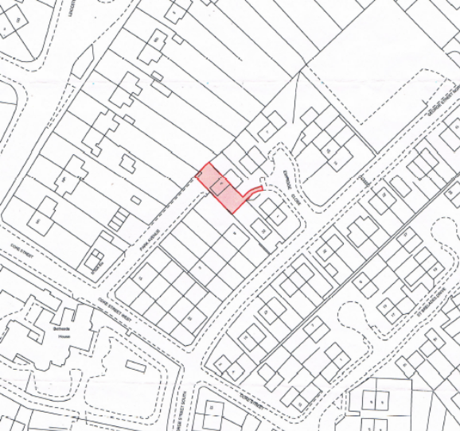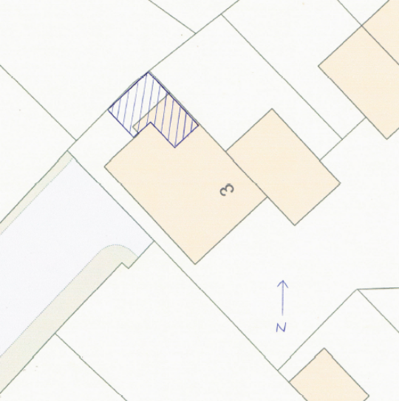

Figure 1 – the subject site under consideration

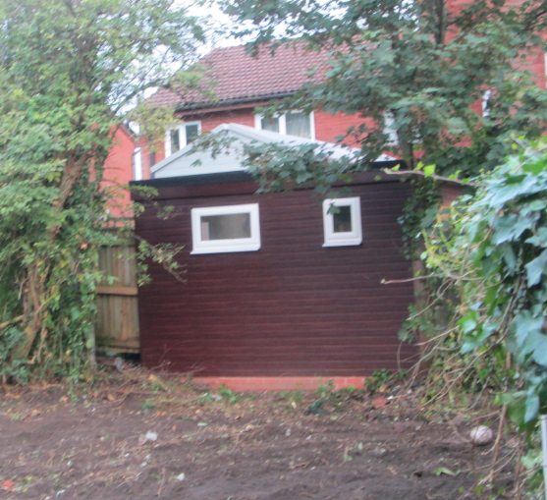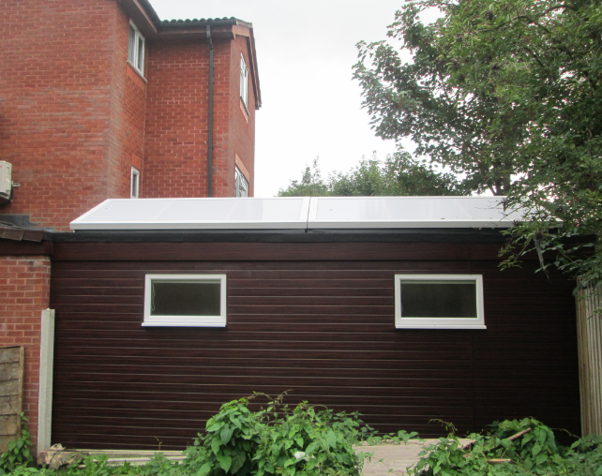

Figure 2 – the single storey rear extension under consideration from the rear and the view from no.4 Eskrigge Close.

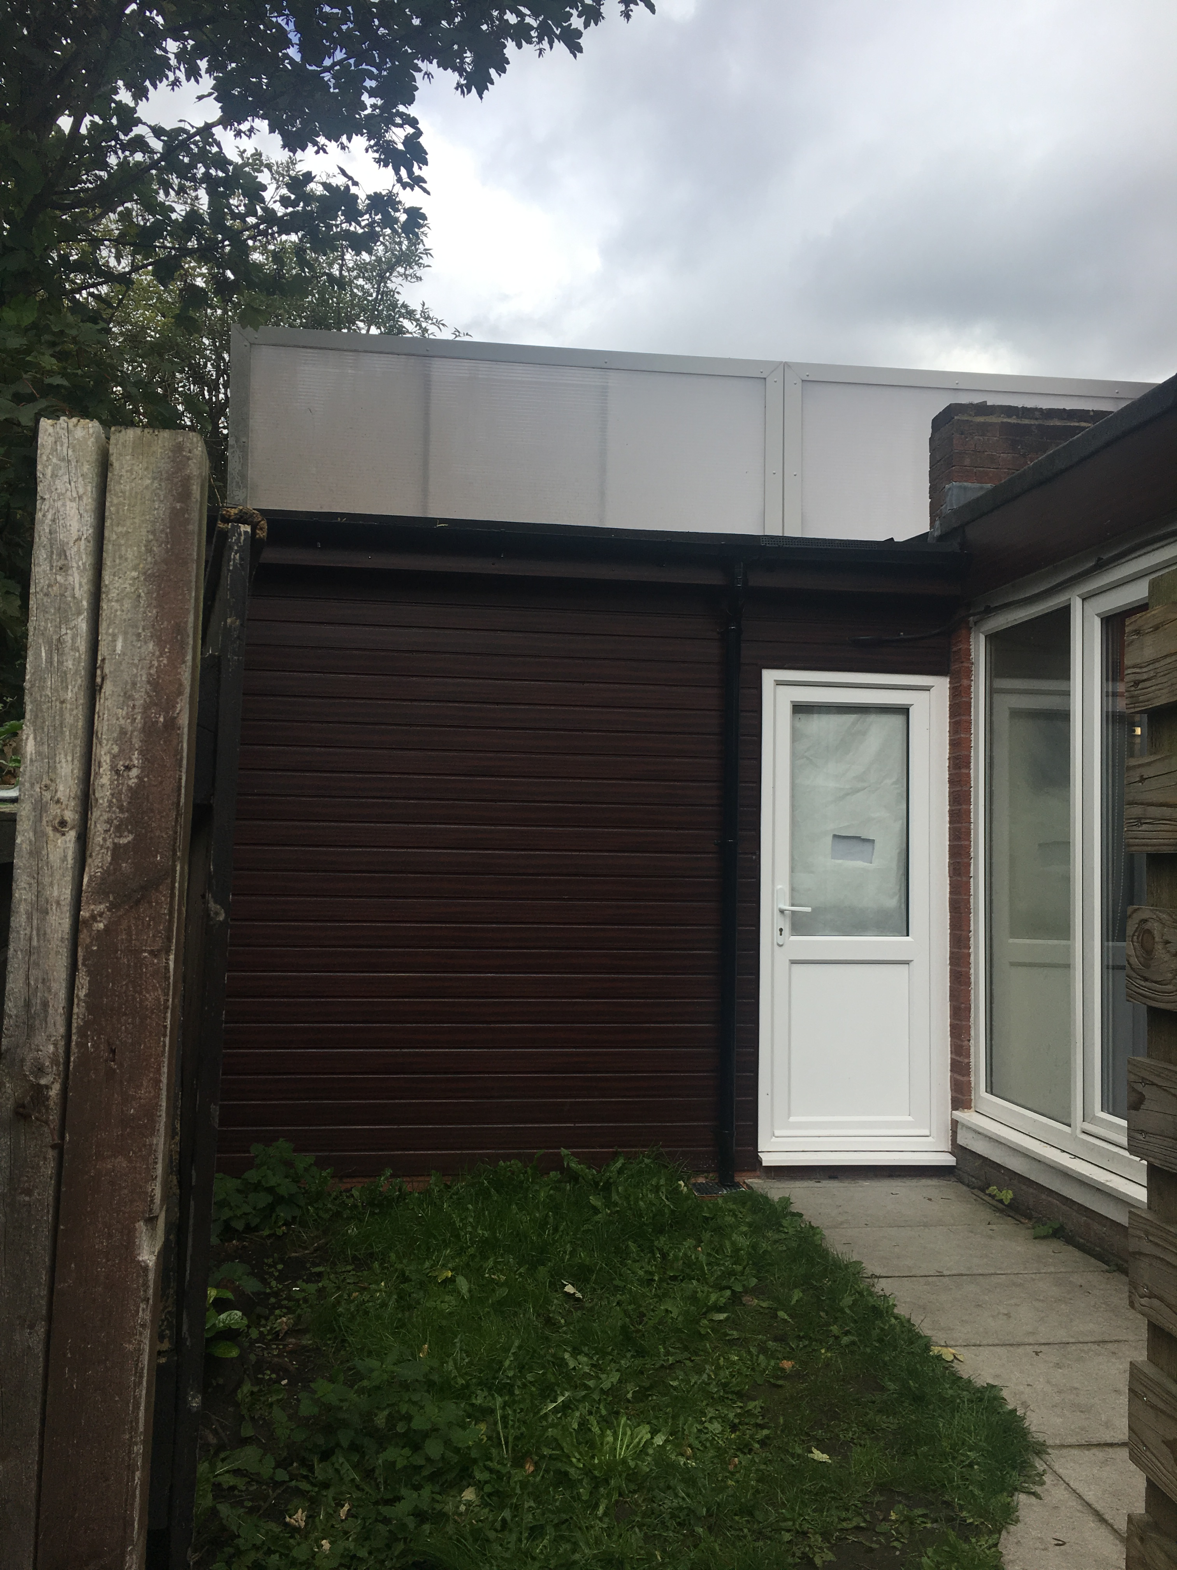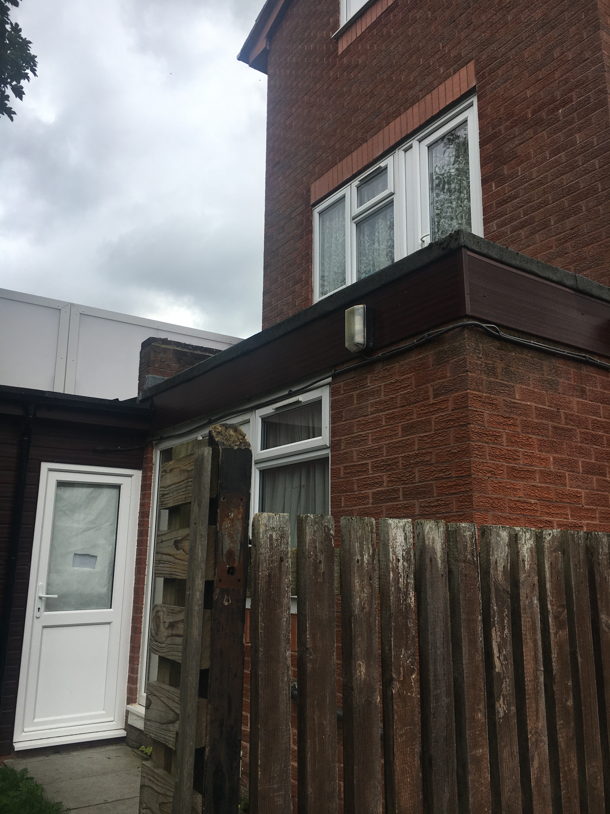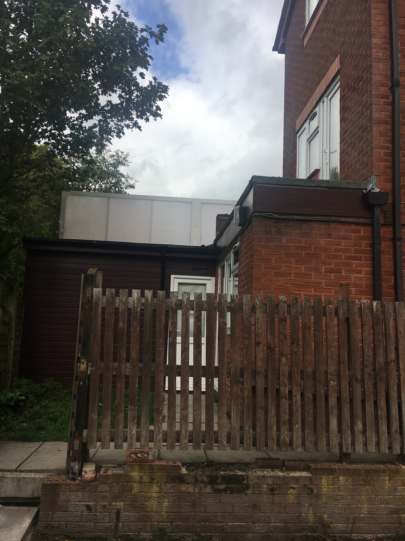

Figure 3 – the single storey rear extension from Park Avenue

Description of Proposal

- The application under consideration is for the retention of single storey wooden sukkah room extension.
- The single storey rear extension extends a distance of 6.3m from part of the rear elevation (next to common boundary of no.4 Eskrigge Close) and 3.6m from part of the rear elevation (closer to Park Avenue) of the original dwelling.
- The single storey rear extension has a width of 4.2m and is set in 0.2m from the common boundary of no.4 Eskrigge Close.
- The single storey rear extension includes a principal window and a secondary window of a habitable room with a rear outlook. The single storey rear extension also includes 2 obscured glazed windows with a side outlook over no.4 Eskrigge Close’s garden, an external door to the opposing side and a sukkah roof.
- The single storey rear extension does not exceed the height of the roof ridges or roof eaves.
- The single storey rear extension has mahogany UPVC walls, UPVC windows and doors. The roof has been made with a plastic sukkah roof.
- Plans and elevations are shown below.

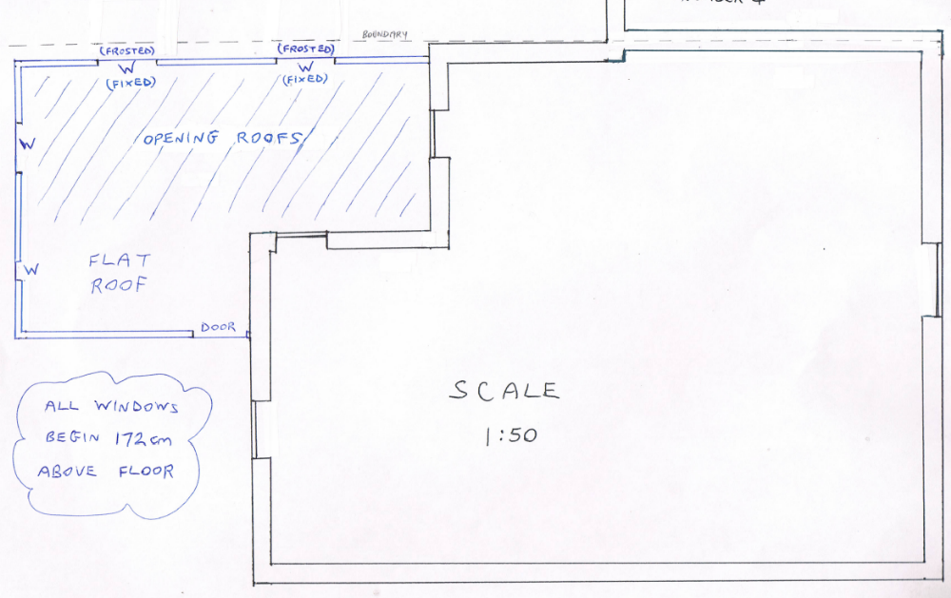

Figure 4 – the ground floor layout

Relevant Site History

- 04/48338/HH - Erection of part single and part three storey rear extension – Application Permitted (20.07.2004)

Consultations

Not applicable.

Publicity

Earliest Decision Date: 26 September 2018
Revised Expiry Date: No extension agreed

Site Notice: Not applicable
Reason: Not applicable

Press Advert: Not applicable
Reason: Not applicable

Representations

There have been no representations made.

Planning Policy

Development Plan Policy

Unitary Development Plan DES1 - Respecting Context

This policy states that development will be required to respond to its physical context and respect the positive character of the local area in which it is situated and contribute towards a local identity and distinctiveness.

Unitary Development Plan DES7 - Amenity of Users and Neighbours

This policy states that all new development, alterations and extensions to existing buildings will be required to provide potential users with a satisfactory level of amenity in terms of space, sunlight, daylight, privacy, aspect and layout. Development will not be permitted where it would have an unacceptable impact on the amenity of occupiers or users of other development.

Unitary Development Plan DES8 - Alterations and Extensions

This policy states that planning permission will only be granted for alterations or extensions to existing buildings that respect the general scale, character, rhythm, proportions, details and materials of the original structure and complement the general character of the surrounding area.

Other Material Planning Considerations

National Planning Policy Framework
National Planning Policy Guidance

Local Planning Policy

Supplementary Planning Document - House Extension

This document contains a number of policies and standards to ensure that extensions within the curtilage of dwellings have a limited and acceptable impact on neighbouring residents; future residents of the application dwelling and that development makes a positive contribution to the local environment in terms of design.

It is not considered that there are any local finance considerations that are material to the application

Appraisal of the Proposed Development

Impact on the character of the area

- The single storey rear extension is not visible from Eskrigge Close but is partially visible from Park Avenue. The view of the subject single storey rear extension is interrupted by the existing rear extension (04/48338/HH) and boundary fence. Park Avenue is a quiet road and is used by limited residents.
- It is considered that the subject single storey rear extension would not have an unacceptable impact on the character of the area.

Impact on the amenity of neighbours

- There is a distance of 46m between the principal windows of a habitable room with a rear outlook at no.3 Eskrigge Close and the principal windows of a habitable room with a rear outlook at no.152 Leicester Avenue in accordance with HE1. It is considered subject to a glazing condition that the subject windows do not result in a significant loss of privacy to neighbouring residents, to their dwelling or by overlooking their gardens.
- The single storey rear extension is within 5m of the common boundary of no.4 Eskrigge Close. The secondary windows of a habitable room with a side outlook are set at a height of 1.8m and have been obscure glazed in accordance with HE2. It is considered that secondary windows of a habitable room with a side outlook do not result in a loss of privacy to neighbouring residents.
- There are no ground floor principal windows of a habitable room facing the single storey rear extensions gable elevation. It is considered the single storey rear extension does not result in a loss of daylight and/or sunlight to the neighbouring dwellings.
- The single storey rear extension would not project beyond a 45 degree line drawn from the mid-point of any principal window of a ground floor habitable room in the adjoining dwelling (no.4 Eskrigge Close) in accordance with HE5. It is considered the single storey rear extension does not result in a loss of light and/or appear overbearing for neighbouring residents.

Impact on the highway network

- The single storey rear extension does not increase the number of bedrooms at no.3 Eskrigge Close.
- There is street parking in the surrounding area and adjacent roads. It is considered that the single storey rear extension has limited impact on the highway network.

Other issues

Does the proposal require any work to trees? NO

Is there a significant change in levels across the site or between the site and the neighbouring land? NO

Has the applicant/agent indicated any personal circumstances? NO

Recommendation:

Approve, subject to the following conditions:

- The development hereby permitted shall be carried out in accordance with the following plans:

  - PLN2 – Proposed Floor Plan – Suka (Received: 31/08/2018)

Reason: For the avoidance of doubt and in the interest in proper planning.

- The principal windows in the rear elevation facing the common boundary with no.152 Leicester Avenue; shall be fitted with, and permanently glazed, in textured glass whose obscuration level is at least 3 on the Pilkington scale of 1-5 (where 1 is clear and 5 is completely obscure) within the next 3 months.

Reason: In the interest of the amenity of residents in accordance with policy DES7 of the City of Salford Unitary Development Plan and the National Planning Policy Framework.

Statement of conformity with Article 35 of The Town and Country Planning (Development Management Procedure) (England) Order 2015

The proposal complies with the development plan and would improve the economic, social and environmental conditions of the area. It therefore comprises sustainable development and the Local Planning Authority worked proactively and positively to issue the decision without delay. The Local Planning Authority has therefore implemented the requirement in Paragraph 38 of the NPPF.

Officer | Sam Pierce | DC | M Hodgson | LPA | Claire Thorn
Date | 23.10.2018 | Date | 23.10.2018 | Date | 24.10.18

