HOUSE EXTENSION REPORT

REF: 19/73687/HH

Address: 1 Botany Road, Eccles, Manchester, M30 8JS

Proposal: Demolition of garage and conservatory and erection of single storey rear and side extension.

Appropriate consultation undertaken: Yes
Earliest Decision date: 16 July 2019
Reason for delay beyond stat deadline and EoT: N/A

Description of Site and Surrounding Area

The application relates to a semi-detached dwelling located within a residential area of Eccles. The surrounding dwellings are similar in size and design; finished with brickwork walls, roof tiles and UPVC windows and doors. There is hardstanding to the front of the property and a garden to the rear. The property has an existing single storey rear extension and detached garage that would be demolished to accommodate the proposed extension.

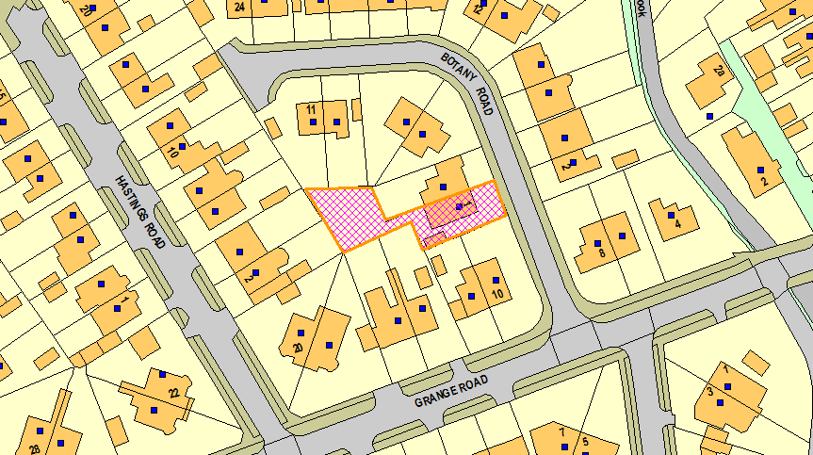

Figure 1 – the subject site under consideration

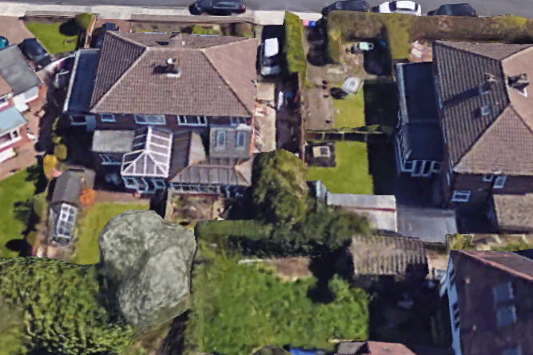

Figure 2 – the subject dwelling

Description of Proposal

The proposed single storey rear extension would extend 4.4m further than the rear elevation of the original dwelling at the side nearest to no.3. It would be built up to the boundary and have a flat roof to accommodate a roof lantern.

The proposed single storey side extension would extend 6.45m further than the rear elevation and 3.05m further than the side elevation of the original dwelling. It would be set 1m from the side boundary shared by no.10 and 12 Grange Road and have a flat roof to accommodate a roof lantern.

The proposed extension would be built in materials to match the existing dwelling. Plans and elevations are shown below.

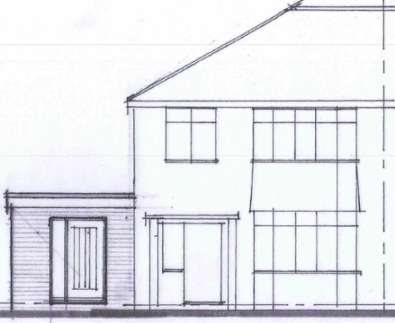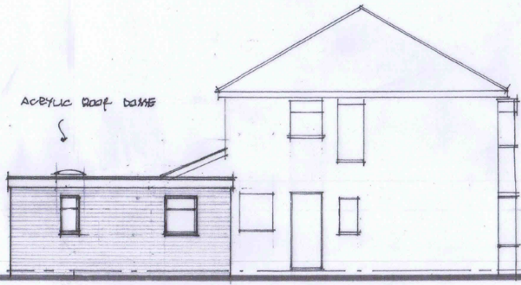

Figure 3 – the proposed front (left) and side (right) elevation

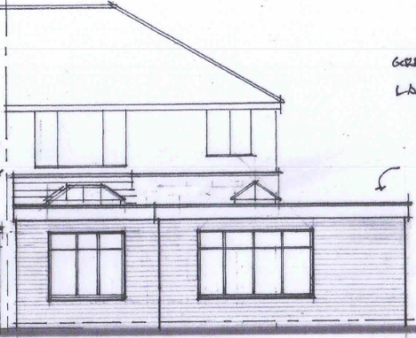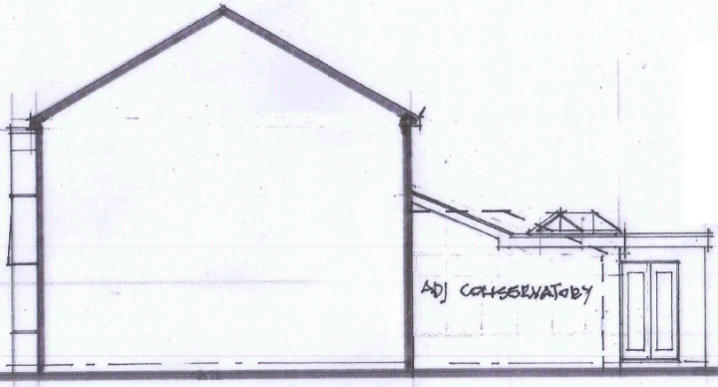

Figure 4 – the proposed rear (left) and side (right elevation

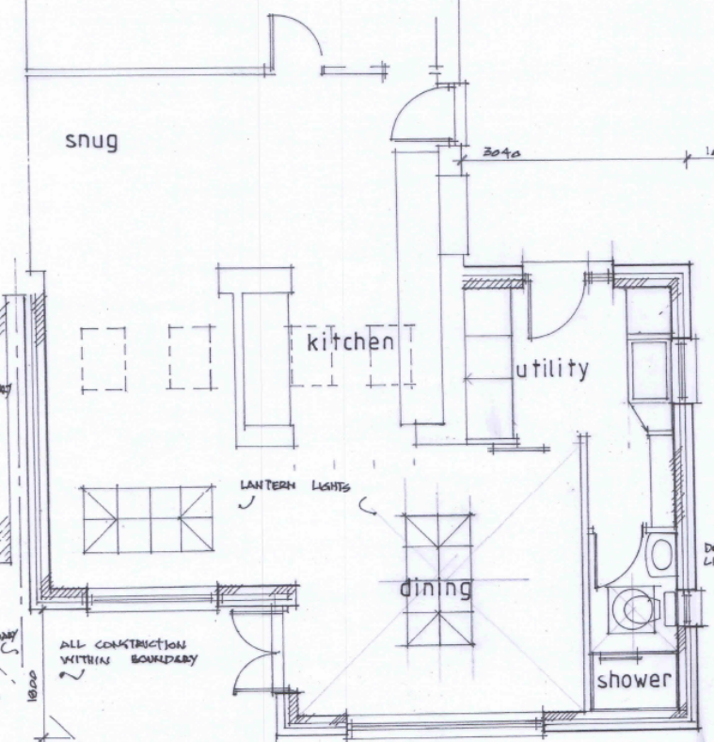

Figure 5 – the proposed ground floor plan

Relevant Site History

07/55483/HH - Erection of part single/part two storey side extension – Permitted (26.11.2007)

Consultations

Not applicable.

Publicity

Earliest Decision Date: 16 July 2019
Revised Expiry Date: 16 August 2019

Site Notice: Not applicable
Reason: Not applicable

Press Advert: Not applicable
Reason: Not applicable

Representations

None received.

Planning Policy

Development Plan Policy

Unitary Development Plan DES1 - Respecting Context

This policy states that development will be required to respond to its physical context and respect the positive character of the local area in which it is situated and contribute towards a local identity and distinctiveness.

Unitary Development Plan DES7 - Amenity of Users and Neighbours

This policy states that all new development, alterations and extensions to existing buildings will be required to provide potential users with a satisfactory level of amenity in terms of space, sunlight, daylight, privacy, aspect and layout. Development will not be permitted where it would have an unacceptable impact on the amenity of occupiers or users of other development.

Unitary Development Plan DES8 - Alterations and Extensions

This policy states that planning permission will only be granted for alterations or extensions to existing buildings that respect the general scale, character, rhythm, proportions, details and materials of the original structure and complement the general character of the surrounding area.

Unitary Development Plan EN19 - Flood Risk and Surface Water
This policy states that any application for development that it is considered likely to be at risk of flooding or increase the risk of flooding elsewhere will need to be accompanied by a formal flood risk assessment. It should identify mitigation or other measures to be incorporated into the development or undertaking on other land, which are designed to reduce that risk of flooding to an acceptable level.

Other Material Planning Considerations

National Planning Policy Framework
National Planning Policy Guidance

Local Planning Policy

Supplementary Planning Document - House Extension
This document contains a number of policies and standards to ensure that extensions within the curtilage of dwellings have a limited and acceptable impact on neighbouring residents; future residents of the application dwelling and that development makes a positive contribution to the local environment in terms of design.

The Greater Manchester Spatial Framework Draft 2019 (“GMSF”) and the Revised Draft Local Plan 2019 were subject to public consultation until 18th March and 22nd March 2019 respectively. They will go through a number of further stages, including examination at a public inquiry, before they are adopted. Adoption is expected to take place towards the end of 2020 or early 2021.

Now the GMSF and Local Plan are published documents decisions, including those by the Council and ultimately by inspectors on appeal, are able to start to afford them some weight as emerging policies. However, as the weight given depends on the stage of the plan; unresolved objections; and consistency with the Government’s policies, the weight currently to be attached to the GMSF and Local Plan is only limited. The weight moving forward will be reviewed and is likely to depend on the extent to which there are unresolved objections emerging from the consultation process.

In addition, following the publication of the National Planning Policy Framework (NPPF) it is necessary to consider the weight which can be afforded to the policies of the Council's adopted Unitary Development Plan (paragraph 213 NPPF February 2019).

In terms of this application it is considered that the relevant policies of the UDP can be afforded due weight for the purposes of decision making as the relevant criteria within the UDP policies applicable to the proposed development are consistent with the policies contained in the NPPF.

It is not considered that there are any local finance considerations that are material to the application

Appraisal of the Proposed Development

Impact on the character of the area

The proposed single storey side extension would be visible from the street scene. It has been proposed in materials to match the existing dwelling and is considered to appear subservient to the main dwelling. The extension would not detract from the existing dwelling and would respect the context of the area. It is not considered to have a significant impact upon the character of the area.

In accordance with Policy DES1 and DES8 of the Salford UDP, a consistent theme in term of the design and materials for the development has been proposed to correspond with the existing dwelling.

Impact on the amenity of neighbours

There would be a separation distance of 3.2m between the proposed rear windows and the rear boundary shared by no.12 Grange Road. However, it is considered that overlooking would not significantly increase as the extension would replace an existing rear conservatory. In addition there are existing boundary treatment and high hedges that would interrupt any views into the neighbouring garden. The proposed windows are not considered to result in a significant loss of privacy to any neighbouring residents.

There would be a separation distance of 12.4m between the existing rear principal windows of the neighbouring dwelling (no.12 Grange Road) and the proposed single storey extensions gable elevation, which accords with Policy HE4 of the House Extensions SPD.

The proposed extension would not project beyond a 45 degree line drawn from the midpoint of any principal windows of a ground floor habitable room in the adjoining dwelling, which accords with Policy HE5 of the House extensions SPD. It is considered that the proposed development would not result in an unacceptable loss of daylight and/or appear overbearing to the neighbouring dwellings.

Given the preceding discussion, it is considered that the proposed development would not have a significant impact upon the general amenity of neighbouring residents in accordance to the Retained Policy DES7 of the Salford UDP.

Impact on the highway network

The proposed extension would not impact on the hardstanding to the front of the dwelling considered sufficient to accommodate at least one vehicle. The development is not considered to result in an unacceptable impact on highway safety or the free flow of traffic.

Flood Risk

The site is located within Flood Risk Zone 3. The applicant has submitted a flood risk assessment and confirmed that the floor levels within the proposed extension will be set no lower than the existing levels and that flood proofing of the extension will be incorporated. This is considered appropriate for a householder extension with this flood zone and is therefore in accordance with Policy EN19 of the Salford UDP.

Other issues

Does the proposal require any work to trees? NO

Is there a significant change in levels across the site or between the site and the neighbouring land? NO

Has the applicant/agent indicated any personal circumstances? NO

Recommendation:

Approve, subject to the following conditions:

- The development must be begun not later than three years beginning with the date of this permission.

Reason: Required to be imposed by Section 91 of the Town and Country Planning Act 1990 (as amended).

- The development hereby permitted shall be carried out in accordance with the following plans:

  - Drwg. No. 430/PL01 – Site and Location Plan (Received: 26.06.2019)
  - Drwg. No. 430/PL01 – Proposed Elevations (Received: 26.06.2019)
  - Drwg. No. 430/PL02 – Proposed Ground Floor Plan (Received: 26.06.2019)

Reason: For the avoidance of doubt and in the interest in proper planning.

- The external materials used shall match those of the existing building so far as practicable.

Reason: In order to ensure a satisfactory appearance in the interests of visual amenity in accordance with Policies DES1 and DES8 of the City of Salford Unitary Development Plan and the requirements of the National Planning Policy Framework.

Statement of conformity with Article 35 of The Town and Country Planning (Development Management Procedure) (England) Order 2015

The proposal complies with the development plan and would improve the economic, social and environmental conditions of the area. It therefore comprises sustainable development and the Local Planning Authority worked proactively and positively to issue the decision without delay. The Local Planning Authority has therefore implemented the requirement in Paragraph 38 of the NPPF.

Officer | Sam Pierce | DC | Faye Tomlinson | LPA | Amelia Lucas
Date | 08.08.2019 | Date | 12.08.2019 | Date | 16.08.2019

