HOUSE EXTENSION REPORT

REF: 20/75664/HH

Address: 19 Bedford Avenue, Worsley, M28 7GG

Proposal: Demolition of existing rear conservatory. Construction of two storey side extension and single storey rear extension. In addition to a new garden room to rear of property.

Appropriate consultation undertaken Yes
Earliest Decision date: 09 October 2020
Reason for delay beyond stat deadline and EoT:

Description of Site and Surrounding Area

The application relates to a dwelling on the end of a semi-detached row within a residential cul-de-sac. The dwelling is to the North of Bedford Fields. The surrounding properties vary in design; there is a mix of detached, semi-detached two storey properties and detached bungalows. The dwellings are built in brickwork including the subject property.

There is hardstanding to the front and a garden to the rear of the property. There is an existing single storey extension and conservatory to the rear of the property. The rear extension would remain, whilst the conservatory would be demolished to accommodate the proposed development.

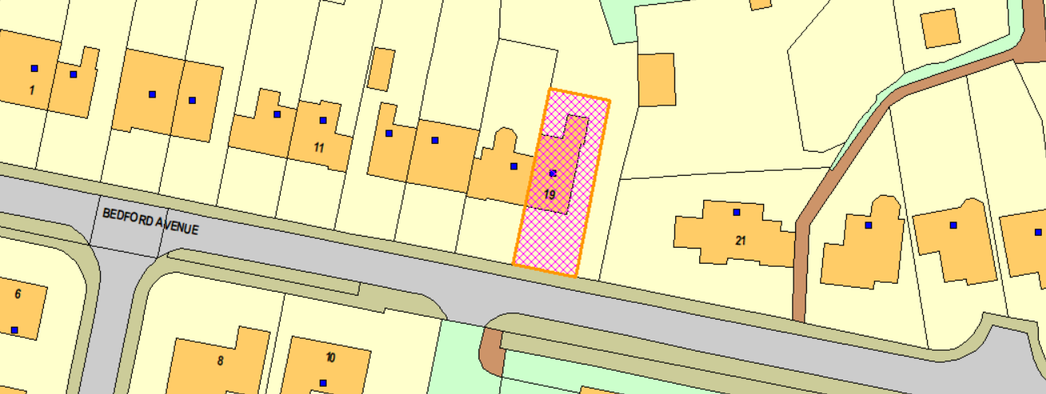

Figure 1 – the subject site under consideration

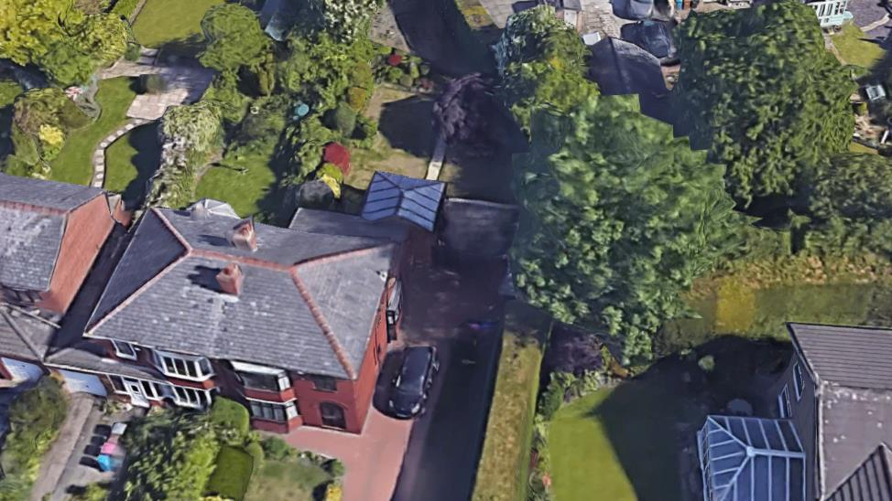

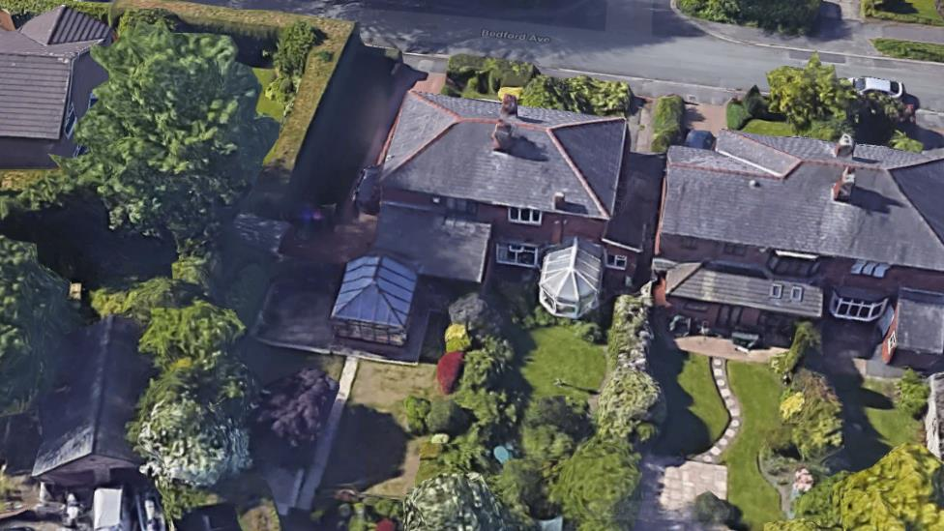

Figure 2 – the subject dwelling
Description of Proposal

The proposed two storey side extension would extend between 3.7-4.75m beyond the side elevation of the original dwelling. It would run flush with the front and rear elevation of the principal dwelling. It would maintain a minimum separation distance of 2m to the side boundary shared by no.21. The extension would have a hipped roof.

The proposed single storey rear extension would be built to the side of the existing single storey rear extension. It would extend 3.43m beyond the rear elevation of the principal dwelling to run flush with the existing extension. The extension would have a mono-pitched roof and accommodate 2no. roof lights.

The proposed garden room would be 5.5m x 4.03m. It would have a sloping roof and the maximum height would measure 3.41m from the ground floor level. It would be located to the rear of the dwelling and built up to the boundary shared by no.17. The garden room would be built with reclaimed brickwork and roof tiles to match the proposed extension/existing dwelling.

Plans and elevations below.

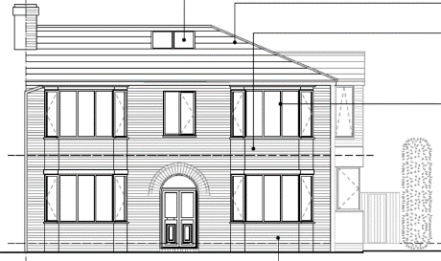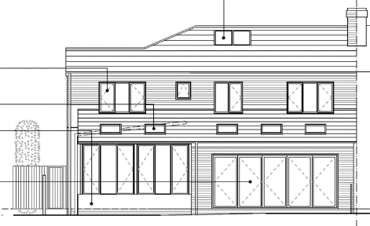

Figure 3 – the proposed front and rear elevation

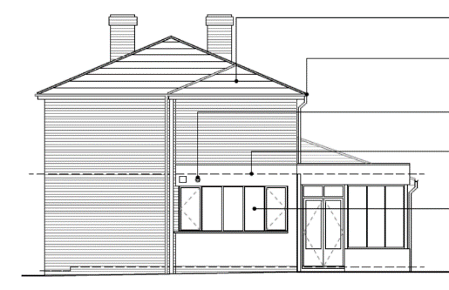

Figure 4 – the proposed side elevation

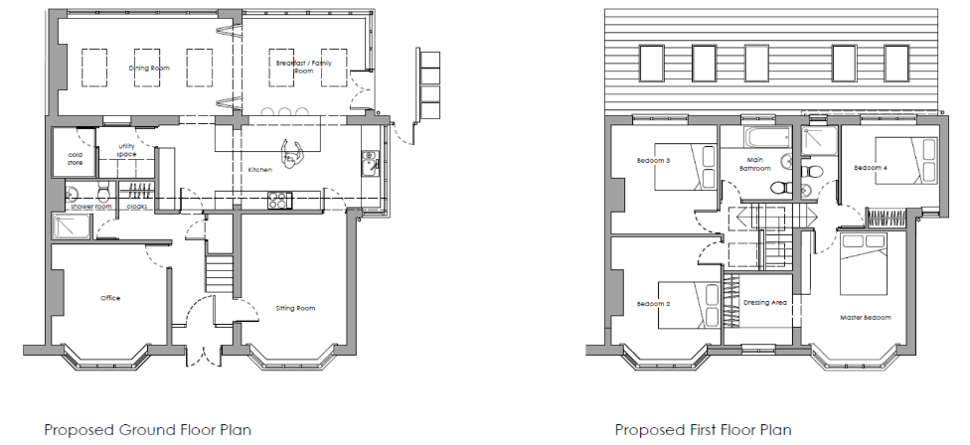

Figure 5 – the proposed ground and first floor layout

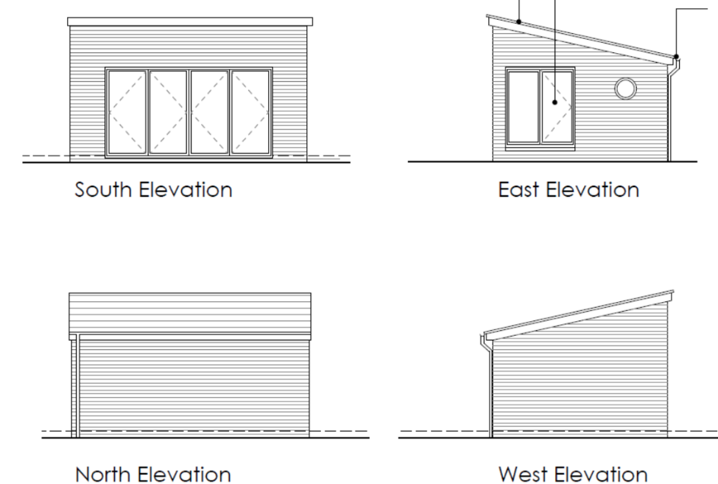

Figure 6 – the proposed garden room

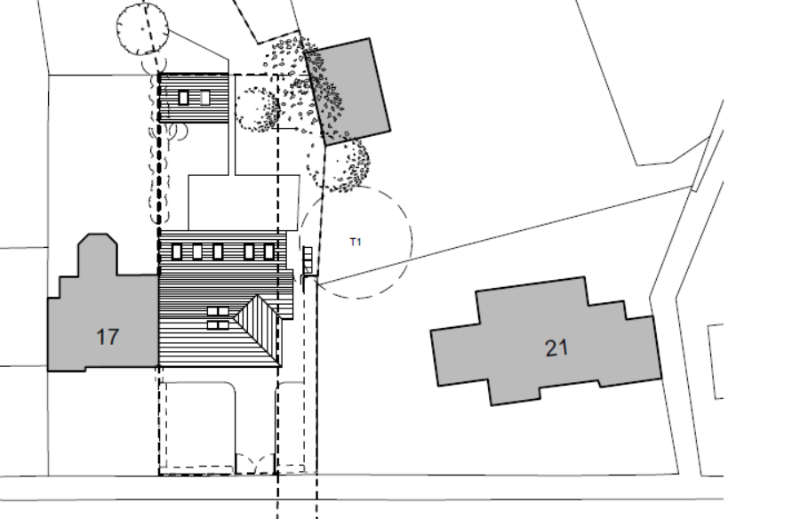

Figure 7 – the proposed site plan

Relevant Site History

09/57550/HH - Erection of a single storey extension and conservatory to the rear/side – Permitted (22.05.2009)

Consultations

Not applicable.

Publicity
Earliest Decision Date: 9 October 2020
Revised Expiry Date: 23 October 2020

Site Notice:
Reason:

Press Advert:
Reason:

Representations

There have been no representations received.

Planning Policy

Development Plan Policy

Unitary Development Plan DES1 - Respecting Context
This policy states that development will be required to respond to its physical context and respect the positive character of the local area in which it is situated and contribute towards a local identity and distinctiveness.

Unitary Development Plan DES7 - Amenity of Users and Neighbours
This policy states that all new development, alterations and extensions to existing buildings will be required to provide potential users with a satisfactory level of amenity in terms of space, sunlight, daylight, privacy, aspect and layout. Development will not be permitted where it would have an unacceptable impact on the amenity of occupiers or users of other development.

Unitary Development Plan DES8 - Alterations and Extensions
This policy states that planning permission will only be granted for alterations or extensions to existing buildings that respect the general scale, character, rhythm, proportions, details and materials of the original structure and complement the general character of the surrounding area.

Other Material Planning Considerations

National Planning Policy Framework
National Planning Policy Guidance

Local Planning Policy

Supplementary Planning Document - House Extension
This document contains a number of policies and standards to ensure that extensions within the curtilage of dwellings have a limited and acceptable impact on neighbouring residents; future residents of the application dwelling and that development makes a positive contribution to the local environment in terms of design.

The Revised Draft Greater Manchester Spatial Framework (‘GMSF’) was subject to public consultation at the start of 2019. The next version of the plan is expected to be published in for a period of representations in November 2020. In accordance with paragraph 48 of the National Planning Policy Framework it is considered that very limited weight can be given to the policies in the GMSF.

The Publication Salford Local Plan: Development Management Policies and Designations (‘Local Plan’) was published on 27 January 2020 and comments were invited until 20 March 2020. This is the version of the document that the city council would like to adopt and has been subject to a significant amount of public consultation in previous stages of its production. However, in accordance with paragraph 48 of the National Planning Policy Framework the weight that can be given to the Local Plan overall is currently limited. The city council is in the process of considering the comments made to determine the extent to which there are unresolved objections to the policies in the Plan. Those policies with less significant (or no) objections will be capable of carrying more weight than those with significant unresolved objections.
In terms of this application it is considered that the relevant policies of the UDP can be afforded due weight for the purposes of decision making as the relevant criteria within the UDP policies applicable to the proposed development are consistent with the policies contained in the NPPF.

It is not considered that there are any local finance considerations that are material to the application

Appraisal of the Proposed Development

Impact on the character of the area

Due to the adjacent dwelling (no.21) being angled away from the subject dwelling, forward of the building line and has been built in a different architectural style there is very limited possibility of the dwellings ever appearing to be a terrace rather than separate dwellings. Nonetheless, the proposed side extension would maintain a separation distance of at least 2m from the shared side boundary and thus is in accordance with Policy HE8 of the House Extensions SPD.

The proposed side extension and single storey rear extension would appear proportionate and would not detract from the principal dwelling. The side extension has been proposed with a hipped roof to respect the principal dwelling and the rear extension has been proposed with a mono-pitched roof to respect the existing rear extension. Brickwork and roof tiles have been proposed to respect the dwelling and surrounding properties within the area.

The proposed garden room is located to the rear of the property and would not be visible from the street scene. It would have a maximum height consistent with single storey additions/out buildings (for example, 600mm lower than the existing single storey rear extension) and would remain a subordinate feature to the principal dwelling. It has been proposed in materials to match the existing dwelling and would respect the context of the area. The development would not have an unacceptable impact upon the character of the area.

Impact on the amenity of neighbours

There are no dwellings immediately to the rear of the site as the neighbouring gardens back on to each other. A separation distance of 16.7m from the rear facing window in the rear extension and 18.7m from the rear facing window in the side extension would be maintained to the shared boundary by no.339 Broadway, which accords with Policy HE1 of the House Extensions SPD.

The proposed ground floor side facing window would be within 5m of the side boundary shared by no.21. However, there is an existing hedge along the boundary that would interrupt any views into the neighbouring garden.

There would be a separation distance of circa 12.75m from the window in the side conservatory at no.21 Bedford Avenue. However, the adjacent dwelling is slightly angled away, reducing the overbearing impact of the extension. As the conservatory is a glazed extension, there is no ‘principal’ window that the Local Planning Authority would seek to protect. Thus, the proposed side extension would not result in a significant loss of light and/or be overbearing for the neighbouring residents at no.21 Bedford Avenue.

The proposed single storey rear extension is an infill to the side of the existing rear extension. It would be set circa 15.7m away from any rear windows at no.21 and to the side. Thus, it would not result in any impact to the neighbouring residents.

The proposed outbuilding would be located 12.92m away from the rear window of the principal dwelling at no.17 Bedford Avenue and 10.78m from the rear conservatory window. However, views of the outbuilding would be ‘incidental’ as it would be at an angle rather than a direct line from the windows. The outbuilding would have a maximum height typical of a single storey outbuilding and is not considered to appear a dominant feature or overbearing to the neighbouring residents. Thus, it is considered to be acceptable.

Impact on the highway network

Hardstanding of 9m in length by 3.6m in width would be maintained to the front of the dwelling, which accords with Policy HE11 of the House Extensions SPD. The hardstanding would be sufficient to accommodate at least one vehicle clear of the highway. It is considered the development would not result in an unacceptable impact on highway safety or the free flow of traffic.

Other issues

Does the proposal require any work to trees? NO

Is there a significant change in levels across the site or between the site and the neighbouring land? NO

Has the applicant/agent indicated any personal circumstances? NO

Recommendation:

Approve, subject to the following conditions:

- The development must be begun not later than three years beginning with the date of this permission.

Reason: Required to be imposed by Section 91 of the Town and Country Planning Act 1990 (as amended).

- The development hereby permitted shall be carried out in accordance with the following plans:

  - Drwg. No. DP179 P01 rev B – Proposed Site Plan (Received: 23.10.2020)
  - Drwg. No. DP179 P03 rev B – Floor Plans (Received: 21.10.2020)
  - Drwg. No. DP179 P04 rev A – Proposed Garden Room (Received: 31.07.2020)
  - Drwg. No. DP179 P06 rev B – Front and Rear Elevations (Received: 21.10.2020)
  - Drwg. No. DP179 P07 rev A – Proposed Side Elevation (Received: 31.07.2020)

Reason: For the avoidance of doubt and in the interest in proper planning.

- The external materials used shall match those of the existing building so far as practicable.

Reason: In order to ensure a satisfactory appearance in the interests of visual amenity in accordance with Policies DES1 and DES8 of the City of Salford Unitary Development Plan and the requirements of the National Planning Policy Framework.

Statement of conformity with Article 35 of The Town and Country Planning (Development Management Procedure) (England) Order 2015

The proposal complies with the development plan and would improve the economic, social and environmental conditions of the area. It therefore comprises sustainable development and the Local Planning Authority worked proactively and positively to issue the decision without delay. The Local Planning Authority has therefore implemented the requirement in Paragraph 38 of the NPPF.

Officer | Sam Pierce | LPA | M Hodgson
Date | 23/10/2020 | Date | 23.10.20

