

Application Ref. | PA/2025/0602
Location | 228 Leigh Road, WORSLEY, MANCHESTER, M28 1LE
Ward | Boothstown and Ellenbrook Ward
Applicant | Mr Simon Thompson
Proposal | Conversion of garage into a habitable space and front / porch extension including external alterations
Recommendation | Approve with Conditions

Location Plan

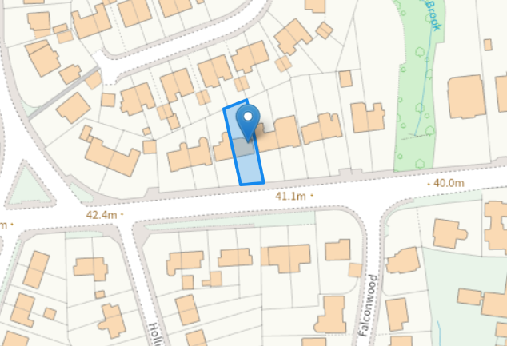

Description of Site and Surrounding Area

The application relates to a two storey semi-detached property on Leigh Road. There are predominantly semi-detached properties within the vicinity of the site.

Description of Proposal

A single storey front / porch extension with a mono-pitched roof is proposed across the main front entrance and existing garage and would project 1m from the front elevation of the property. The extension would slightly project past the existing front bay window.

The existing garage would be converted into a living space serving lounge. The existing garage door in the front elevation of property would be replaced with a window.

External alterations include new obscure glazed window in the side eastern elevation of the existing side extension at ground floor serving W/C & utility room.

Proposed Elevation & Floor Plans

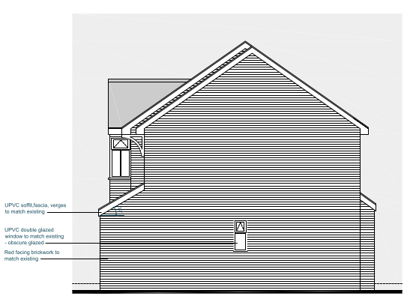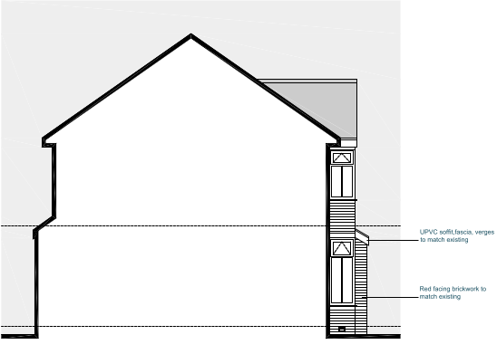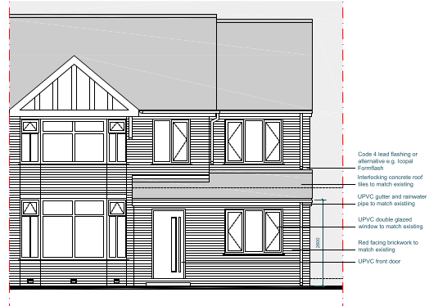
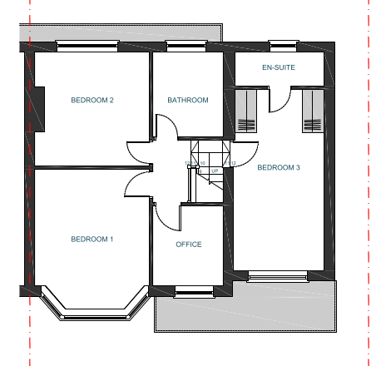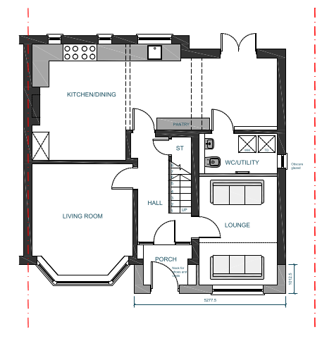

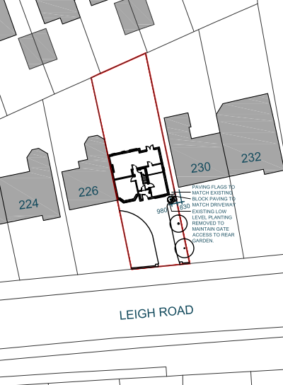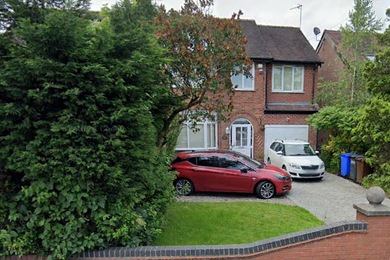

Relevant Planning History
08/56310/HH - Householder planning permission
Decision: Approve - Sent: 21 May 2008
228 Leigh Road, Worsley, M28 1LE
Erection of a part first floor/part two storey side extension.
Publicity
Neighbours - Publicity Start Date - 30 April 2025
Neighbour Notification
6 neighbouring properties have been notified of the application via letter. No representations have been received.

Consultations

N/A

Planning Policy
Salford Local Plan: Development Management Policies and Designations (SLP:DMP)
Policy A6 Highway network
Policy D1 Design principles
Policy D2 Local character and distinctiveness
Policy D3 Layout and access
Policy D5 Amenity
Policy D8 Alterations and extensions

Other Material Planning Considerations
National
- National Planning Policy Framework
- National Planning Practice Guidance

Local Planning Policy and Development Framework/ Strategies
- Supplementary Planning Document – House Extensions (2006)

Local Finance Considerations
It is not considered that there are any local finance considerations that are material to the application.

Appraisal
Impact on the Character of the Area

The development would be visible from the street scene. It is considered that the design of the proposal would appear cohesive with the existing dwelling, surrounding area and with neighbouring dwellings. Materials used within the extension are proposed to match to maintain a coherent relationship to the host dwelling in accordance with Policies D1, D2 and D8 of the SLP:DMP.

Impact on the Amenity of Neighbours

The proposal would be set away from neighbouring properties No.230 Leigh Road and No.226 Leigh Road either side of the host dwelling by 0.9m and 13m from the shared common boundary respectively. Given the layout, relationship, and distance maintained the proposal would not have a negative impact on the amenity of any neighbours.

The proposal would maintain 21m+ to the property across the road therefore it would not introduce any significant additional overlooking to the house opposite.

The insertion of a window serving W.C & utility room at ground floor in the side elevation of the existing side extension does not raise any issues given that this window would face No.230 Leigh Road’s side blank gabled wall beyond.
The development does not therefore cause any undue harm to the amenity of the users and amenity
or privacy of the neighbouring users and is in line with Policy D5 of the SLP:DMP, SPD and the NPPF.

Impact on the Highway Network

The development does not impact on the hardstanding to the front of the property or the loss of parking provision; Therefore, the development does not have an impact on the highway network.

Other Issues
Does the proposal require works to trees?
No
Is there a significant change in levels across the site or between the site and neighbouring land?
No
Has the applicant/agent indicated any personal circumstances?
No

Recommendation
Approve with Conditions

Document Approval
Report Author | R.Sharma
Date | 25/06/2025
Reviewer | M Hodgson
Date | 25.06.25

