

Application Ref. | PA/2025/0722
Location | 5 Falmouth Road, IRLAM, MANCHESTER, M44 6EJ
Ward | Higher Irlam and Peel Green Ward
Applicant | Mr & Mrs Chris & Victoria Rowan
Proposal | Demolition of garage / front canopy and erection of single storey side and rear wrap round extension
Recommendation | Approve with Conditions

Location Plan

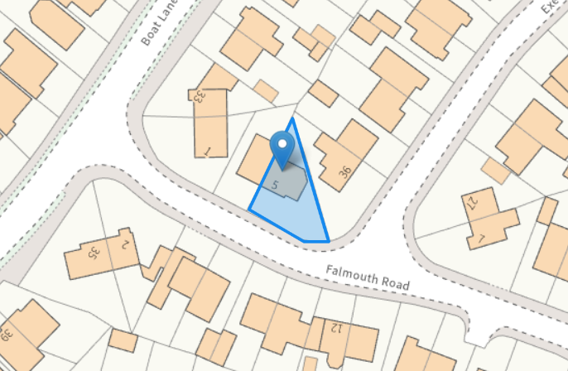

Description of Site and Surrounding Area

The application relates to a two storey semi-detached dwellinghouse located on Falmouth Road. There are predominantly semi-detached properties within the vicinity of the site.

Description of Proposal

A single storey side and rear wrap round extension with a mono pitched roof including roof lights is proposed and would project 3.44m from the main side elevation, in line with the main front elevation and would project 3m from the main rear elevation of the dwellinghouse.

The existing single storey side garage including front canopy across the main front entrance will be demolished/removed to allow for development.

Proposed Elevations & Floor Plans

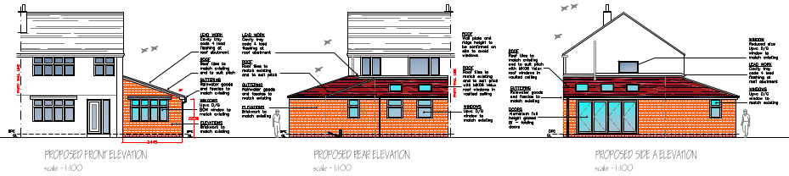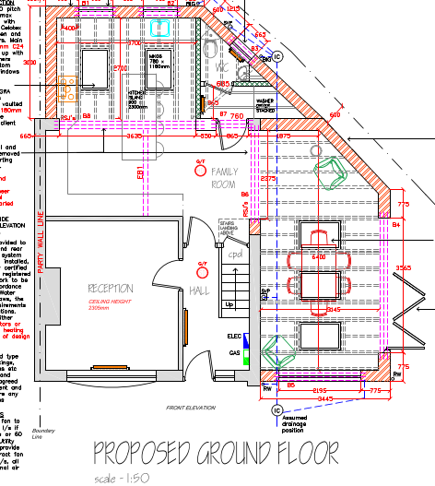

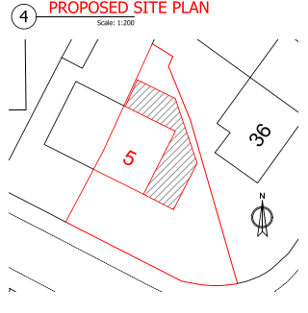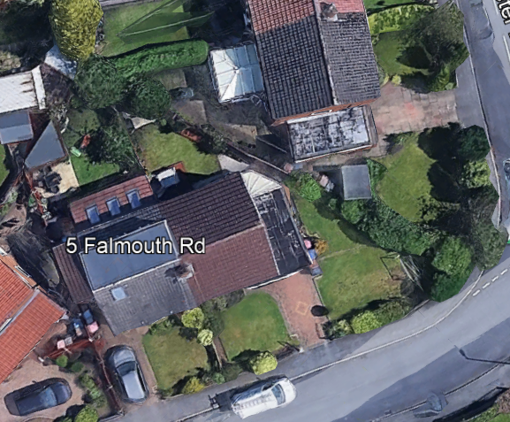

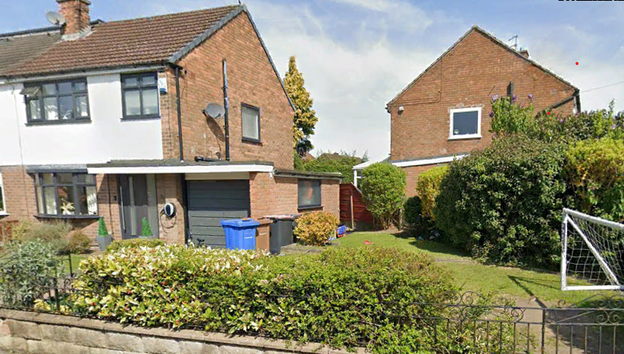

Relevant Planning History

No relevant planning history

Publicity
Neighbours - Publicity Start Date - 28 May 2025
Neighbour Notification
8 neighbouring properties have been notified of the application via letter. No representations have been received.

Consultations

N/A

Planning Policy
Salford Local Plan: Development Management Policies and Designations (SLP:DMP)
Policy A6 Highway network
Policy D1 Design principles
Policy D2 Local character and distinctiveness
Policy D3 Layout and access
Policy D5 Amenity
Policy D8 Alterations and extensions

Other Material Planning Considerations
National
- National Planning Policy Framework
- National Planning Practice Guidance

Local Planning Policy and Development Framework/ Strategies
- Supplementary Planning Document – House Extensions (2006)

Local Finance Considerations
It is not considered that there are any local finance considerations that are material to the application.

Appraisal
Impact on the Character of the Area

The development would be visible from the street scene and is set well back from the road. It is considered that the design of the proposal would appear cohesive with the existing dwelling, surrounding area and with neighbouring dwellings. Materials used within the extension are proposed to match to maintain a coherent relationship to the host dwelling in accordance with Policies D1, D2 and D8 of the SLP:DMP.

Impact on the Amenity of Neighbours

As the side element of the extension does not project beyond the parent dwelling from the front it would not introduce any significant additional overlooking to the houses to the front (across the road) set at an angle to the application site.

The adjacent property No.36 Exeter Drive is set at a right angle to the host dwelling including its rear garden area and its single storey attached garage. The proposal would replace the existing side element and would increase its footprint to the side/rear with one obscure opening serving W.C directly facing No.36’s rear garden area, conservatory, including their window in their main rear elevation serving a kitchen. The proposal would be set away from the shared common boundary with No.36 by a minimum of 0.6m due to the splayed alignment of the site boundary. The proposal would be in line with No.36’s original side elevation of their dwellinghouse set 5m away from the proposal.

In addition the proposal proposes large bi-fold doors in its side elevation of the extension serving dining room and would have a main outlook over the applicant’s small section of their side / front garden area and would maintain a minimum distance of 1.3m to the side boundary consisting of tall hedging interrupting views with the neighbouring front / side garden of No.36 Exeter Drive beyond the splayed alignment of the site boundary. Due to the existing relationship and layout between No.5 and No.36 as well as the proposed in-between distance maintained to the shared common boundary it is considered that the proposal would not result in an unacceptable loss of daylight and/or sunlight or pose a detrimental overbearing impact or create undue overshadowing or to result in a significant loss of privacy to neighbouring occupiers at No.36. The conservatory extension at No.36 will still retain outlook out past the rear of the proposed extension, to the north-west.

A condition has been added to ensure that the window serving W.C in the side elevation is fitted with obscure glazing to ensure no unacceptable loss of privacy for the occupiers of No.36. The window shall also be non-opening unless the parts of the window which can be opened are more than 1.7m above the floor level.

The overall design and siting of the extension minimizes the loss of daylight and/or sunlight to No.36. Furthermore, the direction of sun path is from the east and moves round to the west of the properties (round the side, front and side of No.36). Given this there would be no shadowing, and the proposal would not result in loss of daylight and or sunlight.

To the other side, the extension does not project beyond a 45-degree line from a point 3m along the boundary from the rear elevation of No.3 Falmouth Road, which has been subject to a single storey rear extension. It is considered that the development would not result in an unacceptable loss of daylight and/or sunlight or pose a detrimental overbearing impact or create undue overshadowing to this neighbouring property.
The rear extension would have a main outlook over the rear garden area and would maintain a minimum distance of approximately 4m to the rear boundary consisting of a 1.8m high boundary timber fence combined with a tall hedge interrupting views with the neighbouring garden (rear section of No.36 Exeter Drive) beyond. It is considered the proposal would not introduce any additional overlooking opposite.
The development does not therefore cause any undue harm to the amenity of the users and amenity or privacy of the neighbouring users and is in line with Policy D5 of the SLP:DMP, SPD and the NPPF.

Impact on the Highway Network

The development would not increase in the number of bedrooms but would result in the loss of a vehicle parking space in the existing garage. However, the existing hardstanding would remain to the front. This is considered sufficient to accommodate at least 1 vehicle as well as unrestricted on-street parking in the wider area. Therefore, the development would not result in an unacceptable impact on the highway network.

Other Issues

Does the proposal require works to trees?
No
Is there a significant change in levels across the site or between the site and neighbouring land?
No
Has the applicant/agent indicated any personal circumstances?
No

Recommendation
Approve with Conditions

Document Approval
Report Author | R.Sharma
Date | 21/07/2025
Reviewer | M Hodgson
Date | 21.07.25

