

Application Ref. | PA/2025/1547
Location | 762 Liverpool Road, ECCLES, MANCHESTER, M30 7LN
Ward | Higher Irlam and Peel Green Ward
Applicant | Mr Serhiy Dabizhevskyy
Proposal | Erection of a two storey side and part two, part single storey rear / side extension and roof alteration of the existing rear garage from pitched to flat roof including garage extension. Retrospective application for construction of front / side boundary treatment consisting of brick wall/pillars with railings including retention of driveway/surfacing including external alterations
Recommendation | Approve with Conditions

Location Plan

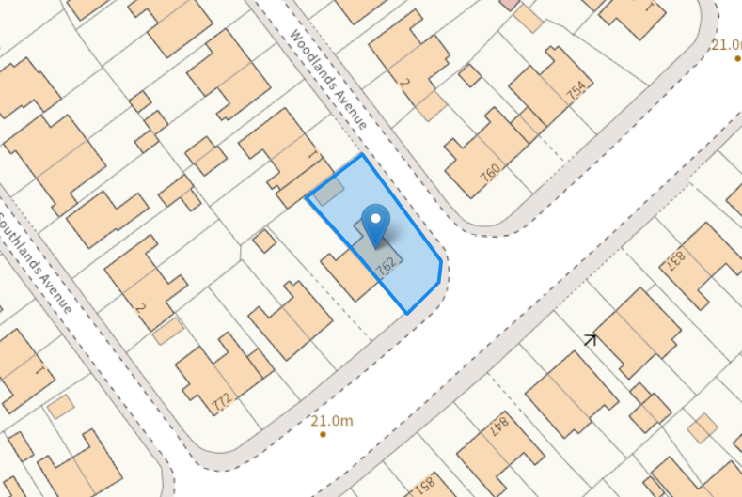

Description of Site and Surrounding Area

The application relates to a two storey semi-detached dwelling located on Liverpool Road, sited on the corner at its junction with Woodlands Avenue. There are mainly semi-detached properties within the vicinity of the site.

Description of Proposal

A two storey side and part two, part single storey rear /side extension is proposed and would project 1.8m from the main side elevation, with the side element set back from the main front elevation by 3.5m and with the rear element projecting between 3m and 3.9m from the main rear elevation of the dwellinghouse creating a stepped rear elevation. The first floor rearward element of the extension would be set away from the adjoining property by 3.4m. The two storey element would feature a hipped roof structure, the eaves height would match the existing eaves level. The ridge over the two storey side / rear extension would be set at a lower height from the main roof ridge. The single storey elements will feature mono-pitched roofs.
The proposal includes an extension to the existing detached garage towards its rear, positioned along the shared boundaries, together with a roof alteration from a pitched to a flat design to infill the space between neighbouring properties.

Google Maps imagery (see below) indicates that the applicant has replaced the original low level boundary treatment with a brick wall and pillars approximately 1.6m high, incorporating black railings along the frontage and continuing around the side, where the height increases to around 2m from ground level. The development also includes a vehicle access point positioned at the corner adjoining the highway and the front/side garden areas have been hard surfaced to accommodate two new parking spaces by replacing a large section of the soft landscaped area with a resin finish with 10mm open course tarmac (permeable) with buildup covering an area of 56.1sqm as stated on Drawing No.P23260224A – Proposed Site Plan. The applicant is using the existing dropped kerb at the junction of Liverpool Road and Woodlands Avenue, which is intended for pedestrian use.

It is noted an there is existing driveway at the rear of the site with a dropped kerb which provides access to the driveway from Woodlands Avenue, with the existing garage positioned to the north west of the application site.

External alterations include insertion of a tall window in the main side elevation of the dwellinghouse between the ground and first floor serving hallway / landing areas.

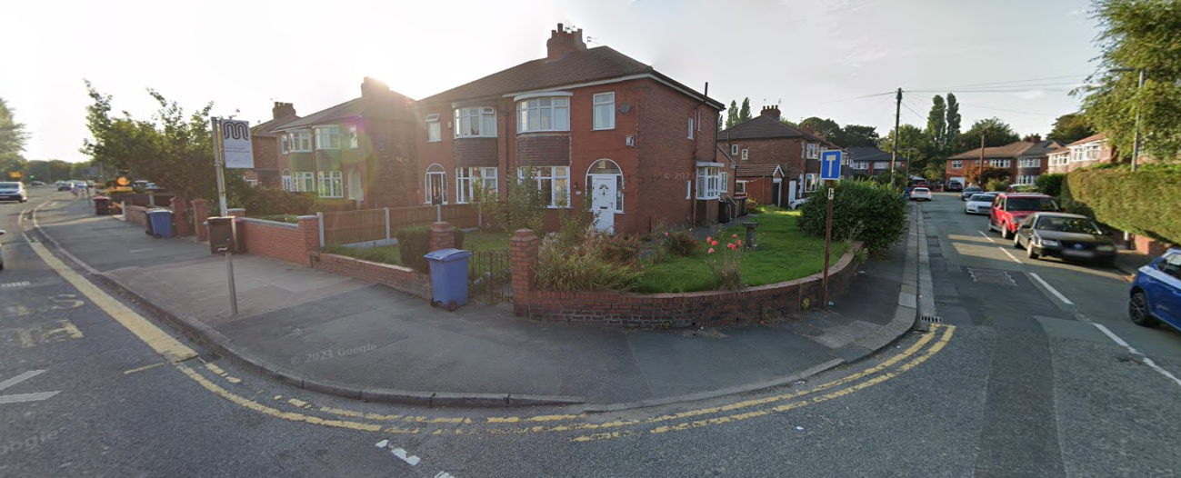
Google Maps imagery - dated September 2021

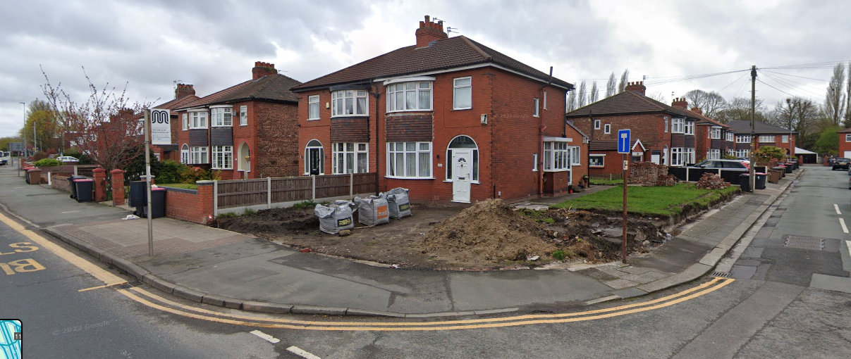
Google Maps imagery - dated April 2023

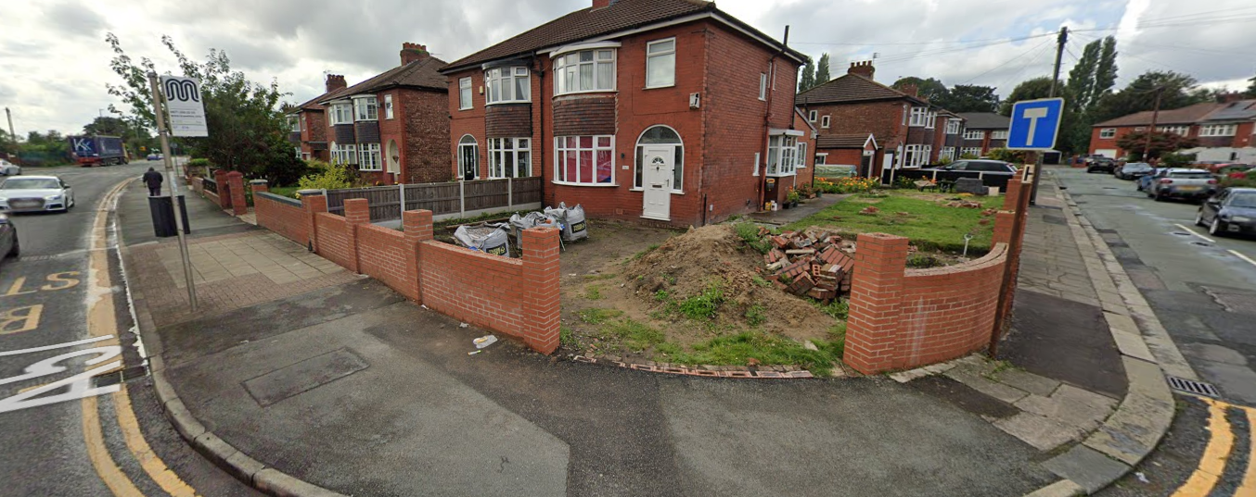
Google Maps imagery - dated August 2023

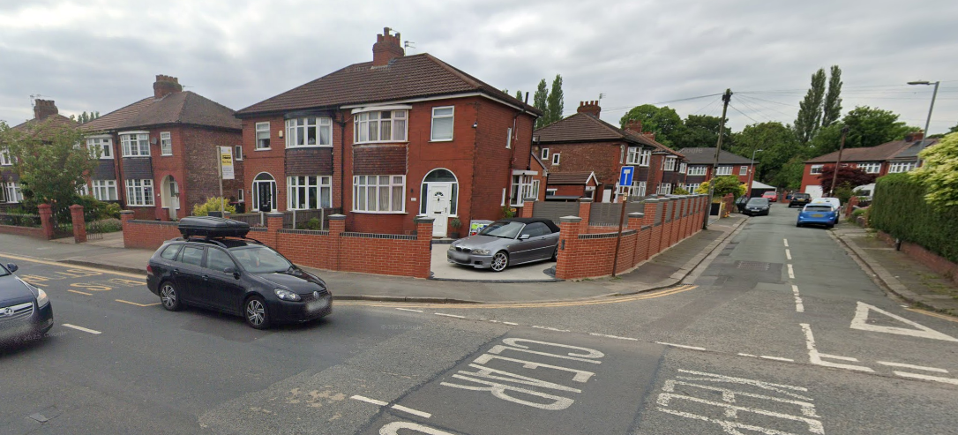
Google Maps imagery - dated May 2024

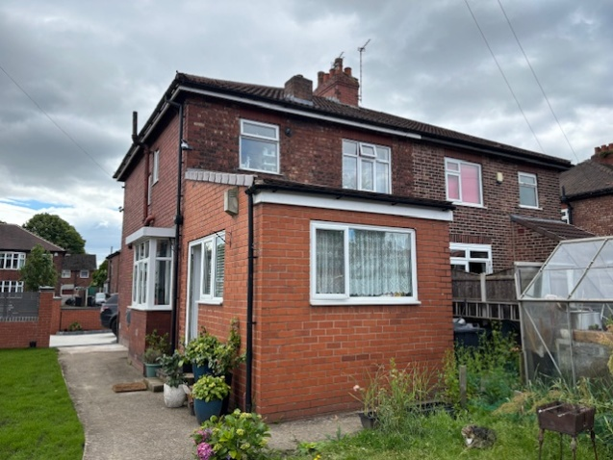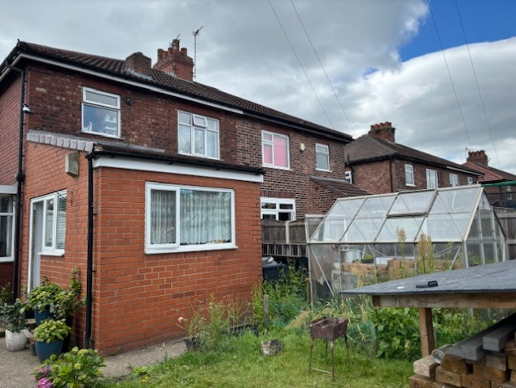

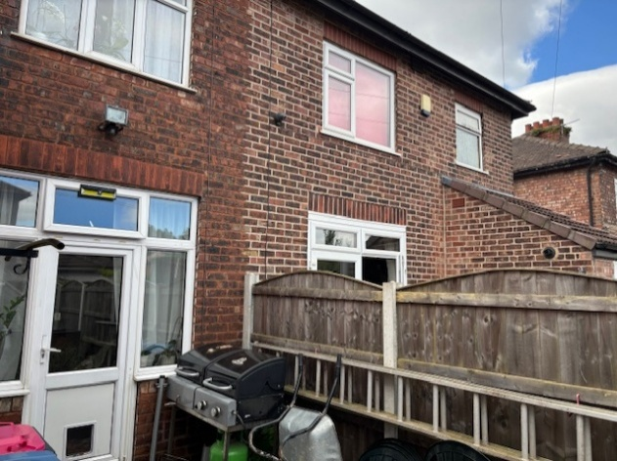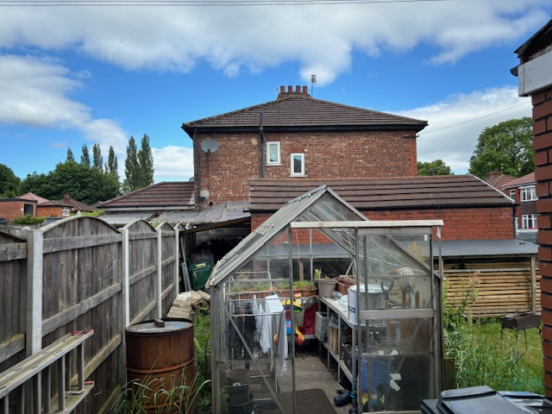

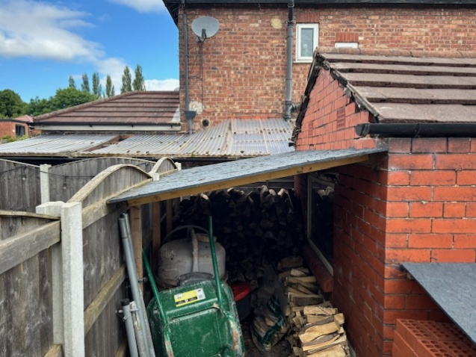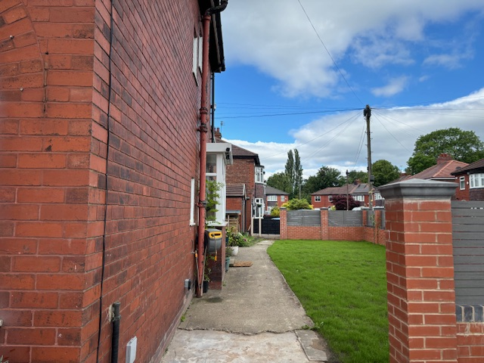

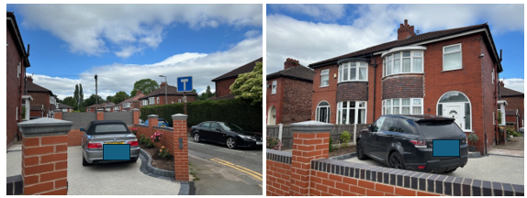

Relevant Planning History
No relevant planning history

Publicity
Neighbours - Publicity Start Date - 11 November 2025
Neighbour Notification
9 neighbouring properties have been notified of the application via letter. No representations have been received.

Consultations
Salford Highways Officer (DM)
Having consulted the Council's Road Safety Team it has been advised that while the recently introduced driveway entrance is not recommended at this corner location, being so close to the junction with Liverpool Road; as the driveway has been in operation for over 2 years without any known incident the LHA have no objections. An informative has been added to make the applicant aware of their responsibilities.

Planning Policy
Salford Local Plan: Development Management Policies and Designations (SLP:DMP)
Policy A6 Highway network
Policy D1 Design principles
Policy D2 Local character and distinctiveness
Policy D3 Layout and access
Policy D5 Amenity
Policy D8 Alterations and extensions

Other Material Planning Considerations
National
- National Planning Policy Framework
- National Planning Practice Guidance

Local Planning Policy and Development Framework/ Strategies
- Supplementary Planning Document – House Extensions (2006)

Local Finance Considerations
It is not considered that there are any local finance considerations that are material to the application.

Appraisal
Impact on the Character of the Area

The front / side boundary wall with pillars and railings is visible from the street scene. While the front and side boundary treatment differs slightly in appearance from neighbouring properties, the design and use of materials integrate well with the existing dwelling. The combination of brick walls and pillars with black railings fronting Liverpool Road has created an attractive and coherent addition. The boundary treatment has been designed sympathetically in relation to its surroundings, with an acceptable height and design along the front and side boundary. It is considered comparable in scale and style to several other boundary treatments nearby, thereby mitigating any potential harmful visual impact on the character of the surrounding area.

Typically, the dwellings in the surrounding area are two semi-detached properties. However, a number of properties have undergone extensive development to the side and rear. The proposed side and rear extension respects the proportions and details of the parent dwelling. Due to the setting of the dwelling adjacent to Woodlands Avenue the highway arrangement eliminates any potential for terracing to occur. The side extension maintains a minimum of 4.4m to the back of footpath. The proposed extension would not appear overbearing in the street scene and is a subservient addition. It is considered that the proposal is considered acceptable in relation to its impact on the character of the area.
The development would be subordinate to the host dwelling and would not represent an overdevelopment of the plot. The scale, massing, roof form and fenestration detailing is considered to be appropriate in the context of the area and would not have an adverse impact upon the character of the dwelling or the area in accordance with Policies D1, D2 and D8 of the SLP:DMP and Policies HE8 and HE9 cited within the House Extensions SPD.

Impact on the Amenity of Neighbours

Two storey side, part two, part single storey side / rear extension:

As the side element of the extension does not project beyond the parent dwelling from the front it would not introduce any significant additional overlooking to the houses opposite.

Two windows and one large double patio door is proposed in the side elevation of the side/rear extension at ground floor serving a wet room, utility room and kitchen and two windows are proposed at first floor serving a bathroom and bedroom including insertion of a tall window in the main side elevation of the dwellinghouse serving hallway / landing areas which would a maintain a minimum distance of 15m to the ground floor blank side elevation of the single storey side extension at No.760 Liverpool Road. It is noted there are windows in the side elevation of No. 760 at first floor serving non-habitable rooms, with its principal windows serving habitable rooms in the front and rear elevations. In this instance given the distance, relationship (across Woodlands Road) and layout maintained it is considered the proposal would not result in an unacceptable loss of daylight and/or sunlight, be overbearing or create undue overshadowing, overlooking or loss of privacy to neighbours in compliance with Policy D5 of the SLP:DMP.

In the absence of an extension along the common boundary to the adjoining dwelling No.764 Liverpool Road the 3m projection of the single storey element of the rearward extension would be sited along the shared common boundary with the adjoining property No.764. The proposal does not project beyond a 45-degree line from a point 3m along the boundary from the rear elevation of No.764.
Furthermore, the ground floor element steps out to 4.9m, and the first floor element steps out by 3.4m however the proposal would be set away from the shared boundary by 3.4m. Given this separation distance maintained to the shared common boundary it is considered that the proposal would not result in an unacceptable loss of daylight and/or sunlight or pose a detrimental overbearing impact or create undue overshadowing to neighbouring occupiers at No.764 complying with Policy HE7 and Policy HE5 of the House Extensions SPD and Policy D5 of the SLP:DMP.

Policy D5 of the SLP:DMP states that a minimum distance of 13m shall be maintained from the principal windows of habitable rooms to other walls that are one storey higher. Policy HE3 of the SPD goes on to state the design and sitting of proposed extensions should have regard to minimising the loss of daylight and/or sunlight to neighbouring dwellings and they should not be so large or close to other dwellings that they appear overbearing or dominant. No.1 Woodlands Avenue is set at a right angle to the application property and is located close to the shared common boundary beyond the applicant’s northern rear site boundary. A minimum distance of 8m is maintained to the rear boundary and 11m to No.1’s first floor side elevation (given the location of No.1’s single storey attached garage) from the first floor of the proposed extension. Although this distance falls short of the recommended distance by 2m the impact relates to the application property rather than the neighbour, as there are no habitable room windows in the side elevation of No. 1 Woodlands Avenue. In addition, the large open plan living / kitchen space has several means of outlook including to the side elevation. Therefore the shortfall against this provision is not considered to be unacceptable.

The extended garage would be set along the western side site boundary with No.764 Liverpool Road’s rear garden directly beyond the 1.8m high intervening fence and also abutting with the neighbour’s garage directly beyond the application site’s rear site boundary on Woodlands Avenue. The existing timber fence and neighbour’s garage would mitigate any potential harm with regards to dominance from the perspective of those enjoying the garden of the neighbouring properties. It is therefore considered that the proposed extension to the garage and alteration to its roof (from pitched to flat) would not result in an unacceptable overbearing/dominant impact on the amenity of neighbours nor result in an unacceptable loss of daylight and/or sunlight (considering the height of the existing fence and neighbour’s garage) in compliance with Policy D5 of the (SLP:DMP).

Impact on the Highway Network

The development would not result in the loss of parking provision. The existing parking layout is considered sufficient to accommodate 2 x vehicles at the front accessed via Liverpool Road and 2 x vehicles (1 x in existing garage) to the rear accessed via Woodlands Avenue as well as unrestricted parking in adjacent roads. The front garden area has been excavated and resurfaced with a porous material including planting areas around the sides to support sustainable drainage which is considered to be acceptable. The development was reviewed by the Highways and Road Safety Team who have no objections to the proposal, as such it is considered that the development would have a minimal impact on highway safety.

Other Issues
Does the proposal require works to trees?
No
Is there a significant change in levels across the site or between the site and neighbouring land?
No
Has the applicant/agent indicated any personal circumstances?
No

Recommendation
Approve with Conditions

Document Approval
Report Author | R.Sharma
Date | 16/12/2025
Reviewer | G Clegg
Date | 17/12/2025

