

Application Ref. | PA/2025/1567
Location | 2 Granville Avenue, SALFORD, M7 4GD
Ward | Kersal and Broughton Park Ward
Applicant | Simon Moshe
Proposal | Proposed first floor rear extension and loft conversion with front and rear dormer extensions.
Recommendation | Approve with Conditions

Location Plan
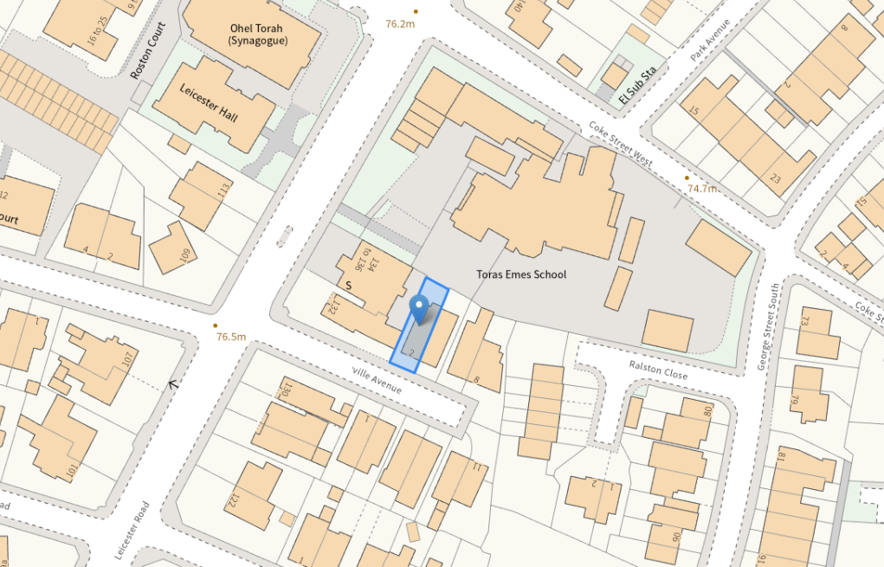
Description of Site and Surrounding Area
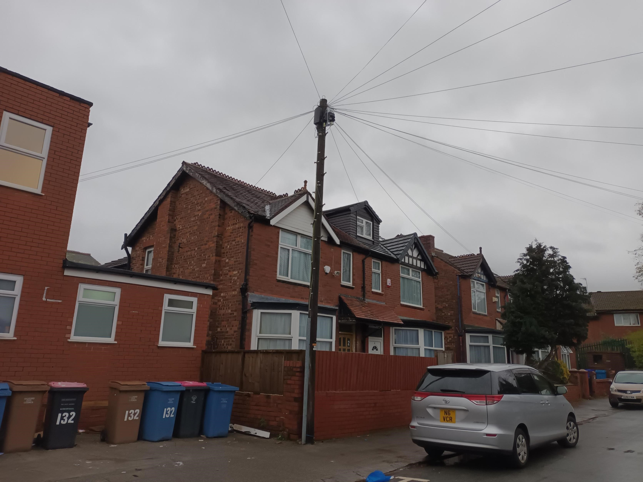
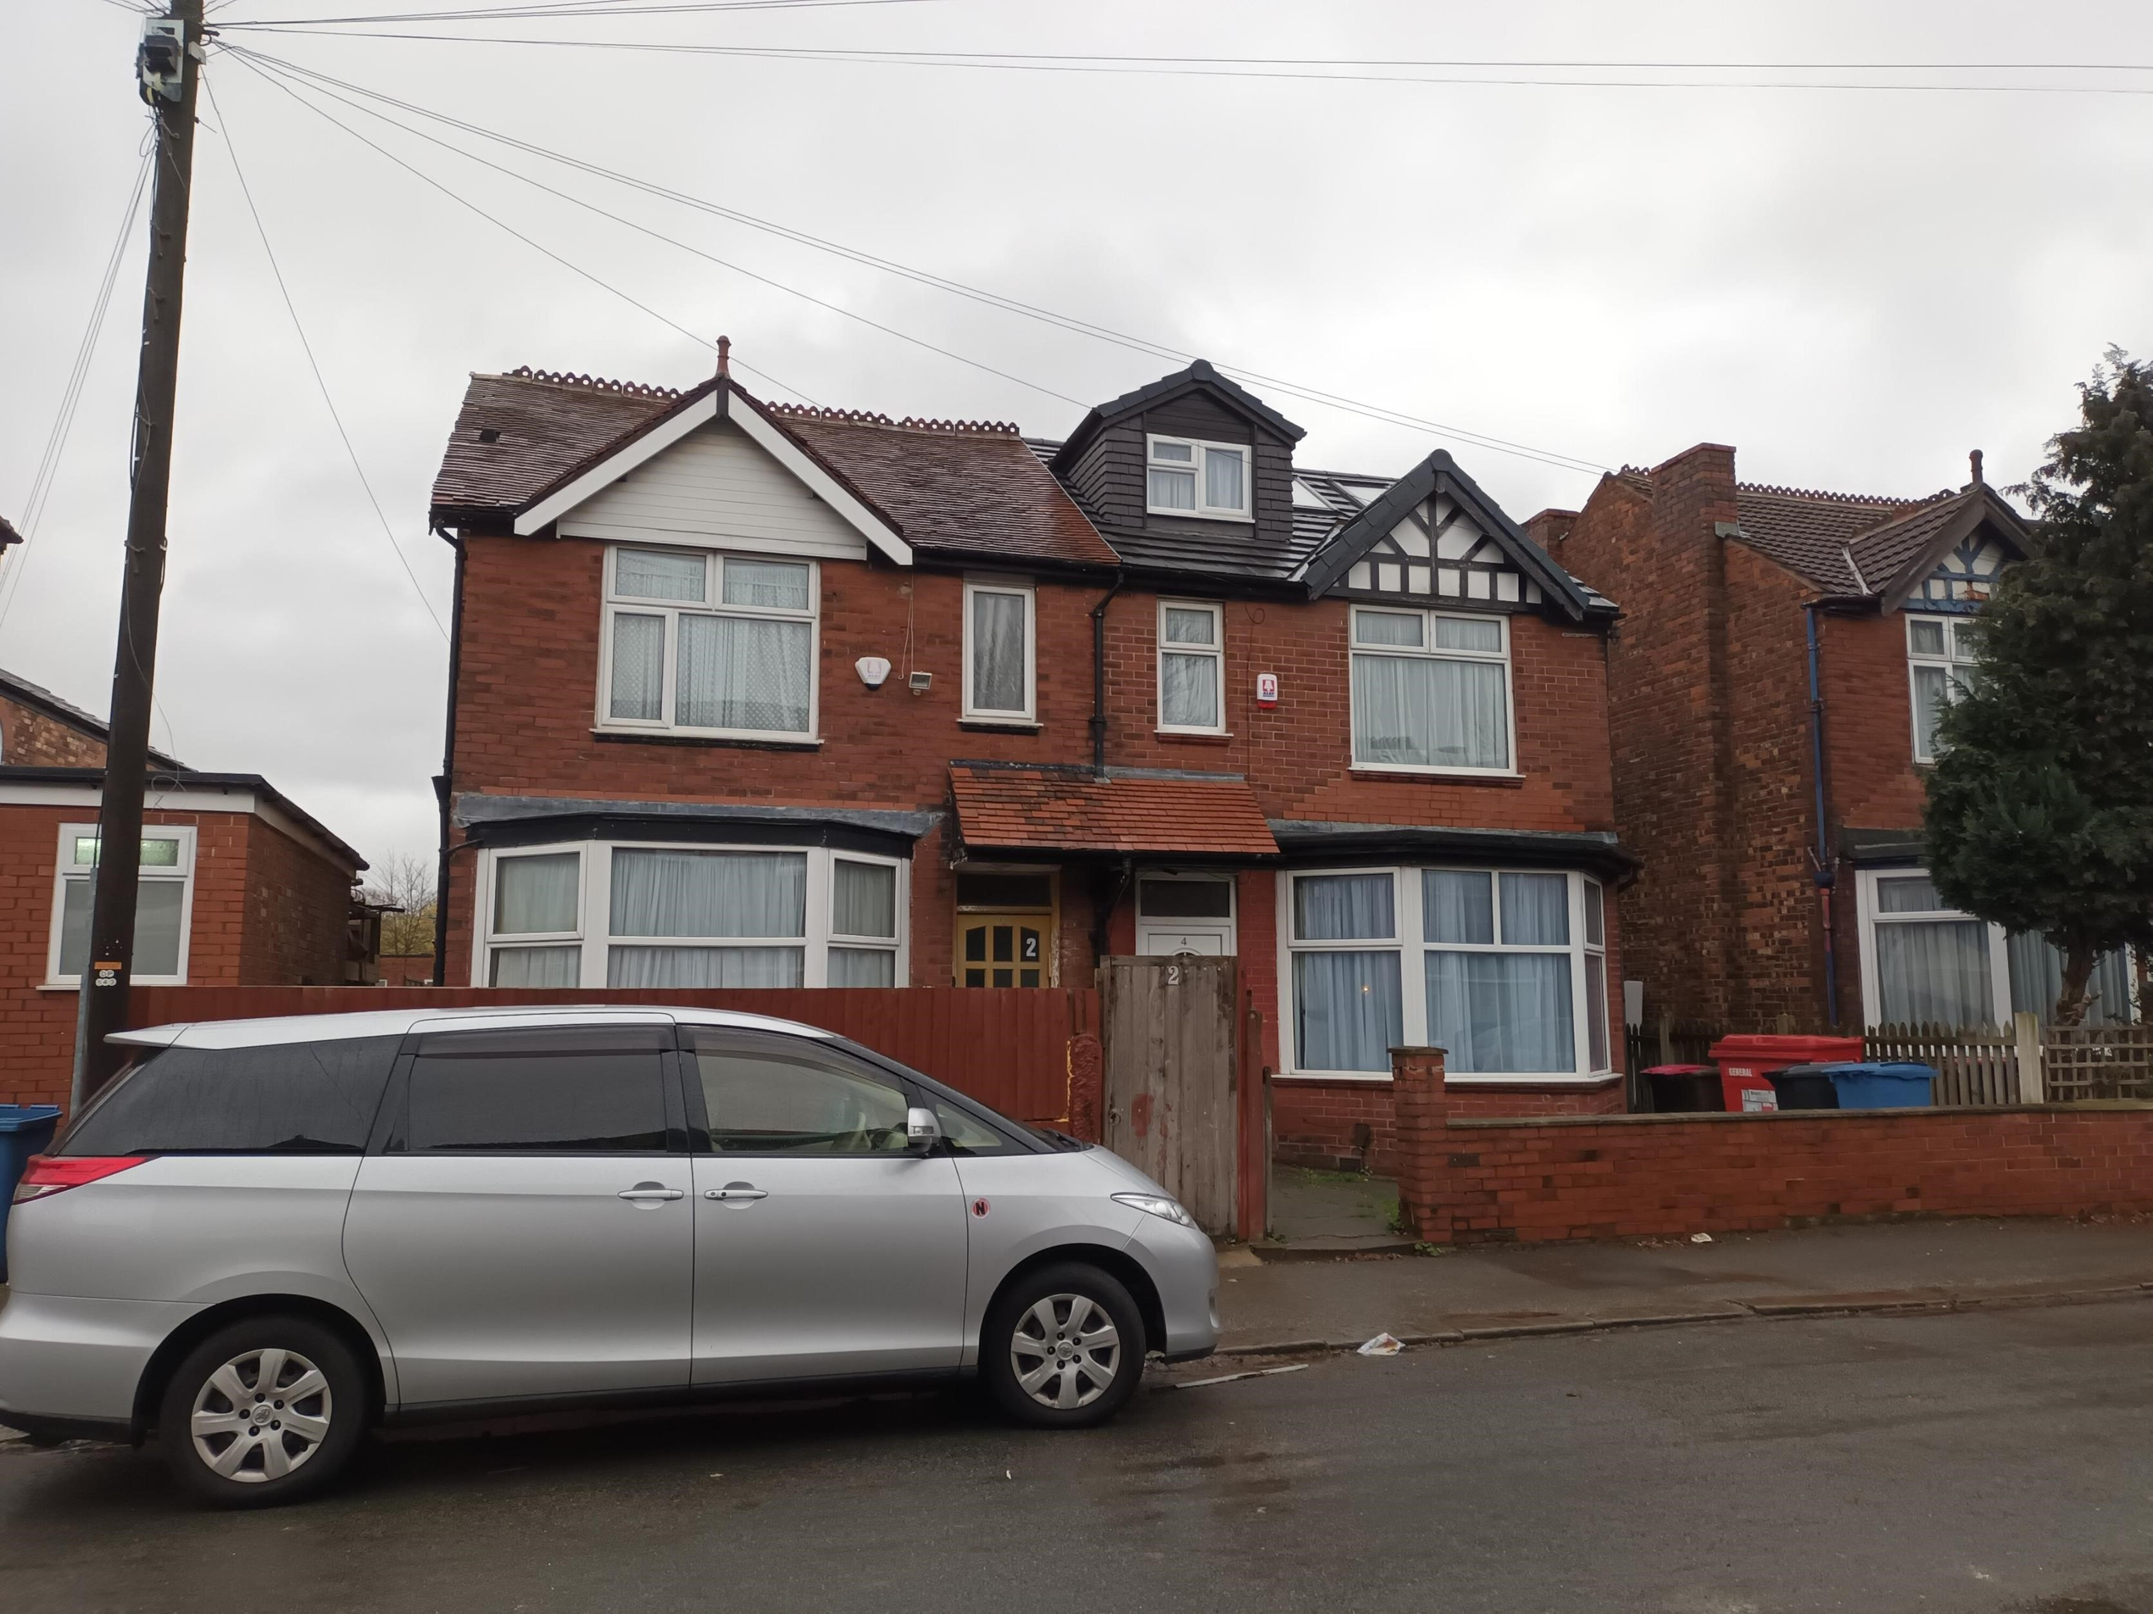
The application relates to a two-storey semi-detached property within a short residential cul-de-sac. The property has an existing single storey rear extension. There is a synagogue to the west of the site, and a school to the north. Several of the surrounding properties have large rear dormers, with the adjoining property no. 4 also having a front dormer.
Figure 2 Street scene.
Figure 1 Front of the application property.
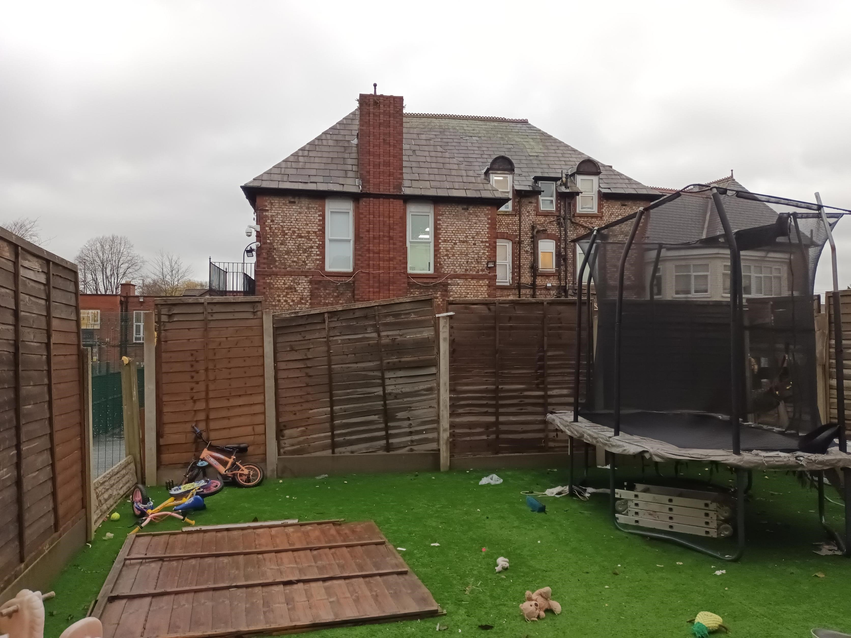
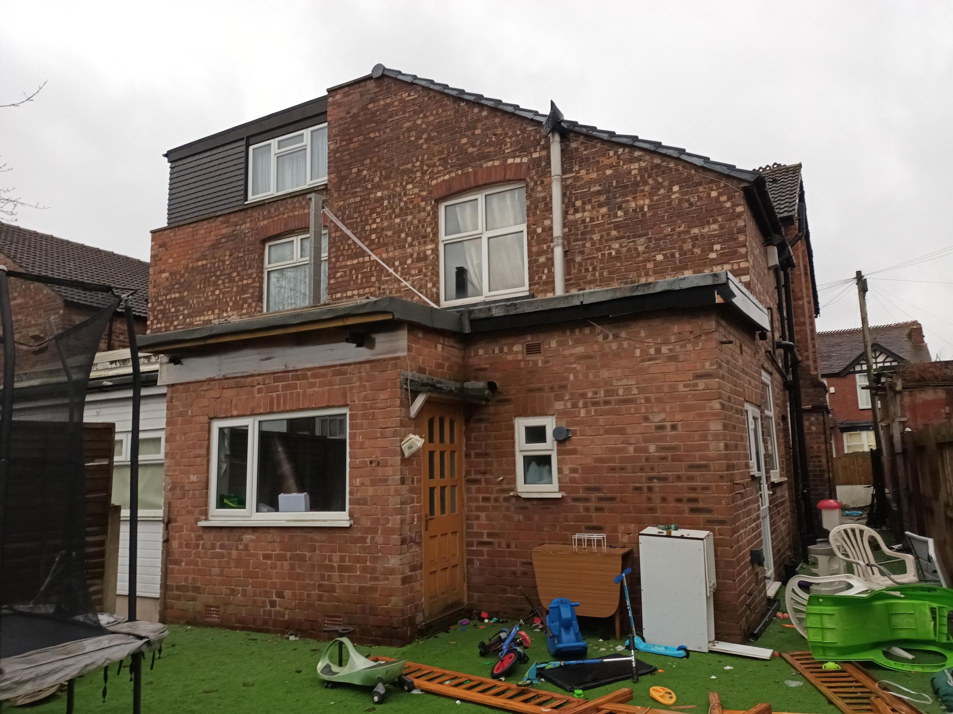
Figure 4 Rear boundary with school.
Figure 3 Rear of the property.
Description of Proposal

The proposal consists of a first-floor rear extension over part of the existing single storey extension, and a loft conversion with a front and rear dormer. The proposal would facilitate a laundry room to the first floor, with three additional bedrooms, an ensuite, and bathroom to the second floor. The application as submitted proposed two front dormers, however officers raised concerns that it would result in a cluttered, overdeveloped roofscape. The scheme was amended to remove one of the front dormers. The scheme was further amended to improve the materiality of the rear dormer.
- The first-floor rear extension would project 2.6m from the main rear elevation of the property, in line with part of the existing single storey extension below, and have a width of 2.8m. The proposal would have a pitched roof with asymmetrical eaves to tie into the eaves of the existing roofscape. The lower eaves would have a height of 5.2m, and the higher eaves would be 6m. The ridge height would be 6.3m.
- The front dormer would be situated 0.9m above the eaves height of the main roof form. The ridge of the dormer would be in line with the ridge height of the existing main roof. The front dormer would have a pitched roof, with a maximum height of 1.8m, and would have a maximum projection of 2.5m. The dormer would have a maximum width of 2m.
- The rear dormer would project a maximum of 8.2m from the ridge line, to be in line with the existing main rear elevation. It would have a maximum height of 2.9m, and a maximum width of 5.4m.
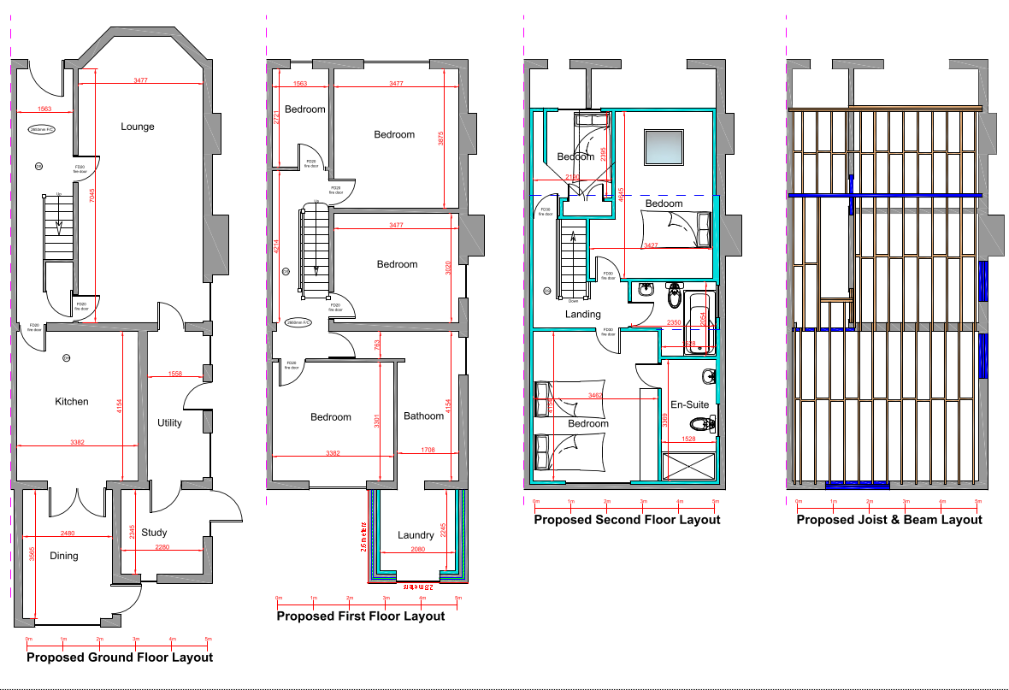

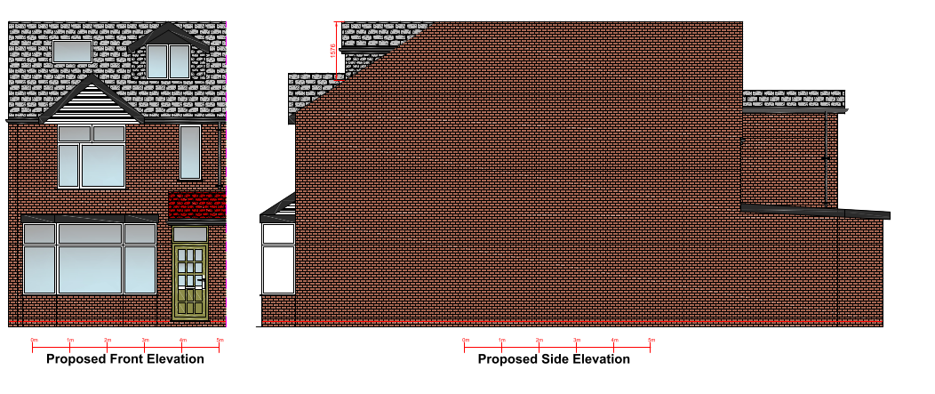
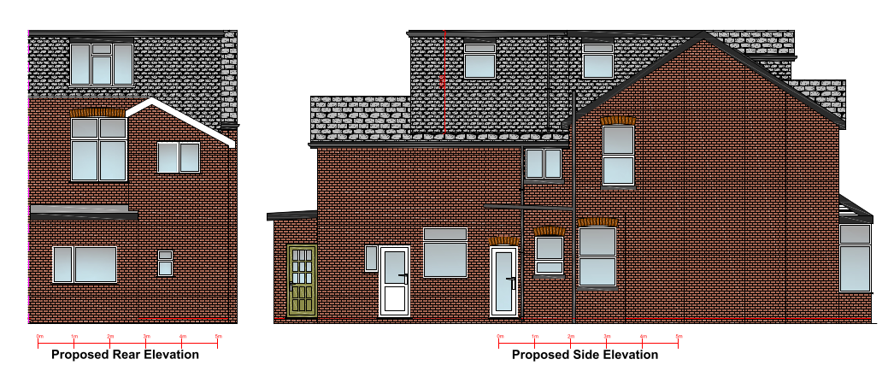

Relevant Planning History
Planning Applications
21/77432/HH - Householder planning permission
Decision: Approve - Sent: 8 July 2021
4 Granville Avenue, Salford, M7 4GD
Dormer loft conversion to the front and rear of the existing dwelling.
Publicity
Neighbours - Publicity Start Date - 13 November 2025

Neighbour Notification
Neighbouring properties have been notified of the application via letter. Representations that have been received, are detailed as below
The number of neighbouring properties notified – 13

Representations from neighbours and members of the public
No representations have been received.

Consultations
Not applicable.

Planning Policy
Salford Local Plan: Development Management Policies and Designations (SLP:DMP)
Policy D1 Design principles
Policy D2 Local character and distinctiveness
Policy D3 Layout and access
Policy D5 Amenity
Policy D8 Alterations and extensions

Other Material Planning Considerations
National
- National Planning Policy Framework
- National Planning Practice Guidance

Local Planning Policy and Development Framework/ Strategies
- Supplementary Planning Document – House Extensions (2006)

Local Finance Considerations
It is not considered that there are any local finance considerations that are material to the application.

Appraisal

Impact on the Character of the Area

- The front dormer would comply with Policy HE 10 of the House Extensions SPD: it would be sited below the roof ridge, set back from the eaves and not built off any external walls of the original house.
- The proposed front dormer would be visible from Granville Avenue. Whilst front dormers are not common among the dwellings along Granville Avenue, apart from the adjoining property, no.4, all have front gable features. Some have undergone roof alterations as set out in the above section. The dormer would be well-positioned within the roof plane having regard to the existing gable feature and would appear subservient to the main dwelling. Therefore, it is considered not to be significantly harmful to the character and appearance of the subject dwelling and the surrounding area.
- The second-floor rear extension has been designed with a flat roof. Originally the existing brick line of the gable to the rear was to be maintained, however, it was considered that the diagonal of hanging tiles with window dissecting the two caused the dormer to be read as an additional storey and would have an unacceptable visual impact. The proposal was amended to bring the hanging tiles down in level with the ridge of the first floor rear extension. This would create a visual break between the accommodation in the roof space and floors below, which lessens the visual impact of the large rear dormer. It is also noteworthy that the neighbours at no. 8 and no.4 have similar rear extensions. Accordingly, the second-floor rear extension is not considered to be an incongruous feature within this setting.
- Overall, the proposal is in accordance with D1, D2 and D8 of the SLP: DMP and H10 of the SPD: HE.

Impact on the Amenity of Neighbours

- The front dormer would be set 1.3m back from the front elevation of the main property where there are existing windows serving habitable rooms. Therefore, the proposed front dormer would not negatively impact the amenity of no. 1 and 3 any more than the existing arrangements.

- The side elevation of the property faces the side elevation of a synagogue. The proposal would not introduce any additional habitable windows to the side elevation. The windows which are proposed to be introduced serve bathrooms, where obscured glazing will be conditioned. Overall, the proposal would not result in any undue amenity issues to the synagogue to the side.

- To the rear of the property lies the playground of Toras Emes School. The rear facing window inserted within the rear dormer extension would not be closer to the rear boundary than the existing principal windows of habitable rooms in the rear elevation of the dwelling. The rear first floor extension would serve a laundry room, a non-habitable room and would be situated 6.5m from the rear boundary, in excess of the distance considered ‘close’ under policy HE2 of the SPD: HE. Therefore, it is not considered to generate any undue overlooking.

- The adjoining property no.4 is situated to the east of the site. The rear dormer would be in line with the existing rear dormer at no.4. The first-floor rear extension would project 2.6m from the main rear elevation. This is in line with policy HE 6 of the SPD: HE as the first floor does not project beyond the neighbour’s ground floor extension and the first floor does not project beyond a 45-degree line from a point 3m along the common boundary from the rear elevation of the adjoining dwelling.

- Overall, the proposal is considered acceptable in line with policy D5 of the SLP: DMP and the SPD: HE.

Does the proposal require works to trees?
No.
Is there a significant change in levels across the site or between the site and neighbouring land?
No.
Has the applicant/agent indicated any personal circumstances?
No.

Recommendation
Approve with Conditions

Document Approval
Report Author | Amelia Smith
Date | 12/01/2026
Reviewer | G Clegg
Date | 13/01/2026

