

Application Ref. | PA/2025/1577
Location | 137 Shakespeare Crescent, Eccles, Manchester, M30 0PE
Ward | Eccles Ward
Applicant | Mr Anthony Gosling
Proposal | Change of use of existing property from a dwelling house (use class C3) to a 3 bedroom, 3 person House in Multiple Occupation (HMO) (use class C4)
Recommendation | Approve with Conditions

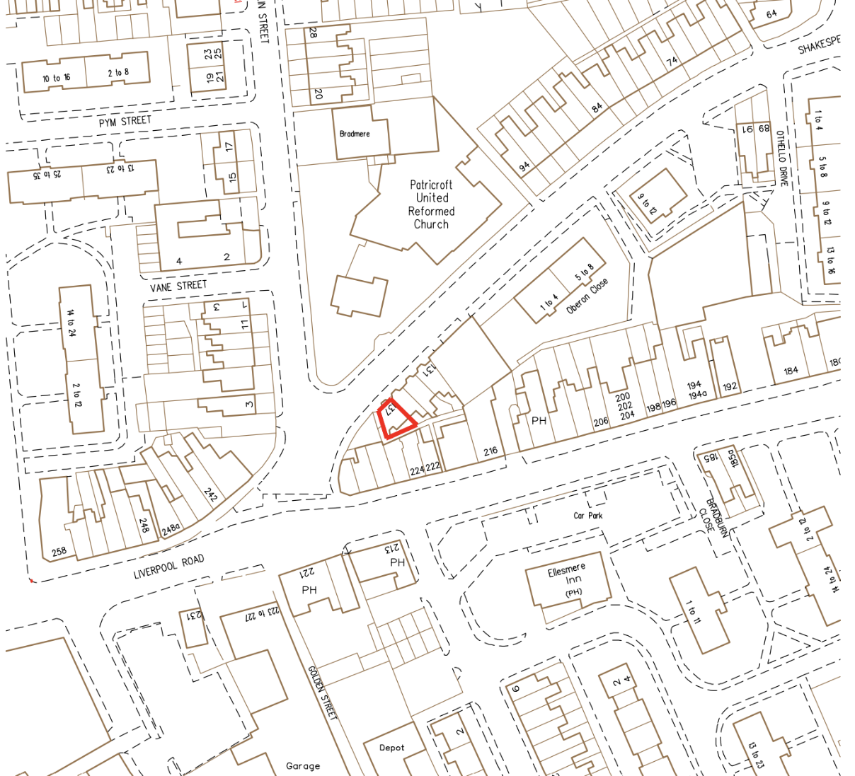
Location Plan

Description of Site and Surrounding Area

The application relates to a two storey, 3-bedroom end-terrace dwelling on the south side of Shakespeare Cresent in Eccles. The dwelling has been extended to the rear by a single storey.

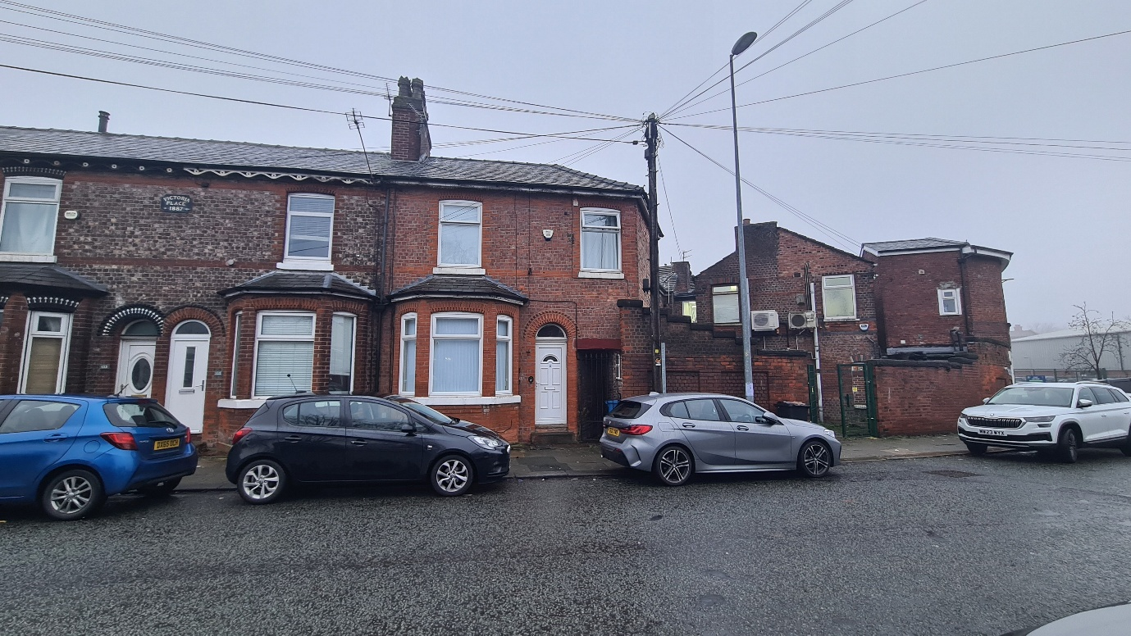
Description of Proposal

Planning permission is sought to change the use of the property from a dwelling (Use Class C3) to a 3-bed, 3-person House in Multiple Occupation (“HMO”) (Use Class C4).

The measurements for the internal floor area of each room to be considered against the HMO standards are shown below:

Ground floor
Bedroom 1: 11.76 m²
Kitchen: 9.36 m²
Lounge: 10.44m²

First floor
Bedroom 2: 9.49 m²
Bedroom 3: 9.37 m²
Bathroom: 7.85 m²
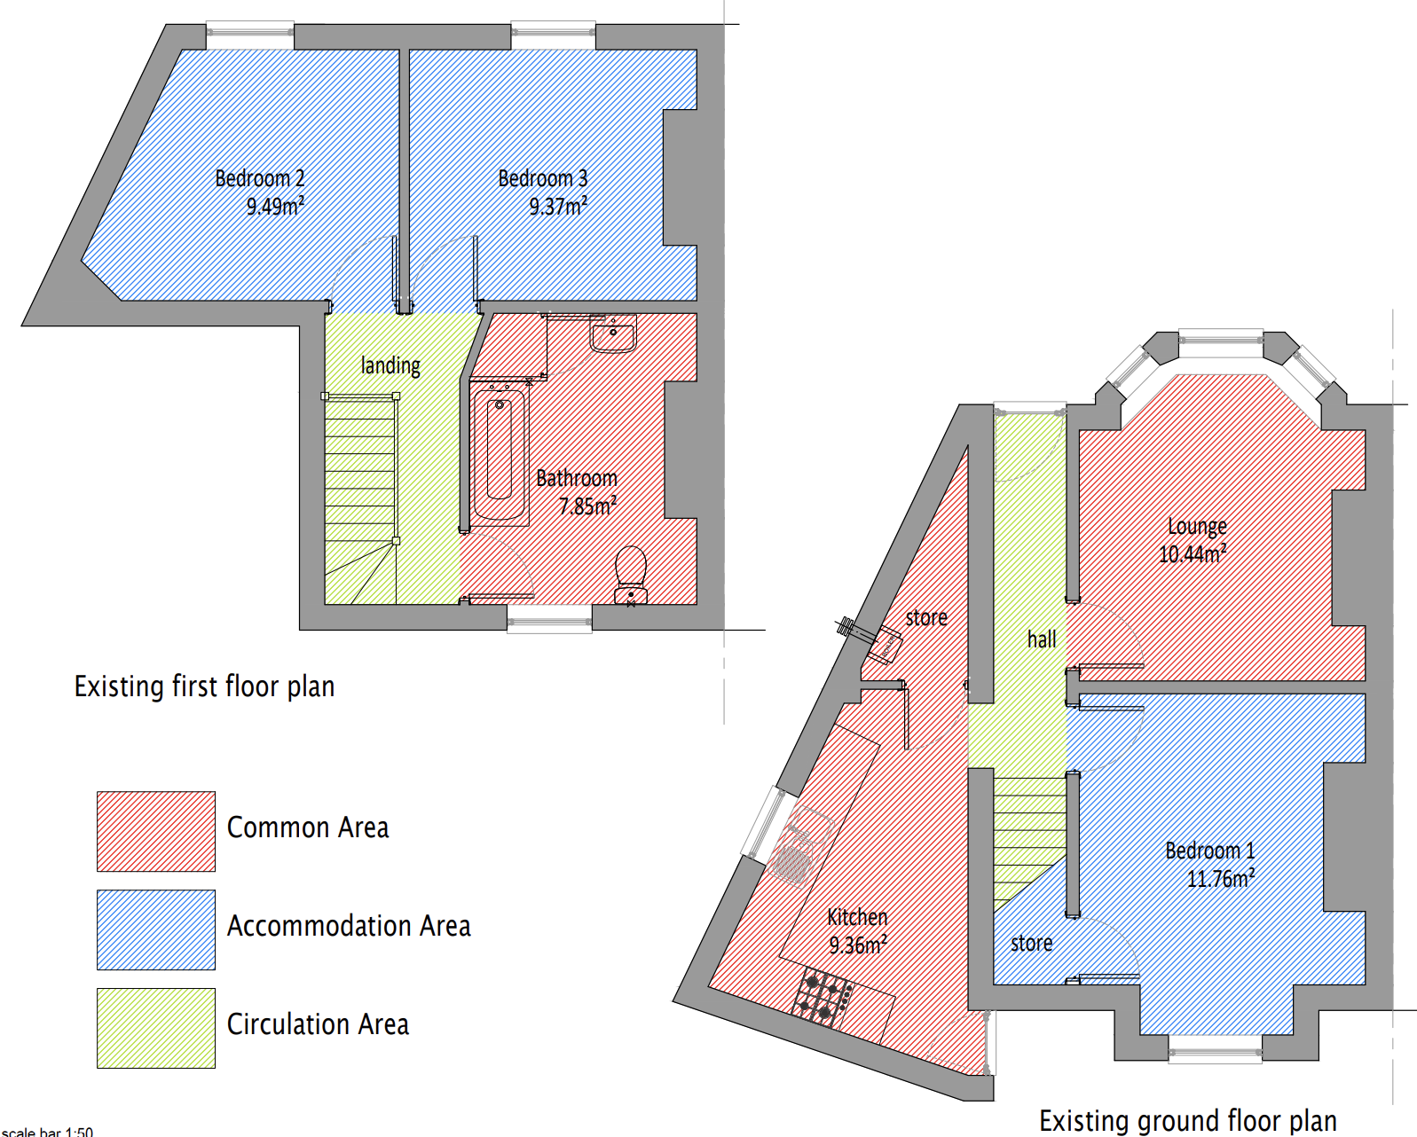

Relevant Planning History
None
Appeal Cases

Publicity
Neighbours - Publicity Start Date - 26 November 2025

Neighbour Notification
Neighbouring properties have been notified of the application via letter.
The number of neighbouring properties notified - 15
Representations from neighbours and members of the public
None
Consultations
Salford House in Multiple Occupation (HMO) Licensing Team (DM)
Summary – The proposal meet the requirements of a 3 person HMO
Salford Highways Officer (DM)
Summary – No objections
Planning Policy
Salford Local Plan: Development Management Policies and Designations (SLP:DMP)
Policy F1 An inclusive development process
Policy F2 Social value and inclusion
Policy F3 Inclusive places
Policy F4 Fairness between generations
Policy CC1 Climate Change
Policy EF1 Efficient use of land
Policy EF2 Co-ordinated development
Policy H1 Type of housing
Policy H2 Size of dwellings
Policy H10 Conversion and change of use of existing houses and new build residential developments of non-self-contained units
Policy HH1 Development and Health
Policy A3 Walking and cycling
Policy A6 Highway network
Policy A7 Motor vehicle parking provision and drop-off facilities in new developments
Policy WA5 Surface water and sustainable drainage
Policy D1 Design principles
Policy D2 Local character and distinctiveness
Policy D3 Layout and access
Policy D5 Amenity
Policy D6 Design and crime
Policy D7 Housing design
Policy D8 Alterations and extensions
Policy PH1 Pollution control
Policy WM1 Waste and development

Places for Everyone (PfE)
Policy JP-S1: Sustainable Development
Policy JP-H3: Type, Size and Design of New Housing
Policy JP-P1: Sustainable Places
Policy JP-C1: An Integrated Network
Policy JP-C6: Walking and Cycling
Policy JP-C8: Transport Requirements of New Development

Other Material Planning Considerations
National
- National Planning Policy Framework
- National Planning Practice Guidance

Local Planning Policy and Development Framework/ Strategies
- Houses in Multiple Occupation Supplementary Planning Document (June 2024) (updated January 2025)

Local Finance Considerations
It is not considered that there are any local finance considerations that are material to the application.

Appraisal

The site is located within one of the areas of the city where an Article 4 Direction came into effect on 25 November 2018. The Article 4 Direction was introduced in order to positively manage potential amenity and character impacts associated with HMOs and their concentrations, as well as to ensure that balanced communities are maintained within the city. This means that planning permission is required for the change of use of a dwellinghouse to a small HMO within this part of the city.

HMOs can make an important contribution to housing supply, generally providing low-cost private sector accommodation for those on lower incomes, students, and those seeking temporary accommodation. They are normally located in areas with good access to public transport (in particular bus routes) and local services. However, high concentrations of HMO accommodation can sometimes have a detrimental impact on local housing areas.

Policy H1 of the SLP:DMP states that individual new residential developments shall contribute to the provision of a broad mix of housing options across Salford and within the local area, ensuring that identified housing needs can be met.

Policy F3 of the SLP:DMP states that all places and developments shall be as inclusive as possible. Achieving this will involve a diverse mix of decent and adaptable homes, including affordable housing that enables everyone to meet their housing needs.

Proportion of HMOs in the area

Policy H10 of the SLP:DMP sets out how conversions and changes of use from existing dwellings to HMOs and other stated uses will be controlled to ensure that a good supply of houses is maintained within Salford and the positive character of neighbourhoods is protected.

Part 1 of Policy H10 of the SLP:DMP states that conversions to HMOs (amongst other uses listed) will only be permitted where it can be demonstrated that the proposal would not, either individually or cumulatively with other listed uses (including completed developments and schemes with planning permission or prior approval) have an unacceptable impact on the positive residential character of the surrounding neighbourhood, having particular regard to potential increases in noise and disturbance, on-street car parking, waste management and population turnover levels that could reduce community stability.

Part 3 of Policy H10 of the Local Plan also states that conversions to HMOs will only be permitted where it can be demonstrated that the proposal would not, either individually or cumulatively with other completed developments and schemes with planning permission or prior approval, result in any house that is in use as a single dwelling being immediately adjacent to more than one property in use as student housing, houses in multiple occupation, hotels, residential institutions, hostels, children’s homes and similar uses and non-residential uses such as offices.

For the avoidance of doubt, Policy H10 clarifies that for the purpose of this policy, immediately adjacent properties include properties directly behind and opposite, as well as to either side.

The Council has adopted the Houses in Multiple Occupation Supplementary Planning Document (the “HMO SPD”) which has been produced to better manage the provision of new HMOs throughout Salford by providing a threshold to guide the distribution/location of them. Policy HMO1 within the HMO SPD states that planning permission will not normally be granted for new HMOs, or for proposals to extend existing HMOs that would increase the number of bedrooms within it, where:

- the proportion of HMOs already exceeds 10% of all residential properties within a 100-metre radius of the application property; or

- the proportion of HMOs would exceed 10% of all residential properties within a 100-metre radius of the application property as a result of a proposed new HMO.

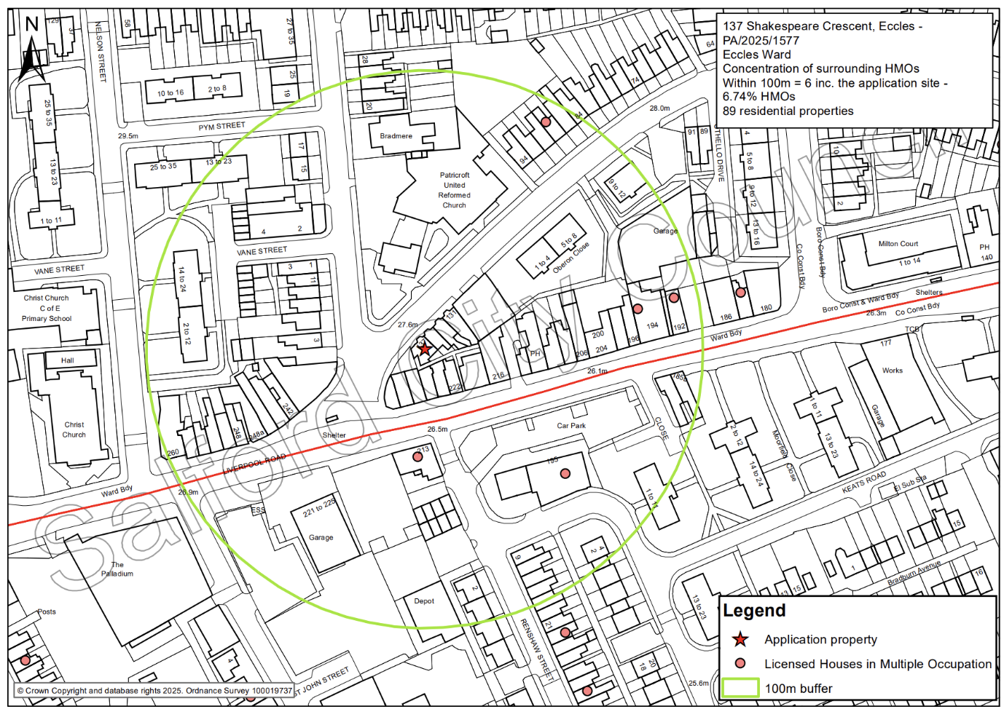
The figure below shows the distribution of existing HMOs in the immediate area. The application property would be one of several HMOs within a 100m radius, but the concentration would overall remain below the 10% threshold (at 6.74%), in accordance with Policy HMO1 of the HMO SPD.

It is clear from the above that the site’s use as an HMO would not contribute to an overconcentration in this part of the city, as per Policy HMO1. For this reason and given the proposed HMO could make a positive contribution towards meeting the housing needs of those requiring lower cost accommodation, the principle of the change of use to provide a 3 person HMO is considered to be acceptable with the proposal making a positive contribution to the mix of housing types in this part of the city. The loss of a family dwelling is acknowledged; however, it is not considered that the loss of one unit would have an unacceptable adverse impact on the overall mix of dwellings in the area or the supply of family housing in the vicinity of the site.

Residential Amenity – Neighbours

The use of the application property as an HMO would result in a single dwelling being immediately adjacent to more than one property in use as an HMO or other non-residential use. No. 135 Shakespeare Crescent adjoins the application property and is directly adjacent to no. 222 Liverpool Road to the south (a commercial use) and opposite from the Church of God in Manchester to the north. However, given the separation of this neighbour from the church site which has a long frontage and an extensive curtilage and has its car park off Franklin St (away from this neighbour) and that 222 Liverpool Road is a mixed commercial use (carpet shop) with 2 flats above and appears to be served from the main road with any access or activity limited at the rear, the overall impact by way of noise and disturbance on this neighbour is considered minimal. Furthermore the proposed HMO is limited in size/occupancy with many similarities with the existing C3 use in terms of layout and bedrooms. In combination whilst a technical adjacency trigger can be established the harm arising is very limited or immaterial.
There will be a level of noise and disturbance associated with the future occupants as they go about their daily business independently, moving to and from the property and as they use the building and the outdoor space.

The HMO would have 3 bedrooms (restricted to a maximum of 3 occupants) and it is understood that the current use is as a 3 bedroom dwelling (based on the submitted existing floor plans). As such the change of use is not necessarily considered to result in a notable increase in the number of people occupying the property than could have been feasible previously as a family dwelling.

Residential Amenity – future occupiers

The NPPF, at Paragraph 135, requires development to achieve a 'high standard’ of amenity for existing and future users. Policy F3 of the SLP:DMP seeks to deliver a diverse mix of decent and adaptable homes and Policy D5 seeks to ensure that development provides all potential users with an acceptable level of amenity.

The Council’s Standards for houses in multiple occupation document offers guidance to landlords on the physical standards that are required for licensing purposes including minimum room sizes, bathroom and kitchen facilities and fire safety provision. Whilst this document does not form part of the development plan, Local Plan Policy H2 confirms that all HMOs shall meet the minimum room size and amenity standards set out in this document.

The property has a small rear courtyard, but is also within walking distance of local parks – the closest being Cromwell field, located circa 170m northeast of the site, and Ivy Street Recreation Ground, c. 330m south - which would provide additional amenity benefits to occupants.

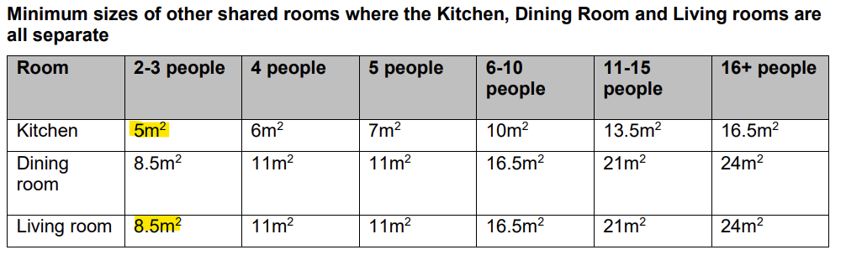
All habitable rooms within the property would be served by adequately sized and sited windows, and the occupants would have access to a communal kitchen and lounge. According to the Council’s Standards for houses in multiple occupation document, the following relevant space standards are required to be met:

When assessing the suitability of an HMO with regards to space standards, officers make a recommendation by assessing the HMO as a whole and the potential use of the space provided. When considering the requirements, the minimum floor space for a kitchen is 5m² for 3 occupants. Only one of the bedrooms exceeds or is at least 10m², as such there is a requirement for a living room in addition to a kitchen, dining or kitchen / dining room. The existing / proposed lounge measures 11.76m², which exceeds the minimum requirement of 8.5 m².

Whilst outlook from bedroom 1 would be poor owing to the small rear yard to which is faces, officers accept that this would be no different to the existing arrangement and that it would not be possible to improve this bedrooms outlook given its ground floor location. Overall. officers are satisfied that the rooms would provide a satisfactory amount space and amenity for occupants and raise no objections in this regard.

In view of the above it is therefore considered that the proposed development would provide appropriate living conditions for the future occupiers, with regard to satisfactory outlook, adequate space and daylight received. The proposal is therefore considered compliant with Policies HH1, H2 and D5 of the SLP:DMP.

Parking and Highway Safety

The site is sustainably located; within walking distance to Liverpool Road which offers regular bus services to Bolton, the Trafford Centre and Manchester City Centre.

No on-site parking is available as part of the development. However, there is unrestricted on-street parking available along Shakespeare Crescent and the surrounding roads.

Officers acknowledge that a change of use from a 3 bedroom dwelling to a 3-bedroom HMO could result in additional on-street parking demand, however, any impact that does occur as a consequence of the change of use would not have an unacceptable impact on highway safety or the residual cumulative impact on the road network, as per Policy A7 of the SLP:DMP.

In accordance with paragraph 116 of the NPPF: Development should only be prevented or refused on highways grounds if there would be an unacceptable impact on highway safety, or the residual cumulative impacts on the road network, following mitigation, would be severe, taking into account all reasonable future scenarios.

For these reasons it is not considered that the use of the property would have an unacceptable adverse impact upon highway safety in accordance with Policies A6 and A7 of the SLP:DMP.

Cycle and Bin Storage

In terms of bin storage, it is not considered that the use of the property would significantly intensify the need for extra provision, with the property having a suitably proportioned rear yard and side alley that can be used to store the necessary bins, as per Policy WM1 of the SLP:DMP.

In terms of cycle storage, the Council’s parking standards require at least 1 secure cycle parking space per 2 bedrooms for an HMO. The applicant has not indicated where cycle storage is to be provided, however it is not considered that it would be necessary to provide cycle storage given the constraints of the site which would make it difficult to erect any such store within the curtilage of the property without compromising the amenity of its occupants or the ability to transport bins.

Recommendation
Approve with Conditions

Document Approval
Report Author | Aslan Saylam
Date | 19.01.2026
Reviewer | M Hodgson
Date | 20.01.2026

