

Application Ref. | PA/2025/1642
Location | 19 Greenacre Lane, WORSLEY, MANCHESTER, M28 2PQ
Ward | Worsley and Westwood Park Ward
Applicant | Ms Kayleigh Coverdale
Proposal | Erection of a two storey side extension and single storey side/ rear extension
Recommendation | Approve with Conditions

Location Plan

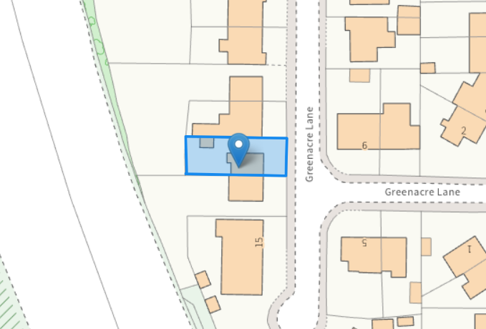

Description of Site and Surrounding Area

This application relates to a two storey semi-detached dwelling located on Greenacre Lane with predominantly semi-detached properties within the vicinity of the site. Trees are located to the rear of the site; however, they are not protected by a Tree Preservation Order (TPO) and are positioned well away from the proposed development, with the M60 situated beyond them.

Description of Proposal

A two storey side extension and single storey side/rear extension is proposed and would project 2.5m from the main side elevation, the ground floor of the side extension is in line with the main front elevation and the first floor is set in by 2m from the main front elevation and in line with the main rear elevation of the dwellinghouse.

The single storey side/rear element would project a maximum of 2.7m from the main rear elevation of the dwellinghouse with a stepped rear elevation.

The two storey element would feature a hipped roof structure, the eaves height would match the existing eaves level and the ridge would be set at a lower height as the main roof ridge. The single storey elements would feature a mono-pitched roof to the front and a mono-pitched roof combined with a pitched roof at the rear.

Proposed Floor Plans & Elevations

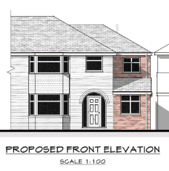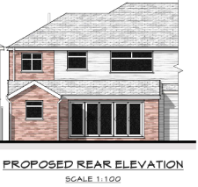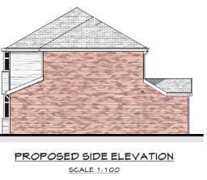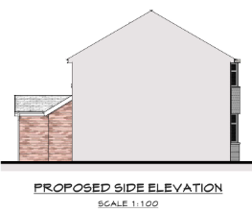

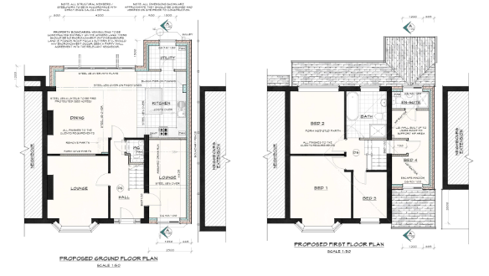
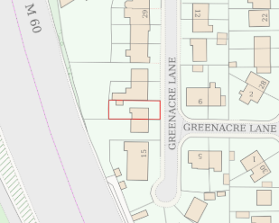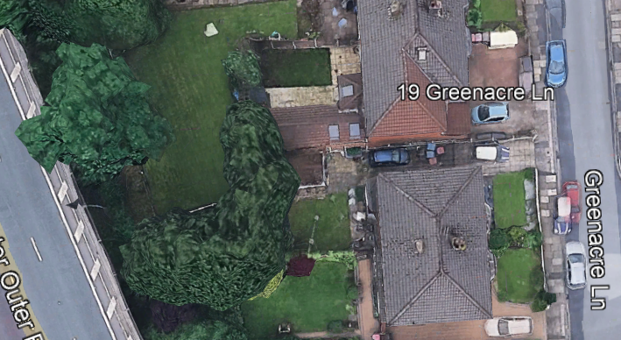

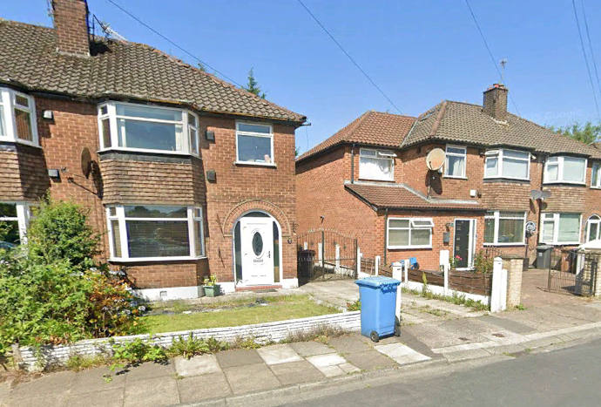

Relevant Planning History

No Planning history

Publicity
Neighbours - Publicity Start Date - 4 December 2025
Neighbour Notification
4 Neighbouring properties have been notified of the application via letter. No representations that have been received,

Consultations

N/A

Planning Policy
Salford Local Plan: Development Management Policies and Designations (SLP:DMP)
Policy A6 Highway network
Policy D1 Design principles
Policy D2 Local character and distinctiveness
Policy D3 Layout and access
Policy D5 Amenity
Policy D8 Alterations and extensions
Policy WM1 Waste and development

Other Material Planning Considerations
National
- National Planning Policy Framework
- National Planning Practice Guidance

Local Planning Policy and Development Framework/ Strategies
- Supplementary Planning Document – House Extensions (2006)

Local Finance Considerations
It is not considered that there are any local finance considerations that are material to the application.

Appraisal
Impact on the Character of the Area

The proposal is sited close to the shared common boundary with the adjacent property No.21 Greenacre Lane and would be set back at first floor from the main front elevation of the house by 2m. As such, there is no terracing effect occurring.
The refuse bins (currently stored at the side of the house) would have to be positioned to the front of the property. A condition is imposed to ensure a suitably designed bin store is provided given the relatively open frontage.

On this basis, it is considered the scale, massing, roof form and fenestration detailing is appropriate, and the extension would appear as a subordinate addition against the host dwelling whilst using materials to match. On this basis, it is considered that the proposal is considered acceptable in relation to its impact on the character of the area. in accordance with Policies D1, D2, D8 and WM1 of the SLP:DMP and Policy HE8 cited within the House Extensions SPD.

Impact on the Amenity of Neighbours

As the side extension does not project beyond the parent dwelling from the front it would not introduce any significant additional overlooking to the house/garden to the front set at a right angle to the application site.

The proposal would be set away from the shared common boundary with the adjacent property No.21 Greenacre Lane by 0.4m. No openings are proposed in the side elevation of the extension. It is noted No.21 also have a two storey and single storey side / rear extension with a blank side elevation with principal windows serving habitable rooms in the front and rear elevation of their dwellinghouse.

In addition to the above No.21’s extension is constructed along the shared common boundary with the host dwelling. The proposed development would not project further that No.21’s side / rear extension protecting their residential amenity.
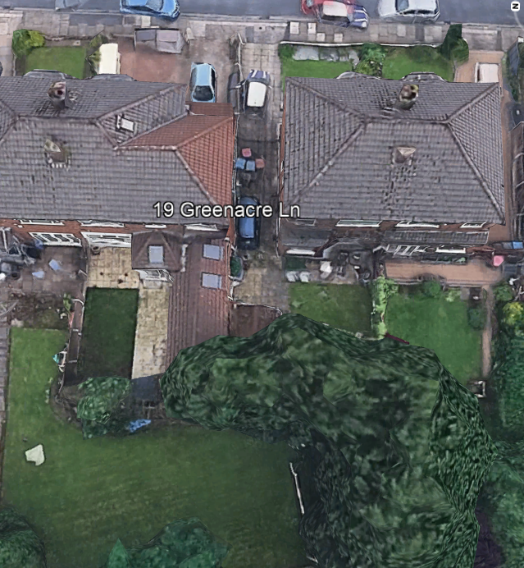

To the other side, the rearward extension sited along the shared common boundary with the adjoining property No.17 Greenacre Lane would not encroach beyond a line drawn at 45 degrees at a point 3m along the common boundary with No.19. It is considered that the extension would not result in an unacceptable loss of daylight and/or sunlight, be overbearing or create undue overshadowing to neighbouring residents complying with Policy HE5 of the SPD and Policy D5 of the SLP:DMP.
There are no residential properties beyond the rear site boundary that the development could affect.

The development does not therefore cause any undue harm to the amenity of the users and amenity or privacy of the neighbouring users and is in line with Policy D5 of the SLP:DMP, SPD and the NPPF.

Impact on the Highway Network

The development would increase in the number of bedrooms from a 3 bed to a 4 bed and would result in the loss of a vehicle parking space to the side of the dwellinghouse however the existing hardstanding would remain to the front. This is considered sufficient to accommodate at least 1 vehicle as well as unrestricted on-street parking in the wider area. Therefore, the development would not result in an unacceptable impact on the highway network.

Other Issues

Does the proposal require works to trees?
No
Is there a significant change in levels across the site or between the site and neighbouring land?
No
Has the applicant/agent indicated any personal circumstances?
No

Recommendation
Approve with Conditions

Document Approval
Report Author | R.Sharma
Date | 22/01/2026
Reviewer | A Stephenson
Date | 22.1.26

