- Executive Summary:
Central YMCA has made an application to Salford Planning Authority to seek change of planning use (Reference NOT/2025/1218) for Unit 4 Worsley Court from Office Space to Education.

That application has been marked as invalid as Central YMCA is required by the planning authority to address noise and transport concerns.
In summary:
- We are only trying to regularise our current use of the site under a licence so that we can commit to a longer-term (5 year) lease on the building.
- No development or construction works are proposed with the layout of the offices already suitable as classrooms for 16-19 year olds, our target learners.
- In the academic year ending July 2026 and future years, we only expect around 45 learners to be taught at the site.
- Most of these learners are local [define] and are expected either to walk or take public transport to site.
- The classroom subject matter is only theoretical with any practical work delivered off site.
- We can see no significant adverse impact on transport or the local noise environment.

Background:
Central YMCA (Central Young Men’s Christian Association Ltd, a limited company registered in England no.119249.) is a registered charity (213121), and part of the international YMCA movement.
The Central YMCA has several operating units including its Study Programme unit. This operation provides educational services to 16-19 years olds that have typically fallen out of mainstream education and provides them with a new opportunity to achieve qualifications.
The education provision we provide includes:
- Level 1 & Level 2 Horticulture Studies
  - City & Guilds Level 1 and Level 2 Horticulture qualifications that focus on developing practical skills and knowledge for working in the horticulture industry or for personal gardening. Level 1 covers foundational skills like preparing soil, planting, basic propagation, and plant care. Level 2 builds on this, introducing more advanced techniques like pruning, specialized planting, and understanding plant health.
- Level 1 Occupational Studies
  - The NCFE Level 1 Occupational Studies course offers a broad introduction to various workplace skills and vocational areas. It covers topics like health and safety, teamwork, problem-solving, and exploring career options. Additionally, it can provide a foundation for specific industries like childcare or logistics, with units focusing on areas like food hygiene, basic cooking, or handling good all with transferable skills into the vocation of the learner’s choice
- English & Maths
  - We offer of Functional Skills from Entry Level to Level 2 subject to learners prior learning. If Learner does not have a Grade 3, GCSE is offered.
None of our educational services are residential and unlike many other YMCAs, the Central YMCA does not provide any residential services and has no plans to do so.
Central YMCA’s Study Programme business operates across England out of a number of partner sites and our own dedicated premises at:
- Doncaster
- Two sites in Leeds
- Manchester
Until April 2025 our Manchester services were provided out of a building located in Walkden at the Walkden Community Hub CIC, 25 Holyoake Road, Walkden, M28 3DL. We encountered many issues with that building and took the decision to vacate in early 2025.
Since April 2025, our Manchester services have been provided out of 4 Worsley Court, Walken, M28 3NJ. Our occupation of that building is via a licence with the landlord. We would like to take a longer-term commitment on that building but understand that the Permitted Use for planning purpose of that building is as office space E (g)(i) and not for Educational Purposes (F).
In the academic year ending 31st July 2026, we are planning to enrol around 45 students at Worsley Court. This amounts to 5% of our national intake.
Central YMCA has made an application to Salford Planning Authority to seek change of planning use (Reference NOT/2025/1218).
That application has been marked as invalid as Central YMCA is required to address noise and transport concerns. This document attempts to address those concerns.

The Building
Number 4 Worsley Court is located on the north side of High Street (A6) close to its junction with Bolton Road (A575) in Walkden Town Centre. The property is within close proximity to Walkden Shopping Precinct and includes a large range of shops and places to eat. Walkden Train station is approximately 0.5 mile southeast of the subject property. Junction 14 of the M60 motorway is approximately 1 mile southeast. Walkden is situated 7 miles northwest of Manchester City Centre.
The property comprises refurbished office space within Worsley Court – a purpose-built office premises of brick construction beneath a pitched slate roof. The accommodation is arranged over ground, first and second floors each of around 1,000 square foot each. (3,000 square feet in total). The property has kitchen and toilet facilities [On each floor?]
How many rooms are there on each floor?
There are three car parking spaces provided with the property and further parking in the surrounding car parks.
Photos of the property are provided in Appendix 1.
Under the terms of our licence for occupation, Central YMCA cannot make any alterations to the building without the express permission of the Licensor and agreement of a Licence to alter.
Under the proposed terms of the lease for the building, Central YMCA may not make any structural alterations or additions to the property and may not make any other alterations unless with the Landlord's consent in writing.
Notwithstanding these conditions, Central YMCA has no plans to make any structural changes to the building or any alterations that would require landlord consent.
This is because the property is spread over three floors with each floor providing good space to be set up as a classroom rather than a traditional office.
[Can we get some photos of how it is set up]

How we plan to use the building
As already stated, around 45 students are planned to be enrolled at the site in the academic year ending July 2026 with similar numbers envisaged for future years.
Typical class sizes are between [X & Y] students with one teacher per class.
Classes are around [X hours] in duration and are timetabled between 0830 and 1630 Monday to Friday. There are no classes at weekends.
Typically, a student would spend around [X hours] in class per week coming to site on [X] number of days.
At anyone time a maximum of X students and Y teachers would be on site.
No students are allowed on site without the presence of a teacher.

Comparison to use as office space
The building currently has a permitted use as Office space, Typically, one would expect up to 10 office workers for 1,000 square feet of space meaning that the entire building (3,000 square feet) could accommodate up to 30 workers.
[Compare this to the maximum on site?]

- Noise Impact Assessment:

Impact upon our staff and learners of proposed use of the building
- 4 Worsley Court has previously been used successfully as office space. Although it is an urban environment, the property is double glazed and our site visits by our Education and Facilities manager assessed the property as a good classroom environment.
- This has been confirmed by our initial use of the property for teaching under our licence.
- In our opinion, the property makes good classroom space where the student are not distracted or exposed to excessive urban noise.

Impact upon of our plans on the local noise environment
- Our planned use of the building does not require any structural or alterations to the fabric of the building. Therefore, there will not be any construction noise to impact the local environment.
- Although the planned use is for Education, this is not for young children but 16–19-year-old young people. The classes taught are theoretical classes only with no noisy practical classes (where these are required e.g. Horticulture these are done off site at alternative suitable locations).
- The 16-19 year olds do not congregate in a ‘playground’ like younger children might and so there is not the risk of noise associated with play and lunchtime at institutions for younger children.
- We have not taken any Noise and / or vibration Surveys and do not believe that the noise / vibration assessment criteria to relevant British Standard are relevant in this case as we are not undertaking any construction activities.
- It is our assessment that the requested change of permitted use from Office Space to Education will have negligible impact on the local noise environment.

Transport Statement
The transport impacts of using 4 Worsley Court as classrooms and not office space are not significant and will not lead to a substantive change in journeys.

Site Access:
- The site already has good road and pedestrian access.
- The site includes 3 dedicated parking spaces for our staff. Further car parking is available at Walkden Gateway less than six minutes’ walk away.
- The site is 8 minutes’ walk from Walkden train station which is served by 4 trains an hour in either direction.
- Walkden is also well served by Manchester’s extensive bus network with lines 20,29, 36,37 and 994 all passing close to the centre.
- Cycle parking?

Getting to site:
Tutors:
- Given that they often take materials and equipment home with them, it is more than likely that our teaching staff will drive to site and use the parking available. With no more than [X] tutors on site at anyone time there is sufficient parking on site.
Learners:
- Our learners are aged between 16-19 years old and therefore many are too young to drive. Many are also from poorer socioeconomic backgrounds and we typically find car ownership amongst our learner population to be very low.
- Enrolment of learners is typically from the local area and the majority will either walk, or take local public transport. [Can we say anymore about this?]
- With around 45 students most of whom will be on site no more than X times per week, this only generates, Y number of new trips per week during term time.

Conclusion
We are excited about the opportunity that 4 Worsley Court offers for our young learners to achieve qualifications and get the start in life that they may not have been afforded my mainstream education.
Whilst we are currently occupying the site under a licence, we seek the planning authorities support for a change of permitted planning use from Office Space E (g)(i) and not for Educational Purposes (F).
Securing the change of permitted planning use would allow us to commit to a five-year lease with the landlord and give around 45 sixteen to nineteen year olds every year a chance to secure meaningful qualifications.
We are confident that this would be achieved with no discernible impact upon the local noise environment or transport infrastructure.

Appendix 1: Photos of the site
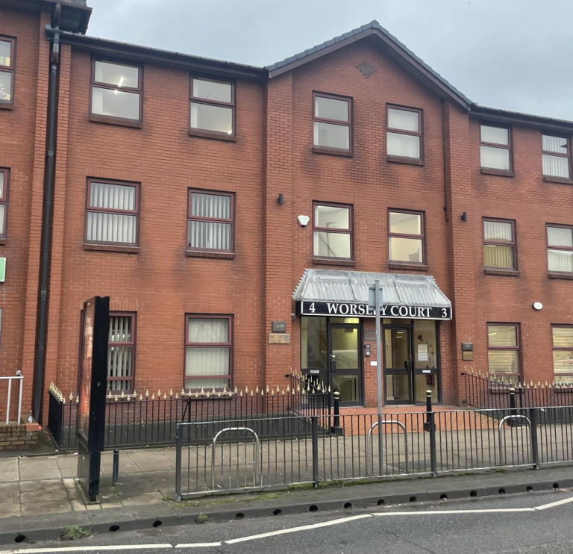
Figure 1: Front view

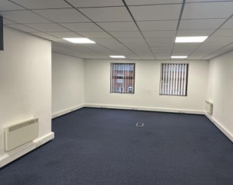
Figure 2: office space
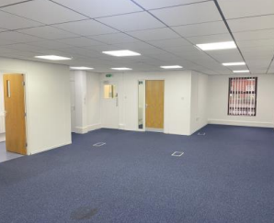
Figure 3: Office space
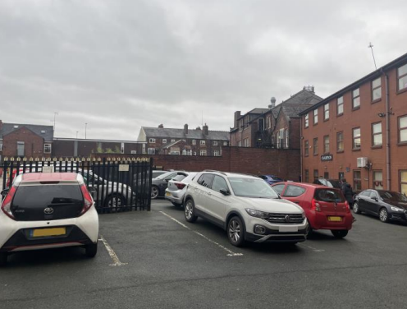
Figure 4: Building rear and car park

