

Application Ref. | PA/2025/1719
Location | 90 Wellington Road, ECCLES, MANCHESTER, M30 9GW
Ward | Eccles Ward
Applicant | Mr. Mark Tyldesley
Proposal | Change of use from existing 6 bedroom House in Multiple Occupation (HMO) (use class C4) to 7 bedroom HMO (sui generis) with 9 residents
Recommendation | Approve with Conditions

Location Plan
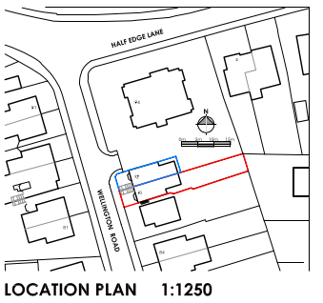

Description of Site and Surrounding Area
The application site relates to a large three-storey, with a basement, semi-detached property, located to the east of Wellington Road. The property has an area of hardstanding to the front and a private garden to the rear. The application site is located within a predominantly residential area, with a hotel located within close proximity to the application site, to the north east of the rear garden, facing Half Edge Lane.

Description of Proposal
The application is for the change of use of the property from a small house in multiple occupation (HMO) (Use Class C4), to a larger HMO for 9 occupants (Sui Generis). The description of development has been amended since the original submission, following comments from the Council’s HMO Licensing Team. There are no proposed external alterations.

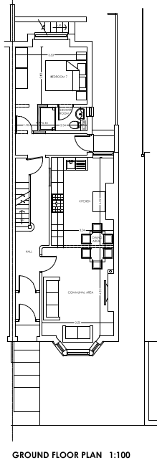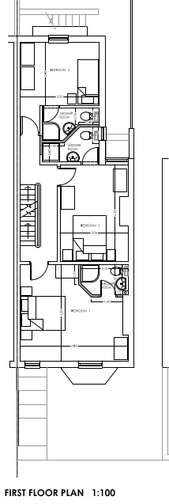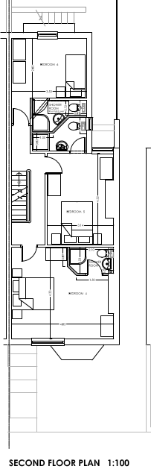

Ground floor
Bedroom 7: 10.6m²
Kitchen/dining/living room: 28.5m²

First floor
Bedroom 1: 17.3m²
Bedroom 2: 12.6m²
Bedroom 3: 9.9m²

Second floor
Bedroom 4: 17.5m²
Bedroom 5: 12.8m²
Bedroom 6: 9.9m²

Each of the bedrooms would have an en-suite.

Relevant Planning History
None relevant
Publicity
Neighbours - Publicity Start Date - 16 December 2025
Neighbour Notification
Neighbouring properties have been notified of the application via letter.
The number of neighbouring properties notified - 14
Representations from neighbours and members of the public
Comments of Support - 0
Comments of Objection - 0
Other Representations - 1

Summary of comments received:
- No objections in principle
- Concerns raised of lack of parking and nearby parking restrictions which further impact parking capacity.

Consultations
Salford Environment Officer (DM)
Summary – No objections or observations with respect to air quality, noise or land contamination.
Salford Highways Officer (DM)
Summary – No objections. Comments are discussed in the appraisal below.
Salford House in Multiple Occupation (HMO) Licensing Team (DM)
Summary - The property meets the space standards for a 7-bedroom HMO. The plans state some rooms will be used as double bedrooms. The only bedroom that would be suitable as a double is bedroom 1 and 4. The property is suitable as a 7-bedroom, 9 person HMO.
Planning Policy
Salford Local Plan: Development Management Policies and Designations (SLP:DMP)
Policy F1 An inclusive development process
Policy F2 Social value and inclusion
Policy F3 Inclusive places
Policy F4 Fairness between generations
Policy CC1 Climate change
Policy EF1 Efficient use of land
Policy EF2 Co-ordinated development
Policy H1 Type of housing
Policy H2 Size of dwellings
Policy H3 Housing density
Policy H4 Affordable Housing
Policy H5 Build to Rent
Policy H10 Conversion and change of use of existing houses and new build residential developments of non-self-contained units
Policy HH1 Development and Health
Policy A3 Walking and cycling
Policy A4 Public transport
Policy A6 Highway network
Policy D1 Design principles
Policy D2 Local character and distinctiveness
Policy D5 Amenity
Policy D8 Alterations and extensions
Policy PH1 Pollution control
Policy WM1 Waste and development

Places for Everyone (PfE)
Policy JP-S1: Sustainable Development
Policy JP-H3: Type, Size and Design of New Housing
Policy JP-P1: Sustainable Places
Policy JP-C1: An Integrated Network
Policy JP-C6: Walking and Cycling
Policy JP-C8: Transport Requirements of New Development

Other Material Planning Considerations
National
- National Planning Policy Framework
- National Planning Practice Guidance

Local Planning Policy and Development Framework/ Strategies
- Houses in Multiple Occupation Supplementary Planning Document (June 2024) (updated January 2025)

Local Finance Considerations
It is not considered that there are any local finance considerations that are material to the application.

Appraisal
Principle
The NPPF advocates a presumption in favour of sustainable development. It is the role of the planning system to support strong, vibrant and healthy communities by providing the supply of housing needed to meet the needs of present and future generations and by creating a high-quality built environment with accessible local services that reflect the community’s needs and support its health, social and cultural wellbeing.

It is recognised that HMOs can make an important contribution to the housing supply, generally providing low-cost private sector accommodation for those on low incomes, students, and those seeking temporary accommodation. However, where there is a high proportion of HMOs clustered in one area, harmful impacts associated with this housing type can occur. These can involve a more intense use of dwellings that may increase noise pollution or car parking demands, they can increase pressures on local services, and they can impact on social cohesion given that they often have a higher turnover of residents and therefore a more transient population.

Policy H1 of the SLP: DMP states that individual new residential developments shall contribute to the provision of a broad mix of housing options across Salford and within the local area, ensuring that identified housing needs can be met.

Policy F3 of the SLP: DMP states that all places and developments shall be as inclusive as possible. Achieving this will involve a diverse mix of decent and adaptable homes, including affordable housing that enables everyone to meet their housing needs.

Proportion of HMOs in the area
Policy H10 of the SLP:DMP sets out how conversions and changes of use from existing dwellings to HMOs and other stated uses will be controlled to ensure that a good supply of houses is maintained within Salford and the positive character of neighbourhoods is protected. It is noted that Policy H10 is not directly applicable to this proposed development, as it only applies to the conversion of existing dwellings, and the application property is currently in use as a HMO however, the principles of Policy H10 are still considered relevant.

Part 1 of Policy H10 of the SLP:DMP states that conversions to HMOs (amongst other uses listed) will only be permitted where it can be demonstrated that the proposal would not, either individually or cumulatively with other listed uses (including completed developments and schemes with planning permission or prior approval) have an unacceptable impact on the positive residential character of the surrounding neighbourhood, having particular regard to potential increases in noise and disturbance, on-street car parking, waste management and population turnover levels that could reduce community stability.

Part 3 of Policy H10 of the Local Plan also states that conversions to HMOs will only be permitted where it can be demonstrated that the proposal would not, either individually or cumulatively with other completed developments and schemes with planning permission or prior approval, result in any house that is in use as a single dwelling being immediately adjacent to more than one property in use as student housing, houses in multiple occupation, hotels, residential institutions, hostels, children’s homes and similar uses and non-residential uses such as offices. For the avoidance of doubt, Policy H10 clarifies that for the purpose of this policy, immediately adjacent properties include properties directly behind and opposite, as well as to either side.

The proposal involves the conversion of an existing HMO and therefore whilst Policy H10 is not directly relevant, the proposal would in any case not result in any house that is in use as a single dwelling being immediately adjacent to more than one property in uses as defined within points B-G of Policy H10 of the Local Plan.

The Council has adopted the Houses in Multiple Occupation Supplementary Planning Document (the “HMO: SPD”) which has been produced to better manage the provision of new HMOs throughout Salford by providing a threshold to guide the distribution/location of them. Policy HMO1 within the HMO SPD states that planning permission will not normally be granted for new HMOs, or for proposals to extend existing HMOs that would increase the number of bedrooms within it, where: A) the proportion of HMOs already exceeds 10% of all residential properties within a 100-metre radius of the application property; or B) the proportion of HMOs would exceed 10% of all residential properties within a 100-metre radius of the application property as a result of a proposed new HMO.

The figure below provides a view of the existing HMOs in the immediate area. The proposal would not lead to an over-concentration of HMOs, with the total number of HMOs within a 100m radius below the 10% threshold (1.69%), in accordance with Policy HMO1 of the HMO SPD.

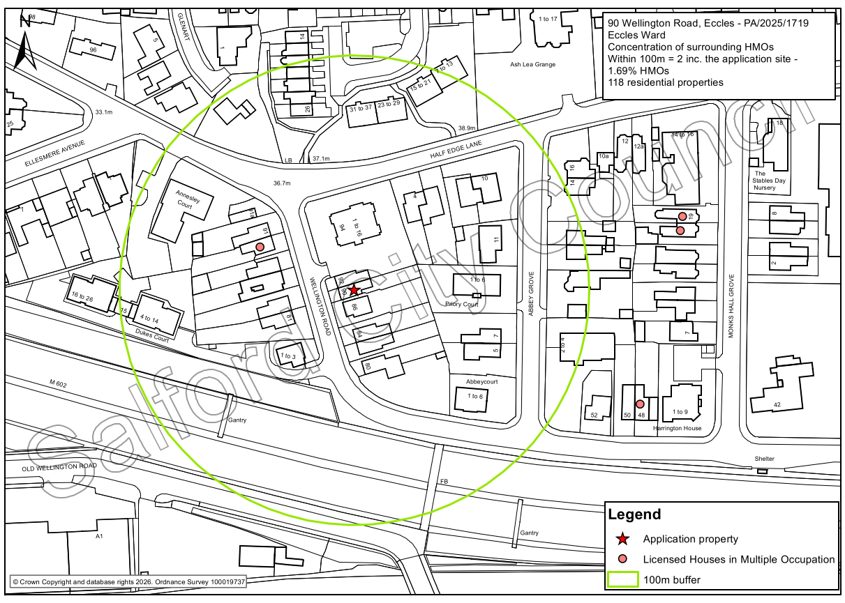

Visual Amenity
There would be no external alterations to facilitate the conversion and therefore it is not considered the proposal would adversely affect the character and appearance of the application property or the visual amenities of the wider area. The development is therefore considered to be in accordance with the design policies in the Local Plan and the NPPF.

Residential Amenity
Amenity of neighbours
The proposal would not alter the scale or massing of the property or its relationship to the neighbouring residential properties. As such it is not considered that the proposal would result in neighbouring residents experiencing any unacceptable loss of light, privacy and/or overbearing impact.

There will be a level of noise and disturbance created by occupants as they go about their daily business, moving to and from the property and as they use the building and the outdoor space. The property would have originally been used as a six-bedroom family home. The property has been operating as an HMO for 6 people since 2022. The proposed HMO would have 7 bedrooms (restricted to a maximum of 9 occupants), which is an increase of 1 bedroom but an increase of 3 additional residents. It is considered that this increase would not result in any unacceptable additional impact in terms of comings and goings and the general activity especially when considering the property is located on a relatively busy road and most of the immediate neighbours are apartment blocks and not necessarily family dwellings.

Amenity of occupiers

According to the Council’s Standards for houses in multiple occupation document, the following relevant space standards are applied for a 9 person HMO:

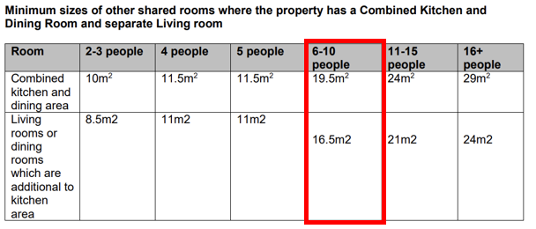

As two of the bedrooms are below 10sqm (at 9.9sqm), the HMO standards explain that this would typically require an additional living area (i.e. 36sqm communal area in total). However given the very minor under provision in the size of these two bedrooms, and that the communal space (28.5sqm), considerably exceeds the 19.5sqm minimum if all bedrooms were 10sqm, on balance, it is considered that there is sufficient communal space to afford a suitable standard of amenity for future occupiers, and it is not considered the Council could substantiate a reason for refusal on this basis.

The submission has been reviewed the Council’s HMO team who have confirmed that the proposal complies with the HMO standards in terms of space standards and with all habitable rooms being provided with windows that provide adequate light and outlook.

In view of the above it is therefore considered that the proposed development would provide appropriate living conditions for the future occupiers, with regard to satisfactory outlook, adequate space and daylight received. The proposal is therefore compliant with Policies HH1 and D5 of the SLP:DMP.

Parking and Highway Safety
The site is located on Wellington Road within 750m of Eccles town centre and Eccles train station. There are bus stops located on Wellington Road and Half Edge Lane, as well as at Eccles town centre, which provide frequent services to Swinton, Bolton, Manchester City Centre and other destinations. Eccles Tram Stop is also located within 1km walk of the site and provides regular connections to the Trafford Centre, Media City, Manchester City Centre and further destinations. Therefore, the site is located within a highly sustainable location.

There is a driveway to the front of the property with capacity for 1no. car. There are minimal on street parking opportunities available within the local area. Therefore, it is anticipated that any parking associated with the development will take place on the driveway and on the surrounding roads.

The driveway does not have a formally dropped kerb, and the installation of the vehicular crossover point must be designed and constructed with the City Council’s current specifications which will be detailed within the attached informative.

To improve the sustainability of the site the highways officer has recommended that the applicant provides cycle parking in accordance with Salford’s Local Plan Annex C Parking Standards, which states HMO properties and should provide 1 cycle parking space per 2 bedrooms. While the application is only to increase the occupancy of the building by one bedroom (an increase of 3 persons), it is recommended cycle parking for 4no. cycles should be provided in a secure lockable shelter to prevent theft or vandalism with locking points for each individual cycle. The exact details of the cycle parking will be secured by way of a condition.

The highways officer has evaluated that due to the minor scale and sustainable location of the development, the proposal is not considered to have an unacceptable impact on highway safety or the residual cumulative impact on the road network, in accordance with Policy A6 of the Salford’s Local Plan.

Waste Management
The location plan indicates the storage of bins along the side of the application property. The provision set out is acceptable as per Policy WM1 of the SLP:DMP.

Recommendation
Approve with Conditions

Document Approval
Report Author | Laura Holden
Date | 27/01/2026
Reviewer | G Clegg
Date | 27/01/2026

