
Application Ref. | PA/2025/1637
Location | 68 Barlow Street, Eccles, M30 0QJ
Ward | Barton and Winton Ward
Applicant | Mr Anthony Pilkington
Proposal | Change of use to a 4 bedroom 4 person House in Multiple Occupation (HMO) (use class C4) and erection of a single storey rear extension
Reason for Referral | Objections received from more than five separate premises
Recommendation | Approve with Conditions

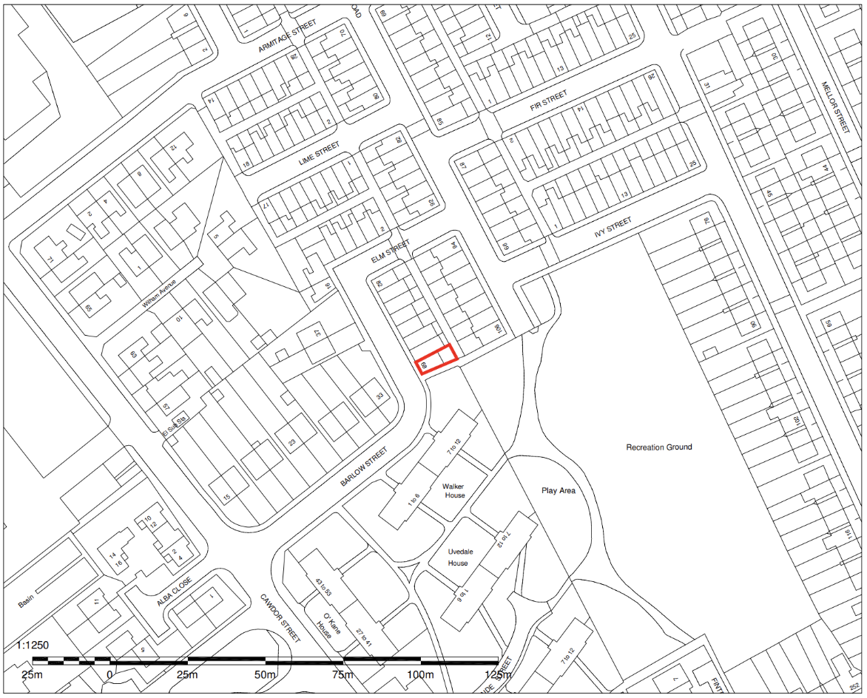
Location Plan
Figure 1: Location Plan

Description of Site and Surrounding Area

The application relates to a two storey end-terrace dwelling on the east side of Barlow Street in Eccles. The dwelling is faced in brick, painted white, and sits beneath a pitched roof.

A public footpath runs along the southern gable elevation of the dwelling which connects Barlow Street to Station Road. To the southeast lies Ivy Street Recreation Ground.

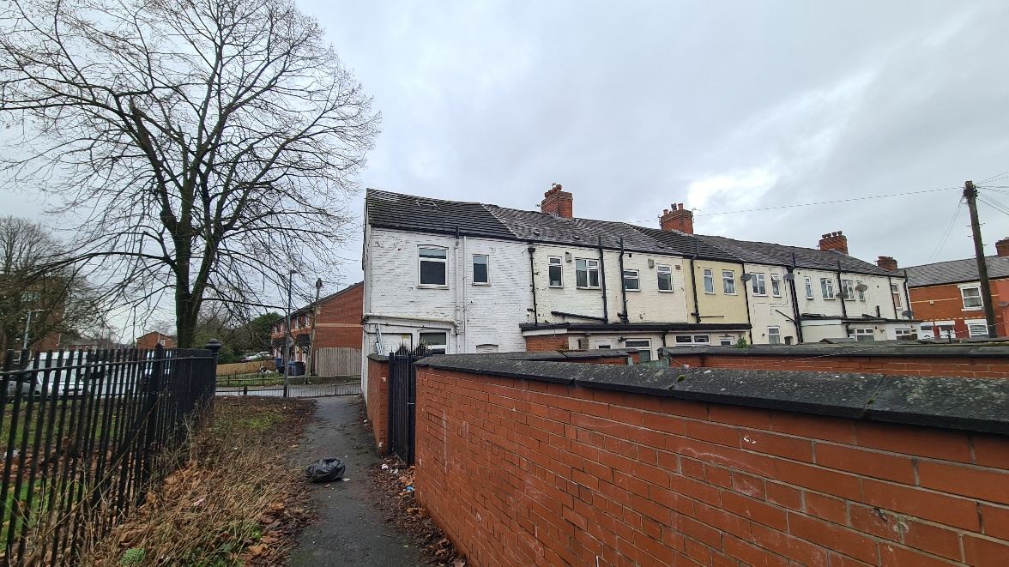
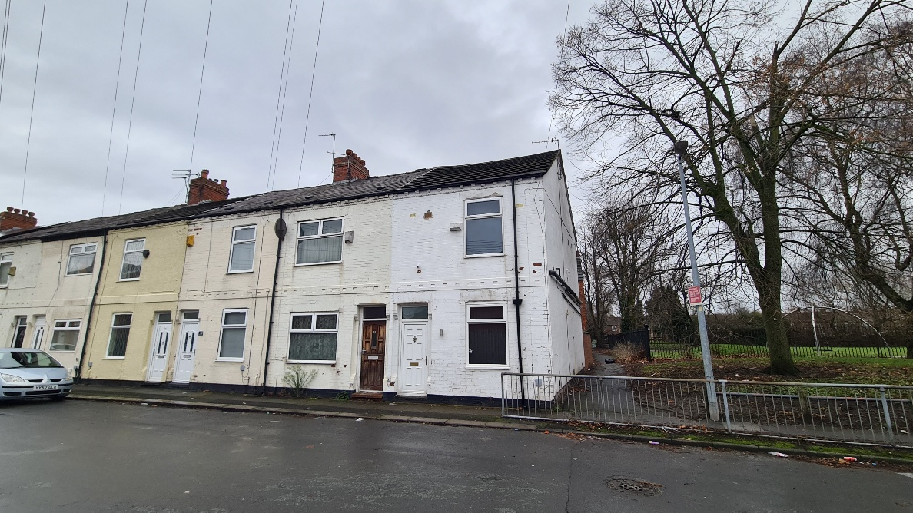
Figure 2: Site Photographs

Description of Proposal

Planning permission is sought for change of use of the property from a single dwellinghouse (Use Class C3) to a 4-person House in Multiple Occupation (“HMO”) (Use Class C4). To facilitate the conversion, the proposal also includes the erection of a single storey rear extension:
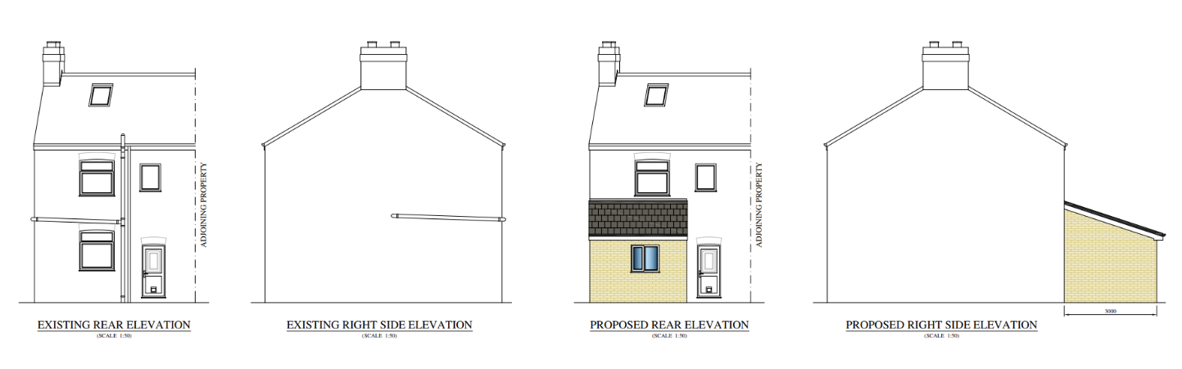
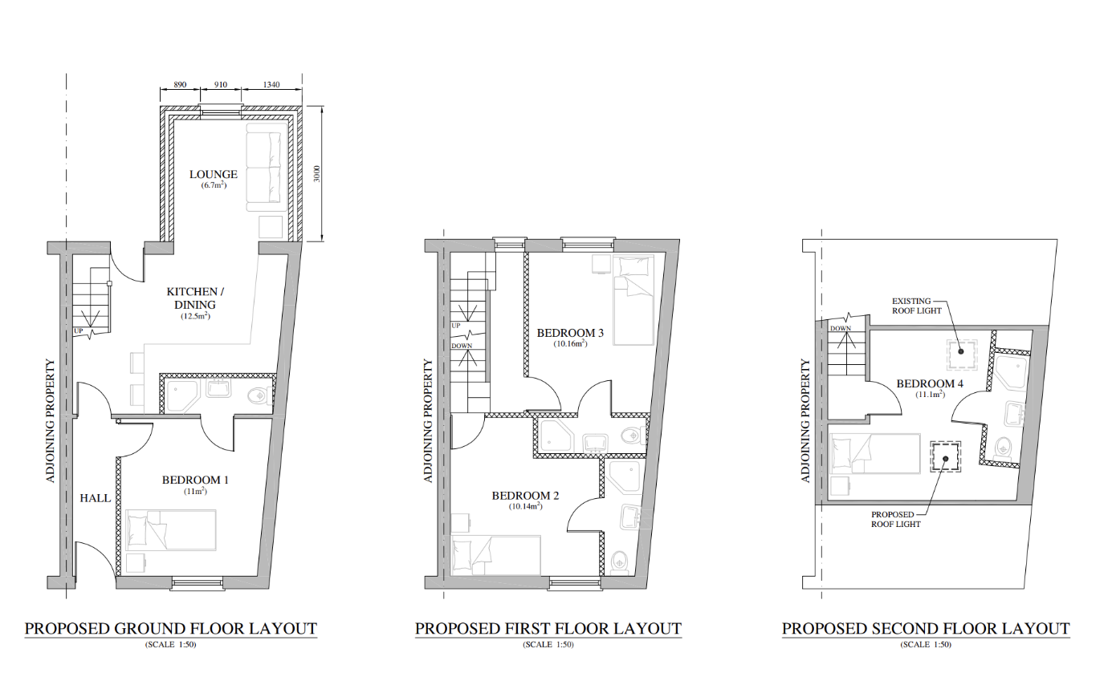
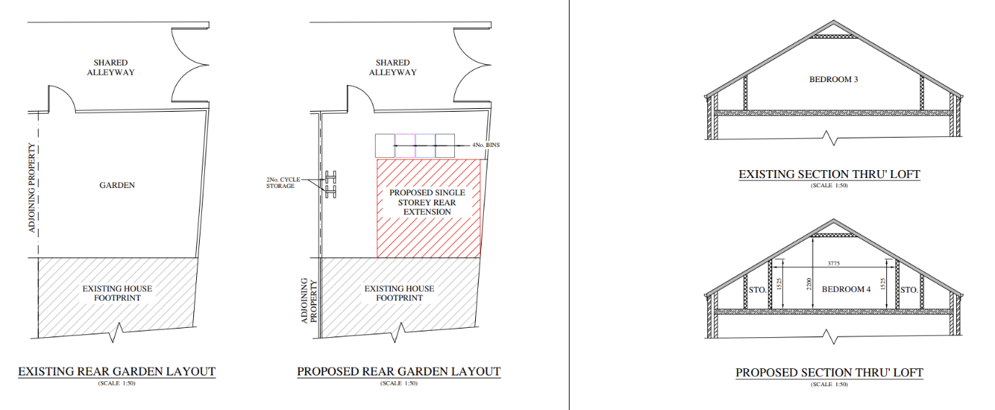
Figure 3: Proposed Plans

The proposed measurements for the internal floor area of each room to be considered against the HMO standards are shown below:

Ground floor
Bedroom 1: 11.0m²
Kitchen / Dining / Lounge: 19.2m²

First floor
Bedroom 2: 10.14m²
Bedroom 3: 10.16m²

Second floor
Bedroom 4: 11.1m² (with a floor to ceiling height in excess of 1.5m)

All bedrooms would have ensuites.

No on-site parking is proposed.

Amendments have been made to the proposed design during the consideration of the application. The proposal now includes an additional roof light to the front facing roof slope, and an internal wall between the proposed lounge and kitchen / dining room is to be removed to create a more open, shared living space at ground floor.

Relevant Planning History
None
Publicity
Neighbours - Publicity Start Date - 4 December 2025
Neighbour Notification
Neighbouring properties have been notified of the application via letter. Representations that have been received, are detailed as below:
The number of neighbouring properties notified - 4
Representations from neighbours and members of the public
Comments of Support – 0
Comments of Objection – 8 (from 7 separate addresses) – including an objection from Councillor Fahy
Other Representations – 1
The objections from neighbouring residents are summarised below:
Character of Area
- Introducing an HMO would alter the dynamic of the family-oriented community, leading to a concentration of transient occupants rather than permanent residents
- The proposed rear extension would not be in keeping with the character of the area
- The HMO would go against the interests of the residents and the aims of Salford City Council by introducing a transient population into an already struggling area
- The proposal could set a precedent for further HMO developments in the area, resulting in over-concentration and a gradual erosion of the residential character of the neighbourhood
Officer Comment: the impact of the proposal on the character of the neighbourhood is addressed in the appraisal below.
Parking and Highway Safety
- There is insufficient on-street car parking available in the area and the proposed use would exacerbate the issue. The property is located on a bend in the road and associated parking would pose a highway safety risk
- The development would result in traffic generation, and exacerbate the risk to children playing in the street

Officer Comment: The Council’s Highways Officer has reviewed the application. Their comments are discussed within the ‘Parking and Highway Safety’ section of this report.

Amenity
- The introduction of multiple occupants would cause noise and disturbance to neighbours.
- Neighbours would be overlooked due to the narrow alley separating the application site to the properties to the rear
- The proposed use would cause noise and disrupt neighbours

Officer comment: The only new window opening proposed to the rear would be at ground floor level, as part of the single storey rear extension.

Matters concerning impacts on the amenity of neighbouring properties are discussed within the ‘Residential Amenity – Neighbours’ section of this report.

Other
- The change of use could make it difficult for neighbours to sell their property and could affect property values
- The property is located close to a park where children play – the proposed use could pose a risk to children
- There are schools nearby
- The applicant is responsible for dumping in the communal alleyway to the rear of the site
- The HMO would put additional strain on public services, local amenities and infrastructure
- The HMO would form part of the applicant’s business portfolio
- The proposed HMO could house asylum seekers
- There is an inadequate fire escape for the proposed attic room
- The change of use could result in antisocial behaviour and increase waste generation / dumping
- Most residents directly affected by the development were not consulted
- The landlord should consider only tenants from known backgrounds

Officer Comment:

Impacts on property values and the site’s proximity to schools / play areas in the context of the safety of children are not material to determining this planning application. Similarly, issues relating to any previous dumping of waste in the communal alleyway fall outside of the scope of this application.
Matters relating to fire safety would be dealt with through Building Regulations.

It is not considered that the change of use from a 3-bedroom dwelling to a 4-bedroom HMO would put a significant additional strain on public services, amenities or infrastructure in the area.

It is also advised that it is not the role of the planning system to consider why a particular application has been submitted, with it not being possible for the Local Planning Authority to control who the residents of the proposed HMO will be. There is no objective evidence to suggest that occupants of the proposed HMO would exhibit the behaviours that have been described. Similarly, the owner or occupants of the property will not be any more or less likely than any other individuals to keep the property in a reasonable state of repair.

Objection from Councillor Fahy:

• The property is close to two primary schools
• The property is close to a park and youth centre
• An HMO is not in keeping with the area which is full of young families with children
• Excessive waste and parking issues

Officer Comment:

Matters relating to waste generation and impacts on parking are assessed within the report, as is the proposal’s impact on the character of the area.

As stated above, whether or not the site is located close to schools is not material to the determination of this application.

The applicant has submitted a response to the objections, following the circulation of a letter to properties in the vicinity of the site which they state has spread inaccurate and misleading information concerning the proposed development. They note that the letter claims that the HMO would be overcrowded and used to rehouse individuals from hotels.

The applicant states that they would like to clarify that the application follows pre-application advice, and that the proposal has been designed to exceed the requirements of planning policy, licensing standards, and building control regulations. The applicant states that their intention that upon completion, the property will either be let to professionals or leased to a registered housing provider supporting individuals affected by domestic violence. They state that there is a pressing need for well-managed, compliant HMO accommodation to meet local housing demand, which the proposal would contribute towards.

Consultations
Salford Environment Officer (DM)
Summary - The Council’s Environment Officer has reviewed the application and has no objections with regard to the proposal’s impact on noise, air quality and contamination. An informative is recommended to restrict the hours of noise generative construction work, and to highlight building regulation requirements with respect to internal noise transmission.
Salford Highways Officer (DM)
Summary - The Council’s Highways Officer considers the site to be sustainably located and notes that there are no on-street parking restrictions along this section of Barlow Street or the surrounding roads. They consider that the parking demand that would arise would be similar to the property’s previous use as a C3 dwelling and any increase would not cause a severe impact on highway safety or capacity.
Salford House in Multiple Occupation (HMO) Licensing Team (DM)
Summary - The Council’s HMO Licensing Team confirm that the proposed internal layout meets the Council’s space standards for a four person HMO.
Planning Policy
Salford Local Plan: Development Management Policies and Designations (SLP:DMP)
Policy F1 An inclusive development process
Policy F2 Social value and inclusion
Policy F3 Inclusive places
Policy F4 Fairness between generations
Policy CC1 Climate Change
Policy EF1 Efficient use of land
Policy EF2 Co-ordinated development
Policy H1 Type of housing
Policy H2 Size of dwellings
Policy H10 Conversion and change of use of existing houses and new build residential developments of non-self-contained units
Policy HH1 Development and Health
Policy A3 Walking and cycling
Policy A6 Highway network
Policy A7 Motor vehicle parking provision and drop-off facilities in new developments
Policy WA5 Surface water and sustainable drainage
Policy D1 Design principles
Policy D2 Local character and distinctiveness
Policy D3 Layout and access
Policy D5 Amenity
Policy D6 Design and crime
Policy D7 Housing design
Policy D8 Alterations and extensions
Policy PH1 Pollution control
Policy WM1 Waste and development

Places for Everyone (PfE)
Policy JP-S1: Sustainable Development
Policy JP-H3: Type, Size and Design of New Housing
Policy JP-P1: Sustainable Places
Policy JP-C1: An Integrated Network
Policy JP-C6: Walking and Cycling
Policy JP-C8: Transport Requirements of New Development

Other Material Planning Considerations
National
- National Planning Policy Framework
- National Planning Practice Guidance

Local Planning Policy and Development Framework/ Strategies
- Houses in Multiple Occupation Supplementary Planning Document (June 2024) (updated January 2025)
- House Extensions Supplementary Planning Document (July 2006) (the “SPD”)

Local Finance Considerations
It is not considered that there are any local finance considerations that are material to the application.

Appraisal

The site is located within one of the areas of the city where an Article 4 Direction came into effect on 25 November 2018. The Article 4 Direction was introduced in order to positively manage potential amenity and character impacts associated with HMOs and their concentrations, as well as to ensure that balanced communities are maintained within the city. This means that planning permission is required for the change of use of a dwellinghouse to a small HMO within this part of the city.

HMOs can make an important contribution to housing supply, generally providing low-cost private sector accommodation for those on lower incomes, students, and those seeking temporary accommodation. They are normally located in areas with good access to public transport (in particular bus routes) and local services. However, high concentrations of HMO accommodation can sometimes have a detrimental impact on local housing areas.

Policy H1 of the SLP:DMP states that individual new residential developments shall contribute to the provision of a broad mix of housing options across Salford and within the local area, ensuring that identified housing needs can be met.

Policy F3 of the SLP:DMP states that all places and developments shall be as inclusive as possible. Achieving this will involve a diverse mix of decent and adaptable homes, including affordable housing that enables everyone to meet their housing needs.

Proportion of HMOs in the area

Policy H10 of the SLP:DMP sets out how conversions and changes of use from existing dwellings to HMOs and other stated uses will be controlled to ensure that a good supply of houses is maintained within Salford and the positive character of neighbourhoods is protected.

Part 1 of Policy H10 of the SLP:DMP states that conversions to HMOs (amongst other uses listed) will only be permitted where it can be demonstrated that the proposal would not, either individually or cumulatively with other listed uses (including completed developments and schemes with planning permission or prior approval) have an unacceptable impact on the positive residential character of the surrounding neighbourhood, having particular regard to potential increases in noise and disturbance, on-street car parking, waste management and population turnover levels that could reduce community stability.

Part 3 of Policy H10 of the Local Plan also states that conversions to HMOs will only be permitted where it can be demonstrated that the proposal would not, either individually or cumulatively with other completed developments and schemes with planning permission or prior approval, result in any house that is in use as a single dwelling being immediately adjacent to more than one property in use as student housing, houses in multiple occupation, hotels, residential institutions, hostels, children’s homes and similar uses and non-residential uses such as offices.

For the avoidance of doubt, Policy H10 clarifies that for the purpose of this policy, immediately adjacent properties include properties directly behind and opposite, as well as to either side.

The Council has adopted the Houses in Multiple Occupation Supplementary Planning Document (the “HMO SPD”) which has been produced to better manage the provision of new HMOs throughout Salford by providing a threshold to guide the distribution/location of them. Policy HMO1 within the HMO SPD states that planning permission will not normally be granted for new HMOs, or for proposals to extend existing HMOs that would increase the number of bedrooms within it, where:

- the proportion of HMOs already exceeds 10% of all residential properties within a 100-metre radius of the application property; or

- the proportion of HMOs would exceed 10% of all residential properties within a 100-metre radius of the application property as a result of a proposed new HMO.

The figure below shows the distribution of existing HMOs in the immediate area. The application property would be the only HMO within a 100m radius and therefore falls well below the 10% threshold (at 0.58%), in accordance with Policy HMO1 of the HMO SPD.
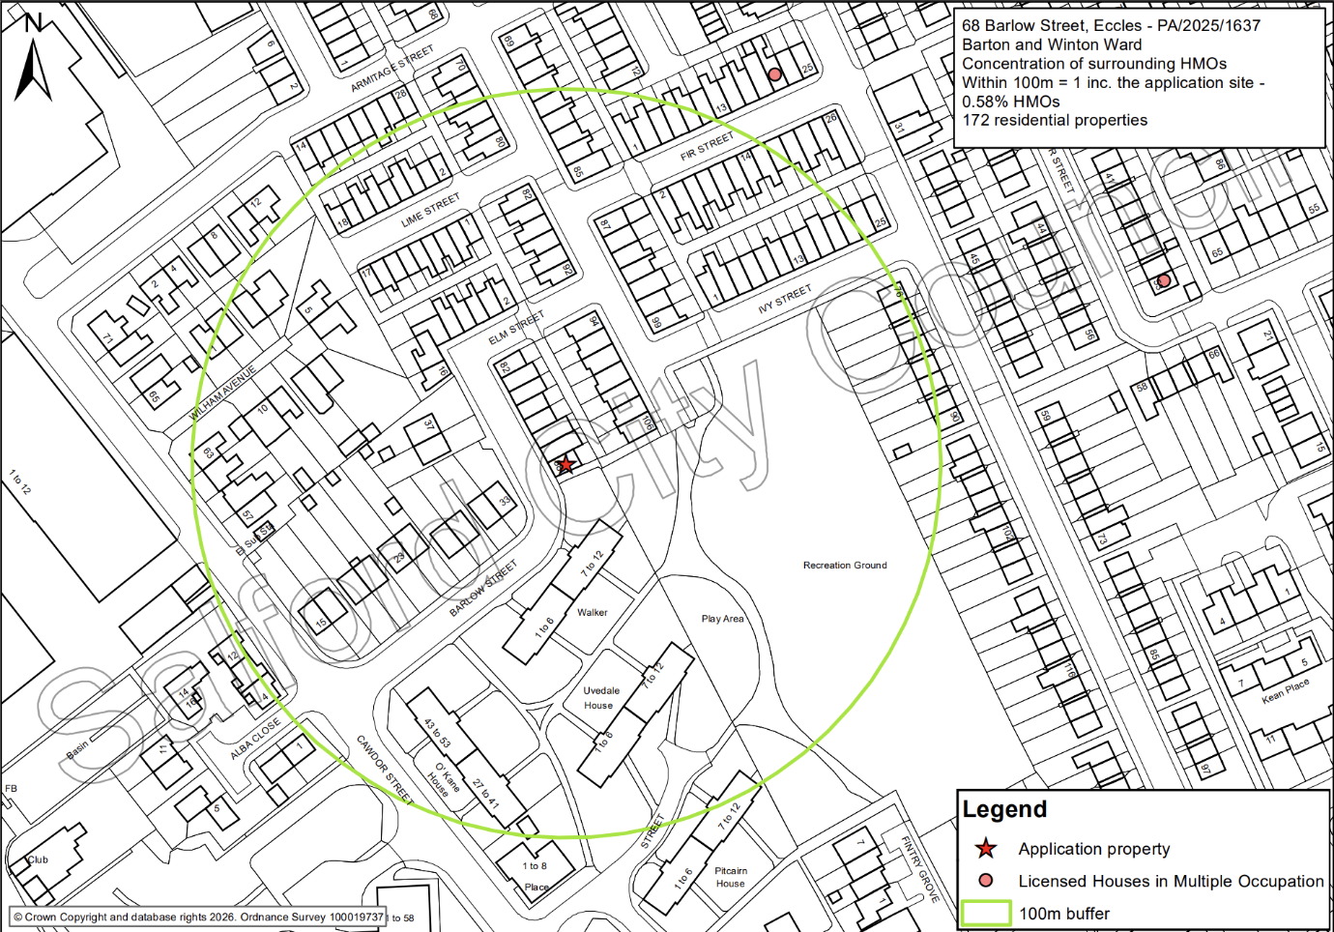
Figure 4: 100m radius map (applicant property indicated by red star)

It is clear from the above that the proposal would not lead to an overconcentration of HMOs in this part of the city, in accordance with Policy HMO1. For this reason and given the proposed HMO could make a positive contribution towards meeting the housing needs of those requiring lower cost accommodation, the principle of the change of use to provide a 4 person HMO is considered to be acceptable with the proposal making a positive contribution to the mix of housing types in this part of the city. The loss of a family dwelling is acknowledged; however, it is not considered that the loss of one unit would have an unacceptable adverse impact on the overall mix of dwellings in the area or the supply of family housing in the vicinity of the site.

The case officer has reviewed the planning history for the properties in the immediate vicinity of the site, and there are no other relevant uses (listed B) to G) within Policy H10) within the vicinity. The conversion of the application property to an HMO would not therefore result in a single dwelling being immediately adjacent to more than one property in use as an HMO or other relevant uses as per Part 3 of Policy H10. The development is therefore compliant with this policy.

Design

The proposed single storey rear extension would be largely hidden from public views – minimising its effect on the street scene. Partial views are available from along Barlow Street to the south and the footpath adjoining the site, however these would be largely obscured by the existing boundary wall.

Facing materials are to match, which together with the overall scale and roof form is considered proportionate and sympathetic to the parent dwelling.

It is not considered that the extension would have a detrimental impact on the character and appearance of the surrounding area as per Policies D1, D2 and D8 of the Local Plan

Residential Amenity – Neighbours

There will be a level of noise and disturbance associated with the future occupants as they go about their daily business independently, moving to and from the property and as they use the building and the outdoor space.

In respect to the magnitude of change that would arise, the application property was formerly used as a 3-bedroom family dwelling with 2 bedrooms being of a size that could accommodate two people. The proposed HMO would have 4 bedrooms (restricted to a maximum of 4 occupants) so the increase of 1 bedroom is not necessarily considered to result in more people occupying the property than could have been feasible previously.

As such, it is not considered that the uplift in activity at the site or the comings and goings associated with an HMO of this size, would be so significant so as to create unacceptable harm.

The extension would introduce a new window serving a living area at ground floor, which would be approximately 1.5m from the boundary to the rear, beyond which lies the shared alley. Due to the presence of the boundary wall, the window would not directly overlook any neighbouring property’s private garden space, and it is not considered that there would be any unacceptable loss of privacy in this regard.

With a projection of 3m, the extension would not intersect with a line drawn at a 45 degree angle from the midpoint of the ground floor habitable window or a point 3m along the common boundary with the adjoining neighbour, no. 70 Barlow Street, in accordance with Policy HE5 of the House Extensions SPD. In addition, it is recognised that the applicant would be able to erect a similar size extension without the need for planning permission under permitted development rights.

With the exception of the single storey rear extension, the only other additional window opening would be the roof light proposed to the front roof slope. Objections have been received raising concern that the proposal would result in additional overlooking of neighbouring properties due to the narrow alley separating the two terraces to the rear. The only scope of overlooking that would arise in this context would be from the existing first floor window in the rear elevation which already serves a bedroom. It is not considered that the proposal would result in any significant change in the use of this room, and as such it is not considered that neighbouring occupiers would experience any notable change in terms of overlooking or loss of privacy.

Overall, the proposal is considered compliant with Policy D5 of the SLP:DMP and the House Extensions SPD.

Residential Amenity – future occupiers

The NPPF, at Paragraph 135, requires development to achieve a 'high standard’ of amenity for existing and future users. Policy F3 of the SLP:DMP seeks to deliver a diverse mix of decent and adaptable homes and Policy D5 seeks to ensure that development provides all potential users with an acceptable level of amenity.

The Council’s Standards for houses in multiple occupation document offers guidance to landlords on the physical standards that are required for licensing purposes including minimum room sizes, bathroom and kitchen facilities and fire safety provision. Whilst this document does not form part of the development plan, Local Plan Policy H2 confirms that all HMOs shall meet the minimum room size and amenity standards set out in this document.

The property has a small yard area to the rear. It also lies adjacent to Ivy Street Recreation Ground to the south, which would provide additional amenity benefits to occupants.

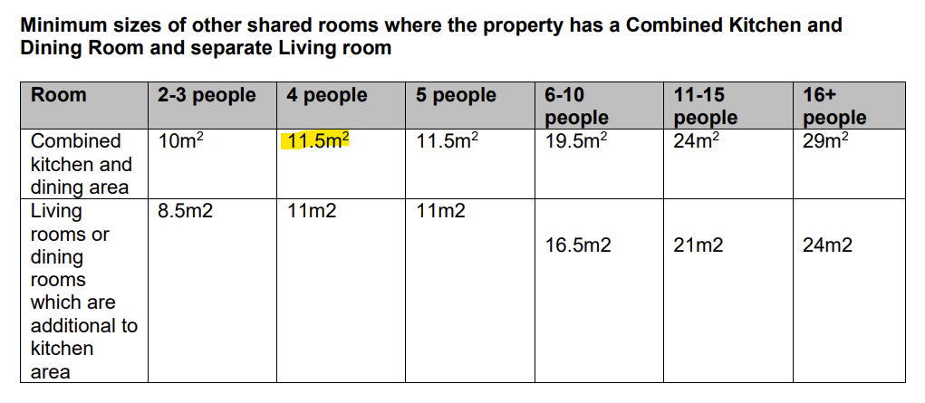
All habitable rooms within the property would be served by adequately sized and sited windows, and all 4 bedrooms would be served by an ensuite. According to the Council’s Standards for houses in multiple occupation document, the following relevant space standards are required to be met:
Figure 4: HMO standards

When assessing the suitability of an HMO with regards to space standards, officers make a recommendation by assessing the HMO as a whole and the potential use of the space provided. When considering the requirements, the minimum floor space for a combined kitchen and dining area is 11.5m² for 4 occupants. As all of the bedrooms exceed 10m² there is no requirement for an additional living room. The open plan kitchen / dining / lounge area would measure 19.2m², exceeding the minimum standards by 7.7m².

The Council’s HMO Licensing Team have been consulted and have advised that they have no objection to the proposal and consider it complies with the space standards for a 4 person HMO.

In view of the above it is therefore considered that the proposed development would provide appropriate living conditions for the future occupiers, with regard to satisfactory outlook, adequate space and daylight received. The proposal is therefore considered compliant with Policies HH1, F3, H2 and D5 of the Local Plan.

Parking and Highway Safety

The site is sustainably located; close to Liverpool Road which is served by public transport (bus), with regular services to Bolton, the Trafford Centre and the City Centre via Eccles Town Centre.

No on-site parking is available for the property. However, unrestricted on-street parking is available along Barlow Street and the neighbouring streets.

While acknowledging that the proposal could result in some limited additional on street parking demand, the Council’s Highways Officer has stated that they consider any impact that does occur as a consequence of the proposal would not be unacceptable or severe.

In accordance with paragraph 116 of the NPPF: Development should only be prevented or refused on highways grounds if there would be an unacceptable impact on highway safety, or the residual cumulative impacts on the road network, following mitigation, would be severe, taking into account all reasonable future scenarios.

For these reasons it is not considered that the proposal would have an unacceptable adverse impact upon highway safety in accordance with Policies A6 and A7 of the SLP:DMP.

Cycle and Bin Storage

In terms of bin storage, it is not considered that the proposal would significantly intensify the need for extra provision, with the property having a rear yard that can be used to store the necessary bins, as per Policy WM1 of the SLP:DMP.

In terms of cycle storage, in accordance with the Council’s parking standards, at least 1 secure cycle parking space per 2 bedrooms is required for an HMO. The applicant has indicated that cycle storage would be accommodated within the rear yard. Details of secure cycle parking provision will therefore be secured by condition.

Recommendation
Approve with Conditions

