

Application Ref. | PA/2025/1761
Location | 14 Hawthorne Drive, WORSLEY, MANCHESTER, M28 2DA
Ward | Boothstown and Ellenbrook Ward
Applicant | Matthew Parsons
Proposal | Roof alteration from a flat roof to mono-pitched roof over the existing single single storey side and rear elements including partial garage conversion to a habitable space
Recommendation | Approve with Conditions

Location Plan

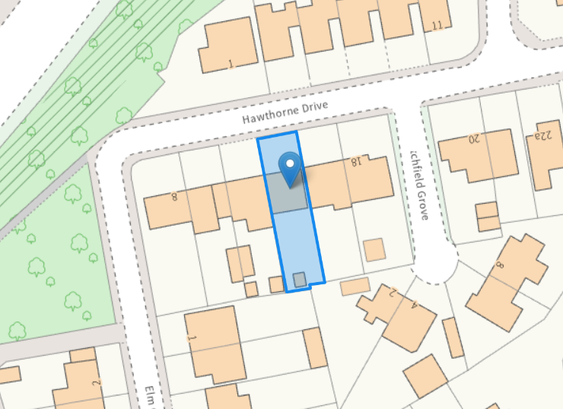

Description of Site and Surrounding Area

This application relates to a two storey semi-detached dwelling located on Hawthorne Drive. There are a mix of semi-detached / link semi-detached and detached properties within the vicinity of the site.

Description of Proposal

The flat roof of the existing single storey side garage and rear element will be replaced with a mono-pitched with rooflights.

The existing integral garage would be converted into a utility room and the existing garage door in the front elevation will remain.

Proposed Elevation & Floor Plans

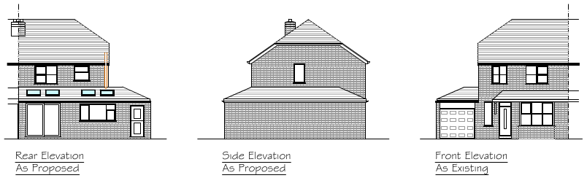

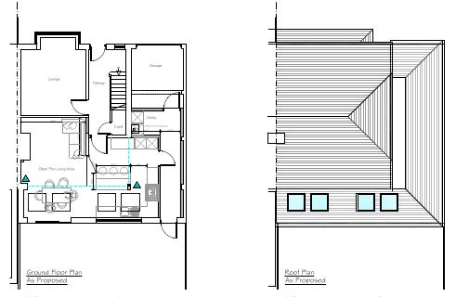

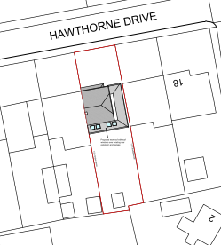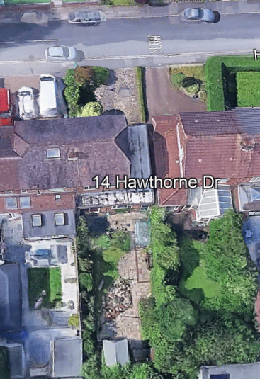

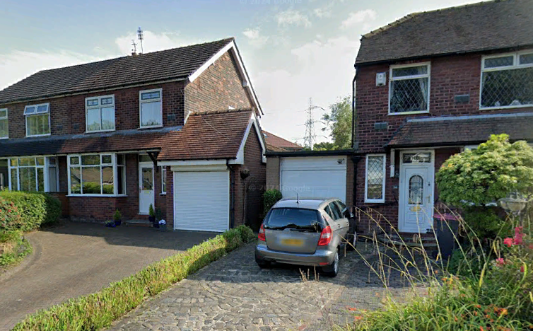

Relevant Planning History
No relevant planning history
Publicity
Neighbours - Publicity Start Date - 22 December 2025
Neighbour Notification
8 neighbouring properties have been notified of the application via letter. No representations have been received.

Consultations

N/A

Planning Policy
Salford Local Plan: Development Management Policies and Designations (SLP:DMP)
Policy A6 Highway network
Policy D1 Design principles
Policy D2 Local character and distinctiveness
Policy D3 Layout and access
Policy D5 Amenity
Policy D8 Alterations and extensions

Other Material Planning Considerations
National
- National Planning Policy Framework
- National Planning Practice Guidance

Local Planning Policy and Development Framework/ Strategies
- Supplementary Planning Document – House Extensions (2006)

Local Finance Considerations
It is not considered that there are any local finance considerations that are material to the application.

Appraisal
Impact on the Character of the Area

The development would be visible from the street scene but is mainly set the rear. It is considered that the design of the proposal would appear cohesive with the existing dwelling, the surrounding area and uses material to match. Therefore the proposed development would not result in detrimental impact upon the character of the surrounding area in accordance with Policies D1, D2 and D8 of the SLP:DMP.

Impact on the Amenity of Neighbours

The proposal would be positioned up to the shared boundary with the adjoining and adjacent neighbouring properties at Nos. 12 and 16, both of which have previously been extended to the side and rear. As the proposed roof alteration aligns with the single storey rear element of the host dwelling, the development would not extend beyond the depth of the neighbouring rearward extensions and would therefore protect their residential amenity. Furthermore, the proposal would not result in any adverse impact on the gardens located at a right angle to the rear of the application site.
The development does not therefore cause any undue harm to the amenity of the users and amenity
or privacy of the neighbouring users and is in line with Policy D5 of the SLP:DMP, SPD and the NPPF.

Impact on the Highway Network

The existing front driveway / parking layout is considered sufficient to accommodate at least 2 x vehicles as well as unrestricted parking in the wider area. Therefore, the development would not result in an unacceptable impact on the highway network.

Other Issues
Does the proposal require works to trees?
No
Is there a significant change in levels across the site or between the site and neighbouring land?
No
Has the applicant/agent indicated any personal circumstances?
No

Recommendation
Approve with Conditions

Document Approval
Report Author | R.Sharma
Date | 27/01/2026
Reviewer | A.Williams
Date | 30.01.2026

