DESIGN AND ACCESS
STATEMENT



R T DESIGN
Architectural and Surveying Services

25 Seymour Drive, Bradshaw, Bolton, BL2 3HB

PROPOSED CONVERSION OF FIRST FLOOR
OFFICES AT FAULKNER HOUSE, ELM STREET,
SWINTON INTO A 13 BEDROOM HMO

This statement is being submitted to support a planning application for the conversion of the first floor of Faulkner House, Elm Street, into a House in Multiple Occupation.

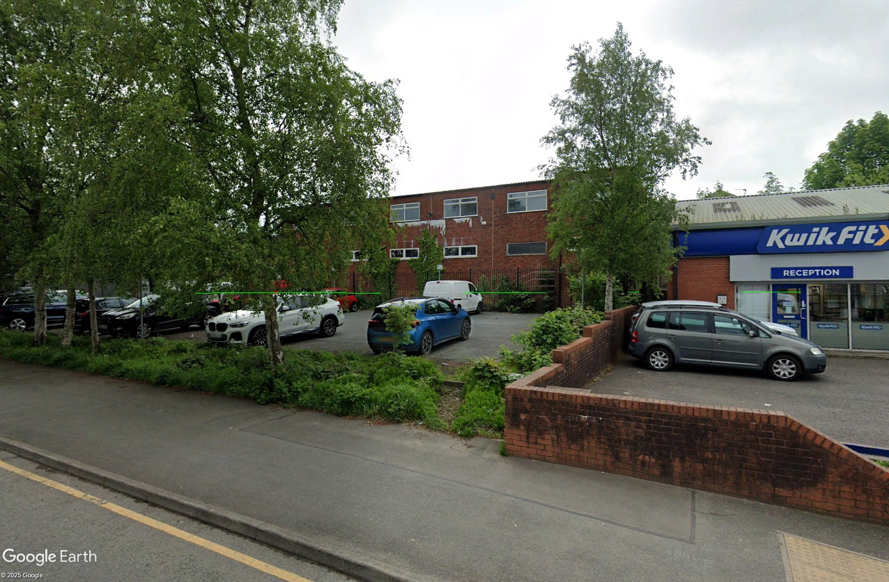

Faulkner House viewed from Chorley Road

The building is currently split into several uses within differing planning use classes. The ground floor is currently used as a dance class (leisure), a warehouse and offices. The first floor is offices which are currently vacant.

The proposal is to convert the first floor into an HMO which will be accessed from the entrance on Elm Street, with the entrance to the front corner of the building to use the existing staircase as a secondary/fire escape staircase, which is also shared with the dance studio and is compartmented.

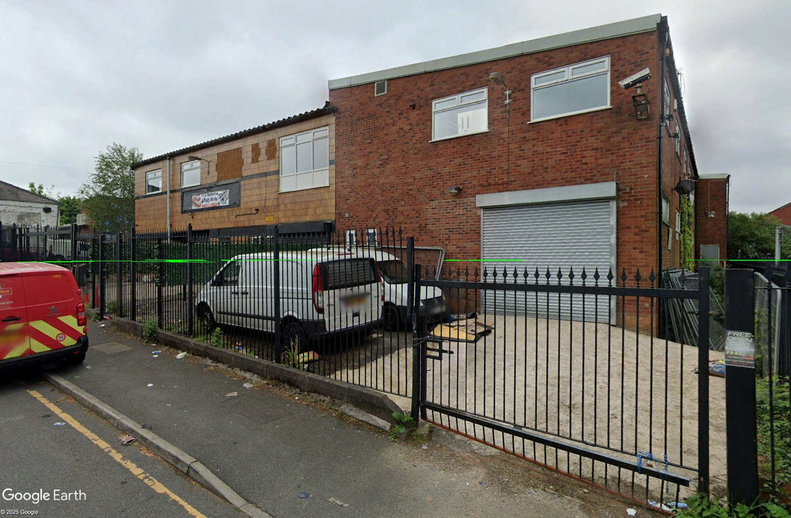

Faulkner House viewed from Elm Street

There have been numerous applications over the past few years. Several applications submitted in 2017 were all withdrawn. An application was submitted in 2018 (Ref 18/71566/P3JPA) for prior approval for a change of use from B1(a) offices to C3 (dwelling house). This application was refused prior approval on the grounds that:

1. The proposed development is not permitted under Class O.1 (b) of Schedule 2, Part 3 of the Town and Country Planning ( General Permitted Development) (England) Order 2015 (as amended) as part of the building associated with the change of use was not used for B1(a) (office) on 28th May 2013, nor had such use commenced (and subsequently ceased) prior to that date.

The current owner has recently obtained information concerning business rates for the property from a government website, which shows that the use of the building is as a dance studio and offices.

The proposals are to be within the existing footprint of the building with the rest of the building being retained in its’ current uses. The only changes to the fabric of the building will be the reinstatement of a window to the Elm Street elevation and new windows to the rear of the building above the warehouse roof.

The HMO will also have amenity space, bin storage and cycle storage within the secured area off the main entrance as shown on the Elm Street elevation above.

A search of the Salford Council HMO website shows that there are only a few licensed HMO’s within the area.

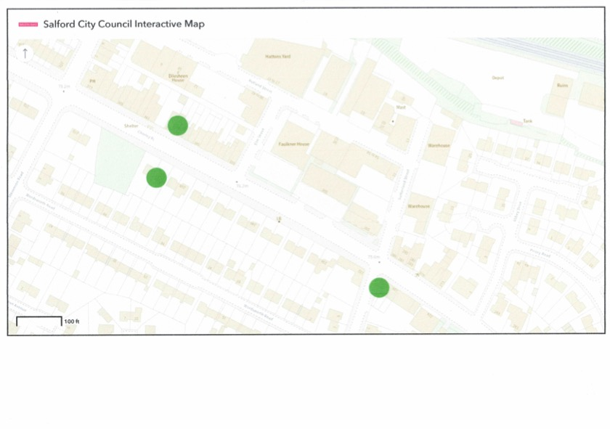
The map shows that there are 3 licensed HMO’s within the area which are :

- 353 Chorley Road (MAU169679) which is 78metres away
- 262 Chorley Road (MAU177248) which is 93metres away
- 230 Chorley Road (MAU170681) which is 110metres away

Therefore in line with the requirements of policy HMO1 of the Salford Houses in Multiple Occupation SPD, which advises that permission will not normally be granted for new HMO’s where the proportion of HMO’s already exceeds 10% of all residential properties within a 100metre radius of the application property.

The above map shows that out of approximately 45 residential properties there are only two licensed HMO’s within 100metres of the site which represents under 5%, therefore the proposals would meet the requirements of the SPD.

The proposed development would provide 13no rooms, all which will have
en-suites, with the rooms all providing a standard of accommodation (from 10.2sq metres to 19.2sq metres) that will exceed the Salford standards, which require rooms to be a minimum size of 10sq metres (where there is no communal lounge) and also a kitchen/dining room (24.3sq metres) which is greater than the standard of 24sq metres for a kitchen/dining room for 11-15 people.

It is therefore proposed that the proposal will meet the requirements for a licensed HMO within the guidelines of Salford Councils SPD and HMO standards requirements.

The proposals were submitted as a Pre-application in July 2025 and the findings of that submission have been considered and implemented within this application.

Planning Policy

The site is not subject to a protective designation within the Local Plan. The site is surrounded by a mixture of commercial and residential properties.

NPPF
Paragraph 124 advises that “Planning policies and decisions should promote an effective use of land in meeting the need of homes and other uses.”

Paragraph 125 states that ”Planning Policies and decisions should give substantial weight to the value of using suitable brownfield land within settlements for homes.”

Places for Everyone Plan (PfE)
Policy JP-S1 advises that “To help tackle climate change, development should aim to maximise its economic, social and environmental benefits simultaneously, minimise its adverse impacts, utilise sustainable construction techniques and actively seek to secure net gains across each of the different objectives.”

Response

The proposed development would meet the needs of the NPPF in making effective use of a building within a brownfield site that would provide homes in support of the government’s objective of significantly boosting the supply of housing (Section 5 of the NPPF para 61) with local planning authorities to plan for different groups in the community by facilitating different housing in terms of size, type and tenure (para 63).

The proposals are also in line with the requirements of PfE Policy JP-S1 as it would utilise a vacant building within a brownfield site which would secure net gains in housing needs whilst using sustainable construction techniques that would meet the requirements of the Building Regulations, using products that would provide safe and healthy living conditions.

Loss of Employment Use
The pre-application report received from the LPA stated that Policy EC1would support a number of uses within existing employment areas where they would not have any significant adverse impact. Points 1 to 6 of Policy EC1 identifies the use as industry, warehousing and offices.

Response

The first floor offices have been vacant for some time and the applicant has made attempts to sell or rent out the space through an agent since July 2023.

Below is a copy of a letter from Prospect Properties Group together with screenshots of the advertising of the offices for sale and for rent on the Zoopla website.

With the current employment market and the decline in employment due to the government’s budget changes, there is no prospect of the commercial sector making a recovery any time soon.

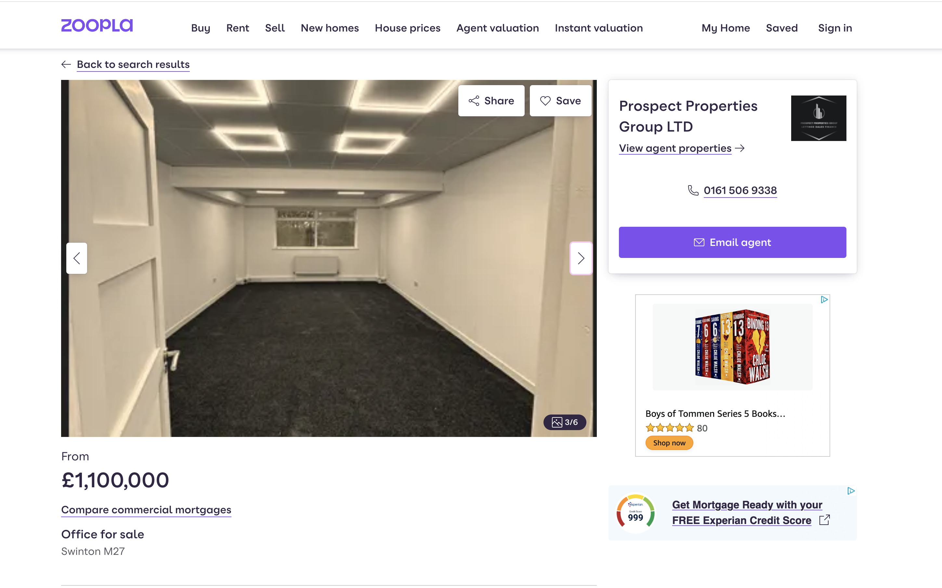

ZOOPLA FOR SALE ADVERTISEMENT

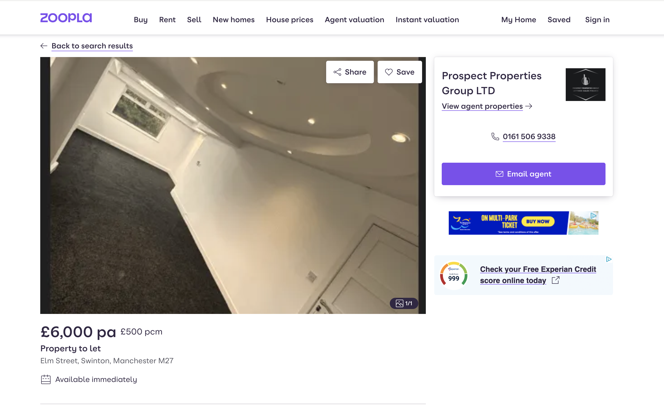

ZOOPLA FOR RENT ADVERTISEMENT

Places for Everyone Policy JP-P1 Sustainable Places
The policy advises that developments should conserve and enhance, where appropriate, the natural environment, landscape features, historic environment and local history and culture, enable a clear understanding of how the place has developed.

Local Pan
Policy D1 (Design principles) high density quality, Policy D3, layout and access and Policy D4 Spaces, set out the criteria for the design, layout and space of sites and buildings. Policy D2 Local Character promotes development protecting and enhancing the local area and contributing to local identity.

Response

National policy on residential development is contained within the NPPF, which makes it clear that the focus on additional housing should be in existing towns and urban areas.

Section 2 of the NPPF recognises the role of the planning system in providing the supply of housing required to meet the needs of present and future generations and the need to boost significantly the supply of housing.

The proposals would provide a form of lower cost housing which will meet a particular need, thereby making a small but positive contribution to the number of households and the mix of housing available.

The use of the building with minimal external changes to the appearance, whilst improving the quality, with the introduction of higher quality glazing to reduce internal and external ambient noise levels, to enable the proposed use to co-exist with the existing surrounding business uses and provide suitable living accommodation. This application is supported by a comprehensive noise assessment survey and report which concluded that residential amenity for future occupants of the development can be suitably protected and noise need not be a reason for refusal of planning permission.

Crime and Design

PfE Policy JP-P1 Sustainable places advises that developments should be safe, including the designing out of crime, reducing opportunities for anti-social behaviour.

Policy D6 (Design and Crime) states that development should be designed to minimise crime and the fear of crime and should maximise natural surveillance, encourage activity within public areas.

Response

These measures will be adopted using the standards and guidelines provided by the Secured By Design (SBD) Guide for homes 2024, an initiative supporting the principles of designing out crime through the use of effective crime prevention.

All windows that are easily accessible should be made secure to SBD standards and feature opening restrictors and locks. Doors to each room should be secured with a locking mechanism which must be capable of being overridden from the side of the person escaping without the use of a key.

The building is to be provided with a store room to the HMO to provide secure storage for the use of bicycles and other items of value that will not be kept in the occupants room. This store will be locked with all occupants having access. The store room will be accessed internally on the internal corridor to the HMO rooms and will have no external access.

The common use areas will be provided with suitable lighting for security and for the provision of fire escape routes as required by building regulations.

To deter vandalism, anti-social behaviour and theft, the property will be provided with security cameras and an external lighting system in line with SBD guidelines, implementing lighting compatible with CCTV surveillance.

All occupants should be provided with a crime prevention pack/welcome pack, advising them how to stay safe and reduce the crime risk.

Residential Amenity
The NPPF and Local Plan Policy D5 states that development should provide a satisfactory level of amenity.

Response

The proposals would meet the requirements for the interface distances with surrounding residential properties. The sizes of the rooms are in line with the requirements of the Salford HMO Standards, with appropriately placed windows, using either existing window positions or providing new window openings that will match the design and fenestration of the existing windows.

Whilst the site provides little external amenity space, there are areas that are within walking distance of the site that would provide amenity for the use of residents in line with PfE policies. There is Moorside Park off Shelley Road, which is 450m away and Swinton and Pendlebury Leisure Centre on Cromwell Road which is 550m away.

Noise
The Pre-application letter required that any planning application would need to be accompanied by an assessment of noise likely to affect the application site, giving ambient noise levels required to be achieved, together with ventilation measures in line with the ANC Acoustics Ventilation and Overheating Residential Design Guide.

Response

A survey and report were commissioned and carried out by EnviroSolution Ltd and has been submitted with this application.

Environment
Policies PfE JP-P1 and JP-S5 together with Policies F4, PH1 and D5 stated that the proposals should pay attention to tackling air pollution and land contamination.

The report goes on to state that with regards to Air Quality, “the proposed development is not within the Greater Manchester Air Quality Management Area and that the development the development is not likely to have a significant impact on traffic.”

With regards to Land Contamination the report states that “there are no objections to the proposals on the grounds of land contamination”, but that the application must be accompanied by a Phase 1 Risk Assessment Report.

Response

A Phase 1 Environmental Assessment Report was commissioned and carried out by EnviroSolution Ltd and is to be submitted with this application.

Parking and Highway Safety and Car Parking
Paragraph 116 of the NPPF advises that development should only be refused if there would be an unacceptable impact on highway safety and PfE Policy JP-C8 new development to encourage walking, cycling and public transport use.

Response

The proposed use as an HMO would have a lesser impact on the need for parking than the current office use. The site is adjacent to a free to use car park accessed off Elm Street.

The site is well served by public transport within walking distance. There are bus stops on Chorley Road heading South 95m from the site and heading North 225m from the site. There is also Moorside train station on Moorside Road which is 600m from the site.

Flood risk and Drainage
The report makes reference to Policy PfE JP-S4 (Flood risk and the Water Environment) with regards to flood risk and Local Plan Policy WA4 relating to reducing flood risk.

Response

The site lies within a Zone 1 flood risk and is therefore a low risk of flooding. A flood risk map and report are to be submitted with this submission.

The submission will also include a drainage statement prepared by Flood Flow Ltd.

Ecology, Biodiversity Net Gain and Trees
Policy JP-G8 and Local Plan Policy BG2 advise that the development should deliver a BNG net gain.
The report goes on to state that ”As submitted, the development would not appear to impact a priority habitat and impacts less than 25sq metres of on-site habitat. Therefore the development would be exempt from providing any biodiversity net gain.”

Waste Management and Deliveries
Policy WM1 relates to the provision of waste storage and collection. The report states that no refuse arrangements were provided with the Pre-application.

Policy D7 requires that all residential development incorporates provision for the secure delivery of shopping and parcels.

Response

The proposed development will incorporate suitable bin storage as required by Salford City Council Policy document on the provision of waste and recycling collection and storage facilities document.

It is proposed that the relevant bins will be sited within a storage area within the enclosed area to the Elm Street entrance to the site. The bins are to be stored within an enclosed area near to the entrance (as shown on the site plan) with access to the pavement on Elm Street. A waste management plan is to be provided to assist in the organising of the bins to be made available for collection and being returned to the site on collection dates.

Recycling facilities are to be made available within the development to assist in the daily use of the individual rooms and community areas.

The ground floor entrance area is to be provided with a post room facility as shown on the proposed plans.

Sustainability
Policy EG1 (sustainable energy) requires that the residential development exceeds the fabric energy efficiency required under Part L of the Building Regulations.
Policy WA2 of the Local Plan requires the development to minimise water use

Response

The requirements of meeting the above policies will be subject to the requirements of a building regulations submission that would be submitted following the approval of the planning application.

Conclusion

This Design and Access Statement together with the submitted plans and all relevant consultants reports has been submitted to meet the information provided within the Pre-application report provided by Salford Planning department. Every effort has been made to meet the standards requested.

The information provides, particularly with regards to loss of employment use and the suitable amenity of future occupiers has been assessed in detail.

The applicant has proven that all attempts to sell or rent the offices for the existing uses have been unsuccessful. With the current employment market being substantially impacted by the ever increasing demands made by the government, it is not anticipated that this will change in the coming years. Also with the evident need for housing, which again is not being met by the targets set by the government, the need to provide all types of accommodation need to be met by the adapting of current unoccupied commercial properties such as Faulkner House. The proposals would bring in to use a vacant part of the building whilst not affecting the existing commercial uses with the rest of the building.

The report provided for the noise assessment has also provided the necessary information to show that the conversion of the first floor to residential accommodation can achieve the environmental sustainability set out in Places for Everyone, to provide a place that is socially inclusive, safe, functional and convenient.

The development will be comfortable and well connected, with public transport links well catered for and open green spaces available in close proximity to the site.

It is also well served by local shops, supermarkets (Asda and Morrisons 850m away), medical centres (Poplar Medical Centre 650m away) and schools, The Dean Primary School, St Charles RC Primary School, Co-Op Academy and Moorside High School all within 1km of the site.

Section 2 of the NPPF recognises the role of the planning system in providing the supply of housing required to meet the needs of present and future generations and the need to boost significantly the supply of housing.

The proposals would provide a form of lower cost housing which will meet a particular need, thereby making a small but positive contribution to the number of households and the mix of housing available.

