

Application Ref. | PA/2025/1794
Location | 1 Cartmel Grove, WORSLEY, MANCHESTER, M28 2SF
Ward | Worsley and Westwood Park Ward
Applicant | Mr KISHOR PATEL
Proposal | Application for a lawful development certificate for a proposed detached garage to the front / side of garden
Recommendation | Refuse

Location Plan

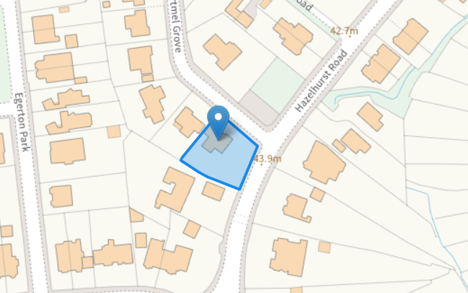

Description of Site and Surrounding Area

The application relates to a detached bungalow dwellinghouse located on the corner of the junction between Cartmel Grove and Hazelhurst Road. The surrounding area is residential in nature.

Description of Proposal

The applicant is seeking a Certificate of Lawful Development for a proposed detached garage featuring a dual-pitched roof, to be positioned at the front/side section of the garden. The structure would be sited approximately 2.8 m from the eastern boundary and no less than around 0.5 m from the splayed northeastern boundary shared with the highway. The garage would have a maximum height of 2.5 m, measured from the highest ground level adjacent to the building.

Relevant Planning History
No relevant planning history

Publicity

N/A

Neighbour Notification
N/A
Consultations

N/A

Planning Policy

National Planning Policy

The Town and Country Planning (General Permitted Development) (England) Order 2015 (as amended)

Appraisal

Garage building

In respect of the outbuilding the development is assessed against Schedule 2, Part 1, Class E, of the Town and Country Planning (General Permitted Development) (England) Order 2015 (as amended), subject to compliance with the following relevant criteria:

Class E permits the following:

E. Buildings etc incidental to the enjoyment of a dwellinghouse.

E.1 Development is not permitted by Class E if—

(a)permission to use the dwellinghouse as a dwellinghouse has been granted only by virtue of Class
G M, [MA,] N, P, [PA] or Q of Part 3 of this Schedule (changes of use);

-Not applicable.

(b)the total area of ground covered by buildings, enclosures and containers within the curtilage (other
than the original dwellinghouse) would exceed 50% of the total area of the curtilage (excluding the
ground area of the original dwellinghouse);

-The total area of ground covered by buildings within the curtilage (other than the original
dwelling) would not exceed 50% of the total area of the curtilage.

(c)any part of the building, enclosure, pool or container would be situated on land forward of a wall
forming the principal elevation of the original dwellinghouse;

-The proposed garage would be situated on land forward of a wall forming the principal
elevation of the original dwellinghouse.

(d)the building would have more than a single storey;

-The outbuilding would be single storey.

(e)the height of the building, enclosure or container would exceed—
(i)4 metres in the case of a building with a dual-pitched roof,
(ii)2.5 metres in the case of a building, enclosure or container within 2 metres of the boundary of the
curtilage of the dwellinghouse, or
(iii)3 metres in any other case;

-The proposed garage would have a maximum height of 2.5m with a dual pitched roof, measured from the highest ground level adjacent to the building within 2m of the boundary of the curtilage of the dwellinghouse.

(f)the height of the eaves of the building would exceed 2.5 metres;

-The proposed eaves of the outbuilding would not exceed 2.5m.

(g)the building, enclosure, pool or container would be situated within the curtilage of a listed building;

-Not applicable.

(h)it would include the construction or provision of a verandah, balcony or raised platform;

-Not applicable.

(i)it relates to a dwelling or a microwave antenna; or

-Not applicable.

(j)the capacity of the container would exceed 3,500 litres,

-Not applicable.

(k) the dwellinghouse is built under Part 20 of this Schedule (construction of new dwellinghouses).

-Not applicable.

E.2 In the case of any land within the curtilage of the dwellinghouse which is within—

(a)an area of outstanding natural beauty;

(b)the Broads;

(c)a National Park; or

(d)a World Heritage Site,

development is not permitted by Class E if the total area of ground covered by buildings, enclosures,
pools and containers situated more than 20 metres from any wall of the dwellinghouse would exceed
10 square metres.

-Not applicable.

E.3 In the case of any land within the curtilage of the dwellinghouse which is article 2(3) land, development is not permitted by Class E if any part of the building, enclosure, pool or container would be situated on land between a wall forming a side elevation of the dwellinghouse and the boundary of the curtilage of the dwellinghouse.

-Not applicable.

Summary and Conclusion

The application IS NOT permitted by Schedule 2, Part 1, Class E.1 (c) (of the Town and Country Planning (General Permitted Development) Order 2015 (as amended). The proposed garage building is considered to be situated on land forward of a wall forming the principal elevation of the original dwellinghouse.

Recommendation
Refuse

Document Approval
Report Author | R.Sharma
Date | 28/01/2026
Reviewer | Jade Corcoran
Date | 03/02/2026

