

Application Ref. | PA/2025/1754
Location | 19 Cheltenham Crescent, SALFORD, M7 4FP
Ward | Kersal and Broughton Park Ward
Applicant | Kloyzener
Proposal | Change of use from a dwellinghouse (use class C3) to an 8-bedroom, 8 person House in Multiple Occupation (HMO) (sui generis)
Recommendation | Refuse

Location Plan

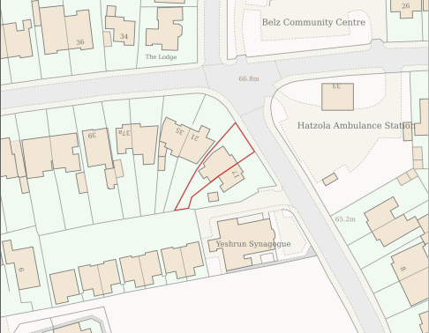
Figure 1: Site Location Plan

Description of Site and Surrounding Area

The application site is located at 19 Cheltenham Crescent, Salford, M7 4FP in the Kersal and Broughton Park Ward.

The site contains a 7 bedroom two-storey dwellinghouse (use class C3) with a converted roof space. The property has been subject to previous extensions to the side, rear and roof.

The site is located close to the junction with Broom Lane and Waterpark Road and is 400 metres from the Leicester Road Local Centre. The site is also walking distance from bus services on Bury New Road and Leicester Road which have services into Salford and Manchester.

The site is mainly within a residential area, but also contains some religious and community facilities including the Yeshrun Synagogue to the south of the site and Hatzola Ambulance Station to the east of the site.

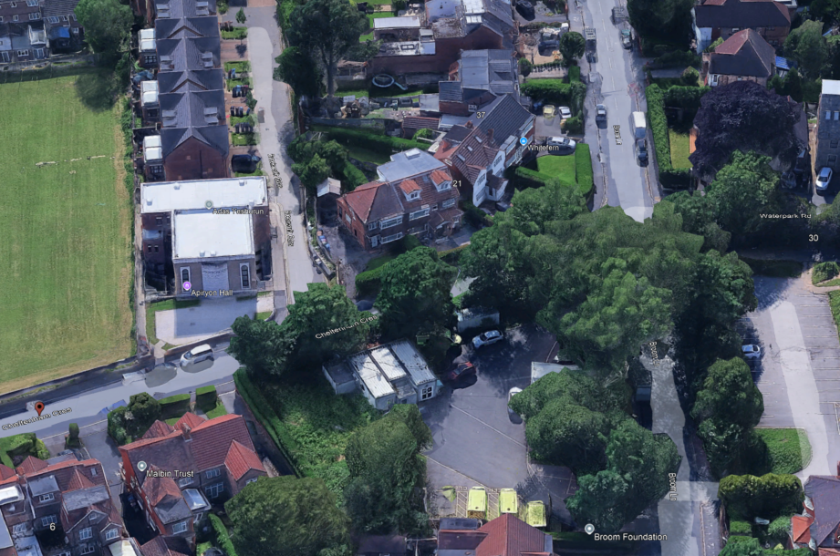
Figure 2: Aerial Image of application site and surrounding context.
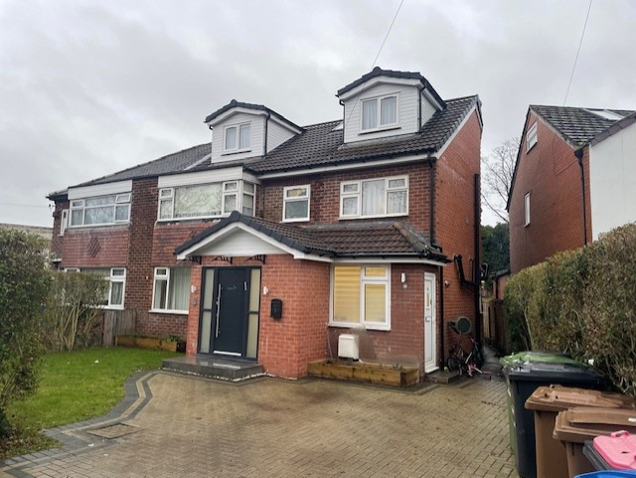
Figure 3: Front elevation of application property at 19 Cheltenham Crescent

Description of Proposal

Background

A Direction made under Article 4(1) of the Town and Country Planning (General Permitted Development) (England) Order 2015 applies to the area in which the application property is located.

The Direction came into force in the Kersal and Broughton Park Ward on the 25th November 2018 and removes the permitted development rights under Schedule 2, Part 3, Class L(b), i.e. the change of use of a building from a use falling within Class C3(dwellinghouses) to a use falling within Class C4(houses in multiple occupation).

Proposal

Change of use from a dwellinghouse (use class C3) to an 8-bedroom, 8 person House in Multiple Occupation (HMO) (sui generis).

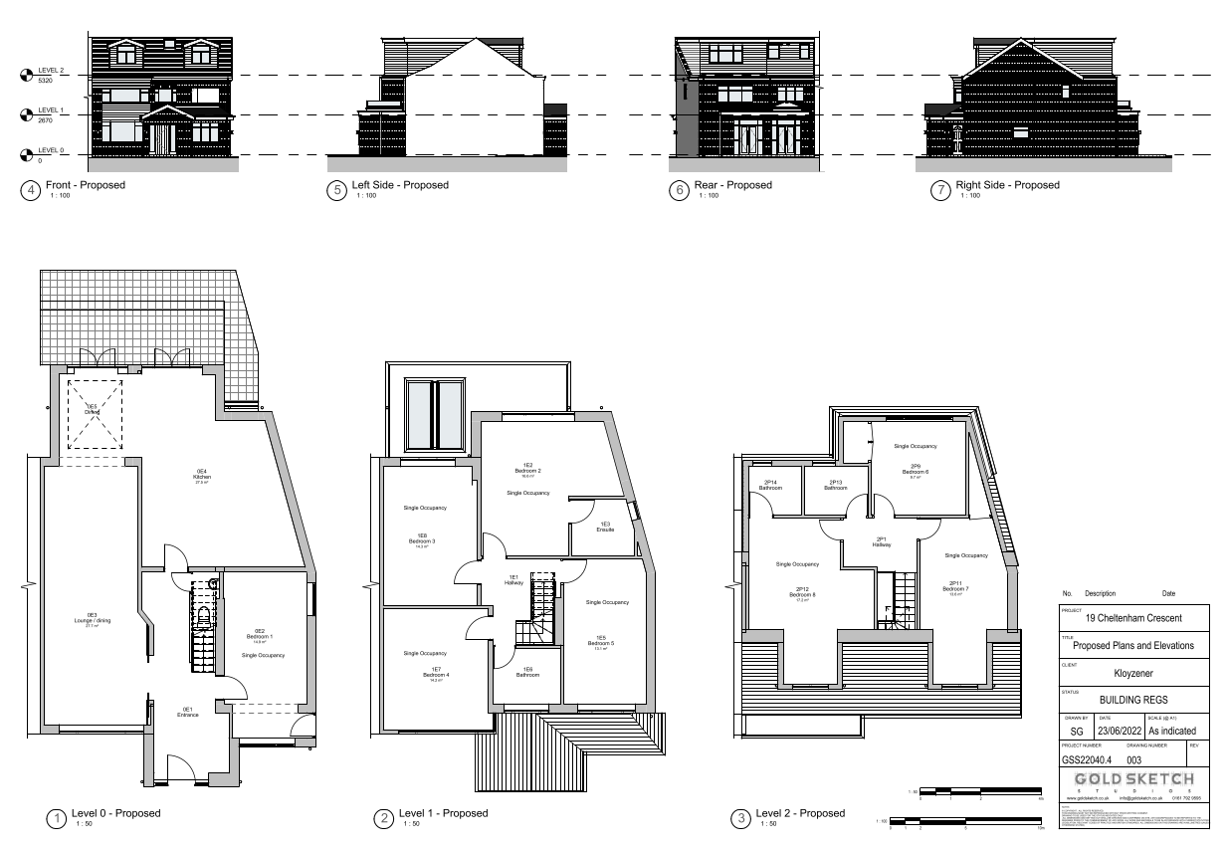
Figure 4: Proposed Plans

The schedule of accommodation is listed below:

Ground Floor
Kitchen = 27.5 m²
Lounge/dining = 27.7m²
Bedroom 1 = 14.9m²

First Floor
Bedroom 2 = 16.6 m²
Bedroom 3 = 14.3 m²
Bedroom 4 = 14.2 m²
Bedroom 5 = 13.1m²

Second Floor
Bedroom 6 = 9.7 m²
Bedroom 7 = 13.6 m²
Bedroom 8 = 17.2 m²

The development would also provide 2 shared off street parking spaces, refuse storage and rear garden.

Relevant Planning History
Planning Applications
22/80990/HH - Householder planning permission
Decision: Approve - Sent: 27 January 2023
19 Cheltenham Crescent, Salford, M7 4FP
Demolition of part single storey rear extension and erection of single storey front porch extension, part first floor rear extension and hip to gable loft conversion with front and rear dormer.
22/80265/HH - Householder planning permission
Decision: Approve - Sent: 13 September 2022
19 Cheltenham Crescent, Salford, M7 4FP
Demolition of part of single storey rear extension. Erection of part first floor rear extension and hip to gable loft conversion with front and rear dormer
01/43294/HH - Householder planning permission
Decision: Approve - Sent: 24 December 2001
19 Cheltenham Crescent, Salford
Erection of single storey extensions at front and rear of dwelling.
Publicity
Neighbour letters 19/12/25 - 23/01/2026

Neighbour Notification

Neighbouring properties have been notified of the application via letter.
The number of neighbouring properties notified - 4.
Representations from neighbours and members of the public
Comments of Support - 0
Comments of Objection - 0
Other Representations - 0
Summary of comments received: N/A

Consultations

Salford Environment Officer (DM) Summary – No objections or observations with respect to air quality, noise or land contamination.
Salford Highways Officer (DM) Summary – No objection as the proposal unlikely to harm highway safety or network capacity subject to cycle parking condition.
Salford House in Multiply Occupation (HMO) (DM) Summary - The property meets the space standards as an 8-bedroom HMO.

Planning Policy

Salford Local Plan: Development Management Policies and Designations (SLP:DMP)
Policy F1 An inclusive development process
Policy F2 Social value and inclusion
Policy F3 Inclusive places
Policy F4 Fairness between generations
Policy CC1 Climate change
Policy EF1 Efficient use of land
Policy EF2 Co-ordinated development
Policy PC1 Planning conditions and obligations
Policy H1 Type of housing
Policy H2 Size of dwellings
Policy H10 Conversion and change of use of existing houses and new build residential developments of non-self-contained units
Policy A3 Walking and cycling
Policy A6 Highway network
Policy WA4 Development and flood risk
Policy WA5 Surface water and sustainable drainage
Policy D1 Design principles
Policy D2 Local character and distinctiveness
Policy D5 Amenity
Policy D8 Alterations and extensions
Policy PH1 Pollution control
Policy WM1 Waste and development

Places for Everyone (PfE)
Policy JP-S1: Sustainable Development
Policy JP-S4: Flood Risk and the Water Environment
Policy JP-H3: Type, Size and Design of New Housing
Policy JP-P1 Sustainable Places
Policy JP-C1: An Integrated Network
Policy JP-C6: Walking and Cycling
Policy JP-C8: Transport Requirements of New Development

Other Material Planning Considerations

National
National Planning Policy Framework
National Planning Practice Guidance

Local Planning Policy and Development Frameworks/Strategies
Houses in Multiple Occupation Supplementary Planning Document

Local Finance Considerations
It is not considered that there are any local finance considerations that are material to the application.

Appraisal

The NPPF advocates a presumption in favour of sustainable development. It is the role of the planning system to support strong, vibrant and healthy communities by providing the supply of housing needed to meet the needs of present and future generations and by creating a high quality built environment with accessible local services that reflect the community’s needs and support its health, social and cultural wellbeing.

Local Plan Policy H1 states that residential developments shall contribute to the provision of a broad mix of housing options across Salford and within the local area, ensuring that identified housing needs can be met.

Policy F3 states that all places and developments shall be as inclusive as possible. Achieving this will involve a diverse mix of decent and adaptable homes, including affordable housing that enables everyone to meet their housing needs.

HMOs can make an important contribution to the housing supply, generally providing low-cost private sector accommodation for those on low incomes, students, and those seeking temporary accommodation. There is a need to ensure that this development does not have an unacceptable impact on the positive residential character and residential amenity of the surrounding neighbourhood in accordance with Policy H10 and the HMO Supplementary Planning Document (SPD).

Proportion of HMOs in the area

Local Plan Policy H10 sets out how conversions and changes of use from existing dwellings to HMOs and other stated uses will be controlled in order to ensure that a good supply of houses is maintained within Salford and the positive character of neighbourhoods protected.

Part 1 of Policy H10 states that conversions to HMOs (amongst other uses listed) will only be permitted where it can be demonstrated that the proposal would not, either individually or cumulatively with other listed uses (including completed developments and schemes with planning permission or prior approval) have an unacceptable impact on the positive residential character of the surrounding neighbourhood, having particular regard to potential increases in noise and disturbance, on-street car parking, waste management and population turnover levels that could reduce community stability.

Policy HMO1 of the Council’s HMO SPD states that planning permission will not normally be granted for new HMOs where:

- The proportion of HMOs already exceeds 10% of all residential properties within a 100-metre radius of the application property; or
- The proportion of HMOs would exceed 10% of all residential properties within a 100-metre radius of the application property as a result of a proposed new HMO.

Having reviewed the number of HMOs, the proposal would be the only HMO within a 100m radius, which equates to a concentration level of 2.22% (figure 5 below). This would not exceed the 10% concentration threshold set out in Policy HMO1.

Assessment against Part 3 of Local Plan Policy H10 of the SLP:DMP

The supporting text to Local Plan Policy H10 states that it is important that conversions to such uses, and to more commercial uses are carefully controlled so that they do not compromise the attractiveness of the wider neighbourhood as a residential location or the amenity of individual dwellings. Some uses can be quite transitory in nature, having a relatively rapid turnover of occupants, and consequently a high concentration of them can adversely affect the stability of a neighbourhood. Some uses can also increase the pressure on their surroundings due to an increase in the number, or a change in the type of occupants.

Part 3 of Policy H10 states that conversions to HMOs will only be permitted where it can be demonstrated that the proposal would not, either individually or cumulatively with other completed developments and schemes with planning permission or prior approval result in any house that is in use as a single dwelling being immediately adjacent to more than one property in use as student housing, houses in multiple occupation, hotels, residential institutions, hostels, children’s homes and similar uses and non-residential uses such as offices.

Policy H10 clarifies that for the purposes of this policy “immediately adjacent properties include properties directly behind and opposite, as well as to either side”.

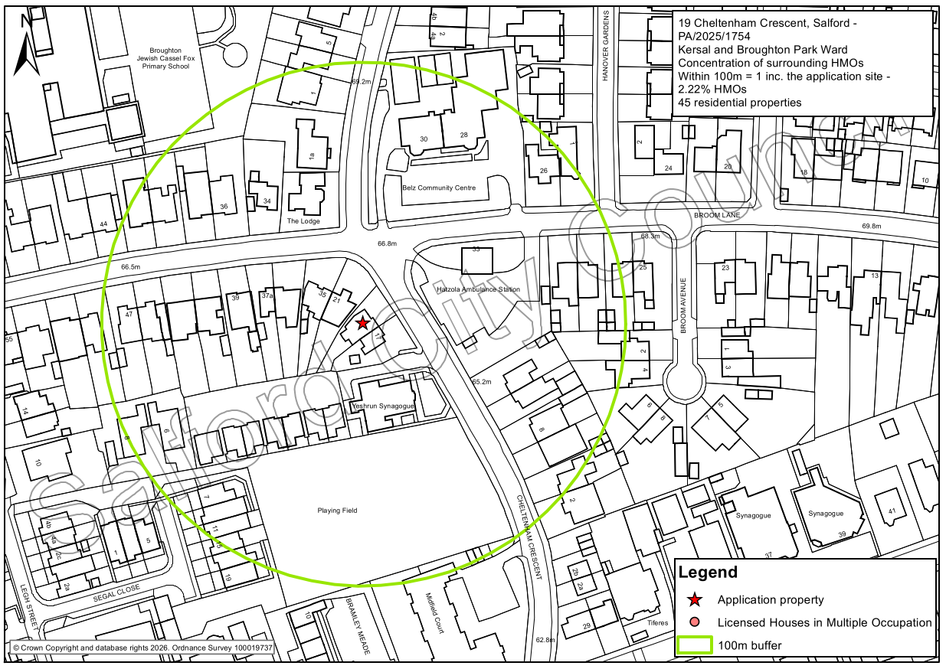
Figure 5: HMO 100m buffer map.
The planning history for the properties in the immediate vicinity has been reviewed as highlighted in Figure 5 and there is no record of any other HMOs within the area. The adjacent properties at numbers 17 and 21 Cheltenham Crescent are dwellinghouses (use class C3).

However, it is noted that the site is located close to the Yeshrun Synagogue to the south of the site and Hatzola Ambulance Station to the east of the site, which are classed as existing non-residential uses within the list of B) to G) uses outlined in Policy H10. The proposal would therefore not comply with part 3) of Policy H10 in respect of No’s 17 and 21 Cheltenham Crescent as it would mean that these properties would be immediately adjacent to more than one property in uses B) to G) as defined in the policy.

Impact on 17 Cheltenham Crescent

The dwellinghouse at no 17 Cheltenham Crescent is the adjoining property directly to the south of the application site, which is also adjacent to an existing non-residential use at the Yeshrun Synagogue to the south. It is separated from the Synagogue by a narrow private road (Brockworth Gardens) containing a terrace of dwellings to the rear. As a place of worship serving the local community the Synagogue involves various services, events and functions.

The proposed change of use to an 8 bed 8 person HMO at no. 19 Cheltenham Crescent would result in number 17 Cheltenham Crescent being adjacent to both the proposed large HMO, and an existing non-residential use (Yeshrun Synagogue) contrary to Part 3 of Policy H10. Considering this conflict with the adjacency test in Policy H10 and the large scale of the 8 bed 8 person HMO, it is considered that the proposal would result in an unacceptable impact on the residential amenity on the occupants of no. 17 Cheltenham Crescent.

It is noted that the Hatzola Ambulance Station is opposite the site which is a 24-hour use. However, Cheltenham Crescent is a wide road, the ambulance station has a high boundary hedge, and the access is off Broom Lane, which would lessen the cumulative impacts by reason of adjacency with the proposed large HMO.

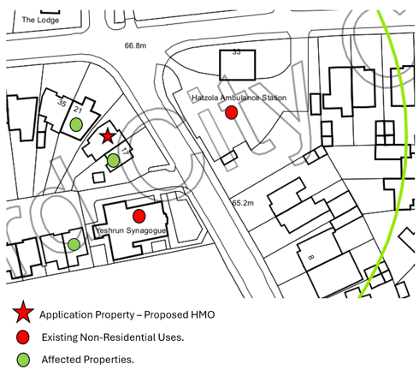
Figure 6: Close up map showing affected properties.

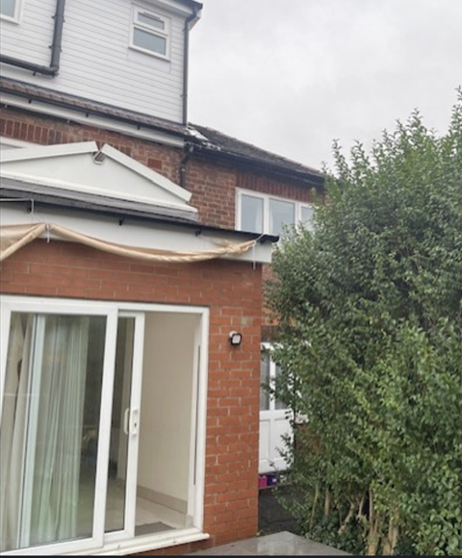
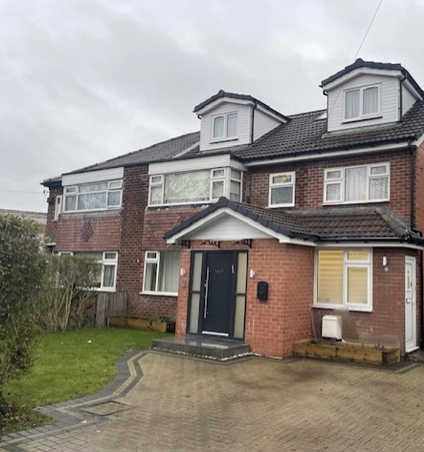
Figure 7: Front & Rear Relationship with no 17 Cheltenham Crescent

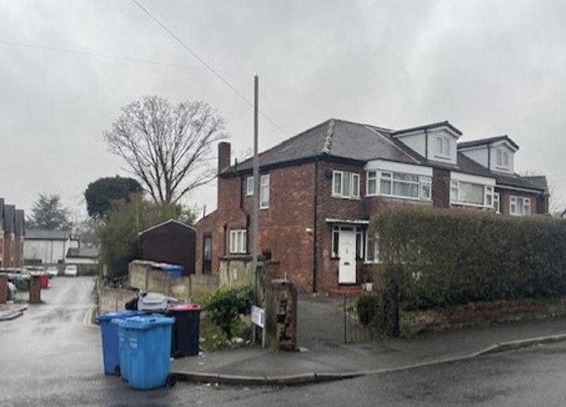
Figure 8: Adjoining Property at no. 19 Cheltenham Crescent (also showing Brockworth Gardens Private Road)

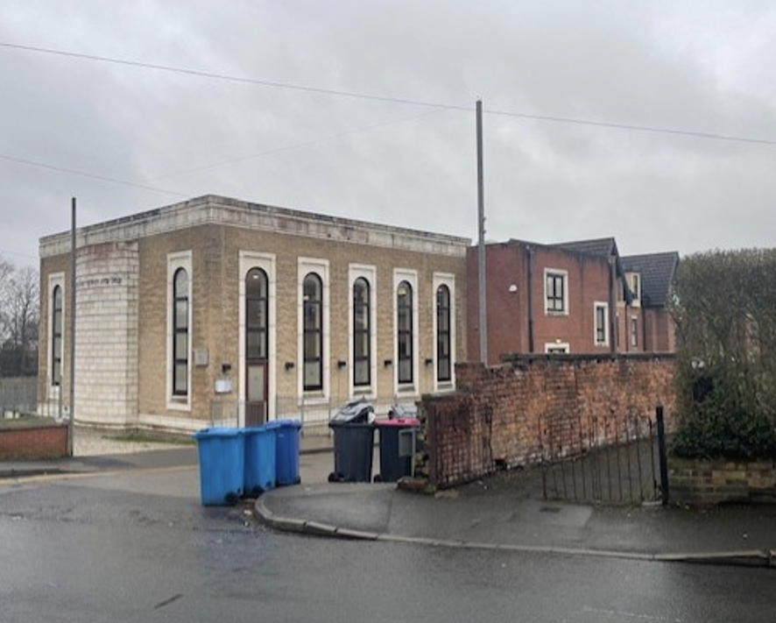
Figure 9: Synagogue adjacent to no. 17 Cheltenham Crescent

Impact on 21 Cheltenham Crescent

Whilst the development would also result in the adjacent dwelling at 21 Cheltenham Crescent being adjacent to the proposed large HMO and the Hatzola Ambulance Station contrary to policy H10, it is not considered that this policy conflict would translate into significant harm to the residents of that property. This is because no. 21 is separated (detached) from no 19, angled way from it, and the road is wide therefore reducing any impacts.

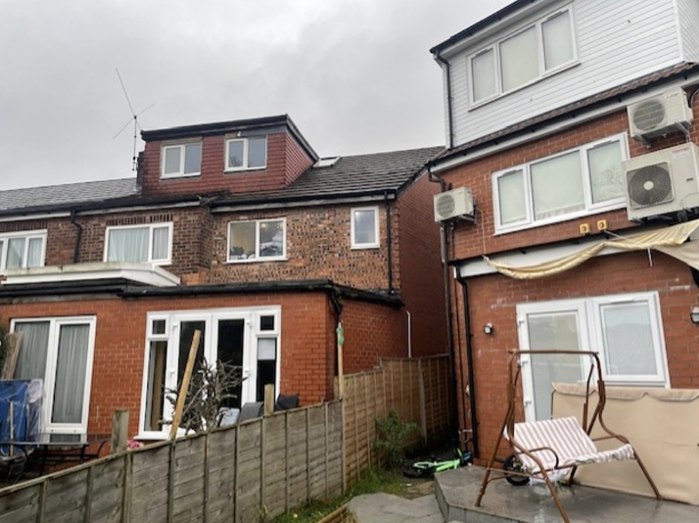
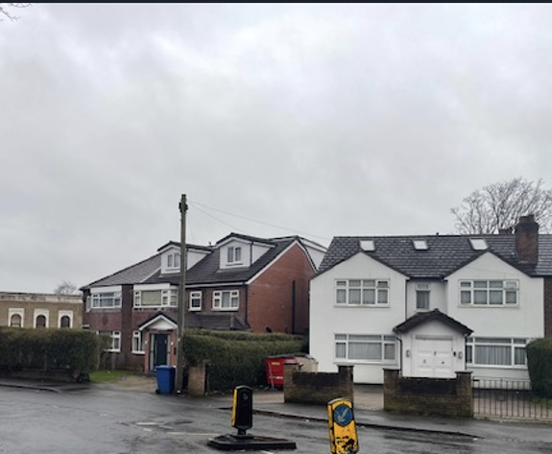
Figure 10: Front & Rear Relationship with no 21 Cheltenham Crescent

Impact on Brockworth Gardens

The development would also result in the dwelling to the rear on Brockworth Gardens being adjacent to the proposed large HMO and the Synagogue. However, this property is well separated by the rear garden of the application site and the access road on Brockworth Gardens thereby also reducing the impacts.

Design/Visual Amenity

There are no external alterations to facilitate the conversion and therefore it is not considered the proposal would adversely affect the character and appearance of the application property or the visual amenities of the wider area. The development is therefore considered to be in accordance with the design policies in the Local Plan and the NPPF.

Residential Amenity

Amenity of neighbours

Local Plan Policy D5 states that development shall ensure that it does not have an unacceptable impact on the amenity of the users of other buildings and spaces.

The proposal would not alter the scale or massing of the property or its relationship to the neighbouring residential properties, with the proposal not introducing windows/doors into elevations where they do not currently exist. As such it is not considered that the proposal would result in neighbouring residents experiencing any unacceptable loss of light, privacy and/or overbearing impact.

However, the occupiers of a HMO are more likely to lead independent lives from one another. Taking account of the activity generated by this large HMO with 8 people living independent lives, with separate routines, and their associated comings and goings along with those of their visitors and deliveries, the proposal would lead to a significant increase in the level of activity and an intensification in use when compared to that associated with the existing dwellinghouse. Consequently, due to the property’s close relationship with 17 Cheltenham Crescent it is considered that the proposal would have an adverse amenity impact on the living conditions of the occupiers of that neighbouring property through an unacceptable increase in noise and disturbance contrary to Local Plan Policy D5.

The Salford Environment Officer has no objections in respect of noise. However, whilst it is acknowledged that there may not be a statutory noise impact, it is considered that the level of noise and disturbance from the proposed large HMO would result in a material impact on the residential amenity of the occupants of 17 Cheltenham Crescent in planning terms.

The plans show the removal of part of the hedge between 19 and 21 Cheltenham Crescent which reduces the screening between these properties. Had this development been otherwise acceptable amendments would have been sought to retain this.

Future Occupiers

The Council’s Standards for houses in multiple occupation document offers guidance to landlords on the physical standards that are required for licensing purposes including minimum room sizes, bathroom and kitchen facilities and fire safety provision. Whilst this document does not form part of the development plan, Local Plan Policy H2 confirms that all HMOs shall meet the minimum room size and amenity standards set out in this document.

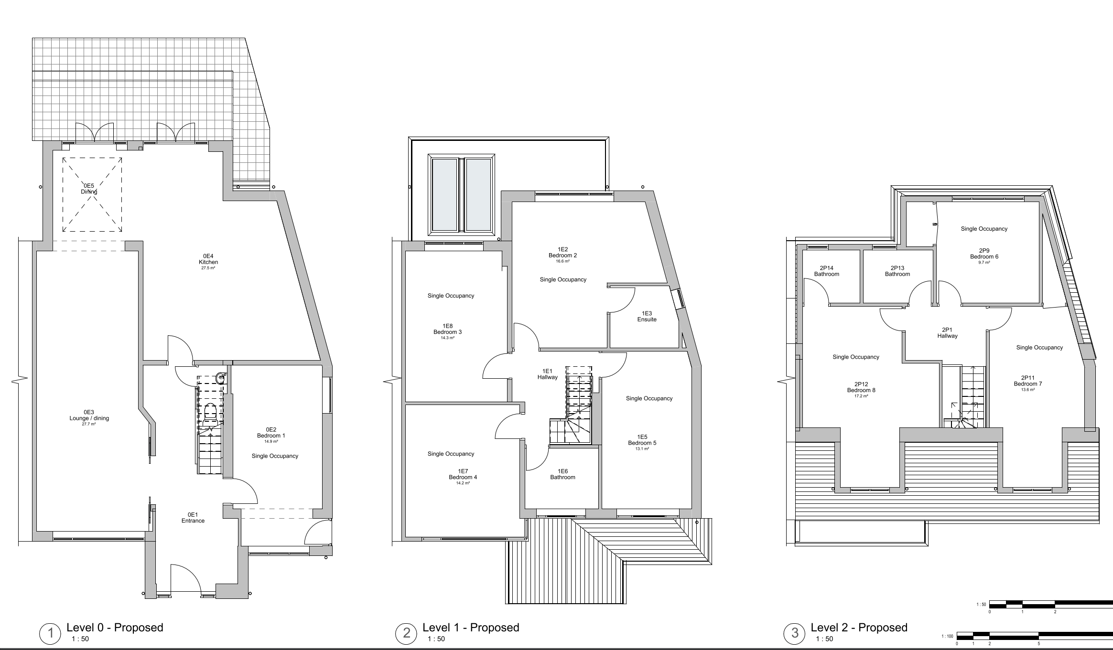
Figure 11: Proposed Floorplans of HMO

All habitable rooms inside the property have at least one window to the front or rear of the dwelling, allowing for sufficient light within the rooms and a satisfactory outlook. The property also benefits from a rear garden which will provide the occupants with private amenity space.

The schedule of accommodation is listed below:

Ground Floor
Kitchen = 27.5 m2
Lounge/dining = 27.7m2
Bedroom 1 = 14.9m2

First Floor
Bedroom 2 = 16.6 m2
Bedroom 3 = 14.3 m2
Bedroom 4 = 14.2 m2
Bedroom 5 = 13.1m2

Second Floor
Bedroom 6 = 9.7 m2
Bedroom 7 = 13.6 m2
Bedroom 8 = 17.2 m2

All of the bedrooms in the proposed HMO would exceed the Council’s HMO standards of 6.51 m² for single occupancy rooms.

The kitchen (27.5 m²) and living/dining room (27.7 m²) in the proposed HMO would exceed the Council’s HMO standards (highlighted in figure 8 below).

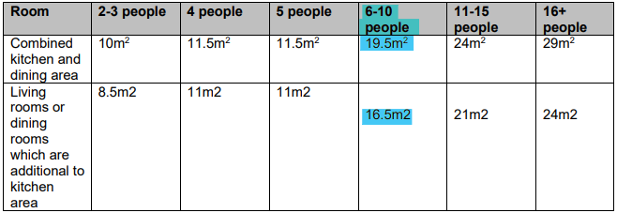
Figure 12: HMO space standards for communal spaces.

The standards state there is a requirement for a living room in a HMO unless all bedrooms are 10m² or greater. The proposed HMO includes a bedroom below 10m², so a living room has been provided.

In respect of bathing facilities, the property exceeds the minimum requirements as shown below as it provides an en-suite (shower/toilet/wash hand basin) in two of the bedrooms, and separate bathrooms on the first and second floors.

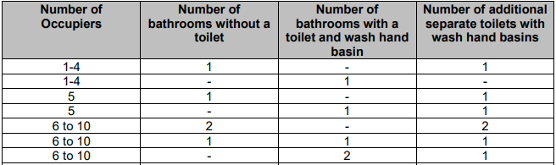
Figure 13: Standards for HMO bathroom facilities and personal hygiene.

The HMO Licensing Team have been consulted and have advised that they have no objection to the proposal and consider it complies with the space standards for a 8 person HMO.

Officers are satisfied that the rooms comply with the Council’s Standards for houses in multiple occupation document and therefore raise no objections in this regard.

Impact on Highway

Site Sustainability

The site is located on Cheltenham Crescent, close to the junction with Broom Lane and Waterpark Road and is 400 metres from the Leicester Road Local Centre. The site is also walking distance from bus services on Bury New Road and Leicester Road for services into Salford and Manchester and other destinations. Therefore, the site can be considered to be located within a sustainable location.

Parking Provision

The property is situated on Cheltenham Crescent within an established residential area and benefits from proximity to local amenities along Bury New Road. Public transport accessibility is good, with bus stops located approximately 450 metres away on Bury New Road, offering frequent services to Prestwich, Bury, Manchester City Centre, and other destinations. The Local Highway Authority (LHA) considers the site to be in a sustainable location.

Analysis of 2021 Census data on car ownership by tenure indicates that owner-occupied properties typically have around 84% car ownership, while privately rented and socially rented properties average approximately 53% and 44% respectively. Given the proposed use, car ownership is expected to align more closely with private or social rental patterns, equating to an estimated 3–4 vehicles. Although the change of use may generate additional parking demand, the property includes a large driveway capable of accommodating two vehicles. Furthermore, there are no parking restrictions on Cheltenham Crescent or adjacent streets, allowing for on-street parking. Consequently, the impact on the local highway network is anticipated to be minimal.

Cycle Parking

The current proposal does not include cycle parking provision; however, the rear yard offers sufficient space for such facilities. In line with Salford City Council’s Local Plan, a minimum of one cycle space per two bedrooms is required for HMO developments, meaning four secure spaces should be provided. Cycle storage must comply with Policy A3, ensuring it is secure, conveniently located with good natural surveillance, provides adequate clearance and manoeuvring space, and includes multiple locking points.

Given the modest scale of the development and its sustainable location, the proposal is not considered to have an adverse impact on highway safety or the cumulative effect on the road network, in accordance with Policy A6 of Salford’s Local Plan.

The Highways Officer has no objections.

Impact on Waste Management

The proposed plans show the proposed HMO will be provided with an area of bin storage for 8 bins at the front/side of the property which is where the bins are stored currently.

Conclusion

Planning law states that any determination must be made in accordance with the development plan unless material considerations indicate otherwise.

The development has been assessed and found to be contrary to the Local Plan, as it would result in the adjacent dwellinghouse at no 17 Cheltenham Crescent being adjacent to the proposed large HMO and an existing non-residential use, which would be harmful to the residential amenity of the occupants of that property. Whilst there are some benefits of the development including the contribution to low cost housing supply, it is considered that this would not outweigh the harm caused to neighbouring amenities in this case.

Recommendation

Refuse

Document Approval
Report Author | Robert Lester
Date | 30.01.2026
Reviewer | A Stephenson
Date | 3.2.26

