

Application Ref. | PA/2025/1770
Location | 61 Westwood Crescent, ECCLES, MANCHESTER, M30 8DY
Ward | Worsley and Westwood Park Ward
Applicant | Pintum Properties Limited
Proposal | Change of use from residential dwellinghouse (use class C3) to 5 bedroom 5 person House in Multiple Occupation (HMO) (use class C4) and erection of a single storey rear including external alterations
Recommendation | Approve with Conditions

Location Plan

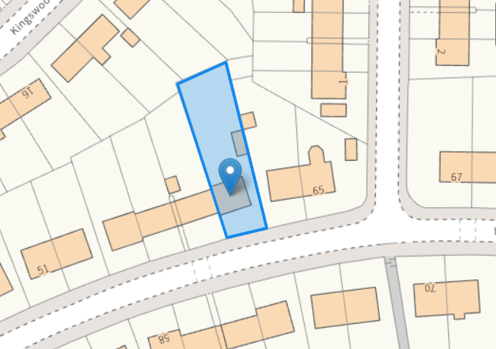

Description of Site and Surrounding Area

This application relates to a two storey end terrace (row of four) dwellinghouse with an existing detached outbuilding / store within the rear garden. The existing property is in use as a dwellinghouse (use class C3). The surrounding dwellings are a mix of terraced and semi-detached properties. The site subject to this application is located in Worsley and Westwood Park Ward and is covered by the existing Article 4 Direction which came into effect in November 2024 thereby removing the permitted change of use from a dwelling (use class C3) to a small HMO (use class C4).

Description of Proposal

Permission is sought for the change of use of the dwelling to a 5 person House in Multiple Occupation (HMO) (Use Class C4).

The proposal also comprises the erection of a single storey rear extension with a flat roof which would project 1.35m from the main rear elevation of the property to facilitate the development.

External alterations include insertion of a window at ground floor in the main rear elevation of the property serving the dining area.

Proposed Floor & Elevation Plans (amended plans received dated 28/01/2026 – insertion of a window in the main rear elevation at ground floor serving dining area)

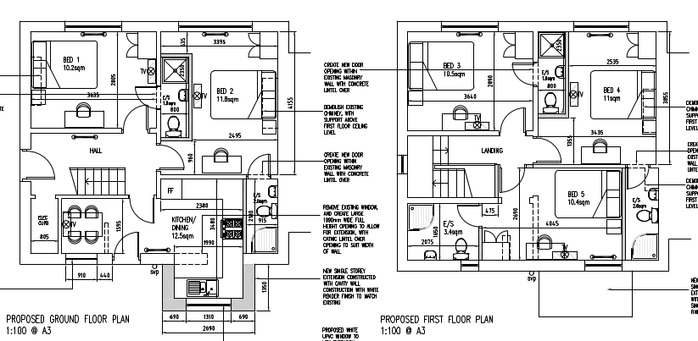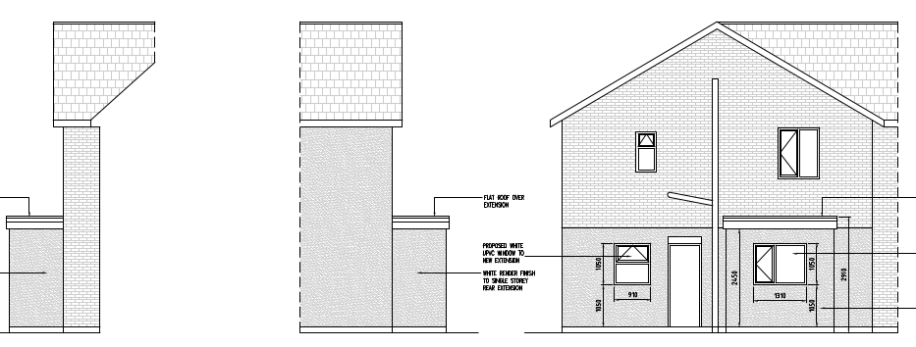

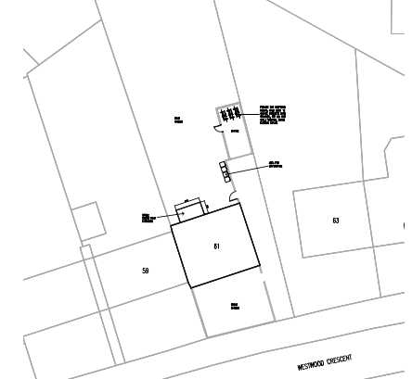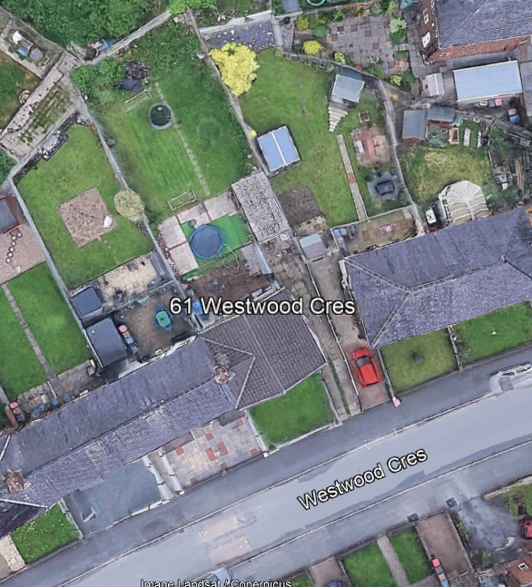

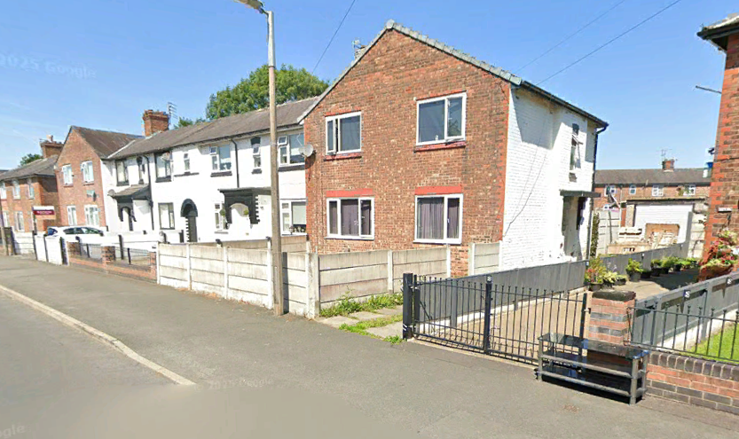

The floor space of each room would be as follows:

Ground Floor
Kitchen / Diner: 12.5m²
Bedroom 1: 10.2m²
Bedroom 2: 11.8m²

First Floor
Bedroom 3: 10.5m²
Bedroom 4: 11m²
Bedroom 5: 10.4m²
Each of the bedrooms would have an ensuite.
A bin store and cycle store would be provided within the rear garden.

Relevant Planning History

No planning history

Publicity
Neighbours - Publicity Start Date - 13 January 2026
Neighbour Notification
12 neighbouring properties have been notified of the application via letter. 5 objections and 1 expression of support have been received from neighbouring properties.

Summary of comments received:

Overdevelopment & Change in Character:
- Converting a single family home into a five-bed HMO is considered excessive for the plot.
- The proposal is out of keeping with an area characterised by long-established family homes and a stable residential community.

Noise & Disturbance:
- HMOs typically generate more noise, particularly due to higher turnover of residents.
- The proposal includes garden seating directly beside neighbouring bedrooms and living rooms, increasing the likelihood of disruptive noise, especially in the evenings and at night.
- Concerns include increased noise from toilets, showers, doors, and general activity associated with higher occupancy.
- Increase in noise from multiple occupants would seriously affect health and wellbeing.

Parking Pressure:
- On-street parking is already extremely limited.
- A five-bed HMO could mean several adult residents, each potentially with a vehicle, placing unacceptable strain on local parking and raising road safety concerns.

Inadequate Waste Provision:
- The plans do not demonstrate sufficient or discreet waste and recycling storage for up to five occupants.
- Risk of overflowing bins, hygiene issues, and visual impact on the street scene.

Loss of Family Housing:
- Family homes are already in short supply. Converting this property into an HMO removes a valuable family-sized dwelling from the area.
- This further undermines the long-term sustainability of the neighbourhood as a family-focused community.

Amenity Impacts:
- Potential for increased noise, refuse, and general disturbance affecting households with young children and elderly residents, and will have a detrimental impact on the health of neighbouring residents as a result.
- The area is not designed for intensified use or transient occupancy.

Safeguarding & Management Concerns:
- Lack of clarity regarding:
    - occupancy levels
    - who the rooms will be rented to
    - overall management and supervision of the property

Concerns Based on Other Local HMOs:
- Existing HMOs on Parrin Lane have caused issues such as rubbish accumulation, noise, nuisance behaviour, and disturbance from vehicles and young occupants and fear similar impacts here.

Consultations
Salford Environment Officer (DM)
No objection subject to informatives to make the applicant aware of their responsibilities.
Salford Highways Officer (DM)
No objection, subject to a condition requesting details of cycle storage.
Salford House in Multiple Occupation (HMO) Licensing Team (DM)
The property meets the space standards for a 5 bedroom HMO.
Planning Policy
Salford Local Plan: Development Management Policies and Designations (SLP:DMP)

Policy F1 Inclusive development process
Policy F2 Social value and inclusion
Policy F3 Inclusive places
Policy F4 Fairness between generations
Policy CC1 Climate change
Policy H1 Type of housing
Policy H2 Size of dwellings
Policy H3 Housing density
Policy H10 Conversion and change of use of existing houses, and new build residential development
of non-self contained units
Policy HH1 Development and health
Policy A1 Supporting sustainable transport
Policy A3 Walking and cycling
Policy A6 Highway network
Policy EG1 Sustainable energy
Policy D1 Design principles
Policy D2 Local character and distinctiveness
Policy D3 Layout and access
Policy D5 Amenity
Policy D6 Design and crime
Policy D7 Housing design
Policy D8 Alterations and extensions
Policy BG2 Development and biodiversity
Policy PH1 Pollution control
Policy WM1 Waste and development

Places for Everyone (PfE)

Policy JP-S1: Sustainable Development
Policy JP-C6: Walking and Cycling
Policy JP-H3: Type, Size and Design of New Housing

Other Material Planning Considerations
National
- National Planning Policy Framework
- National Planning Practice Guidance

Local Planning Policy and Development Framework/ Strategies
- Houses in Multiple Occupation SPD – 4 June 2024

Local Finance Considerations
It is not considered that there are any local finance considerations that are material to the application.

Appraisal

The NPPF advocates a presumption in favour of sustainable development. It is the role of the planning system to support strong, vibrant and healthy communities by providing the supply of housing needed to meet the needs of present and future generations and by creating a high-quality built environment with accessible local services that reflect the community’s needs and support its health, social and cultural wellbeing.

Policy H1 of the Local Plan states that individual new residential developments shall contribute to the provision of a broad mix of housing options across Salford and within the local area, ensuring that identified housing needs can be met.

Policy F3 of the Local Plan states that all places and developments shall be as inclusive as possible. Achieving this will involve a diverse mix of decent and adaptable homes, including affordable housing that enables everyone to meet their housing needs.

The site subject to this application is located in Worsley and Westwood Park Ward and is covered by the existing Article 4 Direction which seeks to to positively manage potential amenity and character impacts associated with HMOs and their concentrations, as well as to ensure that balanced communities are maintained within the City. Notwithstanding this it is recognised that HMOs can make an important contribution to the housing supply, generally providing low-cost private sector accommodation for those on low incomes, students, and those seeking temporary accommodation. However, where there is a high proportion of HMOs clustered in one area, harmful impacts associated with this housing type can occur.

Proportion of HMOs in the area

Policy H10 of the Local Plan sets out how conversions and changes of use from existing dwellings to HMOs and other stated uses will be controlled in order to ensure that a good supply of houses is maintained within Salford and the positive character of neighbourhoods protected.

Part 1 of Policy H10 of the SLP:DMP states that conversions to HMOs (amongst other uses listed) will only be permitted where it can be demonstrated that the proposal would not, either individually or cumulatively with other listed uses (including completed developments and schemes with planning permission or prior approval) have an unacceptable impact on the positive residential character of the surrounding neighbourhood, having particular regard to potential increases in noise and disturbance, on-street car parking, waste management and population turnover levels that could reduce community stability.

The Council has adopted the Houses in Multiple Occupation Supplementary Planning Document (HMO SPD) which has been produced to better manage the provision of new HMOs throughout Salford by providing a threshold to guide the location of them. Policy HMO1 within the SPD states that planning permission will not normally be granted for new HMOs, or for proposals to extend existing HMOs that would increase the number of bedrooms within it, where: A) the proportion of HMOs already exceeds 10% of all residential properties within a 100-metre radius of the application property; or B) the proportion of HMOs would exceed 10% of all residential properties within a 100-metre radius of the application property as a result of a proposed new HMO.

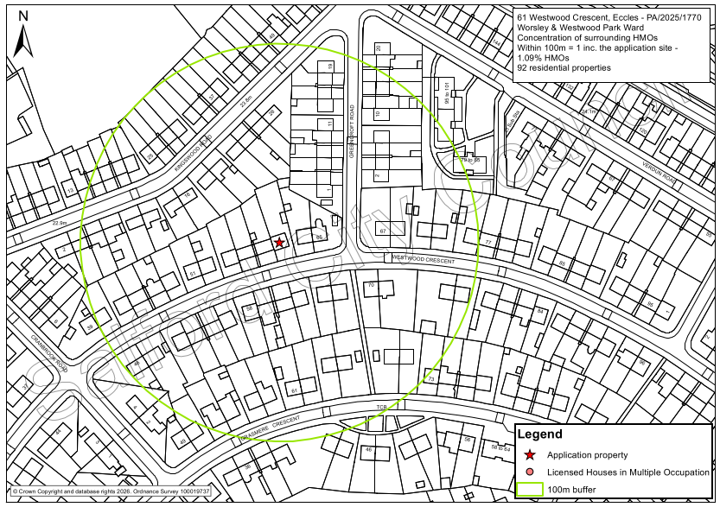
100m radius map (applicant property indicated by red star)

The above map shows there are no existing HMOs within the immediate locality. There are 92 residential properties within a 100m radius of the application property, and none of these is an existing licensed HMO. The application proposal would therefore be the only HMO within the 100m radius, representing 1.09% of all residential properties. As such this would fall below the 10% threshold, in accordance with Policy HMO1 of the HMO SPD.

Assessment against Part 3 of Policy H10 of the SLP:DMP

Part 3 of Policy H10 of the SLP:DMP states that conversions to HMOs will only be permitted where it can be demonstrated that the proposal would not, either individually or cumulatively with other completed developments and schemes with planning permission or prior approval result in any house that is in use as a single dwelling being immediately adjacent to more than one property in use as student housing, houses in multiple occupation, hotels, residential institutions, hostels, children’s homes and similar uses and non-residential uses such as offices.

The conversion of the application property to a HMO would not result in a single dwelling being immediately adjacent to more than one property in use as a HMO, as shown below. For the avoidance of doubt, Policy H10 clarifies that for the purposes of this policy “immediately adjacent properties include properties directly behind and opposite, as well as to either side”.

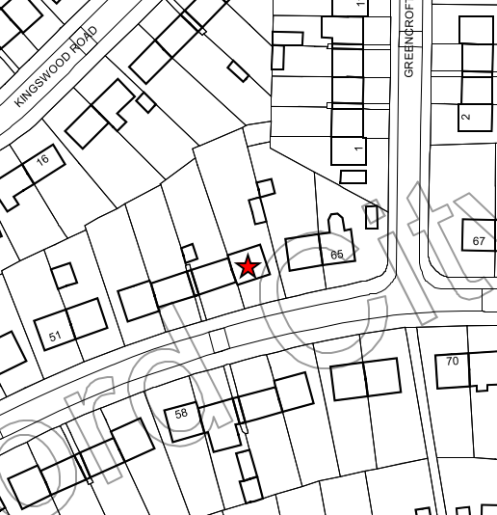
Close up map of HMOs from Licensing records on Westwood Crescent

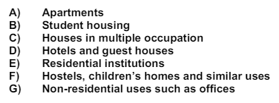
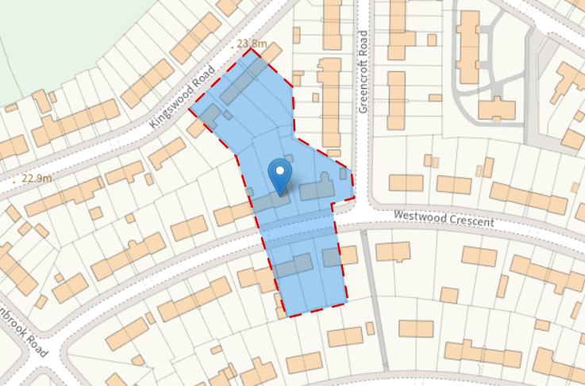
Site history search within immediate locality and uses listed in Policy H10

The case officer has reviewed the planning history for the properties in the immediate vicinity as highlighted above and there are no uses listed B) to G) within Policy H10.

For the purposes of carrying out the assessment of Policy H10 in respect to the proposed change of use of the applicant property, it is not considered that the proposal would result in a single dwelling being immediately adjacent to more than one property within uses listed B) to G) within Policy H10 of the SLP:DMP. The development is therefore compliant with the policy.

Visual Amenity

The single storey extension would be sited to the rear and would be a subservient and modest addition to the existing dwelling.

The proposal uses materials to match and would not have an unacceptable detrimental impact upon the character of the surrounding area in accordance with Policies D1, D2, and D8 of the SLP:DMP.

Residential Amenity

Amenity of neighbours

The single storey rear extension would be set away from the shared common boundary by 1.1m and 6.1m respectively from the adjoining and adjacent properties Nos 59 and 63 Westwood Crescent. The extension would not encroach beyond a line drawn at 45 degrees at a point 3m along the common boundary, protecting the amenity of neighbours on either side of the host dwelling. It is considered the extension would not result in an unacceptable loss of daylight and/or sunlight, be overbearing or create undue overshadowing to the neighbouring residents complying with Policy HE5.

A distance of circa. 21m+ is maintained between the development and the rear site boundary with sufficient separation distance such that the insertion of new openings would have limited/no impact on the neighbouring gardens /houses beyond the rear site boundary set and which are slightly angled away from the application site.
Noise
The existing property has 3 bedrooms, all of which could accommodate double beds. Whilst there will be a level of noise and activity associated with future occupiers going about their day, the proposal would be for a maximum of 5 people and so the level of activity associated with the HMO would not be significantly different than could be expected for a 3 bedroom dwelling house.
Amenity of occupiers
The Council’s Standards for houses in multiple occupation document offers guidance to landlords on the physical standards that are required for licensing purposes including minimum room sizes, bathroom and kitchen facilities and fire safety provision. Whilst this document does not form part of the development plan, Local Plan Policy H2 confirms that all HMOs shall meet the minimum room size and amenity standards set out within it.

According to the Council’s Standards for houses in multiple occupation document, the following relevant space standards are required to be met:
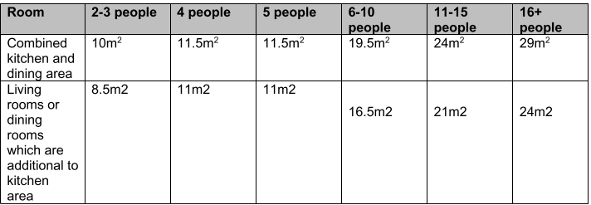
It is noted that the ground floor plan shows an open plan kitchen and dining room. The standards state that for a 5 person HMO, a combined kitchen and dining area should be a minimum of 11.5m^{2.}. The ground floor plan floor shows the open plan kitchen and dining area would be 12.5m², slightly exceeding the minimum standards by 1m².

The standards state there is a requirement for a living room in a HMO unless all bedrooms are 10m² or greater. All bedrooms would exceed 10m² and therefore this is not required. In addition, each bedroom within the property would be provided with an ensuite shower room.
The application property has a generous rear garden which provides external amenity space for the occupiers of the HMO. Broadoak Park is also within a short walk of the site. All habitable rooms within the property would be served by adequately sized and sited windows.

The HMO Licensing Team have been consulted and have advised that they have no objection to the proposal and that it complies with the space standards for a 5 person HMO.

Waste Management

The proposed plans show the HMO will be provided with an area of bin storage at the rear of the property. The management company can enter into a contract for additional bins and/or collections as deemed necessary thereby ensuring that waste accumulation does not become an issue either in respect of visual amenity or pest control. The property’s rear garden can be used to store the necessary bins as per the existing situation and consequently, it is considered that appropriate facilities for the disposal of waste and recycling can be provided.

Highways and Parking
Site Sustainability
The property is located within a residential neighbourhood within walking distance of local amenities. There are bus stops located directly outside of the site on Westwood Crescent and within 450m walk off the site on Parin Lane and Worsley Road which provides regular connections to Eccles, Worsley and Manchester City Centre amongst many other destinations. Therefore, the development would be located within a sustainable area.

Parking Provision
There is a driveway to the front of the property with an associated dropped kerb, however the driveway measures 2m in width at the access point and is unlikely to be able to accommodate modern cars. There are no parking restrictions on this section of Westwood Crescent and there are minimal parking restrictions on the surrounding roads therefore, any parking associated with the property is likely to take place on Westwood Crescent and the surrounding streets where there are on street parking opportunities. It is likely that there may be an increase in car ownership associated with the property compared to the previous use albeit a small increase. With the minor scale of the development and the close proximity to local public transport links; in accordance with the NPPF it would not be considered to have a "severe" impact on the local highway network.

Cycle Parking
The applicant has indicated cycle parking within the garage in the rear garden for 6no. cycles, utilising
3no. Sheffield stands, this is considered acceptable. Cycle parking should be provided in accordance with Salford's Local Plan Annex C Parking Standards, which for a C4 HMO requires a minimum of 1 space per 2 bedrooms. Therefore a minimum provision of 3 secure cycle parking spaces would be required. Any cycle storage should be provided in accordance with Policy A3 of Salford's Local Plan being:

a) Secure;

b) Provided in a location that is visible, has good natural surveillance, and is convenient and attractive
to potential users;

c) Allows sufficient aisle widths, turning spaces and clearance distances from walls; and

d) Provides multiple locking points.

A condition will be imposed to secure the cycle parking.

Due to the minor scale and sustainable location of the development, the proposal would not have a severe impact on the local highway network and therefore the Local Highway Authority have raised no objection to the planning application.

Other issues
Objectors have expressed concerns that the HMO will increase anti-social behaviour in the area but it would not be reasonable to refuse permission on the assumption that tenants would behave in such a way. Noise and anti-social behaviour are matters that can be addressed through environmental health legislation and tenancy management. HMOs are a recognised part of the housing mix. While family housing is important, HMOs also meet a specific housing need, particularly for young adults and key workers therefore a balanced housing mix is essential. The planning application is assessed on its own merits and would not automatically set a precedent for future HMO conversions and / or extensions, which would be subject to their own assessment against relevant policies and standards. All other matters are addressed in the Appraisal section of the report.
Recommendation
Approve with Conditions

Document Approval
Report Author | R.Sharma
Date | 04/02/2026
Reviewer | G Clegg
Date | 04/02/2026

