

Application Ref. | PA/2025/1583
Location | 28 Wheaters Street, Salford, M7 1AW
Ward | Broughton Ward
Applicant | Mr B Davis
Proposal | Continued use of the dwelling as a short term holiday let (sui generis)
Recommendation | Refuse

Location Plan
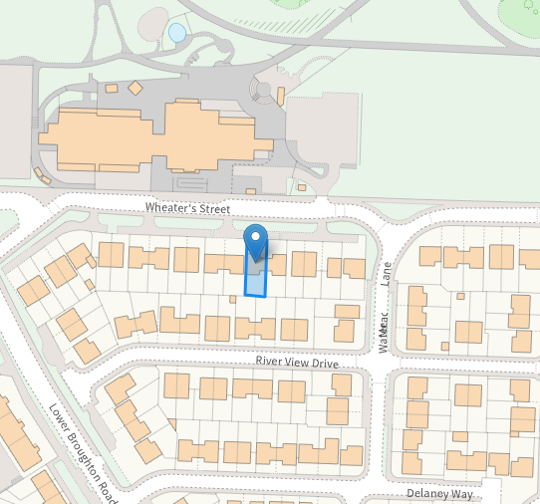

Description of Site and Surrounding Area
The application site relates to a two storey link-detached dwelling with attic accommodation located within a residential area in Salford. The property sits along Wheaters Street with parking to the front of the property and a garden to the rear. The property currently operates as a short term let (sui generis) and the application form indicates that this change of use commenced from 1 April 2022.
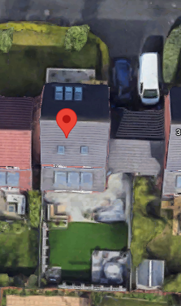
Figure 1: Aerial of the site.

Description of Proposal
Planning permission is sought for the continued use of the dwelling as a short term holiday let (sui generis). The applicant has confirmed that the maximum number of occupants within the property is 8 and that guests have to book for a minimum of three nights.
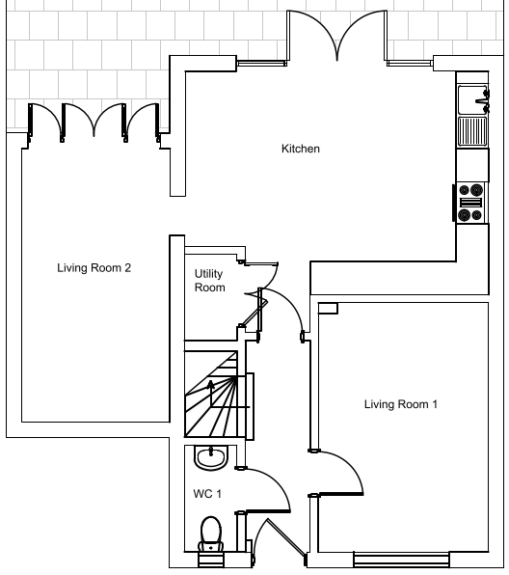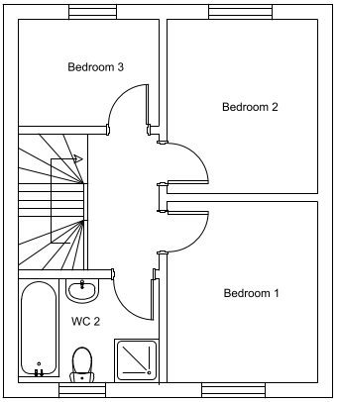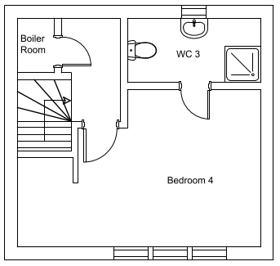
Figure 2: Floor plans of the dwelling.

Relevant Planning History

Planning Applications
12/62582/EIAHYB - Hybrid with Environmental Impact Assessment
Decision: Approve - Sent: 8 March 2013
Land Bounded By Lower Broughton Road, Great Clowes Street, Cumberland Street And Wheaters Street, Lower Broughton, Salford, M7 1QE
Full planning permission for the demolition of 41 Great Clowes Street and Mocha Parade and the erection of 189 dwellings with associated works. Outline application with all matters reserved except for access for the redevelopment of Mocha Parade Neighbourhood Centre (use class A1 to A5 and D1) for up to 4500sqm of gross retail floorspace and 225 car parking spaces together with associated works.

Publicity

- Neighbours - Publicity Start Date - 19 November 2025

Neighbour Notification
Neighbouring properties have been notified of the application via letter.
The number of neighbouring properties notified - 4

Representations from neighbours and members of the public
Comments of Support - 0
Comments of Objection – 32 (from 15 individual addresses)
Other Representations - 0

Summary of comments received: The material planning considerations will be assessed in the appraisal below.
Noise, disturbance & Antisocial Behaviour

- Repeated late-night and early-morning noise from guests, including loud music, shouting, singing, drunken behaviour.
- Frequent house parties, sometimes extremely large (reports of 20+ people, one instance cited as 60+).
- Outdoor gatherings causing shouting, swearing, and loud music audible across the estate.
- Disturbances occurring mid-week as well as weekends; guests often in “holiday mode” with no regard for neighbours.
- Complaints made to Airbnb and the council over several years, with neighbours reporting no meaningful action from owner/host.
- Taxi drop-offs/pickups at antisocial hours; car doors slamming throughout the night.
- Cannabis smells, alcohol misuse, nitrous oxide canisters and other litter left around the property and street.
- Some residents describe the property as known locally as a “party house”, reinforced by its inclusion in a lifestyle magazine feature promoting it for parties.

Safety, Security & Safeguarding Concerns

- Guests entering neighbouring homes or attempting to climb into gardens without permission.
- Families reporting fear and anxiety due to strangers passing close to front doors on shared driveways.
- Concerns about safeguarding children — especially with property directly opposite a primary school.
- Aggressive behaviour from guests when approached about noise concerns.
- Reports of drug use, drug paraphernalia and intoxicated individuals around the area.
- General feeling of reduced safety due to constant flow of unknown adults.

Impact on Residential Amenity

- Residents unable to sleep due to persistent night-time noise.
- Gardens difficult or impossible to use during stays due to noise, smoke, inappropriate behaviour.
- Hybrid workers unable to work from home because of noise and disturbances.
- Overlooking and loss of privacy with unknown adults in close proximity.
- Anxiety among residents due to unpredictability of guest behaviour and turnover.

Parking, Traffic & Access Issues

- Large groups often arrive in multiple vehicles despite the applicant claiming otherwise.
- Overflow parking creates congestion, obstructs driveways and causes safety concerns.
- Issues amplified because the property sits on a shared private driveway requiring guests to pass close to other homes.
- School traffic combined with Airbnb traffic creates additional hazards.

Waste, Litter & Management Failures

- Waste exceeding domestic bin capacity due to large groups.
- Accumulation of rubbish, bottles, cans, nitrous oxide canisters and takeaway litter.
- Application admits no commercial waste strategy despite large occupancy.

Policy Conflicts (Local Plan & National Policy)

Many objections reference formal policy conflicts, including:
- H10 – loss of family housing; undermining community stability.
- F3 – incompatible with inclusive, stable residential neighbourhood.
- D5 – harm to residential amenity (noise, disturbance, privacy).
- PH1 – risk to health, safety, pollution, noise disturbance.
- JP-P1 – conflict with strategic policies.
- NPPF – safeguarding, community cohesion, amenity protection.

Residents consistently state the proposal mirrors issues identified in refusal of the short-term let at 1 Delaney Way, making an approval inconsistent.

Loss of Housing & Impact on Community Cohesion

- Removal of a four-bed family home from housing stock.
- Long-term residents state the estate was designed as a stable mixed-tenure community under regeneration principles.
- Short-term let undermines community cohesion and sense of neighbourliness.
- High turnover of guests described as “transient”, “unknown”, and “uninvested in the community”.

Failure of Management / Noise Management Plan

- Strong and uniform distrust of proposed Noise Management Plan.
- Seen as reactive, unenforceable, and unsupported by evidence of past compliance.
- Claims of “only four affected neighbours” challenged as factually untrue and unacceptable in principle.
- Measures such as soft furnishings, signage, curfews and remote management viewed as ineffective or unrealistic.
- Reliance on neighbour reporting seen as unfair; historic evidence shows complaints did not lead to improvements.
- Concern that proposed “warden attendance within 1 hour” is vague, unproven and impractical.

Flood Risk & Emergency Planning

- Located in Flood Zone 2/3 with inadequate flood risk management for transient guests.
- Concern that short-term visitors unfamiliar with area would not understand flood alerts.
- Risk heightened by potential sleeping accommodation on ground floor.

Inconsistencies / Inaccuracies in the Applicant’s Planning Statement

- Claim of “no complaints” disputed; residents report multiple complaints to Airbnb, council, MP, and GMP.
- Misrepresentation of guest demographics: residents report predominantly large adult groups, not families.
- Claims about transport habits (mostly public transport) challenged as inaccurate.
- Statements regarding low-key operation contradicted by years of disturbance.

Consultations

Salford Flood Risk and Drainage Officer
Summary – There are no objections to the application on the grounds of flood risk or drainage.

Salford Highways Officer
Summary – There are no objections on highways grounds.

Salford Environment Officer
Summary – There are no objections on the grounds of air quality and land contamination. The objection relating to noise has been overcome following the submission of a Noise Management Plan.

Planning Policy
Salford Local Plan: Development Management Policies and Designations (SLP:DMP)
Policy F1 An inclusive development process
Policy F2 Social value and inclusion
Policy F3 Inclusive places
Policy F4 Fairness between generations
Policy CC1 Climate change
Policy EF1 Efficient use of land
Policy H1 Type of housing
Policy H2 Size of dwellings
Policy H3 Housing density
Policy H10 Conversion and change of use of existing houses and new build residential developments of non-self-contained units
Policy HH1 Development and Health
Policy A1 Supporting sustainable transport
Policy A3 Walking and cycling
Policy A6 Highway network
Policy A7 Motor vehicle parking provision and drop-off facilities in new developments
Policy WA4 Development and flood risk
Policy WA5 Surface water and sustainable drainage
Policy D1 Design principles
Policy D5 Amenity
Policy D6 Design and crime
Policy D7 Housing design
Policy BG2 Development and biodiversity
Policy PH1 Pollution control
Policy WM1 Waste and development

Places for Everyone (PfE)
Policy JP-S1: Sustainable Development
Policy JP-S2: Carbon and Energy
Policy JP-S4: Flood Risk and the Water Environment
Policy JP-S5: Clean Air
Policy JP-G8: A Net Enhancement of Biodiversity and Geodiversity
Policy JP-P1: Sustainable Places
Policy JP-C1: An Integrated Network
Policy JP-C5: Streets for All
Policy JP-C6: Walking and Cycling
Policy JP-C8: Transport Requirements of New Development

Other Material Planning Considerations
National
- National Planning Policy Framework
- National Planning Practice Guidance

Local Finance Considerations
It is not considered that there are any local finance considerations that are material to the application.

Appraisal

Impact of the proposal on the character of the area

A short term holiday or serviced accommodation let is a property that is let out for several days or weeks; they are often referred to as holiday lets and are aimed at offering temporary accommodation for tourists and holidaymakers and people visiting an area on business. Unlike hotels, they are not typically purpose built as visitor accommodation and are often converted from other uses. As short term holiday lets are intended to provide holiday and visitor accommodation on a temporary basis, they are not intended to provide the main home of an occupant, even for a temporary period.

Whilst short term holiday lets or serviced accommodation can provide decent quality, flexible accommodation for visitors that complement purpose-built hotels and support local tourism, they can have some negative impacts if not managed correctly. They can cause noise and disturbance in a residential area, cause increased demand on local services, change the character of an area, and result in a loss of housing stock.

Policy F3 of the Salford Local Plan: Development Management Policies and Designations, 2023 (Local Plan) requires that all places and developments should be as inclusive as possible. Policy H1 is an overarching housing policy which requires, amongst other things, for individual new residential developments to contribute to the provision of a broad mix of housing options across Salford and within the local area, ensuring that identified housing needs can be met.

Policy H10 of the Local Plan seeks to carefully control the conversion of existing houses to ensure that a good supply of houses is maintained and to protect the positive character of neighbourhoods. This is due to the transitory nature of some uses that have a rapid turnover of occupants. Policy H10 states [amongst other points] that except in the case of developments specifically designed as serviced apartments, the short-term letting of dwellings will not be permitted where this would result in them not being available for use as the primary residence of a household. This will be achieved, where appropriate, by:

- Taking enforcement action where short-term letting results in the material change of use of a dwelling
- Refusing planning permission for a change of use from a dwelling to short-term letting
- Applying conditions to new developments that prevents the short-term letting of dwellings within them

The reasoned justification to this policy provides additional justification for this approach; “The short-term letting of properties that have long-term occupants, such as when those occupants are on holiday, can help to secure the more efficient use of buildings and enable more people to visit the city. However, the more continuous use of housing for short-term letting reduces the supply of homes for permanent residents, and can result in worsening affordability. The greater intensity of activity often associated with short-term lets can also create amenity issues for neighbouring occupiers, detracting from the attractiveness of residential areas. Consequently, the city council will resist the use of dwellings for short-term letting where this prevents or is inconsistent with their occupation by permanent residents, except where they are designed specifically for this purpose such as in the form of serviced apartments” (SLP: DMP para 11.41).

The wider surrounding area is covered by an Article 4 Direction which removes permitted development rights that allow a change of use of a dwellinghouse to a small HMO. The Article 4 Direction is evidence that such changes of use are having a significant negative impact on the settled character of this residential neighbourhood.

It is noted that the transient pattern and occupancy of short term let accommodation, and its associated service provision does increase general comings and goings to the property. The occupiers of short term let accommodation are necessarily more transient in nature than those of a C3 residential dwelling or HMO rooms. This is due to the length of stays generally being in days and weeks rather than months; meaning that the occupiers of the short term let rooms/serviced accommodation tend to have little connection to the local area and hence may be less inclined to respect the surrounding area and its existing residents, meaning they have fewer concerns or realisation of causing noise and disturbance.

In terms of noise and disturbance this can be generated by general activities that take place within and outside of the property, but will be most noticeable in terms of use of the outdoor areas. In this respect, any potential intensification of use and its associated impacts upon occupiers of neighbouring properties needs to be assessed.

The officer’s report for the housing development of which the application property forms part (app no: 12/62582/EIAHYB) states that the development was designed to ‘contribute to broadening the housing mix of the wider area’ by creating new dwellings where the size and type would be appropriate. 28 Wheaters Street sits within an established residential area, arranged to create linear perimeter blocks that connect into the existing street network. As a result, activity associated with the use of the application property is likely to be apparent and impact the occupiers of the nearby dwellings given their proximity.

The LPA acknowledges that C3 dwelling residents will generate activity. Notwithstanding that, the pattern of comings and goings by short term let visitors/guests, who may wish to take full advantage of the attractions the city and wider area has to offer, in the evening / night as well as the daytime, are typically very different from the lifestyles pursued by the more settled residential population. Such activity may well occur at times when most residents ought to be able to expect periods of relative peace and quiet, i.e. weekends and bank holidays and in the evening / night.

During the course of the application, the applicant has submitted a Noise Management Plan setting out occupancy and use controls, guest information and house rules, and various management, monitoring, and enforcement measures. Although the Noise Management Plan is noted and the Environment Officer raises no objections in this regard, it does not give the Local Planning Authority confidence that the measures will be adhered to. The approach places significant responsibility on neighbouring residents to report disturbances, with the hope that the local warden can attend the site within an hour of a complaint. In addition, the plan’s effectiveness relies heavily on guests cooperating with the house rules throughout their stay. Taken together, these factors reduce confidence in the robustness of the measures and weaken assurance that neighbouring amenity would be adequately protected.

The extent and nature of objections received in relation to this application and the issues cited strongly suggest that the LPA’s concerns are well founded in this regard.

In the LPA’s view, good neighbourliness is an important yardstick for assessing a use such as this. Activity associated with the short term let tenants entering or leaving the accommodation, and using the rear garden area, together with vehicles stopping and starting, and the closing of car doors, is likely to be disturbing to the neighbouring properties, and the typical intensity of use and activity as short term let accommodation is considered to be greater than that of a residential dwelling.

The consequences attributable to one property in this respect may be limited in overall neighbourhood terms. But were this to be repeated elsewhere, far from helping to create a sustainable community, the cohesion of the local community can be eroded. This, in turn, makes the area a less pleasant place in which to live and is at odds with the social objective to support strong vibrant and healthy communities contained in the National Planning Policy Framework (NPPF) and the Local Plan.

It is considered that the development is contrary to the NPPF, Local Plan Policies D5, H10 and PH1, and Places for Everyone policy JP-P1 which, amongst other things, states that planning permission will only be granted for development that ensures the amenity of neighbours, and the character of the area are protected.

Impact on residential amenity

In respect of loss of privacy/overlooking or loss light/overbearing issues, no internal alterations or external extensions to the existing building have been made to accommodate the proposal and the function of the rooms remain the same.

As mentioned above, noise can have a significant adverse impact on health, quality of life and amenity enjoyed by individuals and communities.

The proposed development is in a residential area of Salford, with noise sensitive receptors (NSRs) on all sides. There is concern that properties used for this type of accommodation can cause significant noise issues due to guests hosting house parties, playing loud music inside and outdoors and general anti-social behaviour.

The Environment Officer has advised that, without effective management, the use of the property is likely to generate noise that would significantly harm the health, quality of life and amenity of neighbouring residents. To overcome their concerns, the applicant has submitted a Noise Management Plan to demonstrate how noise from the property will be controlled to ensure the amenity of neighbouring residential uses is unaffected.

On that basis, the Environment Officer is satisfied that the Noise Management Plan is considered robust and sets out appropriate controls – such as CCTV, signage, clear instructions, a warning system and potential warden attendance – to manage noise.

Despite the proposed measures, for the reasons set out above, the LPA considers that disturbance remains a concern due to unpredictable guest behaviour and the lack of continuous on‑site management.

Impact on highways

There is a driveway to the front of the building that could accommodate 1no. car. There are minimal parking restrictions surrounding the property on Wheaters Street with some on-street parking opportunities.

As the use of the building is existing, it is thought that the proposal would not cause any increase in the
parking associated with the site.

Due to the minor scale and sustainable location of the development the proposal is considered not to have an unacceptable impact on highway safety or the residual cumulative impact on the road network, in accordance with Policy A6 of Salford's Local Plan.

Impact on flood risk and drainage

The site is located within Flood Zone 2 and a Flood Risk Assessment has been submitted in support of the application. There are no physical alterations required for the use of the property as a short term let and it is noted that the vulnerability classification is ‘More Vulnerable’ which is accepted for dwellings in this location.

Impact on biodiversity

An application such as this would require a 10% net gain in biodiversity as per PFE policy JP-G8 and Local Plan Policy BG2 unless the development would fall under one of the exemptions provided under the Biodiversity Gain Requirements (Exemptions) Regulations 2024.

The application involves a change of use only and does not involve any external works. It does not impact an onsite priority habitat, and the development does not impact more than 25 square metres of onsite habitat that has biodiversity value and is therefore exempt from providing biodiversity net gain.

Recommendation
Refuse

Document Approval
Report Author | Lucy Livesey
Date | 03.02.2026
Reviewer | G Clegg
Date | 05/02/2026

