

Application Ref. | PA/2025/1751
Location | 11 Nona Street, Salford, M6 5PG
Ward | Weaste and Seedley Ward
Applicant | GG-372-510 Ltd
Proposal | Change of use from a dwellinghouse (use class C3) to a 5 bedroom, 5 person House in Multiple Occupation (HMO) (use class C4), together with alterations to rear elevation to create doorway
Recommendation | Refuse

Location Plan
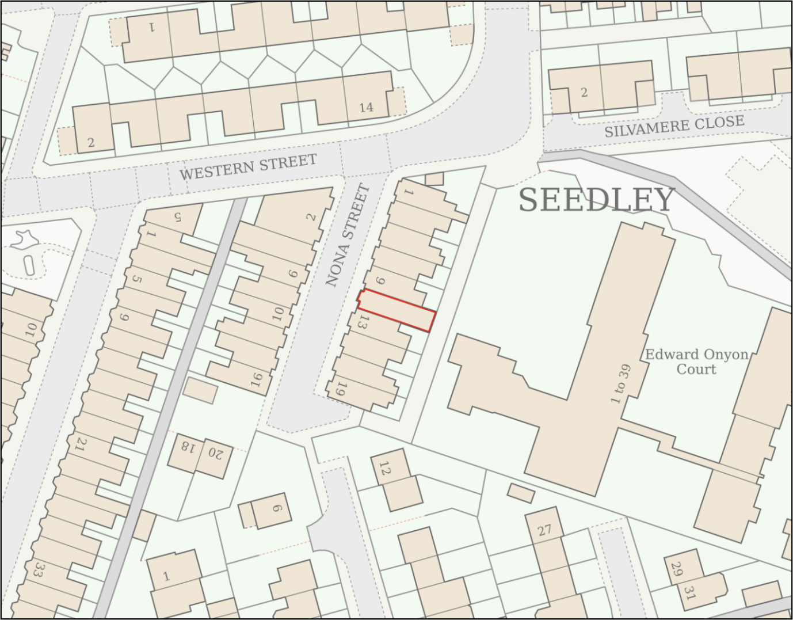
Description of Site and Surrounding Area

The application relates to a two storey mid-terrace dwelling with basement level, located on the east side of Nona Street in Seedley.

The dwelling is faced in brick and its original two storey rear outrigger has been previously extended to the rear with a two storey flat roofed extension.
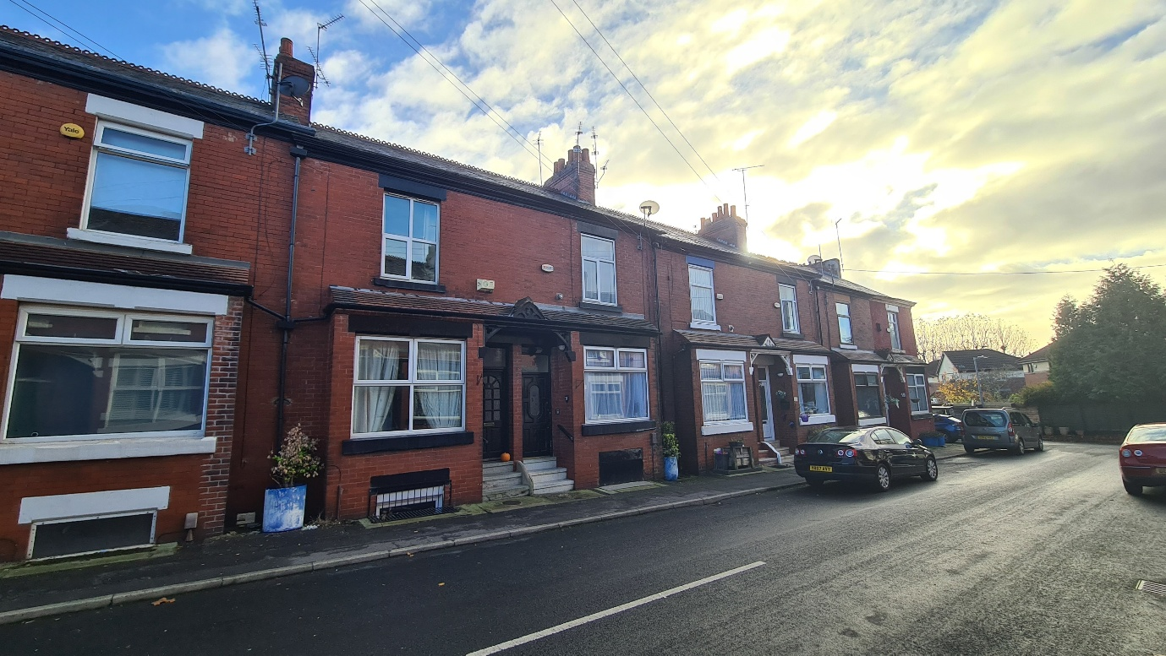
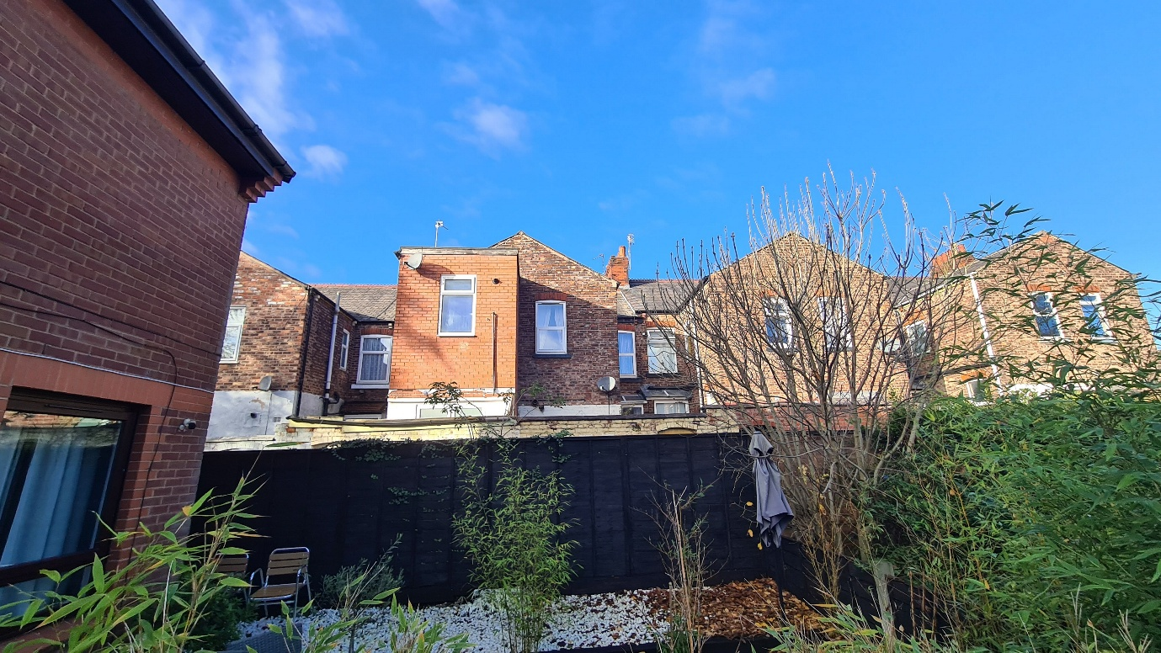

Description of Proposal

Planning permission is sought to convert the property into a 5-bedroom, 5-person house in multiple occupation (“HMO”) (Use Class C4).

The application follows the refusal of planning application reference: PA/2025/1407 (the “previous application”) which sought permission to change the use of the dwelling to a 6-bedroom, 6-person HMO.

The new proposed measurements for the internal floor area of each room to be considered against the HMO standards are shown below:

Ground floor
Bedroom 1: 11.6 m²
Bedroom 2: 10.6 m²
Kitchen / dining: 16.8m²

First floor
Bedroom 3: 13.3 m²
Bedroom 4: 14.1 m²
Bedroom 5: 12.0 m²
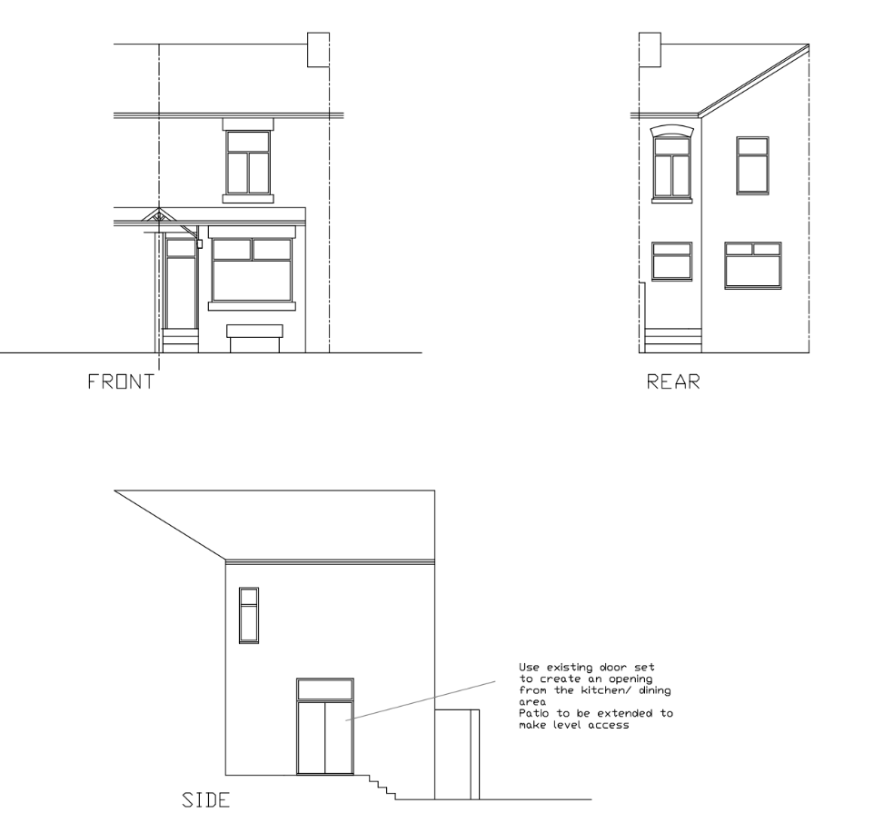
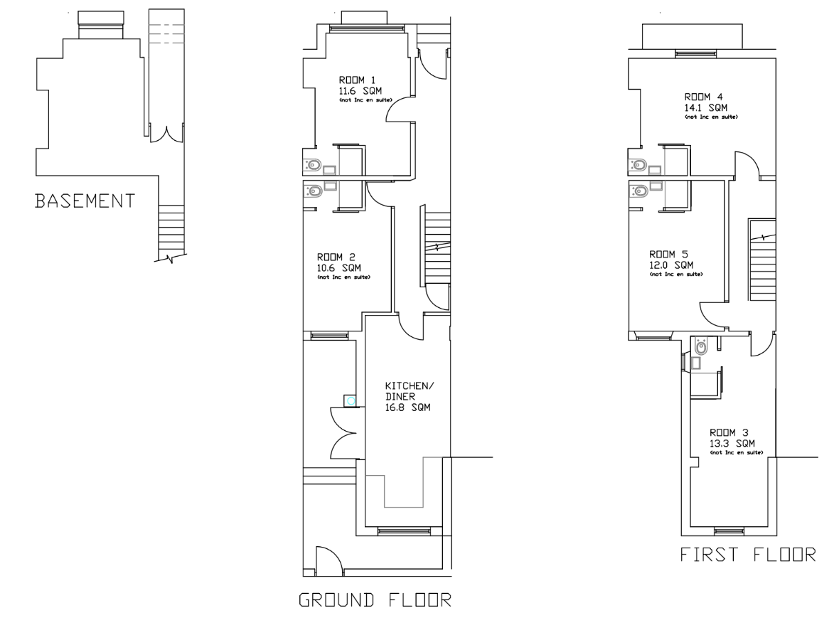
All bedrooms would have ensuites, with a small rear yard to be used for cycle / bin storage (as per the submitted design and access statement).

An external door is to be inserted on the side elevation of the two storey rear outrigger with the existing rear entrance replaced by a window to facilitate the change of use.

Unliked the previous application, the proposal does not involve reinstating the existing blocked-up front lightwell or conversion of the basement room to habitable accommodation. Neither does this proposal include the erection of any extensions to the property.

No on-site car parking is proposed, although unrestricted street parking is available along Nona Street.

Relevant Planning History
PA/2025/1407 - Full planning permission
Decision: Refuse - Sent: 24 November 2025
11 Nona Street, SALFORD, M6 5PG
Change of use from residential dwelling (use class C3) to 6 bedroom, 6 person House in Multiple Occupation (HMO) (use class C4), together with erection of a single storey rear extension and alterations to elevations

Refused on the following grounds:

- The proposal would result in cumulative unacceptable harm to the positive residential character of the surrounding neighbourhood due to the concentration of Houses in Multiple Occupation (HMOs) within the immediate area. This would be particularly experienced by the occupiers of nos. 6 and 9 Nona Street which as a result of the proposed development would be immediately adjacent to more than one property in use as a HMO. The proposal would result in an unacceptable impact on the amenity of these neighbouring occupiers by reason of comings and goings and associated noise and disturbance, and would contribute to issues related to high population turnover levels that risk reducing community stability and social cohesion. As such, the proposal is contrary to Policies H1, F3, D5 and H10 of the Salford Local Plan: Development Management Policies and Designations and the National Planning Policy Framework.

- The proposed development would fail to achieve an acceptable standard of amenity for future occupiers by reason of the poor level of outlook and natural light that would be afforded to the occupier of Bedroom 3. It is considered the development does not support strong, vibrant and healthy communities and does not achieve a high standard of amenity for all future occupants. Consequently, the development is contrary to Policies HH1, F3, H2 and D5 of the Salford Local Plan: Development Management Policies and Designations and the National Planning Policy Framework.
Publicity
Neighbours - Publicity Start Date - 18 December 2025

Neighbour Notification
Neighbouring properties have been notified of the application via letter.
The number of neighbouring properties notified - 6
Representations from neighbours and members of the public
Comments of Support - 0
Comments of Objection – 6 (including an objection petition signed by 11 individuals)
Other Representations - 0

Summary of comments received:
- There is already an overconcentration of HMOs in the area
- There are HMOs at nos. 3, 7, 4, 16 and 18 Nona Street
- No.2 Nona Street is currently under investigation for its use as an HMO and has had additional bedroom(s) included within a loft space – a Building Control application for these works is referenced elsewhere (05/06634/MULFP)
- Existing HMOs have resulted in increased waste and vermin from the increased number of residents and bathrooms
- The conversion would result in a dwelling being sandwiched between two HMOs which would impact occupants due to increased noise and disturbance
- The Officer report for the previous application recorded an HMO saturation of 9.31% which omitted 3 Nona Street - a licensed commercial HMO. The actual density of Nona Street is 20% (4 out of 20 houses)
- A restrictive covenant is in place at no. 20 Nona Street . The Council has a contractual and ethical duty to uphold the restrictive covenants that preserve these homes for family use, not commercial business.

Issues raised which are considered material to this application are addressed within the appraisal section of this report. The implication of any restrictive covenant that may exist is a civil matter and is not a relevant planning consideration.

In relation to 2 Nona Street, the case officer has checked with the Council’s HMO Licensing team who have confirmed that they are not aware that the property is operating as a HMO.

Consultations
Salford Environment Officer (DM)
Summary – No objections.
Salford Highways Officer (DM)
Summary - The Local Highways Authority (“LHA”) do not consider the proposal would have an unacceptable impact on the highway network and note that on-street parking is available along Nona Street and the surrounding roads. The LHA accept the proposed cycle parking arrangements, noting that a larger secure shelter may not be feasible given the constraints of the site.
Salford House in Multiple Occupation (HMO) Licensing Team (DM)
Summary – The property meets the requirements of a 5 person HMO.

Planning Policy
Salford Local Plan: Development Management Policies and Designations (SLP:DMP)
Policy F1 An inclusive development process
Policy F2 Social value and inclusion
Policy F3 Inclusive places
Policy F4 Fairness between generations
Policy CC1 Climate Change
Policy EF1 Efficient use of land
Policy EF2 Co-ordinated development
Policy H1 Type of housing
Policy H2 Size of dwellings
Policy H10 Conversion and change of use of existing houses and new build residential developments of non-self-contained units
Policy HH1 Development and Health
Policy A3 Walking and cycling
Policy A6 Highway network
Policy A7 Motor vehicle parking provision and drop-off facilities in new developments
Policy WA5 Surface water and sustainable drainage
Policy D1 Design principles
Policy D2 Local character and distinctiveness
Policy D3 Layout and access
Policy D5 Amenity
Policy D6 Design and crime
Policy D7 Housing design
Policy D8 Alterations and extensions
Policy PH1 Pollution control
Policy WM1 Waste and development

Places for Everyone (PfE)
Policy JP-S1: Sustainable Development
Policy JP-H3: Type, Size and Design of New Housing
Policy JP-P1: Sustainable Places
Policy JP-C1: An Integrated Network
Policy JP-C6: Walking and Cycling
Policy JP-C8: Transport Requirements of New Development

Other Material Planning Considerations
National
- National Planning Policy Framework
- National Planning Practice Guidance

Local Planning Policy and Development Framework/ Strategies
- Houses in Multiple Occupation Supplementary Planning Document (June 2024) (updated January 2025)

Local Finance Considerations
It is not considered that there are any local finance considerations that are material to the application.

Appraisal

The site is located within one of the areas of the city where an Article 4 Direction came into effect on 25 November 2018. The Article 4 Direction was introduced in order to positively manage potential amenity and character impacts associated with HMOs and their concentrations, as well as to ensure that balanced communities are maintained within the city. This means that planning permission is required for the change of use of a dwellinghouse to a small HMO within this part of the city.

HMOs can make an important contribution to housing supply, generally providing low-cost private sector accommodation for those on lower incomes, students, and those seeking temporary accommodation. They are normally located in areas with good access to public transport (in particular bus routes) and local services. However, high concentrations of HMO accommodation can sometimes have a detrimental impact on local housing areas.

Policy H1 of the SLP:DMP states that individual new residential developments shall contribute to the provision of a broad mix of housing options across Salford and within the local area, ensuring that identified housing needs can be met.

Policy F3 of the SLP:DMP states that all places and developments shall be as inclusive as possible. Achieving this will involve a diverse mix of decent and adaptable homes, including affordable housing that enables everyone to meet their housing needs.

Proportion of HMOs in the area

Policy H10 of the SLP:DMP sets out how conversions and changes of use from existing dwellings to HMOs and other stated uses will be controlled to ensure that a good supply of houses is maintained within Salford and the positive character of neighbourhoods is protected.

Part 1 of Policy H10 of the SLP:DMP states that conversions to HMOs (amongst other uses listed) will only be permitted where it can be demonstrated that the proposal would not, either individually or cumulatively with other listed uses (including completed developments and schemes with planning permission or prior approval) have an unacceptable impact on the positive residential character of the surrounding neighbourhood, having particular regard to potential increases in noise and disturbance, on-street car parking, waste management and population turnover levels that could reduce community stability.

Part 3 of Policy H10 of the Local Plan also states that conversions to HMOs will only be permitted where it can be demonstrated that the proposal would not, either individually or cumulatively with other completed developments and schemes with planning permission or prior approval, result in any house that is in use as a single dwelling being immediately adjacent to more than one property in use as student housing, houses in multiple occupation, hotels, residential institutions, hostels, children’s homes and similar uses and non-residential uses such as offices.

For the avoidance of doubt, Policy H10 clarifies that for the purpose of this policy, immediately adjacent properties include properties directly behind and opposite, as well as to either side.

The Council has adopted the Houses in Multiple Occupation Supplementary Planning Document (the “HMO SPD”) which has been produced to better manage the provision of new HMOs throughout Salford by providing a threshold to guide the distribution/location of them. Policy HMO1 within the HMO SPD states that planning permission will not normally be granted for new HMOs, or for proposals to extend existing HMOs that would increase the number of bedrooms within it, where:

- the proportion of HMOs already exceeds 10% of all residential properties within a 100-metre radius of the application property; or

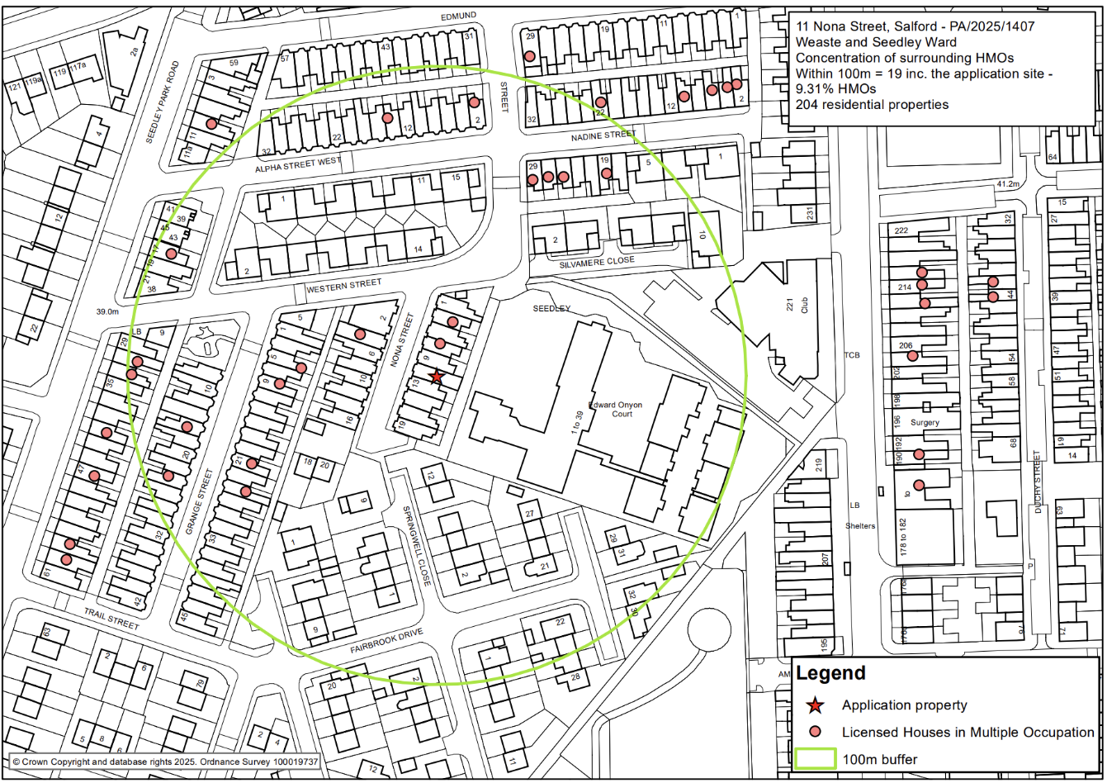
- the proportion of HMOs would exceed 10% of all residential properties within a 100-metre radius of the application property as a result of a proposed new HMO.

The figure above shows the distribution of existing HMOs in the immediate area. Taken together with the application property the licensing data identifies that there would be a total of 19 HMOs within a 100m radius and this falls just below the 10% threshold (at 9.31%), in accordance with Policy HMO1 of the HMO SPD.

The applicant has undertaken their own assessment whereby they have found a 7% concentration of HMOs within a 100m radius of the site. However, it can be seen that the applicant’s assessment does not include all of those licensed HMOs within the radius as per the above which has also been generated to scale and is considered more accurate.

Additional analysis has been carried out by objectors, who claim that the proposal would result in a 20% concentration along Nona Street. The Council’s records identify that nos. 3, 4 and 7 Nona Street are licensed HMOs. On the basis that there are 20 properties on Nona Street, the application proposal would therefore result in 20% of properties on Nona Street being in use as HMOs. Whilst this indicates a localised concentration, the HMO SPD specifically defines how concentration is to be calculated for the purposes of applying Policy HMO1 and this relates to the 100m radius as outlined above rather than on a per street basis.

When considering the Council’s assessment based on the 100m radius, whilst it is close to the 10% threshold, it is not considered that the proposal would lead to an overconcentration of HMOs in this part of the city, in the context of Policy HMO1.
The case officer has reviewed the planning history for the properties in the immediate vicinity of the site, and with the exception of nos. 3, 4 and 7 Nona Street, there do not appear to be any other relevant uses (listed B) to G) within Policy H10) within the immediate vicinity of the site.

No. 4 Nona Street which lies opposite the application property and no. 7 are both in use as licensed HMOs. The conversion of the application property to an HMO would therefore result in two dwellings (the adjoining no. 9 Nona Street and no. 6 opposite) being immediately adjacent to more than one property in use as an HMO as per Part 3 of Policy H10. The development therefore fails to comply with Policy H10(3) and indicates an overconcentration of HMOs along this section of the street which would have an unacceptable cumulative negative impact on the character of the area and particularly on the amenity of nos. 9 and 6.

Residential Amenity – Neighbours

There will be a level of noise and disturbance associated with the future occupants as they go about their daily business independently, moving to and from the property and as they use the building and the outdoor space.

In respect to the magnitude of change that would arise, it is understood that the application property is currently used as a 3-bedroom family dwelling. The proposed HMO would have 5 bedrooms (which would be restricted to a maximum of 5 occupants, if the application was otherwise acceptable). Future occupants would likely have independent routines and therefore result in a higher level of activity than a single family dwelling.

Noting the proximity to the other HMOs along Nona Street, it is considered that the cumulative effects that would arise from the uplift in activity at the site and the comings and goings associated with the HMO use, when taken together with the existing neighbouring HMOs, would have an unacceptable cumulative impact on the amenity of the adjoining neighbour, no. 9. and the neighbour opposite, no. 6.

Residential Amenity – future occupiers

The NPPF, at Paragraph 135, requires development to achieve a 'high standard’ of amenity for existing and future users. Policy F3 of the SLP:DMP seeks to deliver a diverse mix of decent and adaptable homes and Policy D5 seeks to ensure that development provides all potential users with an acceptable level of amenity.

The Council’s Standards for houses in multiple occupation document offers guidance to landlords on the physical standards that are required for licensing purposes including minimum room sizes, bathroom and kitchen facilities and fire safety provision. Whilst this document does not form part of the development plan, Local Plan Policy H2 confirms that all HMOs shall meet the minimum room size and amenity standards set out in this document.

The property has a small private yard to the rear, albeit the amount of usable space would be reduced once bin / cycle storage is accounted for, meaning there would be very limited space within the yard for any external amenity. The site is however within walking distance of local parks – the closest being Buile Hill Park circa 150m northwest of the site - which would provide additional amenity benefits to occupants.

All habitable rooms within the property would be served by adequately sized and sited windows and include ensuites, and the occupants would have access to a communal kitchen / dining room.

According to the Council’s Standards for houses in multiple occupation document, the following relevant space standards are required to be met:

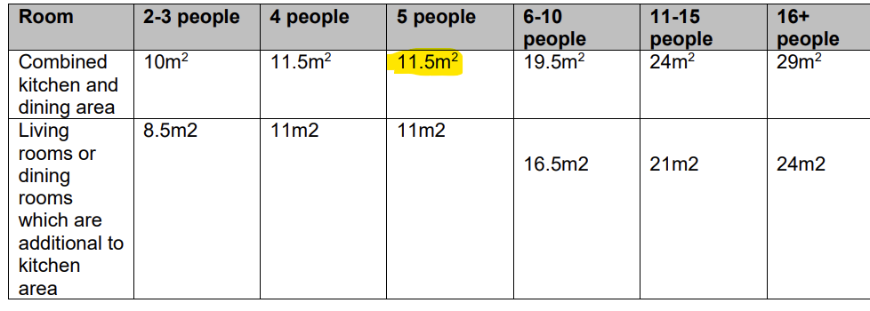
When assessing the suitability of an HMO with regards to space standards, officers make a recommendation by assessing the HMO as a whole and the potential use of the space provided. When considering the requirements, the minimum floor space for a combined kitchen and dining area is 11.5m² for 5 occupants. All of the proposed bedrooms exceed 10m², so there is no requirement for an additional living room. The proposed kitchen / dining area would measure 16.8m² which meets the minimum requirement.

Officers are satisfied that the rooms comply with the Council’s Standards for houses in multiple occupation document and raise no objections in this regard. The proposal is therefore considered compliant with Policies HH1, F3, H2 and D5 (as concerns future occupiers) of the SLP:DMP.

Parking and Highway Safety

The site is sustainably located within walking distance to Langworthy Road and Seedley Road, which provide regular bus services to Bolton, Eccles, Salford Quays and Manchester City Centre.

No on-site parking is proposed as part of the development. However, there is unrestricted on-street parking available along Nona Street and the surrounding roads.

While acknowledging that the proposal could result in a slight increase in demand, the Highways Officer has stated that they consider any impact that does occur as a consequence of the proposal would not have an unacceptable impact on highway safety or the residual cumulative impact on the road network, as per Policy A7 of the SLP:DMP.

In accordance with paragraph 116 of the NPPF: Development should only be prevented or refused on highways grounds if there would be an unacceptable impact on highway safety, or the residual cumulative impacts on the road network, following mitigation, would be severe, taking into account all reasonable future scenarios.

For these reasons it is not considered that the proposal would have an unacceptable adverse impact upon highway safety in accordance with Policies A6 and A7 of the SLP:DMP.

Cycle and Bin Storage

In terms of bin storage, it is not considered that the proposal would significantly intensify the need for extra provision, with the property having a rear yard that can be used to store the necessary bins, as per Policy WM1 of the SLP:DMP.

In terms of cycle storage, in accordance with the Council’s parking standards, at least 1 secure cycle parking space per 2 bedrooms is required for an HMO. The Applicant has indicated that cycle storage spaces are to be provided within the site. However, given the constrained nature of the rear yard it is not considered that it would be feasible to erect a cycle shelter (noting the need to also store bins in this area). As such, further details of cycle parking provision would not be required to be secured via condition were the application to be recommended for approval.

Recommendation
Refuse

Document Approval
Report Author | Aslan Saylam
Date | 03.02.2026
Reviewer | G.Clegg
Date | 05/02/2026

