Construction Management Plan
Built Developments
Built Developments Main Safety Goal: To establish and maintain an injury-free work environment through proactive risk management, continuous training, and a culture of safety that empowers every team member to actively participate in creating and sustaining a safe and healthy construction site.
This goal emphasises the importance of prevention, education, and teamwork, fostering a site culture where safety is everyone’s responsibility.
Project Title: Park Street
Project Location: Park Street Swinton Salford
Planning Ref: PA/2024/1538
Prepared by: Jay Culbert
Date: 4/11/25
-Site Working times:
Monday- Friday 8:00am- 5:30pm
Saturday- 9am-2pm
No Sunday Working or Bank Holidays
Access gates to site compound can be opened to allow Site Operatives to enter the site priory to 8am.
Operation of heavy good vehicles and heavy machinery shall be limited to between 8am-6pm Monday to Friday and 9am-2pm Saturday only (no working on Sundays or Bank Holidays).

Site Visitors:
- Advance Notice: Please make every effort to call ahead of your visit to inform the management team that you would like to tour the site. We recommend scheduling visits during quieter times, preferably after 3PM.
- Footwear and PPE: If you enter the site under supervision, please wear sensible footwear. Additionally, you will be required to wear any personal protective equipment (PPE) deemed necessary by our team.
- Site Induction: Upon arrival, you will receive a site induction to familiarise yourself with safety protocols and procedures. Your contact details will be recorded on our induction form for safety tracking.
- Additional Support: If you require any additional assistance or supervision during your visit, please discuss these needs with us prior to entering the site. This will help us ensure that all necessary provisions are in place for your safety and comfort.
We appreciate your cooperation in keeping our site safe for everyone. Thank you for your understanding, and we look forward to welcoming you.
1. Project Overview Description:
Construction of 42no. affordable apartments (Use Class C3) with external amenity space, associated parking and access and associated infrastructure.
Scope of Work:
- The site necessitates remediation of the ground, involving the removal of relic foundations and a cut-and-fill operation to establish appropriate levels. The drainage and access to the site will be fully completed, including the installation of mains services. Upon completion, the foundations of the building will be constructed using a Vibro Pile solution, supported by a shallow ring beam. The building will be constructed from a specialised SiPs frame, featuring a flat roof and a brickwork facade. The internal fit-out will encompass a plant room, a cycle store, communal areas including emergency fire and smoke systems, two lift shafts, two smoke shafts, and 42 apartments.
- Project Drawings Site Plan:
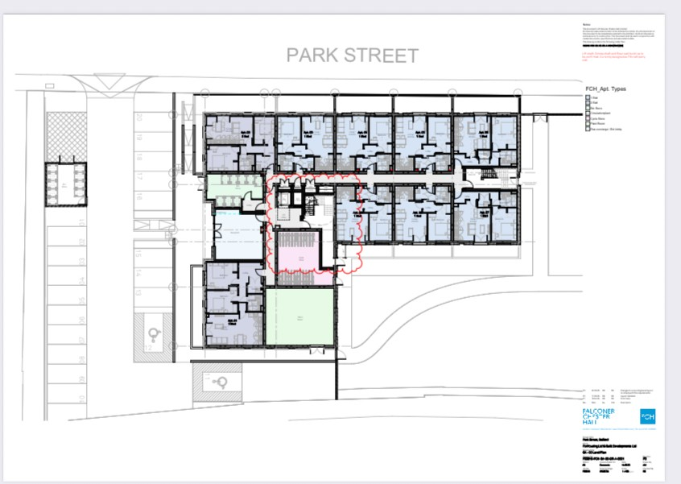

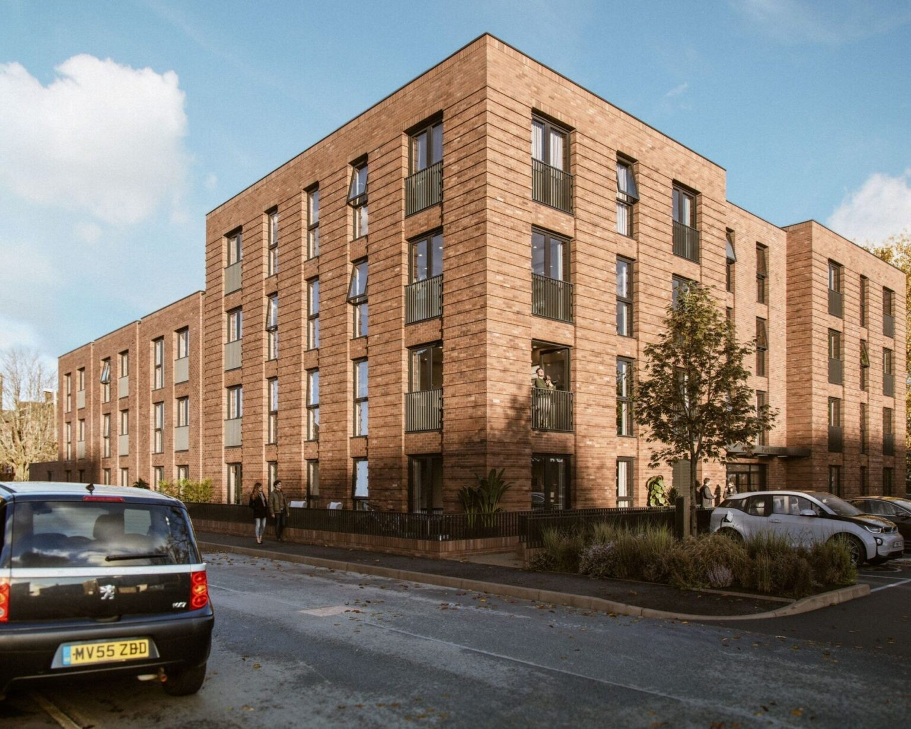
- Construction Schedule
Key Milestones
Project Start: 05/01/26
Enabling: 05/01/26
Roads and Sewers: 09/02/26
Foundation Start: 08/04/26
Superstructure: 07/07/26
Final Inspection: 21/05/27
Site surfacing: 30/04/27
Project Completion: 22/06/27
- Project Team
- Project Manager: Built Developments Kevin Morrissey 07854 116513
- Site Supervisor: Kieron McCarthy 07858 718189
- Safety Officer: Ian Eardley GMCT 01706559292
- CDM Manager: Tom Griggs 07738 804685
- Client Project Manager: Colleen Grady 07715 414 918
- Client CoW: Mark Mcgahey 07860 808090
- Key designers:
- Architect: FCH Rasheed Evans 0161 711 0960
- Ground Engineer: Andrew Spooner 01246 568 772
- Drainage Engineer: Richard McDermott 0161 694 7087
- Superstructure Engineer: Ryan McDermott 01995 679444
- M&E Engineer: Barry James 07850709541
- Key Subcontractors:
- Services Contractor: Energetics 0330 111 2014
- Ground-workers: Built Developments Ash 07872 971035
- Framing Contractor: Flitcraft 01995679444
- Security Contractor: Taurus Security 0161 273 6600
- Fencing Contractor: Ben Carpenter Carpenter Fencing 07877 715764
The primary gates will prominently display contact information for the 24-hour Security switchboard team at Taurus Security, including a contact number linked to the Site Management.
5. Safety Management Plan
Personal Protective Equipment (PPE)
- Required PPE includes hard hats, high-visibility vests and safety boots, as mandated by regulations. Additional PPE will be stated in the approved Risk Assessment and Method Statement for specific operations.
Site Inductions, Competency, RAMs, Site Managers:
- Inductions must be carried out for all visitors and workers on site. Competency will be check via CSCS cards and appropriate qualifications. RAMs will be read and understood and signed before work commences. Site Managers will hold SMSTS, Supervisors or better CSCS Card, First Aid training, experience in new build construction.
6. Risk Management
A. Environmental Management Plan
Discharging of Water from site : Erosion and Sediment Control:
- Implement measures such as gully bags and ditch barriers to prevent water containing sediment from leaving site or entering into local surface water gullies.
- Waste Management:
- Waste will be managed by Kenny Waste and monitored during the construction period.
- Soils will be sourced and sent to licensed facilities and by appropriate transport carriers.
- Off-site manufacturing has reduced wasted associated to the scheme.
- The correct storage and re use of materials where appropriate will be promoted.

- Traffic Management Plan:

Any further traffic management measures to safeguard member of public required on the highway to be communicated with as much lead in time as possible with the LHA.

Any off-site works must also be indicated on a plan accompanied by measures to protect member of the public.

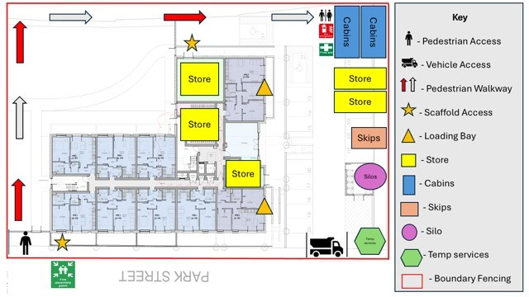
- Noise Management:
Use Low-Noise Equipment:
The site will push contractors to use battery powered tools where possible.
Plant will be turned off when not in use.
The initial welfare cabin to site will utilise a hybrid system of battery and combustion for 12-16 weeks. Beyond this the compound will be powered from mains electricity Reducing the noise factors.
Regular Maintenance:
All Plant and Equipment will undergo regular maintenance to aid in a quiet
Acoustic Barriers:
The compound will be enclosed with 6ft fencing which will offer acoustic mitigation.
Radio’s will be monitored to prevent excessive blaring of music.
Work Scheduling:
Plan and noisy tasks during off-peak hours to minimise disturbance to surrounding areas.
Off-site Manufacturing:
The Site will use Off site manufacturing for multiple components to prevent excessive cutting.
Personal Protective Equipment (PPE):
Ensure all workers in high-noise areas wear hearing protection (e.g., earmuffs, earplugs).
Monitor Noise Levels:
The foundations for Park Street have been set for Vibro Piling. During the process we will ensure vibration monitoring is in place for the full duration and notice is given to the residents before commencing.
Feedback Mechanism:
We encourage workers and nearby residents to report noise complaints and suggestions for improvement via our complaints procedure listed below. D. Vibration Management:
The 42 block of apartment on Park Street will undergo a Vibro foundation installation. Throughout this process, we will implement vibration monitoring to ensure that unacceptable levels of vibration do not adversely affect the local residents. We have opted for this method because we believe that pre-cast driven concrete piles generate significantly more vibration and noise.
E. Fire Management:
The site team will notify the local fire station that work has commenced and invite them to have a look around if they feel it is required.
The CCTV system monitoring on site has thermography technology that detects smouldering. The system is monitored from Taurus Security Control 24 hours a day, 7 days a week. This early detection and warning can assist if a fire were to start.
Fuel sources such as diesel, timber materials and skips will be kept away from the building.
Strict housekeeping will be enforced from the construction team.
Signage will be present throughout the development Related to fire safety.
Fire Plan:
Firefighting equipment and alert systems will be set around the development As per the Fire Plan. During the superstructure the scaffolding will have 3 ladder systems and a staircase for access and egress. Inside the apartment building during construction fire doors will be fitted once weather tight, fire fighting equipment and alert systems will be housed on every floor. The emergency plan will be displayed for operatives to see and follow if required .
Trades on site will be using battery operated equipment where possible but other machinery will be maintained.
F. Dust Management:
There will be no demolition required on site.
Plant and Machinery will be promoted to stay on hard standing to prevent mud entering the site hard standing and surrounding roads. This reduces the need to sweep which can create dust. Beyond this all hard standings will be wet swept when possible. We will also promote clean and tidy equipment.
All cutting of clay and concrete will be wet and if possible be done off site. They will follow the appropriate Risk Assessment and Method Statement.
All cutting of Timber products will be subject to dust suppression. They will follow the appropriate Risk Assessment and Method Statement.
All mixing of binding agents such as concrete, screed, mortor and tile adhesives will be pre mixed. Plaster products will follow strict guidelines and follow the appropriate Risk Assessment and Method Statement.
All sanding will be mechanical with dust suppression equipment.
Sweeping will be reduced and hovering with class M hoovering promoted where necessary.

G. Mud Management:
A gateman and wheel wash will be stationed at the entrance of the site. This service will involve jet washing the wheels of deliveries and cleaning down the plant and equipment.
As previously mentioned, the Site will promote plant and equipment to remain on firm ground whenever feasible. If necessary, the machine will de-soil before entering onto the firm ground.
Areas that require cleaning will be thoroughly cleaned during construction and at the end of each working day.
‘Site entrance ahead’ signs shall be displayed on all approaches during working hours; •
Every effort to clean mud/debris BEFORE a vehicle leaves your site i.e. pressure washing.
If you have vehicle manoeuvres on and off site, that could potentially deposit mud and debris, we will deploy a street cleansing vehicle during the activity and not just at the end of the morning or afternoon shift.
You shall have signs available (on site) and deploy at the first signs mud being deposited on the adopted highway i.e. slippery road sign with ‘Mud on Road’ sub plates.
Road sweepers will be strategically deployed to maintain cleanliness on all surfaces by removing debris when required.
- Security and Fencing:
Taurus Security is responsible for the development and implementation of a comprehensive CCTV surveillance system across the entire site. This will ensure effective monitoring and deter potential intruders. Additionally, signage will be strategically installed to enhance the site’s security and provide clear signage for visitors.
The site and the current red line deed boundary currently boasts a robust metal fencing system that was installed by the previous land owner the Diocese. It stands at 2.1 meters in height and will be maintained to ensure its longevity and effectiveness.
Any fencing if require that is placed over the adopted highway will need to be agreed with LHA and footway closure orders and permits / licence needs to be applied for prior to undertaking any fencing can be placed over the adopted highway.
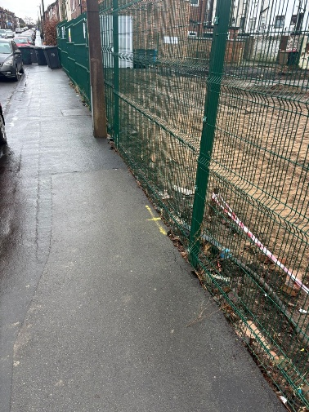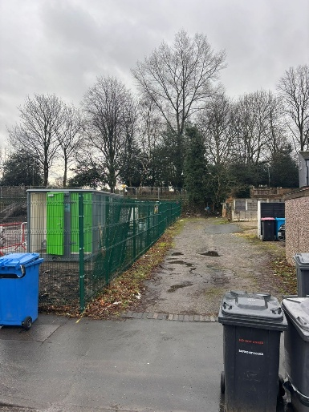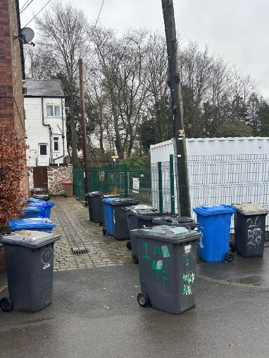

- Parking:
Staff, tradespeople, and visitors are kindly requested to car share for the development, with the deduction of the number of vehicles.
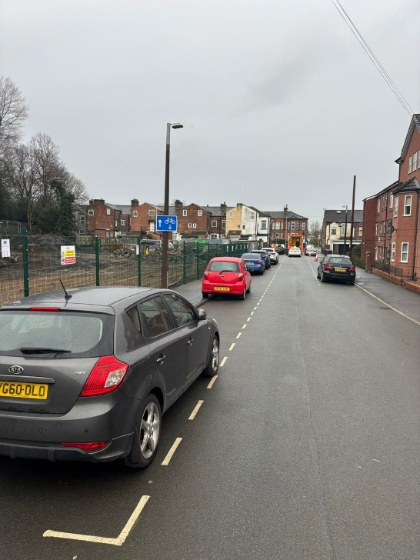

There may be a limited opportunity for on-site parking on the development due to the size of the construction area, lay down area and Tree protection fencing.
Tradespeople will be responsible for offloading their tools and equipment. Workforce to park within the site compound where possible or within designated areas, no obstruction or parking in such a manner as to restrict the operation of the local highway network, local residents and businesses, namely Manchester Road, Park Street and Dorchester Road.
- Managing Materials and Delivery:
Interim Route: This Route will serve as a bridge until the Agreed Route is executed.
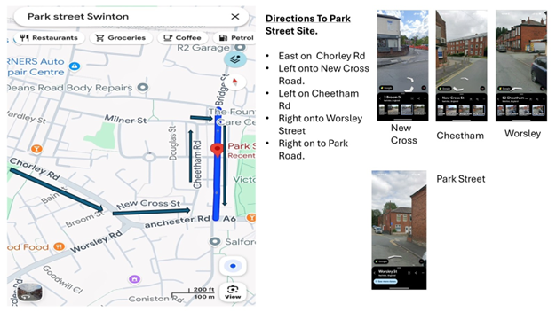
East on Chorley Road, Left onto New Cross
Road, Left onto Cheetham Road, Right onto Worsley Road and Right onto Park Street.
Agreed Route The route for delivering to site is as follows:
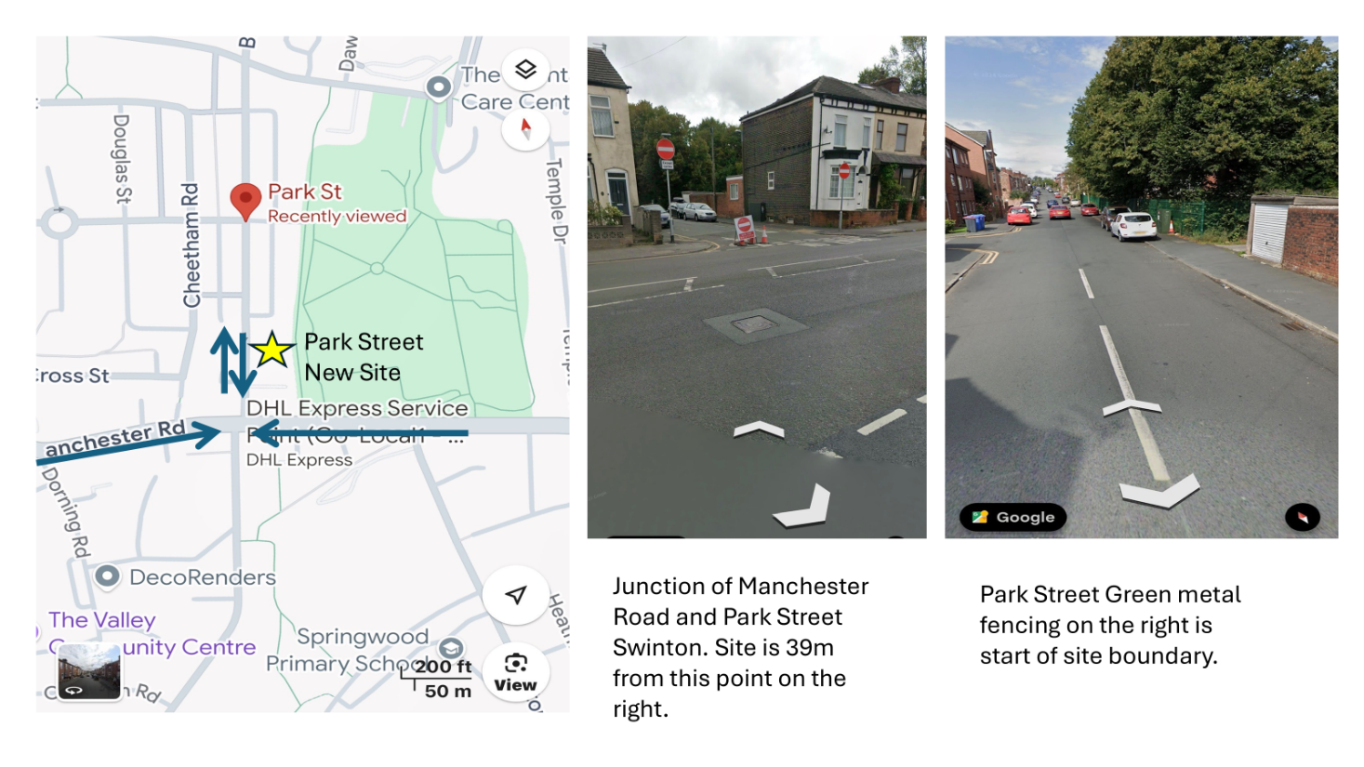

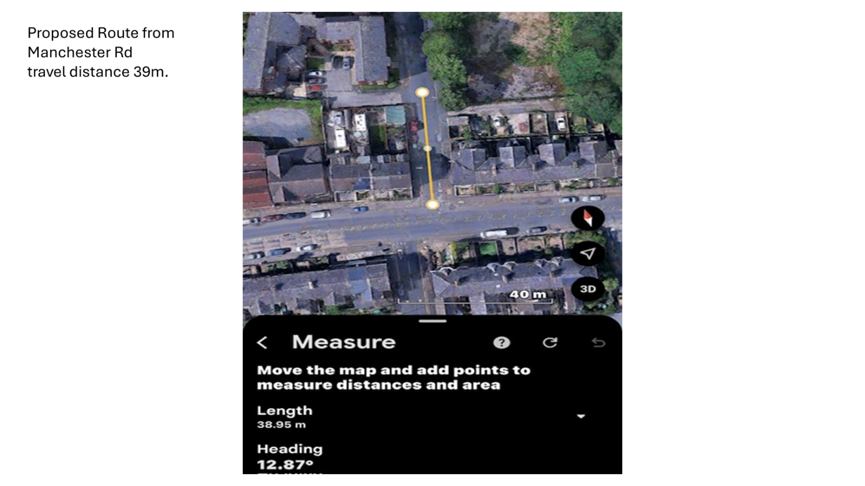

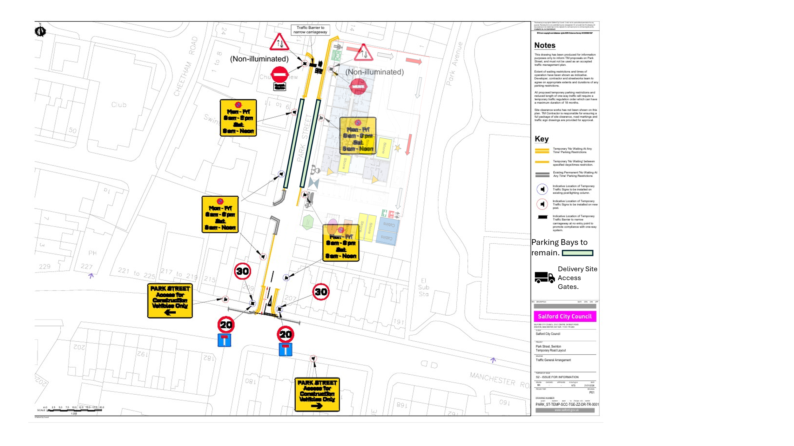

When placing orders, drivers will be reminded to turn off their engines and exercise
courtesy towards residents. Failure to comply with these requests will result in verbal warnings, and further violations may lead to a driver change and potential material supplier replacement.
Please mindful the TTRO process usually take between 6 and 12 weeks. However, due to the nature of the site’s location the council’s Street works team has fast tracked the application and hopefully the TTRO will be approved by the 2nd of March 2026 to allow the “agreed route” to be used. Please include the following text:
No loading and unloading activities of material shall occur on the adopted highway, namely Manchester Road and Park Street.
Delivery vehicles will not be allowed to block access/egress for residents. For larger deliveries, the Site Manager will need to agree in advance arrangements with the suppliers for wagon driver to park safely away from the site and phone in advance of arrival. 2 of 6
Although loading and unloading activities of material on the adopted highway is not permitted, but in certain occasions where there is no other choice. The developer must first seek approval from the LHA in order to implement any traffic management measures to cater for loading and unloading activities on the highway.
Any materials will moved around site must be only carried out by road worthy vehicles complying with Traffic Sigh Manual Chapter 8 requirement (with hazard lights and reflective markings).
- Communication Plan
- Initially, inform the Site Management Team, who will subsequently notify the Forliving Project Team.
- In the event of an out-of-hours call, please contact the security switchboard to lodge a complaint.
- If an unresolved complaint is not resolved, it will be escalated to the Community Liaison Officer.
- If unresolved complaints are not resolved, they will be escalated to the Directors of Forliving and Built Developments.
- Site Management will issue letters to local residents to inform them about key activities taking place which will include: commencement on site, road and footpath closures, Vibro Piling, Completion of the scheme.

