

Application Ref. | PA/2025/1773
Location | 19 Mirfield Drive, Eccles, Manchester, M30 9LH
Ward | Eccles Ward
Applicant | Charlie Lambert
Proposal | Proposed basement conversion, single-storey side extension, loft conversion with installation of roof lights to front roof slope and erection of rear dormer
Recommendation | Approve with Conditions

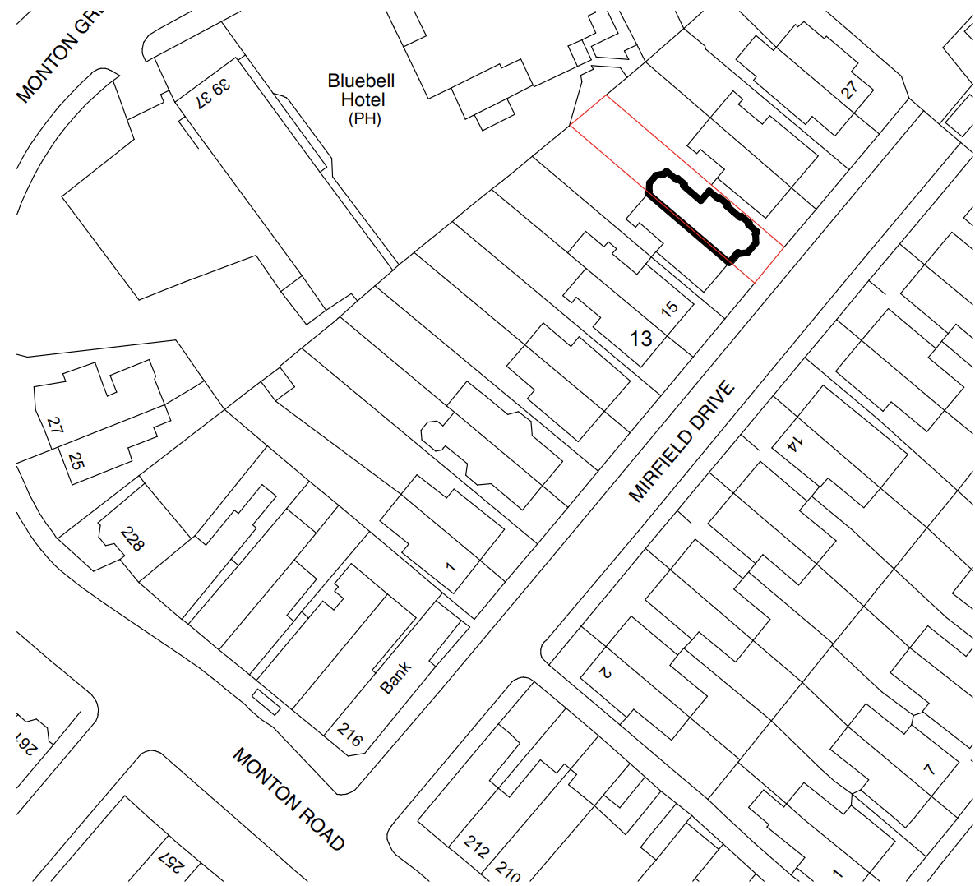
Location Plan

Description of Site and Surrounding Area

The application relates to a two storey semi detached property located on the west side of Mirfield Drive in Monton. The dwelling is faced largely in brick, beneath a pitched roof, and includes bay windows to the front and rear.

To the rear of the site lies The Blue Bell, a public house and locally listed building.
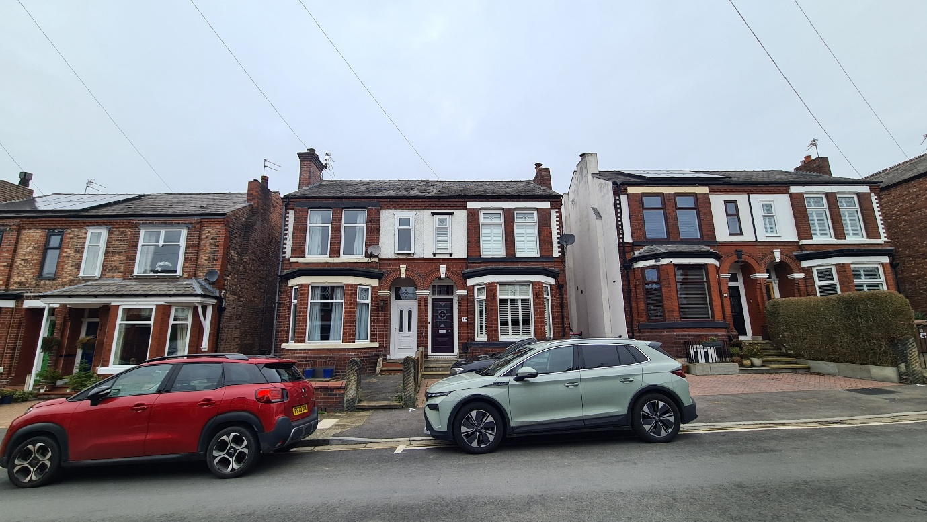

Description of Proposal

Planning permission is sought for a single storey side extension to the rear, off the existing two storey outrigger, in addition to the erection of a rear dormer, installation of roof lights and conversion of a basement into a utility / home workshop.
The dormer would facilitate the provision additional living accommodation in the form of a study and new bedroom with ensuite. The ground floor extension would allow for additional living / dining / kitchen space.

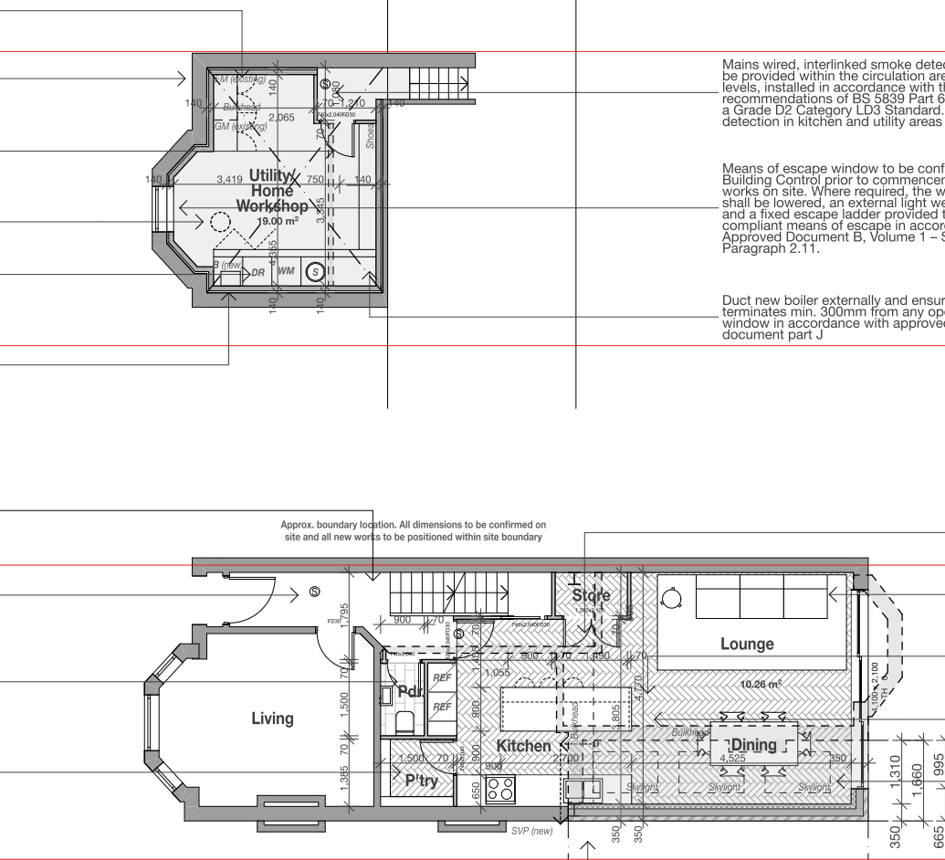
Both extensions would be faced in materials to match those of the existing dwelling.
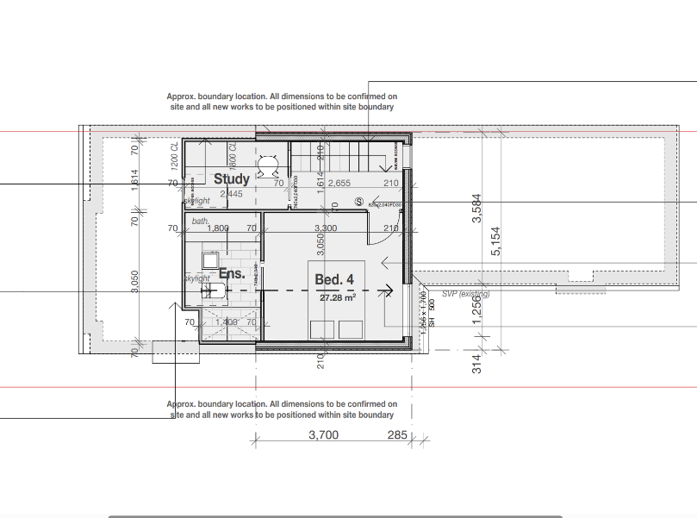
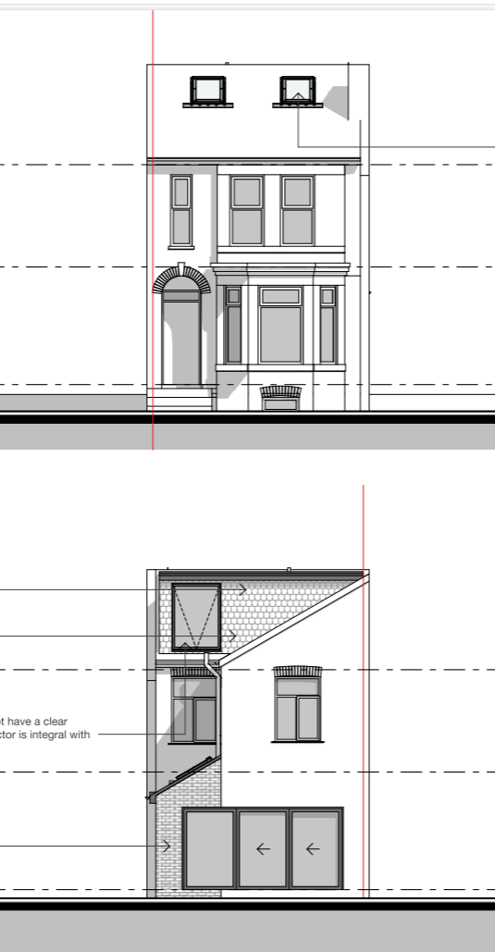

Relevant Planning History
None
Publicity
Neighbours - Publicity Start Date - 22 December 2025
Neighbour Notification
Below is a summary of the comments that have been received on this application. The key material planning considerations are discussed within the appraisal section of this report.
The number of neighbouring properties notified - 7
Representations from neighbours and members of the public
None
Consultations

None

Planning Policy
Salford Local Plan: Development Management Policies and Designations (SLP:DMP)
Policy D1 Design principles
Policy D2 Local character and distinctiveness
Policy D3 Layout and access
Policy D5 Amenity
Policy D8 Alterations and extensions
Policy HE1 Heritage protection
Policy HE2 Managing change across historic areas

Other Material Planning Considerations
National
- National Planning Policy Framework
- National Planning Practice Guidance

Local Planning Policy and Development Framework/ Strategies
- Supplementary Planning Document – House Extensions (2006) (the “SPD”)

Local Finance Considerations
It is not considered that there are any local finance considerations that are material to the application.

Appraisal

- No external changes are proposed to facilitate the basement conversion. Given that this relates solely to internal alterations, this aspect of the proposal does not constitute development.

Impact on the Character of the Area
- The proposal would be set to the rear and largely hidden from public views – minimising its effect on the street scene.

- The proposed dormer would be set in from the dwellings eaves and gable elevation, and sit very slightly below the ridge. Its scale overall is not considered to dominate the roof and given its position is considered appropriate in accordance with Policy H10 of the SPD.

- The proposal would include the demolition of the existing rear bay window. This is an original architectural feature which contributes to the character of the dwelling and its loss is regrettable. However, as mentioned it is not publicly visible and does not contribute to the street scene, as such its loss is not considered unacceptable.

- Facing materials are to match, which reflects the character of the dwelling / street scene. The scale of the extension and rear dormer are considered largely proportionate to the parent dwelling.

- Given the minor scale of the development and its position to the rear of the public house, it is not considered that the development would impact the setting or special interest of the locally listed building.

- It is not considered that the development would have a detrimental impact on the character and appearance of the surrounding area as per Policies D1, D2, D8 and HE1 of the SLP:DMP.

Impact on the Amenity of Neighbours
- The proposed ground floor extension would introduce new openings to the rear serving an open-plan kitchen / living / dining room at ground floor and a bedroom within the roof space (habitable rooms). Distances of approximately 13m (GF) and 18m (dormer) would be maintained between the openings and the rear site boundary so it is not considered the proposal would result in any undue overlooking or have an overbearing impact to the amenity of neighbours, in accordance with policies HE1 and HE2 of the SPD and D5 of the SLP:DMP.

- The extension would be visible from the ground floor rear opening of the adjacent neighbour, no. 21. However, as with the application property, this neighbour’s window is understood to serve the dwelling’s kitchen which is not a habitable room. There is an additional obscurely glazed small window at ground floor within the side elevation of this neighbour. It is not considered that the extension would have a severe negative impact on this neighbours amenity /privacy by way of blocking outlook or appearing overbearing.

- Given the position of the dormer it is not expected that this will have any materially greater impact on the amenity / privacy of nos. 17 or 21 than the existing situation by way of overlooking or being overbearing.

- Similarly the roof lights would not impose upon the amenity or privacy of neighbouring properties.

- Noting the orientation of the dwelling and the roof form of the existing dwelling, it is not considered that the proposal would have any meaningful impact by way of overshadowing or blocking sunlight to its adjoining neighbours.

- Taking into consideration the above, the proposal’s impact on the amenity of neighbours is considered acceptable and compliant with Policy D5 of the SLP:DMP and the SPD.

Other Issues

Does the proposal require works to trees?
No
Is there a significant change in levels across the site or between the site and neighbouring land?
No
Has the applicant/agent indicated any personal circumstances?
No

Recommendation
Approve with Conditions

Document Approval
Report Author | Aslan Saylam
Date | 06.02.2026
Reviewer | Caerwen Ramsden
Date | 09.02.2026

